CHAPTER III
RESEARCH METHODOLOGY

3.1Research Models
In this study, development research is used as a research design. The procedure entails a cycle of research and development, R&D that includes field testing, reviewing, and refining research findings. Inadequacies discovered during the field test phase are fixed using this procedure.
R&D cycle from Borg&Gall (2019:24), the process of developing takes more the presentation of this process. The process doesn‘t end to the developing steps. Furthermore, it will be continued to the validating and revising steps.
The steps of the R&D cycle, as outlined by Borg & Gall (2019:24), are as follows: planning, research and information gathering, significant product revision, initial field trials, initial product development, dissemination, and implementation. To put it briefly, there are three primary phases to the R&D cycle: information research and testing, initial product development, and evaluation. Interviews, observation, and needs analysis are all part of research and information collection.

3.2 Research Location and Time
This research was conducted at SMP Negeri 4 Tanjung Morawa, Medan that located at Jalan Sultan Serdang, Pasar V, Kec. Tanjung Morawa, Kabupaten Deli
Serdang, Sumatera Utara 20362. The research took place from January to March 2024 during the odd semester of the 2023/2024 academic year. The schedule of research could see at table 1 below:

Tabel 4: Research Schedule
No | Activity | Time
No | Activity | Agustus 2023 |  |  |  | November 2023 |  |  |  | Desember 2023 |  |  |  | August-Sept 2024 |  |  |  | October-Nov 2024
No | Activity | I | II | III | IV | I | II | III | IV | I | II | III | IV | I | II | III | IV | I | II | III | IV
1 | Find title of research
2 | Proposal mentoring
3 | Proposal Seminar
4 | Research preparation, Study plan , and data collection
5 | Research analysis data
5 | Research mentoring
6 | Result Seminar

3.3 Population and Sample
- Population of this research is 9th grade Students of SMP Negeri 4 Tanjung Morawa that stay in class 9A and 9B.
- Sample of this research is the class between 9A and 9B that have lower listening and speaking score after pre-test
3.4Research Design
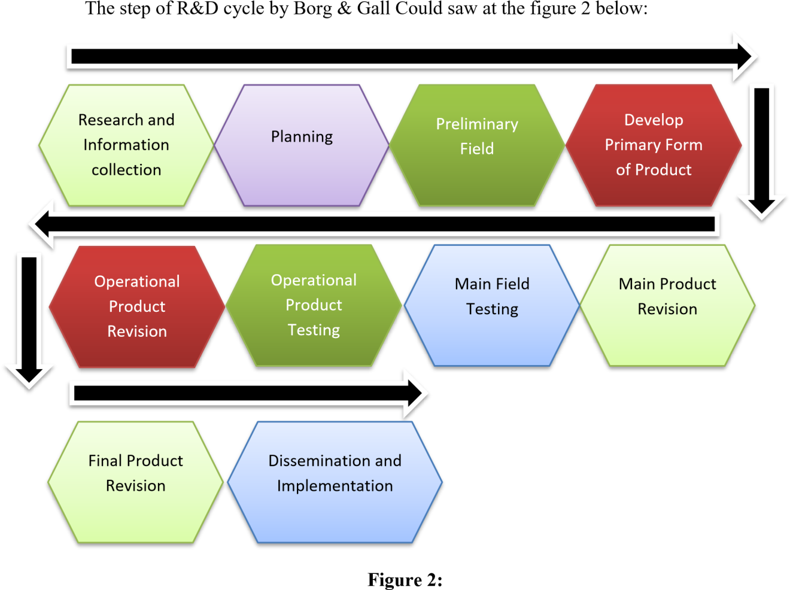
Borg & Gill R&D Step

3.5 Definition Operational Variable
This research is focus at the implementation of Self-record method to Improve student Vocabulary.
    - Self-recording Conceptual Definition
Self-recording video is a practice where students or study participants use technological device.s like smartphones, phones, or laptops to record themselves speaking in the target language, usually English, either inside or outside the classroom. The main goal of self-recording video is to improve language proficiency, particularly speaking in academic language. Through this activity, students or study participants (Nyoman Padmadewi, 2019).
This approach will facilitate comprehension and elucidation of the SelfRecord Video installation at SMPN 4 Tanjung Morawa. Based on the postpositivist philosophy, the qualitative research method is used to study natural object conditions (as opposed to experiments) and uses the researcher as the primary instrument. Triangulation (combined) data collection techniques are used, inductive/qualitative data analysis is used, and meaning is prioritized in qualitative research results rather than generalization (Sugiyono, 2019). This study included an English instructor as one of its participants.
    - Self-record operational definition
- Indicator
Indicator of self-record is the step of this game implementation.
  - Teacher Explain about self-record method aim to the whole student
  - Teacher make a dialog text that sudent use 3)Teacher make a group by student at treatment class
4)Teacher start the games.
- Assesment
In this game there are two assessments conducted, that are student assessment and teacher assessment. The sheet of assessment could see at appendix of this proposal.
3.5.3Listening Conceptual Definition
Listening Skill is defined as the ability to receive, interpret, and understand spoken language and various auditory inputs, encompassing not only the recognition of individual words and phrases but also the comprehension of context, tone, nuance, and the speaker's intent. Proficient listening involves active engagement, focused attention, and the capacity to extract meaning from oral communication effectively (Richards, J. C., & Schmidt, R: 2010).
- Indicator
Student could: , 1. Evaluating Information, 2. Interpreting Messages, 3. Content
Comprehension, 4. Capturing Nuances, 5. Detail Understanding
- Listening assessment
Listening assessment do by test that researcher apply to “treatment student” by answered multiple choice as many as the student can do.
Note: Assessment pattern are following:
Maximum score are 25
Very good | : If Score >22
Good | : If score 18-21
Enough | : If Score 14-17
Poor | : If Score 10-13
Very poor | : If Score < 10

3.5.4Speaking Conceptual Definition
According to Harmer (2007: 284) speaking ability is the ability to speak fluently which presupposes not only knowledge of language characteristics, but also the ability to process information and language 'on the spot'. This requires the ability to work together in managing speaking turns. It takes place in a real situation and has little time for detailed planning. Therefore, fluency is required to achieve the goal of conversation. Speaking ability is an important part of the curriculum in language teaching, and most teachers consider it the most difficult skill to teach because it is an interactive process that requires the ability to cooperate in rotation management.
3.5.5Speaking Oprasional Definition
- Indicator
Speaking score ranged from zero (minimum mark, if they cannot speak) to 20 (maximum mark). According to Speaking Scoring Criteria by Phillips (2007). It examined five components of English language. Philip described each criterion concretely and practically. The speaking test was supposed to score for pronunciation, grammar, vocabulary, fluency, and organization.
- Speaking assessment
Because the test is an oral test, the researcher divides the score into five criteria. In scoring the test, the researcher applies the theory of Brown (2004:171) for assessment speaking. There are five indicators to be assessed in this research which are grammar, vocabulary, comprehension, fluency, pronunciation and each of them has different assessment to do.
Note: Assessment pattern are following:
Maximum score are 25
1.Very good | : If Score >22
2.Good | : If score 18-21
3.Enough | : If Score 14-17
4.Poor | : If Score 10-13
5.Very poor | : If Score < 10

3.6Research Instrument Development The instrument of this research are:
- Observation sheet of students speaking ability
This paper was made to know how much the student mastery English speaking
- Sheet of Test
This paper was made to evaluate students listening abilities
- Pre-test and Post-test Rubric Assessment
This paper is made to know the grade of student speaking abilities
- Students rubric assessment guideline (speaking)
This paper is made to valuated the student speaking abilities
- Teacher assessment guideline
This paper is made to valuated the teacher during the learning process
- Reflection sheet of learning activity (Professional Judgement)
This sheet was consist the valuated of the learning process and suggestion to improve learning process next.
- Learning modul 8.Students Self-phone
.
3.7Data Collection Techniques
The data collection techniques in this research are as follows:
- Observation This activity is conducted by the researcher to assess whether students' English listening and speaking are categorized as good or not. It also aims to evaluate whether the self-record method applied at SMPN 4 Tanjung Morawa was appropriate or not. (Observation sheets can be found in the appendix).
- The Interview Method: involves posing questions to teachers, such as inquiring about the efforts they have made so far to enhance students' English listening and speaking skill, whether they have been using the other method.
- Test (Pre-test and Post-test): This sheet contains assessments of students' English listening and speaking abilities. The assessment criteria on this rubric can be found in the appendix.
  - Data Analysis Techniques
There are three types of analyses that will be conducted by the researcher in this study, namely:
3.8.1Analysis of Instrument
1.Analysis of Validity
According to Arikunto (2013:211) stated validity is a measurement that indicates the level of validity instrument. In this reseach, the researcher used content validity. To test the content validity, the researcher used Pearson Moment Products with the formula adopted from Arikunto (2013) as followed:
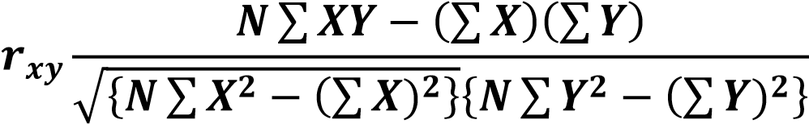
Note: rxy = The product of the total amount variable X and Y N = The number of data pairs X and Y
ΣX = The total of variable Y
ΣY = The total of variable X
ΣX² = The squared total amount of variable X
ΣY² = The squared total amount of variable Y

2.Analysis of Reliability
Reliability refers to extend to which the test is consistent in its score and gives us an indication of how accurate the test score are (Hatch and Farhady, 1982: 244). The concept of reliability comes from the ideas that no measurements is perfect even if we use the same scale, there will always be differences.
Inter-rater reliability was applied in this study in order to ensure the reliability of the score and to avoid the subjectively of the researcher. To achieve the reliability in assessing the students’ speaking performance, the researcher uses a speaking criteria based on Harris (1974), where the focus of speaking abilities assessed are; pronunciation, grammar, vocabulary, fluency, and comprehension. The second rater is the English teacher who has experience in assessing students’ speaking, with the aim of getting a consistent and fair assessment.
After finding the inter-rater coeficient, the researcher will then analyze the coeficient of reliability with the standard of reliability according to Slameto (1998: 147) in Hayanti (2010: 38) as follow:
A very low reliability (range from 0.00 – 0.19), A low reliability (range from 0.20 – 0.39), An average reliability (range from 0.40 – 0.59), A high reliability (range from 0.60 – 0.79), A very high reliability (range from 0.80 –0.100).
3.8.2Analysis of Hypothesis
1.H1 & H2
The researcher used Statistical Package for the Social Science (SPSS) for analyzing the data. Alan Bryan and Duncan Cramer (2005:21) stated SPSS is a manipulating, analyzing, and presenting data program which used in the social and behavior science. After the data was collected from the pre-test and posttest, the researcher analyzed the data with the T-test formulation. The analysis of the data using the Ttest formulation is in the following:
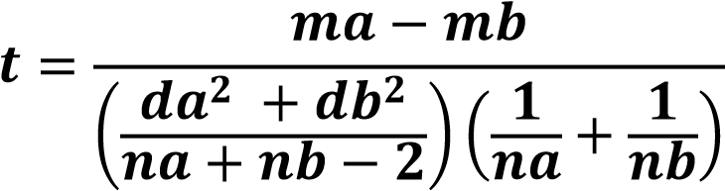
Note:
t = Total
Ma = The mean of experiment group Mb = The mean of control group da = The standart deviation of experiment group db = The standart deviation of control group Na = The total number sample of experiment group Nb = The total number sample of control group.

2.H3
To prove the hypotheses 3 (H3) of this research, researcher use expert judgment to valuating the design of audiolingual learning by using self-record as medium that researcher did. There are three aspect that valuating by the expert, Media using, language using, and method using. Leveling of the method, could find by take the average value of the three aspect of assessment. The assessment was did by the principle of SMP Negeri 4 Tanjung Morawa The assessment of learning process could saw at the appendix of this thesis.

