CHAPTER IV
RESULT AND DISCUSSION
4.1Result of Research
4.1.1Data Analyses
Following the research steps proposed by Borg & Gill, the first step in this study was to “seek and gather information” regarding the listening and speaking abilities of Junior High School 4 Tanjung Morawa students, as well as the learning methods that had been implemented by the school. Based on the results of observations and tests conducted by the researcher, the results were as shown in Table 5 below:
Table 5: Pre-test IX-A
No | Name Of Student |  | Score
No | Name Of Student | Listening Abilities | Condition | Speaking Abilities | Condition
1 | ADELLA CARRISSA ZENOBIA TAMBUNAN | 44 | unpass | 40 | unpass
2 | AHMAD ZEUS SARAGIH | 36 | unpass | 60 | unpass
3 | ALLYSYHA PUTRI | 52 | unpass | 52 | unpass
4 | ANGELICA NAMIRA ULI ARRAZZAQU BR SILITONGA | 56 | unpass | 64 | unpass
5 | AUREL PRICILIA BR. NABABAN | 60 | unpass | 80 | Pass
6 | AYU PRICILLA BR SILABAN | 68 | Unpass | 68 | unpass
7 | BAYKAL ARSYAHVIN | 72 | Pass | 64 | unpass
8 | CIKA ANGELINA BR SIAGIAN | 48 | unpass | 56 | unpass
9 | DEA ANDRI RASYA | 52 | unpass | 44 | unpass
10 | DIMAS PRAYUDHA | 52 | unpass | 56 | unpass
11 | FADHIL IHSAN MUDA TARIGAN | 64 | unpass | 36 | unpass
12 | HAFIZ MAULANA YUSUF | 52 | unpass | 60 | unpass
13 | HAMZAH AR-RASYID | 48 | unpass | 56 | unpass
14 | HAWILA LINDO EVITA BR PASARIBU | 56 | unpass | 60 | unpass
15 | JOSUA ISRAEL PANGGABEAN | 56 | unpass | 68 | unpass
16 | LETIZHA NAMIRA AZRA | 44 | unpass | 32 | unpass
17 | MESSI ALBERT SARAGIH | 52 | unpass | 68 | unpass
18 | MUHAMMAD RASYID | 92 | Pass | 96 | Pass
19 | NACHITA KANAIYA | 88 | Pass | 84 | Pass
20 | NATANAEL HAYES WIJAYA BUTARBUTAR | 32 | unpass | 36 | unpass
21 | NAYLA VORI | 64 | unpass | 72 | Pass
22 | NIKITA REFISIS BR SIAGIAN | 60 | unpass | 56 | unpass
23 | RASTI NUR HIDAYAH | 64 | unpass | 48 | unpass
24 | RIFKY RAMADHANU | 92 | Pass | 84 | Pass
25 | RIZKI AULIA ZAHRA | 40 | unpass | 28 | unpass
26 | SATRIA SITUMORANG | 32 | unpass | 32 | unpass
27 | SYIFA AMELIA RHISHANTY | 48 | unpass | 52 | unpass
28 | WILLYAMS ORLANDO MANURUNG | 32 | unpass | 32 | unpass
29 | WULAN DESTRIANI SIMAMORA | 52 | unass | 48 | unpass
30 | YOLA CRISTIN SITUMORANG | 80 | Pass | 72 | Pass
31 | ZAHARA AUNY BALQIS | 84 | Pass | 88 | Pass
 | Average | 57,16129032 |  | 57,80645161

According to table 5 above, it was evident that in the class IX-A out of 33 students, only 6 students passed the listening material, with an average score of 57,16, and 7 students passed the speaking material with an average score of 57,80.
Tabel 6: Pre-test IX B
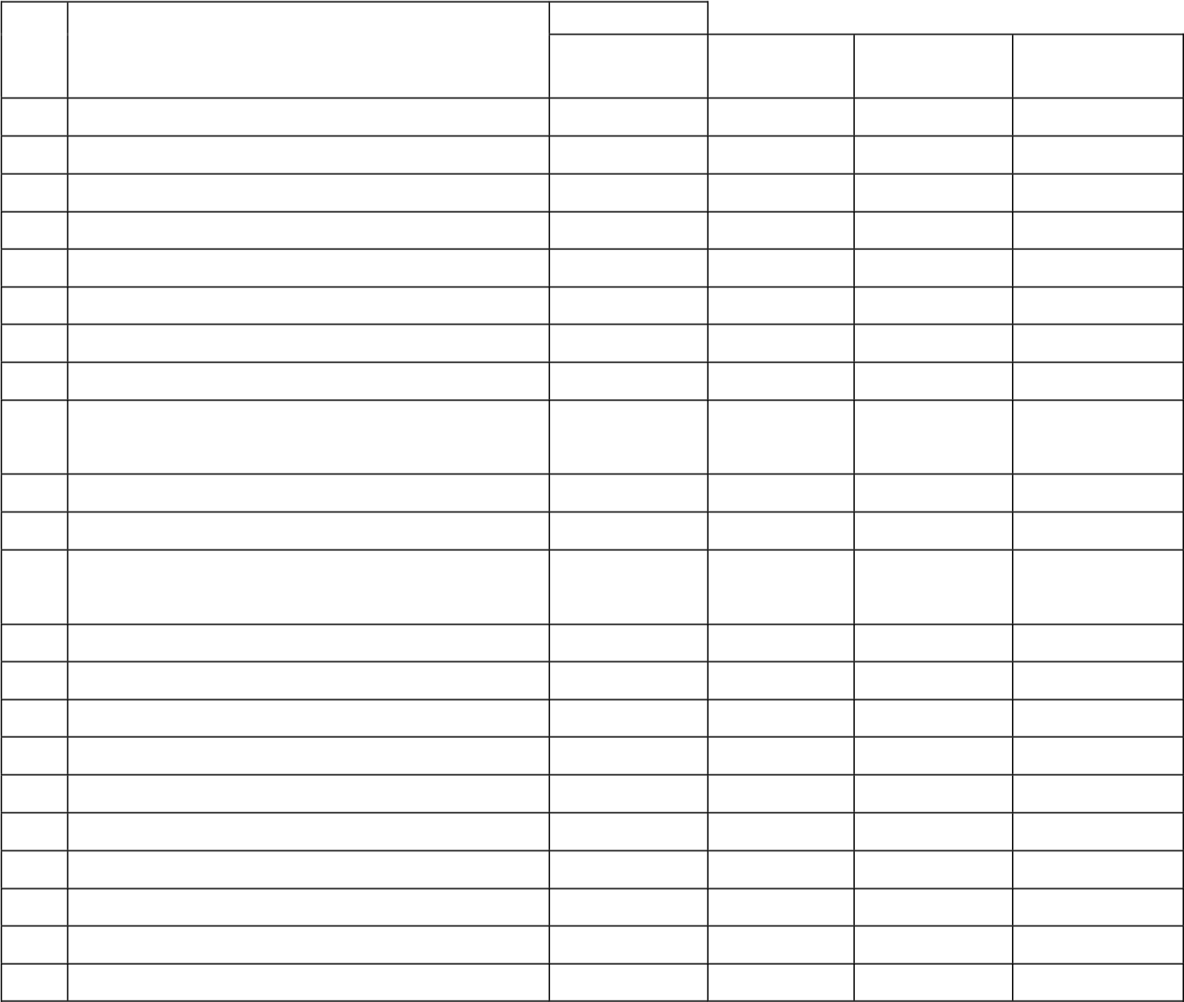
Score
No Name Of Student Listening Speaking
Condition Condition
Abilities Abilities
- ADAM GHIFAHRY 44 unpass 40 unpass
- AFIQA SAFITRI 28 unpass 64 unpass
- AGRIVA SITUMORANG 64 unpass 60 unpass
- ALFARENSA G.D TUMEWU 72 Pass 84 Pass
- ALHAFIZ LIANZA 60 unpass 80 Pass
- ANA STEVANI SIMBOLON 80 Pass 76 Pass
- ANDIKA MANULLANG 72 Pass 84 Pass
- AZAHRA NAILA ARDIANSYAH 48 unpass 56 unpass
- BOSTON BLESING LOOTOHUDANA 48 unpass 40 unpass
GIAWA
- BRIAN FRANKLIN LAOLI 68 unpass 80 Pass
- DAVID PERDAMAIAN GEA 64 unpass 36 unpass
- DEBORA MARTHA ULINA BR 52 unpass 80 Pass
SURBAKTI
- DESPITA BR SIBURIAN 68 unpass 80 Pass
- FAHRI ARDIANSYAH 88 Pass 80 Pass
- FEDRICK SEBASTIAN HUTABARAT 68 unpass 76 Pass
- FIVI JULIA RAHMAT 48 unpass 48 unpass
- IKHSAN ALFIAN 52 unpass 68 unpass
- JEREMY HILTON SIPAHUTAR 80 Pass 88 Pass
- KEZIA TOGI R BR SIMORANGKIR 64 unpass 76 Pass
- MARKUS SILABAN 52 unpass 68 unpass
- MAWAR DELIMA BR SIANIPAR 52 unpass 60 unpass
- MAYLITA TARIGAN 52 unpass 52 unpass
23 | MUHAMMAD ADRIAN MAULANA  SEMBIRING | 64 | unpass | 48 | unpass
24 | MUHAMMAD RIZA | 88 | Pass | 76 | Pass
25 | NANDA PRATIWI | 68 | unpass | 40 | unpass
26 | PUPUT LESTARI BR TAMBA | 48 | unpass | 32 | unpass
27 | RIDO KURNIAWAN | 68 | unpass | 64 | unpass
28 | RISMA ARTAULI PAKPAHAN | 36 | unpass | 28 | unpass
29 | RIZKY RAMADAN SIDABUTAR | 60 | unass | 52 | unass
30 | SAFITRI DWI AYUNING TYAS | 88 | Pass | 72 | Pass
31 | STEVEN PETRUS SIBURIAN | 68 | unpass | 40 | pass
32 | SYAIDHINA SUHAILA | 56 | unpass | 40 | unpass
33 | TRI MULYANI BANCIN | 36 | unpass | 44 | unpass
 | Average | 60,72727273 |  | 60,96969697

Based on Table 6 above, it is known that in class IX-B, out of 33 students, only 7 students passed the listening material, with an average score of 60.72, and 13 students passed the speaking material with an average score of 60.96.
Referring to Tables 5 and 6 above, it is evident that class IX-B has a better average ability compared to class IX-A. Therefore, in this study, the researcher will designate class IX-A as the experimental group and class IX-B as the control group.
After gaining an overview of students' listening and speaking abilities, the researcher conducted “planning and development of the initial design” of the learning materials, adjusting them to suit the students' proficiency levels, particularly in listening and speaking. The learning design created by the researcher can be seen in the appendix of this thesis.
Once the development of the learning design was completed, the next step was “the initial testing”. In this phase, the researcher designated class IX-A as the main subject of the research and class IX-B as the control group. Before testing was did, researcher did the instrument test by used validity anb reliability test. The result of the validity and reliability test could saw at the table below:
- Validity Test
  - Listening Ability
Table 7: Validity of Listening Ability test (Control Class)
Quisioner | r count | r tabel | Status
Item point y1.1 | 0,86961888 | 0,344 | Valid
Item point y1.2 | 0,870192635 | 0,344 | Valid
Item point y1.3 | 0,78266 | 0,344 | Valid
Item point y1.4 | 0,846603334 | 0,344 | Valid
Item point y1.5 | 0,883906625 | 0,344 | Valid

Table 8: Validity of Listening Ability test (Treatment Class)
Quisioner | r count | r tabel | Status
Item point y3.1 | 0,886805027 | 0,355 | Valid
Item point y3.2 | 0,860422863 | 0,355 | Valid
Item point y3.3 | 0,866463846 | 0,355 | Valid
Item point y3.4 | 0,716082088 | 0,355 | Valid
Item point y3.5 | 0,841116589 | 0,355 | Valid

  - Speaking Ability
Table 9:Vallidity of Speaking Ability test (Control Class)
Quisioner | r count | r tabel | Status
Item point y2.1 | 0,864414337 | 0,344 | Valid
Item point y2.2 | 0,796074978 | 0,344 | Valid
Item point y2.3 | 0,820428243 | 0,344 | Valid
Item point y2.4 | 0,887467344 | 0,344 | Valid
Item point y2.5 | 0,870247889 | 0,344 | Valid

Table 10: Validity of Speaking Anility test (Treatment Class)
Quisioner | r count | r tabel | Status
Item point y4.1 | 0,863723802 | 0,355 | Valid
Item point y4.2 | 0,880346882 | 0,355 | Valid
Item point y4.3 | 0,892652605 | 0,355 | Valid
Item point y4.4 | 0,895972889 | 0,355 | Valid
Item point y4.5 | 0,87001359 | 0,355 | Valid

Based on the validity table above, it is evident that the materials used to test the students' listening and speaking abilities, both in the control and treatment groups, were found to be valid. This is evidenced by the r-count values being greater than the r-table values.
- Reliability Test
  - Listening Ability
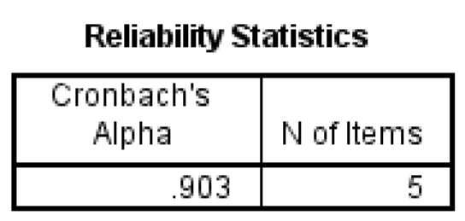
Figure 3:
Reliability of Listening ability test (Control Class)

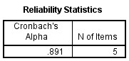
Figure 4:
Reliability of Listening ability test (Treatment Class)

  - Speaking Ability
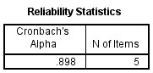

Figure 5:
Reliability of Speaking ability test (Control Class)

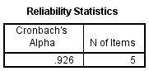
Figure 6:
Reliability of Speaking ability test (Treatment Class)

Based on the reliability test conducted on each class and each learning material, it was found that the Cronbach's alpha value was greater than 0.60, which indicates that the test materials administered to the students were reliable and in the very high reliability level.

After the testing instrument was determined to be valid and reliable, the next step was to assess the students' abilities using this instrument. The results of this initial testing can be seen in Tables 11 and 12below:
Tabel 11:Phase-1 (Control Class)
No | Name Of Student | Score
No | Name Of Student | Listening Abilities | Condition | Speaking Abilities | Condition
1 | ADAM GHIFAHRY | 56 | unpass | 60 | unpass
2 | AFIQA SAFITRI | 40 | unpass | 68 | Unpass
3 | AGRIVA SITUMORANG | 72 | Pass | 64 | Unpass
4 | ALFARENSA G.D TUMEWU | 84 | Pass | 88 | Pass
5 | ALHAFIZ LIANZA | 72 | unpass | 88 | Pass
6 | ANA STEVANI SIMBOLON | 84 | Pass | 80 | Pass
7 | ANDIKA MANULLANG | 80 | Pass | 84 | Pass
8 | AZAHRA NAILA ARDIANSYAH | 64 | unpass | 60 | unpass
9 | BOSTON BLESING LOOTOHUDANA GIAWA | 76 | unpass | 52 | unpass
10 | BRIAN FRANKLIN LAOLI | 84 | Pass | 80 | Pass
11 | DAVID PERDAMAIAN GEA | 80 | Pass | 44 | unpass
12 | DEBORA MARTHA ULINA BR SURBAKTI | 76 | unpass | 80 | Pass
13 | DESPITA BR SIBURIAN | 84 | Pass | 80 | Pass
14 | FAHRI ARDIANSYAH | 88 | Pass | 80 | Pass
15 | FEDRICK SEBASTIAN HUTABARAT | 84 | Pass | 76 | Pass
16 | FIVI JULIA RAHMAT | 52 | unpass | 52 | unpass
17 | IKHSAN ALFIAN | 68 | unpass | 68 | unpass
18 | JEREMY HILTON SIPAHUTAR | 84 | Pass | 88 | Pass
19 | KEZIA TOGI R BR SIMORANGKIR | 68 | unpass | 76 | Pass
20 | MARKUS SILABAN | 64 | unpass | 68 | unpass
21 | MAWAR DELIMA BR SIANIPAR | 56 | unpass | 60 | unpass
22 | MAYLITA TARIGAN | 56 | unpass | 52 | unpass
23 | MUHAMMAD ADRIAN MAULANA  SEMBIRING | 72 | Pass | 56 | unpass
24 | MUHAMMAD RIZA | 92 | Pass | 76 | Pass
25 | NANDA PRATIWI | 72 | Pass | 48 | unpass
26 | PUPUT LESTARI BR TAMBA | 56 | unpass | 40 | unpass
27 | RIDO KURNIAWAN | 72 | Pass | 64 | unpass
28 | RISMA ARTAULI PAKPAHAN | 52 | unpass | 44 | unpass
29 | RIZKY RAMADAN SIDABUTAR | 68 | unass | 52 | unass
30 | SAFITRI DWI AYUNING TYAS | 92 | Pass | 72 | Pass
31 | STEVEN PETRUS SIBURIAN | 72 | Pass | 40 | unpass
32 | SYAIDHINA SUHAILA | 60 | unpass | 48 | unpass
33 | TRI MULYANI BANCIN | 48 | unpass | 48 | Unpass
 | Average | 70,54545455 |  | 64,72727273

Table 12: Phase-1 (Treatment Class)
No | Name Of Student |  | Score
No | Name Of Student | Listening Abilities | Condition | Speaking Abilities | Condition
1 | ADELLA CARRISSA ZENOBIA TAMBUNAN | 64 | unpass | 60 | unpass
2 | AHMAD ZEUS SARAGIH | 52 | unpass | 80 | Pass
3 | ALLYSYHA PUTRI | 68 | unpass | 68 | Unpass
4 | ANGELICA NAMIRA ULI  ARRAZZAQU BR SILITONGA | 72 | Pass | 80 | Pass
5 | AUREL PRICILIA BR. NABABAN | 72 | Pass | 88 | Pass
6 | AYU PRICILLA BR SILABAN | 68 | Unpass | 84 | Pass
7 | BAYKAL ARSYAHVIN | 88 | Pass | 76 | Pass
8 | CIKA ANGELINA BR SIAGIAN | 64 | unpass | 72 | Pass
9 | DEA ANDRI RASYA | 64 | unpass | 60 | unpass
10 | DIMAS PRAYUDHA | 68 | unpass | 72 | Pass
11 | FADHIL IHSAN MUDA TARIGAN | 80 | Pass | 52 | Unpass
12 | HAFIZ MAULANA YUSUF | 72 | Pass | 60 | unpass
13 | HAMZAH AR-RASYID | 64 | unpass | 64 | unpass
14 | HAWILA LINDO EVITA BR PASARIBU | 76 | Pass | 72 | Pass
15 | JOSUA ISRAEL PANGGABEAN | 76 | Pass | 68 | unpass
16 | LETIZHA NAMIRA AZRA | 64 | unpass | 48 | unpass
17 | MESSI ALBERT SARAGIH | 72 | Pass | 76 | Pass
18 | MUHAMMAD RASYID | 96 | Pass | 96 | Pass
19 | NACHITA KANAIYA | 96 | Pass | 96 | Pass
20 | NATANAEL HAYES WIJAYA BUTAR-BUTAR | 56 | unpass | 56 | unpass
21 | NAYLA VORI | 84 | Pass | 84 | Pass
22 | NIKITA REFISIS BR SIAGIAN | 80 | Pass | 64 | unpass
23 | RASTI NUR HIDAYAH | 80 | Pass | 72 | pass
24 | RIFKY RAMADHANU | 96 | Pass | 96 | Pass
25 | RIZKI AULIA ZAHRA | 60 | unpass | 48 | unpass
26 | SATRIA SITUMORANG | 44 | unpass | 52 | unpass
27 | SYIFA AMELIA RHISHANTY | 56 | unpass | 64 | unpass
28 | WILLYAMS ORLANDO MANURUNG | 52 | unpass | 52 | unpass
29 | WULAN DESTRIANI SIMAMORA | 68 | unass | 60 | unpass
30 | YOLA CRISTIN SITUMORANG | 92 | Pass | 88 | Pass
31 | ZAHARA AUNY BALQIS | 84 | Pass | 100 | Pass
 | Average | 71,87096774 |  | 71,22580645

Based on Table 11 above, it is evident that in the control class, regarding the listening ability of 33 students, it was found that 11 students were categorized as passing, with an average score of 70.54. Meanwhile, regarding speaking ability, out of 33 students, 13 students were categorized as passing. Table 12 shows that the students' abilities in the treatment class, in terms of listening, had an average score of 71.87, with 16 out of 31 students categorized as passing. Regarding speaking ability, students in the treatment class had an average score of 71.22, with 16 students passing.
To determine whether the teaching method developed by the researcher successfully influenced the students' listening and speaking abilities, a statistical test is necessary.

- Normality and Homogeneity Test (Phase-1)
Prior to conducting the T-test, the data underwent normality and homogeneity tests. These tests were performed to determine whether the obtained data distribution was normal and homogeneous.

Table 13: Tests of Normality
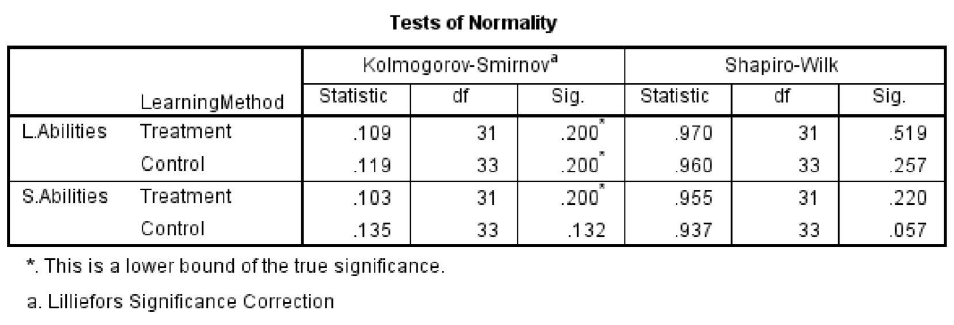
Based on Table 13, the significance values in the Kolmogorov-Smirnov column were greater than the alpha level of 0.05. This indicates that the data did not deviate significantly from a normal distribution, suggesting that the normality assumption was met.

Table 14: Test of Homogeneity of Variance
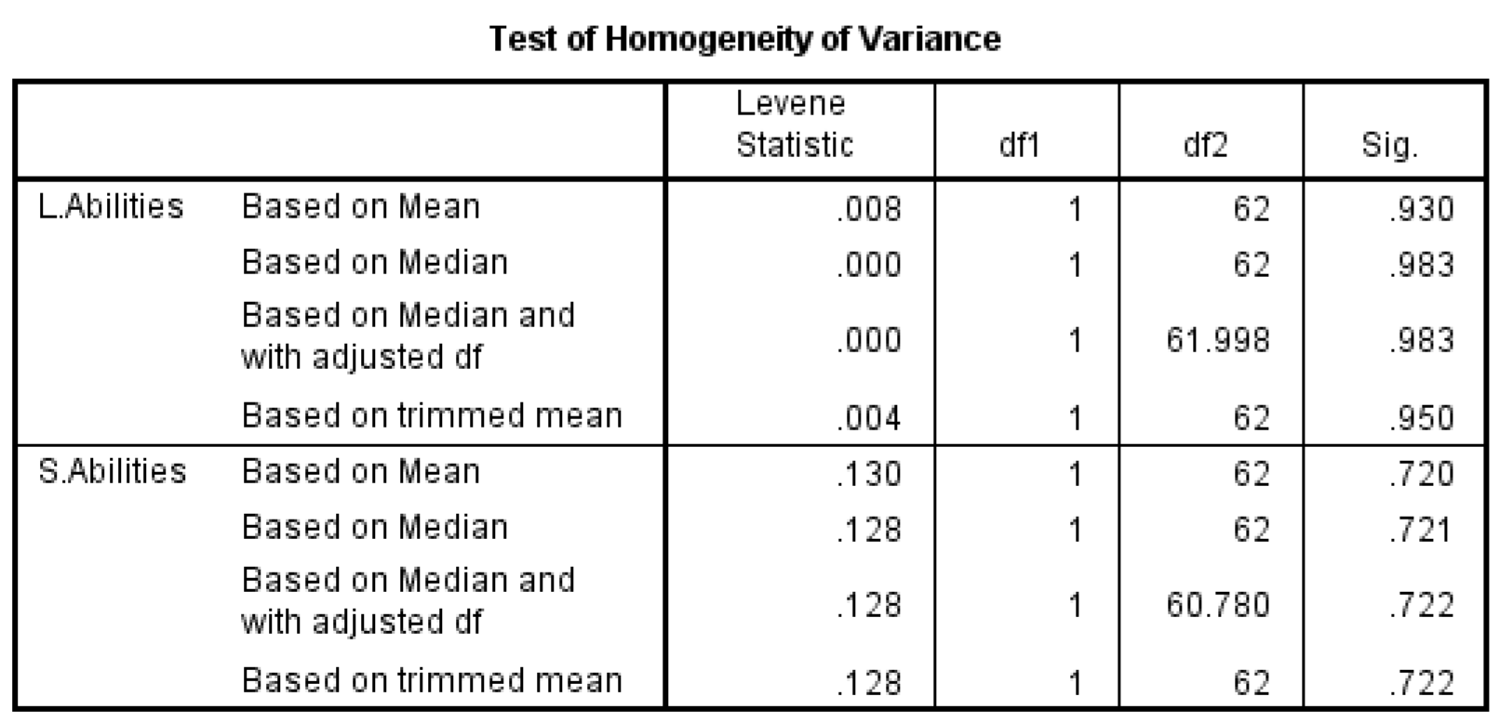
Based on Table 14, the significance levels for the listening abilities test (p =
0.930) and the speaking abilities test (p = 0.720) were both non-significant (p >
0.05). These results suggest that the data collected for both listening and speaking abilities were drawn from a homogeneous population.
- T-Test (Phase-1)
After the data was confirmed to be normally distributed and homogeneous, the next step was to conduct a t-test. This test was performed to determine the significance of the effect caused by the implementation of a learning design using the self-record learning method. The results of the test can be seen in the following table:
Table 15: Listening Abilities T-Test (Phase-1)
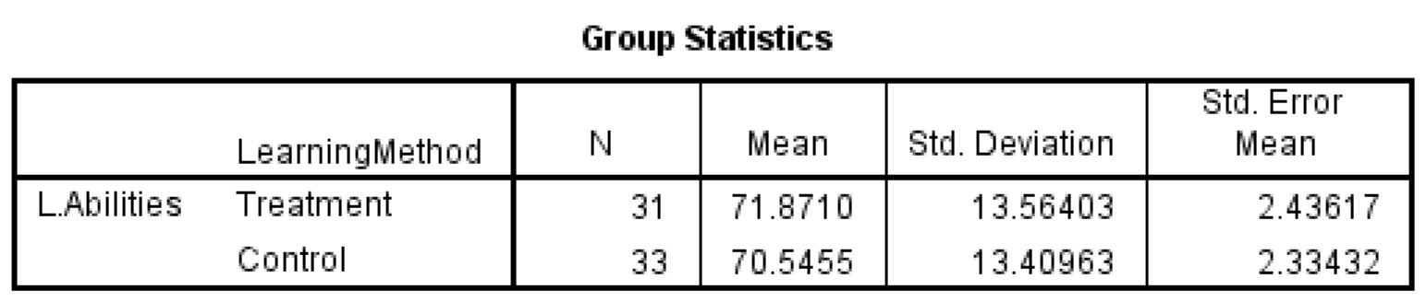
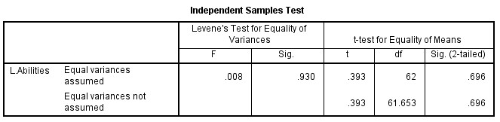
Referring to Table 15 above, it is known that the average score of students in the treatment class was higher compared to the control class. However, the significance value was 0.696, which is greater than the alpha value (0.05). This indicates that the learning method designed by the researcher was not able to provide a significant impact on the listening ability of students at SMP Negeri 4 Tanjung Morawa. Therefore, further evaluation of the research design created by the researcher is needed.
Table:16: Speaking Abilities T-Test (Phase-1)
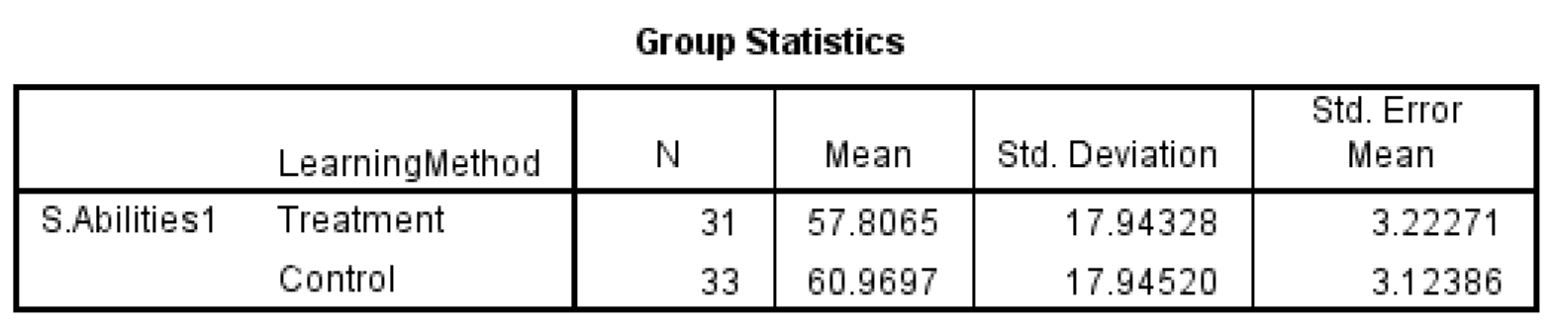
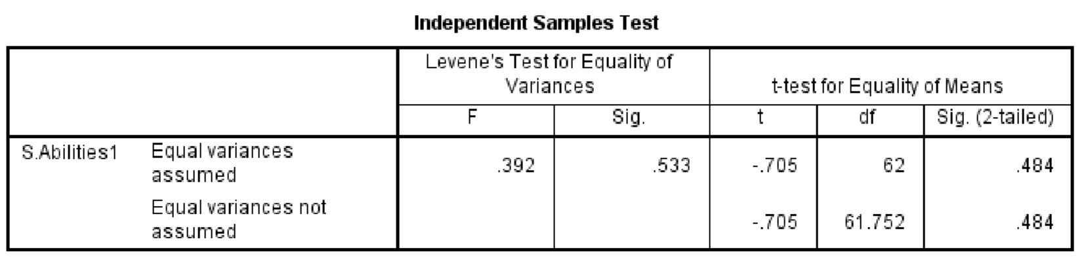
Referring to Table 16 above, it is known that the average score of students in the treatment class was higher compared to the control class. However, the significance value was 0.484, which is greater than the alpha value (0.05). This indicates that the speaking method designed by the researcher was not able to provide a significant impact on the speaking ability of students at SMP Negeri 4 Tanjung Morawa. Therefore, further evaluation of the research design created by the researcher is needed.
Referring to Borg & Gill's research and development method, the next step after the initial design implementation was to revise the designed product. At this stage, the researcher requested feedback and input on the developed method from the principal of SMP Negeri 4 Tanjung Morawa. The principal's assessment can be seen in Table 17 below:
Table 17: Method Assessment (Phase-1)
No | Method Aspect | Sub-Aspect | Assessment Indicator | Point/Score
1 | Material | Content  Suitability | Relevance of Content | 4
1 | Material | Content  Suitability | Richness of Content | 3
1 | Material | Content  Suitability | Organization | 3
1 | Material | Content  Suitability | Engagement | 3
1 | Material | Content  Suitability | Consistency | 4
1 | Material | Content  Suitability | Readability | 3
1 | Material | Presentation | Interactivity | 4
1 | Material | Presentation | Creativity | 4
1 | Material | Presentation | Accessibility | 4
1 | Material | Presentation | Support | 3
1 | Material | Language | Language Accuracy | 3
1 | Material | Language | Completeness of Translations | 3
2 | Language | Language Useage | Grammar | 3
2 | Language | Language Useage | Language Richness | 3
2 | Language | Language Useage | Fluency | 3
2 | Language | Language Useage | Language economy | 3
2 | Language | Language Useage | Language Creativity | 3
2 | Language | Language Useage | Contextual Suitability | 4
2 | Language | Language Useage | Audience Suitability | 3
3 | Method/Media | Presentation | Structure Coherence | 3
3 | Method/Media | Presentation | Use of Method/Media | 2
3 | Method/Media | Presentation | Student Engagment | 2
3 | Method/Media | Presentation | Creativity | 3
3 | Method/Media | Presentation | Accessibility | 3
3 | Method/Media | Effectiveness | Learning Objctives | 3
3 | Method/Media | Effectiveness | Active Teaching | 3
3 | Method/Media | Effectiveness | Student Engagment | 2
3 | Method/Media | Effectiveness | Evaluation | 3
3 | Method/Media | Effectiveness | Use of Technology | 2
3 | Method/Media | Effectiveness | Usability | 3
3 | Method/Media | Effectiveness | Measureability | 4
 | Total |  |  | 92
 | Average |  |  | 2,967741935

According to table 17 above, could saw that the average value of method assessment was at 2,96 that’s means the method that researcher develop was at enough level doesn’t reach good level. There were several point had lower score, that point to be the focus of researcher evaluating. The evaluating point could saw at the appendix of this thesis.
After evaluating the main product, the next steps was main field testing. The result of the main filed testing could saw at the table below:
- Validity Test (Phase-2)
  - Listening Ability
Table 18: Validity of Listening Ability test (Control Class)
Quisioner | r count | r tabel | Status
Item point y1.1 | 0,828125 | 0,344 | Valid
Item point y1.2 | 0,883760081 | 0,344 | Valid
Item point y1.3 | 0,794101388 | 0,344 | Valid
Item point y1.4 | 0,830621963 | 0,344 | Valid
Item point y1.5 | 0,870444298 | 0,344 | Valid

Table 19: Validity of Listening Ability test (Treatment Class)
Quisioner | r count | r tabel | Status
Item point y3.1 | 0,753288131 | 0,355 | Valid
Item point y3.2 | 0,873120875 | 0,355 | Valid
Item point y3.3 | 0,881610577 | 0,355 | Valid
Item point y3.4 | 0,811014068 | 0,355 | Valid
Item point y3.5 | 0,786391504 | 0,355 | Valid

  - Speaking Ability
Table 20:Vallidity of Speaking Ability test (Control Class)
Quisioner | r count | r tabel | Status
Item point y2.1 | 0,83684161 | 0,344 | Valid
Item point y2.2 | 0,798810842 | 0,344 | Valid
Item point y2.3 | 0,819400848 | 0,344 | Valid
Item point y2.4 | 0,880064432 | 0,344 | Valid
Item point y2.5 | 0,86939954 | 0,344 | Valid

Table 21: Validity of Speaking Anility test (Treatment Class)
Quisioner | r count | r tabel | Status
Item point y4.1 | 0,791868681 | 0,355 | Valid
Item point y4.2 | 0,830746329 | 0,355 | Valid
Item point y4.3 | 0,858473883 | 0,355 | Valid
Item point y4.4 | 0,884647826 | 0,355 | Valid
Item point y4.5 | 0,702224973 | 0,355 | Valid
Based on the validity table above, it is evident that the materials used to test the students' listening and speaking abilities, both in the control and treatment groups, were found to be valid. This is evidenced by the r-count values being greater than the r-table values.
- Reliability Test (Phase-2)
  - Listening Ability
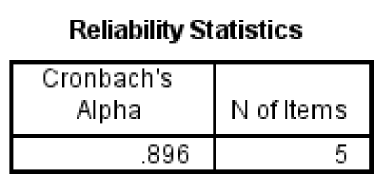
Figure 7:
Reliability of Listening ability test Phase-2 (Control Class)

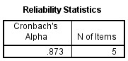
Figure 8:
Reliability of Listening ability test Phase-2 (Treatment Class)

  - Speaking Ability
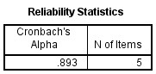
Figure 9:
Reliability of Speaking ability test Phase-2 (Control Class)

Figure 10:
Reliability of Speaking ability test Phase-2 (Treatment Class)

Based on the reliability test conducted on each class and each learning material, it was found that the Cronbach's alpha value was greater than 0.60, which indicates that the test materials administered to the students were reliable and in the very high reliability level.

After the testing instrument was determined to be valid and reliable, the next step was to assess the students' abilities using this instrument. The results of this main field testing can be seen in Tables 22 and 23 below:
Tabel 22:Phase-2 (Control Class)
No | Name Of Student | Score
No | Name Of Student | Listening Abilities | Condition | Speaking Abilities | Condition
1 | ADAM GHIFAHRY | 56 | unpass | 60 | unpass
2 | AFIQA SAFITRI | 44 | unpass | 68 | Unpass
3 | AGRIVA SITUMORANG | 72 | Pass | 64 | Unpass
4 | ALFARENSA G.D TUMEWU | 84 | Pass | 88 | Pass
5 | ALHAFIZ LIANZA | 76 | Pass | 88 | Pass
6 | ANA STEVANI SIMBOLON | 84 | Pass | 80 | Pass
7 | ANDIKA MANULLANG | 80 | Pass | 84 | Pass
8 | AZAHRA NAILA ARDIANSYAH | 64 | unpass | 60 | unpass
9 | BOSTON BLESING  LOOTOHUDANA GIAWA | 76 | Pass | 52 | unpass
10 | BRIAN FRANKLIN LAOLI | 84 | Pass | 80 | Pass
11 | DAVID PERDAMAIAN GEA | 84 | Pass | 44 | unpass
12 | DEBORA MARTHA ULINA BR SURBAKTI | 76 | Pass | 80 | Pass
13 | DESPITA BR SIBURIAN | 84 | Pass | 80 | Pass
14 | FAHRI ARDIANSYAH | 88 | Pass | 80 | Pass
15 | FEDRICK SEBASTIAN HUTABARAT | 84 | Pass | 76 | Pass
16 | FIVI JULIA RAHMAT | 52 | Unpass | 52 | unpass
17 | IKHSAN ALFIAN | 68 | Unpass | 72 | Pass
18 | JEREMY HILTON SIPAHUTAR | 84 | Pass | 88 | Pass
19 | KEZIA TOGI R BR SIMORANGKIR | 68 | Unpass | 76 | Pass
20 | MARKUS SILABAN | 68 | Unpass | 68 | unpass
21 | MAWAR DELIMA BR SIANIPAR | 56 | Unpass | 64 | unpass
22 | MAYLITA TARIGAN | 56 | Unpass | 52 | unpass
23 | MUHAMMAD ADRIAN MAULANA SEMBIRING | 72 | Pass | 56 | unpass
24 | MUHAMMAD RIZA | 92 | Pass | 76 | Pass
25 | NANDA PRATIWI | 72 | Pass | 48 | unpass
26 | PUPUT LESTARI BR TAMBA | 56 | Unpass | 40 | unpass
27 | RIDO KURNIAWAN | 72 | Pass | 64 | unpass
28 | RISMA ARTAULI PAKPAHAN | 52 | Unpass | 44 | unpass
29 | RIZKY RAMADAN SIDABUTAR | 68 | Unass | 52 | unass
30 | SAFITRI DWI AYUNING TYAS | 92 | Pass | 72 | Pass
31 | STEVEN PETRUS SIBURIAN | 72 | Pass | 40 | unpass
32 | SYAIDHINA SUHAILA | 60 | Unpass | 48 | unpass
33 | TRI MULYANI BANCIN | 48 | Unpass | 48 | Unpass
 | Average | 71,03030303 |  | 64,96969697

Table 23: Phase-2 (Treatment Class)
No | Name Of Student |  | Score
No | Name Of Student | Listening Abilities | Condition | Speaking Abilities | Condition
1 | ADELLA CARRISSA ZENOBIA TAMBUNAN | 80 | Pass | 68 | unpass
2 | AHMAD ZEUS SARAGIH | 84 | Pass | 80 | Pass
3 | ALLYSYHA PUTRI | 76 | Pass | 68 | Unpass
4 | ANGELICA NAMIRA ULI  ARRAZZAQU BR SILITONGA | 72 | Pass | 80 | Pass
5 | AUREL PRICILIA BR.  NABABAN | 80 | Pass | 88 | Pass
6 | AYU PRICILLA BR SILABAN | 76 | Pass | 88 | Pass
7 | BAYKAL ARSYAHVIN | 96 | Pass | 84 | Pass
8 | CIKA ANGELINA BR SIAGIAN | 72 | Pass | 84 | Pass
9 | DEA ANDRI RASYA | 76 | Pass | 60 | unpass
10 | DIMAS PRAYUDHA | 84 | Pass | 72 | Pass
11 | FADHIL IHSAN MUDA TARIGAN | 84 | Pass | 52 | Unpass
12 | HAFIZ MAULANA YUSUF | 80 | Pass | 60 | unpass
13 | HAMZAH AR-RASYID | 64 | unpass | 72 | Pass
14 | HAWILA LINDO EVITA BR PASARIBU | 76 | Pass | 72 | Pass
15 | JOSUA ISRAEL PANGGABEAN | 88 | Pass | 76 | Pass
16 | LETIZHA NAMIRA AZRA | 72 | Pass | 72 | Pass
17 | MESSI ALBERT SARAGIH | 80 | Pass | 76 | Pass
18 | MUHAMMAD RASYID | 96 | Pass | 100 | Pass
19 | NACHITA KANAIYA | 96 | Pass | 100 | Pass
20 | NATANAEL HAYES WIJAYA BUTAR-BUTAR | 64 | unpass | 56 | unpass
21 | NAYLA VORI | 88 | Pass | 88 | Pass
22 | NIKITA REFISIS BR SIAGIAN | 88 | Pass | 72 | Pass
23 | RASTI NUR HIDAYAH | 88 | Pass | 92 | Pass
24 | RIFKY RAMADHANU | 100 | Pass | 96 | Pass
25 | RIZKI AULIA ZAHRA | 72 | Pass | 72 | Pass
26 | SATRIA SITUMORANG | 60 | unpass | 72 | Pass
27 | SYIFA AMELIA RHISHANTY | 72 | Pass | 76 | Pass
28 | WILLYAMS ORLANDO MANURUNG | 64 | unpass | 64 | unpass
29 | WULAN DESTRIANI SIMAMORA | 76 | Pass | 72 | Pass
30 | YOLA CRISTIN SITUMORANG | 96 | Pass | 88 | Pass
31 | ZAHARA AUNY BALQIS | 92 | Pass | 100 | Pass
 | Average | 80,38709677 |  | 77,41935484

Based on Table 22 above, it is evident that in the control class, regarding the listening ability of 33 students, it was found that 21 students were categorized as passing, with an average score of 70.54. Meanwhile, regarding speaking ability, out of 33 students, 14 students were categorized as passing. Table 23 shows that the students' abilities in the treatment class, in terms of listening, had an average score of 80,38, with 27 out of 31 students categorized as passing. Regarding speaking ability, students in the treatment class had an average score of 77.41, with 24 students passing.
To determine whether the teaching method developed by the researcher successfully influenced the students' listening and speaking abilities, a statistical test is necessary.
- Normality and Homogeneity Test (Phase-2)
Prior to conducting the T-test, the data underwent normality and homogeneity tests. These tests were performed to determine whether the obtained data distribution was normal and homogeneous.
Table 24: Tests of Normality
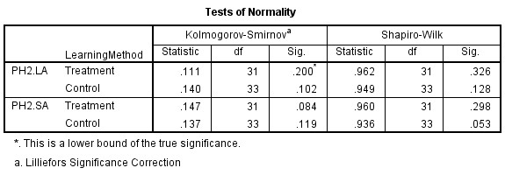
Based on Table 24, the significance values in the Kolmogorov-Smirnov column were greater than the alpha level of 0.05. This indicates that the data did not deviate significantly from a normal distribution, suggesting that the normality assumption was met.

Table 25: Test of Homogeneity of Variance
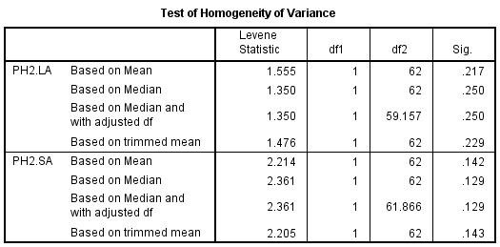
Based on Table 25, the significance levels for the listening abilities test (p =
0.217) and the speaking abilities test (p = 0.142) were both non-significant (p >
0.05). These results suggest that the data collected for both listening and speaking abilities were drawn from a homogeneous population.
- T-Test (Phase-2)
After the data was confirmed to be normally distributed and homogeneous, the next step was to conduct a t-test. This test was performed to determine the significance of the effect caused by the implementation of a learning design using the self-record learning method. The results of the test can be seen in the following table:
Table 26: Listening Abilities T-Test
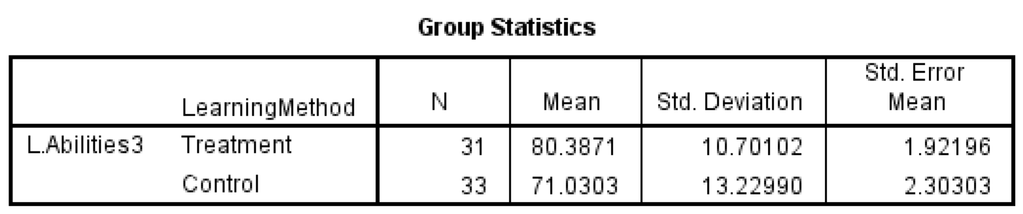
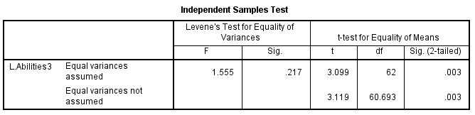
Referring to Table 26 above, it is known that the average score of students in the treatment class was higher compared to the control class. The significance value was 0.03, which is lower than the alpha value (0.05). This indicates that the learning method designed by the researcher was able to provide a significant impact on the listening ability of students at SMP Negeri 4 Tanjung Morawa. Therefore, further evaluation of the research design created by the researcher is needed.
Table 27:Speaking Abilities T-Test
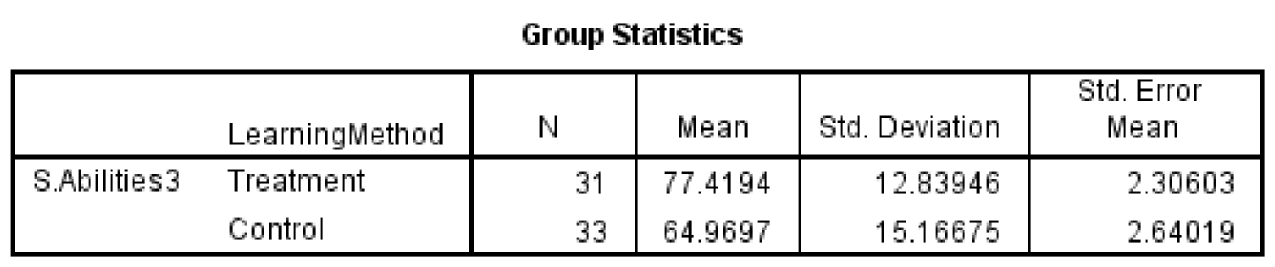
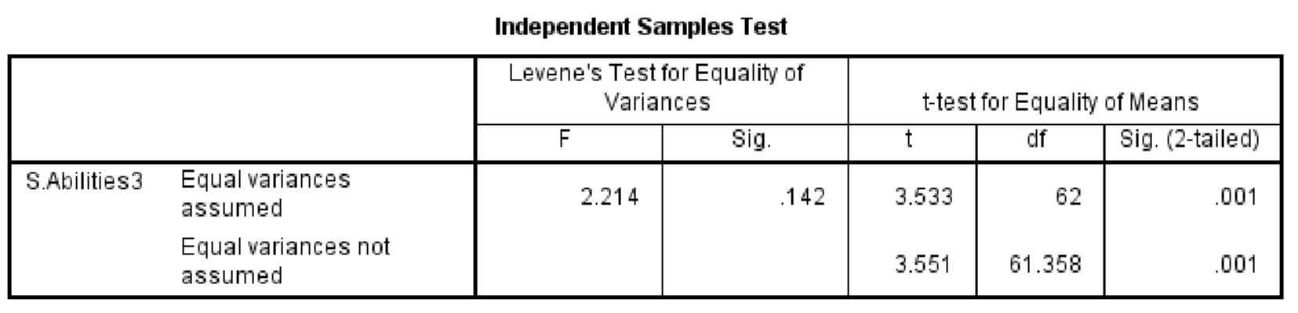
Referring to Table 27 above, it is known that the average score of students in the treatment class was higher compared to the control class. The significance value was 0.01, which is lower than the alpha value (0.05). This indicates that the learning method designed by the researcher was able to provide a significant impact on the speaking ability of students at SMP Negeri 4 Tanjung Morawa. Therefore, further evaluation of the research design created by the researcher is needed
Referring to Borg & Gill's research and development method, the next step after the initial design implementation was to revise the designed product. At this stage, the researcher requested feedback and input on the developed method from the principal of SMP Negeri 4 Tanjung Morawa. The principal's assessment can be seen in Table 28 below:
Table 28: Method Assessment (Phase-2)
No | Method Aspect | Sub-Aspect | Assessment Indicator | Point/Score
1 | Material | Content  Suitability | Relevance of Content | 4
1 | Material | Content  Suitability | Richness of Content | 4
1 | Material | Content  Suitability | Organization | 4
1 | Material | Content  Suitability | Engagement | 3
1 | Material | Content  Suitability | Consistency | 4
1 | Material | Content  Suitability | Readability | 3
1 | Material | Presentation | Interactivity | 3
1 | Material | Presentation | Creativity | 4
1 | Material | Presentation | Accessibility | 4
1 | Material | Presentation | Support | 4
1 | Material | Language | Language Accuracy | 4
1 | Material | Language | Completeness of Translations | 3
2 | Language | Language Useage | Grammar | 4
2 | Language | Language Useage | Language Richness | 3
2 | Language | Language Useage | Fluency | 3
2 | Language | Language Useage | Language economy | 3
2 | Language | Language Useage | Language Creativity | 4
2 | Language | Language Useage | Contextual Suitability | 4
2 | Language | Language Useage | Audience Suitability | 4
3 | Method/Media | Presentation | Structure Coherence | 4
3 | Method/Media | Presentation | Use of Method/Media | 4
3 | Method/Media | Presentation | Student Engagment | 3
3 | Method/Media | Presentation | Creativity | 3
3 | Method/Media | Presentation | Accessibility | 3
3 | Method/Media | Effectiveness | Learning Objctives | 3
3 | Method/Media | Effectiveness | Active Teaching | 3
3 | Method/Media | Effectiveness | Student Engagment | 3
3 | Method/Media | Effectiveness | Evaluation | 3
3 | Method/Media | Effectiveness | Use of Technology | 4
3 | Method/Media | Effectiveness | Usability | 3
3 | Method/Media | Effectiveness | Measureability | 4
 | Total |  |  | 109
 | Average |  |  | 3,516129032

According to table 28 above, could saw that the average value of method assessment was at 3,51 that’s means the method that researcher develop was reach
good level.
Referencing the results obtained in Phase 2, the sixth stage of the listening and speaking instructional design development at SMP Negeri 4 Tanjung Morawa has demonstrated highly favorable outcomes. Thus, based on Borg and Gill's development theory, the development process can be terminated and proceed to the final phase: Dissemination and Implementation.
4.1.2Hypothesis test
1.H1
Referring to the first hypothesis of this study, "Implementing Self-record is significant to increase Student English language listening abilities at SMP NEGRI 4 TANJUNG MORAWA," it was found in Phase 2 that the results were as presented in Table 26. This table shows that there was a difference in the mean scores between the control and treatment groups. The control group had a mean score of 71.03, while the treatment group had a mean score of 80.38.
Given the passing standard of 75 (where 72 points are for academic performance and 3 points are for diligence), the control group, on average, did not meet the passing criteria. According to Table 22, only 21 out of 33 students in the control group passed the listening material. When converted into a percentage, this means that the passing rate for the control group was only 63.63%.
In contrast, a different scenario was observed in the treatment group. Out of 31 students, 27 met the passing standard. When converted into a percentage, this means that a substantial 87.1% of students in the treatment group successfully passed the listening material. Given this significant difference of approximately 23.46% in passing rates between the control and treatment groups, it is reasonable that Table 26's statistical analysis indicates that the instructional design employing the selfrecord method yielded significant results, with a significance value of 0.03, which is lower than the alpha value of 0.05. To visualize the progress of students' abilities in each class, please refer to the figure below.

60.72727273
57.16129032
71.03030303
80.38709677
0
10
20
30
40
50
60
70
80
90
Control
Treatment
Listening abilities
Average Student's Test Score
Control Vs Treatment
Pre-test
Post-test
Figure 11:
Student’s Listening Abilities Improvement
As shown in Figure 11, the increase in students' listening abilities from the pretest to the post-test was 10.31 points in the control group, while in the treatment group, the increase was 23.22 points. Based on these results, it can be inferred that the improvement in students' listening abilities using the self-recording method was significantly higher compared to the previous method. Based on these findings, the researcher concludes that H01 is rejected and H1 is accepted.
2.H2
Referring to the second hypothesis of this study, "Implementing Self-record is significant to increase Student English language speaking abilities at SMP NEGERI 4 TANJUNG MORAWA " it was found in Phase 2 that the results were as presented in Table 27. This table shows that there was a difference in the mean scores between the control and treatment groups. The control group had a mean score of 64,96, while the treatment group had a mean score of 77,41.
Given the passing standard of 75 (where 72 points are for academic performance and 3 points are for diligence), the control group, on average, did not meet the passing criteria. According to Table 22, only 14 out of 33 students in the control group passed the speaking material. When converted into a percentage, this means that the passing rate for the control group was only 42,42%.
In contrast, a different scenario was observed in the treatment group. Out of 31 students, 24 met the passing standard. When converted into a percentage, this means that a substantial 77,41% of students in the treatment group successfully passed the speaking material. Given this significant difference of approximately 34,99% in passing rates between the control and treatment groups, it is reasonable that Table 26's statistical analysis indicates that the instructional design employing the selfrecord method yielded significant results, with a significance value of 0.01, which is lower than the alpha value of 0.05. To visualize the progress of students' abilities in each class, please refer to the figure below.

60.96969697
57.80645161
64.96969697
77.41935484
0
10
20
30
40
50
60
70
80
90
Control
Treatment
Speaking abilities
Average Student's Test Score
Control Vs Treatment
Pre-test
Post-test
Figure 12:
Student’s Speaking Abilities Improvement
As shown in Figure 12, the increase in students' speaking abilities from the pretest to the post-test was 4 points in the control group, while in the treatment group, the increase was 22,61 points. Based on these results, it can be inferred that the improvement in students' speaking abilities using the self-recording method was significantly higher compared to the previous method. Based on these findings, the researcher concludes that H02 is rejected and H2 is accepted.
3.H3
Referring to the third hypothesis of this study, "The learning design of Selfrecord learning models is in the good levels to implementing at SMP NEGERI 4 TANJUNG MORAWA" The research design was evaluated and received a score of 3.51, indicating that the research design developed by the researcher was considered to be of "good" quality.
This evaluation was conducted based on the method assessment sheet completed by the principal of SMP Negeri 4 Tanjung Morawa. The assessment focused on aspects of the teaching method, including the material, language use, and media usage. The results of this assessment can be found in Table 28 of this thesis. Therefore, the researcher concludes that H03 in this study is rejected and H3 is accepted.
4.2Discussion
As revealed in the data analysis presented above, the instructional design incorporating the self-recording method was successfully developed through two rounds of revision and evaluation. This success is evidenced by the improvement in students' listening and speaking abilities, as well as the positive evaluation of the method, which was rated as "good" levels.
In the initial planning phase, the researcher attempted to align the instructional materials with the students' abilities. This alignment was determined based on the results of the researcher's previous observations. The suitability of the materials for the students' abilities was considered a fundamental standard in selecting instructional content. Sabarudin (2018:17) said that;
“Materi pembelajaran yang di dalamnya ada proses penentuan urutan, pemilihannya yang harus mengacu pada standar kompetensi, proses identifikasi aspek dan jenis untuk mendapatkan materi yang relevan dengan SK dan KD, membutuhkan proses cukup panjang dan rumit. Begitu juga ketika materi pembelajaran hendak disampaikan, disaat itulah dibutuhkan media yang benar-benar tepat untuk tersampaikannya materi untuk mencapai tujuan pembelajaran”

In English translation:
“The process of developing instructional materials, which involves determining the sequence and selection of content based on competency standards, as well as identifying the aspects and types of content relevant to the Standards of Competence (SK) and Basic Competencies (KD), is quite lengthy and complex. Similarly, when delivering instructional materials, the selection of an appropriate medium is crucial to ensure that the learning objectives are achieved”.

In the line with Ahyadi, et al (2021:115) did, researcher must be attempted to analyze students’ needs, consisting of personality, competence, weakness, and pleasantness in learning English. Based on the analyze result, the next step was Constructing instructional materials and strategies.
According to the result of the observation, researcher did the design of the listening and speaking learning strategies by used self-record method. Maulana, et al (2023:883) Said that Self-Recording Video increases students' confidence in speaking and provides opportunities to improve abilities. Despite challenges, such as mispronunciations, this approach helps students feel supported and motivated. By using this video, students can practice speaking more confidently and effectively in learning English.
This is in line with what was conveyed by Burn Anne (2019:10)”The main aim of speaking tasks is to help students develop the fluency of expert speakers where meaning is communicated with few hesitations and in a manner that is appropriate for the social purpose of the message. This is achieved through the use of accurate language and discourse routines, appropriate speech enabling abilities, and effective communication strategies”.
In the preliminary test result showed that the preliminary design wasn’t impact the students listening and speaking abilities. This could be happened because, according to the method assessment that did by the principle, the learning material and the language used that researcher did was less compatible to the student’s abilities.
According to this suggestion, researcher was redesign the learning methods by used the common material and language. Researcher did the material by used the simple folklore that students knew well. As the result, the achievement of students listening and speaking abilities was increased significantly.
This result was in line with the statement of Aprianto and Muhlisin (2022:252) that “The finding of to what extent the use of SRV as an English language learning method in developing English learning performance statistically depicted that it has affected the students’ English learning.
Same energy with the Encalada (2019:64) claimed that “SRVs have helped me to develop my speaking abilities," we find out that the majority of students, 48, 1% of them, very agreed and that 43, 2% of them agreed.

