Lampiran 1. Tabulasi Data Penelelitian
Tabulasi Data Variabel Produk (X₁)
No.  Responden | Nomor Item Pertanyaan |  |  |  |  | Total  X₁
 | 1 | 2 | 3 | 4 | 5
1 | 4 | 3 | 5 | 5 | 3 | 20
2 | 4 | 4 | 4 | 3 | 4 | 19
3 | 4 | 3 | 4 | 4 | 4 | 19
4 | 4 | 3 | 5 | 3 | 4 | 19
5 | 3 | 4 | 4 | 3 | 4 | 18
6 | 3 | 4 | 4 | 3 | 4 | 18
7 | 3 | 4 | 4 | 3 | 4 | 18
8 | 3 | 4 | 4 | 3 | 4 | 18
9 | 3 | 4 | 4 | 3 | 4 | 18
10 | 3 | 4 | 4 | 3 | 4 | 18
11 | 5 | 4 | 4 | 4 | 4 | 21
12 | 5 | 4 | 5 | 3 | 4 | 21
13 | 4 | 4 | 4 | 5 | 4 | 21
14 | 4 | 4 | 4 | 3 | 5 | 20
15 | 4 | 4 | 4 | 5 | 4 | 21
16 | 4 | 4 | 3 | 3 | 5 | 19
17 | 4 | 4 | 4 | 4 | 4 | 20
18 | 3 | 4 | 4 | 4 | 4 | 19
19 | 4 | 4 | 5 | 4 | 5 | 22
20 | 5 | 4 | 3 | 4 | 5 | 21
21 | 5 | 4 | 3 | 4 | 5 | 21
22 | 4 | 4 | 5 | 3 | 5 | 21
23 | 5 | 5 | 4 | 4 | 3 | 21
24 | 5 | 4 | 5 | 3 | 3 | 20
25 | 5 | 5 | 4 | 4 | 4 | 22
26 | 5 | 5 | 4 | 4 | 4 | 22
27 | 4 | 4 | 3 | 4 | 3 | 18
28 | 5 | 5 | 4 | 3 | 5 | 22
29 | 5 | 5 | 3 | 4 | 5 | 22
30 | 5 | 4 | 4 | 4 | 5 | 22
31 | 5 | 4 | 5 | 5 | 5 | 24
32 | 5 | 4 | 5 | 5 | 4 | 23
33 | 3 | 4 | 5 | 3 | 4 | 19
34 | 4 | 5 | 4 | 4 | 4 | 21
35 | 4 | 3 | 2 | 2 | 2 | 13
36 | 4 | 3 | 4 | 2 | 2 | 15
37 | 4 | 4 | 4 | 4 | 4 | 20
38 | 4 | 4 | 4 | 4 | 4 | 20
39 | 4 | 4 | 4 | 4 | 4 | 20
40 | 4 | 4 | 4 | 4 | 4 | 20
41 | 4 | 4 | 4 | 4 | 4 | 20
42 | 4 | 4 | 4 | 4 | 4 | 20
43 | 3 | 4 | 4 | 3 | 4 | 18
44 | 3 | 4 | 4 | 3 | 4 | 18
45 | 3 | 4 | 4 | 3 | 4 | 18
46 | 3 | 4 | 4 | 3 | 4 | 18
47 | 3 | 4 | 4 | 3 | 4 | 18
48 | 3 | 4 | 4 | 3 | 4 | 18
49 | 3 | 4 | 4 | 3 | 4 | 18
50 | 3 | 4 | 4 | 3 | 4 | 18
51 | 3 | 4 | 4 | 3 | 4 | 18
52 | 3 | 4 | 4 | 3 | 4 | 18
53 | 5 | 4 | 5 | 3 | 4 | 21
54 | 5 | 4 | 5 | 3 | 4 | 21
55 | 5 | 4 | 5 | 3 | 4 | 21
56 | 5 | 4 | 5 | 3 | 4 | 21
57 | 3 | 4 | 4 | 3 | 4 | 18
58 | 5 | 4 | 5 | 3 | 4 | 21
59 | 3 | 4 | 4 | 3 | 4 | 18
60 | 3 | 4 | 4 | 3 | 4 | 18
61 | 3 | 4 | 4 | 3 | 4 | 18
62 | 5 | 4 | 5 | 3 | 4 | 21
 | ∑X₁ |  |  |  |  | 1214

Tabulasi Data Variabel Harga (X₂)
No.  Responden | Nomor Item Pertanyaan |  | Total  X₂
 | 1 | 2
1 | 4 | 5 | 9
2 | 3 | 4 | 7
3 | 2 | 3 | 5
4 | 4 | 4 | 8
5 | 4 | 4 | 8
6 | 4 | 4 | 8
7 | 4 | 4 | 8
8 | 4 | 4 | 8
9 | 4 | 4 | 8
10 | 4 | 4 | 8
11 | 4 | 4 | 8
12 | 2 | 4 | 6
13 | 2 | 4 | 6
14 | 2 | 4 | 6
15 | 2 | 4 | 6
16 | 4 | 4 | 8
17 | 3 | 4 | 7
18 | 3 | 4 | 7
19 | 3 | 5 | 8
20 | 3 | 5 | 8
21 | 4 | 5 | 9
22 | 4 | 5 | 9
23 | 4 | 4 | 8
24 | 4 | 4 | 8
25 | 4 | 4 | 8
26 | 4 | 4 | 8
27 | 3 | 4 | 7
28 | 3 | 5 | 8
29 | 3 | 5 | 8
30 | 3 | 5 | 8
31 | 4 | 5 | 9
32 | 4 | 4 | 8
33 | 4 | 4 | 8
34 | 4 | 4 | 8
35 | 2 | 2 | 4
36 | 2 | 3 | 5
37 | 4 | 4 | 8
38 | 4 | 4 | 8
39 | 4 | 4 | 8
40 | 4 | 4 | 8
41 | 4 | 4 | 8
42 | 4 | 4 | 8
43 | 4 | 4 | 8
44 | 4 | 4 | 8
45 | 4 | 4 | 8
46 | 4 | 4 | 8
47 | 4 | 4 | 8
48 | 4 | 4 | 8
49 | 4 | 4 | 8
50 | 4 | 4 | 8
51 | 4 | 4 | 8
52 | 4 | 4 | 8
53 | 2 | 2 | 4
54 | 2 | 3 | 5
55 | 2 | 3 | 5
56 | 2 | 3 | 5
57 | 4 | 4 | 8
58 | 2 | 3 | 5
59 | 4 | 4 | 8
60 | 4 | 4 | 8
61 | 4 | 4 | 8
62 | 2 | 3 | 5
 | ∑X₂ |  | 459

Tabulasi Data Variabel Tempat (X₃)
No.  Responden | Nomor Item Pertanyaan |  | Total  X₃
 | 1 | 2
1 | 5 | 4 | 9
2 | 3 | 3 | 6
3 | 4 | 4 | 8
4 | 4 | 4 | 8
5 | 3 | 3 | 6
6 | 3 | 3 | 6
7 | 3 | 3 | 6
8 | 3 | 3 | 6
9 | 3 | 3 | 6
10 | 3 | 3 | 6
11 | 3 | 3 | 6
12 | 4 | 4 | 8
13 | 4 | 4 | 8
14 | 4 | 4 | 8
15 | 4 | 4 | 8
16 | 4 | 4 | 8
17 | 4 | 4 | 8
18 | 4 | 4 | 8
19 | 4 | 4 | 8
20 | 4 | 4 | 8
21 | 3 | 3 | 6
22 | 3 | 3 | 6
23 | 4 | 4 | 8
24 | 4 | 4 | 8
25 | 3 | 3 | 6
26 | 4 | 4 | 8
27 | 4 | 4 | 8
28 | 3 | 3 | 6
29 | 3 | 3 | 6
30 | 3 | 3 | 6
31 | 3 | 3 | 6
32 | 3 | 3 | 6
33 | 4 | 4 | 8
34 | 3 | 3 | 6
35 | 2 | 2 | 4
36 | 2 | 2 | 4
37 | 4 | 4 | 8
38 | 4 | 4 | 8
39 | 4 | 4 | 8
40 | 4 | 4 | 8
41 | 4 | 4 | 8
42 | 4 | 4 | 8
43 | 3 | 3 | 6
44 | 3 | 3 | 6
45 | 3 | 3 | 6
46 | 3 | 3 | 6
47 | 3 | 3 | 6
48 | 3 | 3 | 6
49 | 3 | 3 | 6
50 | 3 | 3 | 6
51 | 3 | 3 | 6
52 | 3 | 3 | 6
53 | 2 | 2 | 4
54 | 2 | 2 | 4
55 | 2 | 2 | 4
56 | 2 | 2 | 4
57 | 3 | 3 | 6
58 | 2 | 2 | 4
59 | 3 | 3 | 6
60 | 3 | 3 | 6
61 | 3 | 3 | 6
62 | 2 | 2 | 4
 | ∑X₃ |  | 403

Tabulasi Data Variabel Promosi (X₄)
No.  Responden | Nomor Item Pertanyaan |  | Total  X₄
 | 1 | 2
1 | 5 | 5 | 10
2 | 3 | 3 | 6
3 | 4 | 3 | 7
4 | 4 | 3 | 7
5 | 3 | 3 | 6
6 | 4 | 4 | 8
7 | 3 | 3 | 6
8 | 4 | 4 | 8
9 | 4 | 4 | 8
10 | 4 | 4 | 8
11 | 4 | 4 | 8
12 | 4 | 4 | 8
13 | 4 | 2 | 6
14 | 4 | 2 | 6
15 | 4 | 2 | 6
16 | 4 | 4 | 8
17 | 3 | 3 | 6
18 | 3 | 3 | 6
19 | 3 | 3 | 6
20 | 3 | 3 | 6
21 | 4 | 4 | 8
22 | 4 | 4 | 8
23 | 4 | 4 | 8
24 | 4 | 4 | 8
25 | 4 | 4 | 8
26 | 4 | 4 | 8
27 | 3 | 4 | 7
28 | 3 | 4 | 7
29 | 3 | 4 | 7
30 | 3 | 4 | 7
31 | 4 | 4 | 8
32 | 4 | 4 | 8
33 | 4 | 4 | 8
34 | 4 | 4 | 8
35 | 3 | 3 | 6
36 | 2 | 3 | 5
37 | 4 | 4 | 8
38 | 4 | 4 | 8
39 | 4 | 4 | 8
40 | 4 | 4 | 8
41 | 4 | 3 | 7
42 | 3 | 4 | 7
43 | 4 | 4 | 8
44 | 4 | 4 | 8
45 | 4 | 4 | 8
46 | 4 | 4 | 8
47 | 4 | 4 | 8
48 | 4 | 4 | 8
49 | 4 | 4 | 8
50 | 4 | 4 | 8
51 | 4 | 4 | 8
52 | 4 | 4 | 8
53 | 3 | 3 | 6
54 | 2 | 3 | 5
55 | 2 | 3 | 5
56 | 2 | 3 | 5
57 | 4 | 4 | 8
58 | 2 | 3 | 5
59 | 4 | 4 | 8
60 | 4 | 4 | 8
61 | 4 | 4 | 8
62 | 2 | 3 | 5
 | ∑X₄ |  | 448

Tabulasi Data Variabel Minat (Y)
No.  Responden | Nomor Item Pertanyaan |  | Total  Y
 | 1 | 2
1 | 5 | 4 | 9
2 | 3 | 3 | 6
3 | 4 | 2 | 6
4 | 3 | 4 | 7
5 | 3 | 4 | 7
6 | 3 | 4 | 7
7 | 3 | 4 | 7
8 | 3 | 4 | 7
9 | 3 | 4 | 7
10 | 3 | 4 | 7
11 | 4 | 4 | 8
12 | 3 | 2 | 5
13 | 5 | 2 | 7
14 | 3 | 2 | 5
15 | 5 | 2 | 7
16 | 3 | 4 | 7
17 | 4 | 3 | 7
18 | 4 | 3 | 7
19 | 4 | 3 | 7
20 | 4 | 3 | 7
21 | 4 | 4 | 8
22 | 3 | 4 | 7
23 | 4 | 4 | 8
24 | 3 | 4 | 7
25 | 4 | 4 | 8
26 | 4 | 4 | 8
27 | 4 | 3 | 7
28 | 3 | 3 | 6
29 | 4 | 3 | 7
30 | 4 | 3 | 7
31 | 5 | 4 | 9
32 | 5 | 4 | 9
33 | 3 | 4 | 7
34 | 4 | 4 | 8
35 | 2 | 2 | 4
36 | 2 | 2 | 4
37 | 4 | 4 | 8
38 | 4 | 4 | 8
39 | 4 | 4 | 8
40 | 4 | 4 | 8
41 | 4 | 4 | 8
42 | 4 | 4 | 8
43 | 4 | 4 | 8
44 | 3 | 4 | 7
45 | 3 | 4 | 7
46 | 3 | 4 | 7
47 | 3 | 4 | 7
48 | 3 | 4 | 7
49 | 3 | 4 | 7
50 | 3 | 4 | 7
51 | 3 | 4 | 7
52 | 3 | 4 | 7
53 | 3 | 2 | 5
54 | 3 | 2 | 5
55 | 3 | 2 | 5
56 | 3 | 2 | 5
57 | 3 | 4 | 7
58 | 3 | 2 | 5
59 | 3 | 4 | 7
60 | 3 | 4 | 7
61 | 3 | 4 | 7
62 | 3 | 2 | 5
 | ∑Y |  | 428

Lampiran 2. Kuesioner

LEMBAR INSTRUMEN PENELITIAN
- Wawancara dengan pemilik Usaha Tabo Coffee Sipirok
- Deskripsi Usaha Tabo Coffee Sipirok
- Bagaimana sejarah usaha Tabo Coffee Sipirok didirikan ?
- Bagaimana struktur organisasi usaha Tabo Coffee Sipirok ?
- Apa saja tugas dari masing-masing posisi karyawan di usaha Tabo Coffee Sipirok ?
- Bagaimana pengaturan jadwal kerja karyawan usaha Tabo Coffee Sipirok?
- Konsep Strategi Bisnis
- Bagaimana strategi usaha Tabo Coffee Sipirok untuk menghadapi persaingan?
- Bagaimana strategi usaha Tabo Coffee Sipirok dalam memasarkan produknya?
- Bagaimana cara usaha Tabo Coffee Sipirok untuk memuaskan konsumennya?
- Bagaimana cara usaha Tabo Coffee Sipirok dalam mempertahankan eksistensinya?
- Product
- Apa yang melatar belakangi dalam pemberian merek Tabo Coffee Sipirok?
- Apa saja jenis produk kopi yang dipasarkan ?
- Jenis Produk apa yang menjadi andalan Tabo Coffee Sipirok?
- Apakah keunggulan dari produk Tabo Coffee Sipirok?
- Bagaimana cara usaha Tabo Coffee Sipirok untuk menjaga kualitas produk?
- Price
- Bagaimana strategi dalam menentukan harga produk Tabo Coffee Sipirok ?
- Berapa batasan harga minimal dan maksimal yang ditetapkan ?
- Apakah harga yang ditetapkan dapat mengalami fluktuasi ?
- Apa yang menjadi tujuan dari penetapan harga produk ?
- Place
- Bagaimana strategi dalam menentukan tempat yang strategis ?
- Bagaimana saluran distribusi produk Tabo Coffee Sipirok ?
- Promosion
- Bagaimana strategi dalam melakukan promosi ?
- Apa saja bentuk promosi yang dilakukan?
- Media apa yang digunakan dalam melakukan promosi ?
- Wawancara Kepada Masyarakat di Kecamatan Sipirok Kabupaten Tapanuli Selatan.
- Bauran Pemasaran (X)
No | Pertanyaan | SB | B | CB | TB | STB
1 | 2 | 3
Product (X₁) |  | 5 | 4 | 3 | 2 | 1
1. | Menurut saudara, bagaimana desain kemasan dari produk Tabo Coffee Sipirok?
2. | Menurut saudara, bagaimana Aroma Tabo Coffee Sipirok?
3. | Menurut saudara, bagaimana tekstur Tabo Coffee Sipirok?
4. | Menurut saudara, bagaimana rasa minuman Tabo Coffee Sipirok?
5. | Menurut saudara, bagaimana ukuran isi produk Tabo Coffee Sipirok yang disajikan?
Price (X₂)
No | Pertanyaan | ST | T | CT | TT | STT
1. | Menurut saudara, apakah harga Tabo Coffee Sipirok terjangkau (Rp 60.000,00/ 200 gr) ?
 |  | SS | S | CS | TS | STS
2. | Apakah harga yang ditawarkan sesuai dengan tampilan Tabo Coffee Sipirok ?
Place (X₃)
No | Pertanyaan | ST | T | CT | TT | STT
1. | Apakah lokasi pemasaran Tabo Coffee Sipirok mudah di jangkau?
 |  | SS | S | CS | TS | STS
2. | Bagaimana pendapat saudara tentang lokasi pemasaran Tabo Coffee Sipirok?
Promotion (X₄)
No | Pertanyaan | SM | M | CM | TM | STM
1. | Dari promosi yang pernah dilakukan Apakah saudara mengenal kopi Merek Tabo Coffee Sipirok ?
 |  | ST | T | CT | TT | STT
2. | Apakah dengan adanya Diskon yang diberikan saudara tertarik untuk Tabo Coffee Sipirok ?

- Minat Beli (Y)
No. | Pertanyaan | ST | T | CT | TT | STT
1. | Apakah saudara tertarik untuk membeli Tabo Coffee Sipirok dengan kualitas dan harga yang tersedia ?
 |  | SB | B | CB | TB | STB
2. | Apakah saudara Berminat untuk membeli Kembali Tabo Coffee Sipirok ?

Lampiran 3. Hasil Regresi
Warning # 849 in column 23. Text: in_ID
The LOCALE subcommand of the SET command has an invalid parameter. It could
not be mapped to a valid backend locale.
REGRESSION
/MISSING LISTWISE
/STATISTICS COEFF OUTS BCOV R ANOVA
/CRITERIA=PIN(.05) POUT(.10)
/NOORIGIN
/DEPENDENT y
/METHOD=ENTER x1 x2 x3 x4
/RESIDUALS DURBIN.

Regression
Descriptive Statistics
 | N | Minimum | Maximum | Mean | Std. Deviation
Unstandardized  Predicted Value | 62 | 3,65600 | 8,74076 | 6,9032258 | 1,00400781
Produk | 62 | 13,00 | 24,00 | 19,5806 | 1,88652
Harga | 62 | 4,00 | 9,00 | 7,4032 | 1,26049
Tempat | 62 | 4,00 | 9,00 | 6,5000 | 1,36406
Promosi | 62 | 5,00 | 10,00 | 7,2258 | 1,12234
Valid N (listwise) | 62

Correlations
 |  |  |  | produk |  | harga |  | Tempat | promosi | minat
produk |  | Pearson Correlation |  | 1 |  | ,107 |  | ,185 | -,063 | ,305*
 |  | Sig. (2-tailed) |  |  |  | ,409 |  | ,151 | ,627 | ,016
 |  | N |  | 62 |  | 62 |  | 62 | 62 | 62
harga |  | Pearson Correlation |  | ,107 |  | 1 |  | ,434** | ,757** | ,836**
 |  | Sig. (2-tailed) |  | ,409 |  |  |  | ,000 | ,000 | ,000
 |  | N |  | 62 |  | 62 |  | 62 | 62 | 62
tempat |  | Pearson Correlation |  | ,185 |  | ,434** |  | 1 | ,385** | ,544**
 |  | Sig. (2-tailed) |  | ,151 |  | ,000 |  |  | ,002 | ,000
 |  | N |  | 62 |  | 62 |  | 62 | 62 | 62
promosi |  | Pearson Correlation |  | -,063 |  | ,757** |  | ,385** | 1 | ,705**
 |  | Sig. (2-tailed) |  | ,627 |  | ,000 |  | ,002 |  | ,000
 |  | N |  | 62 |  | 62 |  | 62 | 62 | 62
minat |  | Pearson Correlation |  | ,305* |  | ,836** |  | ,544** | ,705** | 1
 |  | Sig. (2-tailed) |  | ,016 |  | ,000 |  | ,000 | ,000
 |  | N |  | 62 |  | 62 |  | 62 | 62 | 62
*. Correlation is significant at the 0.05 level (2-tailed).
**. Correlation is significant at the 0.01 level (2-tailed).
Variables Entered/Removedª
Model | Variables Entered |  | Variables Removed |  | Method
1 | promosi, produk, tempat, harga^{b} |  | . |  | Enter
a. Dependent Variable: minat
b. All requested variables entered.

Model Summary^{b}
Model |  |  | R | R Square |  | Adjusted R Square |  | Std. Error of the Estimate |  | Durbin-Watson
1 |  |  | ,891ª | ,794 |  | ,780 |  | ,52864 |  | 2,472
a. Predictors: (Constant), promosi, produk, tempat, harga
b. Dependent Variable: minat

ANOVAª
 | Model |  |  |  | Sum of Squares |  | df |  | Mean Square |  | F | Sig.
 | 1 | Regression |  |  | 61,490 |  | 4 |  | 15,372 |  | 55,007 | ,000^{b}
 |  | Residual |  |  | 15,929 |  | 57 |  | ,279
 |  | Total |  |  | 77,419 |  | 61
 | a. Dependent Variable: minat
 | b. Predictors: (Constant), promosi, produk, tempat, harga

Coefficientsª
Model |  | Unstandardized Coefficients |  | Standardized Coefficients | T | Sig.
 |  | B | Std. Error | Beta
1 | (Constant) | -2,035 | ,857 |  | -2,373 | ,021
 | produk | ,135 | ,038 | ,226 | 3,592 | ,001
 | Harga | ,510 | ,086 | ,571 | 5,914 | ,000
 | tempat | ,140 | ,056 | ,169 | 2,485 | ,016
 | promosi | ,222 | ,096 | ,222 | 2,326 | ,024
a. Dependent Variable: minat

Residuals Statisticsª
 | Minimum | Maximum | Mean | Std. Deviation | N
Predicted Value | 3,6560 | 8,7408 | 6,9032 | 1,00401 | 62
Residual | -1,76124 | 1,22803 | ,00000 | ,51102 | 62
Std. Predicted Value | -3,234 | 1,830 | ,000 | 1,000 | 62
Std. Residual | -3,332 | 2,323 | ,000 | ,967 | 62
a. Dependent Variable: minat

Coefficient Correlationsª
Model |  |  | promosi | harga | Tempat | Produk
1 | Correlations | Promosi | 1,000 | -,146 | -,397 | -,647
 |  | Harga | -,146 | 1,000 | -,327 | ,072
 |  | Tempat | -,397 | -,327 | 1,000 | ,149
 |  | Produk | -,647 | ,072 | ,149 | 1,000
 | Covariances | Promosi | ,014 | -,001 | -,003 | -,004
 |  | Harga | -,001 | ,004 | -,001 | ,000
 |  | Tempat | -,003 | -,001 | ,004 | ,000
 |  | Produk | -,004 | ,000 | ,000 | ,002
- Dependent Variable: minat

Charts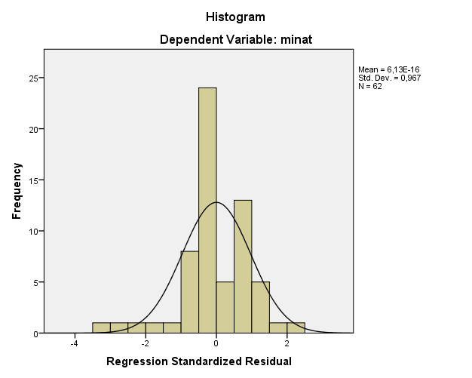
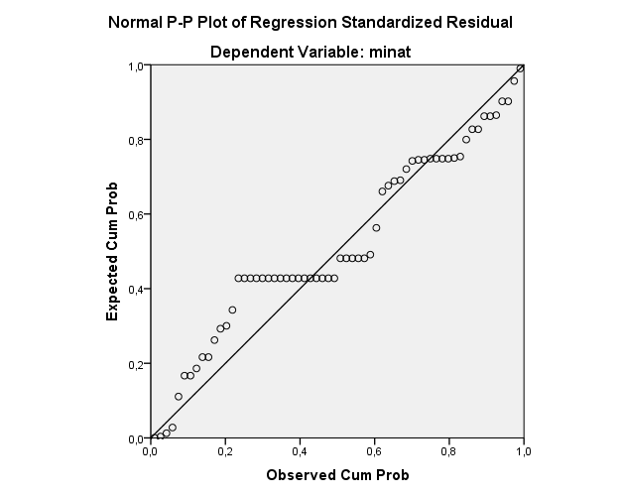
Lampiran 2. Hasil Dokumentasi
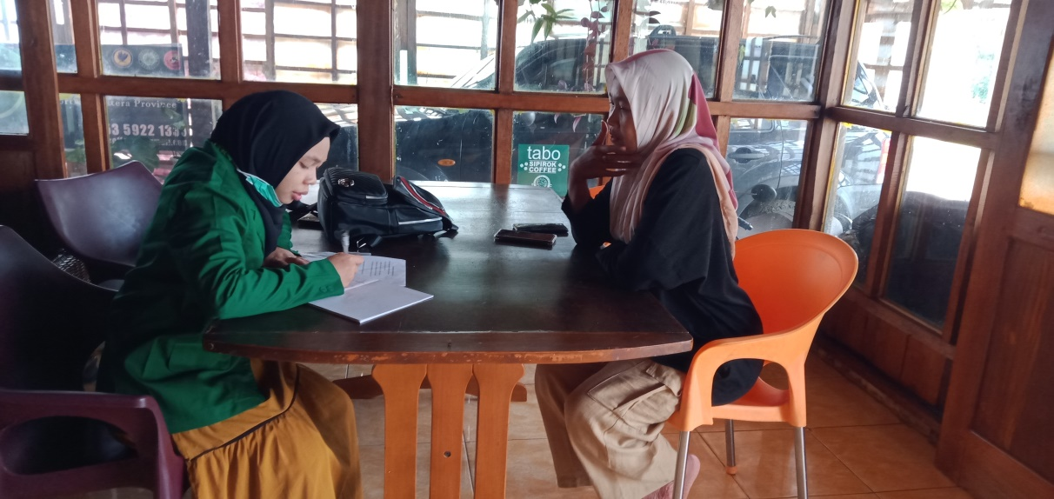
Dokumentasi penelitian, bersama pemilik usaha Tabo Coffee Sipirok
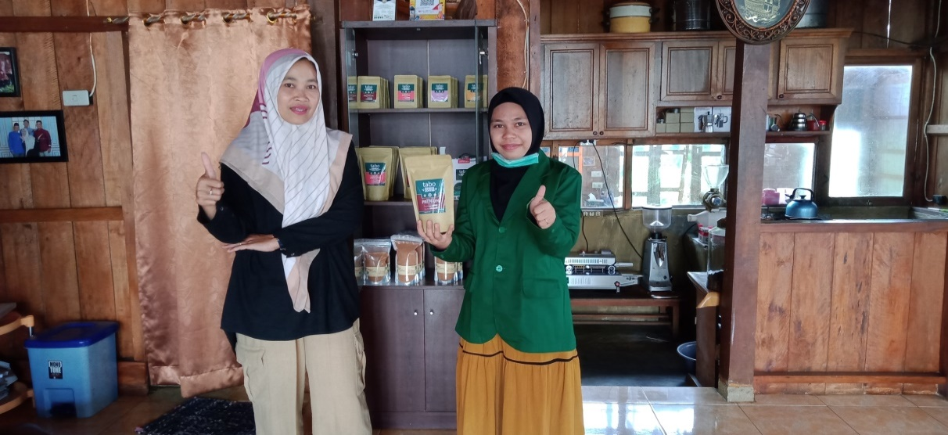
Dokumentasi penelitian, bersama pemilik usaha Tabo Coffee Sipirok
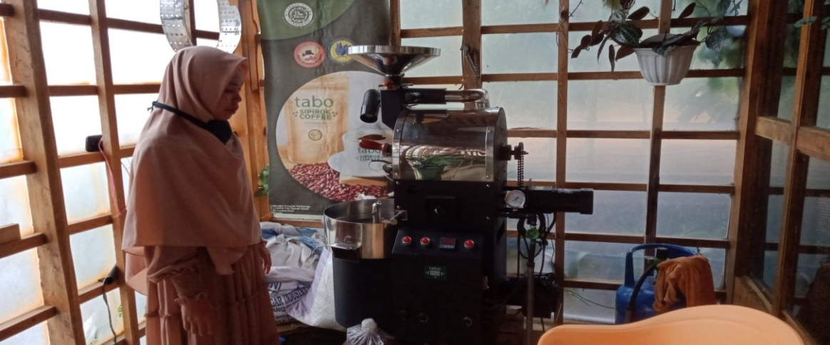Dokumentasi penelitian, usaha Tabo Coffee Sipirok
Dokumentasi wawancara bersama masyarakat di Kecamatan Sipirok
Dokumentasi wawancara bersama masyarakat di Kecamatan Sipirok
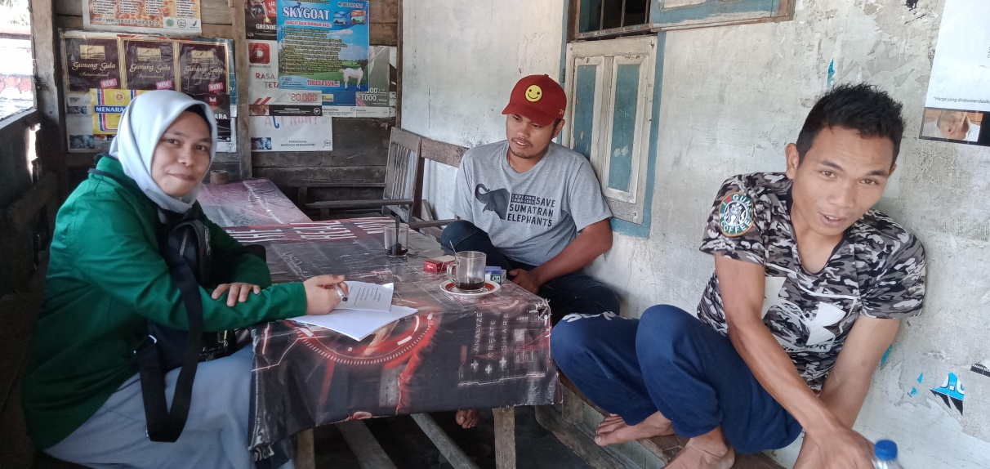Dokumentasi wawancara bersama masyarakat di Kecamatan Sipirok
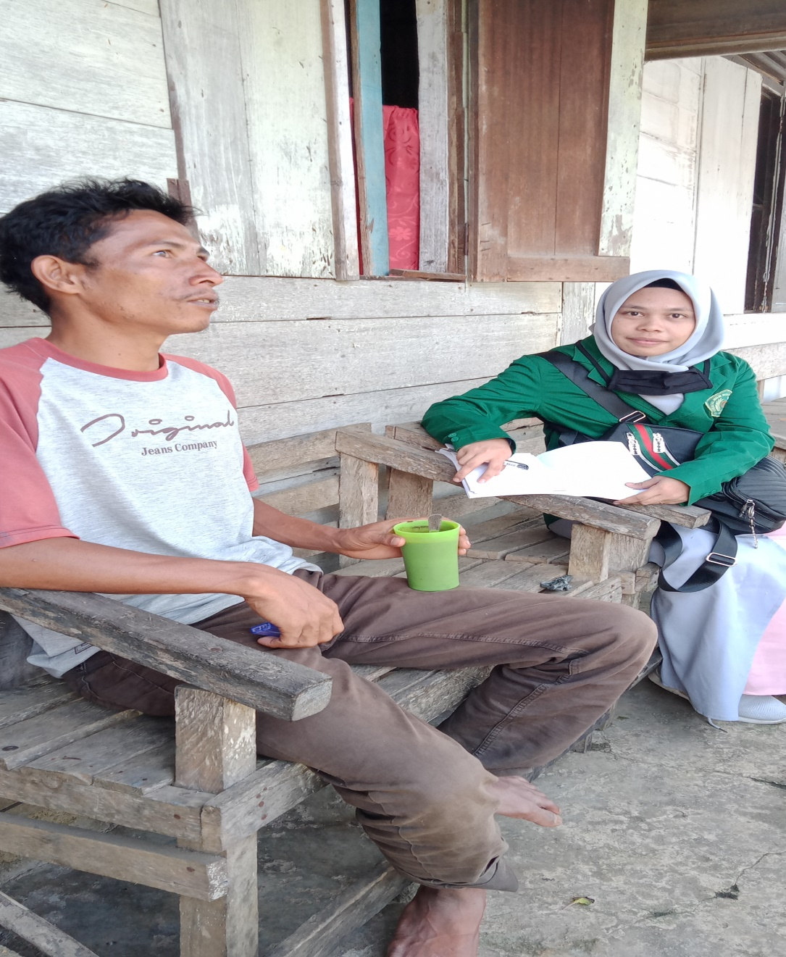
Dokumentasi wawancara bersama masyarakat di Kecamatan Sipirok
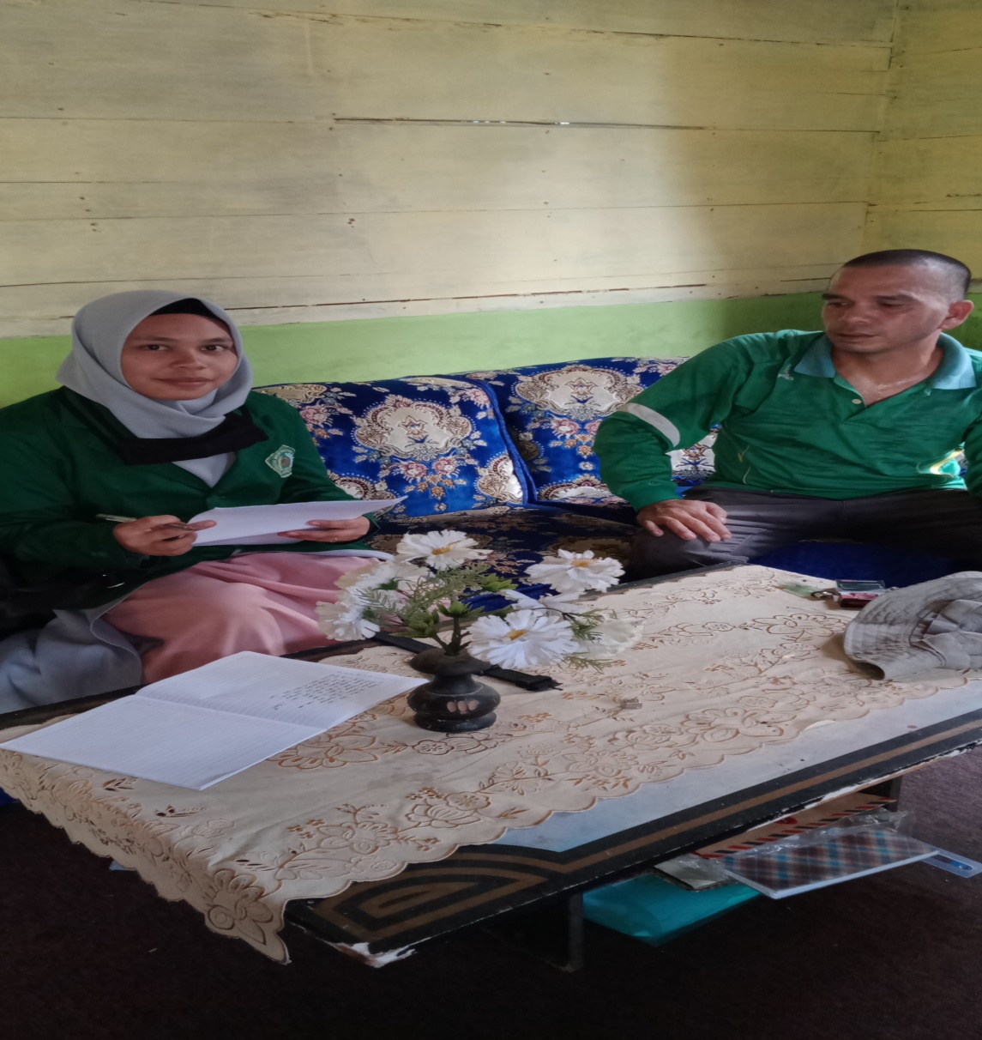
Dokumentasi wawancara bersama masyarakat di Kecamatan Sipirok

