ANALYSISOFSTUDENTS’ACTIONVERBMASTERY IN NARRATIVE TEXT

AThesis BY :

AYUDYAHANGGRAINI201224009



DEPARTEMENT OF ENGLISH EDUCATION FACULTYOFTEACHERSTRAININGANDEDUCATION UNIVERSITAS MUSLIM NUSANTARA AL WASLIYAH
MEDAN 2024

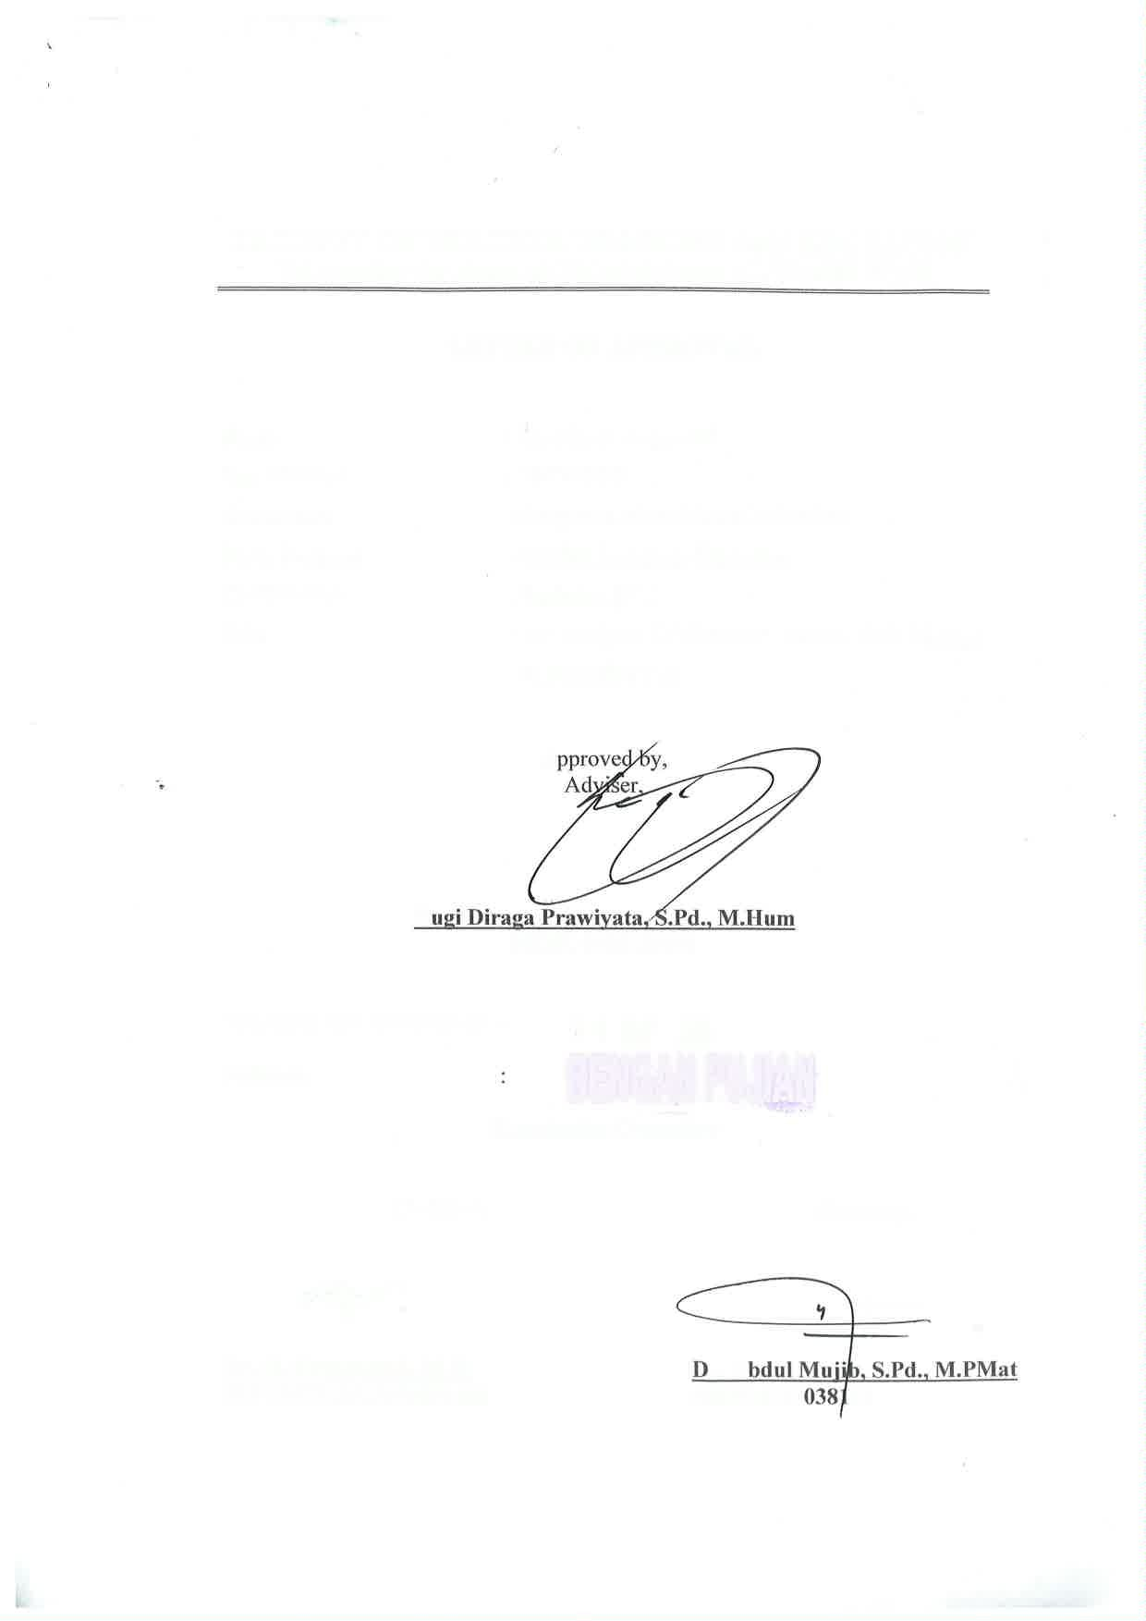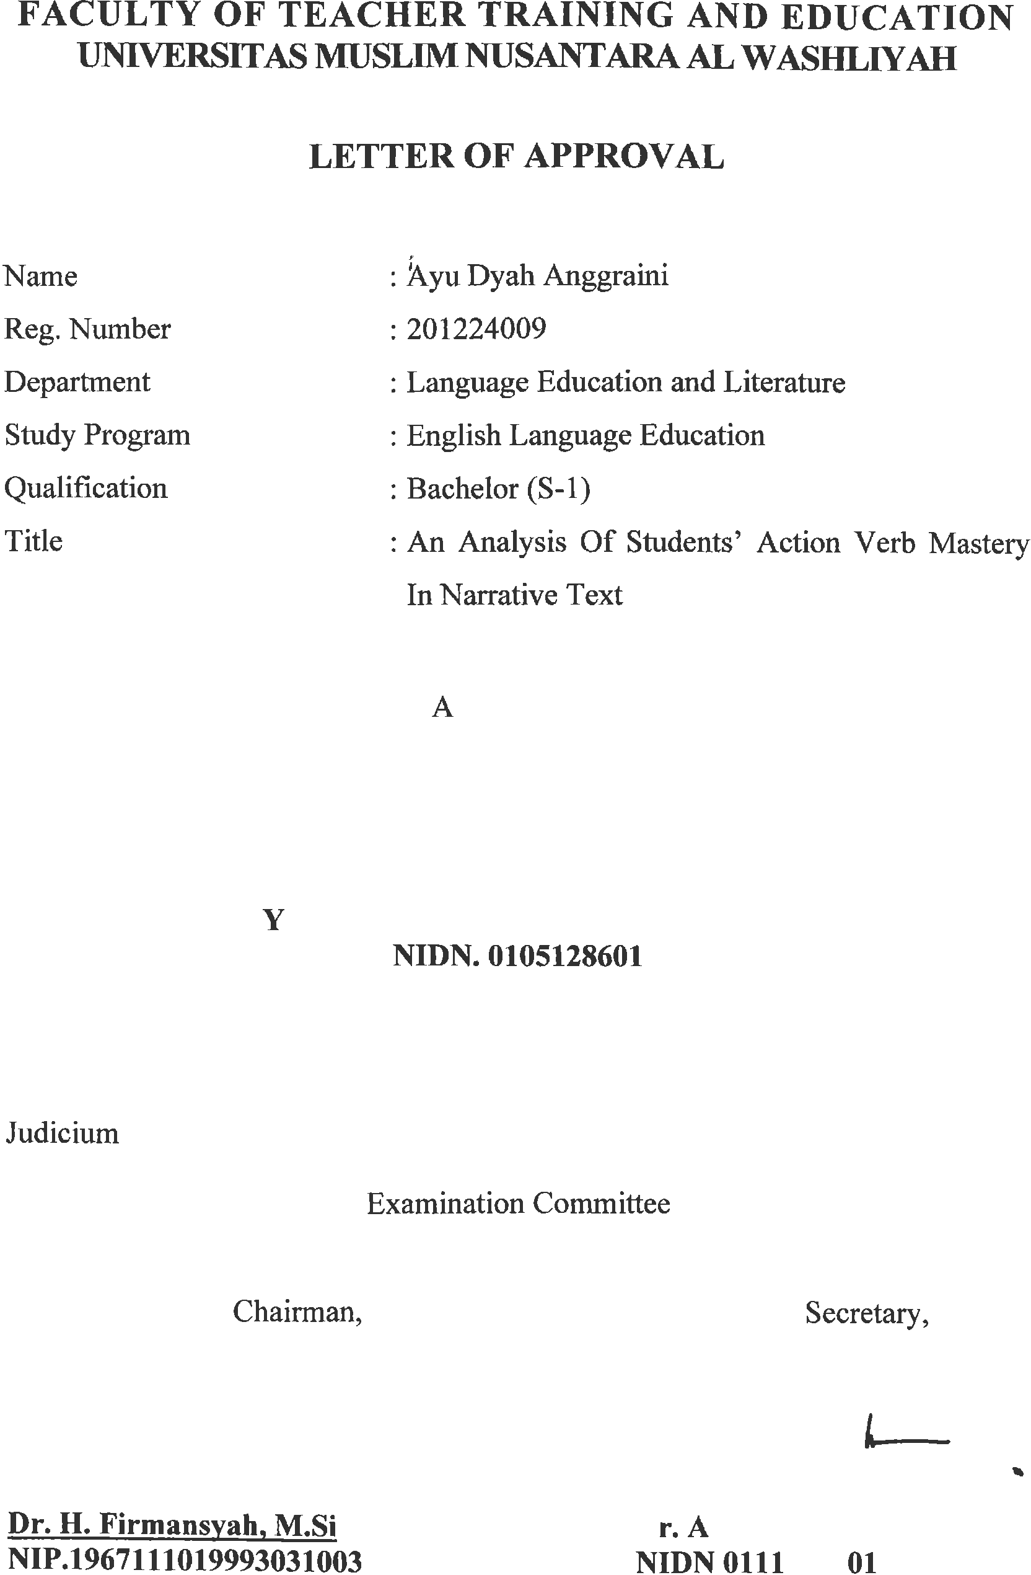

ANANALYSISOFSTUDENTS’ACTIONVERBMASTERY
INNARRATIVE TEXT

ABSTRACT

AYUDYAHANGGRAINI NPM : 201224009

Theresearch concernswith thediscussion to analysis action verb in narrativetext. The problem of this research is “ The lack of capability of the students of SMP IT Rahmat Marendal to analysis action verb? The objective of the research is to describe lack of capability of the students to analysis action verb. Therefore, the population of this research is the achievement of the second year students of SMP IT Rahmat Marendal to analysis action verb. The data were collected by using the test to analysis action verb. To get the data, the second year students of SMP IT Rahmat Marendal are treated respondents. The population of this research is the achievement consist of 25 students. The sample of the research, it is taken 25 students. After analyzing the data, it is found that the result to anlysis action verb, the average score is 84% in categorized ‘good’ and there are 16% score in categorized ‘poor’. In this research, the students of SMP IT Rahmat Marendal can be able to analysis in narrative text.

Keyword:ActionVerb,NarrativeText,Qualitative

MENGANALISISKEMAMPUANSISWADALAMMENGANALISIS KATA KERJA DALAM NARATIF TEKS

ABSTRAK

AYUDYAHANGGRAINI NPM : 201224009

Penelitian ini berkenan dengan kemampuan menganalisis kata kerja dalam naratif teks. Masalah dalam penelitian ini adalah “kelemahan kemampuan siswa SMP IT Rahmat Marendal dalam menganalisis kata kerja?” tujuan dalam penelitian ini adalah untuk mendeskripsikan kelemahan kemampuan siswa dalam menganalisis katakerja.Dengandemikian,populasiinimenganalisiskemampuansiswakelas

VIIISMP IT Rahmat dalam menganalisiskata kerja. Untuk memperoleh data, siswa kelas VIII SMP IT Rahmat Marendal dijadikan responden penelitian. Populasipenelitianiniterdiridari25siswa.Sampelyangdiambiladalah25siswa. Setelah menganalisis data, mencari hasil yang diperoleh dari menganalisis kata kerja,rata-ratanilaiadalah84%kategori‘baik’dan16%kategori‘rendah’.Dalam penelitian ini, siswa SMP IT Rahmat Marendal mampu menganalisis katakerja dalan naratif teks.

KataKunci:KataKerja,TeksNarrative,Kualitatif

ACKNOWLEDGEMENT


Artinya: “ Hai orang-orang yang beriman, maukah kamu aku tunjukkan suatu perniagaan yang dapat menyelamatkanmu dari azab yang pedih? (10). (yaitu) kamu beriman kepada Allah dan Rasul-nya dan berjihad di jalan Allah dengan harta dan jiwamu. Itulah yang lebih baik bagimu, jika kamu mengetahuinya. (11)”.
By saying Alhamdulillah all the praise and gratitude of the writer for the presenceofAllahSWT,becausethankstograceandguidance,thepreparationofa proposal entitled “An Analysis Of Students’ Action Verb Mastery In Narrative Text“ can be completed in order to fulfill one of the requirements in completing educationattheDepartmentofEnglishEducation FacultyoftheTeacherTraining and Education, the University of Muslim Nusantara Al Washliyah Medan.
ShalawatandSalamtoourbelovedProphetMuhammadSAW,thegreatest man ever who teaches us the kindness and good life in order to benthe good Muslim. We hope his salutation in future day.

i

In the process of finishing this thesis, the writer has been given many supports and valuable knowledge from many people. Therefore, the reseaecher would like to express her great appreciation and thanks:
- Dr. H. Firmansyah, M.Si as the Rector of Universitas Muslim Nusantara Al Washliyah Medan.
- Dr. Abdul Mujib, S.Pd.,M.PMat, as the Dean of FKIP of Universitas Muslim Nusantara Al WAshliyah Medan.
- Wariyati, S.Pd., M.Pd as the Head of the English Education Department of Universitas Muslim Nusantara Al Washliyah Medan.
- YugiDiraga Prawiyata, S.Pd., M.Hum as the consultant who give the suggestion toward the writer in finishing the thesis.
- AllofthelecturesoftheEnglishEducationDepartmentofUniversitasMuslim Nusantara Al Washliyah Medan.
- AlloftheAcademicAdministrationStaffofUniversitasMuslimNusantaraAl Washliyah Medan.
- Syahrani Anum, S.Pd the headmaster of SMP IT Rahmat Marendal who has given permission to the writer to conduct the research.
- Mybeloved parents, father Wasliman and mother Sri Hartuti, who never stop giving me love, thank you for always fighting for the writer's life, he did not have the opportunityto experience education until college, but he was able to educatethewriter,motivateandprovidesupport.aswellascontinuousprayers so that the author is able to complete his studies until he graduates.

ii

- Mysibling,AzharyRamadhan,hiswifeandAbiManyuFiqrihavehelpedthe author during his studies so that the author can complete his studies until he graduates.
- Alltheextendedfamilywhosenamescannotbementionedonebyonebecause they have provided support to the author
- All students, especially from the English education study program, for their supportandcooperationduringtheirstudiesandincompletingthepreparation of this thesis.
- Finally, thank you, Ayu Dyah Anggraini, for survivingthis far and beingable to try hard and fight until this thesis is finished. Thank you for continuing to choosetotryandcelebrateyourselfuntilyougettothispoint,eventhoughyou oftenfeelhopelessaboutwhatyouhavetriedandhavenotsucceeded,butthank youfordecidingnottogiveupnomatterhowdifficulttheprocessofpreparing thisthesiswasand forcompletingitasbestandas fullyaspossible,hereis an achievement worth celebrating for yourself. Always be happy wherever you are. Whatever you have less or more, let's celebrate yourself.
Medan,4Agustus2024 The Researcher,

AyuDyahAnggraini

iii

TABLE OF CONTENTACKNOWLEDGEMENT i
TABLE OFCONTENT i
CHAPTERI INTRODUCTION 1
The Background ofthe Problem 1
Identification oftheProblem 5
Limitation ofthe Problem 5
Formulation of theProblem 5
The Objective of the Research 5
The Significance of the Research 5
CHAPTERII REVIEWOFRELATED LITERATURE 7
TheoreticalFramework 7
Definitionof Writing 7
ThePurposeof Writing 8
TheProcesofWriting 9
DefinitionofVerb 10
TypesofVerb 11
Action Verb 12
DefinitionofText 16
TypesofText 16
Theoryof NarrativeText 18
GenericStructuresofNarrativeText 19
Conceptual Framework 21
HypotesisofTheStudy 22
CHAPTERIIIMETHODOLOGYOFTHERESEARCH 23
i
ResearchDesign 23
SettingAndSubjectofTheResearch 23
InstrumentofCollectingData 24
TeqniqueoftheCollectingData 24
TechniqueoftheAnalyzingData 25
CHAPTERIVRESEARCHFINDINGSAND DISCUSSION 26
ResearchFinding 26
Discussion 30
CHAPTERVCONCLUTIONANDSUGGESTION 32
Conclution 32
Suggestion 32
REFERENCES 34

ii

CHAPTER I INTRODUCTION

TheBackground oftheProblem
Humans are social creatures who cannot live alone and always need other people. Language is the most important element needed in communicating with each other. Language allows us to communicate with others, share information, exchangeknowledge,andconveyemotions,thoughts,views,sentiments,opinions, desires, gratitude, and promises (Pasaribu, Herman, & Hutahaean, 2020).
Based on Halliday's theory in a journal create by Tarbiyah UIN Medan in 2017 declared this language to be a human language whose meaning can be understood used in social life. Language is universal, because language is product of the human mind from culture and art, which it can produce aesthetic value in communication. The growing need for international communication, English has become popular to be used by anyone who wants it to participate in extensive interactions.
English is a widely spoken international language, with speakers in many nations, including Indonesian. English is now a topic that must be taught in all Indonesian schools, and it is included in the curriculum from elementary school throughuniversity.WhenteachingEnglish,therearefourlinguisticskillsinvolved. The curriculum targets four skills is listening, speaking, reading, and writing (Prihatnasari&Ferdias,2020).Oneofthelanguageskillsthatstudentsneedtolearn iswritingsinceitplaysabiggerroleinteachingEnglishthanotherlanguageskills do.Writingmaytakenumerousforms,includinggenre.Thereareseveralcategories

1

forthisgenre,includingnarrative,report,descriptive,process,recount,andsoforth. One genre that is studied in English at SMP is narrative literature. One genre that includes the steps involved in completing a task in order is the narrative text. A process is a wayforus to write down our thoughts and opinions. A narrative text's social purpose is to convey the story and amuse the reader.
One of the important elements in masteringNarrative texts for high school studentsisthefirstStudentscanunderstand thegenericstructureofNarrativetext, namely Orientation use who, when, where, Complications use events that cause complications:theremaybethereismorethanoneinastory,Resolutionisusedas a solution to the problem, Re-orientation is used use the character's reactions to complications. Second, students can find out about lexicogrammatical characteristicssuchastheuseofsimplepasttense,focusonindividualsparticipants and the use of temporal order. So by mastering the generic structure and with the lexicogrammaticalcharacteristicsofnarrativetext,studentsarerequiredtobeable to write Narrative text correctly. To master narrative text, students must master important components such as simple past tense, generic structure, lexicogrammatical features, material process, and conjunction. Teachers should also thoroughly teach and explain these concepts (Sari, 2020).
Writingabilityisaproductiveskillthatisquitedifficulttomastermastered becauseinthewritingprocessthereareseveralimportantcomponentsasreference, especially the grammatical aspect, because it is the main rule for producing good writing. Students' uncertainty about grammar causes errors in writing sentences, suchassentencefragmentsorchangingtenses(Afifah,2019).Oneoftheimportant

parts in writing a narrative text is the student's method utilize language features or grammatical features that are important to support the plot story. It deals with grammatical features such as nouns, pronouns, tenses, phrases, and any structure thatsupportsthestory.Therearesomespecificpartsgrammaticalaspectsthatmust beusedinnarrativetexts,suchasnouns(clouds,grass,water),pronouns(they,he, it),nounphrases(oldpeople,redapples),timeConnectingwords/conjunctions(one day, after, before), adverbs/adverbial phrases (In place, there), action verbs (walked,smiled),andpasttense(Hewalkedslowly).Thiselementcanbeaproblem for students because they have to generating ideas and placing ideas with inappropriate grammatical structures in narrative text.
English grammar is one of the English language competencies which consists of a system the language that students must understand and master in English. Grammar is one of the difficulties in mastering a foreign language, a language in a country where English is still a foreign language like in Indonesia. Students are encouraged to understand and master the language components in learning English to give them a better understanding in using English. Understanding and mastering grammar is not an easy thing for students because they have to understand three dimensions of language such as form, its meaning and use. As an important element in language, grammar must also be so mastered by students if they want to be successful in learning English.Mastering English grammar can help students to compose correctly sentences meaningfully and grammatically, so that they are able to use English perfectly.

Vocabulary refers to a collection of meaningful words used for communication (Halawiyah, 2019). Vocabulary has types of parts consisting of nouns,verbs,adjectives,adverbs,conjunctions,pronouns,etc.Verbsareoneofthe mostimportantpartsofavocabularythatstudentsmustlearn.Vocabularyisanother difficulty that students face in writing (Harris, Ansyar, & Radjab, 2014). The positionoftheverbinasentenceisveryimportantdescribestheactionsperformed by the subject.
Students need to acquire and master action verbs as part of their language skills and comprehend how to employ them when writing narrative texts. Action verbs are important for English language and communication. They are used to conveyactionandactivityinsideastatement.Theyareusedtodemonstratewhatis happening in a sentence while also making it more intriguing and lively. Action verbs are also significant since they serve to clarify the statement.
Action verbs are words used to express the action taken. Action verbs are verbsthatexpressphysicalormentalactionandstateswhatthesubjectoftheclause or sentence does physically or mentally. It can be concluded that the definition of anactionverbisaverbwhosesubjectfeelswhatisbeingdone.Someonecanknow and feel physically and mentally when doing a verb. Based on the theory of an expert, namely Chaer (2003) in Research Journal from Pakuan University, Bogor in 2018, syntax is the only aspect connecting language grammatical structures in groups’ sentences in sentence units. The smallest unit of syntax is a word, phrase clauses, sentences, and text.One of the grammars in English language is an action verb.Actionverbsisanactionverbperformedbyhumanshavedoneit.In

grammatical structure, action verbs includes word structure support each other to form sentences with rules in them English grammar.
Based on the explanation above, the researcher wants to conduct a research entitled "An Anlysis of Students’ Mastery of Action Verb in Narrative text”.

IdentificationoftheProblem
Baseonthebackgroundabove,the problemofthis researchare:

- Studentshavedifficultiesinunderstandingactionverb

- Studenthavedifficulties toidentifyingactionverb

Limitationofthe Problem
Basedontheidentificationoftheproblemabove,theresearcherlimitthe problem on the analysis of students’ mastery action verb in narrative text.

Formulationofthe Problem
Beforetheresearchisconducted,theproblemisformulatedstudentscan master action verbs in narrative?

TheObjectiveof theResearch
Basedonthebacground,theobjectiveof thisresearchis :

- Todescribethe studentsmasteryaction verbs

- Toknowthedifficulties toidentifyingaction verb

TheSignificanceoftheResearch
Asanobjectiveoftheresearchhasbeenachieved,itishopetobesignificant. The research is expected to give theoretical and pratical benefits :
Theoretically

      - Theresultofthisstudycanbeusedasthereferenceforthose who want to conductareseach in english teachinglearning narrative text.
      - Theresult of the studyhopefullystrengthen the knowledge of the theory in writing.
Practicially

      - Forthe Researcher

The findings of the research can be used as a starting point inimprovingthewritersteachingability,especiallyteaching narrative text.
      - Forthe Students

This research can add the students’ interst in english learning, so english is not boring lesson for them anymore.
      - FortheEnglishTeacher

This studyis also expected to be useful for english teachers so they can recognize the problem of the students and find the ways to solve it.

CHAPTERII

REVIEW OFRELATED LITERATURE

TheoreticalFramework
Theories are developed to explain, predict, and understand occurrences, as wellastoquestionandextendexistingknowledge,allwithintheconstraintsofthe crucial bounding assumption. The theoretical framework is the structure that may sustainorsupportthetheoryofaresearchinvestigation.Thetheoreticalframework introduces and specifies the theory that explains why the research problem being investigated exists. A theoretical framework consists of concepts, together with their definitions, and existing ideas that are employed for specific studies. It is not readily available in the literature.
When doing research, theories are require to explain some of the concepts or phrases use in the research. The theory use in the research analysis will be compare to prior ones. Some concepts in this research require a theoretical explanation.Thus,thefollowingexplanationaimstoprovideaclearexplanationof the theory as a framework.

Definition of Writing
Naturally the four basic skills in teaching english, writing is the one that most students find most difficult (Rokhmah, 2020). Writing is one of the essential skills in teaching and studying a foreign language, particularly in the x gradeof seniorhigh school. Writing produces an eternal result in the structure of a written text, implying that writing is about generating language rather than obtaining it.

7

Writing is the process of employing symbols, such as letters, punctuation, and spaces, to transmit thoughts and ideas in a legible manner. Writing is one technique to convey ideas, thoughts, views, facts, and concepts in written form. Writing has the same meaning as composing (Nurlaili, 2020).
Writingisanactivitythatallowsindividualstoconveytheirideasinwritten form. Furthermore, they may enhance other aspects of their language, such as vocabulary, spelling, and grammar, so that children learn more than just how to write well (Nur Latifah, 2019).
Based on explain above the researcher conclude that writing is a type of human communication that involves the use of a set of visual markings to express language. It can include numerous styles and genres, such as literary or musical creation. It can be used for personal enjoyment or for an audience of one or more individuals.

ThePurposeof Writing
Writing must correspond the established requirements in order to be considered good writing. It's crucial for individuals to consider this aspect while producingqualitywriting.So,evenifnoconcreteproofwaspresented,readersmay come to the essential point regarding how the writer thinks about them and wrote about it (Jayanti, 2019).
Writingcan be applied in a varietyof ways. Manyindividuals can use it to conveymessages, express thinking, connect to something that has been presented, persuade, and make written suggestions for specific purposes.

Based on the explain above the researcher conclude that the purpose of writing is to communicate with a certain audience. This may be performed in a variety of ways and styles, depending on the researcher objectives.

TheProcesof Writing
The writing process is varied and dynamic, with various stages that all contribute to the formation of a well-structured and logical piece of writing. According (Ratnasari, 2018) there are 3 steps in writing a text :

Prewriting
Authors typically begin with prewriting or first drafts to gather ideas for their chosen topics, which may involve research, daydreaming, note-taking, outlining, title-writing, and lead-writing. Prewriting often takes up 85 percent of an author's time.

Writing
Writingistheactofproducingafirstdraft.Afterprewriting,theauthorgenerates ideas and starts writing. Writing typically accounts for only 1% of a writer's total time.

Rewriting
Rewriting normally takes 14 percents of author‟s time because rewriting includes researching, rethinking, redesigning, rewriting, line-by-line editing until make each words properly placed.

Definitionof Verb
Grammar is a very important part of learning English because grammar is neede to compose a sentence. Without mastering vocabulary, learners will have limitedopportunitiestoapplytheirlanguagelearninginvariouscontexts,including radio,nativespeakers,reading,andtelevision.Additionally,studentsmaystruggle to express themselves in writing (Harris, Ansyar, & Radjab, 2014). One of the aspectscontainedingrammarisverb.Verbasthesmallestaspecthasanimportant role in building a statement.
Averbisatermthatdescribesthebehaviors,procedures,circumstances,or situationsofindividualsorobjects.Thenumberofaverbanditssubjectmustmatch (both might be single or plural). Verbs also communicate tension in a variety of ways. Action verbs, modal verbs, and auxiliary verbs are the three categories of verbs in the English language. There are two categories of action verbs: transitive and intransitive verbs. Using a word in text implies not just its definition but also its context (Jayanti, 2019).
A verb is a terms that shows an activityor state of being and is required to make an argument (Agus Mustajib, 2023). There are many types of verbs is main verbs, linking verbs, auxiliary verbs, and compound verbs.. Verbs can also be classedbytheirvalency,orthenumberofargumentstheytake,suchasintransitive, transitive, ditransitive, or avalent verbs.
Based on definition abovethe research conclude that a verb is a word that showanaction,occurrence,orstateofpresence;itisfrequentlyusedasthe

grammaticalcenterofasentence'spredicate.Verbscanbeinflectedfortense,voice, mood,andaspect,andtheymayneedadirectobjectorbefollowedbyphrasesthat answer questions like where, when, how, or how long.

TypesofVerb
Verbscomeinavarietyofformsdependingonthekindofcomplementthey may have :

LinkingVerb
A linking verb focuses on a sentence's subject by providing information. linking verbare known as "be" verbs, and theyinclude am, is, are, was, and were. Other verbs, though, can also serve as connecting verbs. Act, feel, stay, appear, become,seem,smell,sound,grow,look,prove,stay,taste,andturnarethoseverbs. This list includes several verbs that can also be action verbs. You should try substituting versions of the be verbs for them to see if they are connecting verbs. That verb is a linking verb if the phrase after the alteration still makes sense.

Action Verb
According to Risdiyanto, an action verb expresses an activity finished by the personwhoisthesubject.Verbsthatindicateaconditionalofthesubjectareknown as state verbs, or verb be, while verbs that express an action by the subject are known as action verbs.
someexamplesofactionverbsinclude :

attack assault
strike ambush
rush storm

think | share | play
study | skip | sing
debate | read | cry
shower | cook | cut
want | move | dance
charge | write | creat
break | stand | knit
eat | sit | win
run | make | watch

FiniteorNon-finiteverb
The real verbs that make up sentences are known as finite verbs. One of the twelve tense forms is used when a verb is executed by or refers to a subject; the tense changes based on the subject's number or person.
Not-finiteverbsarenotverbs.Theyfunctionasnouns,adjectives,adverbs,etc. in the phrase instead of acting as verbs. Since non-finite verbs, also known as verbals,havenodirectrelationshiptothesubject,theyremainunchangedregardless of the subject's number or person. They occasionally take on the role of the topic. The infinitive, gerund, and participle are the forms of non-finite verbs; participles acquire the form of a finite verb when they take on an auxiliary verb.

Action Verb
English verbs are classified into three types action verbs, modal verbs, and auxiliaryverbs.Theverbhasnumerousvarieties,includingtheactionverb.

Grammarinvolvestheuseofactionverbs.InEnglish,thepresenttense,pasttense, future tense, and progressive tense are used to indicate the timing of an action or activity.
Action verbs are used to describe something that happens to someone. An expert states that action verbs are verbs that show cause and effect relationships. Actionverbsalsorequireanagentasasubjectandapatientasadirectobject.Based on the definition above, researchers can conclude that action verbs are used to explain a movement by an action carried out by a subject. The process can be something that can be seen, for example writing, eating, drinking, and so on.
Even advanced grammar students sometimes struggle with distinguishing between transitive and intransitive verbs. Understanding objects helps clarify the usage of transitive and intransitive verbs. When using a dictionary to search up verbs,youmaygetconfusedbytheacronymsvi(intransitiveverb)andvt(transitive verb).So,therearetwotypesofactionverbs,namelytransitiveandintransitive.In the transitive verb divided into two types, they are transitive active verbs and transitive passive verbs.

TransitiveandIntransitiveVerbs
Transitive verbs have an object, whether direct or indirect, whereas intransitive verbs do not (Fiktorius, 2019). Thedistinctions between transitive and intransitive verbs are given in the sections below.

TransitiveVerbs

A transitive verb action is a word that is felt by a person or something. Transitiveverbsneedadirectobjecttomakesense,most verbs transitive.Without a direct object, sentences with transitive verbs will sound inappropriate.
Transitiveverbsalwayshaveanounthatreceivestheactionoftheverb,
knownasthedirectobject. This pattern is :
S+V+N
(SUBJECT +VERB+NOUN)
Examples:

  - Jackbrokethe window

  - john gaveSandya present.

  - Let’swalkthedog

  - Sunysent a parcel fromCanada.

  - lilyleftthebagonthefloor

  - Benytook his son to themall

  - Richardowes Jimmysomemoney

  - Shefeedshischildrenwhiletheirmotheris away

  - Shemakes jewelryto sellat themarket.

IntrasnsitiveVerbs
Intransitive verbs are action verbs that do not use words who can answer the question what or who. simply Intransitive verbs are explained as verb that do not take a direct object. This happens because the object is not works as a recipient of actionsandtheactionsthatoccurdonotinvolveadirectobject(AgusMustajib,

2023).Actionverbshelpthereaderpicturethesubjectengagedintheactivityina

clear,precisemanner and aidtheflowofanarticle ortalk.

An intransitive verb lacks a direct object. The language does not specify who or what will get the action.
Intransitive verbs may be followed by a word or phrase that answers the inquiry"how".
Intransitiveverbsdonot haveadirectordirectobject.

Thispatternis:
N+V
(NOUN +VERB )
Example:

- Jackywalkedslowlytoschool
- Alexraninthemarathon.
- Let’swalktothestore
- Sonygrew up to beasinger

- Andreyslept on the sofa
- His sisterdied of Malaria.
Based on explain above the researcher concluded a verb that expresses an action,oradoingword,iscalledanactionverb. It'saverbthat describesanobject orperson acting. Action verbsarewordsthat are used to express duties, tasks, and acts.

Definitionof Text
Thetextisaprocessedandcomprehendedformoflanguage.Anyeventthat conveys meaning, whether it be a book, movie, commercial, telephone conversation, etc., can be considered a text. This indicates that it has to do with language.Itcouldarisefromwrittenorvisualmedia.Itwasbelievedthatlanguage had to be used in every artistic creation.It implies that the reader can be informed or entertained byit. Next, an SMS with a commercial goal was sent. In a nutshell, it'sanartformthatincorporateslanguageinwritten,spoken,orvisualforms.People createtext,whichisapassagewithcompositionandanote,aswellasstructureand function (Pardosi, 2019).
Based on explain above the researcher counclude that text is a wide notion that refers to any material from which an observer might get meaning. This can includewrittenresourcessuchasbooks,articles,andessays,aswellasnon-written materials including films, paintings, television shows, music, political cartoons, internet materials, ads, maps, works of art, and even rooms full of people.

TypesofText
The English Syllabus of School Based Curriculum (K13) suggests that Senior High School students should be taught to write through books. In English, there are five types of English texts used in writing instruction for SMA students.
Teaching writing in English as a foreign or second language often begins with the instruction of sentence structure and text types.
According(Mufida,2020)studentsmustalsounderstandsomeothertypes of text. This is a description:

- Descriptive

Descriptive text is one that describes a certain person, location, or thing. Theobjectiveofdescriptivelanguageistodescribesomeone,alocation,or something in particular.
- Narrative text

A narrative text recounts historical events to entertain and teach readers a morallesson.Textsnarrativecanbeusedtoentertain,amuse,orengagein various ways with real or imagined experiences.
- Recount text

Recount text is a chronological retelling of events inteded to enlighten or entertain. A recount is a story that describes incidents in order to educate or entertainment.
- Reporttext

Report text is used to describe and categorize data. Informative reports often cover both living and non-living topics, such as plants, animals, rivers, mountains, and seas.
Reporttextisatextwhichexplainsthecurrentstateofaffairsinrelationto the configuration of social, natural, and created by humans phenomena in the world around us.
- Procedure

Aprocedure is atext to explains aseries of levels oractions that aretaken to achieve a task.

Based on theoryin above, the researcher decided to focuse on narrative text. ThereasonthatavailableonthesyllabusofsecondsemesterofXgradestudentsat MAS Mualimin. It is also compatible with students need. Since students have difficulty on narrative text.

Theoryof NarrativeText
Writing has a variety of genre one of these is narrative. Narrative is the narrationofanaccurate orfictioneventorarelatedseriesofevents. Narrativetext isatypeofwritingthatdescribesastoryorevent. Thetaleshouldbequiteshortin ordertopresentasingleincidence.Itmaybelengthierandprovideamorecomplete summary of the incident (Sari, 2020).
Narrative text is a storyformed from the scene of events that is beginning, themiddle,andtheendbyauthor‘simagination(Halawiyah,2019).Anarrativetext is a sort of writing that aims to amuse or delight the reader while addressing real and imagined experience in various ways. It also addresses difficult situations that result in crises or other significant moments that ultimately have a conclusion.
A narrative's objective, in addition to providing entertainment, might be to make the audience think about a problem, teach them a lesson, or elicit strong emotions. A well-written narrative employs intelligence, originality, drama, suspense, comedy, or fantasy to convey a major topic or impression. All of the elements work together to create a recognizable story thread that is easy to follow and paraphrase.

Based onthe above explanationitcan be concludedthat Anarrativetextis one that explains a tale or portrays a series of events. It is intended to entertain or educate the reader by providing a sequence of connected events or experiences, whether actual or fictive.

GenericStructuresofNarrativeText
Anarrativetext'sgenericconsistsofseveralcomponents,Genericstructure is divided in to four kinds: they are: orientation, complication, resolution and re- orientation (Sari, 2020) :
- Orientation : focuses on the art of the text, establishing its context or commencement. The scane introduces the participle and context, including time,actorsandlocation.
- Complication:isthesitewhereacrisisoccurs.Thissectionofthetextinforms readers of any problems or incidents that may occur.
- Resolution:referstohowthecrisisishandled,whetherforbetterorworse,and the activities followed to address the situation.
- Re-orientation: refers to a section of a book that indicates the end of the topic beingdiscussed.Re-orientationreferstotheexpressionorclosureofeventsand might.
From the explanation above, the researcher concluded that the generic structure of narrative text is divided in to four kinds: they are: orientation, complication, resolution and re-orientation.

2.1.10LanguageFeaturesof NarrativeText

According(Ery,2024)LanguageFeaturesinNarrativeTextTherearesixlanguage feature of narrative text:
- Usethe pasttimemarker.

- Usinglanguagetelling soit doesn‟tseem formalbut easyto digest.

- Using various type of punctuation and types of word such as nouns, adjective, adverbs, and verbs.
- Containsdialogue,monologue,andstorynarration.

- Usingactiveand passiveverbs.

- Inonesentenceitdoesnotalwaysconsistofsubject,predicate,object,and description
A narrative's objective, in addition to providing entertainment, might be to maketheaudiencethinkaboutaproblem,teachthemalesson,orelicitstrong emotions.Awell-writtennarrativeemploysintelligence,originality,drama, suspense, comedy, or fantasyto conveyamajortopicorimpression. Theelements allworktogethertocreateaclearstoryarcthatissimpletofollowandparaphrase. Besideshavinggeneralstructure,narrativetextalsomustusagekey grammaticalelementsthatsupporttheshapeofanarrativetext(Laia,2019). According to Otong Setiawan Djuharie in journal (Lubis, 2014) that the language elementsuseinwritingnarrativeparagrapharenouns,individualparticipant,past
tense,conjunction,action verb,andsayingverb.

RelatedPrevious Researches
Some previous studies have been conducted on the subject in discussion. ThefirstoneisathesisconductedbyentiledTheActionVerbanalysisInTheLegend

ofPutriHijauComicText.Theresearchermakesadistinctionbetweentheresearch and this article researcher uses the media of a narrative text storyspecificallywith the fairy tale of the green princess, while this uses general narrative text.
The second is a study that was written by (Halwiyah, 2020) entiled The Influence Of Using Short Video Towards Students’action Verb Mastery At The SecondSemesterOfTheEighthGradeOfSmpn3KetapangSouthOfLampungIn TheAcademicYearOf2019/2020.Thedifferencebetweenthepaperandthisarticle is the paper used short video, while this paper use narrative text.
The third one is a thesis written by Afifa, U. (2019) entiled Error Analysis on Using Action Verb in Writing Recount Text of theEighth Grade Students at the First Semester of SMPN 1 Sumberejo in the Academic Year of 2018/2019. The difference between the thesis and this article is the thesis focused on recount text, while this paper focused on narrative text.
Based on the finding in this thesis. The researcher found differences: the threepreviousresearchesusedshortvideoandcomictextasmediaandusedwriting skills in recount text. While researcher use media is narrative text and used vocabulary in narrative text.

Conceptual Framework
Inthisresearch,theresearcheremployethenarrativetextasaneducational media, and the outcome was the students’ improvement in using action verb. The researcher aim to assess the impact of narrative text on students’ writing abilities and determine their usefulness in iproving them. The narrative text encourages students’ easier writing.

HypotesisofTheStudy
Thisresearchinvestigateshowstudentsmasteryactionverbusingnarrative text. Based on the context of this research, the hypothesis has been developed as follows :
Ha: TheNarrativetext does improvestudents action verb mastery

Ho: TheNarrativetext does not improvestudents action verb mastery

CHAPTER III METHODOLOGYOFTHERESEARCH

ResearchDesign
The research design used descriptive research method with qualitative methode as approach. Utilizing the techniques of the natural sciences to generate concrete facts and numerical data is known as qualitative research. It uses mathematical,computational,andstatisticaltechniquestodemonstrateacause-and- effect link between two variables. Because the research will be assess exactly and withaccuracy,itisalsoknownasempiricalresearch.Theinformationgatherbythe researcher shoulf be rank, classify, or quantify using different units of measurement.
Qualitative research is a technique for studying and understanding the meaning that individuals or groups assign to human and social issues (Tenny S, 2023). Qualitativemethod evaluates the quality of information and data. It seeks to gather information about people's opinions and perceptions through interviews and surveys. Qualitative methods are subjective, with results influenced by respondents' emotions, perspectives, and perceptions.

SettingAnd Subjectof The Research
TheresearcherconductedatSchoolSMPITRahmat.Theresearcherselect SMP IT Rahmat Jl. Pendidikan No.23, Marindal Satu, Kec.Patumbak, Kab. Deli Serdang,Prov.SumateraUtaraastheresearcherlocation.Thesubjectsthatusedin

23

this research is student of the second year of SMP IT Rahmat consisted of 25 students in a class.

InstrumentofCollectingData
To get specific information about the mastery action verb in narrative text, theresearcherspecifiesthefocus,selectsinformants,collectsdata,analyzesit,and draws conclusions based on the findings. This researchtaken the results from student interviews and the results of student test sheets of action verb analysis.

Teqniqueof theCollectingData
The very first step in research is data collection, which is crucial for gathering information. According (Sharique Ahmad, 2019) qualitative research offersseveralapproachesforgatheringthoroughinformationonatopicofinterest. Inconductingofthisresearch,theresearcherwilluseinterviewanddocumentation of technique to obtain data about students’ mastering action verb in narrative.
Thereasearcherusedquestionnaireforthestudentsforsupportingthedata. A qualitative interview involves asking participants ended questions and documentation. The interview will gather information regarding students' understanding of the English learning process and their abilityto mastering action verbs in narrative text. The interview aims to gather information from students on their understanding of the English learning process.
Adocumentisarecordofpreviousoccurrences.Documentsmighttakethe form of text, pictures, or major efforts byindividuals. This research collected data useddocumentanalysis.Itisstudents’testsheetsofnarrativetext.Thewriterasked

thestudentstofindoutactionverbontheBatumenangisstory.Thetestweredone in thirty minutes.
- Givethetextofnarrative text

- Askquestionlanguagefeaturesofthetext

- Testofgenerallesson

- Tabulatingthescore

TechniqueoftheAnalyzingData
Thedataanalysistechniquewasdonetodescribethedatabyclassifyingone by one based on the topic. The firts data was those concering with the result of findingoutactionverbanalysisonnarrativetext.Writingtestwasusedtoknowthe students ability in finding out action verb on narrative text.
Formula:P=^{𝑓}x100%
𝑛

Where : P:thepercentageofthestudentspersonalability F : total score
N : maximumscore

CHAPTERIV

RESEARCHFINDINGSANDDISCUSSION

In this chapter, the result of the analysis is presented. The reasearch aim to explain the students’ action verb mastery in narrative text in SMP IT RahmaT Marendal.

ResearchFinding
Theresultinthisresearch,thewriteranalyzedstudents’actionverbmastery innarrativetextofSMPITRahmat. Forknowingthestudents’masterytofindout action verb on narrative text. The researcher made and arranged the test item and interviewfortheresearch,anditdeterminedfromthescoreofthestudents’ answer which could be the data of this research.
The result of this studyare the answers of interviews from participant who learning english at the school. This researcher introduced himself to the students using english and the students also introduced themselve. The researcher used 5 questions in paper and participant answer the interview. The paper were than analysis.
Based on interview result, the researcher found some data about students action verb mastery. The data found was that there 10 students who had a high interest in english and most of students in the class not did like english. Based on the data of students result to find out action verb in narrative text, the writer could beconcludedthatmoststudentsdon'tlikeEnglishbecauseitisconsidereddifficult

in lessons. This is because most of them don't understand the words in English so they don't understand what types of words are in it.
The qualitative data were taken from observation when test was running. Based on the data of the students result to find out action verb, the writer could be councludedthat 84% students werecategorized able,it mean that 16%fair orthey were categorized unable.

TABLE 1

SCOREANDDATA QUALITATIVE

NO | Students’InitialName | Total | Qualitative
1 | AF | 7 | Good
2 | AG | 6 | Good
3 | AS | 7 | Good
4 | AP | 7 | Good
5 | CPS | 9 | Verygood
6 | CAG | 3 | Fair
7 | DSP | 7 | Good
8 | DTA | 6 | Good
9 | DA | 6 | Good
10 | GRF | 6 | Good
11 | KNS | 3 | Fair

12 | KAR | 5 | Morethan fair
13 | MAA | 4 | Fair
14 | MRD | 6 | Good
15 | NA | 9 | Verygood
16 | NGA | 7 | Good
17 | NT | 7 | Good
18 | NA | 7 | Good
19 | RA | 7 | Good
20 | RI | 3 | Fair
21 | RAP | 7 | Good
22 | SAR | 9 | Verygood
23 | SAT | 6 | Good
24 | T | 5 | Morethan fair
25 | WS | 5 | Morethan Fair

TABLE 2 SCOREOFCATEGORY

Thetableisclasificationsscorestointepretationthestudentsmasteryaction verb in narratuve text.

Score | Level
1 – 4 | Fair

5 | Morethanfair
6 – 7 | Good
8 – 10 | Verygood

Fromthe data inthe table, itshows that :

- Therewere3 studentsthat could becategorized at VeryGood

- Therewere15 studentsthatcould becategorizedat Good

- Therewere3students thatcould becategorized atMorethat fair

- Therewere4 studenntsthatcould becategorizedat Fair

Therefore, the counclution from the result we could see that there were 21 from 25 students as sample were categorized as able to find outaction verbs and there were 4 students as sample are categorized as unable. So that the whole percentage can be used the formula :

P=^{𝑓}
𝑛
x100%

Where P:thepercentageofthestudentspersonalmastery F : total score

N:maximumscore That is :
P=²¹x100%
25

=84%(thestudentscategorizedasgood )

P =⁴
25
x100%

=16%(thestudentscategorizedaspoor) Morever, the persentage

TABLE II

THERESULTSPERCENTAGEAND MASTERY

Total ofthe Students | Percentage | Masterylevel
21 students | 84% | Good
4 students | 16% | Poor

From the competence of the students who were categorizedas good were 21 students or 84%. Meanwhile the students who are categorized as poor were 4 students or 16%. From the data it may be concluded that the students of the grade VIII of SMP IT Rahmat Marendal were able to analysis action verb on Narrative text.

Discussion
After the data was collected, the writer found that from 25 students, there were21studentsof84%whowerecategorizedasableand4studentsor16%who were categorized as unable. The writer find out the difficulties of the students analysis action verb there were the students less mastered of action verb types.
The test that have given by teacher was able to improve the students achivement to analysis action verb. The students were active while discussion and givecommentsandsugesstiontoeachstudentthathaspersentedinfrontofthe

class. The student also paid attention a lot and did the test seriously. From the interview,itwasfoundthatthestudenthadknowntypesandanlysisactionverbin narrative text.

CHAPTER V CONCLUTIONANDSUGGESTION
In this chapter, the researcher discussed about conclusion and suggestion of what have been discussed in the previous chapters.

Conclution
The writer would like give the conclution based on the data analysis as follow :
In this research, 25 participants are studying in an English at school. The data was obtained from doing a interview and test. From the result of interview many students don't like English lessons because they are considered difficult and students don't know the meaning and types of verbs. Based on result of test the second grade ofSMP IT Rahmat Marendal were 21 students or84%samplewere able to answer to the test to analysis action verb on narrative text, there were 4 students or 16% that were unable to analysis action verb on narrative text.

Suggestion
Inrelationtothe conclusion,thesuggestionsarerelatedasfollowing:

To get the improvement of next study, the writer would like to propose some suggestions for the students, the teachers, and next researchers, they are:
    - Forthe Students

ForstudentstobeeasiertolearnEnglish,themostimportantthingistolove the English language and pay attention to teachers who explain when learning English.
    - Forthe Teachers

Forteacherstopaymoreattentiontotheirstudentsandexplainwithamore interesting method so that students feel happy and comfortable so that student motivation can grow and give passion for every student learn.
    - For thenextresearchers

For the next researcher in order to develop again this research in order to deepen the motivation of learning, especially learning English in school

REFERENCES

Afifah, U. (2019). Error Analysis on Using Action Verb in Writing Recount Text of the Eighth Grade Students at the First Semester of SMP 1 Sumberjo in the.
AgusMustajib,D.(2023).TheAbilityOfThe2022/2023AcademicYearsStudents OfIndragiriInIdentifiyingBetweenTransitiveAndIntrasnsitiveVerbInA SetenceS. EJI (English Journal of Indragiri): Studies in Education, Literature, and Linguistics.
Fiktorius,T.(2019).TherelationshipBetweenTransitiveAndIntransitiveVerbsin English Language. NOTION: Journal of Linguistics, Literature, and Culture, 1(2), 62-67.
Halawiyah,V.(2019).TheInfluenceOfUsingShortVideoTowardsStudents’.
lampung.
Harris,A.,Ansyar,M.,&Radjab,D.(2014).AnAnalysisOfStudents’Difficulties InWritingRecountTextAtTenthGradeOfSmaN1SungaiLimauVolume 2 Nomor 1. Journal English Language Teaching (ELT).
Jayanti, A. D. (2019). Students’ Writing Ability on English Descriptive Text at Grade. ENGLISH FRANCA: Academic Journal of English Language and Education, 3(1), 72-94.
Laia, M. Y. (2019). The difficulties of students to write narrative text at the eighth gradestudentsofsmpnegeri1lolowau.Urnaleducationanddevelopment, vol. 7.
Lubis, R. F. (2014). Writing Narrative Text vol.02 no.1. English Education. MattewB.Miles,A.M.(2014).QualitativeDataAnalysis:AMethods
Sourcebook.Arizona StateUniversity, ThirdEdition, 31.
Mufida,A.Z.(2020).AnAnalysisOfStudents’abilityInWritingNarrativeTextBy Using Collaborative Writing In The First Semester Of The Tenth Grade At Sma Perintis 1 Bandar Lampung In The Academic Year 2019/2020. Lampung: Doctoral dissertation UIN Raden Intan Lampung.
Nur Latifah, I. N. (2019). Teaching And Learning Narrative Text. English Education: Jurnal Tadris Bahasa Inggris Vol 12 (1) 2019, 78-96.
Nurlaili, I. S. (2020). Peningkatan Keterampilan Siswa Dalam Menulismelaluigambar Animasi Di Mial-Marwakecamatan Medan Denai Sumatera Utara. urnal Pendidikan dan Pembelajaran Terpadu (JPPT)Volume 02, No 01, 71-76.

Pardosi,J.D.(2019).Anerroranalysisofstudentsinwritingnarrativetext.
Linguistic,EnglishEducationandArt(LEEA)Journal.
Pasaribu, B., Herman, & Hutahaean, D. T. (2020). Students’ Difficulties In Translating Narrative Text From English Into Indonesia At Gradeviii Of Smp Negeri 9 Pematangsiantar. Acitya: Journal of Teaching &Education, Vol. 2 No. 1.
Prihatnasari,&Ferdias.(2020).GrammarFocusAnalysisInEnglishTextbookFor Senior. Jurnal AKRAB JUARA.
Ratnasari, N. (2018). The Effectiveness Of Webtoon To Develop Students’writing SkillInNarrativeTextOfTenthGraderInSmkPgri13Surabaya.surabaya: Doctoral dissertation, Universitas Muhammadiyah Surabaya.
Rokhmah, S. (2020). Students’ Writing skill throughTelecollaboration: in the context of WhatsApp and Facebook. Loquen: English Studies Journal.
Sari,S.M.(2020).ACorrelationBetweenSimplePastTenseMasteryAndWriting Vol. 11, No 1: 91-101. Anglo-Saxon : Jurnal Ilmiah Program Studi Pendidikan Bahasa Inggris.
Sharique Ahmad, S. W. (2019). Qualitative v/s. Quantitative Research- A Summarized Review . J. Evid. Based Med. .
Tenny S, B. J. (2023). Qualitative Study. n: StatPearls. StatPearls Publishing, Treasure Island (FL).

Lampiran 1. INTERVIEW
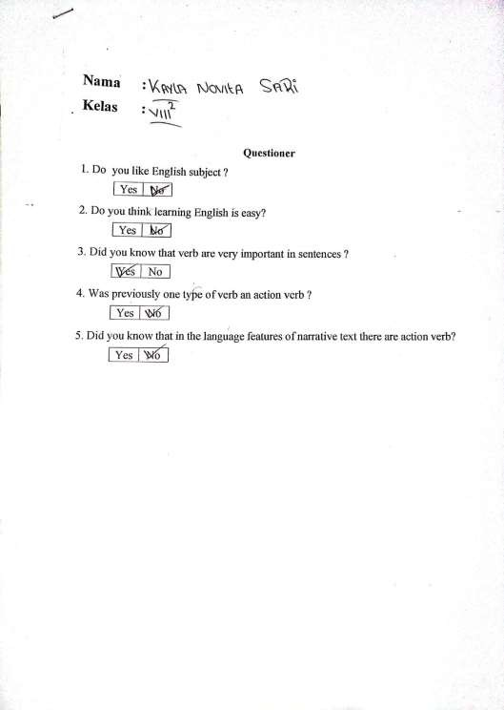

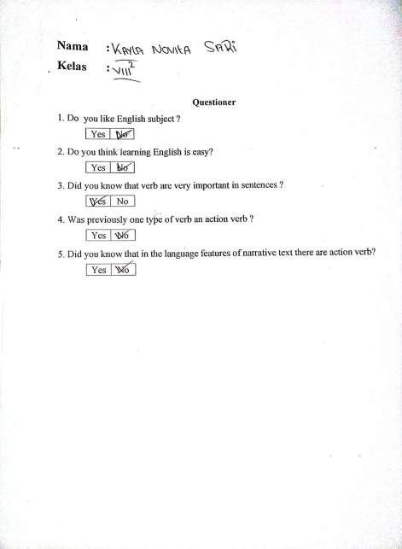

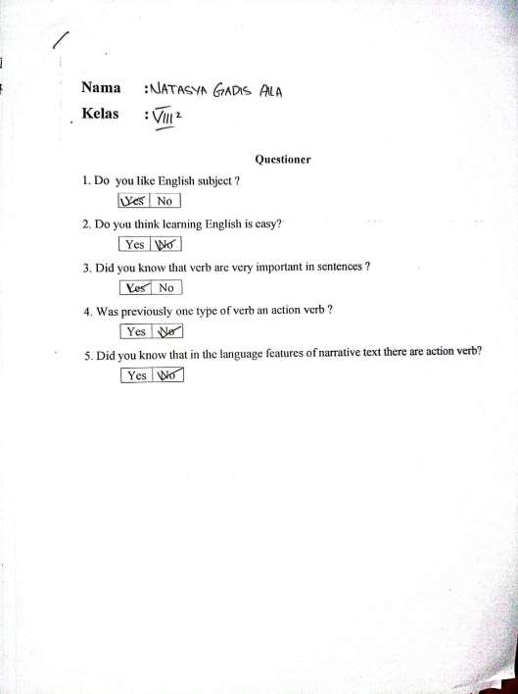

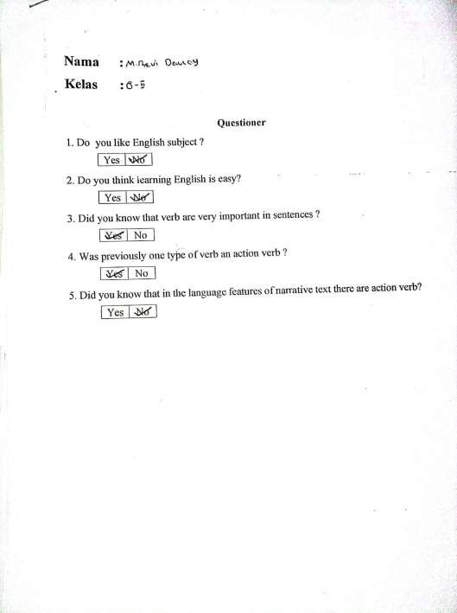

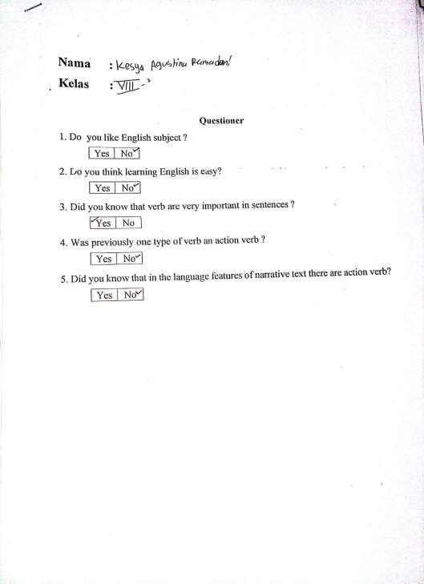

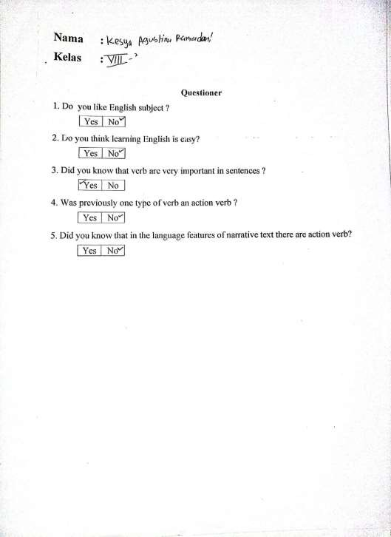

Lampiran2.

TEST
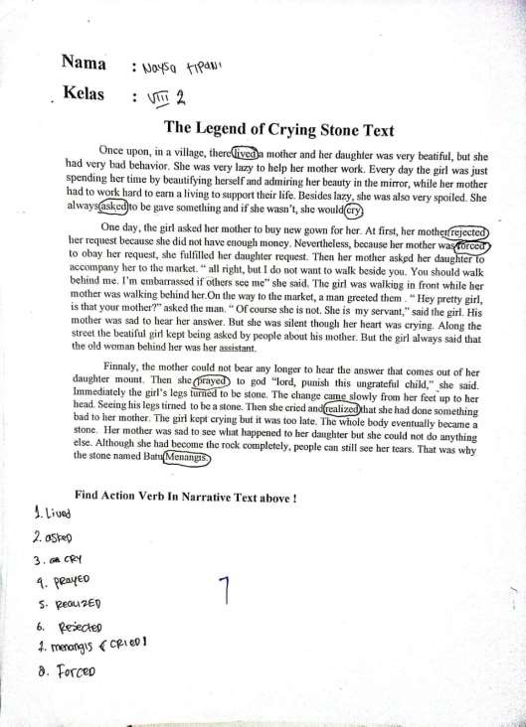

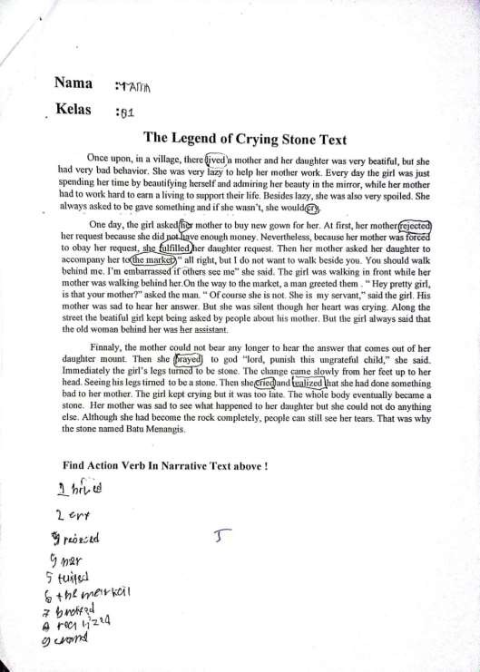

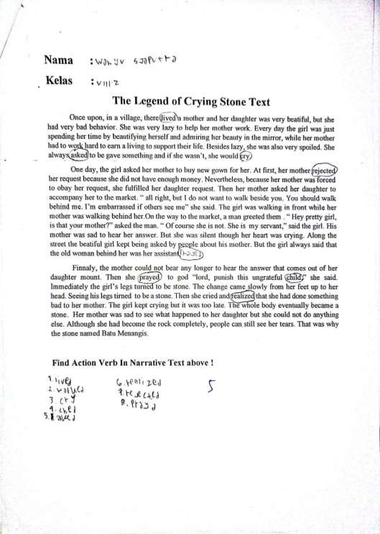

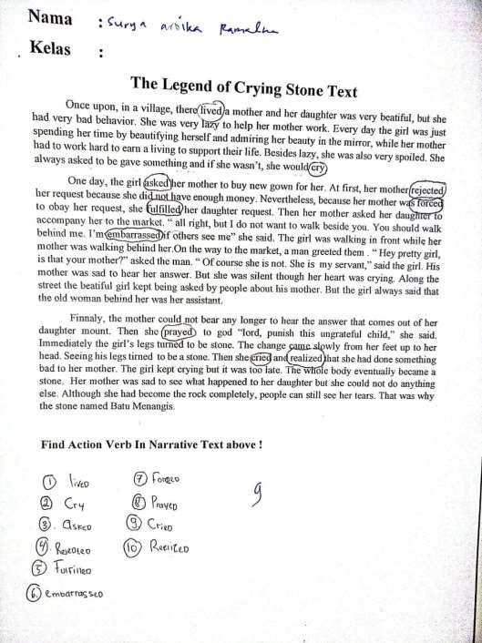

Lampiran3.
DOKUMENTASI
