REFERENCES

Afifah, U. (2019). Error Analysis on Using Action Verb in Writing Recount Text of the Eighth Grade Students at the First Semester of SMP 1 Sumberjo in the.
AgusMustajib,D.(2023).TheAbilityOfThe2022/2023AcademicYearsStudents OfIndragiriInIdentifiyingBetweenTransitiveAndIntrasnsitiveVerbInA SetenceS. EJI (English Journal of Indragiri): Studies in Education, Literature, and Linguistics.
Fiktorius,T.(2019).TherelationshipBetweenTransitiveAndIntransitiveVerbsin English Language. NOTION: Journal of Linguistics, Literature, and Culture, 1(2), 62-67.
Halawiyah,V.(2019).TheInfluenceOfUsingShortVideoTowardsStudents’.
lampung.
Harris,A.,Ansyar,M.,&Radjab,D.(2014).AnAnalysisOfStudents’Difficulties InWritingRecountTextAtTenthGradeOfSmaN1SungaiLimauVolume 2 Nomor 1. Journal English Language Teaching (ELT).
Jayanti, A. D. (2019). Students’ Writing Ability on English Descriptive Text at Grade. ENGLISH FRANCA: Academic Journal of English Language and Education, 3(1), 72-94.
Laia, M. Y. (2019). The difficulties of students to write narrative text at the eighth gradestudentsofsmpnegeri1lolowau.Urnaleducationanddevelopment, vol. 7.
Lubis, R. F. (2014). Writing Narrative Text vol.02 no.1. English Education. MattewB.Miles,A.M.(2014).QualitativeDataAnalysis:AMethods
Sourcebook.Arizona StateUniversity, ThirdEdition, 31.
Mufida,A.Z.(2020).AnAnalysisOfStudents’abilityInWritingNarrativeTextBy Using Collaborative Writing In The First Semester Of The Tenth Grade At Sma Perintis 1 Bandar Lampung In The Academic Year 2019/2020. Lampung: Doctoral dissertation UIN Raden Intan Lampung.
Nur Latifah, I. N. (2019). Teaching And Learning Narrative Text. English Education: Jurnal Tadris Bahasa Inggris Vol 12 (1) 2019, 78-96.
Nurlaili, I. S. (2020). Peningkatan Keterampilan Siswa Dalam Menulismelaluigambar Animasi Di Mial-Marwakecamatan Medan Denai Sumatera Utara. urnal Pendidikan dan Pembelajaran Terpadu (JPPT)Volume 02, No 01, 71-76.

Pardosi,J.D.(2019).Anerroranalysisofstudentsinwritingnarrativetext.
Linguistic,EnglishEducationandArt(LEEA)Journal.
Pasaribu, B., Herman, & Hutahaean, D. T. (2020). Students’ Difficulties In Translating Narrative Text From English Into Indonesia At Gradeviii Of Smp Negeri 9 Pematangsiantar. Acitya: Journal of Teaching &Education, Vol. 2 No. 1.
Prihatnasari,&Ferdias.(2020).GrammarFocusAnalysisInEnglishTextbookFor Senior. Jurnal AKRAB JUARA.
Ratnasari, N. (2018). The Effectiveness Of Webtoon To Develop Students’writing SkillInNarrativeTextOfTenthGraderInSmkPgri13Surabaya.surabaya: Doctoral dissertation, Universitas Muhammadiyah Surabaya.
Rokhmah, S. (2020). Students’ Writing skill throughTelecollaboration: in the context of WhatsApp and Facebook. Loquen: English Studies Journal.
Sari,S.M.(2020).ACorrelationBetweenSimplePastTenseMasteryAndWriting Vol. 11, No 1: 91-101. Anglo-Saxon : Jurnal Ilmiah Program Studi Pendidikan Bahasa Inggris.
Sharique Ahmad, S. W. (2019). Qualitative v/s. Quantitative Research- A Summarized Review . J. Evid. Based Med. .
Tenny S, B. J. (2023). Qualitative Study. n: StatPearls. StatPearls Publishing, Treasure Island (FL).

Lampiran 1. INTERVIEW
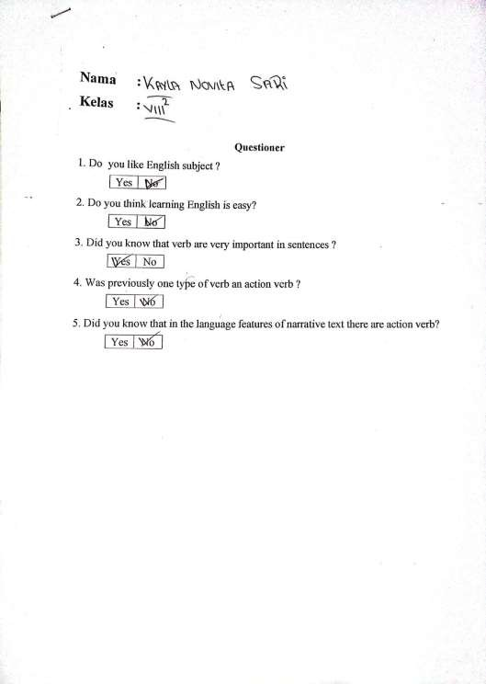

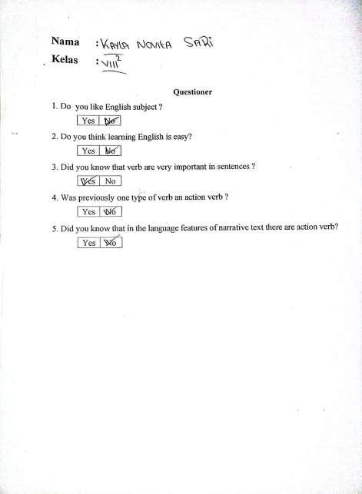

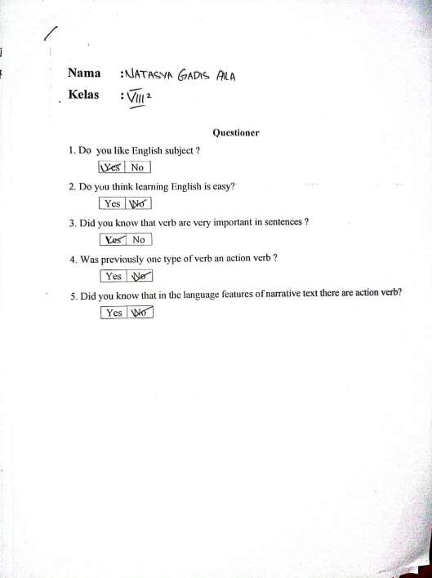

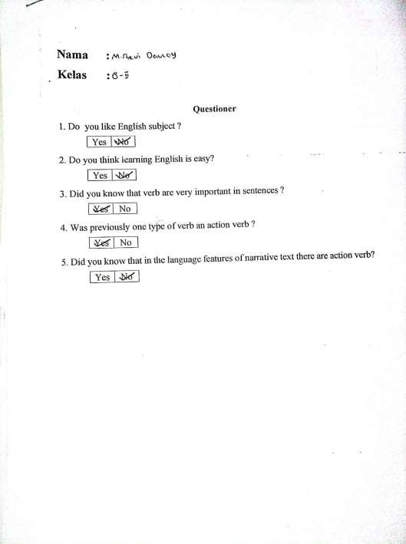

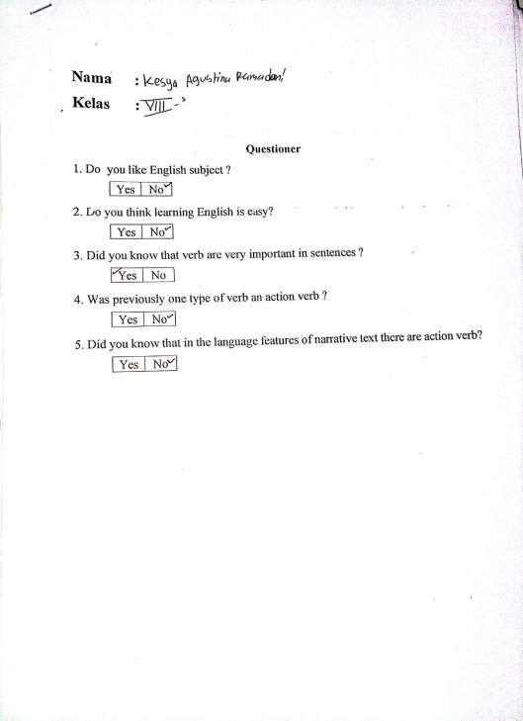

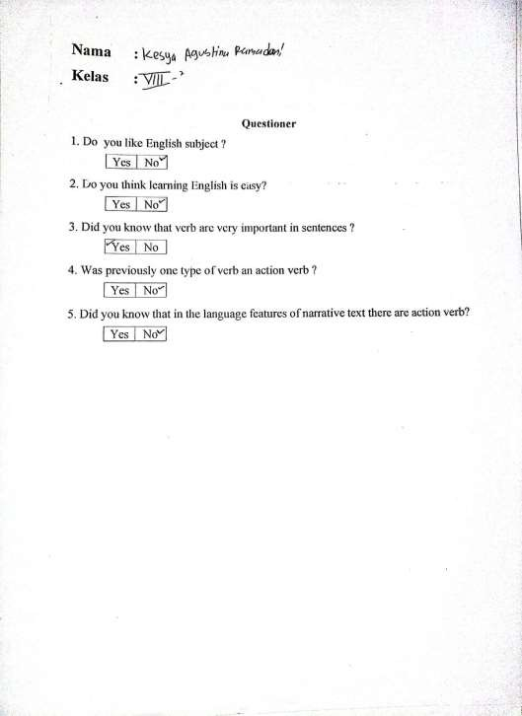

Lampiran2.

TEST
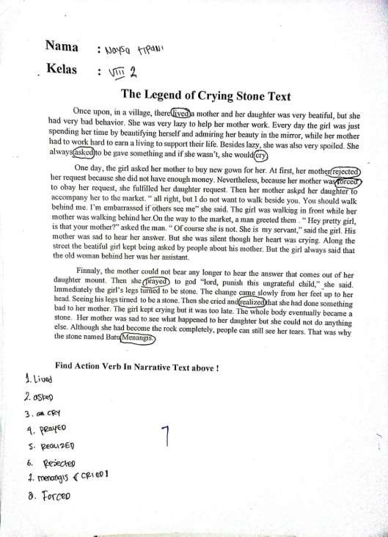

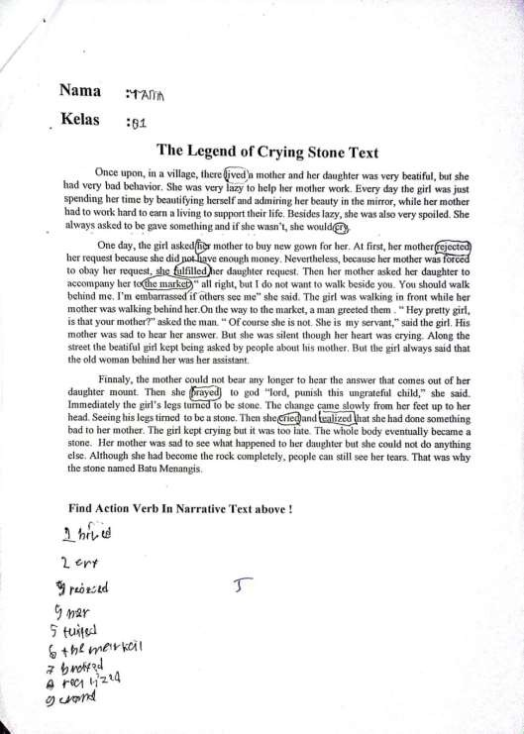

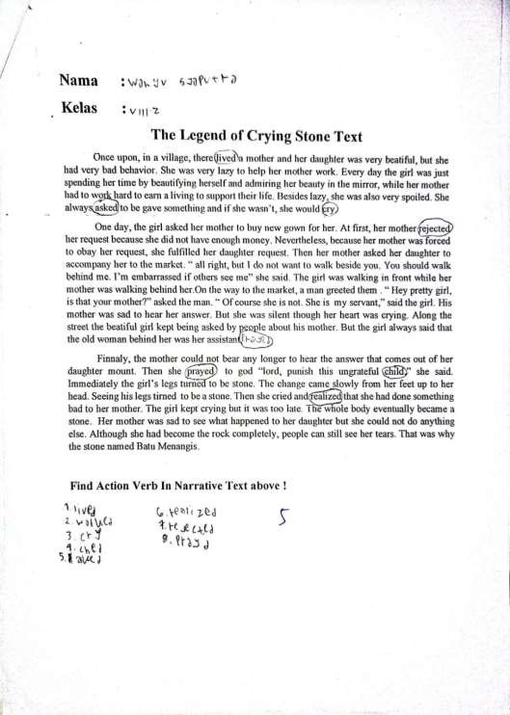

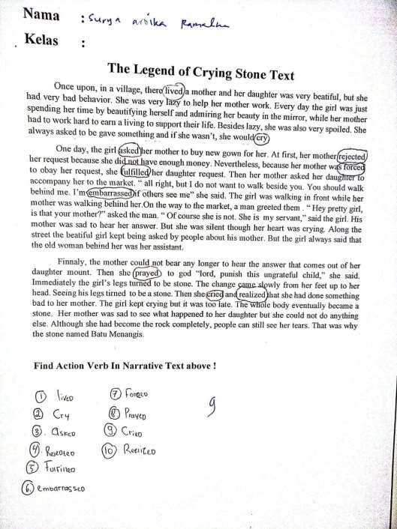

Lampiran3.
DOKUMENTASI
