DAFTAR PUSTAKA

Ainaa, N., Yatim, S. M., Suhaila, N., Hanapi, M., Zaini, N., Anis, A. L., Rashid, R. A., Bonnia, N. N., Nazihah, W., & Ibrahim, W. (2023). Preconcentration And Determination of Nicotine in Tobacco Samples by Dispersive Micro-Solid Phase Extraction and Gas Chromatography-Mass Spectrometry (Pemekatan dan Penentuan Nikotin dalam Sampel Tembakau oleh Pengekstrakan Fasa Pepejal-Mikro Dispersif dan Gas Kromatografi-Spektrometri Jisim). In Malaysian Journal of Analytical Sciences (Vol. 27).
Alauhdin, M. (2020). Kimia Analitik Dasar (Edisi Pertama). Unnes Press. https://creativecommons.or.id/
Al-Dahhan, W. H., Kadhom, M., Yousif, E., Mohammed, S. A., & Alkaim, A. (2022). Extraction and Determination of Nicotine in Tobacco from Selected Local Cigarettes Brands in Iraq. Letters in Applied NanoBioScience, 11(1), 3278–3290. https://doi.org/10.33263/lianbs111.32783290
Arsyad, R., Amin, A., & Waris, R. (2023). Teknik Pembuatan Dan Nilai Rendamen Simplisia Dan Ekstrak Etanol Biji Bagore (Caesalpinia Crista L.) Asal Polewali Mandar. Makassar Natural Product Journal, 1(3), 2023–2138. https://journal.farmasi.umi.ac.id/index.php/mnpj
Asri, M., Mahyarudin, Ika Agus Rini, A. Nurfitriani, Junairiah, Junairiah, Lisa Ainayal Fatih, Widya Lestari, Senja Ikerismawati, & Esna Dilli Novianto. (2024). Bioteknologi Senyawa Antimikroba (A. Karim, Ed.; Edisi pertama). Yayasan Kita Menulis. Web: kitamenulis.id
Bamigboye, C. O., Fatoki, I. O., Yakubu, O. F., & Biodun, R. (2021). Antimicrobial activity and phytochemical analysis of some selected plants against clinical pathogens. Tropical Journal of Natural Product Research, 5(4), 732–738. https://doi.org/10.26538/tjnpr/v5i4.22
Chaudhary, N. K., Chaudhary, A., Shakya, M., Limbu, D. K., & Oli, P. Sen. (2023). Phytochemical Screening and Antimicrobial Activity of Piper betle L. and Nicotiana tabacum L. across Dharan, Nepal. In Himalayan Journal of Science and Technology Original Article (Vol. 7). www.hijost.com
Cocco, E., Farci, D., Guadalupi, G., Manconi, B., Maxia, A., & Piano, D. (2024). The elongation factor 1-alpha as storage reserve and environmental sensor in Nicotiana tabacum L. seeds. Plant Science, 345. https://doi.org/10.1016/j.plantsci.2024.112113
Dasopang, E. S. (2017). Skrining Fitokimia Dan Uji Aktivitas Antibakteri Ekstrak Etanol Daun Sangitan (Sambucus Javanica Reinw) Terhadap Pertumbuhan Bakteri Eschericia coli DAN Salmonella thypi Scrining Fitochemism and Test of Antibacterial Activity of Extract Etanol Leaf Leaves (Sambucus javanica Reinw) on Growth Bacteria Eschericia coli and Salmonella thypi (Vol. 4, Issue 1). http://ojs.uma.ac.id/index.php/biolink
Departemen Kesehatan RI. (1989). Materia Medika Indonesia, jilid V. Jakarta: Depkes RI. Hal 536-540.
Departemen Kesehatan RI. (1979). Farmakope III. Jakarta: Depkes RI.
Departemen Kesehatan RI. (1995). Materia Medika Indonesia, jilid VI. Jakarta: Depkes RI. Hal 299-306, 333-337.
Departemen Kesehatan RI. (1985). Cara Pembuatan Simplisia, Jakarta: Depkes RI.
Dewi, E. R. S. (2020). Dasar-dasar Mikrobiologi (A. Nurwahyunani, Ed.; Edisi Pertama). Universitas PGRI Semarang.
Digna Evifania, R., Apridamayanti, P., & Sari, R. (2020). Uji parameter spesifik dan nonspesifik simplisia daun senggani (Melastoma malabathricum L.). In Jurnal Cerebellum (Vol. 6, Issue 1).
Dragomir, C., Misca, C. D., Dossa, S., Jianu, C., Radulov, I., Negrea, M., Paven, L., & Alexa, E. (2025). Chemical Composition, Antibacterial Activity, and Food Application of Sprouts from Fabaceae and Brassicaceae Species. Applied Sciences (Switzerland), 15(4). https://doi.org/10.3390/app15041896
Dzaky, R. D., & Sudibjo. (2021). Perbandinga Pengaruh Paparan Asap Rokok Konvensional. PMJ Prominentia Medical Journal, 2, 27–34.
Farooq, S., Nissa, M. U., Saba, N. U., Iqbal, M., Nisa, I., Ullah, M., Jamal, M., Qayum, N., Shah, D. A., Siddiqui, M. G., Khan, A., & Khan, F. (2023). Evaluation of Penicillins minimum inhibitory concentration against clinically isolated Streptococcus pyogenes. International Journal of Health Sciences, 7(S1), 2673–2685. https://doi.org/10.53730/ijhs.v7ns1.14564
Fatimah, S., Prasetyaningsih, Y., & Astuti, R. W. (2022). Efektifitas Antibakteri Ekstrak Daun Pegagan (Centella Asiatica) Terhadap Pertumbuhan Bakteri Staphylococcus aureus. Jurnal Ilmu Kefarmasian, 3(1).
Fitriana, H., & Chairani, S. (2022). Antifungal Activity of N-Hexane Extract of Duku Peel (Lansium domesticum Corr.) Against Candida albicans In Vitro. In Sriwijaya Journal of Dentistry (SJD (Vol. 3). https://jurnalkedokteranunsri.id/index.php/SJD/index
Florentika, R., & Kurniawan, W. (2022). Analisis Kuantitatif Tar dan Nikotin Terhadap Rokok Kretek yang Beredar di Indonesia. 2(2), 22–32. https://doi.org/10.54384/er
Gupta, A., Bernacchia, L., & Kad, N. M. (2022). Culture media, DMSO and efflux affect the antibacterial activity of cisplatin and oxaliplatin. Letters in Applied Microbiology, 75(4), 951–956. https://doi.org/10.1111/lam.13767
Hamdani, N. (2011). Tembakau Deli (Edisi Pertama). Balai Pelestarian Sejarah dan Nilai Tradisional Banda Aceh. www.bpsnt-bandaaceh.com
Handayani, S. N., Purwanti, A., Windasari, W., & Ardian, M. N. (2020a). Uji Fitokimia dan Aktivitas Antibakteri Ekstrak Etanol Daun Kencana Ungu (Ruellia tuberosa L.). Walisongo Journal of Chemistry, 3(2), 66. https://doi.org/10.21580/wjc.v3i2.6119
Handayani, S. N., Purwanti, A., Windasari, W., & Ardian, M. N. (2020b). Uji Fitokimia dan Aktivitas Antibakteri Ekstrak Etanol Daun Kencana Ungu (Ruellia tuberosa L.). Walisongo Journal of Chemistry, 3(2), 66. https://doi.org/10.21580/wjc.v3i2.6119
Heo, C. S., Kang, J. S., Yang, J. W., Lee, M. A., Lee, H. S., & Shin, H. J. (2024). Labdane-Type Diterpenoids from Streptomyces griseorubens and Their Antimicrobial and Cytotoxic Activities. International Journal of Molecular Sciences, 25(6). https://doi.org/10.3390/ijms25063311
Hla, T. K., Osowicki, J., Marsh, J. A., Salman, S., Page-Sharp, M., Yoo, O., Azzopardi, K., Morici, M., Batty, K. T., Barr, R. K., Enkel, S. L., Kado, J., Hatchuel, L., Fulurija, A., McCarthy, J. S., Snelling, T. L., Steer, A. C., Carapetis, J., & Manning, L. (2025). Establishing the lowest penicillin concentration to prevent pharyngitis due to Streptococcus pyogenes using a human challenge model (CHIPS): a randomised, double-blind, placebo-controlled trial. The Lancet Microbe. https://doi.org/10.1016/j.lanmic.2024.101038
Hla, T. K., Osowicki, J., Salman, S., Batty, K. T., Marsh, J. A., Kado, J., Barr, R., Enkel, S. L., Snelling, T. L., McCarthy, J., Steer, A. C., Carapetis, J., & Manning, L. (2022). Study protocol for controlled human infection for penicillin G against Streptococcus pyogenes: a double-blinded, placebo-controlled, randomised trial to determine the minimum concentration required to prevent experimental pharyngitis (the CHIPS trial). BMJ Open, 12(12), e064022. https://doi.org/10.1136/bmjopen-2022-064022
Huang, W., Wang, Y., Tian, W., Cui, X., Tu, P., Li, J., Shi, S., & Liu, X. (2022). Biosynthesis Investigations of Terpenoid, Alkaloid, and Flavonoid Antimicrobial Agents Derived from Medicinal Plants. In Antibiotics (Vol. 11, Issue 10). MDPI. https://doi.org/10.3390/antibiotics11101380
Hudaya, A., Radiastuti, N., Sukandar, D., & Djajanegara, I. (2020). Uji Aktivitas Antibakteri Ekstrak Air Bunga Kecombrang (Vol. 7, Issue 1).
Hujjatusnaini, N., Bunga Indah Emeilia Afitri Ratih Widyastuti Ardiansyah Tim Editor Nanik Lestariningsih, Mp., Penelaah Nurul Septiana, Mp., Ayatussadah, Mp., & Ridha Nirmalasari, Mp. (2021). Buku Referensi EKSTRAKSI.
Istiadi, K. A., Jernita Sinaga, Eni Dwi Islamiati, Melati Aprilliana Ramadhani, Dewi Chusniasih, Indah Kurniawati, Windi Susmayanti, Monik KrisnawatiAbdulRoni, Andrey Wahyud, Neli Diah Al Hajar Fuadatus Zurroh, Al Hajar Fuadatus Zurroh, Dwi Endah Kusumawat, & Erma Suryanti. (2024). Mikrobiologi & Virologi (M. J. F. Sirait, Ed.; edisi pertama). Yayasan Kita Menulis .
Julianto, T. S. (2019). Fitokimia Tinjauan Metabolit Sekunder dan Skrining Fitokimia. http:/library.uii.ac.id
Kurama, G. M., Maarisit, W., Karundeng, E. Z., & Potalangi, N. O. (2020). Uji Aktivitas Antibakteri Ekstrak Etanol Daun Benalu Langsat (Dendropthoe sp) Terhadap Bakteri Klebsiella Pneumoniae. The Tropical Journal of Biopharmaceutical), 3(2), 27–33.
Lismandaria, N., Elysa Putri Mambang, D., Munandar Nasution, H., & Putri Rahayu, Y. (2023). Uji Aktivitas Antibakteri Ekstrak Etanol Daun Sedingin (Kalanchoe pinnata (Lam) Pers) Terhadap Bakteri Staphylococcus aureus dan Salmonella typhimurium Antibacterial Activity Test Of Cold Leaf Ethanol Extract (Kalanchoe Pinnata (Lam) Personal) Against Bacteria Staphylococcus aureusand Salmonella typhimurium. In Agustus (Vol. 3, Issue 1).
Maslahah, N. (2024). StandarSimplisiaTanamanObatSebagaiBahanSediaanHerbal (Vol. 2, Issue 2). https://poltekkespim.ac.id
Mo, Z., Duan, L., Pu, Y., Tian, Z., Ke, Y., Luo, W., Pi, K., Huang, Y., Nie, Q., & Liu, R. (2022). Proteomics and Co-expression Network Analysis Reveal the Importance of Hub Proteins and Metabolic Pathways in Nicotine Synthesis and Accumulation in Tobacco (Nicotiana tabacum L.). Frontiers in Plant Science, 13. https://doi.org/10.3389/fpls.2022.860455
Muntasir, Widy Susanti Abdulkadir, Andi Ifriany Harun, Priska Ernestina Tenda, Makkasau, Muliyadi, Reni Yustiati Saksosno, Stefany Fernandez, & Theresia Maria Wonga. (2021). Antibiotik Dan Resistensi Antibiotik (Risnawati, Ed.; Edisi Pertama). Rizmedia Pustaka Indonesia. https://doi.org/https://www.researchgate.net/publication/358041923
Najmah, Asriyani Ridwan, Tacik Idayanti, Emelda, Ni Made Sri Dwijastuti, Dwi Setianingtyas, Syandrez Prima Putra, Dwi Krihariyani, Aini, & Kristanti Parisihni. (2024). Pengantar Mikrobiologi (R. U. Nurlila, Ed.; Edisi Pertama). Eureka Media Aksara.
Nasri, N., Kaban, V. E., Gurning, K., Syahputra, H. D., & Satria, D. (2022). Aktivitas Antibakteri Ekstrak Etanol Daun Pepaya (Carica papaya Linn.) Terhadap Bakteri Pseudomonas aeruginosa. Insologi: Jurnal Sains Dan Teknologi, 1(3), 252–259. https://doi.org/10.55123/insologi.v1i3.438
Nugroho, W., Rosmainar, L., Toepak, E. P., Kimia, P., Mipa, F., Raya, P., Tengah, K., & Article, R. (2023). Skrining Fitokimia Dan Uji Antioksidan Menggunakan Metode Dpph Pada Ekstrak Metanol Buah Terung Asam Besar (Solanum Ferox Linn) (Vol. 5, Issue 1).
Osorio-Tobón, J. F. (2020). Recent advances and comparisons of conventional and alternative extraction techniques of phenolic compounds. In Journal of Food Science and Technology (Vol. 57, Issue 12, pp. 4299–4315). Springer. https://doi.org/10.1007/s13197-020-04433-2
Pranowo, D., Susanti, S. D., & Mulyadi, A. F. (2023). Optimization of tobacco leaves extraction process with microwave assisted extraction (MAE) as an antibacteria agents. Advances in Food Science, Sustainable Agriculture and Agroindustrial Engineering, 6(4), 409–423.
Purba, A. M. V., Miftahul Khairani, Deasy Handayani Purba, Yulia Yesti, A. I. M., Ratna Puspita, Lalu Unsunnidha, Ernawati Siagian, Budiono, & Ira Erdiandini. (2021). Mikrobiologi dan Parasitologi (R. Watrianthos, Ed.; Edisi pertama). Yayasan Kita Menulis .
Purwanitiningsih, E., & Lestari, D. (2020). Uji Aktivitas Antibakteri Ekstrak Daun Cocor Bebek (Kalanchoe Pinnata (Lam)) Terhadap Pertumbuhan Bakteri Salmonella typhi Dengan Metode Kirby Bauer. Jurnal Ilmiah Kesehatan, 12(2), 142–148. https://doi.org/10.37012/jik.v12i2.193
Puspita Sari, R., Teokarsa Laoli, M., Studi, P. S., Imelda Medan, Stik., Bilal No, J., Pulo Brayan Darat Kecamatan Medan Timur, K. I., & -Sumatera Utara, M. (2019). Karakterisasi Simplisia Dan Skrining Fitokimia Serta Analisis Secara Klt (Kromatografi Lapis Tipis) Daun Dan Kulit Buah Jeruk Lemon (Citrus limon (L.) Burm.f.). Maret, 2(2), 59–68. https://jurnal.uimedan.ac.id/index.php/Jurnalfarmasiρ59Journalhomepage:https://jurnal.uimedan.ac.id/index.php/Jurnalfarmasi
Rahmi, M., & Hilda Putri, D. (2020). The Antimicrobial Activity of DMSO as A Natural Extract Solvent Aktivitas Antimikroba DMSO sebagai Pelarut Ekstrak Alami (Vol. 5, Issue 2).
Razali, M., Taufik, M., Atiqah, E. D., Wanto, R., Daulay, A. S., Ardilla, D., Susilawati, E., & Afniwati, . (2022). Relationship of Tobacco Weight in Commercial Cigarettes to Nicotine Levels. 621–625. https://doi.org/10.5220/0010614800002775
Rizki, A. Fadillah. , H. M. Nasution. , Y. P. R. R. Y. (2023). Uji Aktivitas Antibakteri Fraksi Etil Asetat Rimpang Lempuyang Wangi (Zingiber Zerumbet (L.) Roscoe ex Sm.) Terhadap Propionibacterium Acnes Dan Escherichia Coli. Journal of Health and Medical Science, 2, 5–15. https://pusdikra-publishing.com/index.php/jkes/home
Rofiqi Firdiyansyah, M., Sindu Sakti, A., Wulan Kusumo, D., Saiful Amin, M., Lamongan, M., Timur, J., Tinggi Ilmu Kesehatan Nasional, S., & Tengah, J. (2024). Kajian Literatur: Aplikasi Metode Ekstraksi Modern Untuk Mengekstraksi Senyawa Fenolik dari Bahan Alam Review Article: Application of Modern Extraction Methods to Extract Phenolic Compounds from Natural Products. In Journal of Pharmacy (Vol. 13, Issue 2).
Rosnarita, I. A., Akhyasin, A., & Dewi, S. K. (2024). Perbandingan Efektivitas Cefotaxime Dan Ceftriaxone Pada Pasien Rawat Inap Pediatri Dengan Pneumonia. IJF (Indonesia Jurnal Farmasi), 9(1), 35–43. https://doi.org/10.26751/ijf.v9i1.2425
Rumaseuw, E. S., Vera Estefania Kaban, Agung Wibawa Mahatva Yodha, Yulianita Pratiwi Indah Lestari, Asti Vebriyanti Asjur, Muh Taufiqurrahman, Hamsidar Hasan, Teguh Adiyas Putra, & Umarudin. (2023). Farmakognosi (N. Sulung, Ed.; Edisi pertama). Pt Global Eksekutif Teknologi.
Sapoetri, G. I., Revina, R., & Muti, A. F. (2022). Antibacterial Activity Test Of Bay Leaf Extracts (Syzygium Polyanthum (Wight) Walp.) Against Staphylococcus Aureus And Escherichia Coli: Systematic Literature Review. Journal of Research in Pharmacy and Pharmaceutical Sciences, 1(1), 36–42. https://doi.org/10.33533/jrpps.v1i1.4460
Saraswati, H. (2021). Nutrisi Dan Pertumbuhan Mikroba. Universitas Esa Unggul. http://esaunggul.ac.id
Sari, D. Y. (2020a). Effectiveness Test Of Tobacco Leaves Extract in Resolving Growth of Colletotrichum gloeosporiodes and Lasiodiplodia theorobromae. Gontor AGROTECH Science Journal, 6(3), 473. https://doi.org/10.21111/agrotech.v6i3.5013
Sari, D. Y. (2020b). Effectiveness Test Of Tobacco Leaves Extract in Resolving Growth of Colletotrichum gloeosporiodes and Lasiodiplodia theorobromae. Gontor Agrotech Science Journal, 6(3), 473. https://doi.org/10.21111/agrotech.v6i3.5013
Shwaish, M. M., & Ibrahim, O. M. S. (2022). Pharmacodynamics Analysis Of Ceftriaxone Against Klebsiella Pneumonia Isolated From Covid-19 Patients. Journal of Pharmaceutical Negative Results ¦, 13. https://doi.org/10.47750/pnr.2022.13.S10.845
Streimikyte, P., Viskelis, P., & Viskelis, J. (2022). Enzymes-Assisted Extraction of Plants for Sustainable and Functional Applications. In International Journal of Molecular Sciences (Vol. 23, Issue 4). MDPI. https://doi.org/10.3390/ijms23042359
Sunaryo, T. (2013). Kretek Pusaka Nusantara (Derry & D. Sumitra, Eds.; Edisi Pertama). Serikat Kerakyatan Indonesia (SAKTI).
Supiyani, & Dikki Miswanda. (2024). Metabolit Sekunder Tembakau Gayo Isolasi Dan Identifikasi (P. Nasution, Ed.; Edisi Pertama). LPPM UMNAW .
Supiyani, & Saisa. (2023). GCMS Analysis of Bakong Gayo or Gayo Tobacco (Nicotiana tabacum L) Leaves Extract and Pharmaceutical Uses. Indonesian Journal of Chemical Science and Technology (IJCST-UNIMED, 07(1), 95–103. https://jurnal.unimed.ac.id/2012/index.php/aromatika
Supiyani, Saisa, & Anggitha Ningtias. (2023). Phytochemichal identification of Gayo tobacco or bakong Gayo (Nicotiana tabacum L) and its potency for industrial applications. 6(4), 505–512. https://doi.org/10.31764/justek.vXiY.ZZZ
Susilo. (2023). Mikrobiologi Dasar (N. Rosyadi & Maryanti Setyaningsih, Eds.; Edisi Pertama). Ahlimedia Press . http://www.ahlimediapress.web.id
Syahmani, Leny, & Rilia Iriani. (2022). Fitokimia Dan Aplikasinya (Y. D. Prasetyo, Ed.; Edisi Pertama). Lambung Mangkurat University Press.
Tumbel, M. (2010). Analisis Kadar Nikotin dalam Tembakau Tongka Kabupaten Bantaeng Analisis Kadar Nikotin dalam Tembakau Tongka Kabupaten Bantaeng (Analysis on The Concentrate of Nicotine in " Tembakau Tongka " of District Bantaeng).
Turnip, N. U. M. Br., Sinulingga, S. E., & Sahada, P. (2024). Antibacterial Activity Test of Ethanol Extract of Torch Ginger Flowers (Etlingera elatior) Against Streptococcus Pyogenes Bacteria Causing Pharyngitis Disease in Vitro. JURNAL FARMASIMED (JFM), 7(1), 88–93. https://doi.org/10.35451/jfm.v7i1.2334
Umarudin, Gede Angga Adnyana, Rohayati, Nangsih Sulastri Slamet, Febri Sembiring, Yasinta Rakanita, Ni Ketut Yuliana Sari, Ayu Brenda Sumariangen, Iis Kurniati, Yuliawati, Anak Agung Ayu Putri Permatasari, Fusvita Merdekawati, & Asep Dermawan. (2023). Bakteriologi 2 (H. Akbar, Ed.). CV. Media Sains Indonesia. www.medsan.co.id
Weinstein, M. P. . (2019). Performance standards for antimicrobial susceptibility testing. Clinical and Laboratory Standards Institute.
Yan, Y., Li, X., Zhang, C., Lv, L., Gao, B., & Li, M. (2021). antibiotics Review Research Progress on Antibacterial Activities and Mechanisms of Natural Alkaloids: A Review. https://doi.org/10.3390/antibiotics
Yanti, F. (2020). Perhitungan jumlah bakteri di Laboratorium Mikrobiologi menggunakan pengembangan metode Spektrofotometri. In Jurnal Penelitian Sains (Vol. 22, Issue 2). http://ejurnal.mipa.unsri.ac.id/index.php/jps/index
Yati, K., Gozan, M., Mardiastut, M., Anggia, V., Prastiwi, R., & Jufri, M. (2022). Phytochemical Evaluation and Antioxidant Activity of Virginia tobacco Leaves (Nicotiana tabacum L. var virginia) Fractions with DPPH and FTC Methods. Pharmacognosy Journal, 14(3), 544–548. https://doi.org/10.5530/pj.2022.14.69
Zhang, W., Pan, X., Fu, J., Cheng, W., Lin, H., Zhang, W., & Huang, Z. (2024). Phytochemicals derived from Nicotiana tabacum L. plant contribute to pharmaceutical development. In Frontiers in Pharmacology (Vol. 15). Frontiers Media SA. https://doi.org/10.3389/fphar.2024.1372456
Zhang, Y., Fan, W., Shao, C., Wang, J., Jin, Y., Shao, J., Zhang, Y., & Wang, Y. (2021). Rapid Determination of Antibiotic Resistance in Klebsiella pneumoniae by a Novel Antibiotic Susceptibility Testing Method Using SYBR Green I and Propidium Iodide Double Staining. Frontiers in Microbiology, 12. https://doi.org/10.3389/fmicb.2021.650458

LAMPIRAN

Lampiran1HasilIdentifikasiTanamanDaunTembakau(Nicotianatabacum)
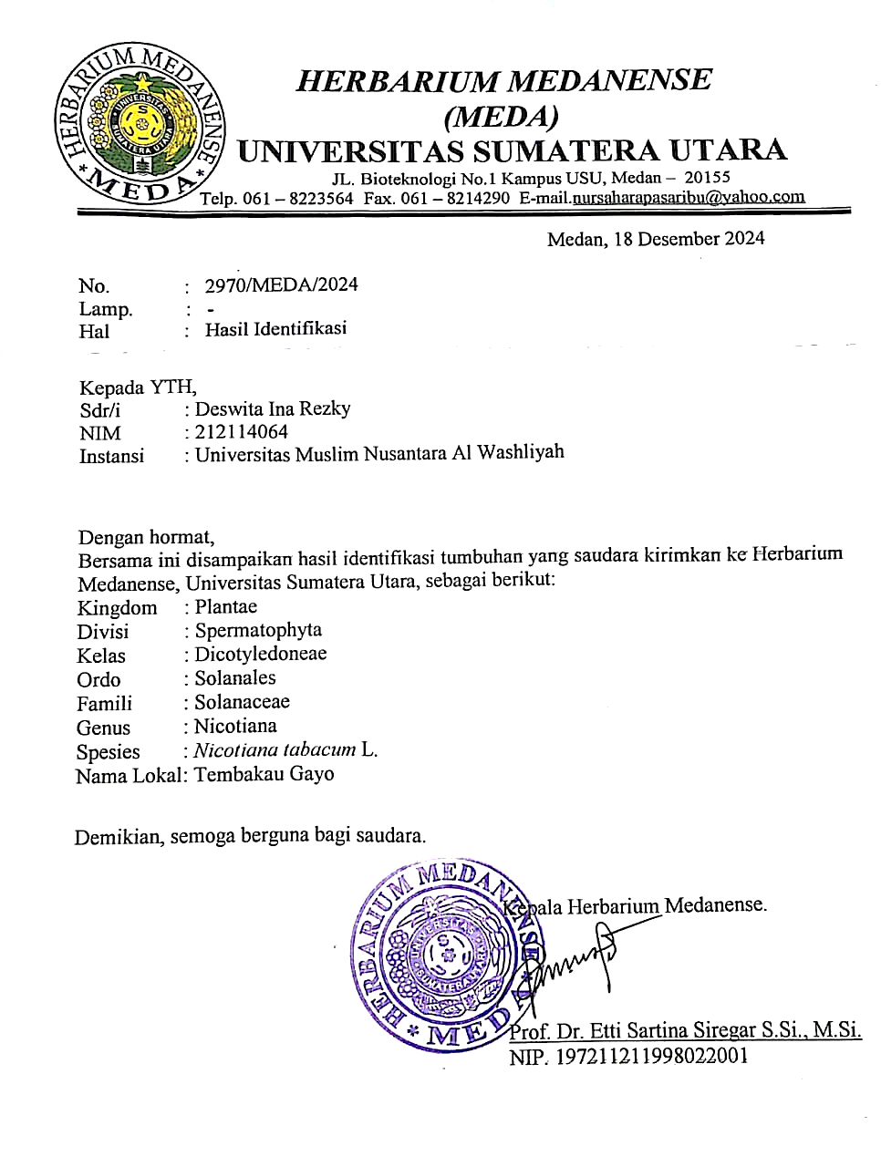

Lampiran2SuratKeteranganTelahMelaksakanPenelitian
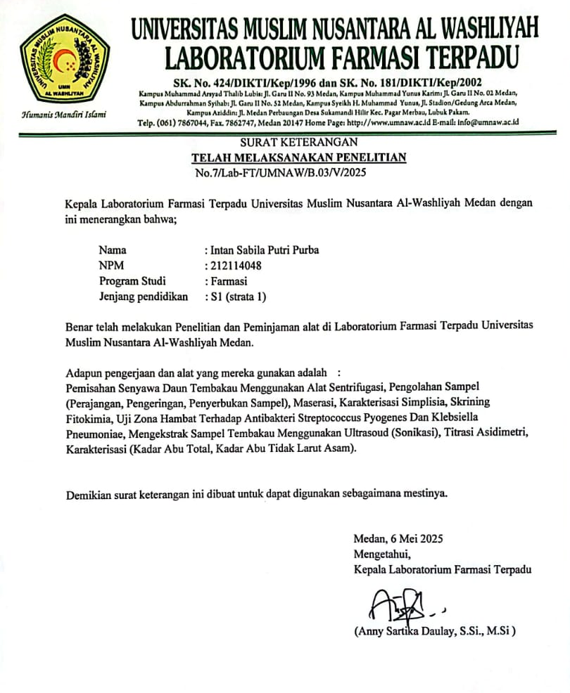

Lampiran3SuratKeteranganBebasLaboratorium
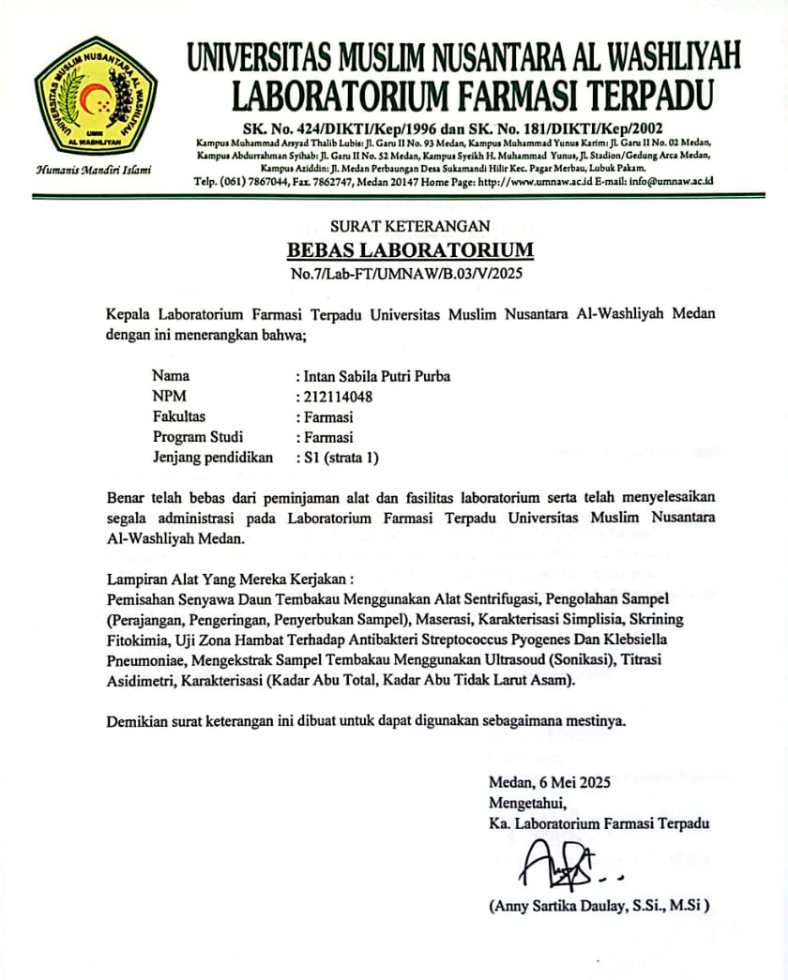

Lampiran4BaganAlirPengolahanSampel
Daun tembakau

Dikeringkanpadasuhu40ºC
Ditimbang
Simplisia kering

Dihaluskan
Ditimbang
Serbuk Simplisia
Dimaserasidenganetanol
KarakteristikSimplisia:
1. PemeriksaanMakroskopik
dan Mikroskopik
2. Penetapan Kadar Air
3. Penetapan Kadar Sari
Larut Dalam Air
4. Penetapan Kadar Air Larut
Dalam Etanol
5. Penetapan Kadar AbuTotal
6. PenetapanKadarAbu
Tidak Larut Asam
96%
Ekstrak Cair
Dipanaskandengan
Ultrasonikdansentrifugasi
Ekstrak kental

Dipekatkandiwaterbath
Skrining Fitokimia 1.Alkaloid
2. Flavonoid 3.Glikosida
4. Saponin
5.Tanin
6. Steroid/triterpenoid

Uji Antivitas Antibakteri Pada Bakteri Streptococcus Pyogenes dan Klebsiella pneumoniae dengan konsentrasi 100%, 80%, 60%, 40%, 20%, 15%, 10%, 10%

moiniae

Penetapan kadar asidimetri

Metode GCMS

Lampiran5BaganAlirPengujianAnktivitasAntibakteriEkstrakEtanolDaun
Tembakau
Biakan Murni Bakteri
Diambil dengan jarum ose
Ditanam pada media Na
Media Padat
Disesuaikan kekeruhan dengan larutan Mc Farland 0,5
Disuspensikan dalam 10 mllarutan fisiologi NaCI 0,9% steril
Inokulum Bakteri
Stok Kultur Bakteri

Diinkubasi pada suhu 37ºC selama 24 jam

Dimasukkan inokulum bakteri lalu dioleskan dengan cotton swabsecara merata pada permukaan MHA
Dimasukkan 15 ml media MHA ke petri, diamkan hingga memadat
Diletakkan kertas cakram yang telah dicelupkan dengan Ekstrak 5%, 10%, 15%, 20% dipermukaan
Diinkubasi pada suhu 37ºC selama 24 jam
Ukur diameter zona hambat sertakan cakram, menggunakan jangka sorong
Hasil

Lampiran6PerhitunganSusutPengeringanDauntembakau

Diketahui:
BobotTumbuhanSegar:1.000gram
BobotSimplisia:300gram
$$\% susut pengeringan=\frac{bobot tumbuhan segar-bobot simplisia}{bobot tumbuhan segar} ×100 \%$$
$$\% susut pengeringan=\frac{1.000 gram-300 gram}{1.000 gram} ×100 \%$$
$$=70 \%$$

Lampiran7PemeriksaanMakroskopikdanMikroskopikdauntembakau

- Makroskopik

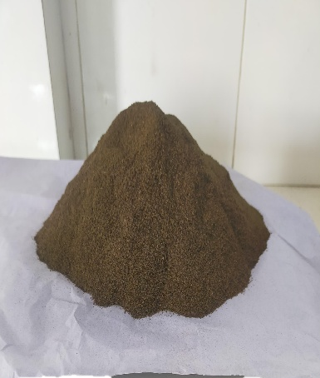
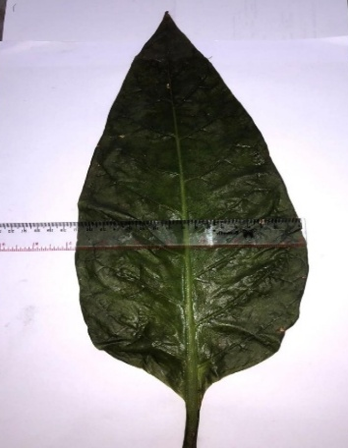
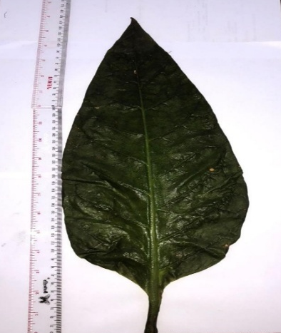

Keternagan:
Tinggi=48
Lebar =18
Organoleptik=Bau:Khas
=Rasa:Pahit
=Warna:Hijau

- Mikroskopik

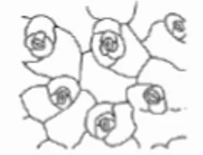

1.

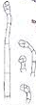
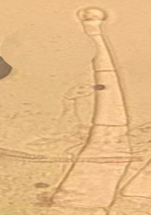

2.

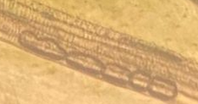
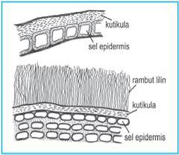
3.

Keterangan:
1.Stomata(Anisositic),selpenjaga
2.TrikomaBerkelenjar,bersel;tangkai,selkepala
3.Epidermisbawah,Berkaspengangkut

Lampiran8DokumentasiProsesEkstraksidauntembakau
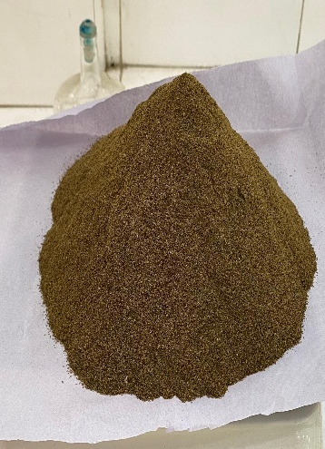
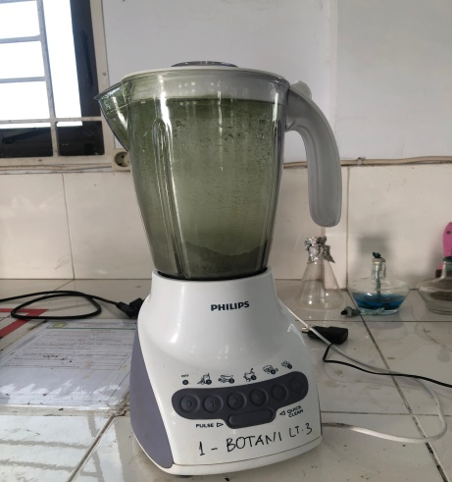
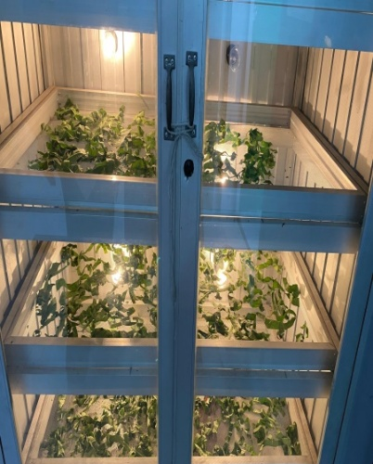
Serbuk daun tembakau
Penghalusan daun tembakau
Pengeringan daun tembakau

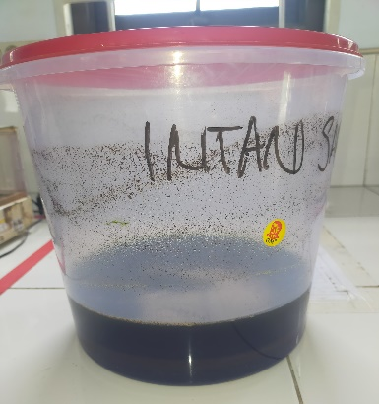
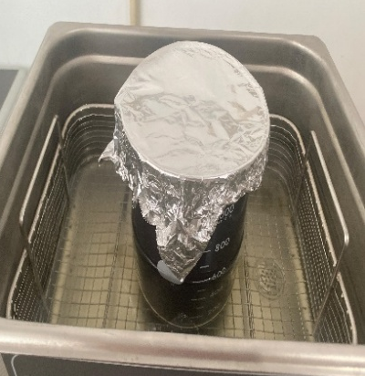
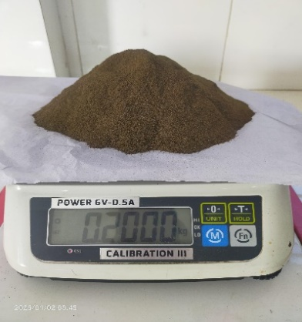
Proses ekstraksi dengan gelombang ultrasonik
Prosesmaserasi daun tembakau
Penimbanganserbuk tembakau

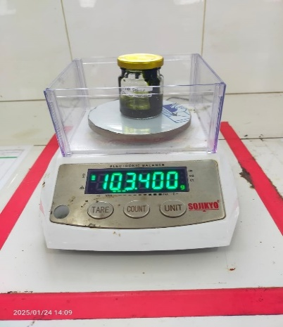
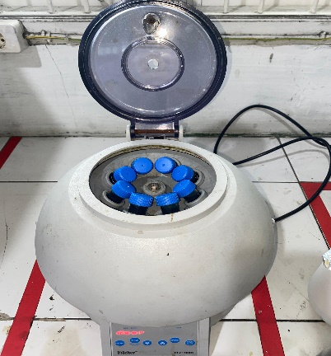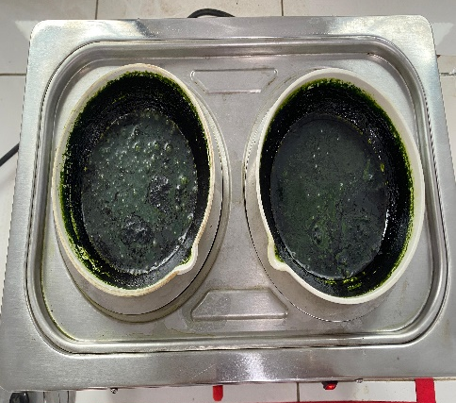
Ekstrak kental
Pemekatan esktrak tembakau pada waterbath
Pemisahan senyawa esktrak tembakau dengan sentrifugasi

Lampiran9PerhitunganDanCaraPembuatanKosentrasiEkstrakDaun
TembakauSebagaiAntibakteri
PerhitunganEkstrak
- Konsentrasi100%
$$\frac{\text{100}}{\text{100}}\text{×25ml=25gram}$$
Ditimbangsebanyak25gramekstrakkental,kemudiandimasukkankedalamlabuukur25ml.

- Konsentrasi80%
Dipipetkonsentrasi100%
V1.C1=V2.C2
V1.100%=10ml.80%
V1=8ml

Dipipetsebanyak8mldarikonsentrasi100%,kemudiandimasukkankedalamlabuukur10ml.SetelahitutambahkanDMSOsampaigaristandabatas.

- Konsentrasi60%
Dipipetkonsentrasi80%
V1.C1=V2.C2
V1.80%=10ml.60%
V1=7,5ml

Dipipetsebanyak7,5mldarikonsentrasi80%,dimasukkankedalamlabutentukur10ml.SetelahitutambahkanDMSOsampaigaristandabatas.

- Konsentrasi40%
Dipipetkonsentrasi60%
V1.C1=V2.C2
V1.60%=10ml.40%
V1=6,6ml

Dipipetsebanyak6,6mldarikonsentrasi60%,dimasukkankedalamlabutentukur10ml.SetelahitutambahkanDMSOsampaigaristandabatas.

- Konsentrasi20%
Dipipetkonsentrasi40%
V1.C1=V2.C2
V1.40%=10ml.20%
V1=5ml

Dipipetsebanyak5mldarikonsentrasi40%,dimasukkankedalamlabutentukur10ml.SetelahitutambahkanDMSOsampaigaristandabatas.

- Konsentrasi15%
Dipipetkonsentrasi20%
V1.C1=V2.C2
V1.20%=10ml.15%
V1=7,5ml

Dipipetsebanyak7,5mldarikonsentrasi20%,dimasukkankedalamlabutentukur10ml.SetelahitutambahkanDMSOsampaigaristandabatas.

- Konsentrasi10%
Dipipetkonsentrasi15%
V1.C1=V2.C2
V1.15%=10ml.10%
V1=6,6ml

Dipipetsebanyak6,6mldarikonsentrasi15%,dimasukkankedalamlabutentukur10ml.SetelahitutambahkanDMSOsampaigaristandabatas.

- Konsentrasi5%
Dipipetkonsentrasi10%
V1.C1=V2.C2
V1.10%=10ml.5%
V1=5ml

Dipipetsebanyak5mldarikonsentrasi10%,dimasukkankedalamlabutentukur10ml.SetelahitutambahkanDMSOsampaigaristandabatas.

PerhitunganAntibiotik
- Ceftriaxon 0,1% dalam 10 ml
$$\frac{\text{0,1}}{\text{100}}\text{×10ml=0,}\text{0}\text{1gram}$$

Ditimbangserbuksebanyak0,01gramkemudiandilarutkandalamDMSOad10ml.
- Penisilin 0,1% dalam 10 ml
$$\frac{\text{0,}\text{1}}{\text{100}}\text{×10ml=0,}\text{0}\text{1gram}$$

Ditimbangserbuksebanyak0,01gramkemudiandilarutkandalamDMSOad10ml.

Lampiran10PerhitunganPenetapanKadarNikotinEkstrakEtanol
%Nikotin=$\frac{v titrasi-v blanko ×fp ×0,162 ×NHCl}{B.Sampel} ×100 \%$
1.NikotinDalamSerbuk
%Nikotin1=$\frac{0,45-0,12 × 2 ×0,162 ×0,0976}{1,000} ×100 \%$=1,04 %
%Nikotin2=$\frac{0,5-0,12 × 2 ×0,162 ×0,0976}{1,000} ×100 \%$=1,20 %
%Nikotin3=$\frac{0,32-0,12 × 2 ×0,162 ×0,0976}{1,000} ×100 \%$= 0,63 %
NO | Hasil
1 | 1,04
2 | 1,20
3 | 0,63
Rata rata | 0,95
SD | 0,29

2.NikotinDalamEkstrak
%Nikotin1=$\frac{0,52-0,12 × 3 ×0,162 ×0,0976}{1,000} ×100 \%$= 1,89 %
%Nikotin2=$\frac{0,42-0,12 × 3 ×0,162 ×0,0976}{1,000} ×100 \%$=1,42 %
%Nikotin3=$\frac{0,61-0,12 × 3 ×0,162 ×0,0976}{1,000} ×100 \%$=2,32 %
NO | Hasil
1 | 1,89
2 | 1,42
3 | 2,32
Rata rata | 1,87
SD | 0,45

3. Blanko
% Nikotin = $\frac{0,12 × 2 ×0,162 ×0,0976}{1,000} ×100 \%$ = 0,37%
4.BakuNikotin
%Nikotin=$\frac{0,45 × 2 ×0,162 ×0,0976}{1,000} ×100 \%$=1,4%
5.StandarisasiHClDenganBoraks
%Nikotin=$\frac{0,42 × 2 ×0,162 ×0,0976}{1,000} ×100 \%$=1,3%

Lampiran11PerhitunganNikotinEkstrakTembakaudenganGCMS
- BakuNikotin=C=100mg/ml~100.000µg/ml

PembuatanLIB

C=50µg/ml

V1.C1=V2.C2
V1.100.000µg/ml=50ml.50µg/ml
V1=$\frac{250 µg/ml}{100.000 µg/ml}$
=0,0025ml~25µl
Carakerja:Dipipetbakunikotin0,0025mlmenggunakanmikropipet,
dimasukkandalamlabutentukur50ml,addenganaquadest
sampaitandabatas.

- 1ppm
V1.C1=V2.C2
V1.50µg/ml=10ml.1µg/ml
V1=$\frac{10 µg/ml}{50 µg/ml}$
=0,2ml
Carakerja:Dipipetbakunikotin0,2mlmenggunakanmikropipet,
dimasukkandalamlabutentukur10ml,addenganaquadest
sampaitandabatas.
- 2ppm
V1.C1=V2.C2
V1.50µg/ml=10ml.2µg/ml
V1=$\frac{20 µg/ml}{50 µg/ml}$
=0,4ml
Carakerja:Dipipetbakunikotin0,2mlmenggunakanmikropipet,
dimasukkandalamlabutentukur10ml,addenganaquadest
sampaitandabatas.

- 3ppm
V1.C1=V2.C2
V1.50µg/ml=10ml.3µg/ml
V1=$\frac{30 µg/ml}{50 µg/ml}$
=0,6ml
Carakerja:Dipipetbakunikotin0,6mlmenggunakanmikropipet,
dimasukkandalamlabutentukur10ml,addenganaquadest
sampaitandabatas.
- 4ppm
V1.C1=V2.C2
V1.50µg/ml=10ml.4µg/ml
V1=$\frac{40 µg/ml}{50 µg/ml}$
=0,8ml
Carakerja:Dipipetbakunikotin0,8mlmenggunakanmikropipet,
dimasukkandalamlabutentukur10ml,addenganaquadest
sampaitandabatas.
- 5ppm
V1.C1=V2.C2
V1.50µg/ml=10ml.5µg/ml
V1=$\frac{50 µg/ml}{50 µg/ml}$
=1ml
Carakerja:Dipipetbakunikotin1mlmenggunakanmikropipet,
dimasukkandalamlabutentukur10ml,addenganaquadest
sampaitandabatas.

- 6ppm
V1.C1=V2.C2
V1.50µg/ml=10ml.6µg/ml
V1=$\frac{60 µg/ml}{50 µg/ml}$
=0,8ml
Carakerja:Dipipetbakunikotin1,2mlmenggunakanmikropipet,
dimasukkandalamlabutentukur10ml,addenganaquadest
sampaitandabatas.

Lampiran12PerhitunganKarakteristikTembakau(Nicotianatabacum)

- PenetapanKadarAir

Pengulangan1
V₀=1,8ml
V₁=2,0ml
Sampel=5gram
Kadarair=$\frac{\left(V1\right)-\left(V0\right)}{Berat Sampel \left(g\right)}×100 \%$
=$\frac{2,0ml - 1,8ml}{5 g}×100 \%$
=4%
Pengulangan2
V₀=1,8ml
V₁=2,1ml
Sampel=5gram
Kadarair=$\frac{\left(V1\right)-\left(V0\right)}{Berat Sampel \left(g\right)}×100 \%$
=$\frac{2,1ml - 1,8ml}{5 g}×100 \%$
=6%
Pengulangan3
V₀=1,8ml
V₁=2,2ml
Sampel=5gram
Kadarair=$\frac{\left(V1\right)-\left(V0\right)}{Berat Sampel \left(g\right)}×100 \%$
=$\frac{2,2ml - 1,8ml}{5 g}×100 \%$
=8%

Rata-RataKadarAir=$\frac{4\% + 6\% + 8\%}{3} = 6\%$

- KadarSariLarutDalamAir
No | BeratSampel(g) | BeratCawanKosong(g) | BeratCawanIsi(g)
1 | 5 | 74,850 | 75,200
2 | 5 | 70,450 | 70,750
3 | 5 | 71,500 | 71,750

%kadarsarilarutdalamair=$\frac{\text{BobotSariSetelahDikeringkan(g)×5}}{\text{BobotSimplisia(g)}}×100\%$
Pengulangan1
%kadarsarilarutdalamair=$\frac{\text{0,35(g)×5}}{\text{5(g)}}×100\% =35\%$
Pengulangan2
%kadarsarilarutdalamair=$\frac{\text{0,30(g)×5}}{\text{5(g)}}×100\% =30\%$
Pengulangan3
%kadarsarilarutdalamair=$\frac{\text{0,25(g)×5}}{\text{5(g)}}×100\% =25\%$
Rata-RataKadarSariLarutDalamAir=$\frac{\text{35\%+30\%+25\%}}{\text{3}}=30\%$
- KadarSariLarutDalamEtanol
No | BeratSampel(g) | BeratCawanKosong(g) | BeratCawanIsi(g)
1 | 5 | 71,450 | 71,600
2 | 5 | 70,400 | 70,600
3 | 5 | 74,850 | 75,050

%kadarsarilarutdalametanol=$\frac{\text{BobotSariSetelahDikeringkan(g)×5}}{\text{BobotSimplisia(g)}}×100\%$

Pengulangan1
%kadarsarilarutdalametanol=$\frac{\text{0,15(g)×5}}{\text{5(g)}}×100\% =15\%$
Pengulangan2
%kadarsarilarutdalametanol=$\frac{\text{0,20(g)×5}}{\text{5(g)}}×100\% =20\%$
Pengulangan3
%kadarsarilarutdalametanol=$\frac{\text{0,20(g)×5}}{\text{5(g)}}×100\% =20\%$
Rata-RataKadarSariLarutDalamEtanol=$\frac{\text{15\%+20\%+20\%}}{\text{3}}=18,3\%$
- KadarAbuTotal
No | Beratsampel(g) | Beratcawankosong(g) | Beratsetelahdipijar(g)
1 | 2 | 42,140 | 42,371
2 | 2 | 35,871 | 36,090
3 | 2 | 47,723 | 47,966
$$\% Kadar Abu Total = \frac{\text{BobotAbuYangDiperoleh(g)}}{\text{BobotSimplisia(g)}}×100\%$$
Pengulangan1
$$\% kadar abu total = \frac{\text{0,23(g)}}{\text{2(g)}}×100\% = 11,5 \%$$
Pengulangan2
$$\% kadar abu total = \frac{\text{0,21(g)}}{\text{2(g)}}×100\% = 10,5\%$$
Pengulangan3
$$\% kadar abu total = \frac{\text{0,24(g)}}{\text{2(g)}}×100\% = 12 \%$$
Rata-RataKadarAbuTotal=$\frac{\text{11,5\%+10,5\%+12\%}}{\text{3}}=11,3\%$
- KadarAbuTidakLarutAsam
No | Beratsampel(g) | Beratcawankosong(g) | Beratsetelahdipijar(g)
1 | 2 | 43,431 | 43,440
2 | 2 | 36,786 | 36,790
3 | 2 | 46,433 | 46,446
$$\% Kadar Abu Tidak Larut Asam= \frac{\text{BobotAbuYangDiperoleh(g)}}{\text{BobotSimplisia(g)}}×100\%$$
Pengulangan1
$$\% kadar abu total = \frac{\text{0,009(g)}}{\text{2(g)}}×100\% = 0,4 \%$$
Pengulangan2
$$\% kadar abu total = \frac{\text{0,004(g)}}{\text{2(g)}}×100\% = 0,2\%$$
Pengulangan3
$$\% kadar abu total = \frac{\text{0,013(g)}}{\text{2(g)}}×100\% = 0,6 \%$$
Rata-RataKadarAbuTotal=$\frac{\text{0,4\%+0,2\%+0,6\%}}{\text{3}}=0,4\%$

Lampiran13DokumentasiSkriningFitokimia
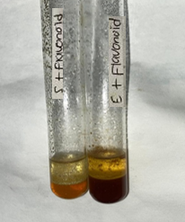
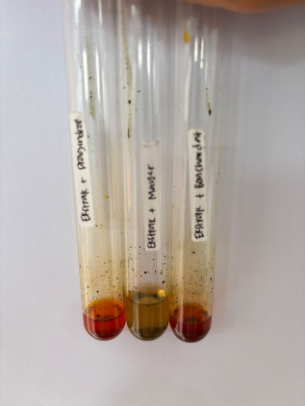
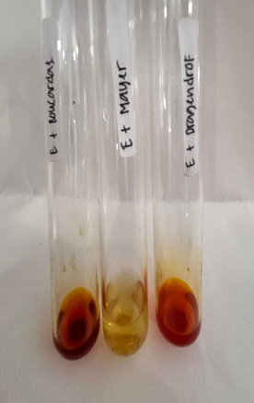
Flavonoid

Alkaloid (+)
Mayer (+), Bouchardat (+), Dragendroff (+)
+

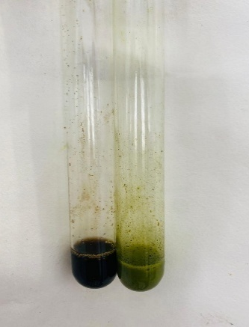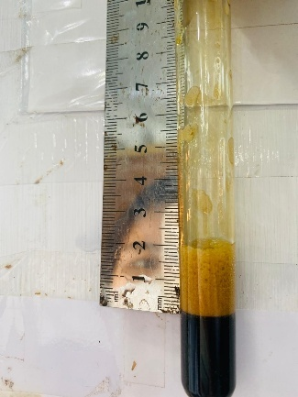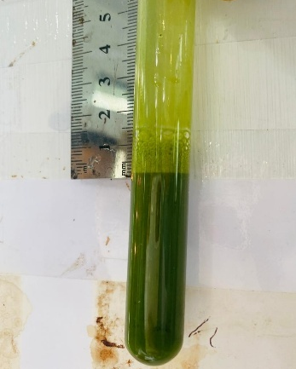
Tanin (+)

Saponin Ekstrak (+)

Saponin Serbuk (+)

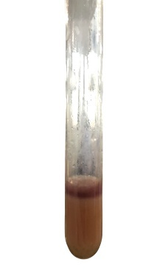
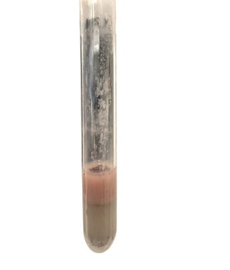
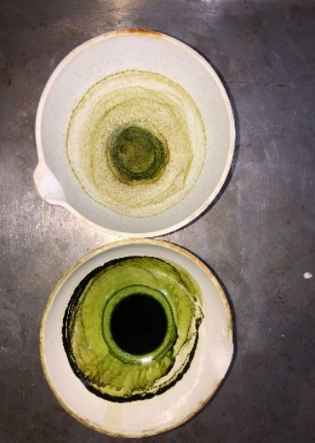
Glikosida (+)

Steroid (+)

Lampiran14DokumentasiKadarAir,KadarSariLarutDalamAir,KadarSari
LarutEtanol,KadarAbuTotal,KadarAbuTidakLarutAsam

PenetapanKadarAir

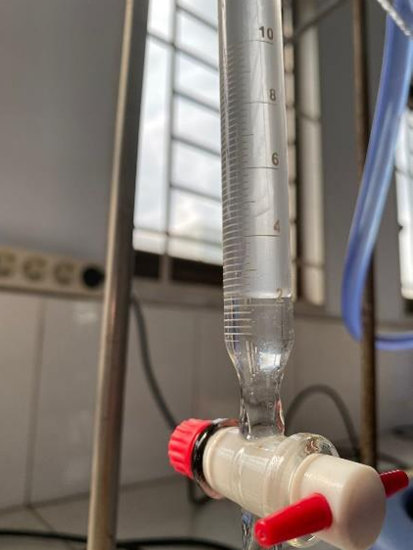
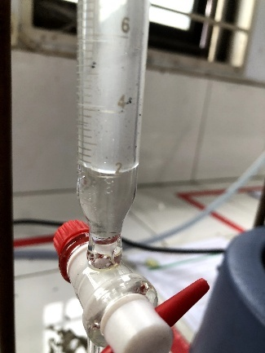
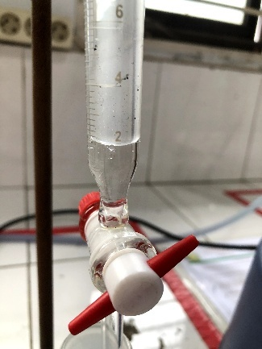

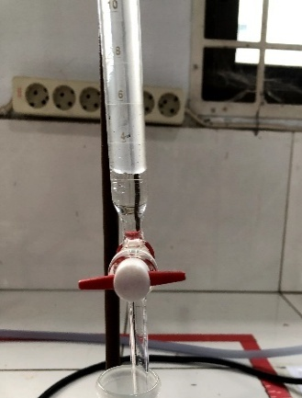

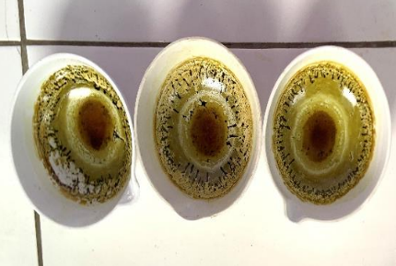
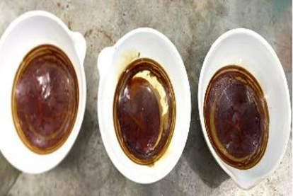

Kadar Sari Larut Air
Kadar Sari Larut Etanol

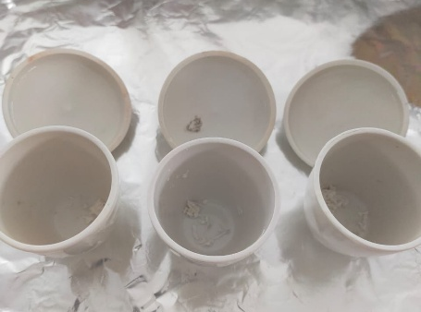
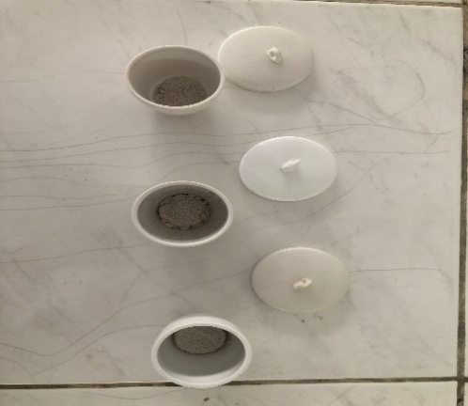

Kadar abu tidak larut asam
Kadar abu total

Lampiran15DokumentasiHasilPenetapanKadarNikotinpadaTitrasi
Asidimetri

Ekstrak Serbuk
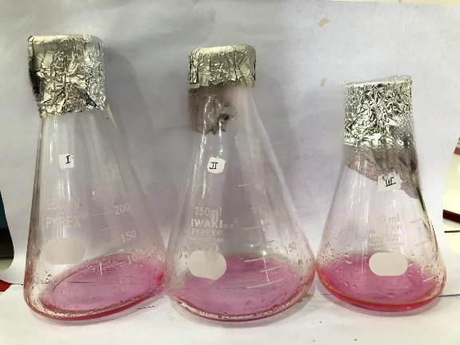
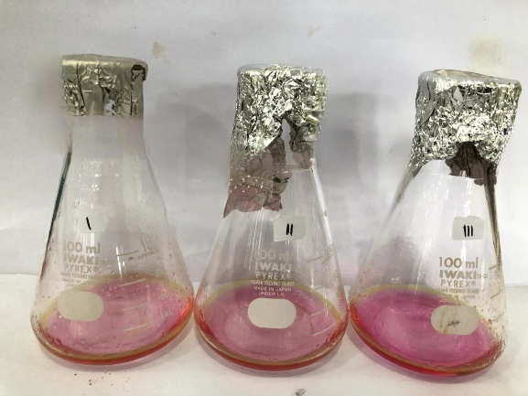

StandarisasiHCl
Blanko BakuNikotin DenganBoraks
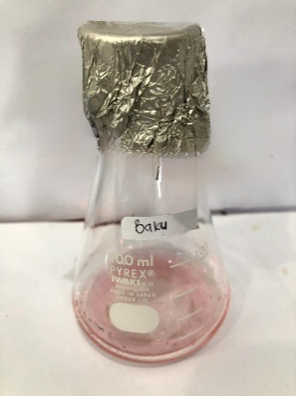
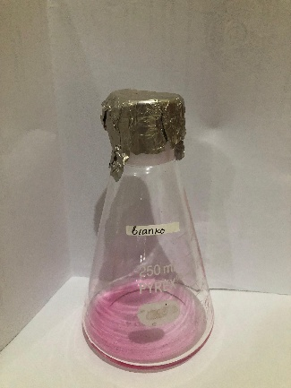
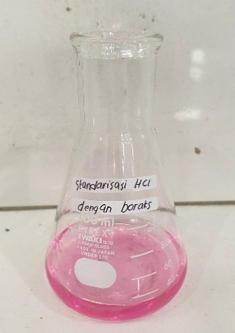

Lampiran16DokumentasiAnalisisNikotinMenggunakanAlatGCMS

AlatGCMS BakuNikotin
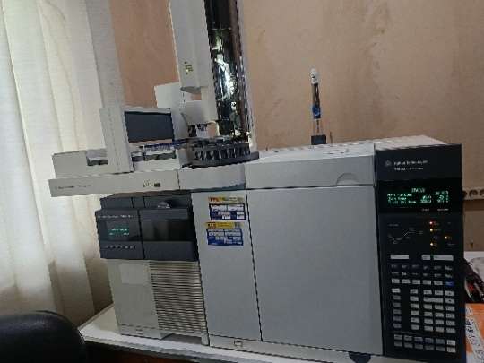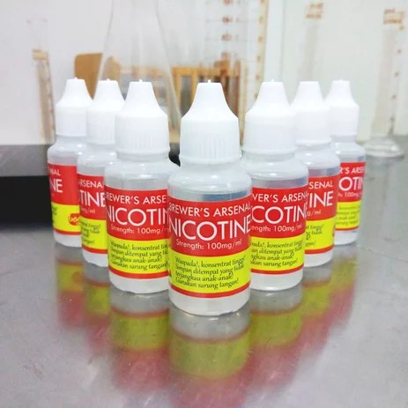

PengenceranNikotin
(1ppm,2ppm,3ppm,4ppm,5ppm,6ppm)
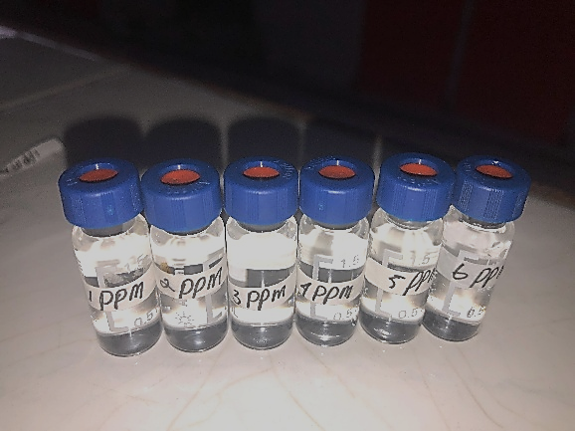

Lampiran17HasilUjiGCMS(GasCromatography-MassSpectrometry)

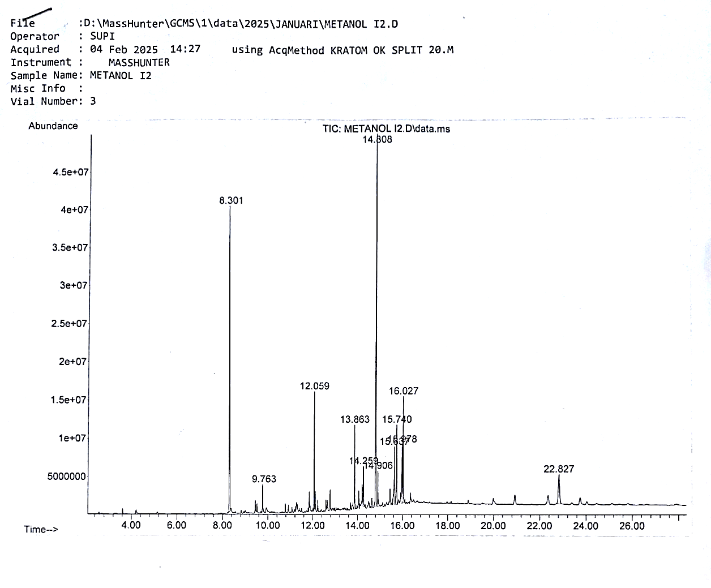
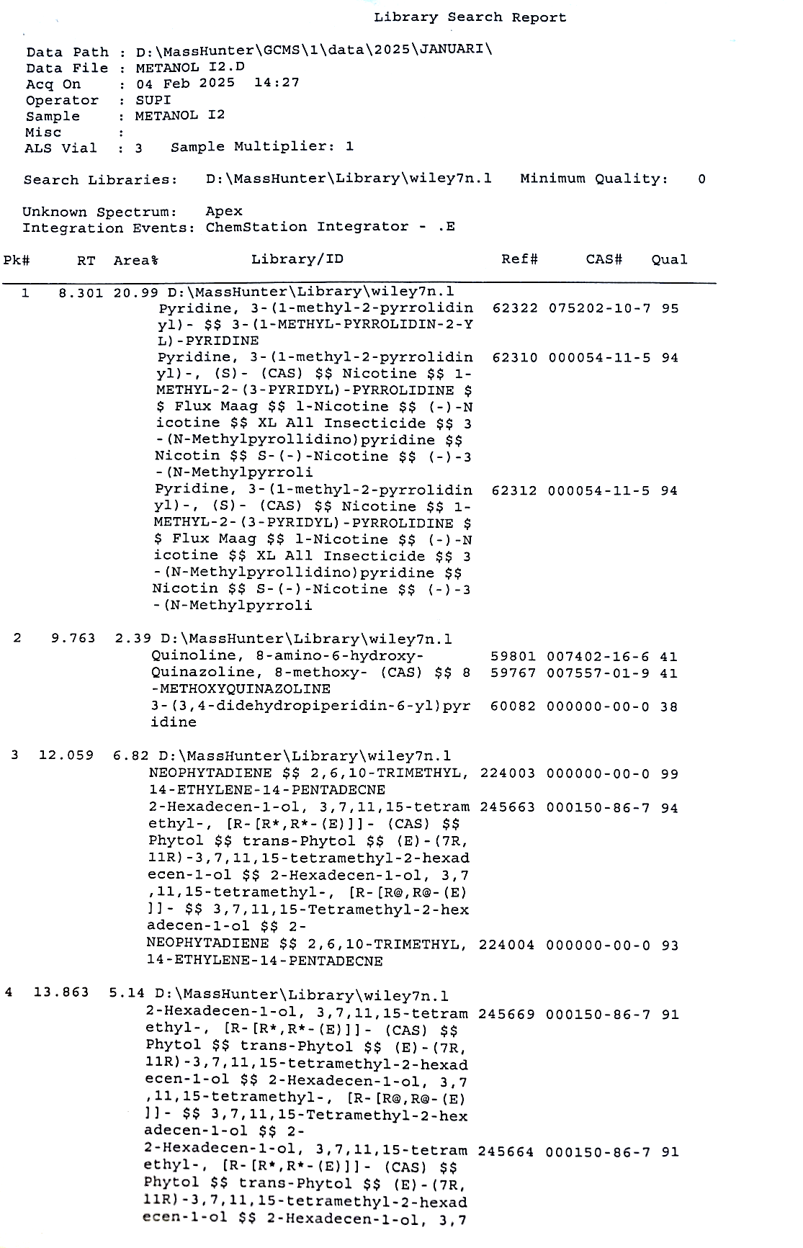

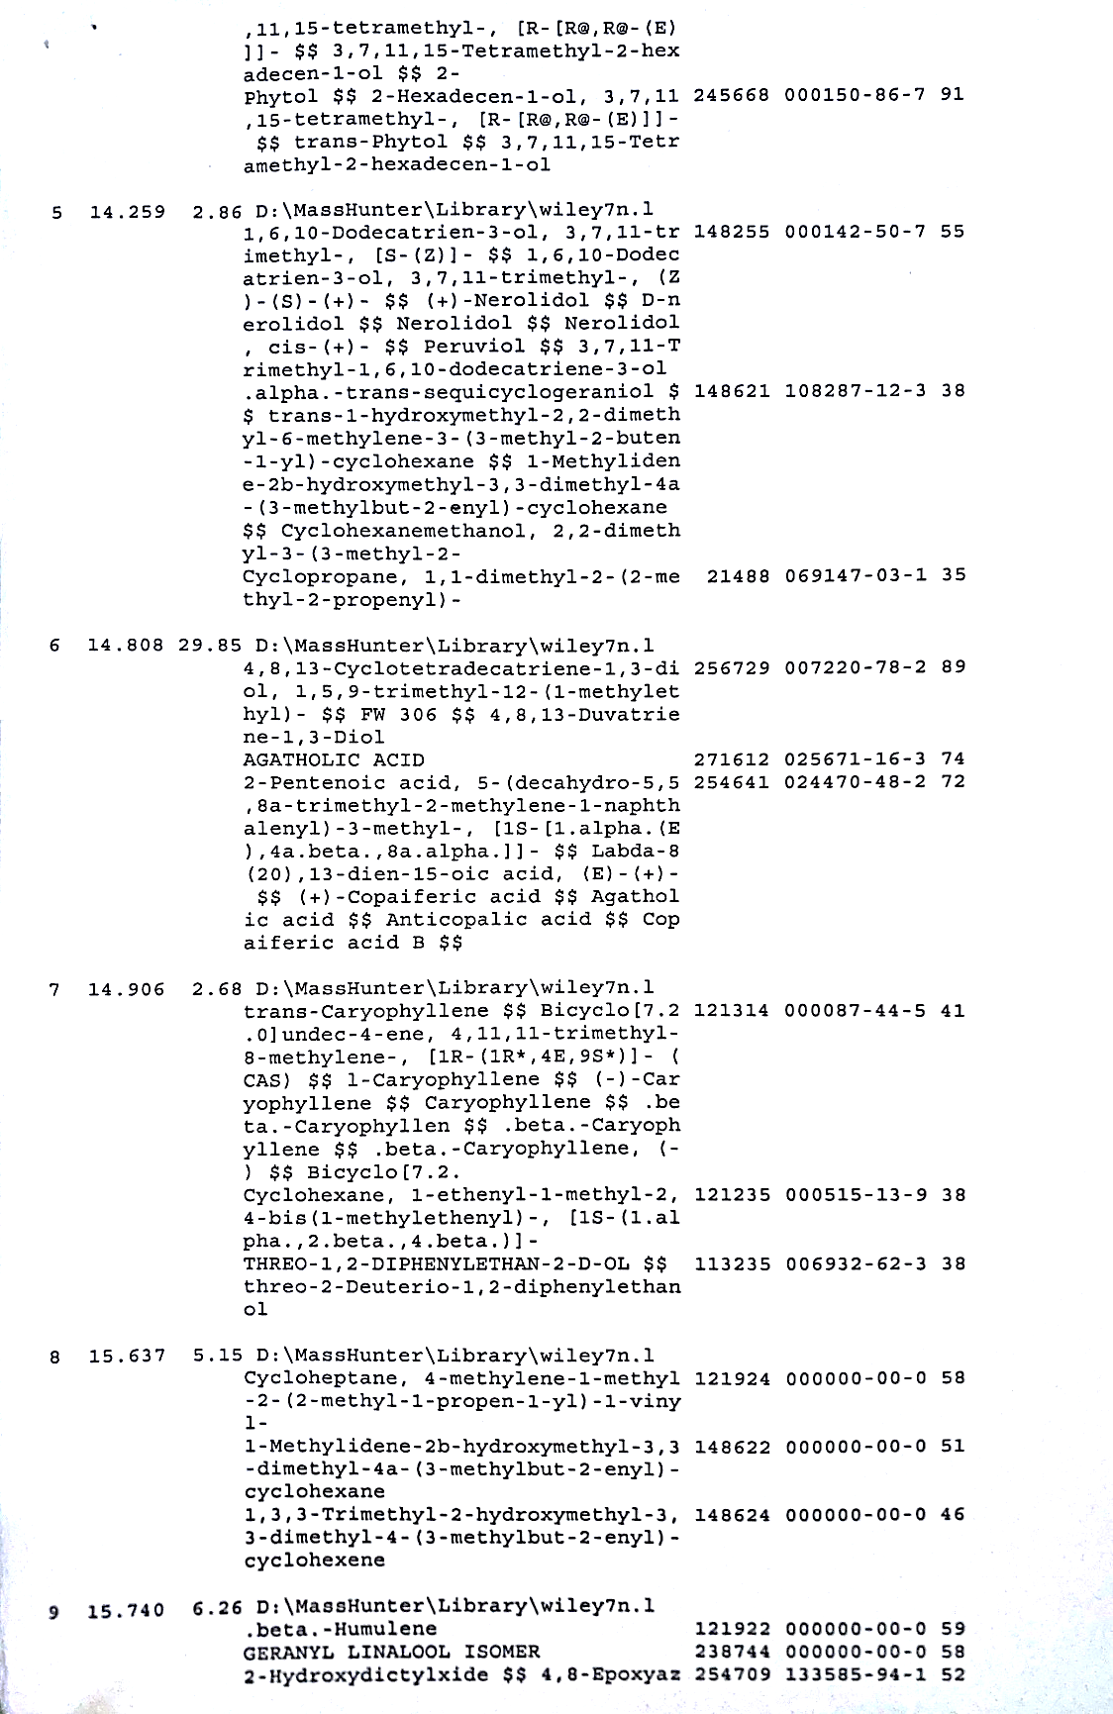

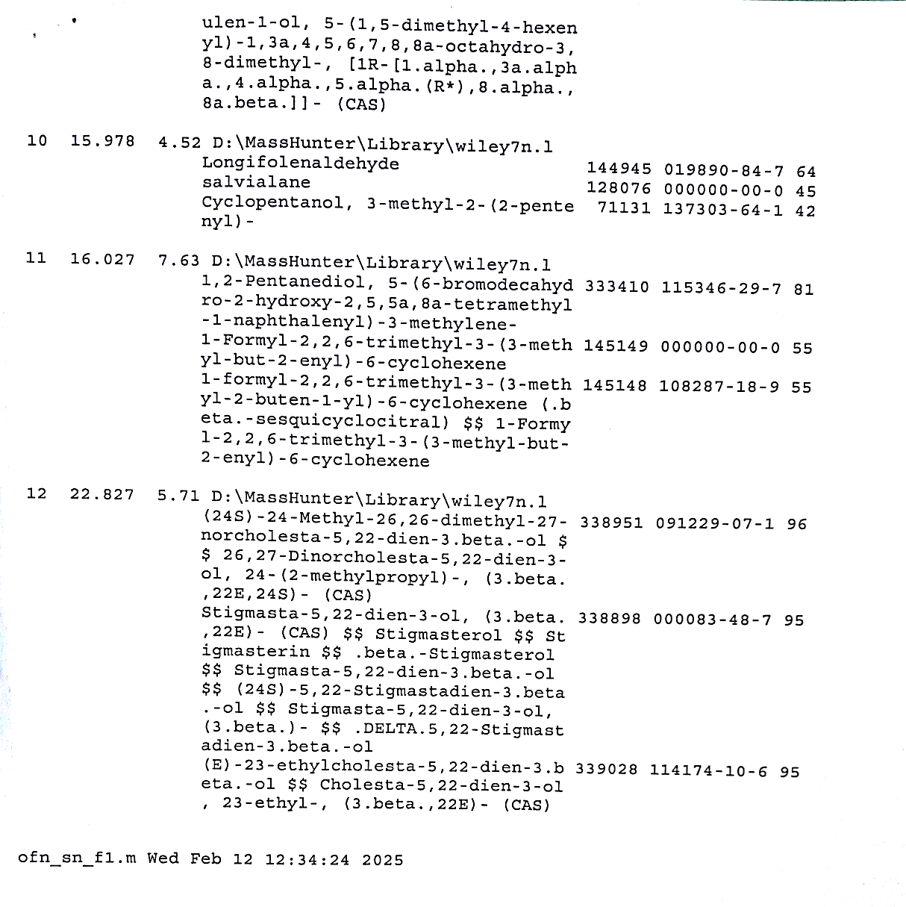

Lampiran18HasilPengamatanAktivitasAntibakteri

- Streptococcuspyogenes
P1 P2
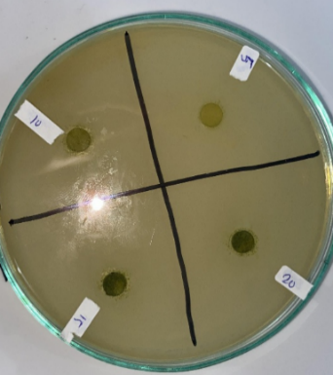
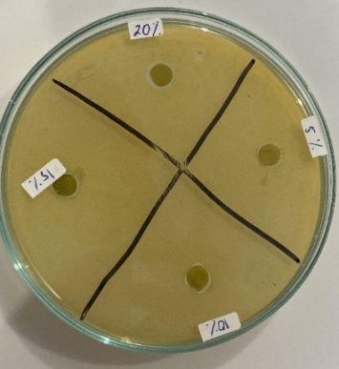
P3
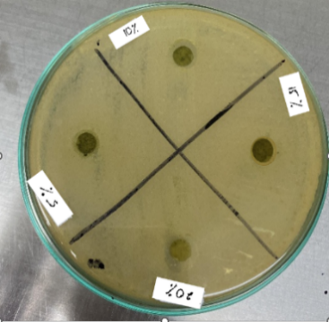

P1P2
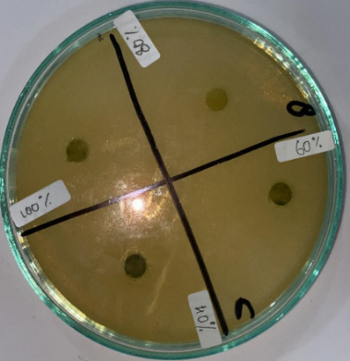
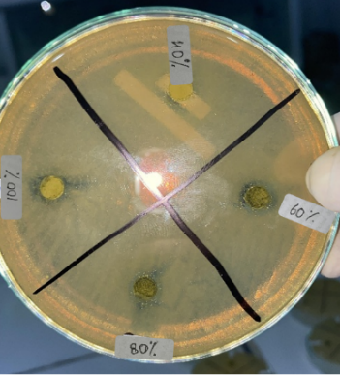

P3
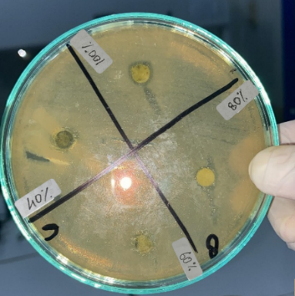

Kontrol(+)dan(-)
P1 P2
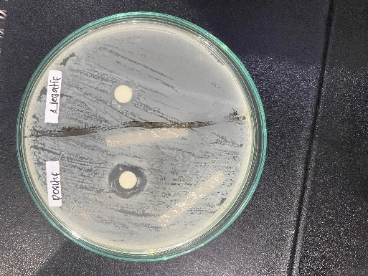
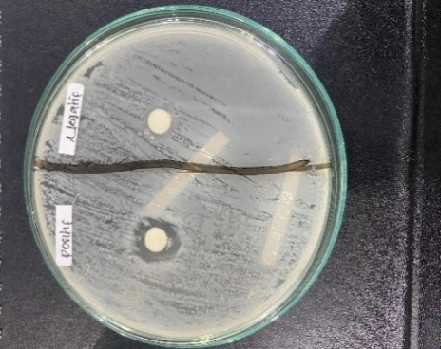

P3
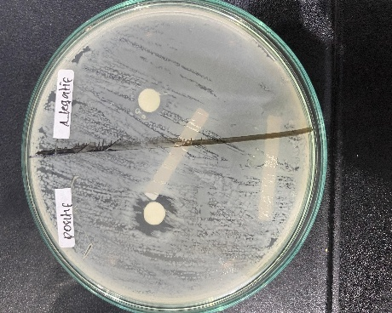

Keterangan:
P1 =Pengulangan1
P2 =Pengulangan2
P3 =Pengulangan3
Kontrol(+)=PenisilinG
Kontrol(-)=DMSO

- Klebsiellapneumoniae
P1 P2
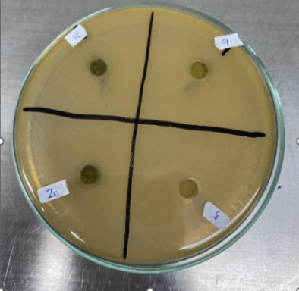
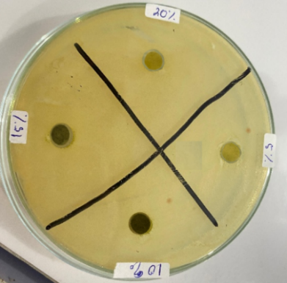
P3
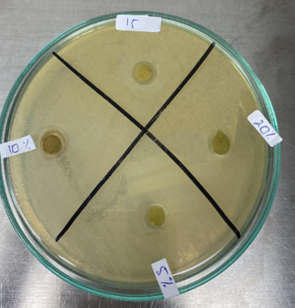

P1 P2
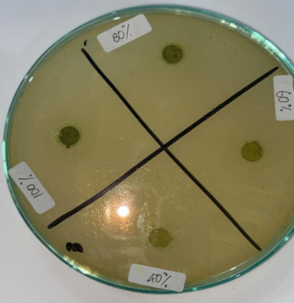
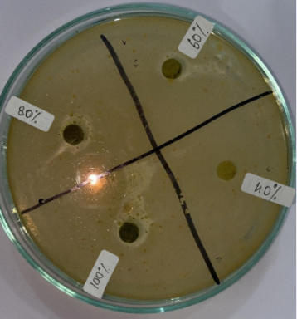

P3
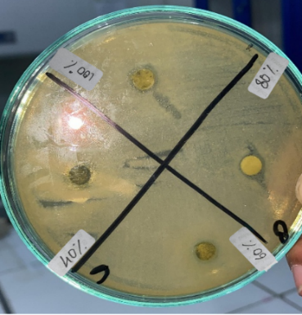

Kontrol(+)dan(-)
P1 P2
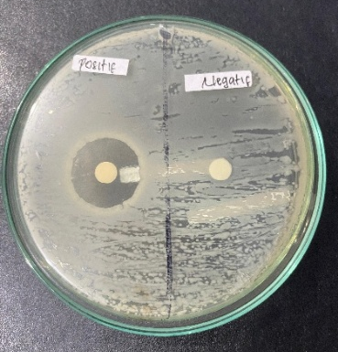
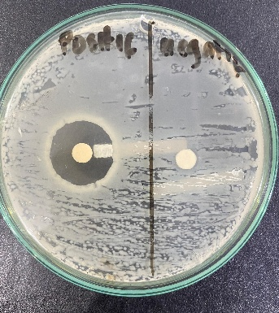

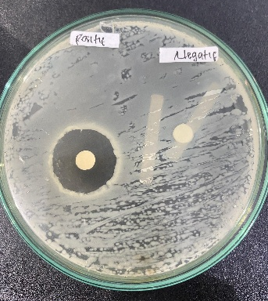
P3

Keterangan:
P1 =Pengulangan1
P2 =Pengulangan2
P3 =Pengulangan3
Kontrol(+)=Ceftriaxon
Kontrol(-)=DMSO

Lampiran19HasilAnalisisData
- Streptococcuspyogenes

UjiNormalitasKolmogorov-SmirnovbakteriStreptococcuspyogenes
One-SampleKolmogorov-SmirnovTest
 |  | UnstandardizedResidual
N |  | 18
NormalParameter^{a,b} | Mean | 0,0000000
NormalParameter^{a,b} | Std.Deviaton | 2,48180209
MostExtremeDifferences | Absolute | 0,154
MostExtremeDifferences | Positive | 0,130
MostExtremeDifferences | Negative | -0,154
TestStatistics |  | 0,154
Asymp.Sig.(2-tailed) |  | 0,200^{c,d}
- TestdistributionisNormal.
- Calculatedfromdata.
- LillieforsSignificanceCorrection.
- Thisisalowerboundofthetruesignificance

UjiHomogenitasbakteriStreptococcuspyogenes
TestofHomogeneityofVariances
AktivitasAntibakteri | LeveneStatistic | df1 | df2 | Sig.
BasedonMean | 2,681 | 5 | 12 | 0,075

UjiANOVAbakteriStreptococcuspyogenes
ANOVA
DiameterZonaHambat
 | SumofSquares | df | MeanSquare | F | Sig.
BetweenGroups | 254,046 | 5 | 50,809 | 75,103 | 0,000
WithinGroups | 8,118 | 12 | 0,677
Total | 262,164 | 17

Ujilanjutan(PostHocTest)bakteriStreptococcuspyogenes
DiameterZonaHambat
Duncanª
Perlakuan | N | Subsetforalpha=0,05
Perlakuan | N | 1 | 2 | 3
KontrolnegatifDMSO | 3 | 0,0000
Konsentrasi5% | 3 |  | 6,1833
Konsentrasi10% | 3 |  | 7,1333
Konsentrasi15% | 3 |  | 7,4167
Konsentrasi20% | 3 |  | 7,5667
KontrolpositifPenisilin | 3 |  |  | 12,8833
Sig. |  | 1,000 | 0,080 | 1,000
Meansforgroupsinhomogeneoussubsetsaredisplayed.
- UsesHarmonicMeanSampleSize=3,000

- Klebsiellapneumoniae

UjiNormalitasKolmogorov-SmirnovbakteriKlebsiellapneumoniae
One-SampleKolmogorov-SmirnovTest
 |  | UnstandardizedResidual
N |  | 18
NormalParameter^{a,b} | Mean | 0,0000000
NormalParameter^{a,b} | Std.Deviaton | 4,29488215
MostExtremeDifferences | Absolute | 0,124
MostExtremeDifferences | Positive | 0,096
MostExtremeDifferences | Negative | -0,124
TestStatistics |  | 0,124
Asymp.Sig.(2-tailed) |  | 0,200^{c,d}
- TestdistributionisNormal.
- Calculatedfromdata.
- LillieforsSignificanceCorrection.
- Thisisalowerboundofthetruesignificance.

UjiHomogenitasbakteriKlebsiellapneumoniae
TestofHomogeneityofVariances
LeveneStatistic | df1 | df2 | Sig.
1,714 | 5 | 12 | 0,206

UjiANOVAbakteriKlebsiellapneumoniae
ANOVA
DiameterZonaHambat
 | SumofSquares | df | MeanSquare | F | Sig.
BetweenGroups | 742,869 | 5 | 148,574 | 251,314 | 0,000
WithinGroups | 7,094 | 12 | 0,591
Total | 749,964 | 17

Ujilanjutan(PostHocTest)bakteriKlebsiellapneumoniae
DiameterZonaHambat
Duncanª
Perlakuan | N | Subsetforalpha=0,05
Perlakuan | N | 1 | 2 | 3 | 4
KontrolnegatifDMSO | 3 | 0,0000
Konsentrasi5% | 3 |  | 6,0000
Konsentrasi10% | 3 |  |  | 7,0167
Konsentrasi15% | 3 |  |  | 7,3333
Konsentrasi20% | 3 |  |  | 7,9433
KontrolpositifSeftriaxon | 3 |  |  |  | 21,3667
Sig. |  | 1,000 | 0,065 | 0,185 | 1,000
Meansforgroupsinhomogeneoussubsetsaredisplayed.
- UsesHarmonicMeanSampleSize=3,000

