DEVELOPING EFL STUDENTS’ SPEAKING MATERIALS BASED ON PROJECT BASED LEARNING

THESIS

By:

IRHAS AZMI
Registration Number.237215003

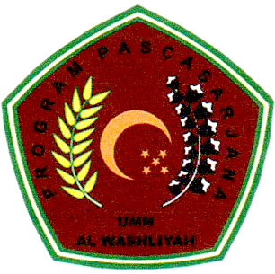

ENGLISH EDUCATION DEPARTMENT
POSTGRADUATION PROGRAM
UNIVERSITAS MUSLIM NUSANTARA AL WASHLIYAH
MEDAN
2025

DEVELOPING EFL STUDENTS’ SPEAKING MATERIALS BASED ON PROJECT BASED LEARNING

THESIS

To Obtain a Master Degree in English Education (M.Pd)
in the Postgraduate Master Program in English Language education (S2) Universitas Muslim Nusantara Al-Washliyah

By:

IRHAS AZMI
Registration Number. 237215003

ENGLISH EDUCATION DEPARTMENT
POSTGRADUATION PROGRAM
UNIVERSITAS MUSLIM NUSANTARA AL WASHLIYAH
MEDAN
2025
