DEVELOPING EFL STUDENTS’ SPEAKING MATERIALS BASED ON PROJECT BASED LEARNING

THESIS

By:

IRHAS AZMI
Registration Number. 237215003



ENGLISH EDUCATION DEPARTMENT
POSTGRADUATION PROGRAM
UNIVERSITAS MUSLIM NUSANTARA AL WASHLIYAH
MEDAN
2025
]]DEVELOPING EFL STUDENTS’ SPEAKING MATERIALS BASED ON PROJECT BASED LEARNING

THESIS

To Obtain a Master Degree in English Education (M.Pd)
in the Postgraduate Master Program in English Language education (S2) Universitas Muslim Nusantara Al-Washliyah

By:

IRHAS AZMI
Registration Number. 237215003

ENGLISH EDUCATION DEPARTMENT
POSTGRADUATION PROGRAM
UNIVERSITAS MUSLIM NUSANTARA AL WASHLIYAH
MEDAN
2025
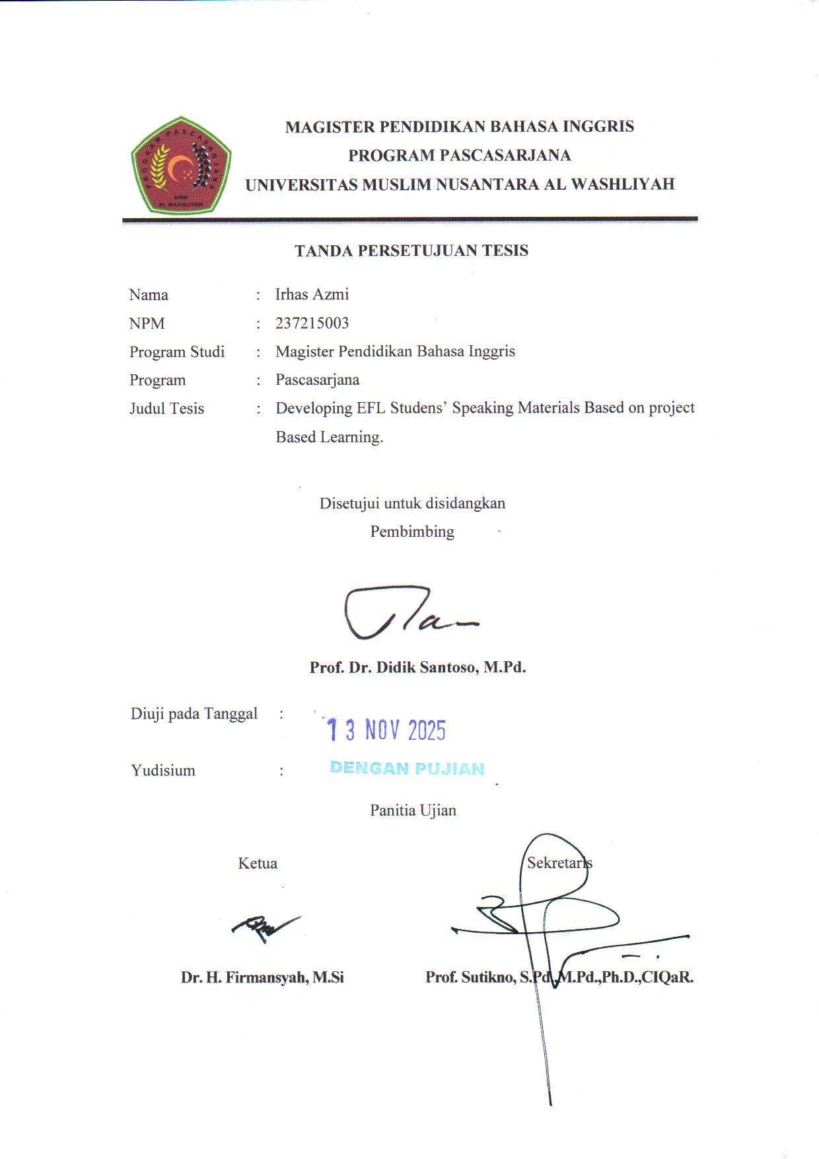

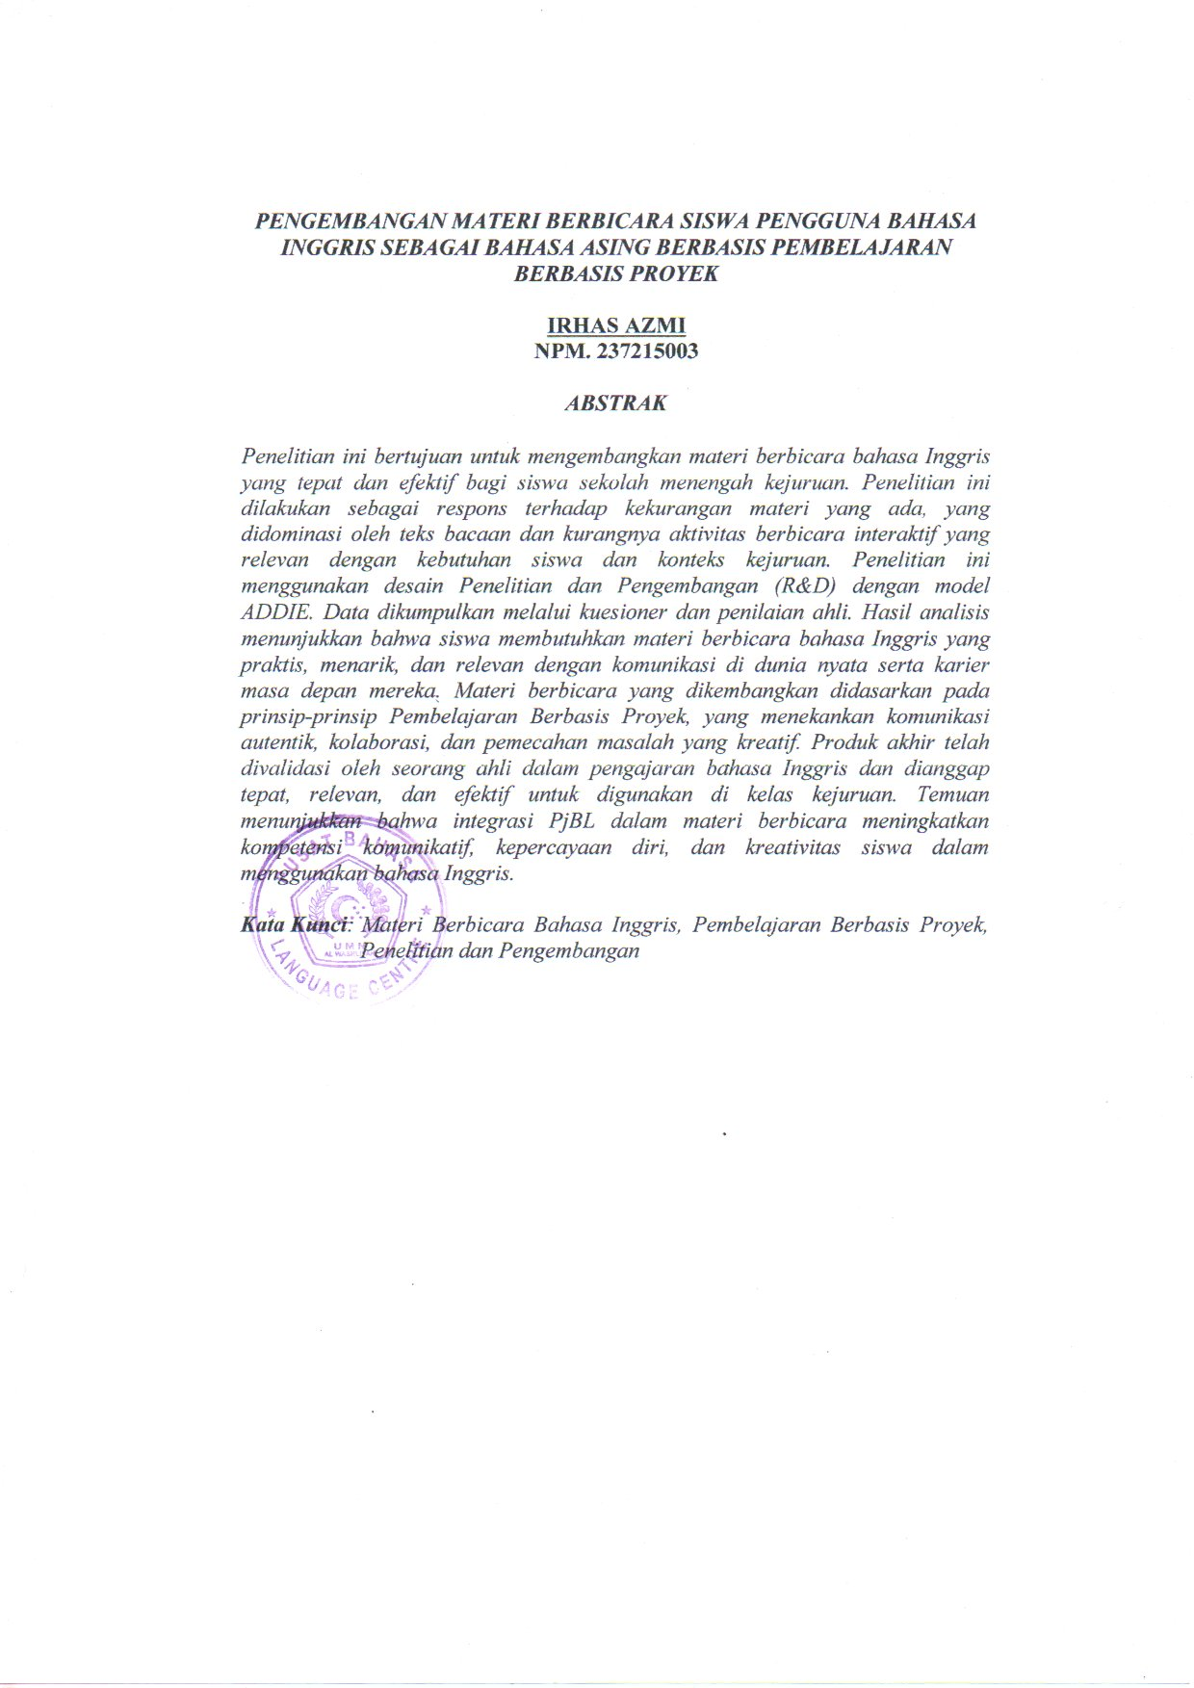
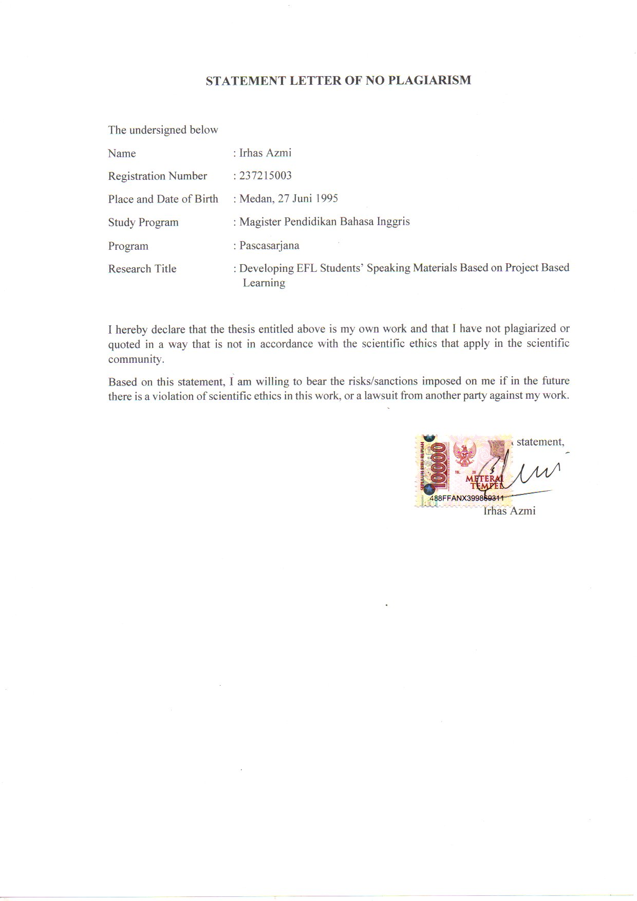
ABSTRACT

DEVELOPING EFL STUDENTS’ SPEAKING MATERIALS BASED ON PROJECT BASED LEARNING

By:

IRHAS AZMI

Registration Number. 237215003

This study aims to develop appropriate and effective English speaking materials for vocational high school students. The research was conducted in response to the inadequacy of existing materials, which were dominated by reading texts and lacked interactive speaking activities relevant to students’ needs and vocational contexts. The study employed the Research and Development (R&D) design using the ADDIE model. The data were collected through questionnaires and expert judgement. The analysis results revealed that students required English speaking materials that were practical, engaging, and relevant to real-life communication and their future careers. The developed speaking materials were based on the principles of Project Based Learning, emphasizing authentic communication, collaboration, and creative problem-solving. The final product was validated by an expert in English language teaching and was considered appropriate, relevant, and effective for use in vocational classrooms. The findings indicate that the integration of PjBL in speaking materials enhances students’ communicative competence, confidence and creativity in using English.

Keywords: English Speaking Materials, Project Based Learning, Material Development.

ACKNOWLEDEGMENTS

First of all, the greatest gratitude to Allah SWT, the Almighty God for the blessing which has been given to the researcher so that the researcher finally completed this thesis in partial fulfillment of the requirements for the degree of master of education, the University of Muslim Nusantara Al Washliyah Medan. This thesis could not have been accomplished without the guidances, suggetions, and comments from several people so that in this opportunity the researcher would like to express her deep gratitude to the following people:
- Prof. Sutikno, S.Pd.,M.Pd., P.h.D, the Directur of the Postgraduate Program of Muslim Nusantara Al Washliyah University.
- Prof Dr. DidikSantoso, M.Pd., the adviser who gave the command, critic and suggestion toward the researcher in finishing the proposal.
- Dr. Asnawi, M.Hum, the head of the English Education Department of Postgraduate Program of Muslim Nusantara Al Washliyah University.
- All of the lectures of the postgraduate program of English Education Department of Muslim Nusantara Al Washliyah University.
- All of the academic administration staffs of postgraduate program of Muslim Nusantara Al Washliyah University.
- Especially for beloved parents, Alm. Muhammad Abduh and Mira Ilham, who have inspired me and offered the prayer. Until the end of his life, his services will always be remembered
- For beloved future wife (Insya Allah), SebyAngella, S.Pd. who have given support and the sincere encouragement to the author to finish his study in the postgraduate program.
- And I will not forget to my best friends who always support me especially Muhammad Ridwan, RizqySunarty, RizkaRahmadini, ZaharaSafitri, Indah Daulay, and TasyaSwary.
Finally, the researcher realized that this thesis was far from being perfect. Therefore, constructive suggestion was needed for the researcher to continue the reasearch.
Medan, 07 November 2025
The researcher

IrhasAzmi

TABLE OF CONTENTS
LETTER OF APPROVAL
STATEMENT OF NO PLAGIARISM
ABSTRACT………………………………………………………………… i
ABSTRAK………………………………………………………………….. ii
ACKNOWLEDGEMENT………………………………………………… iii
TABLE OF CONTENTS………………………………………………….. v
CHAPTER I INTRODUCTION 1
  - Background of the Research 1
  - Identification of the Problem 3
  - Problems Limitation 3
  - Formulation of the Problems 3
  - Purpose of the Research 4
  - Significances of the Research 4
CHAPTER II LITERATURE REVIEW 6
A. English Speaking Materials 6
B. Project-Based Learning 14
1.Definition of Project-based Learning 14
2.The Principles of the Project-Based Learning 16
3.Design ofProject-basedLearning 18
4. ProcedureProject-BasedLearning 19
5.Advantages of Project-based Learning 21
6.Disadvantages of Project Based Learning 22
C. Relevant Studies 24
CHAPTER III RESEARCH METHODOLOGY 26
A. Time and Place of the Study 26
B. Data and Data Source 26
C. Research Method 27
D. Technique of Collecting Data 29
E. Data Analysis 30
F. Data Validation 32
CHAPTER IV RESEARCH FINDING 33
A. Analyzing Existing Speaking Materials 33
B. Students’ Needs of English Speaking Materials 43
C. Speaking Materials Based on PjBL 47
CHAPTER V CONCLUSION 51
A. Conclusion 53
REFERENCES 53
APPENDIX

CHAPTER I
INTRODUCTION

- Background of the Research
English as a Foreign Language (EFL) speaking materials has significant role in enhancing the students’ skills because it can increase language proficiency, builds confidence, and improve their communication skills. Therefore, the material is given to the students should be appropriate to students’ needs. It is used to enable students to increase their knowledge and their English skills. And also it helps teachers in preparing subject matter and guide students in learning. As stated by Cunningsworth in Richards (2002) that the roles of materials in language teaching are: as a resource of activities for learners to practice and communicative interaction, a reference source for the learner on grammar, vocabulary, pronunciation, and so son, and as a source of stimulation and ideas for classroom activities.
Moreover, EFL speaking materials must facilitate effectively and meaningfully students’ needs, and target situations need in learning English language skills, especially for speaking skills. EFL Speaking skill as the parameter of someone’s level of English proficiency, is a skill used to express though, opinions, and feeling in terms of talk of conversation. For these competencies, EFL speaking materials should have sufficient knowledge of the sound, structure, vocabulary, and cultural system of theEnglish language.
However is reality, the students’ speaking materials used by the teacher nowadays still not suitable yet, the fact shows that the researcher found several weaknesses and deficiencies found in the materials, such usthe content of the book which are not relevant to PjBL. For example, in the book, there is too much texts rather than exercises, so the students are quite stunted in their ability. Because of it, the students’ creativity is also stunted, in the end their English speaking skills are also stunted. So, the teacher sometimesdecides to use the other textbook or additional sources.
To solve the problem of EFL speaking materials, the researcher would to implement Project Based Learning (PjBL). PjBL is one of the methods recommended to be applied. PjBL allows “students to design, plan, and carry out an extended project that produces a publicly exhitedouput such as a product, publication, or presentarion” (Patton, 2012).Through PjBL, learners engage in purposeful communication to accomplish genuine activities (project work), thereby providing them the opportunity to practice and utilize authentic language in a natural context (Fragoulis, 2009).Also, Fauziati (2014) mentioned that PjBL permits students to participate in projects that provide opportunities to learn and practice English while also fostering the development of essential skills, including teamwork, critical thinking, and presentation abilities.
Therefore, the researcher would like to conduct a study about development EFL speaking materials based on PjBL.Adopting PjBL in the learning materials can lead to more effective and engaging language learning skills for the students. By engaging students in the projects that needlanguage use, PjBL fosters students’ active learning, collaboration, and real-time application of language skills.
- Identification of the Problem
In teaching English, there are some component to be prepared: formulating learning goal, planning, implementing and evaluating. In planning, the teacher should determine student competency, selecting strategy, choosing relevant media, including learning materials. In this case, the researcher would to develop English speaking materials that suitable for the students. S/he will focus on aligning learning materials with students need. The researcher hopes to enhance the quality of students’ speaking skill.
- Problems Limitation
Based on the consideration that has been identified, the researcherfocuses on the English speaking materials. The reason for this limitation is because the materials still not suitable for the students which is PjBL.
- Formulation of the Study
Based on the background above, there are some questions to be raised as the problem of this analysis, they are:
  - How are the existing speaking materials used today by the students’?
  - What academic speaking materials are needed by the students of?
  - How are the academic speaking materials for the students developed based on the project-based learning approach?

- Purpose of the Research
In line with the formulation of the problem above, the purpose of this research is:
1. To describe the existing of speaking materials by the students.
2. To analyze academic speaking materials are needed by the students.
3. To develop EFL students’ speaking materials through Project Based Learning Method.
- Significance of the Research
The results of the research entitled “Developing EFL Students’ Speaking Materials through Project Based Learning” are expected to benefit:
- Theoretical Significance
This research gives a solution to finding out EFL Students’ Speaking through Project Based Learning.
- Practical Significance
      - For Students
- Students are expected to be more interested in English, especially be able to English speaking.
- Students are expected to be more active in improving their mastery of learning English vocabulary through the process of learning it using Project Based Learning related to improving their English-speaking materials.
      - For English Teacher
- Teacher can use the materials that suitable for the students.
- Teacher can increase the effectiveness of learning English-speaking material.
      - For the School
  - The School can use the EFL speaking material as alternate version.
  - The school can improve the quality of learning materials so that students can achieve improvement to speak English

CHAPTER II
LITERATURE REVIEW
- English Speaking Materials
When we are talking about English speaking, then we will not able to separate from the material, because the material as a place to implement English speaking itself. Brown (1995) defined learning materials as any systematic description of the activities and instructional approaches to be used in a classroom setting. Materials include well-organized methods to make teaching and evaluating easier for teachers. It means that materials are organized tools or plans that describe what activities and teaching methods will be used in the class. They help make teaching smoother and help teachers check how well students are learning.
According to Tomlinson (2012), learning materials are any tools that can be used to speed up language acquisition. Examples include text books, films, graded readers, flashcards, games, and websites. Materials can serve a variety of purposes for language learners, including educating them about the target language, assisting them in speaking it, giving them firsthand experience of the language in use, eliciting their use of the language, and assisting them in making discoveries about the language. As a result, the process of creating and/or using resources for language learning is referred to as materials development. This process includes the evaluation, adaptation, design, exploitation, and study of the materials.
The existence of instructional materials is crucial to the learning process because they serve as intermediates between the ambiguous material offered and the student. The efficient use of time during the implementation of learning is also impacted by the usage of teaching materials (Lasmiyati&Harta, 2014). Teachers can create learning media in the form of lesson plans as on method of doing this. To generate effective and efficient learning, it is necessary to develop teaching materials for the learning process (Lukman&Ishartiwi, 2014).
As a resource of the activities and reference source of teaching activities, the material is given to the students should be appropriate to the related or focused competencies of the teaching. It is used to enable students to increase their knowledge and their English skills, namely, listening, reading, writing, and speaking. It is assumed that the more appropriate the material is given to the students, the higher the possibility of opportunity for students to increase their comptetence in English language skills.
Brown (2001) proposes five components of speaking materials: comprehension, fluency, pronunciation, vocabulary, and grammar.
  - Comprehension
In speaking materials, understanding is needed so that students who perform a conversation understand the meaning of what they are talking about, this will facilitate communication. Based on this, the teachers should pay attention to assessing the level of understanding of the students in their speaking ability.
  - Fluency
According to the latest dictionary of the Indonesian language (2008) “Fluency is driving fast or moving forward quickly”. In this context, the students’ fluency in speaking is not only focused on how student produce language fluently or smoothly, but students also need to consider the appropriateness of what they want to speak, or in other words, it is accuracy. According to Budiwanto (2012), accuracy or precision is a person’s ability to direct a motion to a target per the goal or make a movement without making a mistake.
  - Pronunciation
Pronunciation is also very important in teaching speaking skills because with good pronunciation, the listener will easily understand what is being said. Pronunciation is the study of the technique or procedure of pronunciation English vocabulary, so it is very important to pronounce vocabulary well and correctly in communication. Otherwise, other people will be confused about what you mean, which in turn leads to misunderstandings.
  - Vocabulary
Speaking skills which is a productive skill require a person to have a good vocabulary. The more vocabulary on has, the easier it is to form a sentence, while vocabulary itself is vocabulary is the set of words known by a person or is part of particular language.
Fajriyah (Inayatul, 2013) explained that vocabulary is one of the components of English that has an important role in understanding reading and expressing all ideas in writing or pronunciation. Students can obtain vocabulary from dictionaries, glossaries at the back of English books and others. Vocabulary will always be in the student’s mind if the student always uses it and will disappear if the student does not use it. Due to the large list of words, the way of learning is important to make students master vocabulary. Teachers should choose the right way to teach.
  - Grammar
Grammar focuses on standard of English such as spelling, punctuation, and vocabulary. When dealing with speakers, sometimes grammar seeing is ignored especially by people who are not native speakers. Grammar is needed to be able to speak well meaningfully. All these components of speaking materials; pronunciation, grammar, vocabulary, fluency, and comprehension are the important and complementary components in the development of students’ speaking ability.
The statements above are strengthen by Tomlinson. He said Englishspeaking materials should fulfill the criteria, such as: (1) It should be providing a rich experience of different genres and text types, (2) It should be providing an aesthetically positive experience through the use of attractive illustration, design, and illustration, (3) It should be making use of multimedia resources to provide a rich and varied experience of language learning, (4) It should be providing supplementary materials which provide the learners, and (5) It should be helping the learners to personalize and localize their language learning experience.
Additionally, Tomlinson, cited by Farajnezhad recommended 5 ways to guide how speaking materials can be developed for speaking skills: (1) conceptualizing learner needs, (2) identifying subject matter and commu- nication situations, (3) identifying verbal communication strategies, (4) utilizing verbal sources from real life, and (5) designing skill-acquiring activities.
- Conceptualizing learner needs
Materials design start from who learners are to link language study to learners’ future and to their present receptivity. It is important to look at both subjective need and objective needs in the learner. The subjective needs include such areas as learners’ speaking proficiency and difficulties, all of which will help the teacher decide what to teach. The objective needs include such aspects as personality, learning styles, cultural preferences and expectations of the course, all of which will help the teacher decide how to teach. Seeking to know learner needs does not mean describing learners but it means involving learners in the process of developing materials and giving them a voice in their materials.
- Identifying subject matter and communication situations
Knowledge about learners needs will act as the basis on which experiential content is selected for instructional materials. It is important to explore the context of such environments and for some idea of what skills their social need of a speaker. The more learners say their needs, more the subject matter can be set towards the right sets of topics, situations, functions, strategies, registers, and key structures.
- Identifying verbal communication strategies
Conversational strategies must be included in speaking materials because they are essential tools to serve the communication of mearning. It is essential to build into materials many practical devices that can help facilitate oral production and overcome communication difficulties arising under time pressure. 5 of them: (1) using less complex syntax, (2) making do with short phrases and incomplete sentences, (3) using fixed conversational phrases, (4) adding filler words to gain time to speak, and (5) correcting or improving what one has already said. These technique help materials designer become more aware of what is the normal process of speech production.
- Utilizing verbal sources from real life
To modify materials, besides printed sources such as magazine articles or picture, course developers can use many verbal interactions taken from real and in the classroom. One method for practical teaching ideas is by taping learners peer group interaction in the target language and analyzing it.

- Designing skill-acquiring activities
Once communication content is outlined and its components are selected, the strong step is to create relevant tasks that help learners in three essential aspects: to acquire a new language, to learn rules of interaction and to experience of meanings;
To acquire a new language, learners should be helped to internalize a new language before making it becomes available to discuss topics. It includes helping learners to self-discover form and function. The language must be pushed further into an experiential process such as small tasks. For example of tasks: ranking exercises, brainstorming for keywords and expressions, generating ideas around the topic and so on.
To communicate properly, we must understand not only grammar and vocabulary but also cultural context. This model can be used for identifying and classifying interactional linguistics elements. It was inspired by his belief that, in addition to understanding the vocabulary and grammar of a language, one needs to know the context in which utterances are used.
Hymes devised the mnemonic S-P-E-A-K-I-N-G to aid in the application of his representation into setting and scene, participant, ends, acts sequence, key, instrmentalities, norms, and genre.(1)Setting describes the period of time, while place is related to the location and timing of the dialogue. While scene is “psychological setting” or “cultural definition” such as aspects such as formality range and emotions of play or seriousness (Hymes: 55-56), like the formal or casual dialogue and the sense of the dialogue.(2)Participant is a person who participates in a discussion as a speaker, listener, addressee, sender, or receiver. As the speech continues on, their role can change. (3)End is the outcome of the conversation’s goal, including the participant’s purpose. Inappropriate language use will keep the speaker from achieving their objectives.(4)Act sequence refers to the steps involved in performing a speech, as well as the content and form of the communication demonstrated in the event of the utterance.(5)Key means to represent the intonation of a conversation, like a slow pattern, quickly, or in a hurry.(6)Instrumentalitiesis an instrument or channel for communication that is used in face-to-face interactions involving oral or verbal communication.(7)Norms is the rules that govern conversation and its interpretation, Norms that apply in each location are referred to as the norm in this context.(8)Genre is a style or classification of a conversation’s contents, such as proverbs, apologies, prayers, small talk, problem talk, information or so on.
Based on the theory aboveit can be concluded that speaking material is the systemic description of activities and instructional approaches in a classroom. It includes well-organized methods to make teaching and evaluating easier for teachers. It means that materials are organized tools or plans that describe what activities and teaching methods will be used in the class. The teachers can create materials to generate and efficient learning. The materials given to the students should appropriate to their related competencies, enabling them to improve their English language skills. Speaking materials have five components, such as pronunciation, grammar, vocabulary, fluency, and comprehension. And also speaking materials should fulfill the criteria, such as (1) It should be providing a rich experience of different genres and text types, (2) It should be providing an aesthetically positive experience through the use of attractive illustration, design, and illustration, (3) It should be making use of multimedia resources to provide a rich and varied experience of language learning, (4) It should be providing supplementary materials which provide the learners, and (5) It should be helping the learners to personalize and localize their language learning experience.
Additionally, speaking materials play a vital role in supporting speaking skill development by providing structured, interactive, and meaningful learning experiences. These materials help facilitate language acquisition and enhance the teaching and evaluation process, making them essential tools in the language learning classroom.
- Project-Based Learning
- Definition of Project-Based Learning
Mulyasa (2014) says Project-Based Learning or PjBL is model learning which aims to focus participants’ education on the problem complex needed in do investigate and understanding lessons through investigation. This model also aims to guide the participant to educate in a project collaborative that integrated a variety of curriculum subjects (materials), provide opportunities to participant educate for dig content (material) with use various method meaning for himself, and experiment in a manner collaborative.
Daryanto and Raharjo (2012) define Project-based Learning is a learning model that uses a problems as the first step in gathering and integrating new knowledge based on experience and activity in a manner. PjBL is designed for use on complex problems that require participants educate in doing an investigation and understand it.
Then,Sugihartono (2015) revealed that project method is a learning method form of presentation to learners material lessons that start from a problem which is then discussed from various relevant sides so that a thorough solution is obtained and meaningful. This method allows students to analyze something problems from the perspective of students according to their interests and talents. Fathurrohman (2016) also says that a learning-based project is a learning model that uses projects/activities as a means of learning to achieve competence attitudes, knowledge, and skills. This learning is a substitute for still learning lectures centered. The emphasis of this learning lies in the activities of the participants/education. Which on end learning can produce a product that can mean and useful.
Saefudin (2014) asserts that Project-based Learning is an educational approach that use problems as a foundational stage for acquiring and synthesizing new knowledge derived from real-life experiences. Project-based Learning accentuates contextual challenges encountered by students, fostering critical thinking and enhancing creativity through the creation of tangible products or services. According to Isriani (2015), a learning-based project is a form of learning that provides opportunities for lectures. For overseeing classroom learning through engaged labour projects.
Based on the above theory it can be concluded that Project Based Learning is a learning model student-centered, namely departing from a problem background, which then next with the investigation so participant educate obtain new experiences from real activities in the learning process and can produce something project for reach competence aspect, cognitive, and psychomotor. Result end from work project is something product which between other form report written or oral, presentation, or recommendation.
- The Principles of Project-Based Learning Model
According to Fathurrohman (2016) principle underlying learning project based is as follows:(a) Learning centered on participant education which involves tasks on real life for enriching lessons. (b) A task project says an activity study based on something theme or topic which has been determined in learning. (c) Investigations or experiments are carried out authentically to produce a product real which has been analyzed and developed based on a theme or topic arranged in the form of a product. (d) Curriculum. PjBL no like on curriculum traditional because needs a strategy where the target project is the center. (e) Responsibility. PjBL emphasizes the responsibility and answerability of the participants’ education to their role models. (f) Realism. Student activities are focused on similar work with situations which actually activity integrates task authenticity and produces a professional attitude. (g) Active learning. Growing issues lead to questions and the desire of learners to determine relevant answers so that happens independent learning process. (h) The bait comes back to the discussion. Presentation and evaluation to participant educate produce bait come back which valuable. Matter this push to direction learning based on experience. (i) General skills.PjBL is developed not only in skills tree and knowledge just but also has influence big to skills fundamental like solving the problem, workgroup, and self-management. (j) Driving questions. PjBL is focused on questions or problems that trigger students to solve problems with concepts, principles, and appropriate science. (k) Constructive investigation. Project-based learning (PjBL) should be customized with participant knowledge education. (l) Autonomy. Project make activity participant educate which is important. Blumenfeld describes a project-centered learning-based model on process relatively futures time, units learning to mean.
Based on the explanation above, it can be concluded that the principle of the PjBL learning model is this learning emphasizes that learning must be centered on students because this learning model uses problems that may be encountered in real life which already determined theme and the topic, then experiment or research so that can produce products real accordingly with ability participant educate them, so participant educate can finish problem with draft, principle, and knowledge appropriate, so that becomes more meaningful.
- Design of Project-Based Learning (PjBL)
According to Daryanto and Raharjo (2012), Model Learning Project-based Learning has design as follows: (a) Participants are educated to make decisions about framework work. (b) There is a problem or challenge filed to participant education. (c) Students design processes to determine solutions to problems or challenge filed. (d) Participants educate in a manner collaborative responsible for accessing and managing information to break problems. (e) Process evaluation run in a manner continuous. (f) Participants educate in a manner that periodically do a reflection on activities that are already run. (g) The final product activity study will evaluate in a manner qualitative. (h) Situational learning is very tolerant of error and change.
Based on the explanation, it can be concluded that lectures problems that must be solved by students, and then participant educate must design process and framework for make a solution to the problem. Students must work together to search for information and evaluate the result of their work so that the problem can be resolved, and that participant educated can produce products from the background behind the problem.
- Procedure of Project-Based Learning
Steps implementation model learning Project-based Learning according to Mulyasa (2014) is as follows: (a) Prepare questions or project assignments. This stage is a step early so that students observe more deeply on the questions asked appear from existing phenomenon. (b) Design planning project. As step real answer the questions that exist are drawn up a project plan can go through test. (c) Develop a schedule for the concrete steps of a project. Scheduling is very important that the project is carried out in accordance with the the agreed time available and in accordance with target. (d) Monitoring the activity and progress of the project. Participants teach and assess the project currently in progress.
Steps implementation model learning Project-Based Learning according to module Widiarso (2016) is as following:

Fundamenal question determination
Develop project planning
Compile timetable
Monitoring
Test results
Evaluate experience

Figure: Procedure of Project Based Learning.
Explanation procedure model Project-Based Learning is as following:(a) Fundamental question.Learning commences with fundamental inquiries, specifically questions that can assign tasks to students for engaging in activities. Assignment subjects are pertinent to the education of real-world participants. And commences with an in-depth investigation.(b) Develop project planning.Students are encouraged to take ownership of project planning, which includes role play and election activities that facilitate the answering of critical issues. Additionally, they should combine diverse subjects where feasible and be aware of the tools and materials available to assist in project resolution.(c) Compile timetable.Teachers and participants collaboratively develop a timetable for activities to complete the project. Stage activity occurring among others:Create a timetable for project completion, specifying allocation time. Establish a deadline for the project settlement. Bring participant educate plan method which new. Instruct participants when they employ methods unrelated to the project.Request participant to provide an explanation regarding the rationale behind the election.(d)Monitoringparticipants. Teachers are responsible for monitoring participants' activities during the completion of the project. Monitoring conducted through methods facilitates participant education on each step. Assume the role of a mentor for student activities in conjunction with other lectures. To facilitate the monitoring process, a rubric has been created to document the entire activity, which is essential.(e)Test Results.Assessment is conducted to aid instructors in measuring achievement standards, evaluating each participant's progress, providing feedback on the amount of comprehension attained by participants, and assisting instructors in formulating subsequent learning strategies.(f) Evaluate Experience.On end learning, teacher and participants engage in reflection on the activities and outcomes of completed projects. The reflection process was conducted well, both individually and collectively.
From the description indicates that Project-based Learning commences with inquiries that offer tasks to students for engagement in activities. Questions must pertain to issues that learners may encounter in real life. A small group was formed from the problem, tasked with designing the project plan and compiling the timetable to complete the project. Role lectures here are for monitoring participant education, assessing test outcomes, and evaluating participant performance.
- Advantagesof Project-Based Learning
According to Fathurrohman (2016) benefit learning based project are as follows:(a)Acquire novel knowledge and abilities through learning.(b)Enhance participants' competencies in problem-solving education.(c)Encourage participants to engage more actively in addressing complicated problems related to the tangible outcomes of products or services.(d)Enhance collaboration among participants to explicitly teach on the characteristics of Project-Based Learning (PjBL).(e)Participants are instructed to make decisions and implement the framework effectively.(f)A problem exists for which a solution has not been established previously.(g)Participants acquire skills to formulate processes that yield outcomes.(h)Participants are educated and accountable for acquiring and managing the information collected.(i)Participants learn to conduct the evaluation continuously.(j)Participants instruct in a manner that allows for reflection on their actions.(k)Results end from product evaluated quality.(l)The class has an atmosphere that tolerates mistakes and changes.
Experts can conclude that model learning and project-based approaches are effective. Participants in education benefit by becoming more proactive in problem-solving, thereby acquiring new knowledge and abilities, practicing teamwork within groups, and gaining opportunities to plan projects. The project is organized by students who create a framework to address the predetermined issue. The participant must develop a work process that begins with information retrieval and management, continues through project execution, and concludes with the evaluation of the outcomes.
- Disadvantages of Project-Based Learning
Every mote has drawbacks respectively. Although the method makes the atmosphere of study become pleasant and give student experience to organize projects so as to improve liveliness, practice cooperation and increase their ability to solve the problem. However, PjBL also own weakness which is explained by Daryanto and Raharjo (2012), that is:(a) Need a lot of time to finish the problem. (b) Need cost quite a lot. (c) Many teachers are comfortable with traditional classes, where the instructor holds the main role in class. (d)The amount of equipment which must provide. (e)Students who have weaknesses in experiments and the collection of information will experience difficulty. (f) There is a possibility participants educate that not enough action in the workgroup. (g)When the topic is given to each group differently, worried participant educate no can understand the topic as a manner.
In with their opinions above, Widiasworo (2016) said project-based learning certainly cannot be separated from all barriers and obstalces. These obstacles and constraints reflect that still found some weaknesses of this learning model, among others as follow:(a)Learning-based projects need a lot of time which must provide for finishing problems which quite complex. (b) Many parents feel aggrieved because they have to add cost to using the new system. (c)Many instructors prefer traditional classroom settings, where the instructor assumes a central role in the learning process. The tradition has proven challenging, especially for instructors who have not fully mastered the technology.(d)The amount of equipment to be provided. Therefore, suggested using team teaching in learning. (e)Participants educate own weaknesses in test and collection information will experience difficulty. (f) There is a possibility participants educate that not enough action in the workgroup. (g)If the topics given to the respective group are different, worried participant educates not understand the topic as a whole.
However, various weaknesses in learning-based projects can be overcome with a number of following steps:(a) Facilitate participant education in facing problem. (b) Limit time participants educate in finishing the project. (c) Reduce cost.(d) Provide equipment simple that there is an environment around. (e)Select a study location that is easily accessible.(f)Create an atmosphere study which pleasant so that lectures and participant educate feel comfortable learning.
The Project-based learning, among other things, requires a lot of time that must be provided for solving complex problems, requires more costs compared to other learning models, there is the possibility of participants students who are less active in group work, and if the topic is given on respectively group different, worried participant educate no understand the topic as a whole.

- Relevant Studies
As reinforcing material for this research, the researcher cites several researches that are relevant include:
1. Santoso in his study entitled “Developing Academic Writing Materials for learners of English Education Department Based on Accelerated Learning Approach”. The results of his study show: (1) The existing materials do not show authenticity, relevance, consistency, and adequacy. (2) The results of the learners’ needs analysis writing, the writing materials needed, the writing skills, the grammar focus, the writing topics, the vocabulary, and the tasks. (3)The theoretical model of writing materials based on accelerated learning contains: (a) the components of English writing materials, (b) the communicative principles, (c) approaches integrating the mind, emotion, and body, (d) approaches activating conscious and unconscious thought, and (e) inclusion of relaxation techniques, music and suggestion.
2. Aiedah A.K. & Audrey Lee K.C. in their study entitled " Application of Project-Based Learning in Students' Engagement in Malaysia Studies and English Language" (an exploratory study that looks at the application of project-based learning on student engagement in learning the particular subjects at Taylor's College, School of Hospitality and Tourism, 2012). The findings demonstrate that project-based learning can improve student engagement in subjects such as Malaysian Studies and English language but collaborative learning in which is one of the aspects of student engagement is the most challenging part for instructors and students.
3. Simpson in his study entitled "Integrating Project-Based Learning in an English Language Tourism Classroom in Thai University" (a mixed research study utilizing both quantitative and qualitative instrument, 2011). The result of the study showed that PjBL had a statistically significant effect on the development of low and medium achievers' English language skills, with exception of the structure and written expression of the low achievers.
4. Wei-Jane Lin, Hsiu-Ping Yueh, Murakami &Minoh in their study entitled "Exploring Students' Communication and Project Based Learning Experience in an International Distance Course," (A Case Study conducted by three universities across Japan and Taiwan, 2009). Result of the study showed that students of different countries actually demonstrated different degrees and perception of how useful technologies were in their learning experiences.
5. Srikrai, in his study entitled "Project-based learning in an EFL classroom" (2008). The result of the study showed that the students perceived the value and the benefits of completing the project. The students gained more motivation and confidence in using English especially in listening and speaking.
6. Chayanuvat, in her study entitled "Developing a PjBL English course: A discovery journey" (the implementation of PjBL in a basic English course aiming to develop students' four skills for communicative purposes, 2007). The result of the study showed that more than 50% of the students were confident that PjBL can help improve their English although most of them (74%) were not ready for PjBL in their English class.

CHAPTER III
RESEARCH METHODOLOGY
This chapter discusses the research’s place and time, the research, the population and sample of the research, and the research and development methods. It covered the research design, the setting, the subject, the instrument, the data collecting technique, the data analysis, the research procedure, and the validity of the research.
- Time and Place of the Study
Students in the eleventh-grade SMK Negeri 3 Medan are carrying out this current research. The school is chose because the school still does not provide complementary teaching materials especially in speaking material. The researcher chose the eleventh-grade because they are implementing the Merdeka curriculum in the 2025/2026 academic year.
- Data and Data Source
Data are any selected information that must be collected in the research. The data itself have to be taken from the data source. Sugiyono (2009) stated that based on the sources, data can be classified into two those are primary data and secondary data. Primary data source is source of data which is related to the subject of this study.
In this research the primary data sources came from the teacher and students. While the secondary data sources are taken from other sources which related to the study such as some articles, journal, and some books which are supported this study.
- Research Method
The research design by the researcher is Research and Development (R&D). R&D is a research method consisting of class problems, studying the latest theories about education, product development, development of an educational product, validation of products to experts, and field trials of these products (Latief, 2014). Moreover, Sugiyono (2013) added that research and development are used to produce a particular product and improve existing products. The researchers adopted the ADDIE Model.
The ADDIE (Analysis, Design, Development, Implementation, and Evaluation) model ensures that learners achieve learning objectives. This makes it possible to evaluate student needs and provides a simple procedure for designing and developing materials. Creating products using the ADDIE process is one of the most effective tools. Because the ADDIE process is a framework for navigating complicated circumstances, it is ideal for creating instructional products and learning resources (Branch, 2009).

Figure: ADDIE Approach (Branch, 2009)
Based on Figure 3.1, there are five steps in implementing the ADDIE approach, those are:
- Analysis
In the first phase the researcher analyzed the needs, feasibility and requirements of developing teaching materials by validating problems, determining learning objectives, analyzing students, identifying available sources and identified the objective of the material.
- Design
In the second phase, the researcher was designing the English speaking material based on the curriculum nowadays. In this design phase, the researcher was listed which the material related to and choose the best way which was appropriate to the student’s needs.
- Development
The third phase is to develop the material based on competence. Realization by validating it with the expert to ensure the product was appropriate to the student’s needs. The final step, one-on-one testing, small group trials, and conducting several revisions.
- Implementation
In the fourth phase is try-out period, the product was implied to the students in actual classroom settings. The goal was to determine whether or not the product had achieved the course objectives.
- Evaluation
In the last phase, the researcher evaluates the products implemented in the previous phase. The researcher asked for teachers, which were collected using the rubric in the Appendix. The results of their comments were corrected without facing another try-out step. The correction results are brought to the experts using the expert’s judgment in the Appendix.
In this study, the researcher only carry out until the three step namely Analysis, Design, and Development.
- Technique of Collecting Data
In this study, there are a few information collection strategies carried out:
- Interview
In this study, data was collected through interviews with English teacher and Students which were conducted to find out the problems with English textbooks and materials and the teacher’s perception of English materials at the school.
- Questionnaire
In this study, data were collected through questionnaires such as students’ need question and expert judgment on the development of materials made by researchers.
- Classroom Observation
Classroom observations were conducted once the implementation material system was created. The researchers themselves made perceptions to acquire them.

- Document Study
The document method is a data collection technique by collecting and analyzing documents, both written documents, images and electronics. In addition to using data sources in the form of words, actions, and written sources, the researchers used data sources in the form of photo to document actions. Photos are increasingly being used as a tool. In this study, the researchers used documentation in the form of photos as activities at SMK Negeri 3 Medan.
- Data Analysis
Data analysis technique is the process of collecting data systematically to facilitate researchers in obtaining conclusions. The data of this study will be analyzed by several techniques:
- Qualitative data is analyzed by using Miles and Huberman (1994). According to them analysis consists of three activities that occur simultaneously: data reduction, data display, conclusions drawing/verification. Regarding the three lines will be discussed further as follows:
- Data Reduction
According to Miles and Huberman (1994), data reducation refer to the process selecting, focusing, simplifying, abstracting, and transforming the data that appear in written-up fields notes or transcriptions. As data collection proceeds, further episodes of data reduction occur (writing summaries, coding, teasing out themes, making cluster, making partitions, writing memos). Data reduction is part of the analysis. With data reduction researchers can get rid of unnecessary parts and organize data to get the final conclusions that can be drawn and verified.
- Data Display
A display is an organized, compressed assembly of information that permits conclusion drawing and action. Miles and Huberman (1994) believe that better data display are the primary means for valid qualitative analysis, which consist of: various types of matrices, graphics, networks and charts. All of it is designed to combine information that is arranged in a coherent and easily accessible form. Thus an analyst can see what is happening, and determine whether to draw the correct conclusions or continue to carry out the analysis according to the suggestions told by the presentation as something that might be useful.
- Conclusion Drawing/Verification
Conclusion are also verified as the analyst proceed. When in the midst of data collection, researchers had a brief conclusion. To draw conclusions, of course, cannot be done haphazardly, it must go back to see the data to be verified. The final conclusions do not only occur at the time of the data collection process, but need to be verified so that they are truly accountable.
- Quantitative data is used by percentage. It is a display data that specifies the percentage of observations that exist for each data point or grouping of data points. It is a particularly useful method of expressing the relative frequency of survey responses and other data. The process of creating a percentage involves: first identifying the total number of observations to be represented; then counting the total number of observations within each data point or grouping of data points; and then dividing the number of observations within each data point or grouping of data points by the total number of observations.
- Data Validation
The expert validation process was conducted to ensure that the research instrument met the requirements of content validity and was aligned with the objectives of the study. This stage aimed to evaluate whether the items in the instrument appropriately measured the intended constructs and were relevant to the research context.
In this process, the researcher involved the expert who possess adequate competence and experience in the related field. He was asked to assess the theoretical model that the researcher created.

CHAPTER IV
RESEARCH FINDING
- Analyzing Existing Speaking Materials.
The researcher described the research findings on the data collected. The researcher analyzed an English materials entitled “Bahasa InggrisKelas XI”. It consisted of 170 pages and 8 chapters. The researcher only use English speaking materials in the textbook. The results show below:
- Chapter I
- Pre-Activity
The Pre-Activity in Chapter I from Bahasa InggrisKelas XI is designed by the author to introducing the students about Offers and Suggestions subject. If we assess based on academic materials by Tomlinson, they are authentic, relevant, consistent, and adequate, this part has quite strengths in supporting the process of speaking English in the class.
In terms of authentic, the material presented through a short dialogues shows situations that are very close to the lives of students, such as inviting friends to watch a movie and offering help to do a homework. Although the conversation is simple, it reflects real communication that happen in daily life.
The utterances like “Would you like to go to the movies?” and the response of the hearer “I’d love to, but not right now” show good examples of how language is used in real life contexts. It is suitable with Tomlinson’s principle.
Furthermore, in terms of relevant, the material is suitable with the age and social life of the students. The context used such as talking to the friends, helping each other, and making plans are activities that usually used in their life. Besides, the students are not only to speak the dialogues, but also asked to analyze the types of interpersonal transactions itself.
In terms of consistent, the Pre-Activity is designed as opens the way to another section/parts such as Building Blocks, where the linguistic structure are explained and Practice and Active Conversation. This patterns are consistent with the pedagogical structure of the book as a whole. So, it is suitable with the consistent terms because it successfully builds the foundation before the students move on to another stages.
However, when it analyzed in context of adequate, this section can be said still limited. It is proved by only two example of dialogues are presented. The students should need more examples, variety situations, or additional activities.
And then we are moving to the strengths and weaknesses of the material. The speaking materials presented in Chapter 1 Section A. Pre-Activity have strengths and weaknesses factors. One of the strength aspects of this section is the using of materials is natural, realistic conversations that closely reflected students' everyday interactions. Whether discussing weekend movie plans or offering help with a school project, the dialogues reflect common situations faced by teenagers, making the learning experience more meaningful and relevant.
These conversations are also functionally purposeful, focusing specifically on the language used to make and respond to offers and suggestions-the core topic of this chapter. Expressions such as "Would you like to...?", "How about...?", Let's...", and "I'd rather not..." are presented within a natural flow of conversation, helping students to understand not just the grammar, but also the social function of the language.
And the last, the dialogues are simple and student-friendly, using language that is easy to understand while still being authentic. They are concise and focused, making them ideal for pair or group work without overwhelming the learners. This balance between simplicity and authenticity ensures that all students, regardless of proficiency level, can actively participate in the speaking activity.
Despite these strengths, there are a few weaknesses in the selection of speaking materials. Firstly, the dialogues do not include pronunciation support,such as phonetic transcription, intonation models, or accompanying audio. As a result, students may struggle with stress patterns or natural rhythm unless teachers provide additional guidance. Secondly, the section offers only two sample conversations, which limits the range of contexts and expressions students are exposed to. A broader variety of scenarios such as those involving school, travel, or public places would enhance learners adaptability in real-life conversations. Lastly, the materials are somewhat controlled and scripted, lacking fully open-ended tasks that would allow students to personalize responses or generate their own dialogues spontaneously.
In conclusion, the speaking materials in Section A. Pre-Activity are effective in establishing a foundational understanding of offers and suggestions. Their authentic language use, simplicity, and pair-focused design make them a valuable resource for early speaking practice. With some enhancements in pronunciation modeling and expanded content variety, these materials could serve as an even stronger platform for developing students' confidence and fluency in English communication.
- Building blocks
Section B. Building Blocks of Chapter I in Bahasa InggrisKelas XI textbook serves the material untitled “Offers and Suggestions”. In terms of authentic, the utterances like “Let’s…”, “Why don’t we…”, “I suggest that…”, “Would you like…”, and “Shall I…” are commonly used in daily life. The utterances show its authenticity.
In relevance terms, this part also good. Because the topic is relevant for the students such as offering help for homework, making study group, or suggesting ideas for activities in the school. It make the students find themselves in situations where its functions very necessary. The expressions and sentence that show in this part are applicable for the students in real life, which increase their motivation.
For the consistency, the material is also evident. The Building Blocks part is following from the Pre-Activity part, where the materials are explained deeper through explanation of patterns, grammar, and language function.
But from adequacy, this part still has limitation, especially in practice. It is true the student are given clear examples, but still lack of practice. It should be the students have to practice more. This part more offers explanation rather than application.
And then we are moving to the strengths and weaknesses of the material. The speaking materials in Section B. Building Blocks play an important role in supporting students' understanding how to communicate offers and suggestions in English. One of the strength features of this section is organized and categorized presentation. It helps the learners to easily recognize patterns and understand the difference between similar structures. For example, when someone give the suggestions, he/she should express like "Let's...", "How about...?", and "I suggest that...". It makes easier for the students to practice in the conversation
Another strength also realistic and relatable, reflecting the situations teenagers in their everyday lives such as deciding what to eat, offering assistance with homework, or suggesting weekend plans. This real-life relevance ensures thatstudents can see the practical application of the language, which increases motivation and engagement.
Moreover, the materials place a strong emphasis on functional language, it means helping the learners not just to construct grammatically correct sentences, but also to communicate effectively and appropriately. For example, we can see the definition suggest, suggestion, etc. The inclusion of polite expressions is particularly valuable. It teaches the students how to speak respectfully such as "May I...", "Would you like...", "Shall 1... ". It reflects a sensitivity between linguistic accuracy and cultural appropriateness, which are essential components of communicative competence.
However, despite these strengths, there are also areas that could be improved to enhance the learning experience. For example pronunciation and intonation. The students may struggle with oral delivery such as stress and tone, if they do not receive proper modeling from the teacher or audio materials. Additionally, the section would benefit from the inclusion of contextual dialogues or role-play activities, which allow the students to see these expressions used in interactions and practice more dynamic.
- Active Conversation
The Active Conversation section of Chapter I in the Bahasa InggrisKelas XI textbook is designed to provide students with opportunities to actively use English through interactive speaking tasks. In this section, learners engage in activities such as completing dialogues, creating their own conversations, and performing role plays in situations involving offers and suggestions. The scenarios are a student has to find a way to make two his friends don’t fight anymore.
From the perspective of authenticity, the tasks presented in this section pretty mirror real-life interactions. The dialogues tell about how a people reconciled his/her friends by using offer and suggest. By encouraging learners to communicate in realistic ways, this section ensures that students practice language in a manner that is meaningful and practical beyond the classroom.
The relevance of these tasks to learners’ lives is another strong point. High school students frequently engage in social situations where they need to make suggestions or offer assistance, such as planning group activities or helping friends. The final Think-Pair-Share activity adds further value by requiring students to address a real social problem, like mediating between two friends who had a disagreement, making the task both linguistically and socially meaningful.
The section also demonstrates strong consistency within the overall structure of the chapter. It comes after students have been introduced to sample dialogues in the Pre-Activity, studied language structures in Building Blocks, and completed controlled exercises in Let’s Practice. This logical sequencing aligns well with Tomlinson’s recommended progression from exposure and guided practice to freer language production. As a result, learners can build confidence before using language more creatively.
In terms of adequacy, the section offers several useful activities, including dialogue completion, original dialogue creation, role plays, and collaborative discussions. These tasks provide a balance of input and output, helping students move from comprehension to active production. However, the section could be improved by offering a greater variety of scenarios, increasing the level of challenge, or integrating peer feedback and multimedia resources. Such enhancements would provide students with richer opportunities for meaningful practice and deeper communicative competence.
And then we are moving to the strengths and weaknesses of the material. Section D: Active Conversation in Chapter Iserves as the culminating stage of the speaking lesson, where students move beyond passive observation and controlled drills into active language use. Building on the vocabulary, expressions, and sentence structures introduced in the earlier sections, this part of the lesson invites learners to apply their knowledge in meaningful, interactive conversations that reflect real-life communication.
One of the section’s notable strengths is its real-world relevance. The dialogues and prompts are set in familiar situations, such as offering help to a friend, suggesting weekend activities, or inviting someone to join a group task. By placing students in these relatable contexts, the materials ensure that the expressions they practice—such as “Would you like…?”, “Shall I…?”, “Let’s…”, or “Why don’t we…?”—are not only memorized but also understood as practical tools for everyday interaction. This approach enhances the likelihood that students will transfer their learning beyond the classroom.
Another strong point is the integration and reinforcement of target expressions. Learners are required to reuse the key phrases from the Building Blocks section within longer conversations, which strengthens retention through repetition in context. This recycling of language supports both fluency and accuracy, as students become more comfortable with the grammatical forms and the social nuances of making offers and suggestions.
The section also embraces interactive learning by encouraging pair and group work. These collaborative speaking activities allow learners to engage in turn-taking, listen actively, and negotiate meaning with their peers. In doing so, they develop not only their spoken language but also essential conversational skills such as responding politely, showing agreement or disagreement, and adapting to the flow of dialogue.
However, despite these strengths, the section also has certain limitations. One noticeable weakness is the lack of pronunciation and intonation guidance. While politeness is central to making offers and suggestion in English, there is no audio model or explicit instruction on how tone and stress can affect meaning. Without such modeling, students risk delivering the right words in a way that sounds unnatural or unintentionally impolite.
Another limitation lies in the semi-guided nature of the tasks. Although the conversations are interactive, many activities still rely on prompts or sentence starters, which can restrict spontaneity and creativity. Students are given little opportunity to formulate entirely original offers or suggestions, which is a necessary step toward communicative independence.
Additionally, the section does not incorporate self-assessment or peer feedback, meaning students receive limited guidance on how to improve their speaking performance. Similarly, the scenarios presented are largely informal peer-to-peer exchanges; incorporating more varied contexts, such as formal settings or polite exchanges with authority figures, could expand students’ communicative competence.
In conclusion, Section D: Active Conversation in Chapter I successfully bridges the gap between learning expressions and using them in active communication. Its strengths lie in its authentic contexts, reinforcement of key language forms, and interactive group dynamics. Nevertheless, the learning experience could be enhanced with pronunciation modeling, more open-ended speaking opportunities, feedback mechanisms, and a wider variety of contexts. By integrating these elements, the section could better equip students for confident and effective communication in both formal and informal settings.
- Students’ Needs of English Speaking Materials
This study aims to identify the needs of Grade XI SMK (vocational high school) regarding English speaking materials that are relevant for them. The research is conducted at SMK Negeri 3 Medan, involving Grade XI students from chemical majors and observations of the currently used in teaching materials.
Data were collected through questionnaires. The results of need analysis via questionnaires indicates two kinds of needs: the learning needs and the target needs. The learning needs are described in Table 1.
Table 1
Learning needs
Types | Learning Needs | Number of Respondents
Objective of Learning Speaking | Kosa kata yang diperlukan: Kosa kata laboratorium, bahan, kimia, danumum. (all of them) | 41,37%
 | Media: Lagu | 31,03%
 | Conversation needed: Daily Conver- sation | 58,62%
 | Interested topic: Daily life. | 37,93%
Strategy of Learning Speaking | Semingguberapa kali belajarbahasaInggris: Kurangdaridua kali | 96,54%
 | Tools of speaking: Vocabulary | 37,93%
 | How do you learn English: Individual | 51,72%
 | Teacher’s feedback: Direct Correction | 41,37%

The questionnaire was administered to students of grade XI at SMK to identify their needs and preferences regarding speaking materials in English. The analysis of responses provides valuable insights into the learning objectives, vocabulary requirements, media preferences, learning strategies, and teacher feedback expected by the students.
Regarding learning objectives, 41.37% of the students emphasized the need for vocabulary related to laboratory terms, chemicals, and general usage, which reflects the relevance of English to their vocational background. In terms of conversation needs, the majority (58.62%) indicated daily conversation as the most necessary, showing that students prioritize functional communication for everyday contexts. Meanwhile, topics of interest were dominated by daily life themes (37.93%), suggesting that students prefer relatable and practical subject matter for speaking activities.
When considering media for learning, 31.03% of the respondents selected songs as an effective medium. This finding highlights that students are more motivated when learning materials are engaging and enjoyable.
With respect to learning strategies, most of the students (96.54%) preferred learning English during school time, indicating that they rely heavily on formal instruction rather than extracurricular or independent study. Furthermore, 51.72% reported that they prefer learning English individually, pointing to a tendency for personal study rather than group interaction. Vocabulary was identified as the main tool for speaking improvement by 37.93% of students, underlining the importance of lexical competence in supporting oral communication.
Finally, the students’ expectation for teacher feedback shows that 41.37% prefer direct correction, reflecting their desire for explicit guidance to improve their speaking accuracy.
Overall, the findings suggest that students require English speaking materials that are practical, contextually relevant to their field of study, and oriented toward everyday communication. They also highlight the importance of vocabulary enrichment, engaging media such as songs, and teacher feedback as key elements in designing effective speaking materials for vocational students.
Table 2
Target needs
Target Needs | Number of Respondents
Going abroad | 51,72 %
Translator | 6,89 %
Doctor | 6,89 %
Interview | 24,13 %
Dialogue in workplace | 27,58 %
Presentation | 17,24 %
Others | 41,37 %

The results of the questionnaire regarding students’ target needs in learning English speaking materials indicate a variety of purposes and expectations. The highest percentage of students (51.72%) expressed that their main objective in learning speaking skills is to prepare for opportunities to go abroad such as looking for a job and study to another country. This suggests that global communication and mobility are strong motivators for students.
In addition, 27.58% of respondents stated that they need English speaking materials to engage in dialogues in the workplace, reflecting the relevance of English for professional communication in future careers. Another 24.13% considered interview preparation as their primary goal, which highlights the importance of English competence for employment opportunities.
Meanwhile, 17.24% of students emphasized the need for presentation skills, showing awareness of academic and professional contexts where English is necessary for formal communication. A smaller portion, 6.89%, identified translator and doctor-related communication as their target, pointing to specific career aspirations requiring English proficiency. Finally, 41.37% mentioned other goals, indicating diverse personal motivations and needs beyond the provided categories.
Overall, these findings reveal that students view English speaking competence as essential not only for academic and professional contexts but also for broader life opportunities, especially those involving international mobility.
- Speaking Materials based on PjBL
When learning English speaking materials, the teacher should make the fundamental question about speaking materials. It is expected the teacher opens the learning by explaining the material. Then, the teachers analyze the level of understanding of the material, so the students are able to complete the project. And then, it is continued by asking questions, for example: In greeting material “What do you say when you meet your friend in their morning? What do you do if you would like to know someone condition? What do you express when you leave your speaking partners?”. With that students try to find out if they can make it.
Second, the teacher develop project about the fundamental questions above. At this stage, the teachers plan the process of the project given to students. For example: making member of the student group, mentioning the rues in the process of making the project, how to present, and when, and how to assess it. It is very important because the teacher can ensure the project will be completed on time.
The third is make a timetable of the project, namely determining the time and duration of the project given to students. For example: in greeting material, the timeline should be determined, determining project deadlines, and determining presentations.
To monitoring participants the students are derived into groups, each group will be given another materials. The purpose is to ensure the project goes well, learning condition are conducive and completed on time. Therefore, monitoring is very important to ensure students make progress on the project given.
And then the teacher assess the project that have already done by the students. At this stage, the teacher conducts testing and provides an assessment. The core of the process is when the presentation, the teacher can find out how the method of working on the project. Then the results are in accordance or not with the target. So the evaluation and value can be given in outline.
The last, the teacher and students can discuss the project that has just been completed and then the teacher provides evaluation and input for the next project. Then it can also receive criticism and suggestions in providing the next project.
To summarize the speaking materials based on PjBL, it can be seen in the following figure:
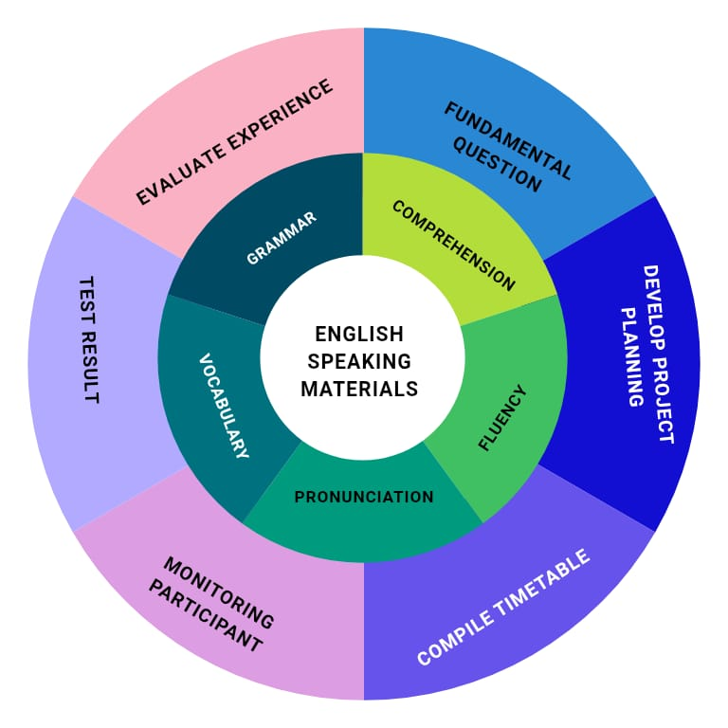
Figure 1: A chart of speaking materials based on project based learning

This model is validated by the expert in English teaching materials. The expert judgement questionnaire was developed to assess the feasibility and appropriateness of the speaking materials designed for Grade XI Vocational High School (SMK) students. The materials were constructed using a Project-Based Learning (PjBL) model, which emphasizes stages such as formulating fundamental questions, developing project planning, organizing timetables, monitoring participants, assessing project outcomes, and evaluating learning experiences. This approach was expected to enhance students’ engagement, contextualize English learning with their vocational field, and improve communicative competence.
To validate the materials, the questionnaire was administered to an expert in English language teaching, Zainuddin, S.S., M.Hum, who has 17 years of teaching experience in Intermediate Speaking at UIN SyahadaPadangsidimpuan-Tapanuli Selatan. The expert was asked to evaluate aspects of the speaking materials including comprehensibility, vocabulary relevance, grammar suitability, cultural content, global communication support, career relevance, and the effectiveness of supporting media and exercises.
The questionnaire consisted of ten closed-ended questions with “Yes” and “No” response options. Through this expert validation, the study ensured that the speaking materials not only align with the vocational context of the students (e.g., pharmacy-related dialogues) but also support broader educational goals such as global communication, career readiness, and intercultural competence. The expert’s responses served as a foundation to refine the materials, ensuring that they are pedagogically sound, relevant, and practical for use in the classroom.

CHAPTER V
CONCLUSION AND SUGGESTION
  - Conclusion
Based on the results of the research entitled “Developing EFL Students’ Speaking Materials through Project-Based Learning (PjBL) Method at SMK Negeri 3 Medan,” several important conclusions can be drawn.
First, the existing English speaking materials used at SMK Negeri 3 Medan were found to be less suitable for the students’ needs. The materials in the current textbook were dominated by reading texts and lacked interactive speaking activities. Consequently, students had limited opportunities to practice English communication actively. The materials were not aligned with the Project-Based Learning approach, which emphasizes authentic communication, collaboration, and real-life application.
Second, the needs analysis revealed that students required speaking materials that were practical, engaging, and relevant to their vocational context. Most students preferred topics related to daily communication, workplace dialogue, and preparation for real-world situations such as job interviews and presentations. They also expressed interest in learning through interactive media such as songs and projects that could increase their motivation and confidence in speaking English.
Third, the speaking materials were successfully developed based on the Project-Based Learning model. The development process followed the ADDIE framework (Analysis, Design, Development, Implementation, and Evaluation) and was completed until the third stage. The materials included stages such as determining fundamental questions, developing project plans, setting timetables, monitoring, assessing outcomes, and evaluating learning experiences. The final product was validated by an expert in English language teaching and was considered appropriate, relevant, and effective for use in vocational high school classrooms.
Finally, it can be concluded that the application of Project-Based Learning in developing speaking materials effectively supports students’ communicative competence, creativity, collaboration, and problem-solving abilities. The model encourages learners to engage in meaningful use of language through real projects, making English learning more contextual and enjoyable. Therefore, PjBL-based materials can serve as an alternative resource to improve students’ speaking ability and overall language proficiency at vocational schools.

REFERENCES
Budiwanto.(2013). Dasar-dasarTeknikdanTaktikBermainBulutangkis.Malang: UM Press.
Branch, Robert Maribe. “Instructional Design: The ADDIE Approach”. Springer Science & Business Media. 2009.
Brown, H. Douglas. “Principles of Language Learning and Teaching”.Longman. 1995.
Brown, H. Douglas. “Teaching by Principles: An Interactive Approach to Language Pedagogy. New Jersey: Prenticed Hall Regents. 2001.
Brown, H. Douglas. “Teaching by Principles: an Interactive Approach to Language Pedagogy”.Longman. 2004.
Cameron, Lyne. “Teaching Languages to Young Learners”. New York: Cambridge University Press. 2001.
Daryanto&Raharjo, Mulyo.“Model PembelajaranInovatif”. Yogyakarta: Gava Media. 2012.
Depdiknas.“StandarKompetensidanKompetensiDasar Mata Pelajaran Bahasa Inggris. Jakarta. 2006.
Fathurrohman, Muhammad. “Model-Model PembelajaranInovatif”. Yogyakarta: Ar-Ruzz Media. 2016.
Fauziati, Endang. “Methods of Teaching English as a Foreign Language: Traditional Method, Designer Method, Communicative Method, and Scientific Approach”. Surakarta: Muhammadiyah University Press. 2014
Fragoulis, L. “Project-based Learning in Teaching of English as a Foreign Language in Greek Primary Schools: From Theory to Practice”. English Language Teaching.Vol. 2. 2009.
Hunter, J. 2011. “Small Talk: Developing Fluency, Accuracy and Complexity in Speaking. Retrieved from https://connect.gonzaga.edu/asset/file/292/ELT_J-2011.Hunterelt_ccq093.pdf on March 24th, 2025.
Hymes, D. “Models of the Interaction of Language and Social Life, In Gumperz, J. &Hymes, D (eds). Directions in Sociolinguistics: The Ethnography of Communication”. New York: Hoolts Rinehart & Winston. 1972.
Isriani&Puspitasari, D. “StrategiPembelajaranTerpadu: Teori, KonsepdanImplementasi”. Yogyakarta: Relasi Inti Media Group. 2015.
Jezberova, R., Bezchlebova, M., Buresova, L., Dvorakova, Z., Manaskova, D., Bartosek, M., Tocíkova, I. “Zakovskeprojekty, cestakekompetencím”. Praha: NUPV. 2011.
Lasmiyati, L,.,&Harta, I. “PengembanganModulPembelajaranuntukMeningkatkanKonsepdanMinat SMP”. PhytagoracJurnalPendidikanMatematika. 2014.
Lukman&Ishartiwi.“PengembanganBahan Ajar dengan Model Mind Map untukPembelajaranIlmuPengetahuanSosial SMP”.JurnalInovasiTeknologiPendidikan. 2014
Mattew B. Miles and A. Michael Huberman “An Expanded Coursebook Qualitative Data Analysis” in W. Newton Suter, Introduction to Educational Research: A Critical Thinking Approach Second Edition (California: Sage). 2012.
McDonough, Jo & Shaw Chrispoher. “Material and Methods in ELT: A Teacher Guide”. Massachusetts: Blackwell Publisher. 1993.
Mukminin, A. et al. “Speaking Anxiety among Senior High School Students and Policies Recommendation”. Journal of Education and Learning. 2015.
Mulyasa, E. “ImplementasiKurikulum 2013”. Bandung: PT RemajaRodakarya. 2014.
Oradee, T. “Developing Speaking Skills Using Three Communicative Activities (Discussion, Problem Solving, and Role Playing)”. International Journal of Social Science and Humanity. 2012.
Patton, G. R. “Work that Matters: The Teacher’s Guide for Project based Learning”. The Paul Hamlyn Foundation. 2012.
P. Alexander, Annie. Lincoln and Guba. 1985. Lincoln and Guba’s Quality Criteria for Trustworthiness. IDC International J. 2019.
Richards, J. C. “Second Language Lectures Education Today”. RELC Journal, 39, 158-177. 2008.
Saefudin, A &Berdiati, I. PembelajaranEfektif. Bandung: PT RemajaRoskadarya. 2014.
Sugihartono. “PsikologiPendidikan”. Yogyakarta: UNY Press. 2015.
Tomlinson, B. “Materials Development for language learning and teaching”. Language Teaching, 45(2), 143-179). 2012.
Widiasworo, Erwin. “19 KiatSuksesMembangkitkanMotivasiBelajarPesertaDidik”. Yogyakarta: Ar-Ruzz Media. 2016.
Widiati, U. &Cahyono. B. Y. “The Teaching of EFL Speaking in the Indonesian Context: The State of the Art”. Journal Bahasa danSeni. 2006.

APPENDIX
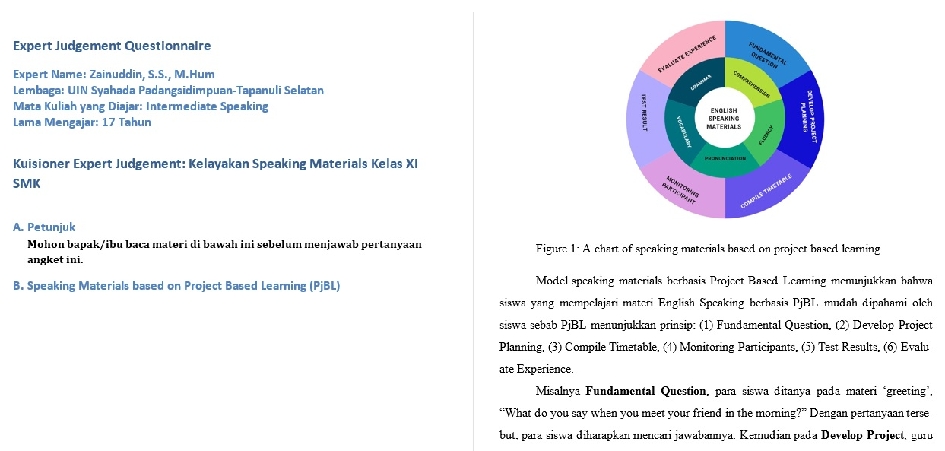
Appendix 1

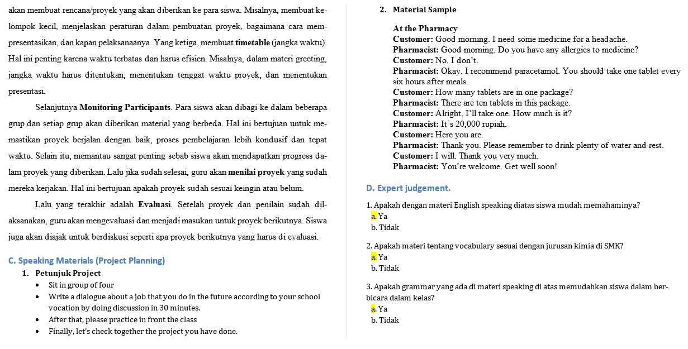
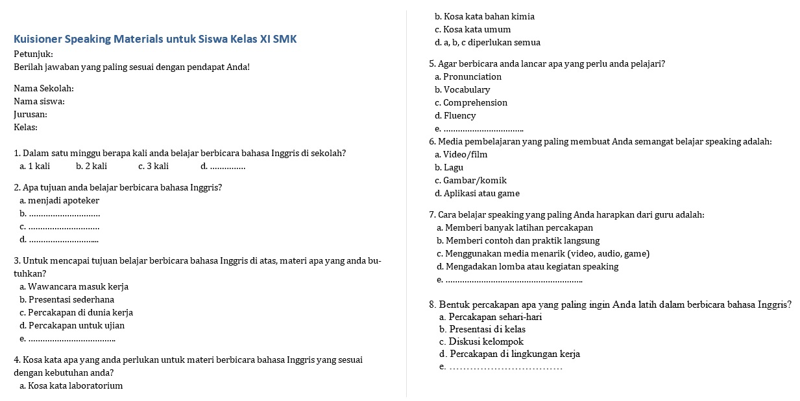
Appendix 2

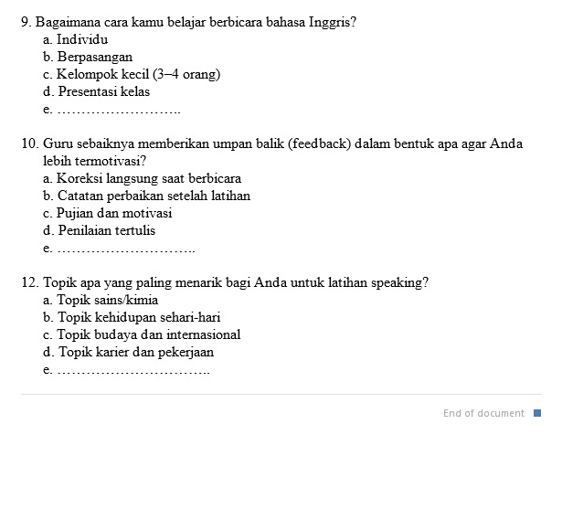
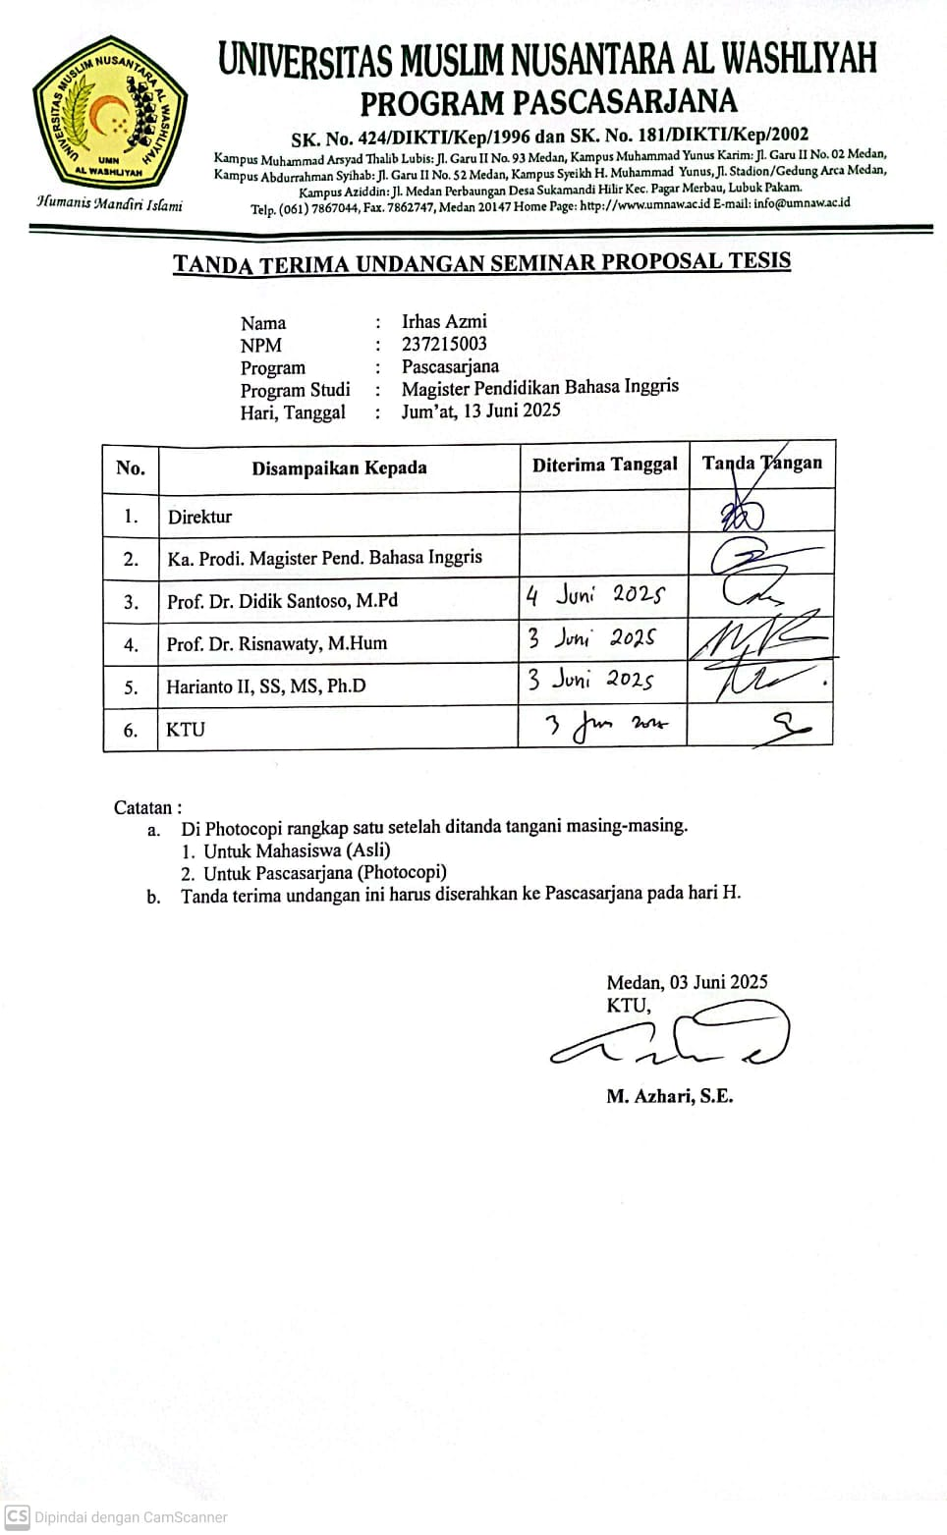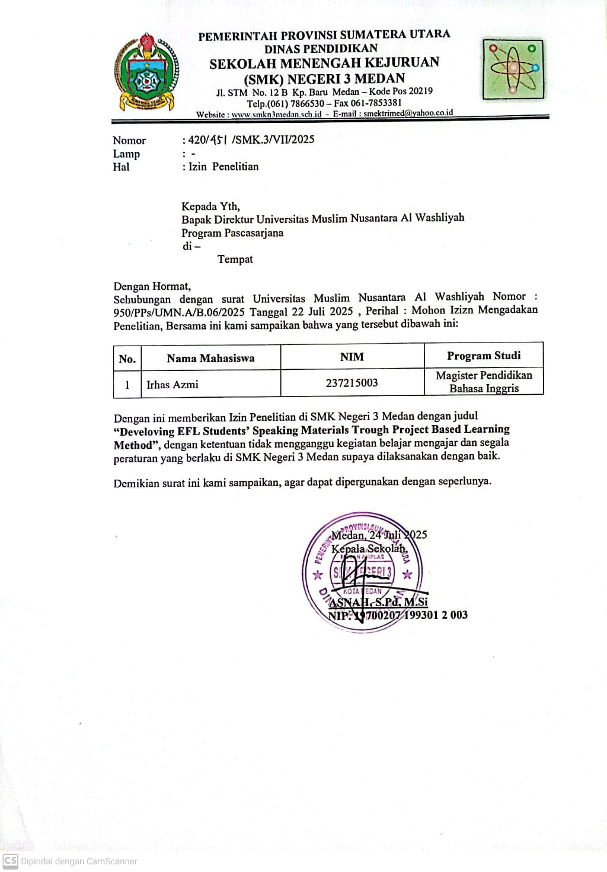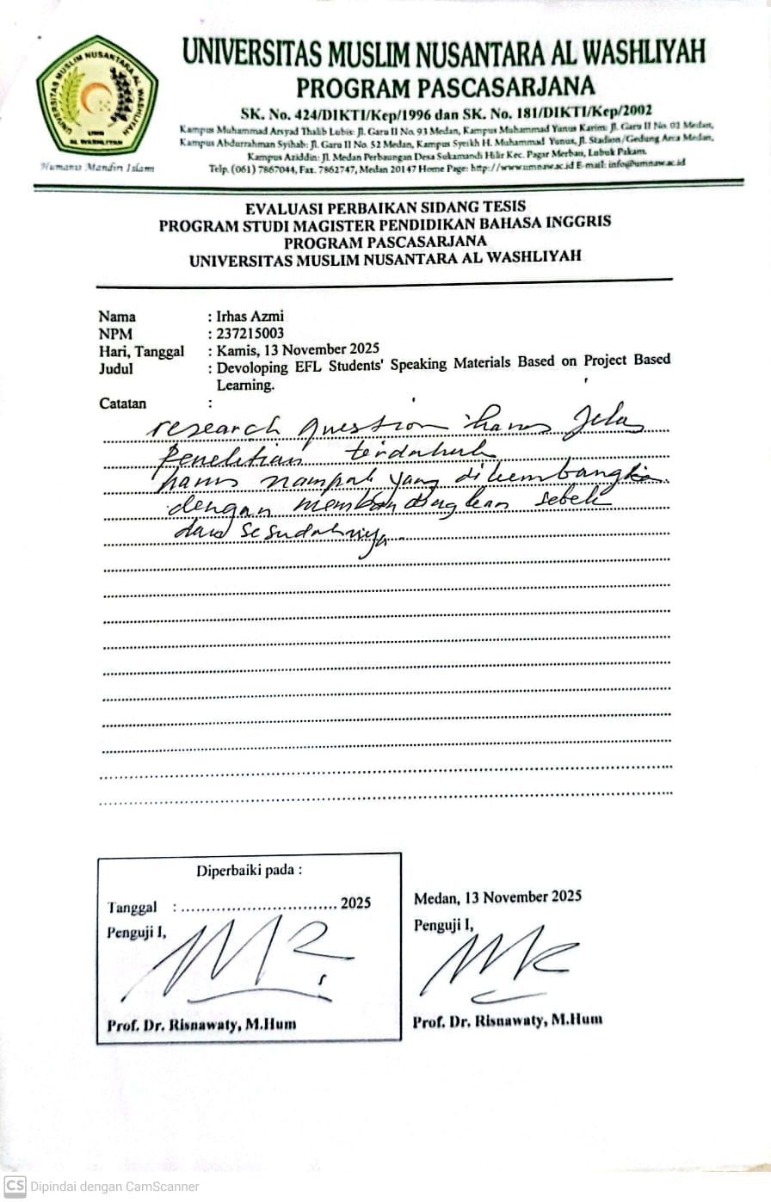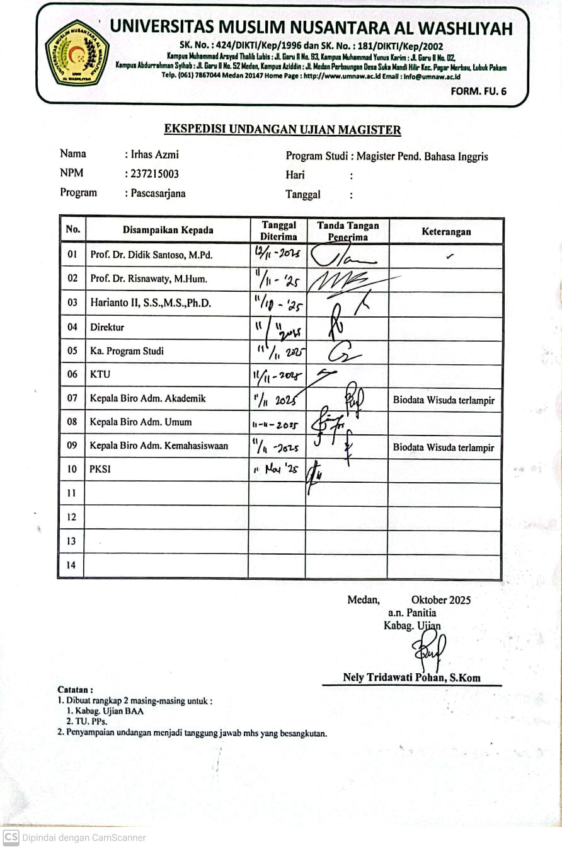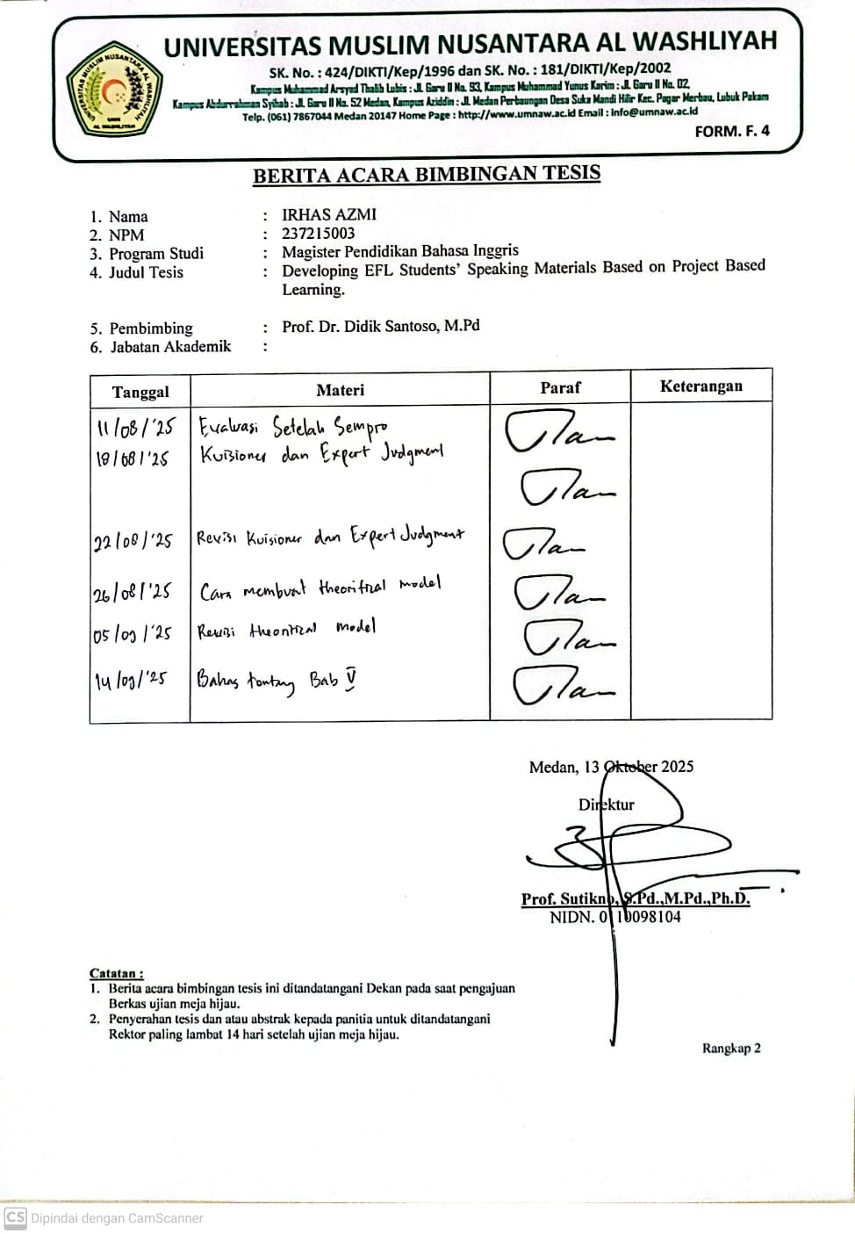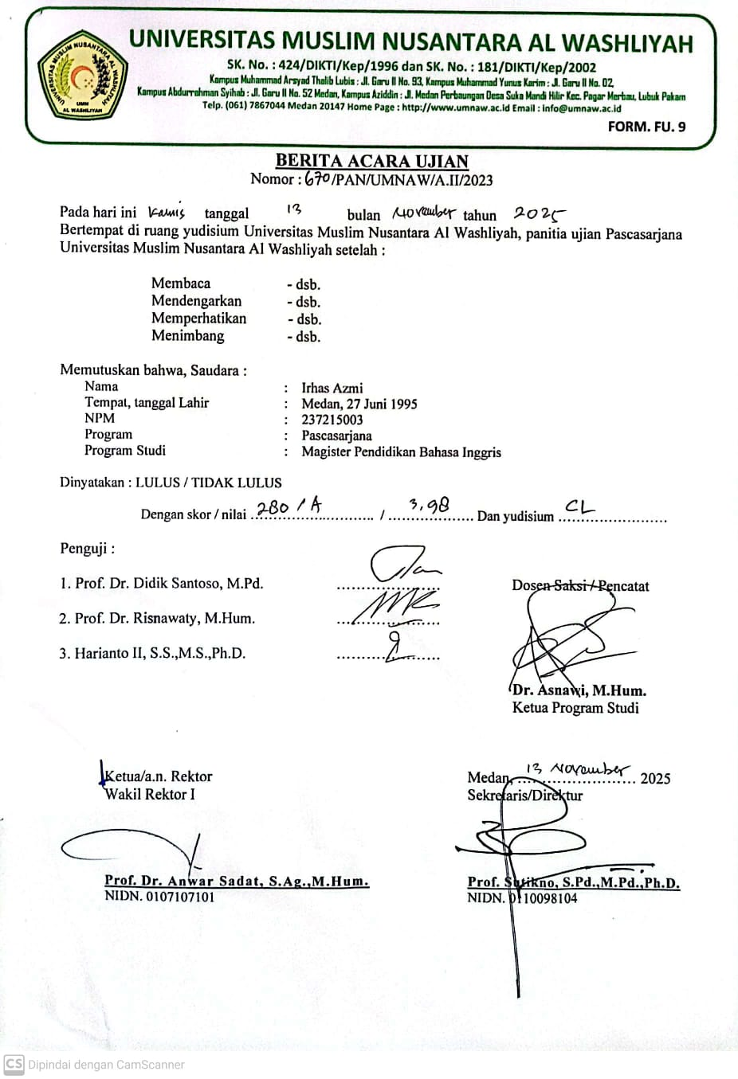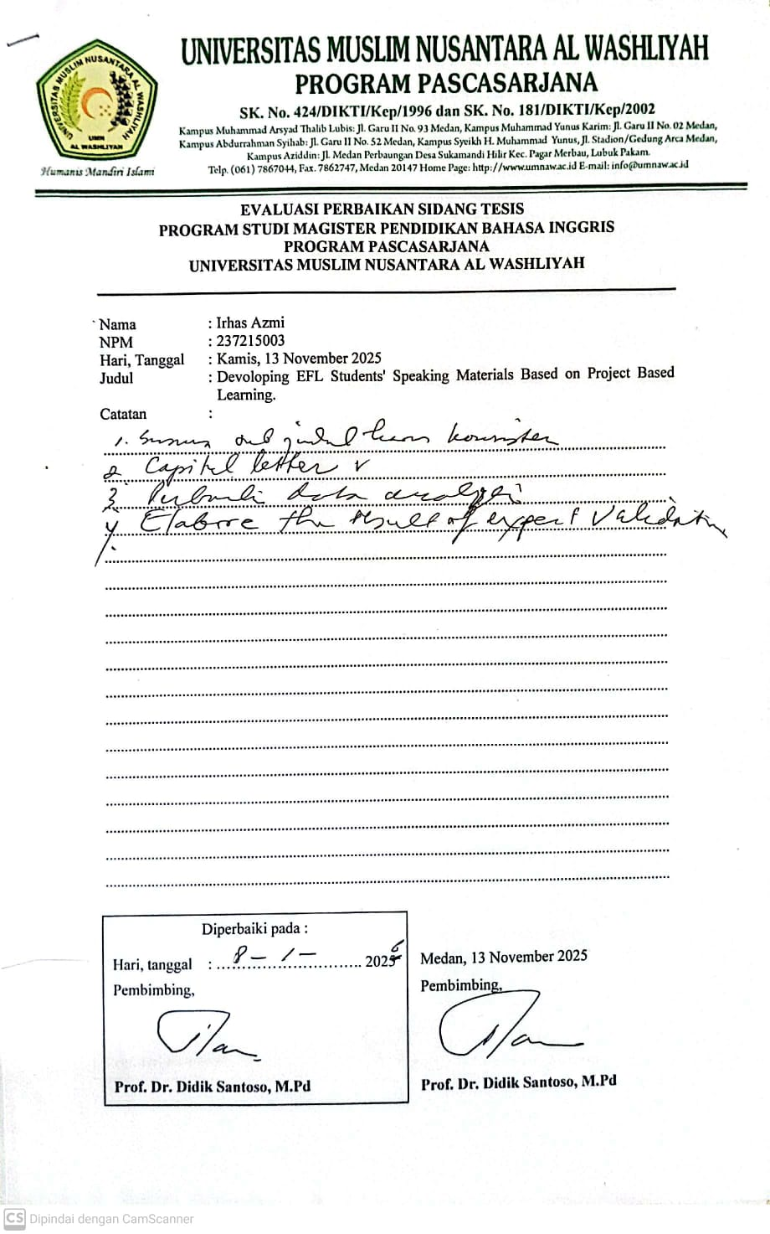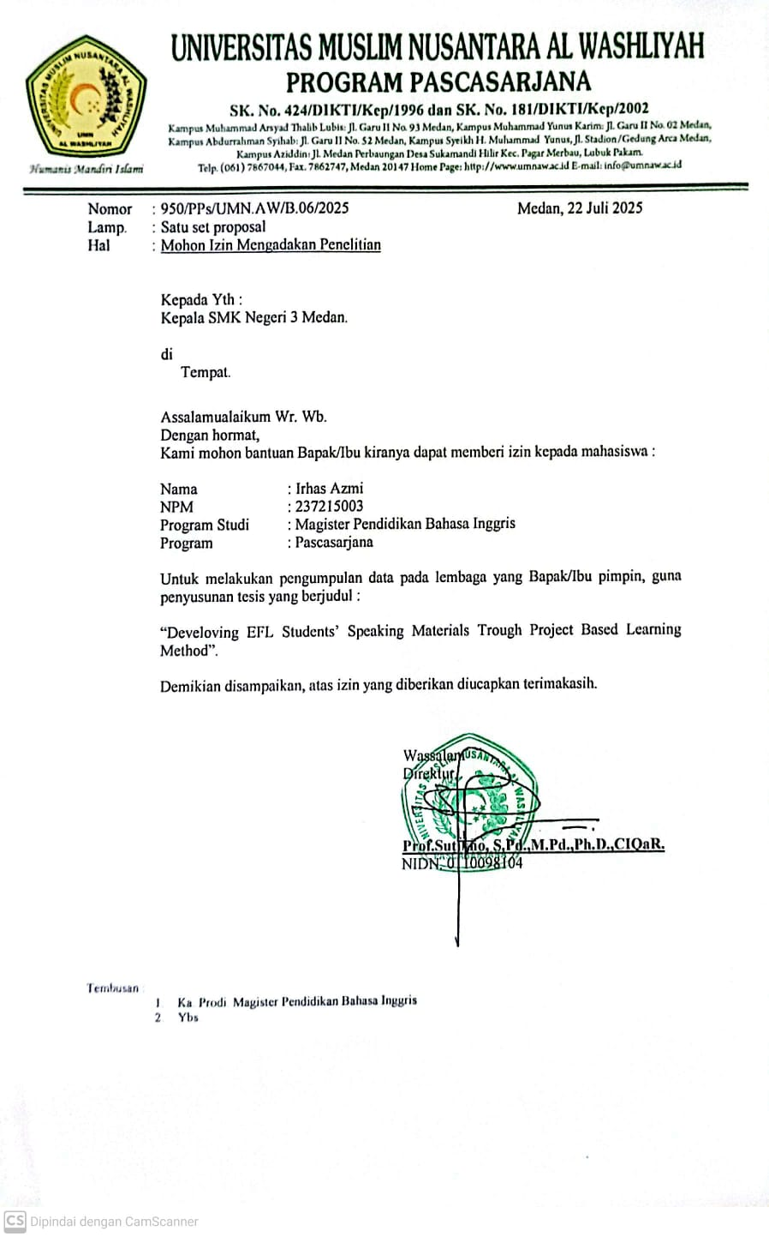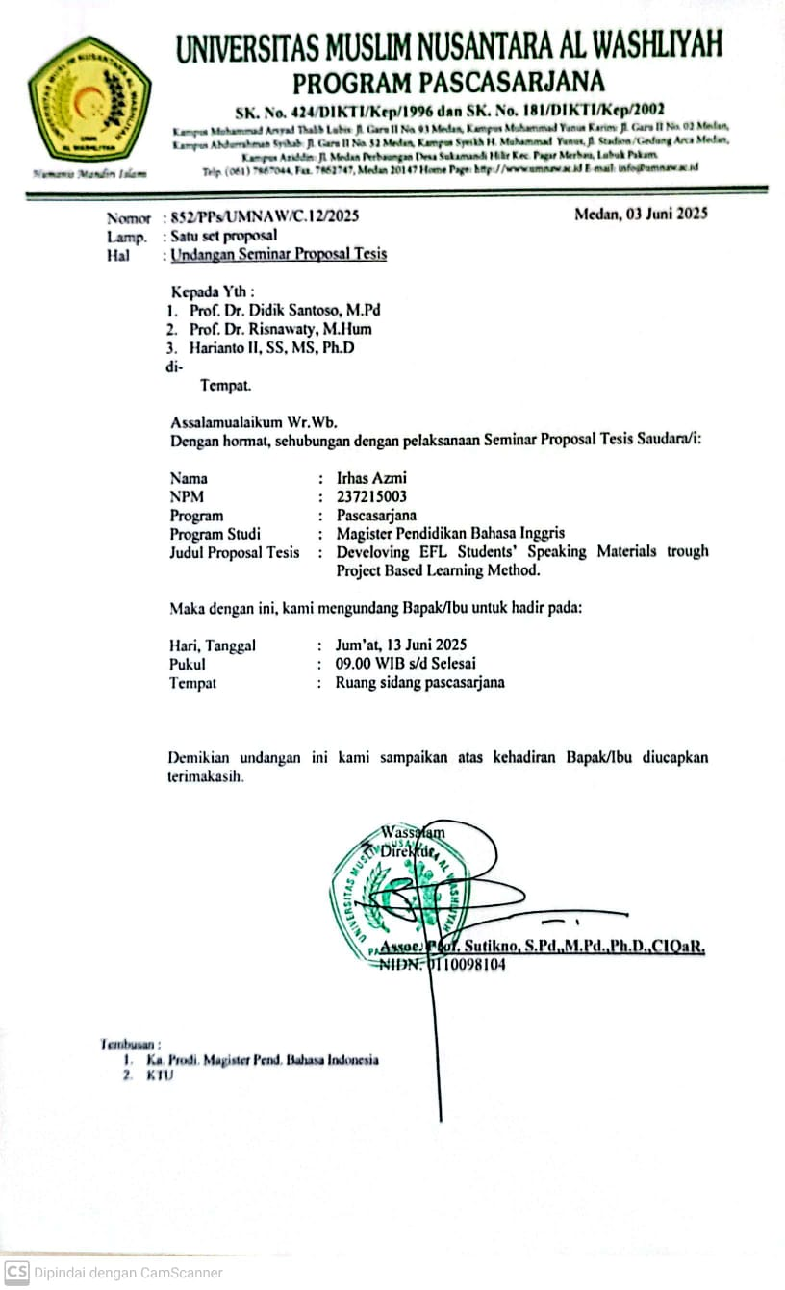
BIODATA MAHASISWA


- IDENTITAS DIRI
Nama : IrhasAzmi
NPM : 237215003
Tempat/T.Lahir : Medan, 27 Juni 1995
JenisKelamin : Laki-Laki
Agama : Islam
Status : BelumMenikah
Pekerjaan : Guru
AnakKe : 2 (Kedua) dari 2 bersaudara
Alamat : JalanRawaCangkuk IV No. 62C Medan
No. Telp/Hp : 082167855900
DosenPembimbing : Prof. Dr. DidikSantoso, M.Pd.
JudulSkripsi : Developing EFL Students’ Speaking Materials based on Project Based Learning (PjBL)
IndeksKumulatif :

- PENDIDIKAN
SD : SD Muhammadiyah 30 Medan
SMP : SMP Negeri 4 Medan
SMA : MAN 2 Model Medan
S1 : Universitas Sumatera Utara

- ORANG TUA
Nama Ayah : Alm. Muhammad Abduh
Pekerjaan : KaryawanSwasta
Nama Ibu : Mira Ilham
Pekerjaan : Guru
Alamat : JalanRawaCangkuk IV No. 62C Medan


Medan, Oktober 2025

IrhasAzmi

