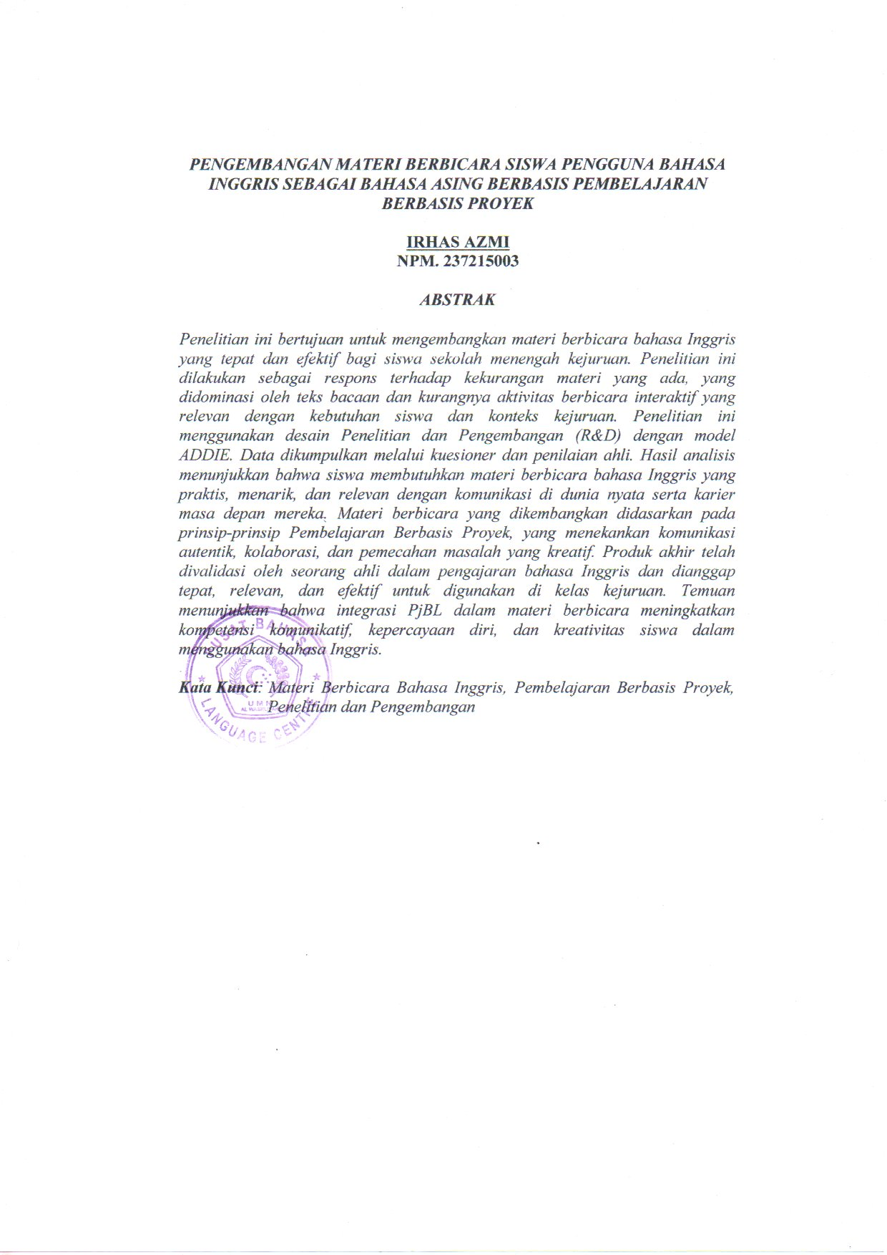
ABSTRACT

DEVELOPING EFL STUDENTS’ SPEAKING MATERIALS BASED ON PROJECT BASED LEARNING

By:

IRHAS AZMI

Registration Number. 237215003

This study aims to develop appropriate and effective English speaking materials for vocational high school students. The research was conducted in response to the inadequacy of existing materials, which were dominated by reading texts and lacked interactive speaking activities relevant to students’ needs and vocational contexts. The study employed the Research and Development (R&D) design using the ADDIE model. The data were collected through questionnaires and expert judgement. The analysis results revealed that students required English speaking materials that were practical, engaging, and relevant to real-life communication and their future careers. The developed speaking materials were based on the principles of Project Based Learning, emphasizing authentic communication, collaboration, and creative problem-solving. The final product was validated by an expert in English language teaching and was considered appropriate, relevant, and effective for use in vocational classrooms. The findings indicate that the integration of PjBL in speaking materials enhances students’ communicative competence, confidence and creativity in using English.

Keywords: English Speaking Materials, Project Based Learning, Material Development.

