
REFERENCES

Adnan, Almira. 2023. Increasing Students’ Reading Skill By Using Wattpad Application In Eighth-Grade Students of SMP Negeri 3 Watampone. Makassar: Universitas Bosowa
Ardiansyah. 2021. The Use Of Youtube Content To Improve Students’ Reading Ability at Smartone Private Jambi. Jambi: Unversitas Jambi
Ariezta, M. 2018. Otak Atik Gathuk Fenomena Numerologi Vs STIFIn. Bandung: Redaksi Kotak Lain.
Banditvilai, C. 2020. The Effectiveness Of Reading Strategies On Reading Comprehension. International Journal of Social Science and Humanity, 10(2),46.https://doi.org/10.18178/ijssh.2020.v10.1012accessed
onMarch2024
Daulay, S. H. 2019. Language And Society. Medan: Lembaga Peduli PengembanganPendidikan Indonesia.
Efendi,A.2019.RevolusiKecerdasanAbad21.Bandung:Alfabeta.
Fadillah, Z., I., Kamil, A., B., Wachyudi, K. 2022. Exploring Students’ Reading Ability in An Extensive Reading Class Through Constructivism of NarrativeText. JIIP (Jurnal Ilmiah Ilmu Pendidikan) Volume 5,Nomor 11 https://jiip.stkipyapisdompu.ac.id/jiip/index.php/JIIP/article/view/1075/1001accessed on March 2024

Gilakjani, A. P., & Sabouri, N. B. 2016. A Study Of Factors Affecting EFL LearnersReading Comprehension Skill And The Strategies For Improvement.InternationalJournalofEnglishLinguistics,6(5),
180.https://doi.org/10.5539/ijel.v6n5p180accessedonMarch2024
Harahap, Cece. 2022. The Effectiveness Of Class Division Based On Stifin (Intelligence Machine) At The Sukma Medan College Of Management Sciences, Especially In Kip Students In The Second Semester Of The Afternoon Class. Indonesian Journal of Multidisciplinary Science. ijoms.internationaljournallabs.com
Khildainy,H.2023.AnalyzingStudents’DifficultiesinReadingComprehensionof Narrative Text at Senior High School. Jakarta: State Islamic University of Syarif Hidayatullah
Mishra, S. B., & Alok, S. 2022. Handbook Of Research Methodology:A CompendiumForScholars&Researchers.NewDelhi:Educreation Publishing
Munjid, M., F., and Astiyandha, T. 2021. Exploring The Students’ Reading StrategiesOnTenthGradeOfSeniorHighSchool.Jakarta: UniversitasIslamAsSyafi’iyahhttps://uia.e-journal.id/Lingua/article/download/1369/825accessedon March 2024
Muthohar,S.&Fatmawati,N.,M.2023.LearningDifferentiationinECEBased on Sensing, Thinking, Intuiting, Feeling and Instinct (STIFIn) IntelligenceTest Results. Semarang: Universitas Negeri Walisongo Semarang
Nayak, J. K., & Singh, P. 2021. Fundamentals of Research Methodology. SSDNPublishers & Distributors. https://doi.org/10.22271/ed.book.1332accessedonMarch 2024
Nurhaliza, Reza. 2023. An Analysis of Students’ Reading Comprehension InDescriptive Text At SMP Ma’arif 03 Labuhan Maringgai In The AcademicYear Of 2022/2023. Lampung: Universitas Islam Negeri Raden Intan
Satriani, E. 2018. Reading Comprehension Difficulties Encountered By EnglishStudents Of Universitas Islam Riau. J-SHMIC, 5(2), 19.
Siregar, Nurhafni., & Harahap, Yulia, S. 2021. Students’ Learning Achievement WithDifferent STIFIn By Using E-Learning Scientific Approach.Medan:Universitas Muslim Nusantara Al-Washliyah

Sridharan, P. N. A., & Said, N. E. M. 2020. The Effect Of Graphic Organizer (KWL Chart) On Young Learners‟ Reading Comprehension In An ESL Setting.InternationalJournalofManagementandHumanities (IJMH),4(8),50. https://doi.org/10.35940/ijmh.H0768.044820accessed
onMarch2024
Tesilia. 2019. Improving Students’ Reading Ability Using Reciprocal Teaching InDescriptiveText.Makassar.UniversityofMuhammadiyahMakassar.

APPENDIXI

ReadingTest

MAKINGEVERYDROPCOUNT

- The history of human civilisation is entwined with the history of the ways we have learned to marvpulate water resources. As towns gradually expanded, water was brought from increasingly remote sources, leading to sophisticated engineering efforts such as dams and aqueducts. At the height of the Roman Empire, nine major systems, with an innovative layout of pipes and well-built sewers, supplied the occupants of Rome with as much water per person as is provided in many parts of the industrial world today.
- During the industrial revolution and population explosion of the 19th and 20th centuries, the demand for water rose dramatically. Unprecedented construction of tens of thousands of monumental engineering projects designed to control floods, protect clean water supplies, and provide water for irrigation and hydropower broughtgreatbenefitsto hundredsofmillionsofpeople.Foodproductionhaskept pace with soaring populations mainly because of the expansion of artificial irrigation systems that make possible the growth of 40% of the world's food. Nearly one fifthថា of all the electricity generated worldwide is produced by turbines spun by the power of falling water.
- Yet there is a dark side to this picture, despite our progress, half of the world's population still suffers, with water services inferior to those available to the ancient Greeks and Romans. As the United Nations report on access to water reiterated in November 2001, more than one billion people lack access to clean drinking water, some two and a half billion do not have adequate sanitation services. Preventable water-related diseases kill an estimated 10,000 to 20,000 children every day, and the latest evidence suggests that we are falling behind in efforts to solve these problems.

39

- The consequences of our water policies extend beyond jeopardising human health Tens of millions of people have been forced to move from their homesoften with little warning or compensation to make way for the reservoirs behind dams. More than 20% of all freshwater fish species are now threatened or endangered because dams and water withdrawals have destroyed the free-flowing river ecosystems where they thrive. Certain irrigation practices degrade soil quality and reduce agricultural productivity Groundwater aquilers are being pumped down faster than they are naturally replenished in parts of India, China, the USA and elsewhere. And disputes over shared water resources have led to violence and continue to raise local, national and even international tensions.
- At the outset of the new millennium, however, the way resource planners think about water is beginning to change. The focus is slowly shifting back to the provision of basic human and environmental needs as top priority ensuring 'same for all. instead of 'more for some'. Some water experts are now demanding that existing infrastructure be used in smarter ways rather than building new facilities, which is increasingly considered the option of last, not first, resort. This shift in philosophyhasnotbeen universallyaccepted, and itcomeswithstrongopposition fram some established water organisations, Nevertheless, it may be the only way to address successfully the pressing problems of providing everyone with clean water to drink. adequate water to grow food and a life free from preventablewater-related illness.
- Fortunately and unexpectedly the demand for water is not rising as rapidly as some predicted. As a result, the pressure to build new water infrastructures has diminished over the past two decades.Although population, industrial output and economic productivity have continued to soar in developed nations, the rate at which people withdraw water from aquifers, rivers and lakes has slowed.And in a few parts of the world, demand has actually fallen.
- Whatexplainsthisremarkableturnofevents?Twofactors:peoplehavefigured out how to use water more efficiently, and communities are rethinking their prioritiesforwater use.Throughoutthefirst three-quartersofthe20th century,the

quantity of freshwater consumed per person doubled on average; in the USA, water withdrawals increased tenfold while the population quadrupled. But since 1980, the amount of water consumed per person has actually decreased, thanks to a range of new technologies that help to conserve water in homes and industry. In 1965, for instance, Japan used approximately 13 million gallons of water to produce $1 million of commercial output; by 1989 this had dropped to 3.5 million gallons (even accounting for inflation) - almost a quadrupling of water productivity. In the USA, water withdrawals have fallen by more than 20% from their peak in 1980.
- On the other hand, dams, aqueducts and other kinds of infrastructure will still have to be built, particularly in developing countries where basic human needs have not been met. But such projects must be built to higher specifications and with more accountability to local people and their environment than in the past. And even in regions where new projects seen warranted, we must find ways to meetdemandswithfewerresources,respectingecologicalcriteriaandtoasmaller budget.

Do the following statements agree with the information given in Reading Passage 1?
Inboxes1-6onyour answer sheet,

YES ifthestatementagreeswiththeclaimsofthewriter

NO ifthestatementcontradictstheclaimsofthe writer

NOTGIVEN ifit is impossible to saywhat the writerthinks about this

- WateruseperpersonishigherintheindustrialworldthanitwasinAncient Rome.
- Feedingincreasingpopulationsispossibledueprimarilytoimprovedirrigation
systems.

- ModernwatersystemsimitatethoseoftheancientGreeksandRomans

- Industrialgrowthisincreasingtheoveralldemandfor water.

- Moderntechnologieshaveled toareduction indomesticwater consumption.

- Inthefuture, governmentsshould maintainownership ofwater infrastructures.

EDUCATINGPSYCHE

Educating Psyche by Bernie Neville is a book which looks at radical new approaches to learning, describing the effects of emotion, imagination and the unconscious on learning. One theory discussed in the book is that proposed by George Lozanov, which focuses on the power of suggestion.
Lozanov's instructional technique is based on the evidence that the connections made in the brain through unconscious processing (which he calls non-specific mental reactivity) are more durable than those made through consciousprocessing. Besides the laboratory evidence for this, we know from ourexperience that we often remember what we have perceived peripherally, long after we have forgotten what we set out to learn. If we think of a book we studied months or years ago, we will find it easier to recall peripheral details - the colour, the binding, the typeface, the table at the library where we sat while studying it - than the content on which we were concentrating. If we think of a lecture we listened to with great concentration, we will recall the lecturer's appearance and mannerisms, our place in the auditorium, the failure of the air-conditioning, much more easily than the ideas we went to learn. Even If these peripheral details are a bit elusive, they come back readily in hypnosis or when we relive the event imaginatively, as in psychodrama. The details of the content of the lecture, on the other hand, seem to have gone forever.
This phenomenon can be partly attributed to the common counterproductive approach to study (making extreme efforts to memorise, tensing muscles,Inducing fatigue), but it also simply reflects the way the brain functions. Lozanov therefore made indirect instruction (suggestion) central to his teaching system. In suggestopedia, as he called his method, consciousness is shifted away from the curriculum to focus on something peripheral. The curriculum then becomes peripheral and is dealt with by the reserve capacity of the brain.

The suggestopedic approach to foreign language learning provides a good illustration, In its most recent variant (1980), it consists of the reading of vocabulary andtext whiletheclassislisteningto music.Thefirstsessionisintwo parts. In the first part, the music is classical (Mozart, Beethoven, Brahms) and the teacherreadsthetextslowlyandsolemnly.withtothedynamicsofthemusic.The students follow the text in their books. This is followed by several minutes of silence. In the second part, they listen to baroque music (Bach, Corelli, Handel) while the teacher reads the text in a normal speaking voice. During this time they have their books closed. During the whole of this session, their attention is passive; they listen to the music but make no attempt to learn the material.
Beforehand, the students have been carefully prepared for the language learning experience.Through meeting withthe staffand satisfied students they develop the expectation that learning will be easy and pleasant and that they will successfully learn. several hundred worch of the foreign language during the class. in a preliminary tall, the reacher introduces them to the material to be covered, but doesnot"teach'it.Likewise,thestudentsareinstructednottotrytolearnitduring this introduction.
Some hours after the two-part session, there is a follow-up class at which the studentsarestimulatedtorecallthematerialpresented.Onceagaintheapproachis indirect. The students do not focus their attention on trying to remember the vocabulary, but focus on using the language to (e.g. through games or improvised dramatisations). Such methods are not unusual in language teaching. What is distinctive in the suggestopedic method is that they are devoted entirely to assisting recall. The "learning" of the material is assumed to be automatic and effortless, accomplished whilelisteningtomusic.Theteacher'staskistoassistthe studentstoapplywhattheyhavelearnedparaconsciously,andindoingsotomake it easily accessible to consciousness. Another difference from conventional teaching is the evidence that students can regularly learn 1000 new words of a foreign language during a suggestopedic session, as well as grammar and idiom.

Lozanov experimented with teaching by direct suggestion during sleep, hypnosis and trance states, but found such procedures unnecessary. Hypnosis, yoga, Silva mind-control, religious ceremonies and faith healing are all associated with successful suggestion, but none of their techniques seem to be essential to it. Such rituals may be seen as placebos. Lozanov acknowledges that the ritualsurrounding suggestion in his own system is also a placebo, but maintains that without such a placebo people are unable or afraid to tap the reserve capacity of their brains, Like any placebo, it must be dispensed with authority to be effective. Just as a doctor calls on the full power of autocratic suggestion by insisting thatthe patient take precisely this white capsule precisely three times a day before meals, Lozanov is categoric in insisting that the suggestopedic session be conducted exactly in the manner designated, by trained and accredited suggestopedic teachers.
While suggestopedia has gained some notoriety through success in the teaching of modern languages, few teachers are able to emulate the spectacular results of Lozanov and his associates. We can, perhaps, attribute mediocre results to an inadequate placebo effect. The students have not developed the appropriate mind set. They are often not motivated to learn through this method. They do not have enough 'faith". They do not see it as 'real teaching, especially as it does not seemto involve the 'work' they have learned to believe is essential to learning.

Choosethecorrectletter,A,B,CorD.

Writethecorrectletterinboxes7-10onyouranswersheet.

- Thebook EducatingPsycheismainly concerned with

  - thepower ofsuggestion in learning.
  - aparticulartechnique forlearningbasedonemotions.
  - theeffectsof emotionontheimaginationandthe unconscious
  - oflearningwhich arenottraditional.

- Lozanov'stheoryclaimsthat,whenwetrytorememberthings,

  - unimportantdetailsaretheeasiestto recall.
  - concentratinghardproducesthebestresults.
  - themostsignificantfactsaremost easilyrecalled.
  - peripheralvision isnot important.

- Inthispassage, theauthorusestheexamplesofabookand alecturetoillustrate
that

  - bothof theseareimportant fordeveloping concentration.
  - histheoryaboutmethodsoflearningis valid.
  - readingisabetter techniqueforlearningthanlistening
  - wecanrememberthingsmoreeasilyunderhypnosis

- Lozanovclaimsthatteachersshouldtrainstudentsto

  - memorisedetailsofthecurriculum.
  - developtheirownsetsof indirectinstructions
  - thinkaboutsomethingotherthanthecurriculumcontent.
  - avoidoverloadingthecapacity ofthe brain.

APPENDIXII

Documentation


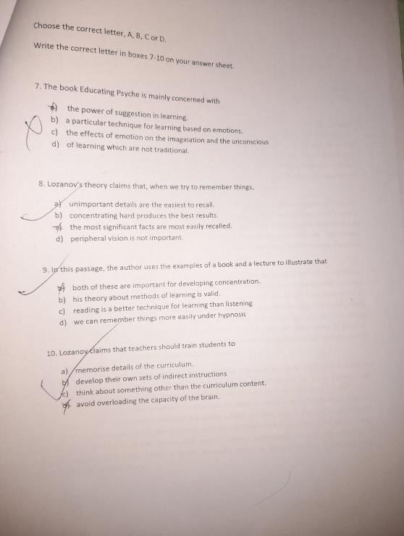

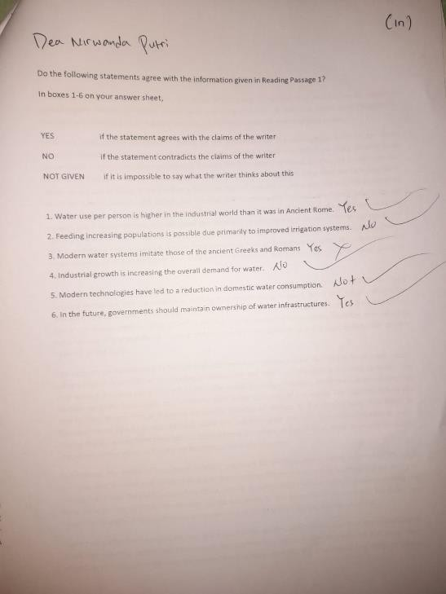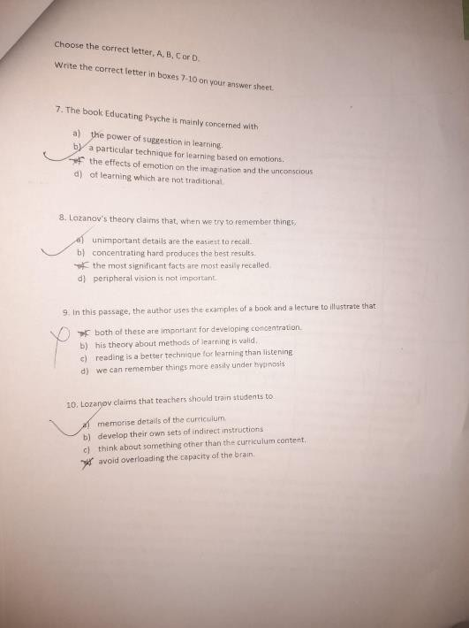


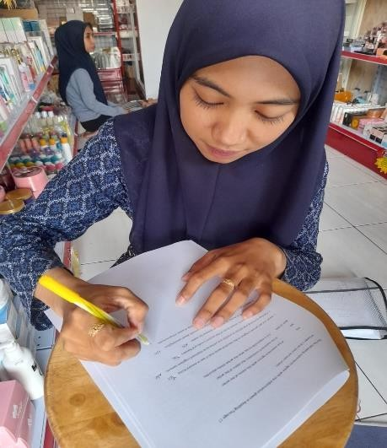

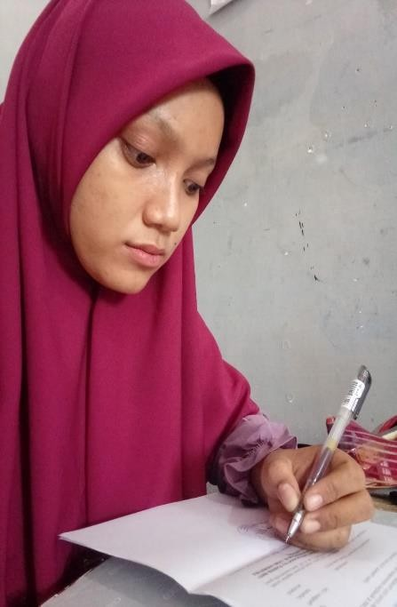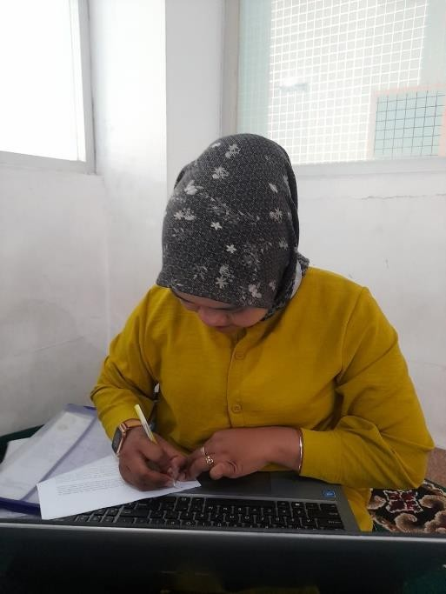

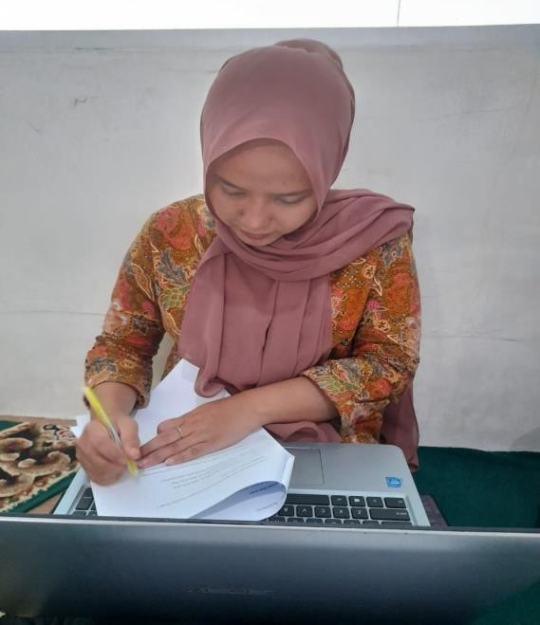
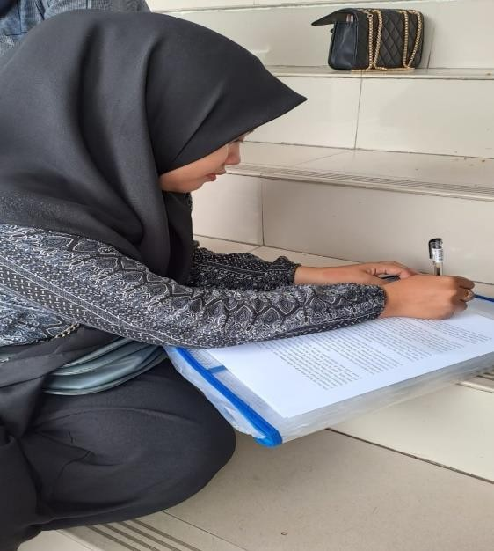

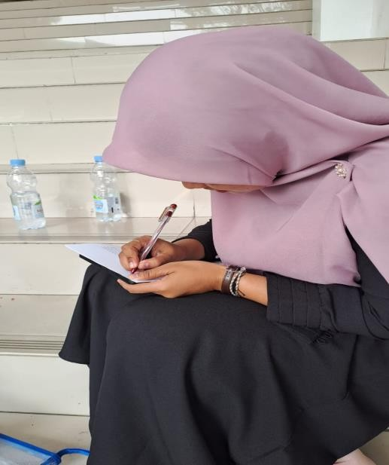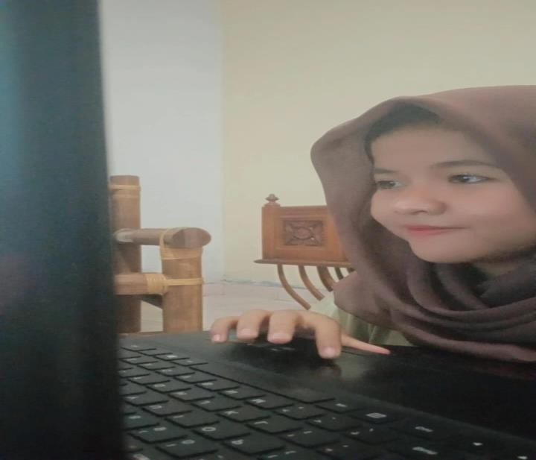

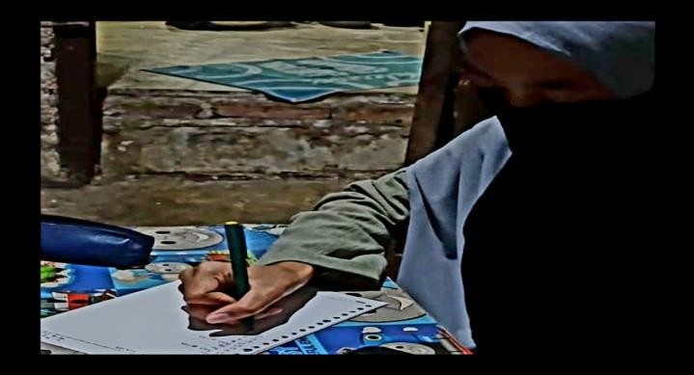

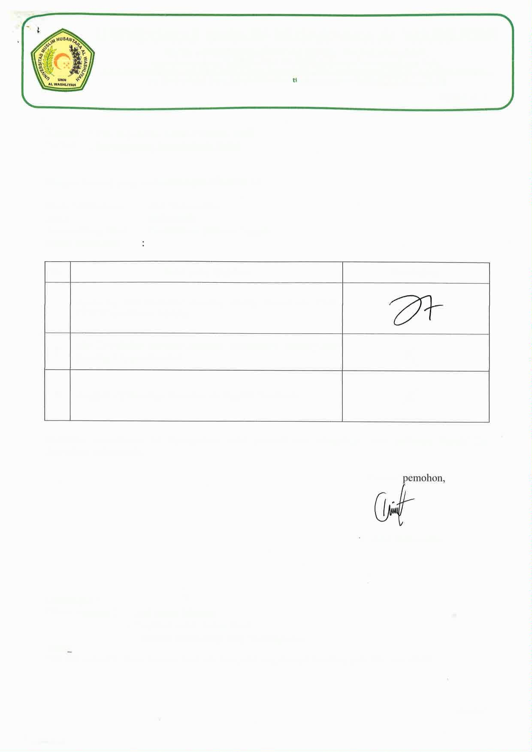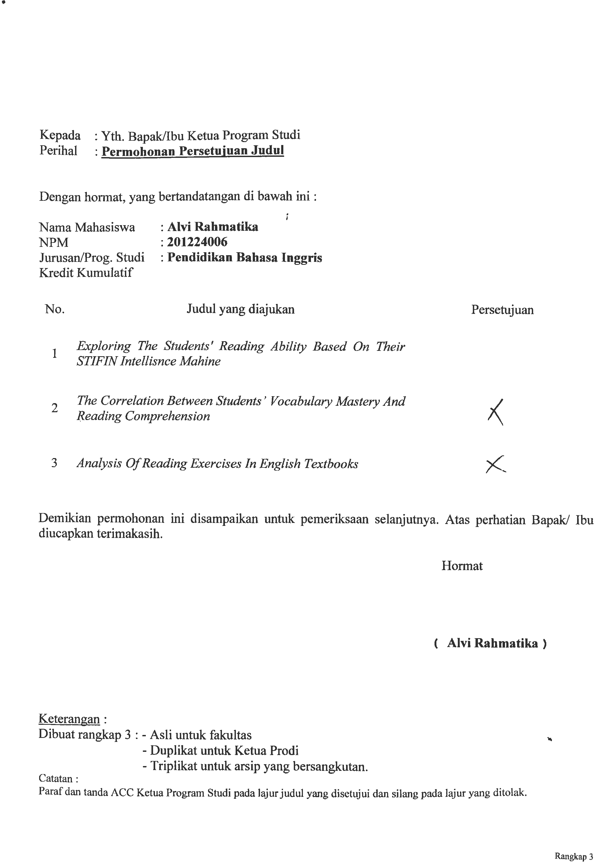

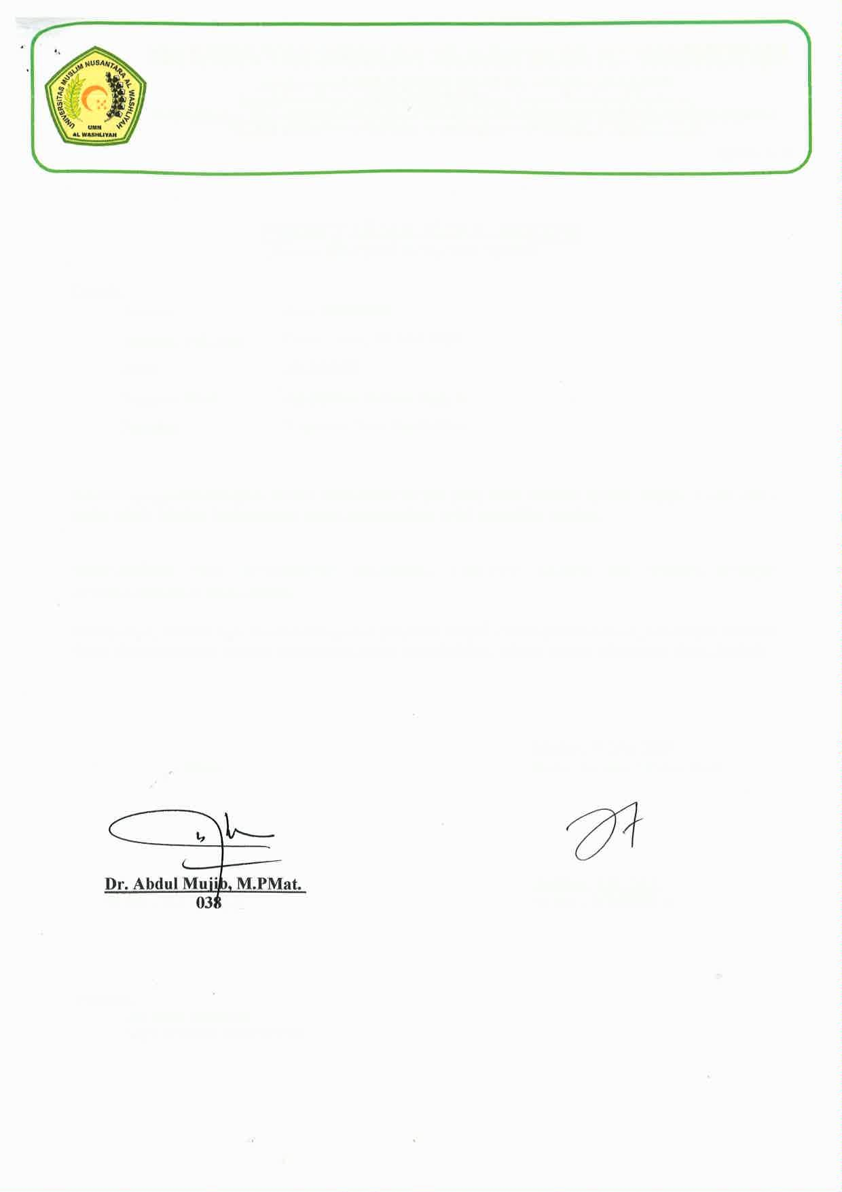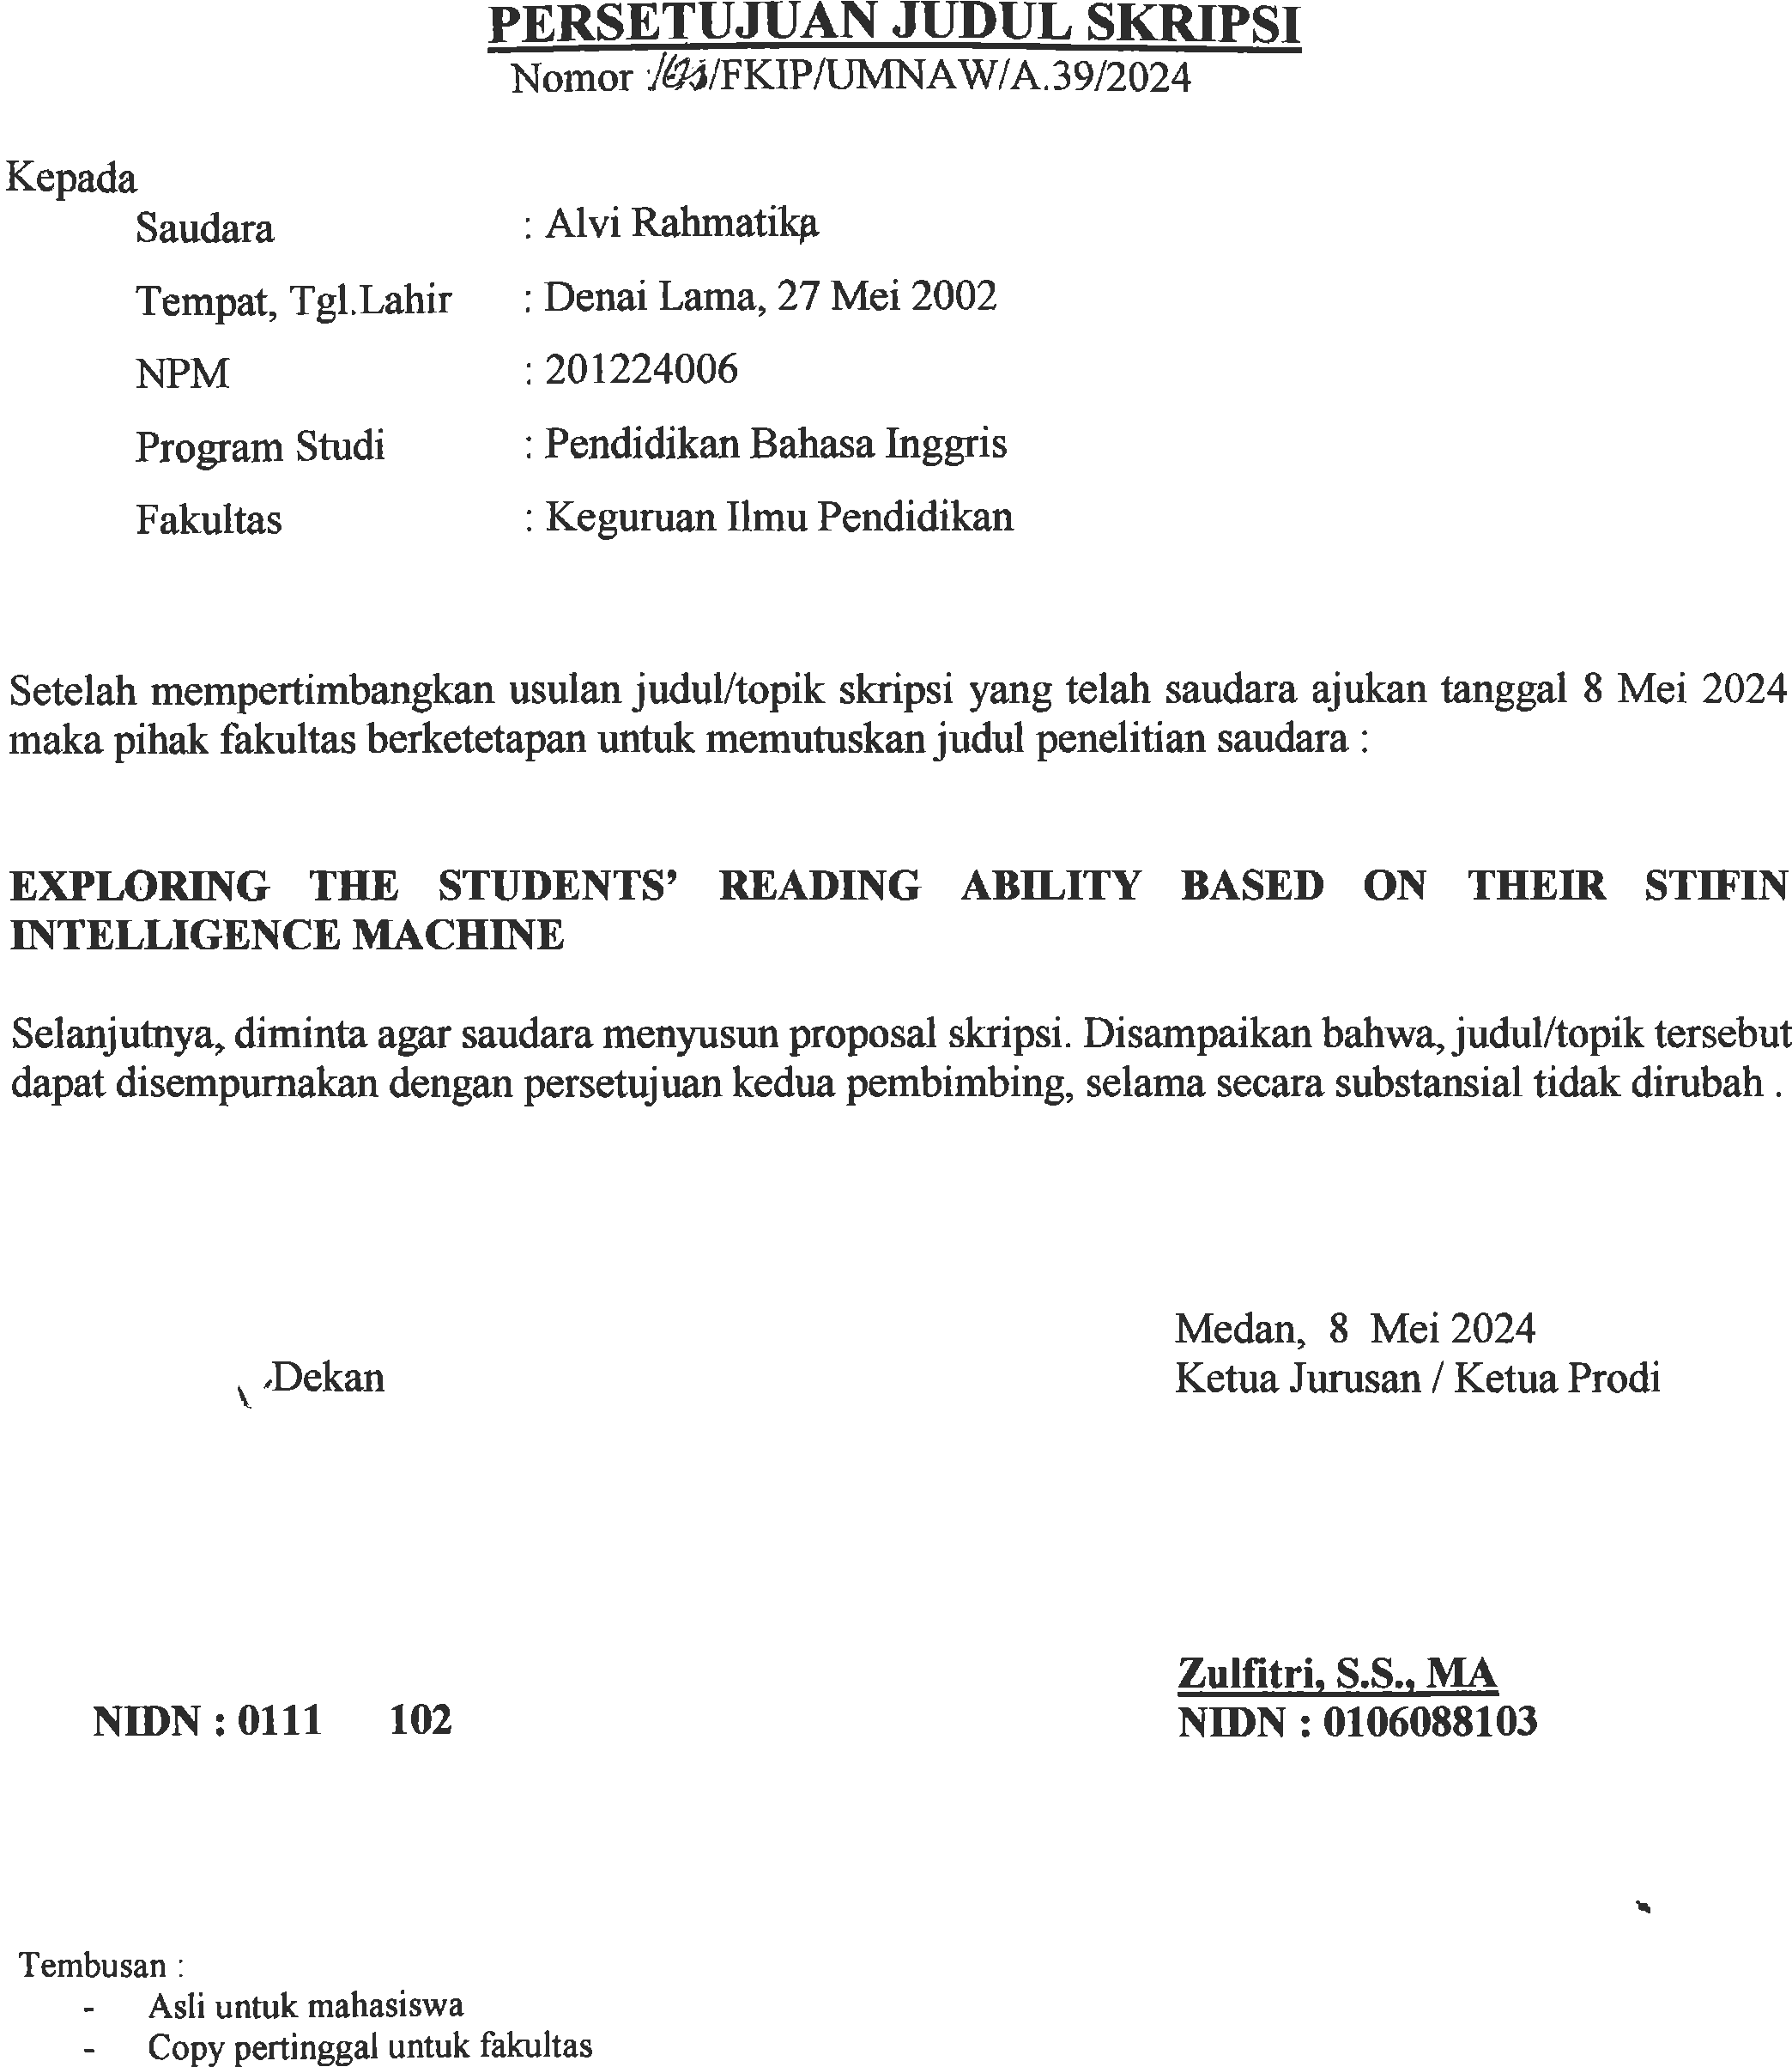

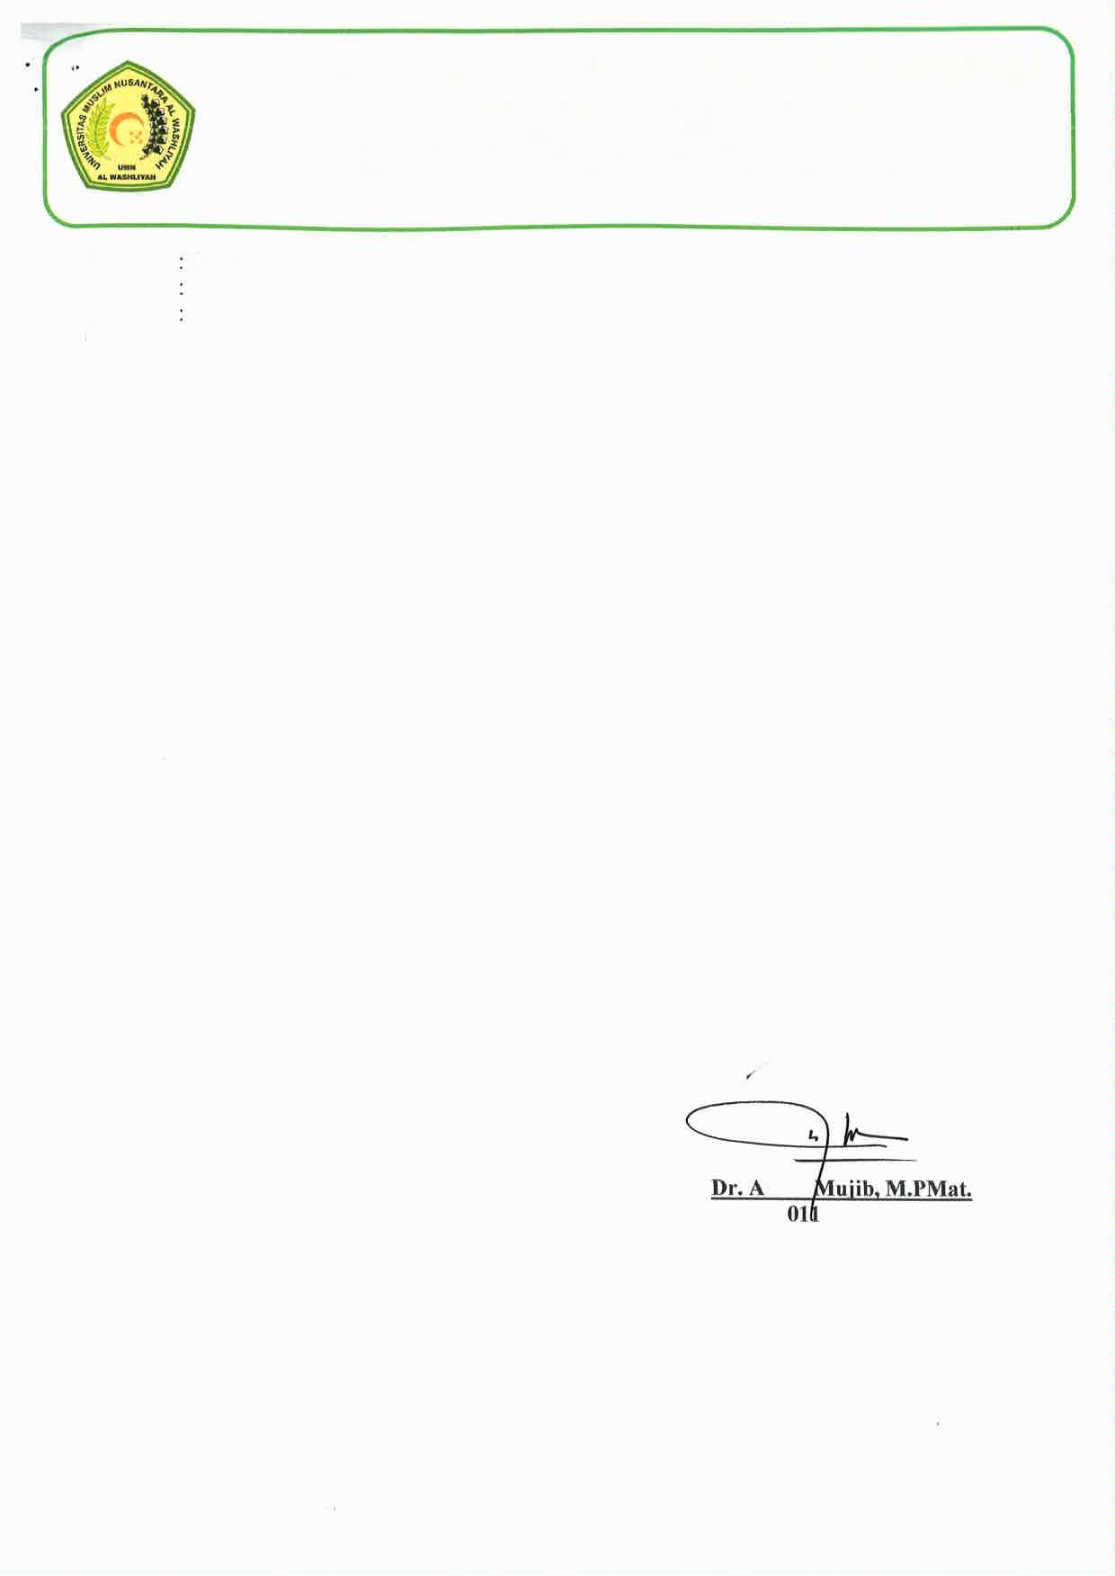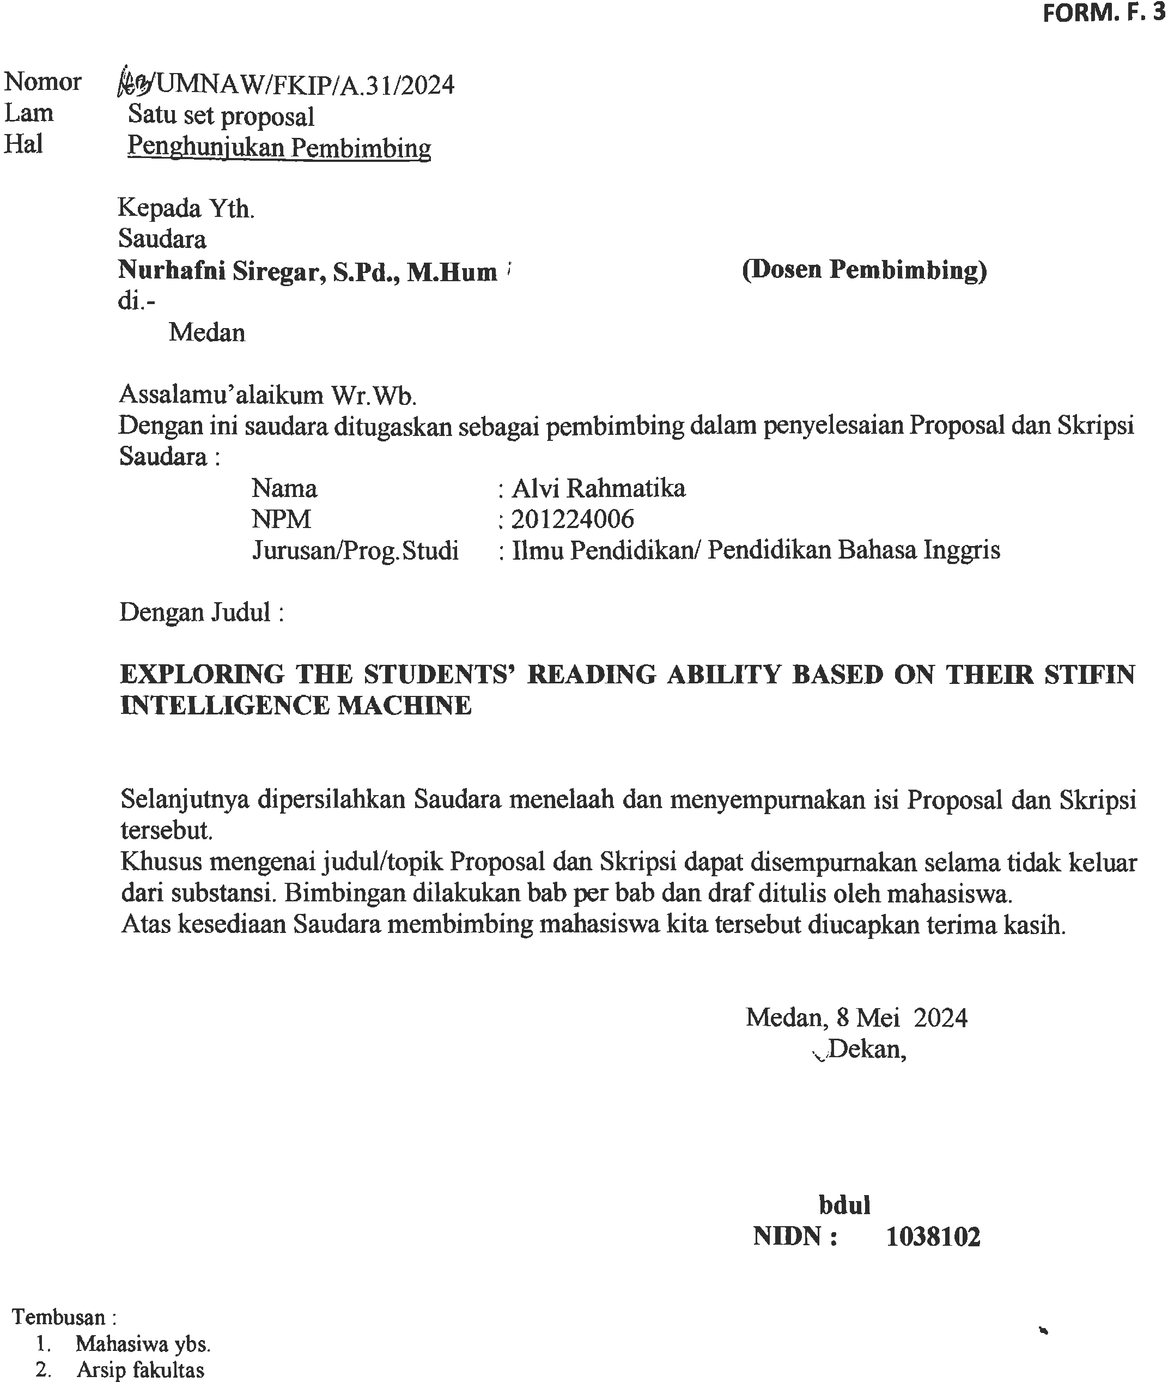

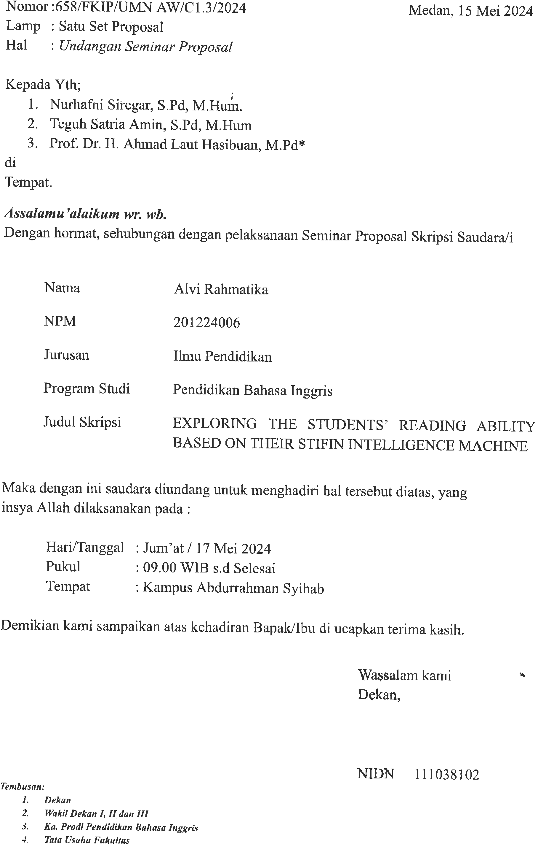

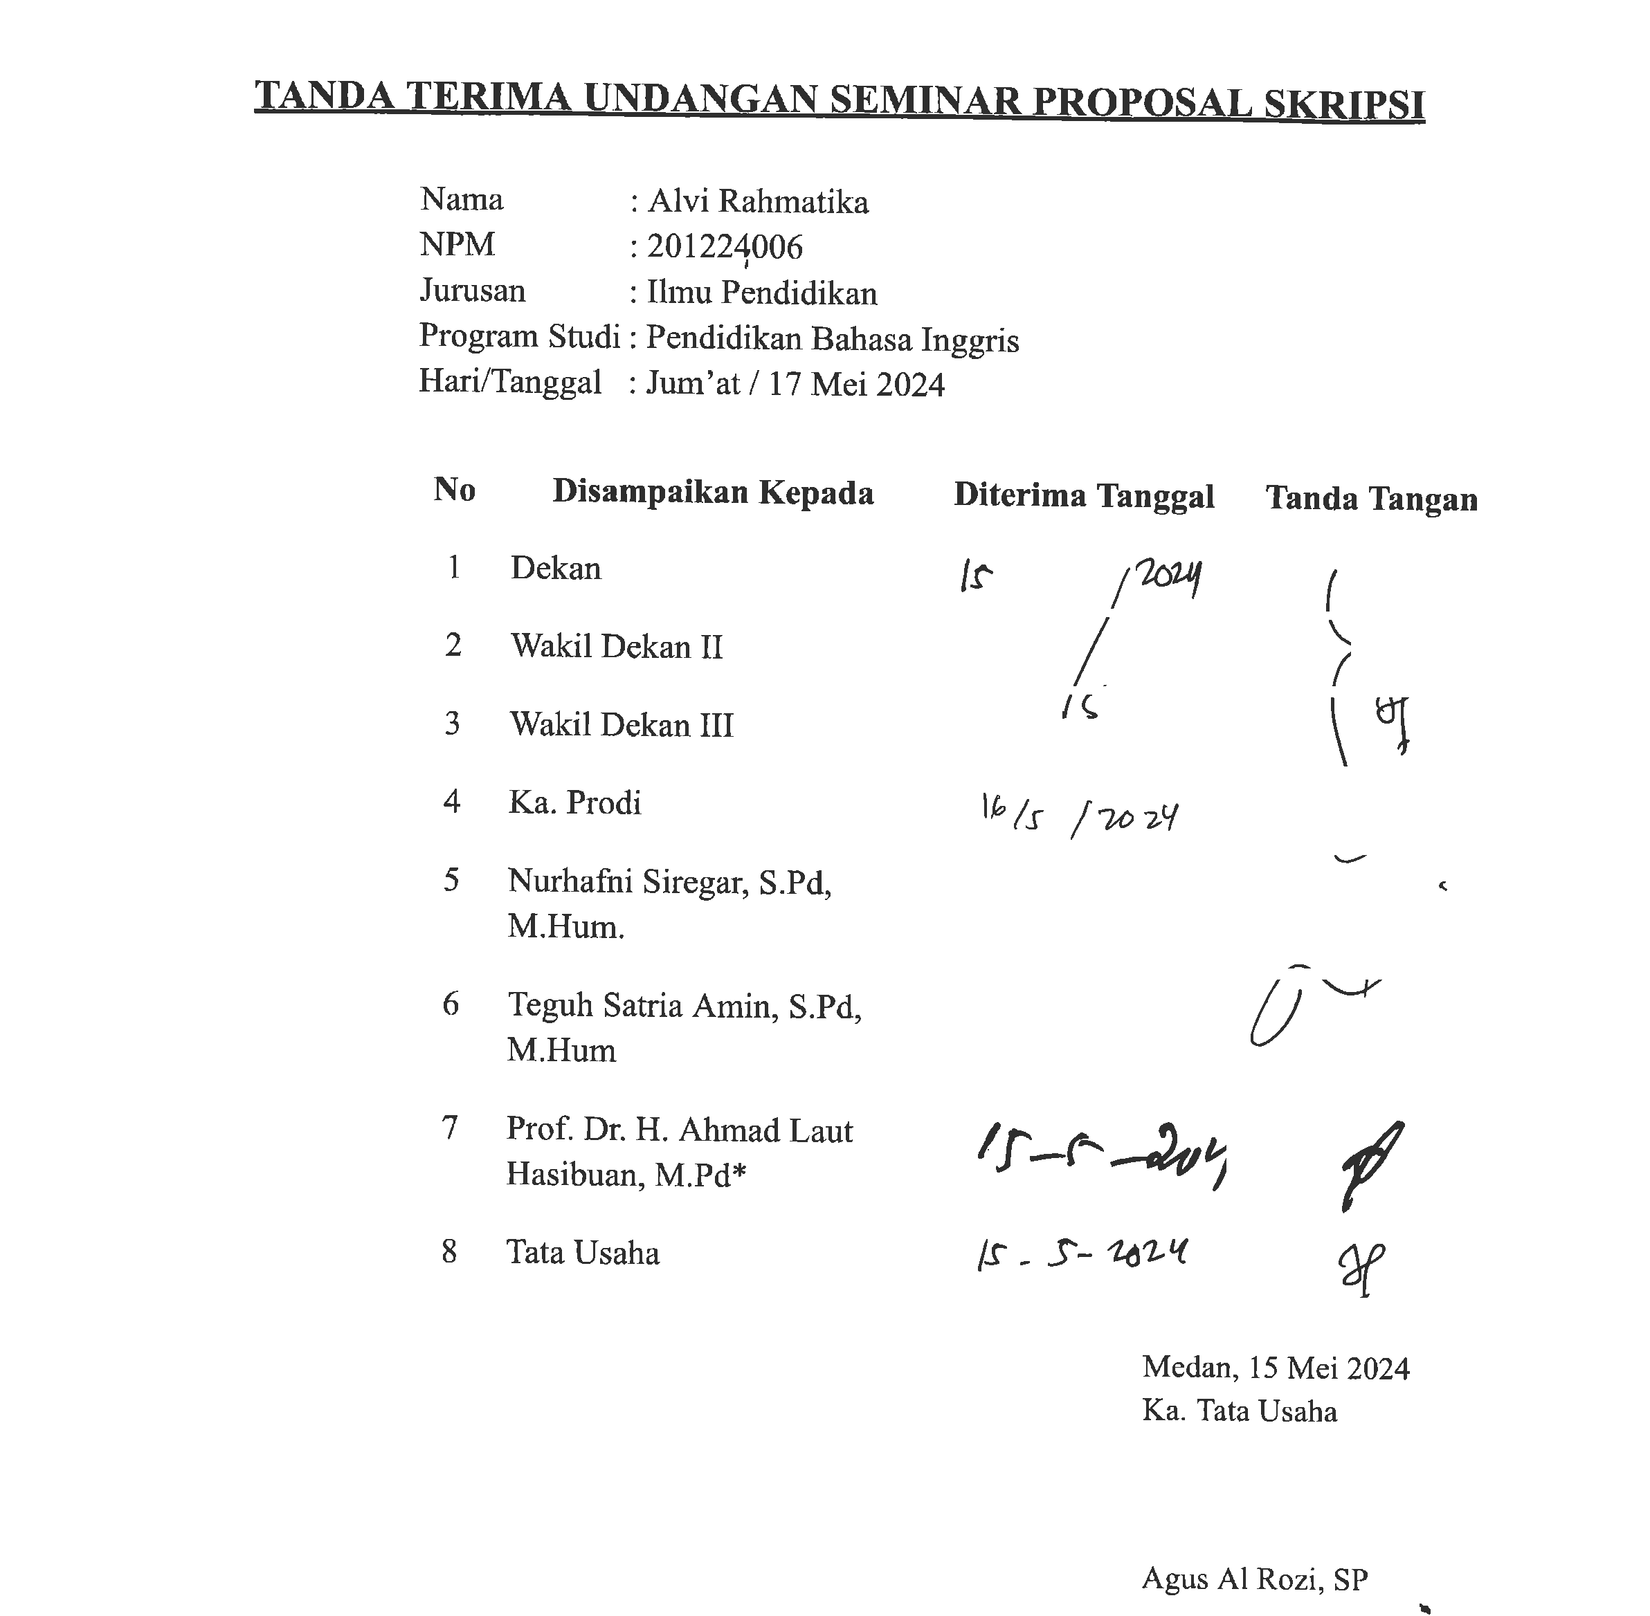

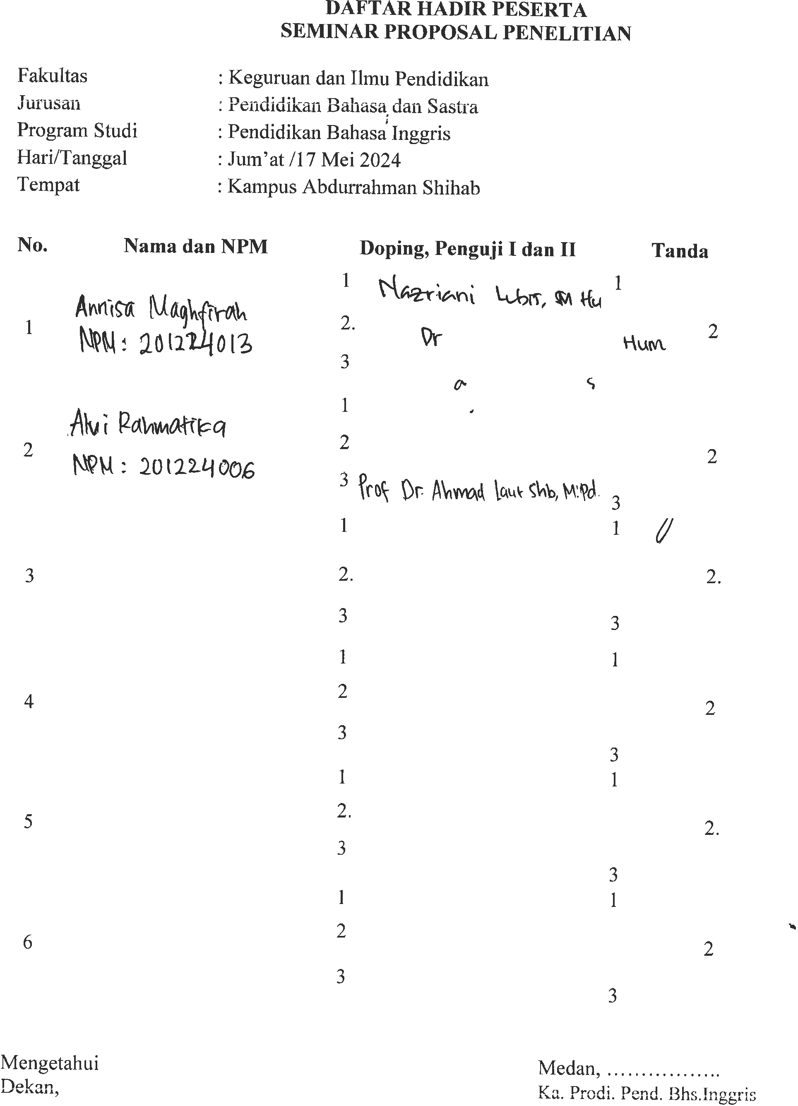

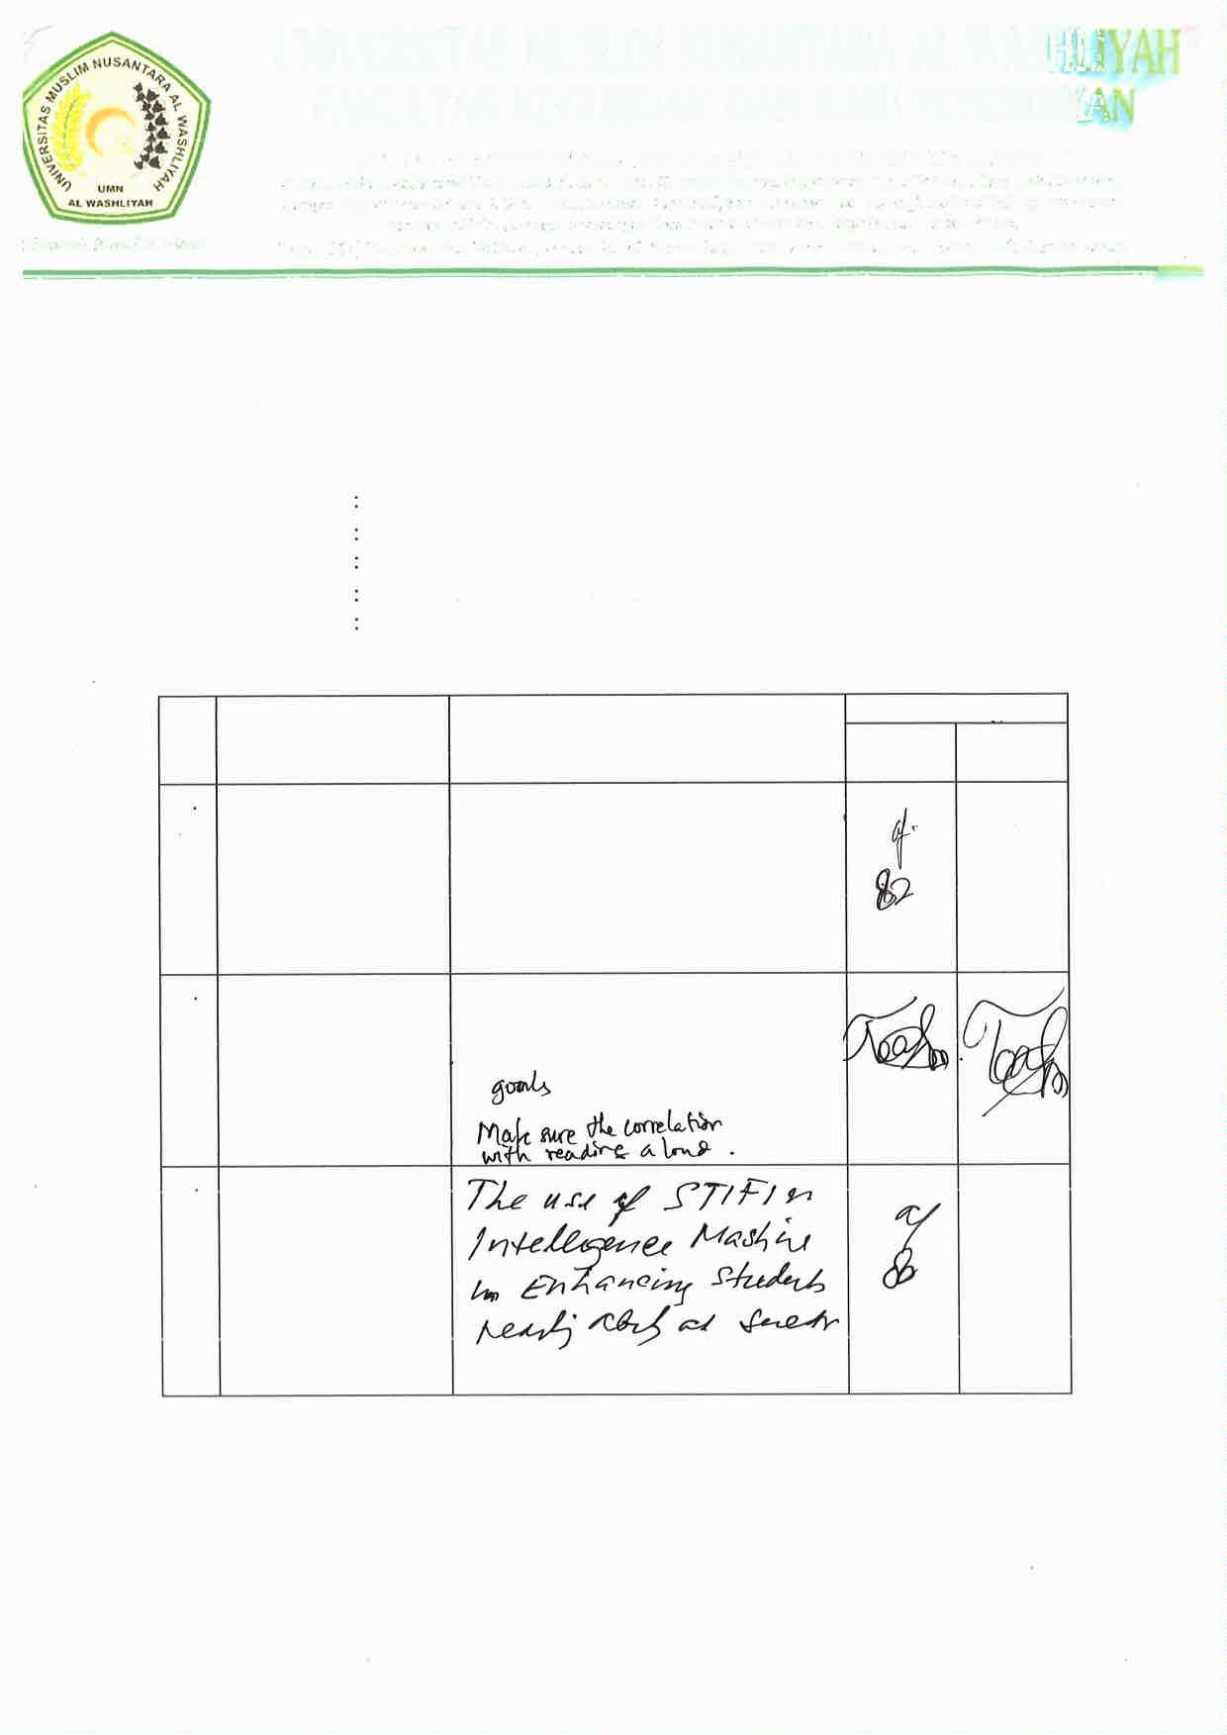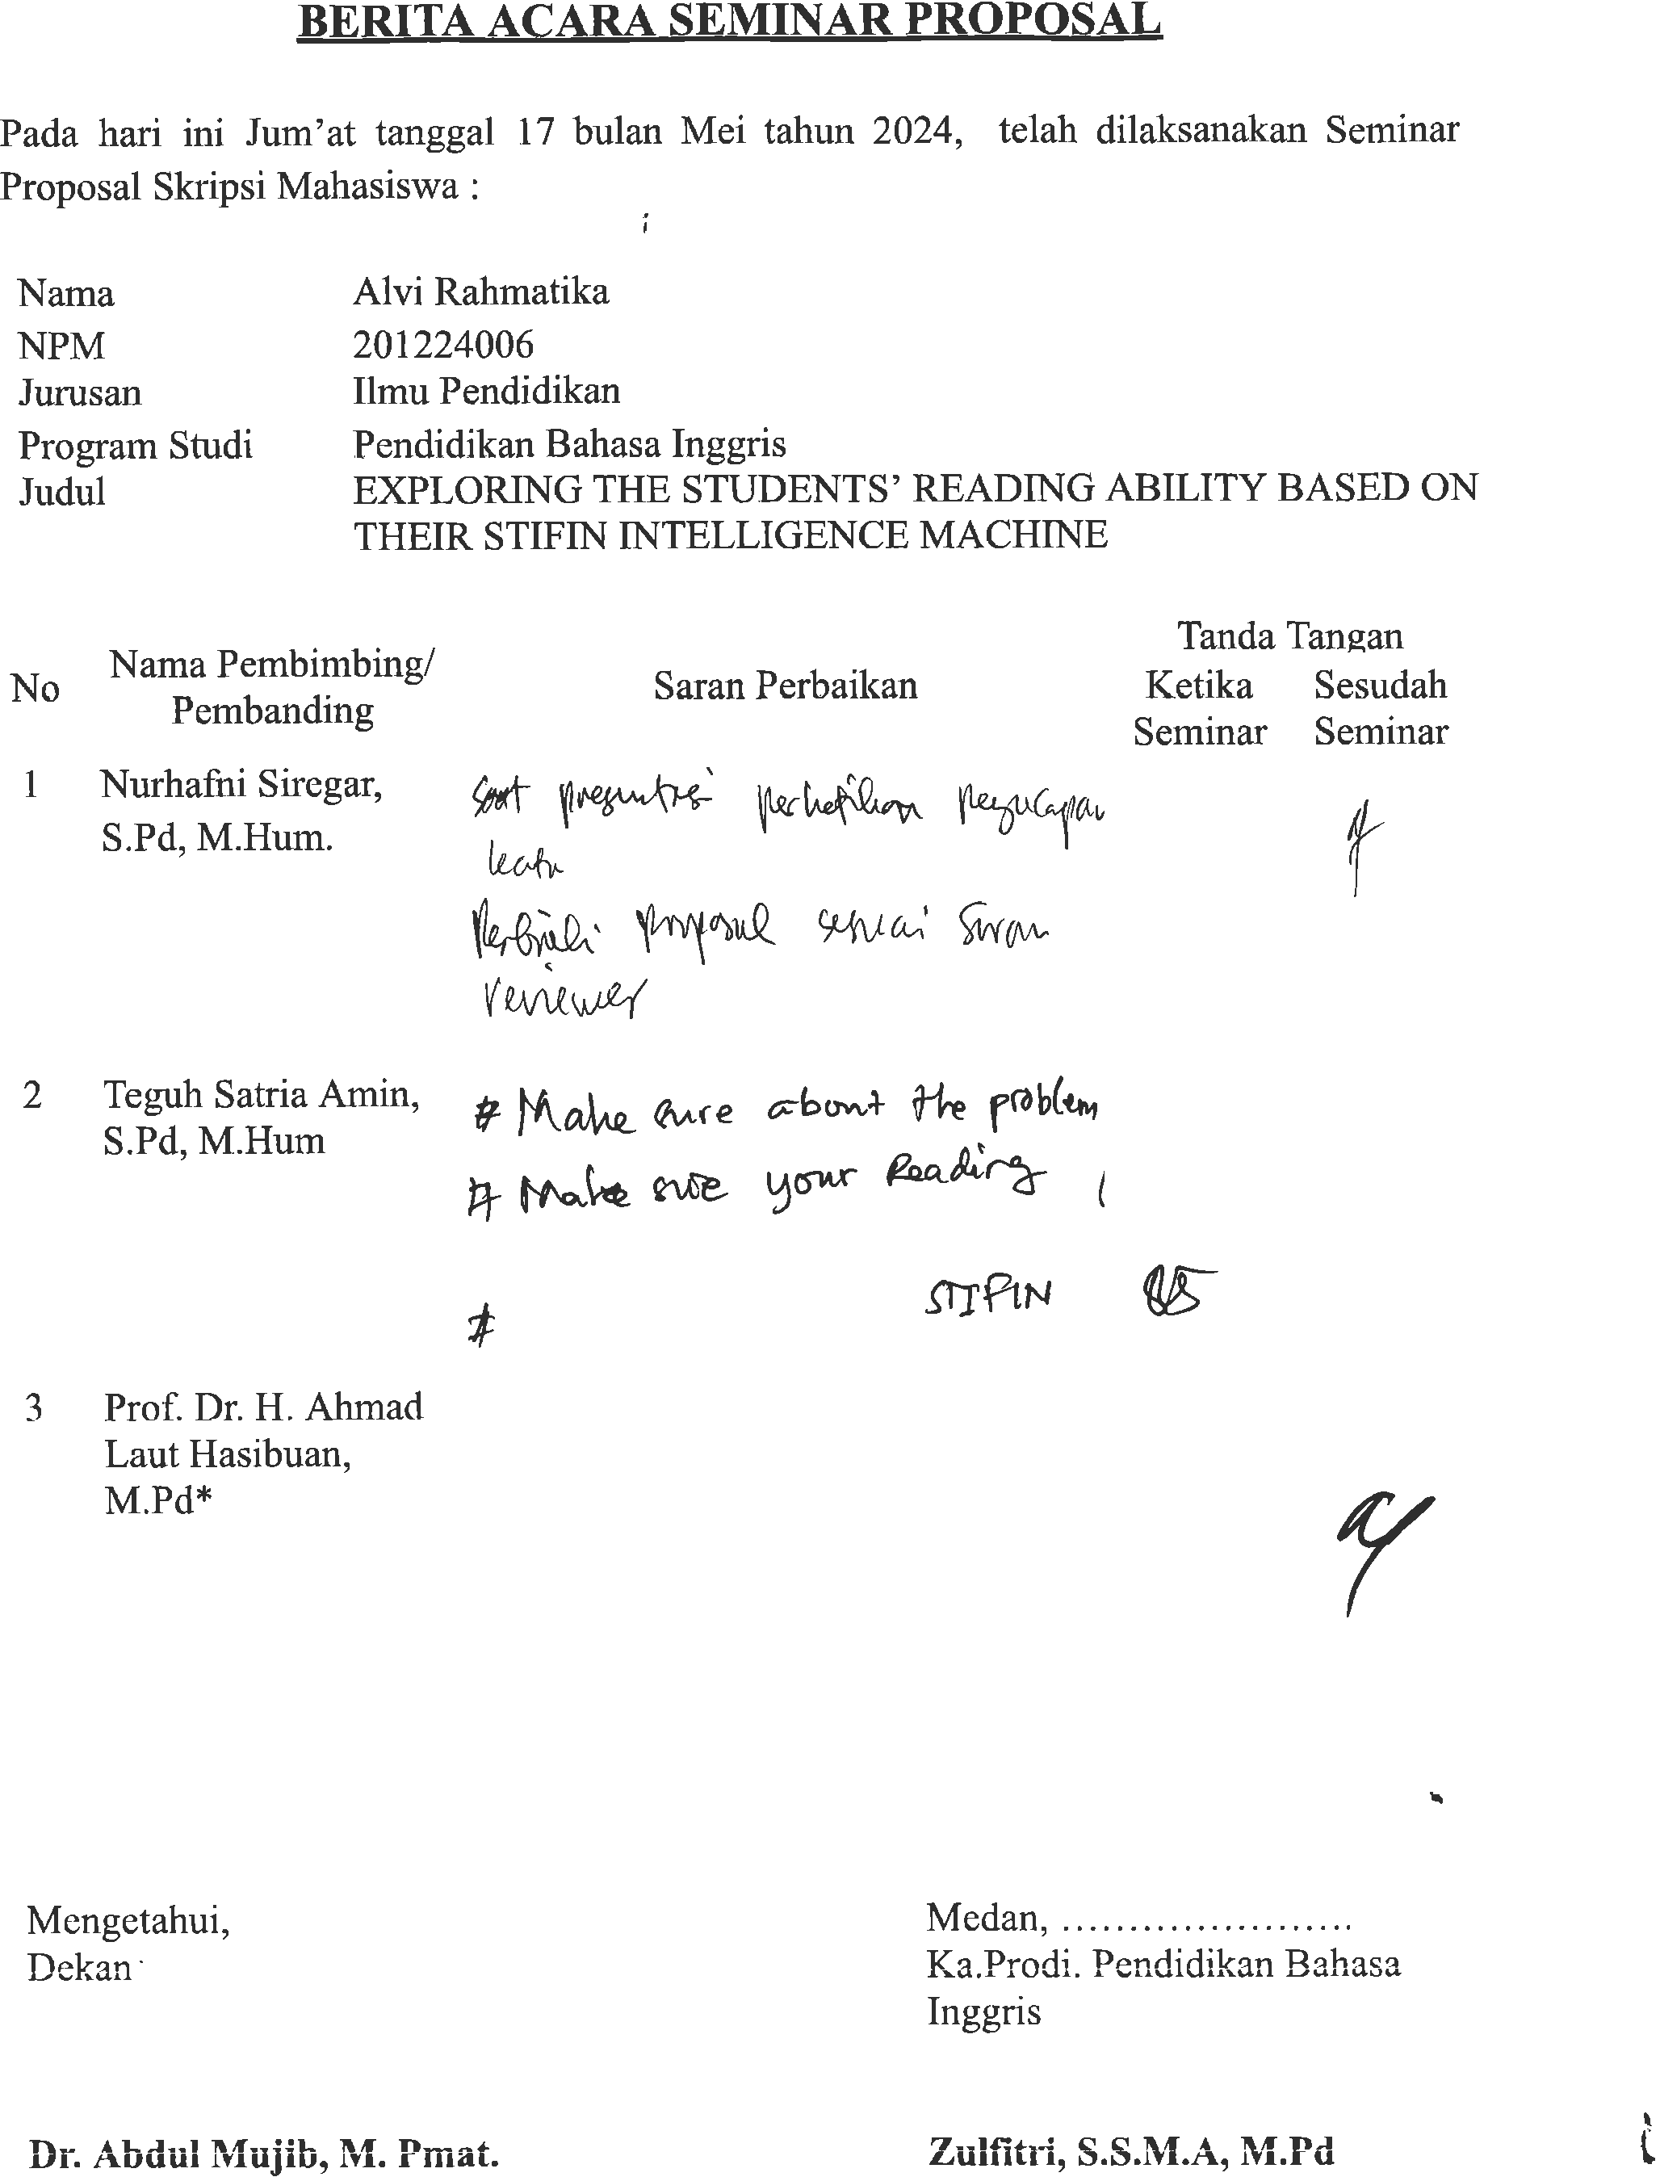

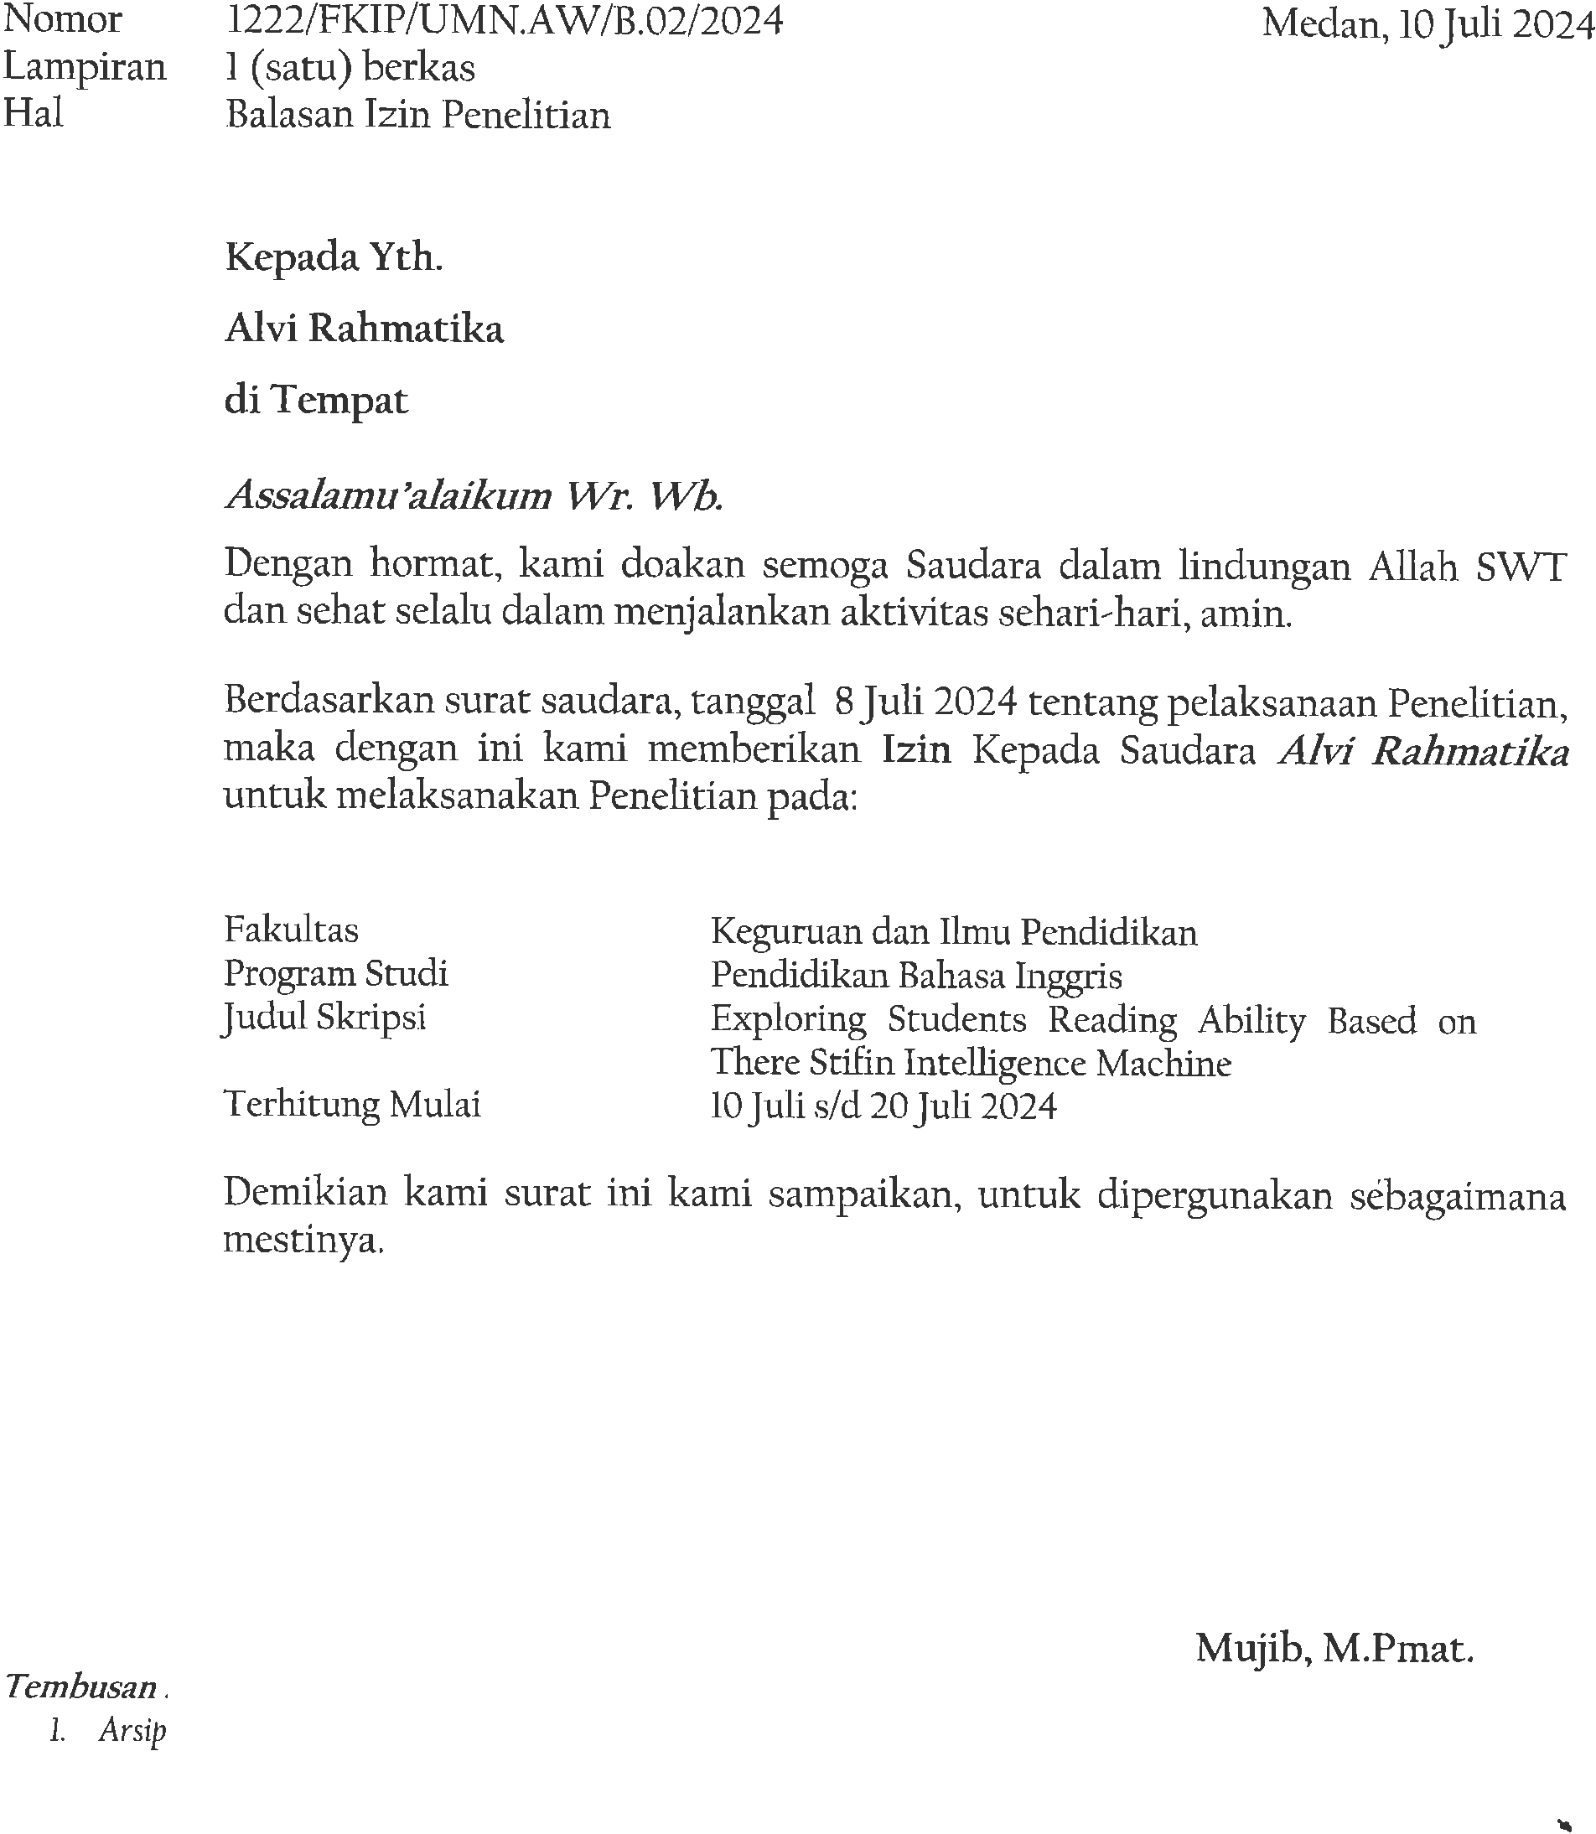

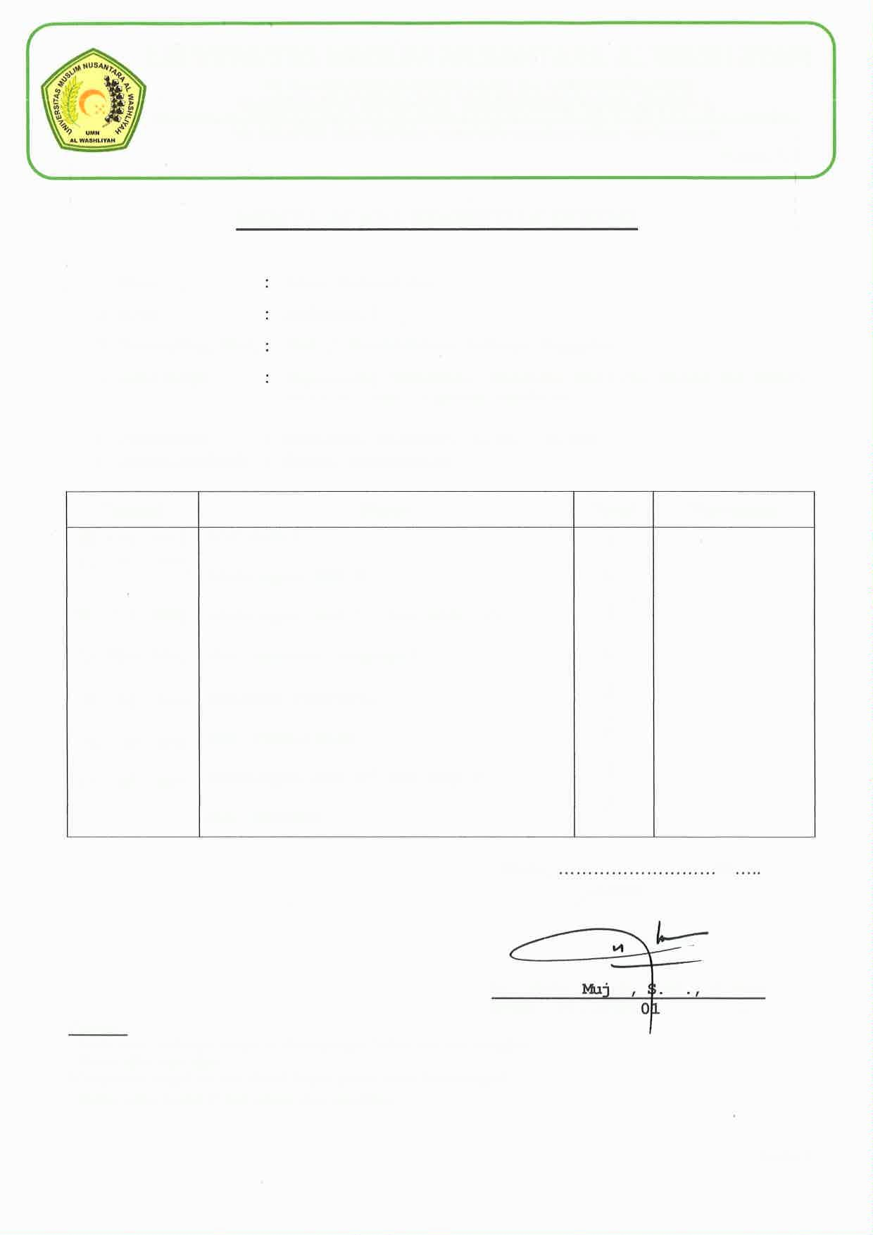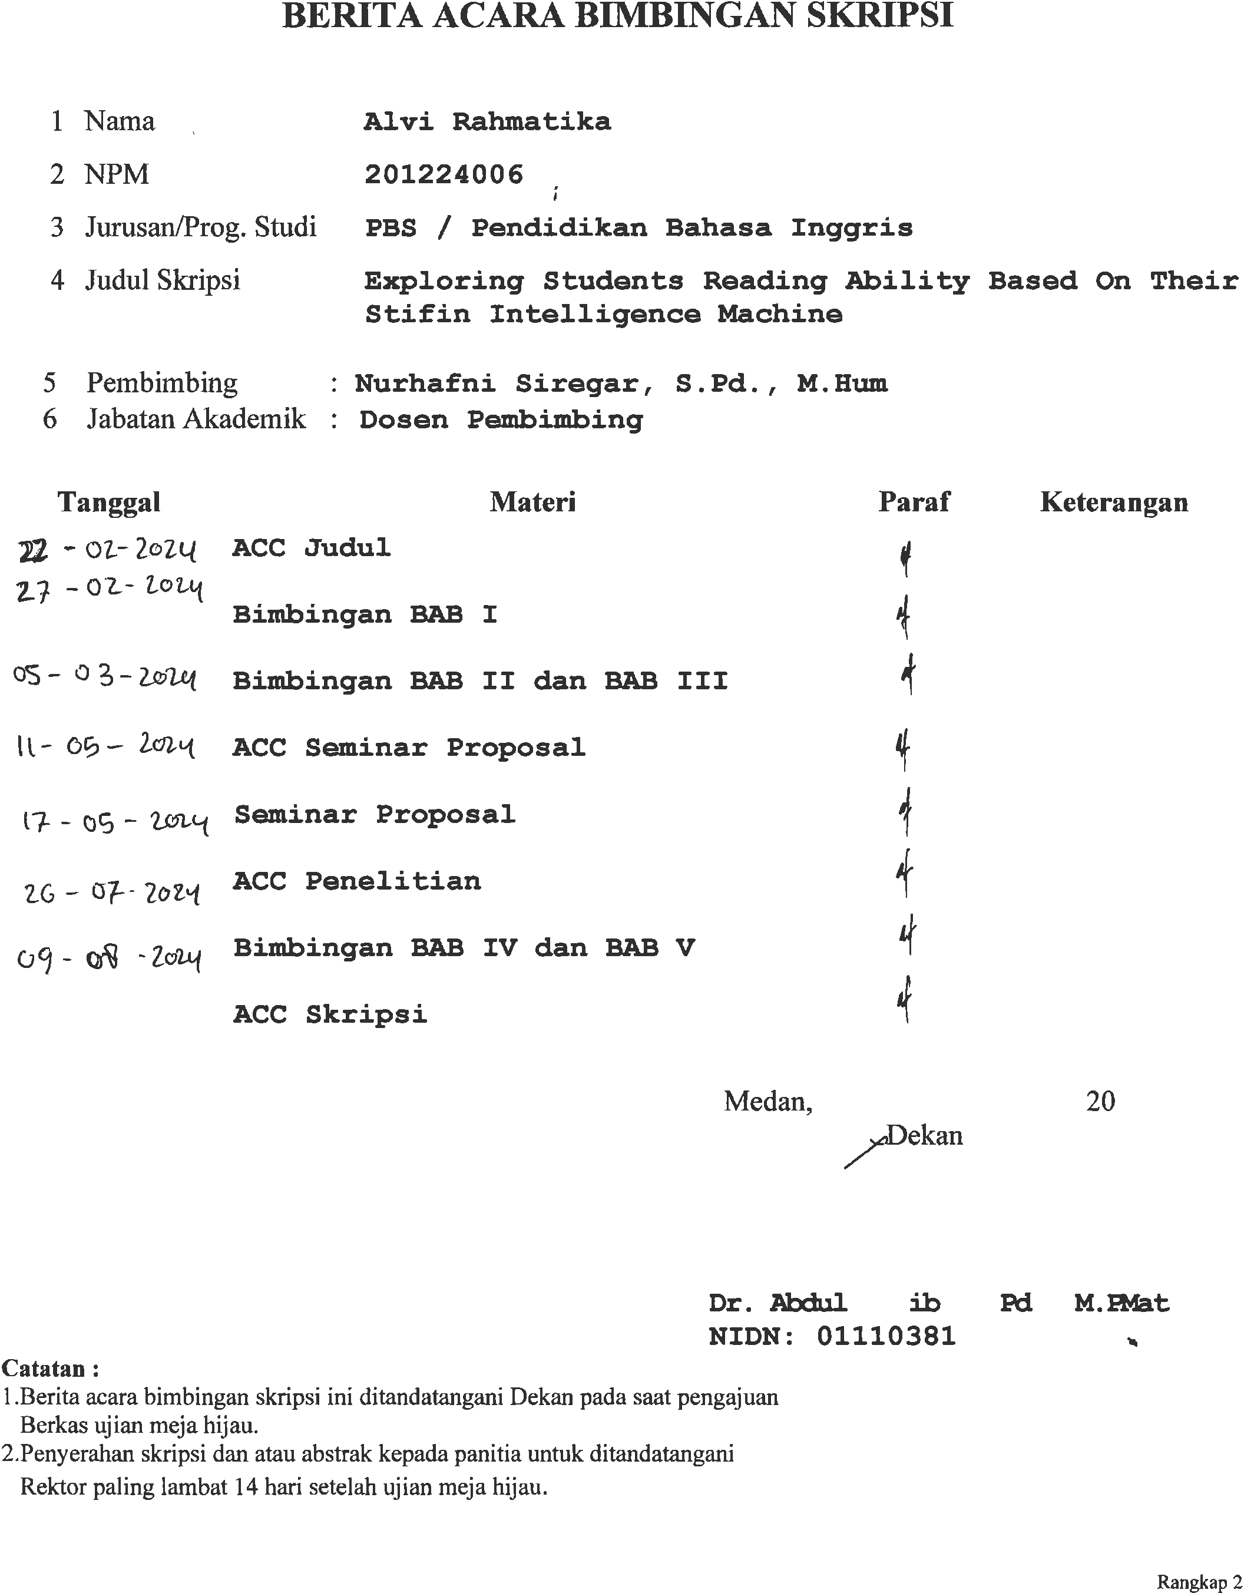

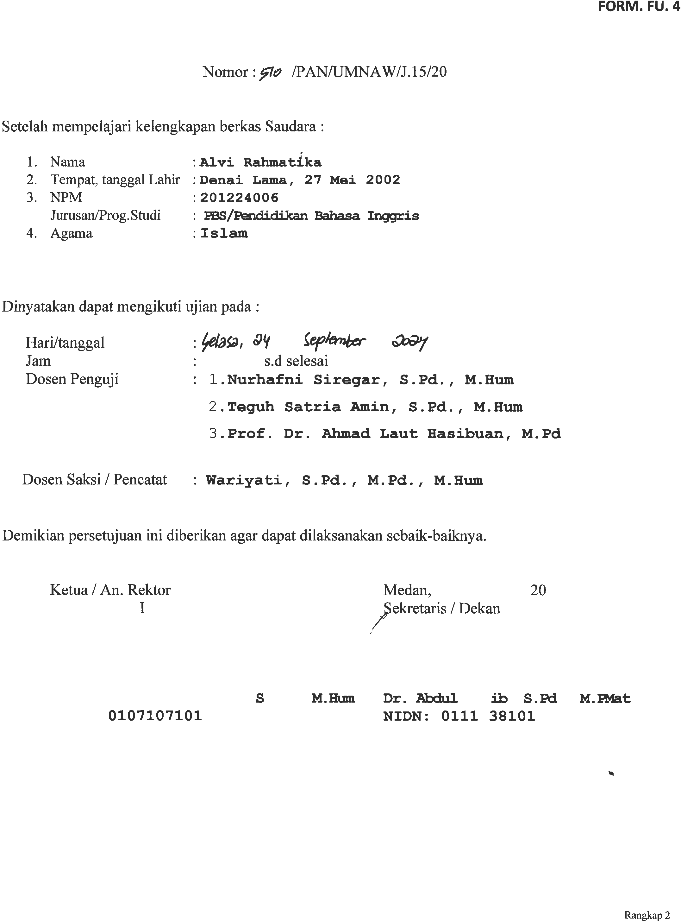

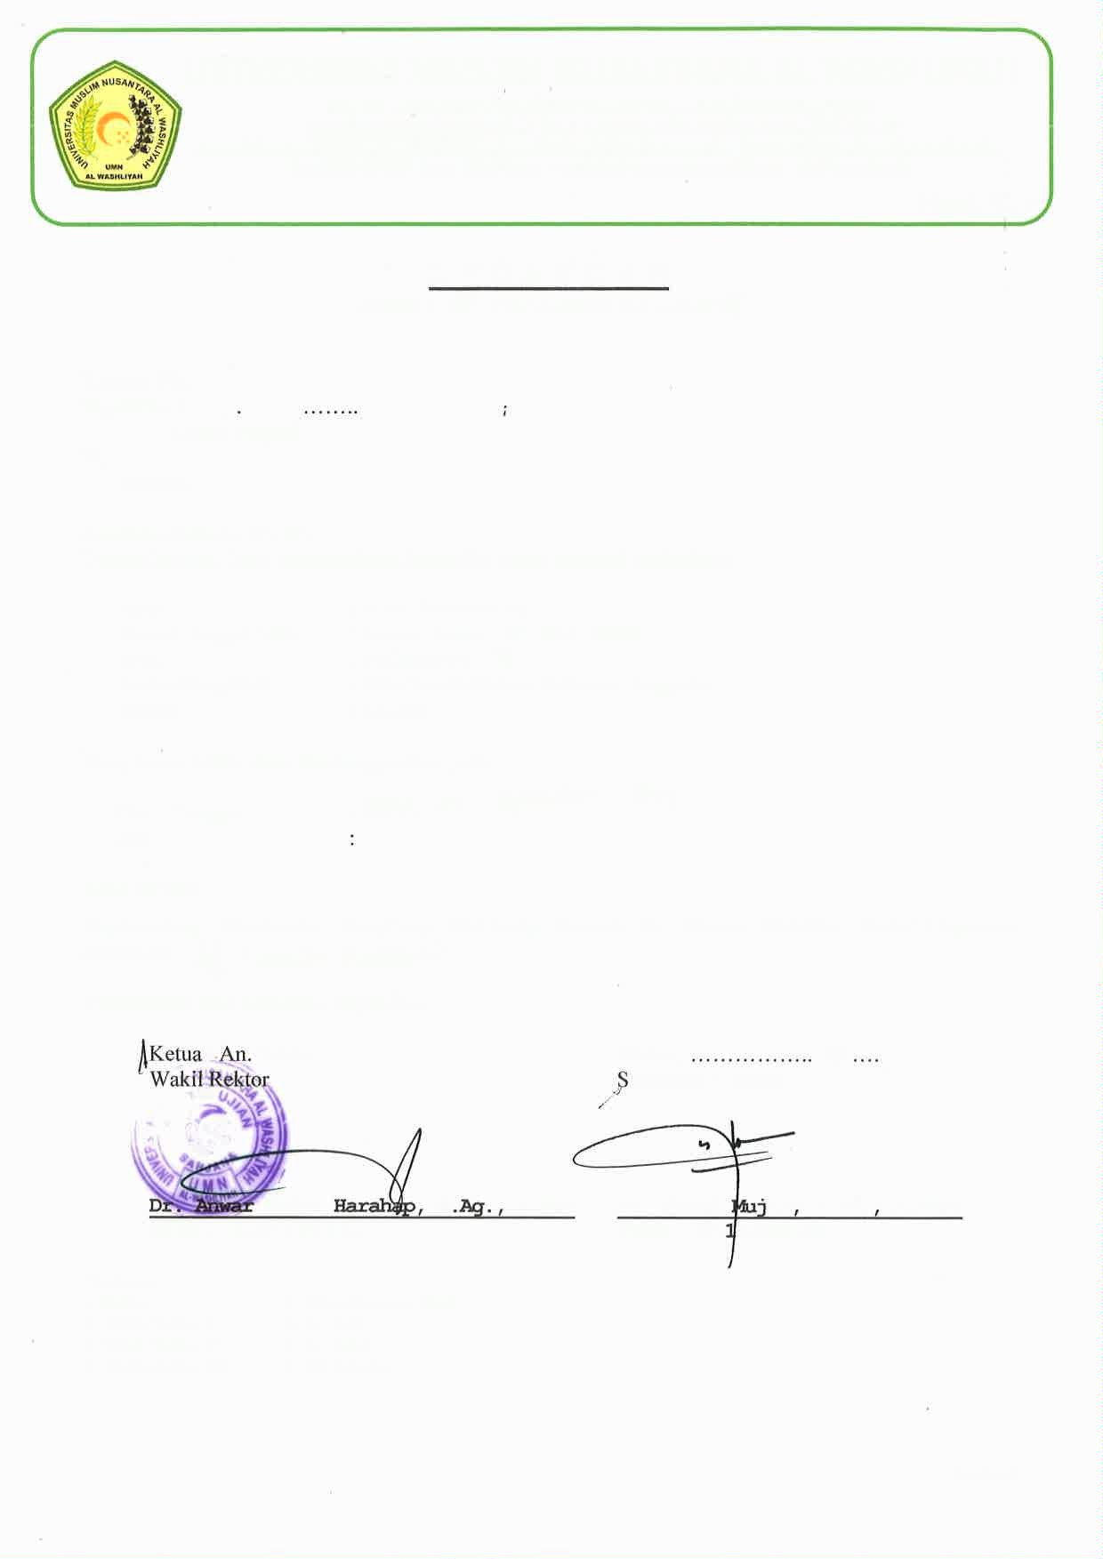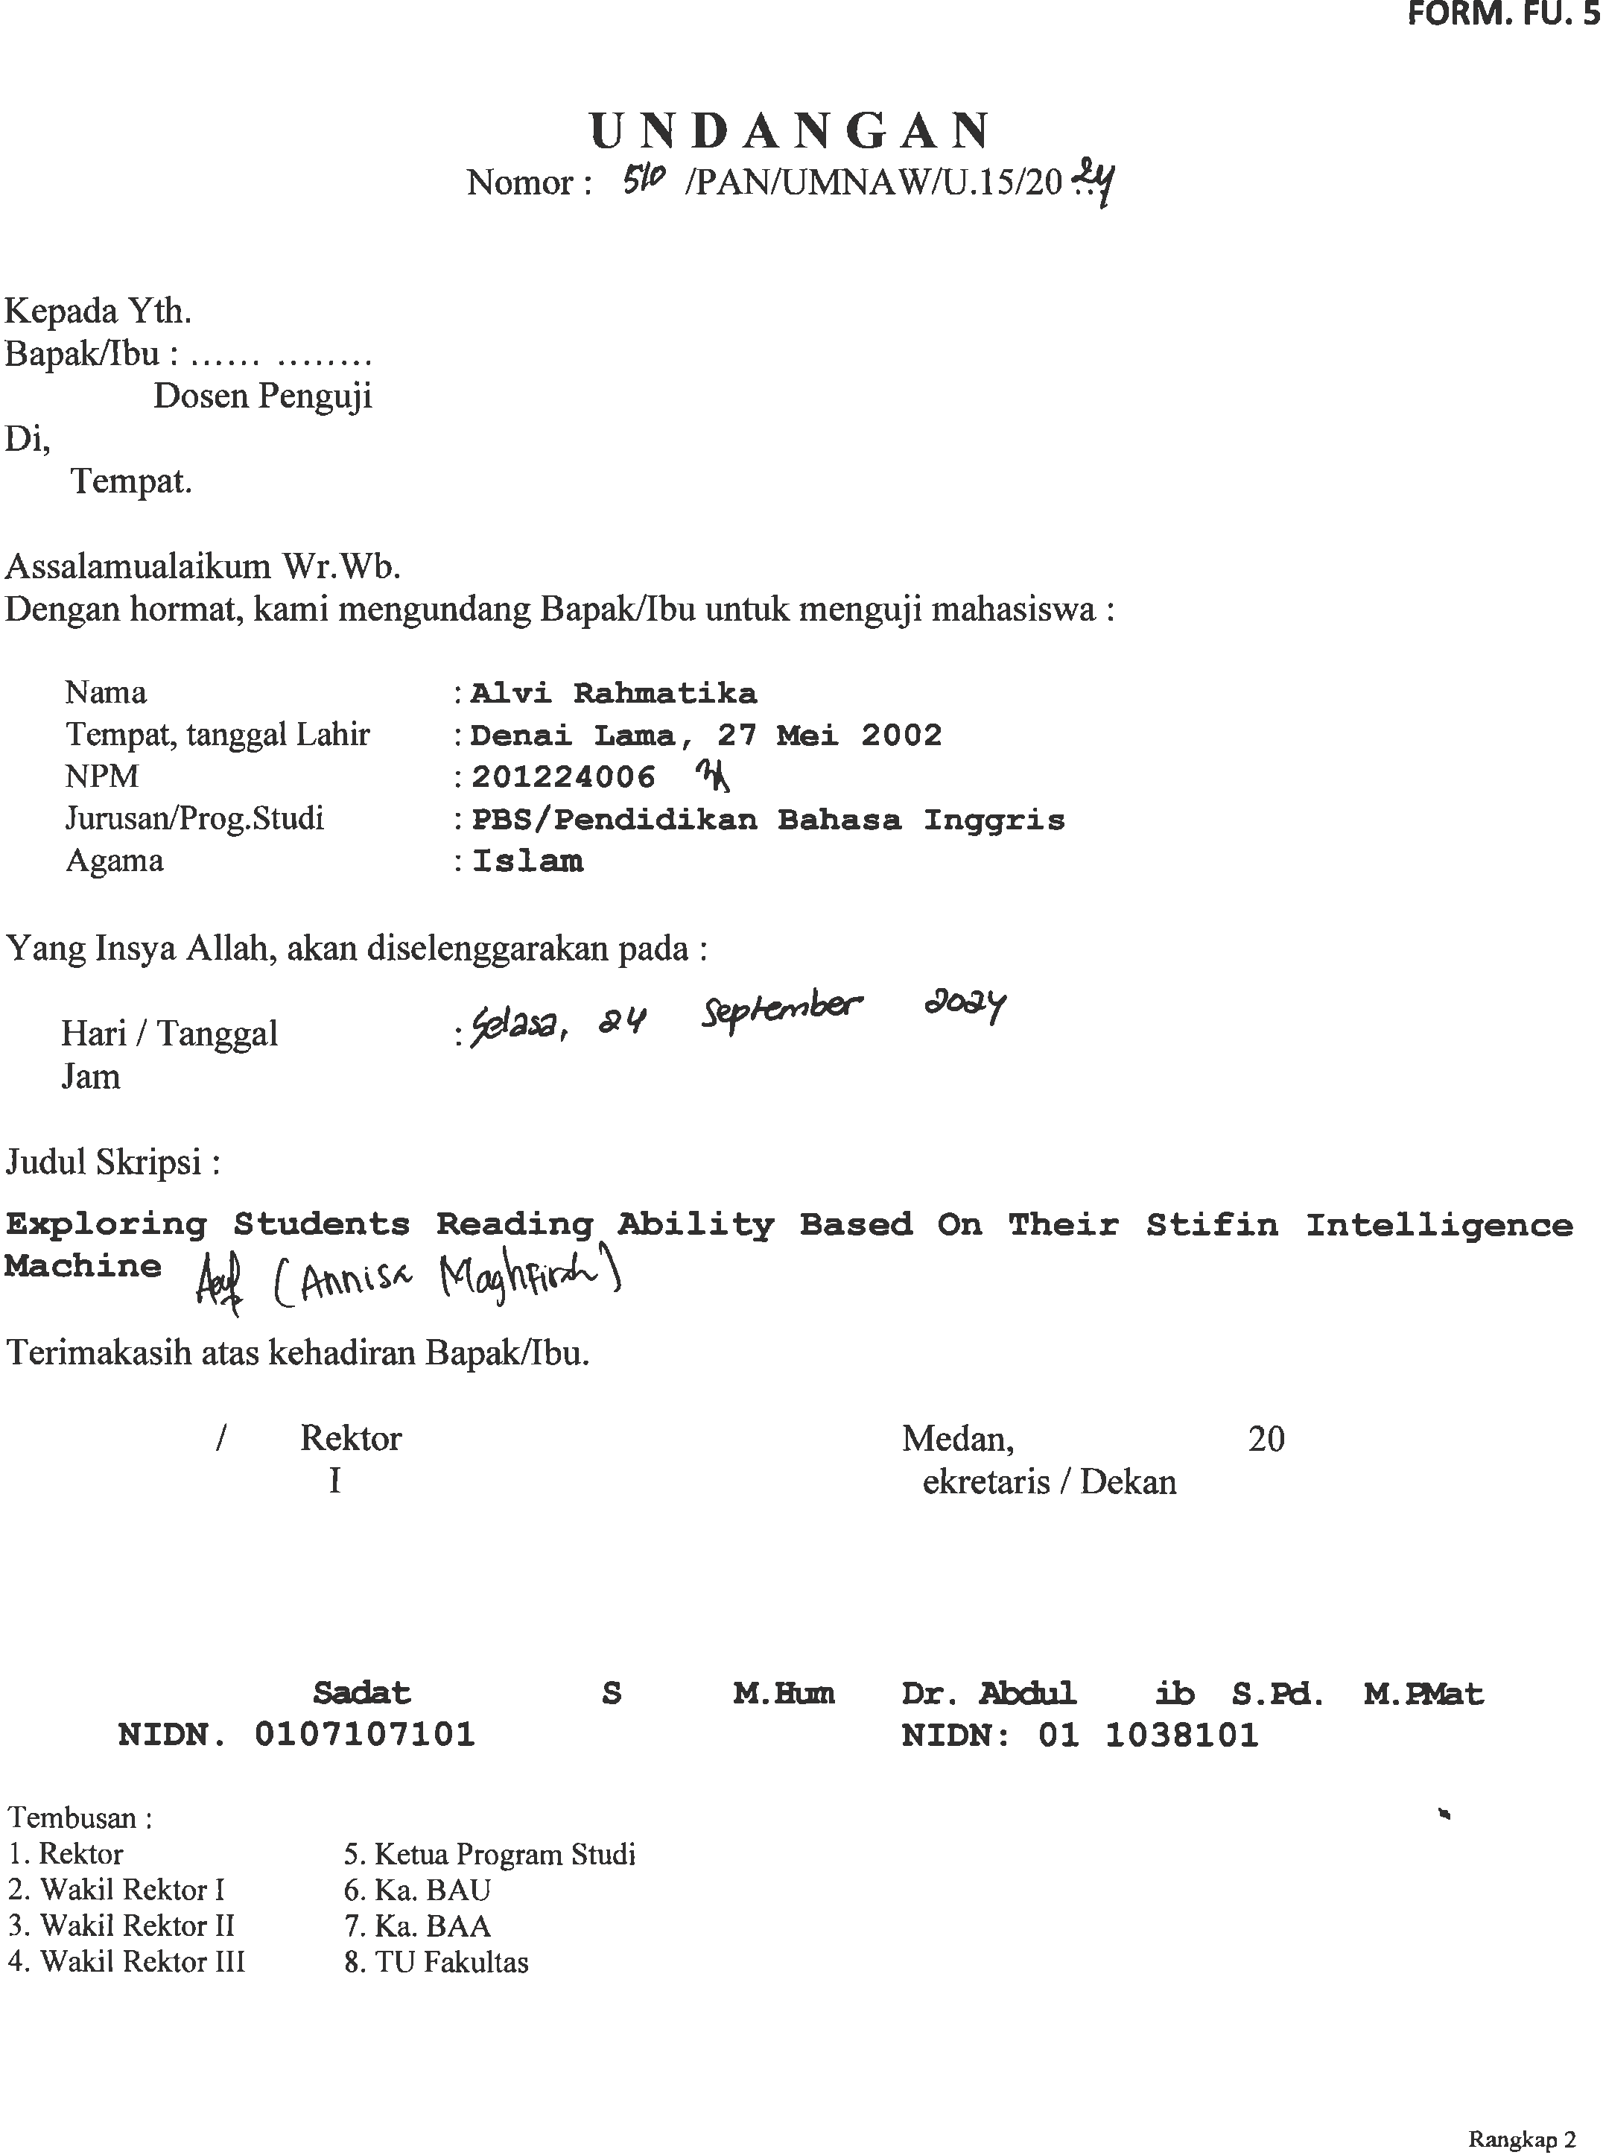

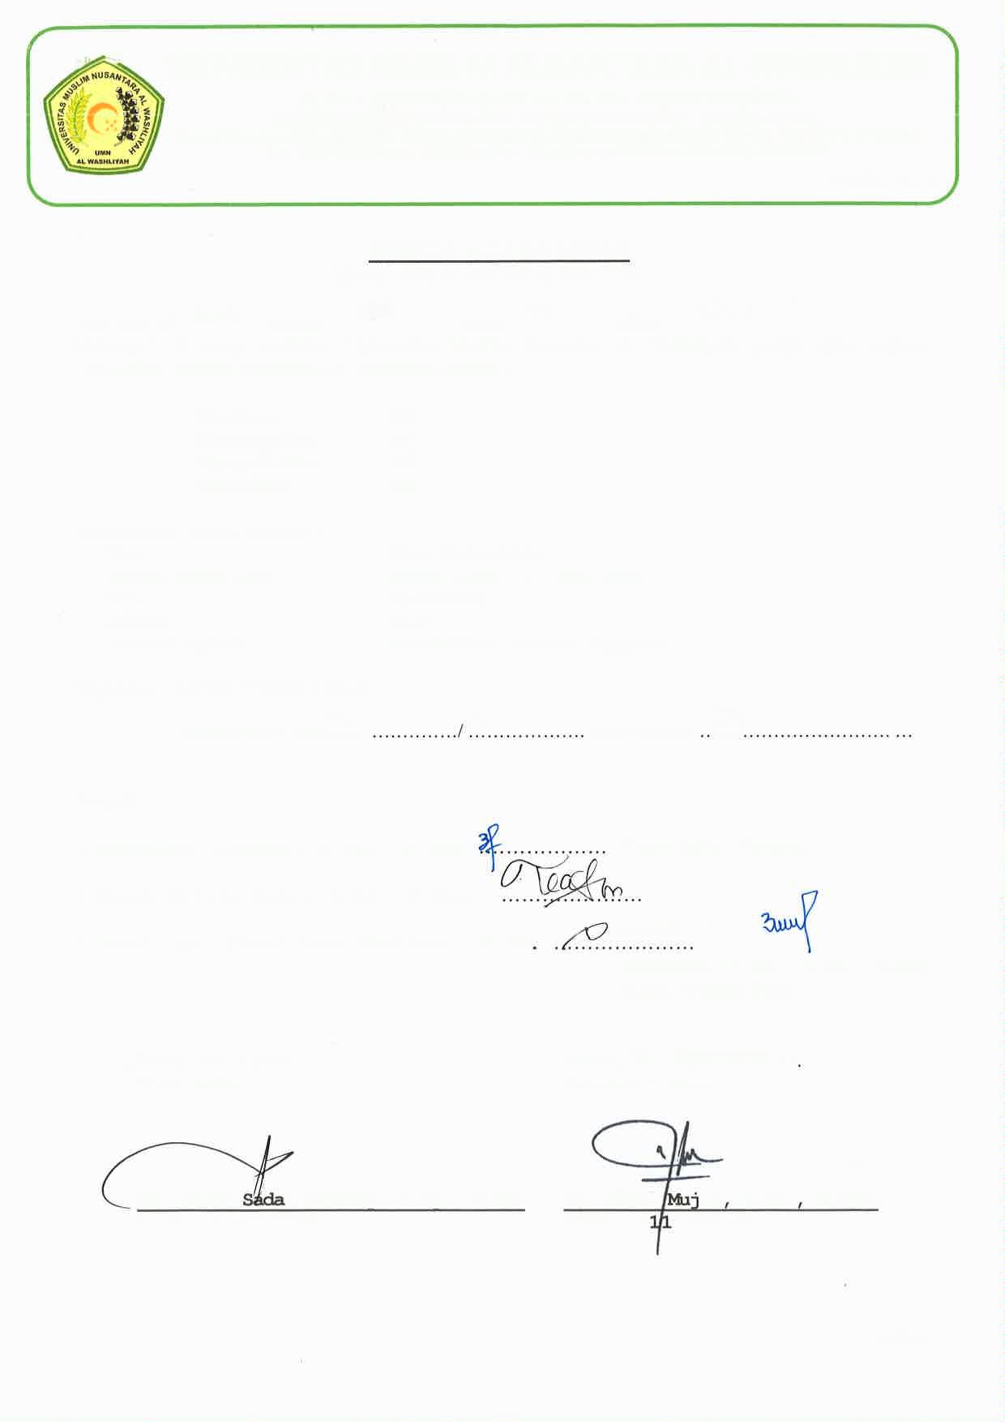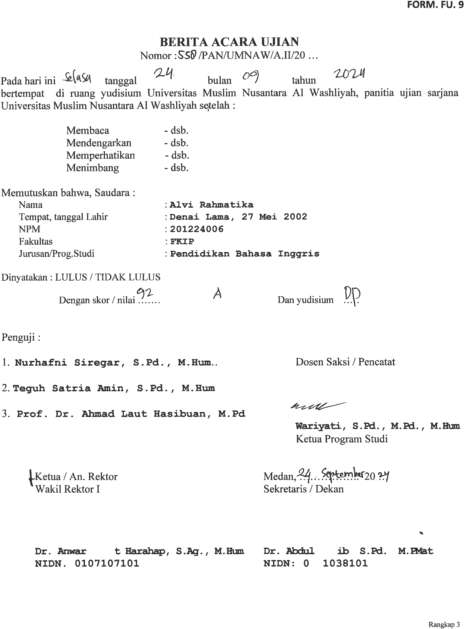

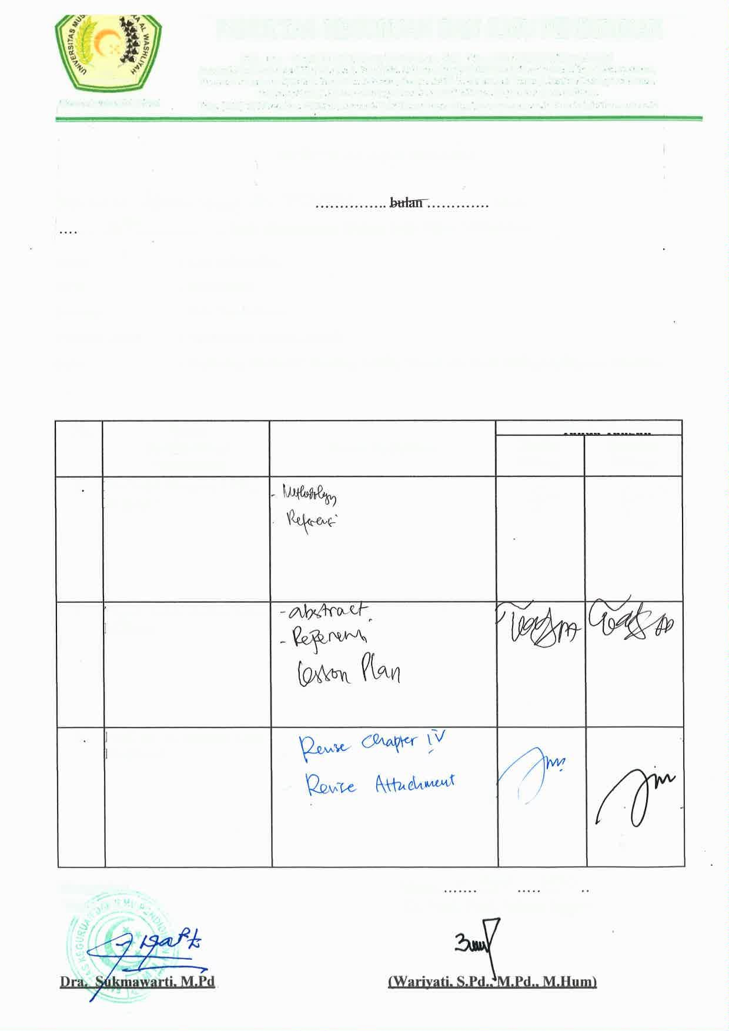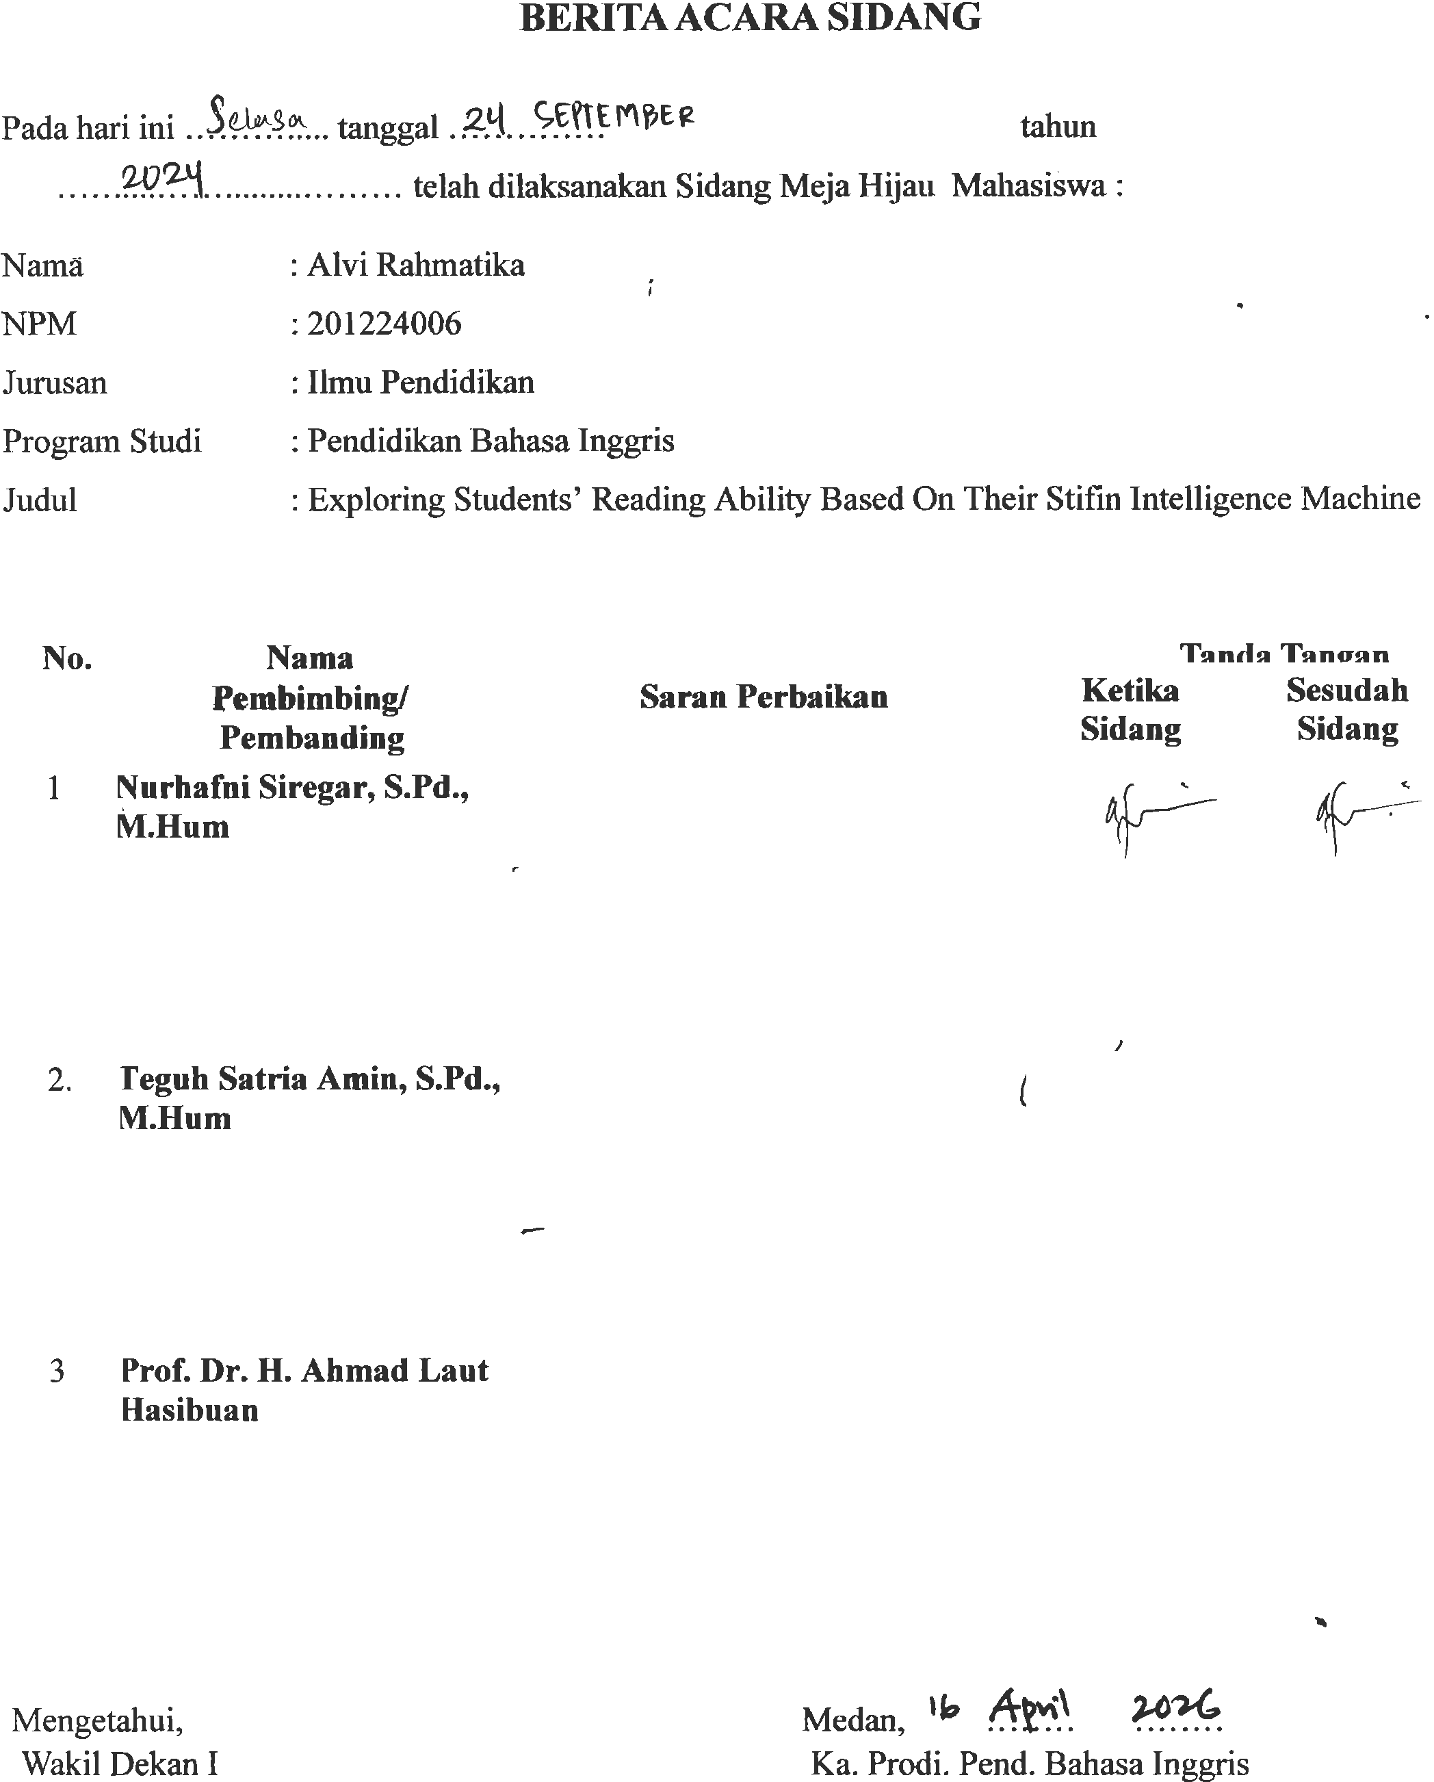

BIODATAMAHASISWA

1.IDENTITASDIRI
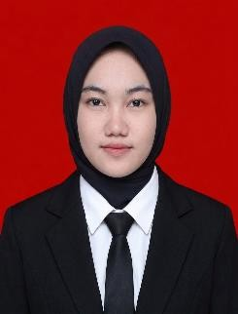
Nama : Alvi Rahmatika
NPM 201224006
Tempat/T.Lahir :DenaiLama,27Mai 2002
JenisKelamin : Perempuan
Agama : Islam
Status :Belum Menikah
Pekerjaan : -
AnakKe :2 Dari3 Bersaudara
Alamat :DenaiLama,Kec.Pantai Labu
No.Telp/Hp :0821-7478-6535
Dosen Pembimbing :NurhafniSiregar,S.Pd, M.Hum
Judul Skripsi :“ExploringTheStudents’ ReadingAbilityBased On
TheirSTIFINInteligence Machine”

II.PENDIDIKAN
SD :SDNegeri105344Denai Lama
SMP :SMPNegeri4PantaiLabu
SMA :SMKNegeri 1Lubuk Pakam

III.ORANGTUA
Nama Ayah :HeriSumanto
Pekerjaan : Petani
NamaIbu :Herna Novita
Pekerjaan :IbuRumahTangga

Alamat : Desa Denai Lama, Kec. Pantai Labu Medan,20April2026

Alvi Rahmatika

