DAFTAR PUSTAKA
Abbas, A. A., Shakir, K. A., & Walsh, M. K. (2022). Functional properties of collagen extracted from catfish (Silurus triostegus) waste. Foods, 11(5), 633.
Abu Elella, M. H., Al Khatib, A. O., & Al-Obaidi, H. (2024). Spray-dried nanolipid powders for pulmonary drug delivery: a comprehensive mini review. Pharmaceutics, 16(5), 680.
Aerssens, J., Dequeker, J., & Mbuyi-Muamba, J. M. (1994). Bone tissue composition: biochemical anatomy of bone. Clinical rheumatology, 13, 54-62.
Alam, M. A. U., Kassu, A., & Kassama, L. (2023). Effect of sonication time and surfactant concentration on improving the bio-accessibility of lycopene synthesized in poly-lactic co-glycolic acid nanoparticles. arXiv preprint arXiv:2301.10850.
Alishlah, T. (2014). Pengaruh Trietanolamin terhadap Karakteristik Fisika Kimia dan Laju Pelepasan Ibuprofen dalam Sediaan Gel Dispersi Padat Ibuprofen-PEG 6000.
Awal S, A. S. (2021). Isolasi dan karakterisasi kolagen dari kulit ikan tawes (Barbonymus gonionotus) (Doctoral dissertation, Universitas Hasanuddin).
Avila Rodríguez, M. I., Rodríguez Barroso, L. G., & Sánchez, M. L. (2018). Collagen: A review on its sources and potential cosmetic applications. Journal of cosmetic dermatology, 17(1), 20-26.
Baek, G. H., Yoo, K. M., Kim, S. Y., Lee, D. H., Chung, H., Jung, S. C., & Kim, J. S. (2023). Collagen peptide exerts an anti-obesity effect by influencing the firmicutes/bacteroidetes ratio in the gut. Nutrients, 15(11), 2610.
Barai, A. A., Inhamuns, A. J., Nóbrega, T. C., Guimarães, C. C., dos Santos Mourão, L., de Souza, A. F. L., & de Oliveira, A. T. (2025). Extraction of collagen from by-products of Amazonian fish tambaqui, Colossoma macropomum and pirarucu Arapaima gigas. Applied Food Research, 100720.
Barzkar, N., Sukhikh, S., Babich, O., Venmathi Maran, B. A., & Tamadoni Jahromi, S. (2023). Marine collagen: purification, properties and application. Frontiers in Marine Science, 10, 1245077.
Bhardwaj, B. Y., Vihal, S., Pahwa, R., Agarwal, S., Gupta, B., Yang, J. C., & Negi, P. (2024). Recent advancements in xanthan gum-based gastroretentive floating formulations: Chemical modification, production and applications. Carbohydrate Polymers, 122809.
Bombaldi de Souza, R. F., Bombaldi de Souza, F. C., Westin, C. B., Barbosa, R. M., & Moraes, Â. M. (2021). Xanthan Gum for Regenerative Medicine. In Polysaccharides of Microbial Origin: Biomedical Applications (pp. 1-29). Cham: Springer International Publishing.
Bonnaterre, P. J. (1788). Tableau encyclopédique et méthodique des trois règnes de la nature : Icthyologie. chez Panckoucke libraire.
Brand-Williams, W., Cuvelier, M. E., & Berset, C. L. W. T. (1995). Use of a free radical method to evaluate antioxidant activity. LWT-Food science and Technology, 28(1), 25-30.
Burhanis, B., Bengen, D. G., & Baskoro, M. S. (2018). Karakter morfometrik dan asosiasi tuna sirip kuning Thunnus albacares dan tuna bambulo Gymnosarda unicolor (Ruppell) di perairan Simeulue, Provinsi Aceh. Jurnal Ilmu dan Teknologi Kelautan Tropis, 10(2), 455-466.
Chen, J., Burger, C., Krishnan, C. V., Chu, B., Hsiao, B. S., & Glimcher, M. J. (2005). In vitro mineralization of collagen in demineralized fish bone. Macromolecular Chemistry and Physics, 206(1), 43-51.
Cholakova, D., Vinarov, Z., Tcholakova, S., & Denkov, N. D. (2022). Self-emulsification in chemical and pharmaceutical technologies. Current Opinion in Colloid & Interface Science, 59, 101576.
Comfort, N., Cai, K., Bloomquist, T. R., Strait, M. D., Ferrante Jr, A. W., & Baccarelli, A. A. (2021). Nanoparticle tracking analysis for the quantification and size determination of extracellular vesicles. Journal of visualized experiments: JoVE, (169), 10-3791.
Cortes, H., Caballero-Florán, I. H., Mendoza-Muñoz, N., Escutia-Guadarrama, L., Figueroa-González, G., Reyes-Hernández, O. D., & Leyva-Gómez, G. (2020). Xanthan gum in drug release. Cellular and Molecular Biology, 66(4), 199-207.
Degobert, G., & Aydin, D. (2021). Lyophilization of nanocapsules: instability sources, formulation and process parameters. Pharmaceutics, 13(8), 1112.
Dewi, P. N. S., Reisa, I. A. N., & Sariningsih, P. A. (2024). POTENSI SERUM KOLAGEN KULIT IKAN TUNA SEBAGAI ANTIAGING DALAM RANGKA SAINTIFIKASI LONTAR USADHA BALI BERBASIS ETHNOMEDICINE. Prosiding Pekan Ilmiah Pelajar (PILAR), 4, 150-162.
Di, Y. U., Chang-Feng, C. H. I., Bin, W. A. N. G., Guo-Fang, D. I. N. G., & Zhong-Rui, L. I. (2014). Characterization of acid-and pepsin-soluble collagens from spines and skulls of skipjack tuna (Katsuwonus pelamis). Chinese Journal of Natural Medicines, 12(9), 712-720.
Eckert, E., Jäger, T., Hiller, J., Leibold, E., Bader, M., & Göen, T. (2024). Biotransformation and toxicokinetics of 2-phenoxyethanol after oral exposure in humans: a volunteer study. Archives of Toxicology, 98(6), 1771-1780.
Evans, M., Lewis, E. D., Zakaria, N., Pelipyagina, T., & Guthrie, N. (2021). A randomized, triple‐blind, placebo‐controlled, parallel study to evaluate the efficacy of a freshwater marine collagen on skin wrinkles and elasticity. Journal of cosmetic dermatology, 20(3), 825-834.
Farooq, S., Ahmad, M. I., Zheng, S., Ali, U., Li, Y., Shixiu, C., & Zhang, H. (2024). A review on marine collagen: sources, extraction methods, colloids properties, and food applications. Collagen and Leather, 6(1), 11.
Fatiroi, N. S., Jaziri, A. A., Shapawi, R., Mokhtar, R. A. M., Noordin, W. N. M., & Huda, N. (2023). Biochemical and Microstructural Characteristics of Collagen Biopolymer from Unicornfish (Naso reticulatus Randall, 2001) Bone Prepared with Various Acid Types. Polymers, 15(4), 1054.
Febrianto, M. R. (2025, February). PEMANFAATAN ARTIFICIAL INTELLIGENCE UNTUK MENGIDENTIFIKASI DAN MENGATASI MASALAH KESEHATAN KULIT WAJAH. In Prosiding Seminar Nasional Sains dan Teknologi" SainTek" (Vol. 2, No. 1, pp. 712-720).
Filippov, S. K., Khusnutdinov, R., Murmiliuk, A., Inam, W., Zakharova, L. Y., Zhang, H., & Khutoryanskiy, V. V. (2023). Dynamic light scattering and transmission electron microscopy in drug delivery: a roadmap for correct characterization of nanoparticles and interpretation of results. Materials horizons, 10(12), 5354–5370.
Fitria, N., & Ratu, A. P. (2022). Karakteristik dan stabilitas sediaan serum ekstrak buah kersen (Muntingia calabura L.) dengan variasi konsentrasi. Jurnal Farmamedika (Pharmamedika Journal), 7(1), 17-27.
Geahchan, S., Baharlouei, P., & Rahman, A. (2022). Marine collagen: a promising biomaterial for wound healing, skin anti-aging, and bone regeneration. Marine drugs, 20(1), 61.
Gong, Y., Chen, X., & Wu, W. (2024). Application of fourier transform infrared (FTIR) spectroscopy in sample preparation: Material characterization and mechanism investigation. Advances in Sample Preparation, 11, 100122.
Grubbs, J., Tsaknopoulos, K., Massar, C., Young, B., O'Connell, A., Walde, C., & Cote, D. (2021). Comparison of laser diffraction and image analysis techniques for particle size-shape characterization in additive manufacturing applications. Powder Technology, 391, 20-33.
Hamdi, N. A. M., Azmi, N. A., Sabari, N. H. M., Harun, A. F., & Haris, M. S. (2023). An insight into the use and advantages of Carbopol in topical mucoadhesive drug delivery system: A systematic review. Journal of Pharmacy, 3(1), 53-65.
Handaratri, A., & Hudha, M. I. (2021). Ekstraksi Kolagen dari Ikan Tuna Sirip Kuning dengan Bantuan Microwave. Reka Buana: Jurnal Ilmiah Teknik Sipil dan Teknik Kimia, 6(2), 104-111.
He, J., Shi, R., & Ji, R. (2023). Effect of ultrasound pre-treatment on extraction and characterization of collagen from bactrian camel skin. Polymers, 15(8), 1943.
Husna, M., Lubis, M. S., Dalimunthe, G. I., & Rani, Z. (2025). FORMULASI DAN EVALUASI MASKER GEL PEEL-OFF NANOEKSTRAK BONGGOL NANAS (Ananas comosus (L.) Merr) SEBAGAI ANTI-AGING. JURNAL FARMASI, SAINS, dan KESEHATAN, 5(1), 13-24
Hussain, R., Alican Noyan, M., Woyessa, G., Retamal Marín, R. R., Antonio Martinez, P., Mahdi, F. M., & Pruneri, V. (2020). An ultra-compact particle size analyser using a CMOS image sensor and machine learning. Light: Science & Applications, 9(1), 21.
Islam, J., & Mis Solval, K. E. (2025). Recent Advancements in Marine Collagen: Exploring New Sources, Processing Approaches, and Nutritional Applications. Marine Drugs, 23(5), 190.
Jaziri, A. A., Shapawi, R., Mokhtar, R. A. M., Noordin, W. N. M., & Huda, N. (2022). Biochemical analysis of collagens from the bone of lizardfish (Saurida tumbil Bloch, 1795) extracted with different acids. PeerJ, 10, e13103.
Karlina, S., & Chaidir, F. Y. (2022). The formulation of nanoemulsion serum-containing Gotu Kola extract (Centella Asiatica L. urban) and chia seed oil (Salvia Hispanica) for skin hydration effect. Int. J. Appl. Pharm, 14, 79-83.
Krishnamoorthi, J., Ramasamy, P., Shanmugam, V., & Shanmugam, A. (2017). Isolation and partial characterization of collagen from outer skin of Sepia pharaonis (Ehrenberg, 1831) from Puducherry coast. Biochemistry and biophysics reports, 10, 39-45.
Kumar, R., Singh, A., & Garg, N. (2019). Acoustic cavitation-assisted formulation of solid lipid nanoparticles using different stabilizers. Acs Omega, 4(8), 13360-13370.
Leo, R., & Daulay, A. S. (2022). Penentuan Kadar Vitamin C Pada Minuman Bervitamin Yang Disimpan Pada Berbagai Waktu Dengan Metode Spektrofotometri UV. Journal of Health and Medical Science, 1(2), 105 115.
Lin, Q., Guo, Y., Li, J., He, S., Chen, Y., & Jin, H. (2023). Antidiabetic effect of collagen peptides from harpadon nehereus bones in streptozotocin-induced diabetes mice by regulating oxidative stress and glucose metabolism. Marine Drugs, 21(10), 518.
Liu, D., Liang, L., Regenstein, J. M., & Zhou, P. (2012). Extraction and characterisation of pepsin-solubilised collagen from fins, scales, skins, bones and swim bladders of bighead carp (Hypophthalmichthys nobilis). Food Chemistry, 133(4), 1441-1448.
Lu, S., Zhang, S., Wang, Y., Ni, J., Zhao, T., & Xiao, G. (2024). Anti-skin aging effects and bioavailability of collagen tripeptide and elastin peptide formulations in young and middle-aged women. Journal of Dermatologic Science and Cosmetic Technology, 1(2), 100019.
Lubis, M. S., Yuniarti, R., Rani, Z., Andjelie, T., & Zulhij, F. (2024). Potensi Antioksidan Dari Ekstrak Etanol Kulit Buah Asam Jawa (Tamarandus Indica L.) sebagai Anti Aging Dalam Sediaan Kosmetik Gel. Indonesian Journal of Pharmaceutical and Clinical Research, 7(1), 28-33.
Lubis, M. S., Asmarani, A., Yuniarti, R., & Nasution, H. M. (2024). The Antibacterial Activity Of Conventional Serum And Nano Face Serum From Pineapple Stem Extract (Ananas Comosus (L.) Merr) Against Staphylococcus Epidermidis. Jurnal Eduhealth, 15(02), 1149-1155.
Mann, R. A., Hossen, M. E., Withrow, A. D. M., Burton, J. T., Blythe, S. M., & Evett, C. G. (2024). Mesoporous Silica Nanoparticles-based Smart Nanocarriers for Targeted Drug Delivery in Colorectal Cancer Therapy. arXiv preprint arXiv:2409.18809.
Mazayen, Z. M., Ghoneim, A. M., Elbatanony, R. S., Basalious, E. B., & Bendas, E. R. (2022). Pharmaceutical nanotechnology: from the bench to the market. Future journal of pharmaceutical sciences, 8(1), 12.
McCormick, R. A., Ralbovsky, N. M., Gilbraith, W., Smith, J. P., & Booksh, K. S. (2024). Analyzing atomic force microscopy images of virus-like particles by expectation-maximization. npj Vaccines, 9(1), 112.
Mendake, R. A., Hatwar, P. R., Bakal, R. L., & Amalkar, S. V. (2024). Review on Nanogel as a Novel Platform for Smart Drug Delivery System. Journal of Drug Delivery & Therapeutics, 14(8).
Meng, H., Lin, W., Dong, Y., Li, L., Yi, F., Meng, Q.& He, Y. (2021). Statistical analysis of age-related skin parameters. Technology and Health Care, 29(1_suppl), 65-76.
Müller, D. J., Dumitru, A. C., Lo Giudice, C., Gaub, H. E., Hinterdorfer, P., Hummer, G. & Alsteens, D. (2020). Atomic force microscopy-based force spectroscopy and multiparametric imaging of biomolecular and cellular systems. Chemical reviews, 121(19), 11701-11725.
Myesha, I., Yuniarti, R., Lubis, M. S., & Rani, Z. (2025). Formulation And Evaluation Of Anti-Aging Face Spray Preparation From Ethanol Extract Of Rosemary Leaf (Salvia Rosmarinus Spenn.) And Antioxidant Activity Test Using The DPPH Method. Jurnal EduHealth, 16(01), 108-125.
Nasution, M. A., Andry, M., Lubis, M. F., Illian, D. N., Rani, Z., & Fauzi, Z. P. A. (2024). Phytochemical Analysis and Nanoparticle Formulations of Extracts Myristica fragrans Houtt Leaves as Antibacterial. Trends in Sciences, 21(10), 8335-8335.
Nilsuwan, K., Fusang, K., Pripatnanont, P., & Benjakul, S. (2022). Properties and characteristics of acid-soluble collagen from salmon skin defatted with the aid of ultrasonication. Fishes, 7(1), 51.
Nsengiyumva, E. M., & Alexandridis, P. (2022). Xanthan gum in aqueous solutions: Fundamentals and applications. International journal of biological macromolecules, 216, 583-604.
Nurdianti, L., Setiawan, F., Maya, I., Rusdiana, T., Kusumawulan, C. K., Gozali, D., & Virgianti, D. P. (2024). Formulation and Evaluation of Radiance Serum Containing Astaxanthin–Zeaxanthin Nanoemulsions as an Anti-Wrinkle Agent: Stability, Ex Vivo, and In Vivo Assessments. Cosmetics, 11(5), 182.
Nurhayati, N., Tazwir, T., & Murniyati, M. (2013). Ekstraksi dan Karakterisasi Kolagen Larut Asam dari Kulit Ikan Nila (Oreochromis niloticus). Jurnal Pascapanen dan Bioteknologi Kelautan dan Perikanan, 8(1), 84-92.
Nurilmala, M., Hizbullah, H. H., Karnia, E., Kusumaningtyas, E., & Ochiai, Y. (2020). Characterization and antioxidant activity of collagen, gelatin, and the derived peptides from yellowfin tuna (Thunnus albacares) skin. Marine drugs, 18(2), 98.
Oba, C., Ito, K., Ichikawa, S., Morifuji, M., Nakai, Y., Ishijima, T., & Kawahata, K. (2015). Effect of orally administered collagen hydrolysate on gene expression profiles in mouse skin: A DNA microarray analysis. Physiological Genomics, 47(8), 355-363.
Ojha, A., & Bhargava, S. (2022). International council for harmonisation (ICH) guidelines. In Regulatory affairs in the pharmaceutical industry (pp. 47-74). Academic Press.
Paterson, G. W., Webster, R. W., Ross, A., Paton, K. A., Macgregor, T. A., McGrouther, D., & Nord, M. (2020). Fast pixelated detectors in scanning transmission electron microscopy. Part II: Post-acquisition data processing, visualization, and structural characterization. Microscopy and Microanalysis, 26(5), 944-963.
Patra, J. K., Das, G., Fraceto, L. F., Campos, E. V. R., Rodriguez-Torres, M. D. P., Acosta-Torres, L. S., & Shin, H. S. (2018). Nano based drug delivery systems: recent developments and future prospects. Journal of nanobiotechnology, 16, 1-33.
Prajaputra, V., Maryam, S., Isnaini, N., Apriani, S., Maqfirah, S., Lestari, A. S., & Mulyana, W. S. (2025). Influence of extraction time on collagen yield and proximate composition from yellowfin tuna (Thunnus albacares) bones: Insights from industrial waste valorization. Ecological Engineering & Environmental Technology (EEET), 26(1).
Purva Rajdev, S., Gaikwad, S. D., Somvanshi, A. A., & Gunjal, S. S. (2022). Formulation and evaluation of face serum. Int. J. Adv. Res. Sci. Commun. Technol, 2, 255-259.
Puspitasari, P., & Taufikurohmah, T. (2023). Antifungal activity test of nanosilver in serum cosmetic preparations. Jurnal Pijar Mipa, 18(6), 950-958.
Rahmawati, D. (2020). Pengaruh variasi jenis asam terhadap produksi kolagen berbahan dasar tulang ikan tongkol (Euthynnus Affinis) (Doctoral dissertation, Universitas Islam Negeri Maulana Malik Ibrahim).
Reddy, S. M., & Baskarla, S. (2021). A Review on Formulation and Development of Solid Self-Nano Emulsifying Drug Delivery Systems. International Journal of Pharmaceutical Sciences and Nanotechnology (IJPSN), 14(4), 5519-5228.
Rodriguez-Loya, J., Lerma, M., & Gardea-Torresdey, J. L. (2023). Dynamic light scattering and its application to control nanoparticle aggregation in colloidal systems: a review. Micromachines, 15(1), 24.
Rohmanah, A., Sari, G. K., & Hapsari, E. A. (2024). Formulasi dan Uji Stabilitas Fisik Sediaan Serum Ekstrak Etanol 96% Biji Alpukat (Persea americana Mill). Pratama Medika: Jurnal Kesehatan, 3(2), 111-130.
Safitri, F. I., Nawangsari, D., & Febrina, D. (2021, January). Overview: Application of carbopol 940 in gel. In International Conference on Health and Medical Sciences (AHMS 2020) (pp. 80-84). Atlantis Press.
Sarpal, K., Pawar, Y. B., & Bansal, A. K. (2010). Self-emulsifying drug delivery systems: a strategy to improve oral bioavailability. Current Research & Information on Pharmaceuticals Sciences (CRIPS), 11(3), 42-49.
Schmidt, M. M., Dornelles, R. C. P., Mello, R. O., Kubota, E. H., Mazutti, M. A., Kempka, A. P., & Demiate, I. M. (2016). Collagen extraction process. International food research journal, 23(3), 913.
Sedláčková, K., Ševelová, L., Igaz, D., & Aydın, E. (2024). Determination of Particle Size Distribution: Comparison of Standard Hydrometer Method and Laser Diffraction Analysis for Use in Forestry. Forests, 15(2), 327.
Setiawan, F., Yunita, O., & Kurniawan, A. (2018). Uji Aktivitas Antioksidan Ekstrak Etanol Kayu Secang (Caesalpinia sappan) Menggunakan Metode DPPH, ABTS, dan FRAP. Media Pharmaceutica Indonesiana , 2(2), 82 89.
Setiawan, P. A., Rahmawanty, D., & Sari, D. I. (2023). Formulasi dan Evaluasi Sifat Fisik Sediaan Serum Wajah Ekstrak Daun Singkong (Manihot esculenta) dengan Variasi Konsentrasi Xanthan Gum. Jurnal Pharmascience, 10(2), 394-404.
Shaik, M. I., Rahman, S. H. A., Yusri, A. S., Ismail‐Fitry, M. R., Kumar, N. S. S., & Sarbon, N. M. (2024). A review on the processing technique, physicochemical, and bioactive properties of marine collagen. Journal of Food Science, 89(9), 5205-5229.
Shoulders, M. D., & Raines, R. T. (2009). Collagen structure and stability. Annual review of biochemistry, 78(1), 929-958.
Siburian, E. T., Dewi, P., & Martuti, N. K. T. (2012). Pengaruh suhu dan waktu penyimpanan terhadap pertumbuhan bakteri dan fungi ikan bandeng. Life Science, 1(2).
Sindi, S., Yuniarti, R., Lubis, M. S., & Rani, Z. (2025). Isolasi Gelatin dari Tulang Ikan Gulamah (Johnius trachycephalus) dan Aplikasinya Pada Permen Jelly. Journal of Pharmaceutical and Sciences, 1368-1383.
Singkuku, F. T., Onibala, H., & Agustin, A. T. (2017). Ekstraksi kolagen tulang ikan cakalang (Katsuwonus pelamis) menjadi gelatin dengan asam klorida. Media Teknologi Hasil Perikanan, 5(3), 69-72.
Stetefeld, J., McKenna, S. A., & Patel, T. R. (2016). Dynamic light scattering: a practical guide and applications in biomedical sciences. Biophysical reviews, 8, 409-427.
Sulistiyawati, S., & Cahya, A. (2017). Food Analysis Labwork Guide as A Learning Media. In Proceeding International Conference on Science and Engineering (Vol. 1, pp. 235-238).
Sultana, A., Zare, M., Thomas, V., Kumar, T. S., & Ramakrishna, S. (2022). Nano-based drug delivery systems: Conventional drug delivery routes, recent developments and future prospects. Medicine in Drug Discovery, 15, 100134.
Tekinay, S. H. (2024). Nanomaterials for skin anti-aging. European Polymer Journal, 217, 113311.
Thomas, N. A., Tungadi, R., Hiola, F., & Latif, M. S. (2023). Pengaruh konsentrasi carbopol 940 sebagai gelling agent terhadap stabilitas fisik sediaan gel lidah buaya (Aloe Vera). Indonesian Journal of Pharmaceutical Education, 3(2).
Todoh, M., Tadano, S., Giri, B., & Nishimoto, M. (2009). Effect of gradual demineralization on the mineral fraction and mechanical properties of cortical bone. Journal of Biomechanical Science and Engineering, 4(2), 230-238.
Utami, S. A., & Lubis, M. S. (2024). Uji Iritasi dan Akseptabilitas Sediaan Gel Asam Salisilat dengan Menggunakan Basis Karbopol-940. Pharmauho: Jurnal Farmasi, 10(1), 10.
Vahabnezhad, A., Taghavimotlagh, S. A., Salarpouri, A., & Mirzaei, M. (2023). Identifying the ecologically significant habitats of Yellow-fin tuna (Thunnus albacares, Bonnaterre, 1788) of Iranian purse seine fishery in the Gulf of Oman and Indian Ocean: An approach using satellite imagery and fishery data. Regional Studies in Marine Science, 68, 103257.
Verleysen, E., Wagner, T., Lipinski, H. G., Kägi, R., Koeber, R., Boix-Sanfeliu, A., & Mast, J. (2019). Evaluation of a TEM based Approach for Size Measurement of Particulate (Nano) materials. Materials, 12(14), 2274.
Wang, H. (2021). A review of the effects of collagen treatment in clinical studies. Polymers, 13(22), 3868.
Wasitaatmadja, S. M. (1997). Penuntun ilmu kosmetik medik. Jakarta: Penerbit Universitas Indonesia, 3, 58-59.
Wu, C. Y., & Wang, W. (2022). Application of antisolvent precipitation method for formulating excipient-free nanoparticles of psychotropic drugs. Pharmaceutics, 14(4), 819.
Wulandari, et al (2020). Karakterisasi Kolagen dari Tulang Ikan. Jurnal Ilmiah Perikanan dan Kelautan, 12(1), 45-52.
Wulandari, W., & Suptijah, P. (2015). Effectiveness of alkaline pretreatment and acetic acid hydrolysis on the characteristics of collagen from fish skin of snakehead. Jurnal Pengolahan Hasil Perikanan Indonesia, 18(3).
Xu, S., Zhao, Y., Song, W., Zhang, C., Wang, Q., Li, R., Shen, Y., Gong, S., Li, M & Sun, L. (2023). Improving the sustainability of processing by-products: Extraction and recent biological activities of collagen peptides. Foods, 12(10), 1965.
Yulin, H. R. (2015). Uji stabilitas fisik gel masker peel off serbuk getah buah pepaya (Carica papaya L.) dengan basis polivinil alkohol dan hidroksipropil metilselulosa.
Zarnke, A., Rasmussen, P. E., David, M. O., Eidi, H., Kennedy, K., Hedges, K., & Boreham, D. (2019). Physical and chemical characterization of McIntyre Powder: An aluminum dust inhaled by miners to combat silicosis. Journal of Occupational and Environmental Hygiene, 16(11), 745-756.
Zeb, A., Rana, I., Choi, H. I., Lee, C. H., Baek, S. W., Lim, C. W., & Kim, J. K. (2020). Potential and applications of nanocarriers for efficient delivery of biopharmaceuticals. Pharmaceutics, 12(12), 1184.
Zelenka, C., Kamp, M., Strohm, K., Kadoura, A., Johny, J., Koch, R., & Kienle, L. (2022). Automated Classification of Nanoparticles with Various Ultrastructures and Sizes. arXiv preprint arXiv:2207.14023.
Zhang, Y., et al. (2019). Characterization of Collagen from Fish Skin and Its Potential Applications. Food Hydrocolloids, 96, 1-10.
Zheng, W., Lei, Y., Li, Y., Gao, H., Lin, L., & Xu, H. (2024). Triethanolamine-modified poloxamer temperature-sensitive hair care gel for intelligent controlled release of sodium thioglycolat. Tenside Surfactants Detergents, 61(6), 555-567.
Zhou, H., Qin, D., Vu, G., & McClements, D. J. (2023). Impact of Operating Parameters on the Production of Nanoemulsions Using a High-Pressure Homogenizer with Flow Pattern and Back Pressure Control. Colloids and Interfaces, 7(1), 21.

LAMPIRAN
Lampiran 1. Hasil Identifikasi Hewan
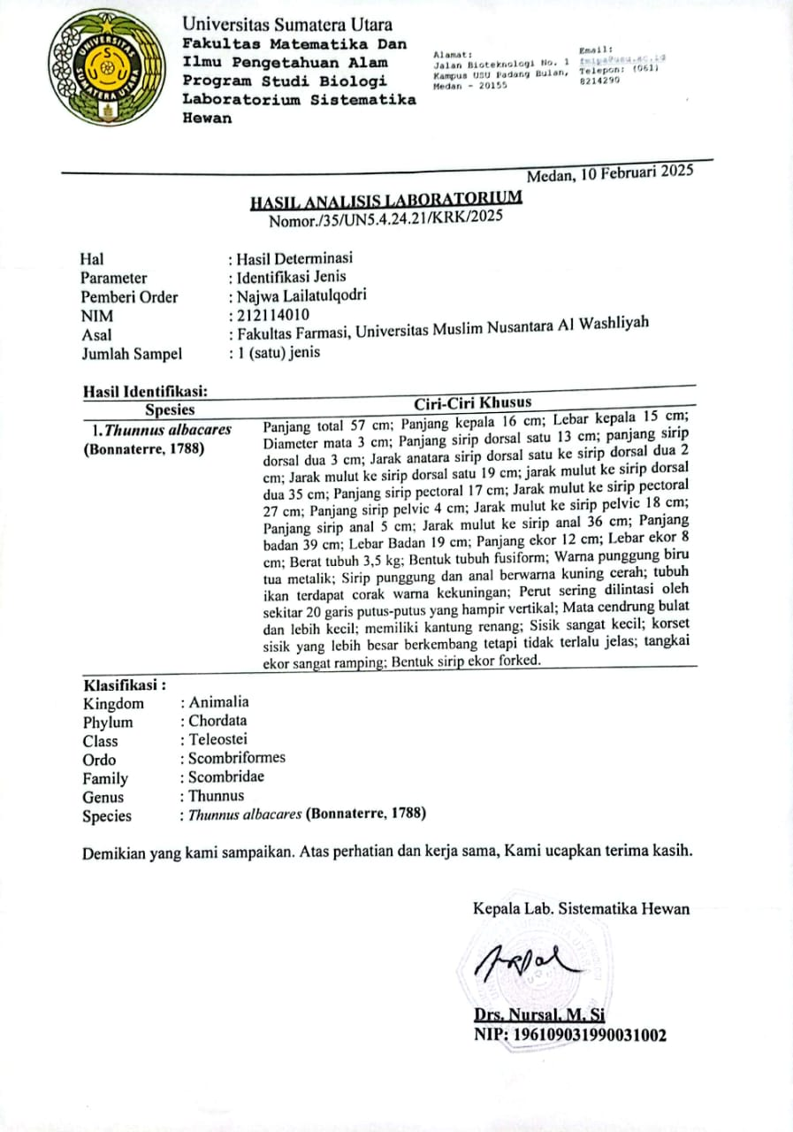

Lampiran 2. Bagan Alir Penelitian
Tulang Tuna Sirip Kuning
Disortasi basah
Dicuci dengan air
Ditimbang berat tulang
Disimpan di kulkas
Berat tulang tuna sirip kuning 1,5kg
Tahap pratreatment
Ditimbang 50g tulang tuna
Direndam dengan NaOH sebanyak 0,05M 500ml (1:10)
Direndam selama 6 jam, ganti larutan NaOH tiap 2 jam sekali
Filtrat
Tulang
Tulang tuna sirip kuning bebas mineral
Dibilas dengan aquadest hingga pH netral (7)
Isolasi kolagen

Lampiran 2. (Lanjutan)
Tahap Hidrolisis Kolagen
Tulang tuna bebas mineral
Direndam tulang tuna dengan asam asetat glasial 0,75M sebanyak 500ml (1:10)
Direndam selama 3 hari
Tulang tuna
Filtrat
Disaring filtrat dengan kertas saring
Filtrat mengandung kolagen

Lampiran 2. (lanjutan)
Tahap Pembuatan Kolagen
Filtrat mengandung kolagen
Diaduk filtrat menggunakan magnetic stirrer di suhu 7°C
Diteteskan filtrat dengan NaOH 0,5M hingga pH netral dan membentuk endapan putih
Dimasukkan filtrat yang berisi endapan putih ke tabung sentrifuse dan masukkan ke alat sentrifugator dengan kecepatan 6000rpm selama 5 menit
Kolagen basah
Dimasukkan kolagen basah ke cawan petri
Dikeringkan kolagen basah di oven dengan suhu 40°C selama 24 jam
Kolagen kering
Digerus kolagen kering di lumpang dan ayak dengan mesh 100
Ditimbang serbuk kolagen dengan timbangan analitik dan hitung %rendemennya
Serbuk kolagen kering 2,1178g ; Rendemen=4,19%
karakterisasi

Lampiran 3. Penyiapan sampel
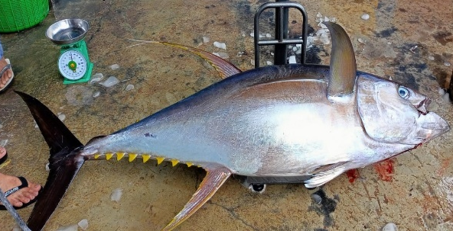 | 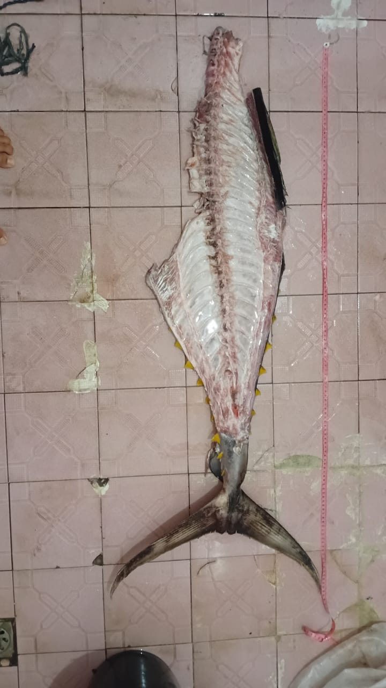
Ikan tuna sirip kuning | Proses sortasi basah
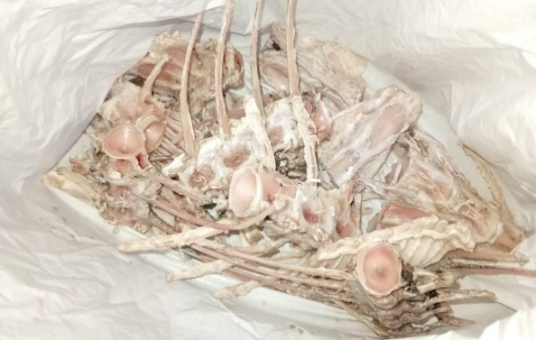 | 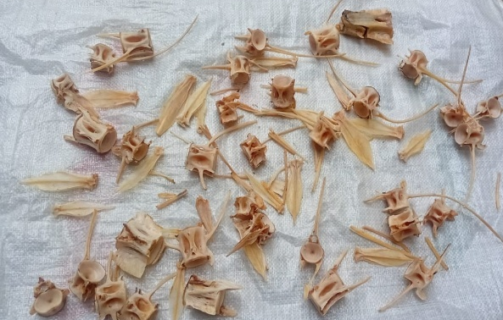
Tulang tuna yang telah bersih
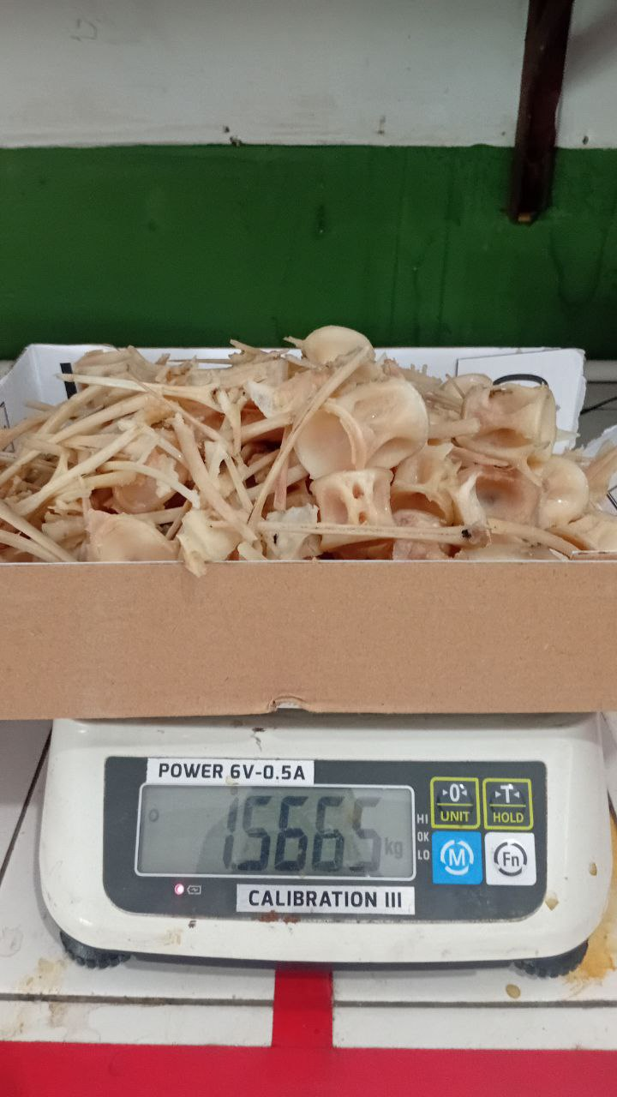
Berat bersih tulang ikan tuna sirip kuning

Lampiran 4. Isolasi Kolagen Tulang Tuna Sirip Kuning
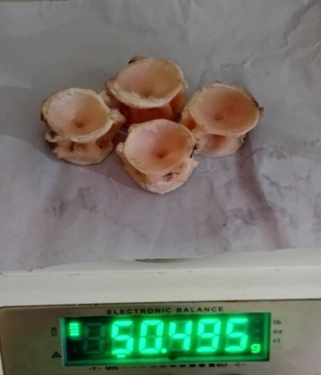 | 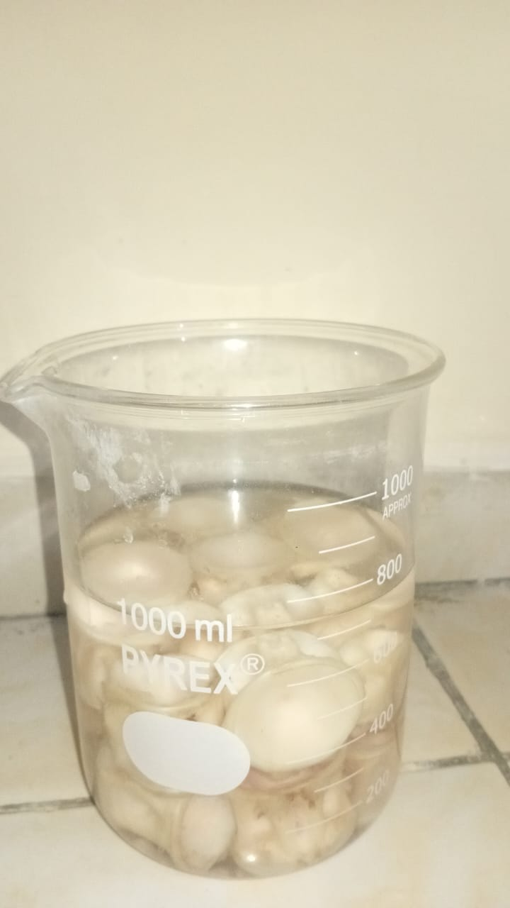
Penimbangan tulang | Proses preparasi
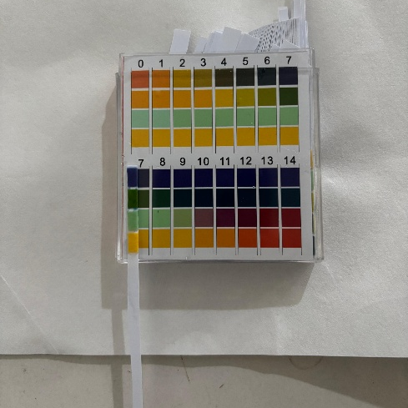 | 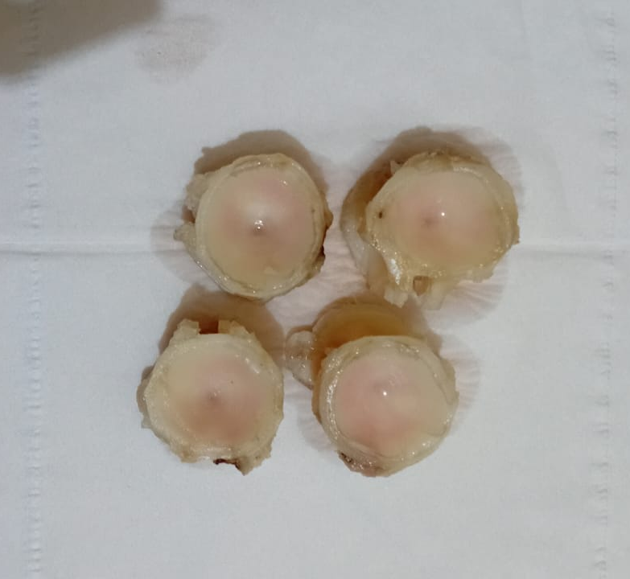
Bilas hingga pH netral | Hasil proses preparasi
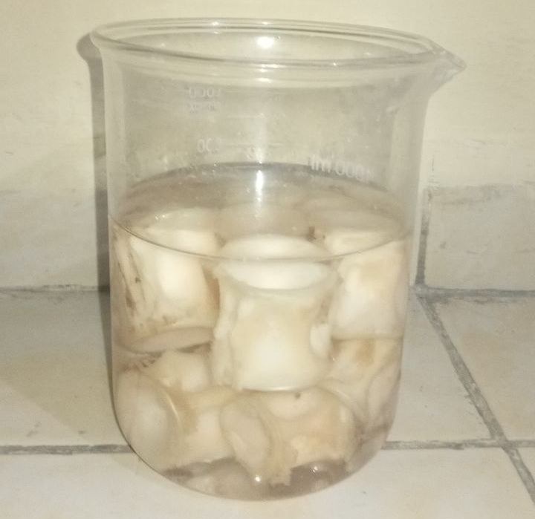 | 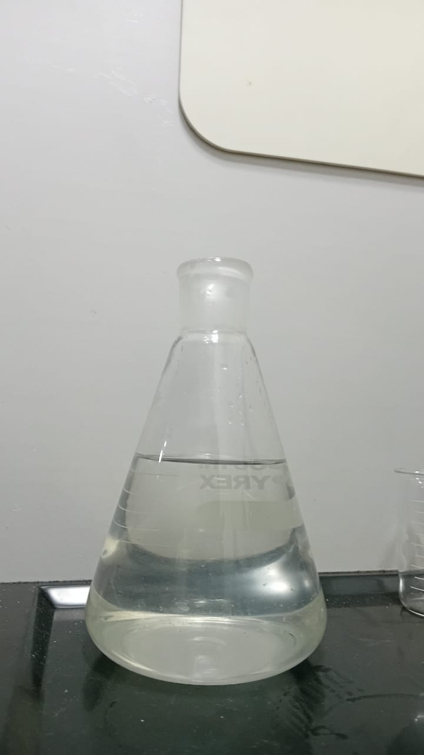
Proses hidrolisis | Filtrat mengandung kolagen

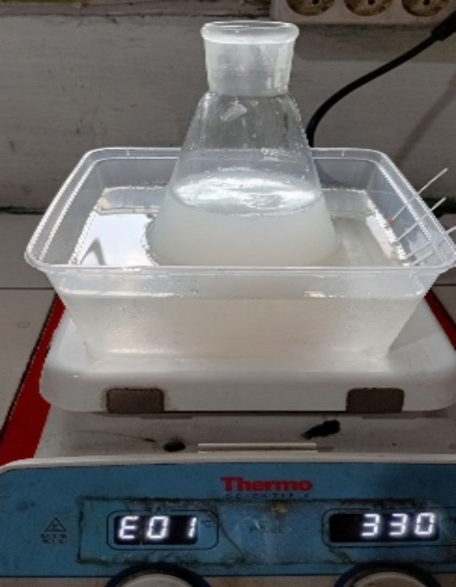 | 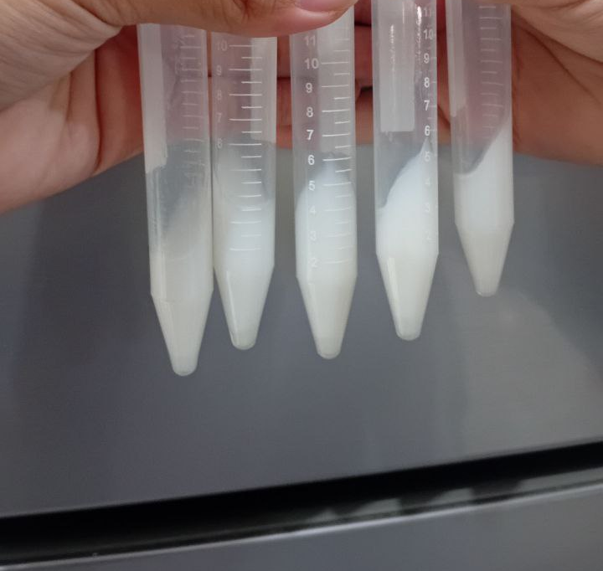
Proses pembentukan kolagen | Endapan Kolagen
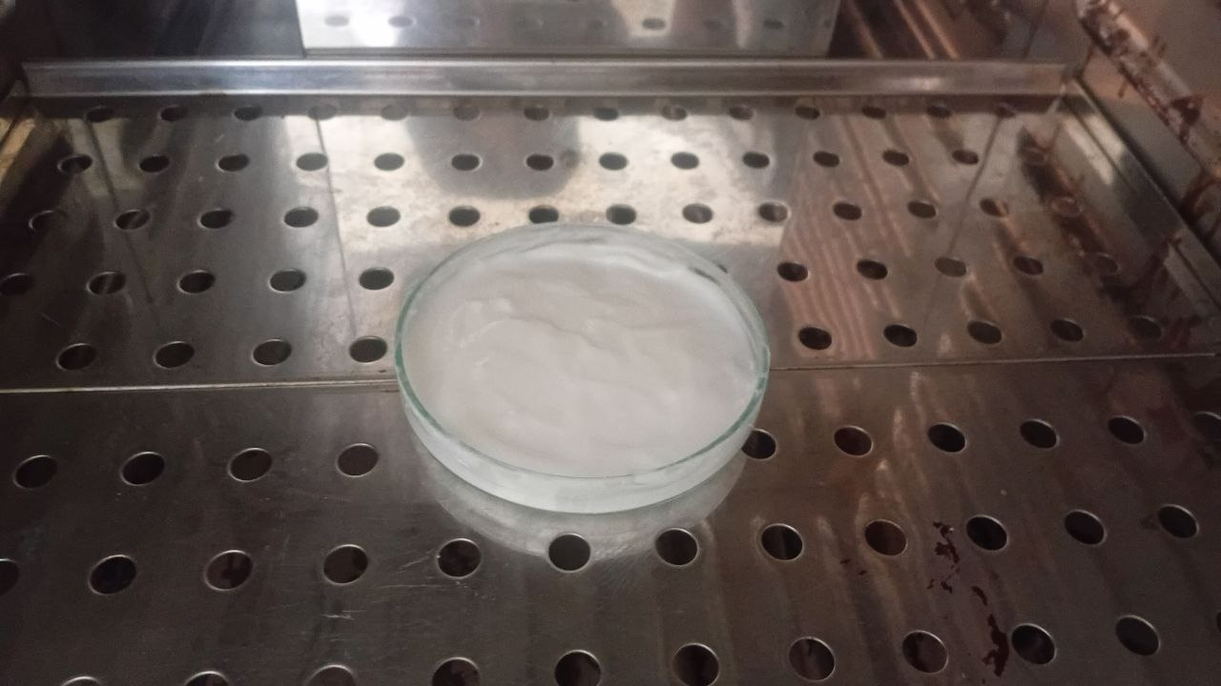 | 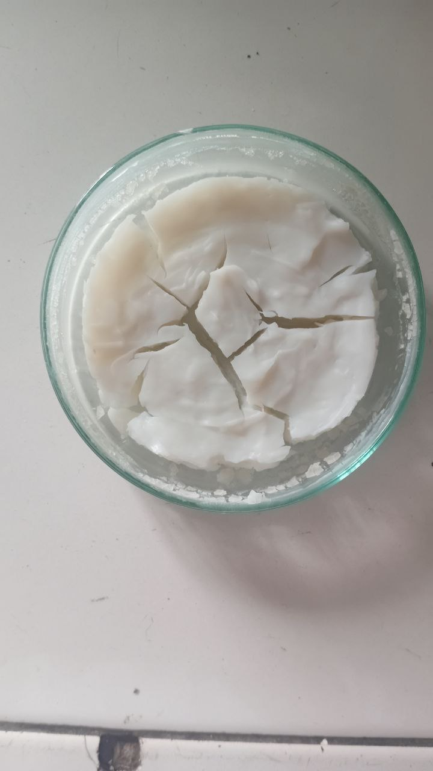
Proses pengeringan kolagen | Kolagen kering
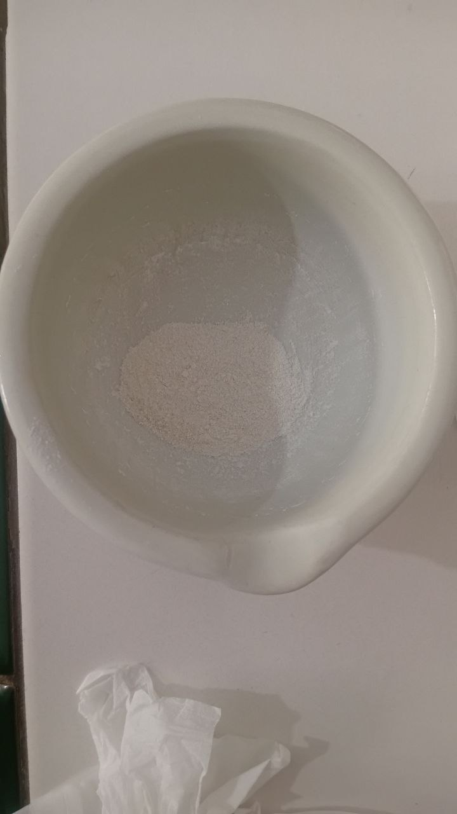 | 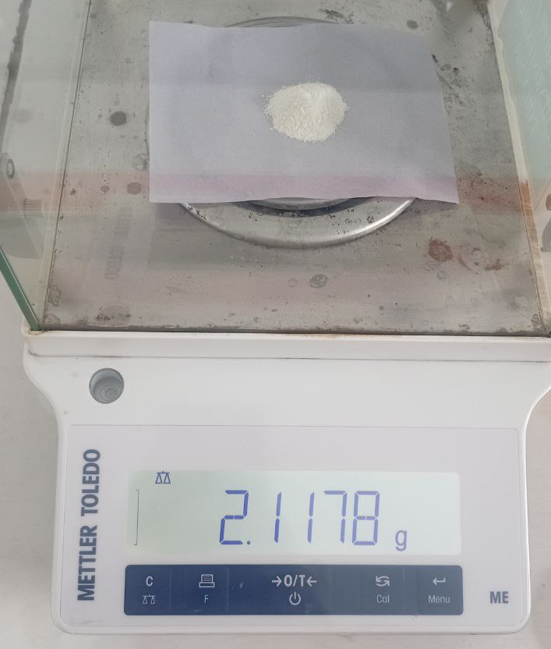
Serbuk kolagen | Berat serbuk kolagen
Lampiran 4. (lanjutan)

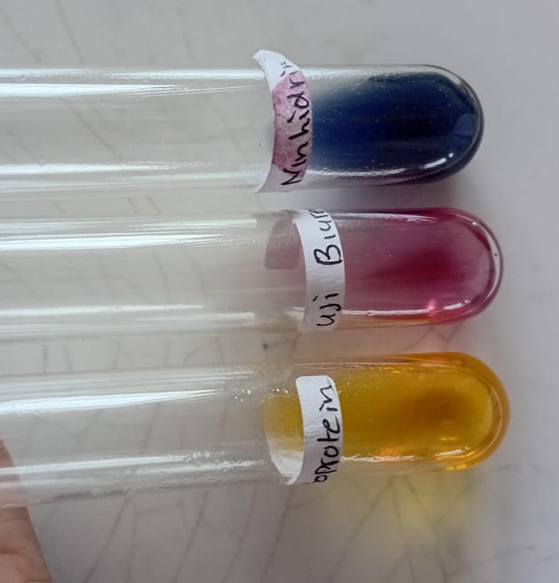
Lampiran 5. Hasil analisis kualitatif kolagen tulang tuna sirip kuning
C
B
A

Keterangan :
A = Uji Xantoprotein
B = Uji Biuret
C = Uji Ninhidrin

Lampiran 6. Hasil karakterisasi kolagen tulang tuna sirip kuning
Kadar air
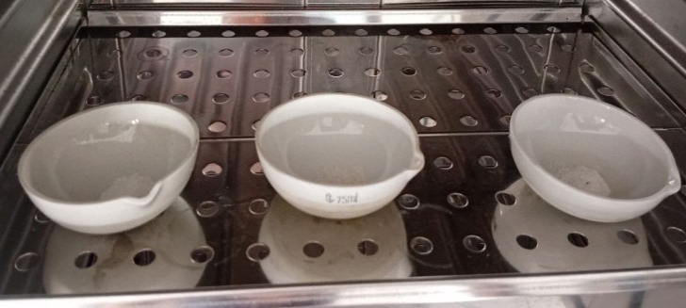
Cawan kosong
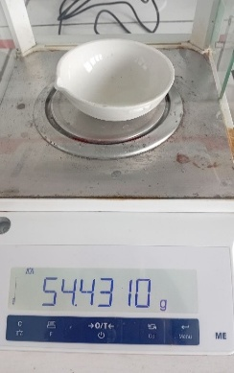 | 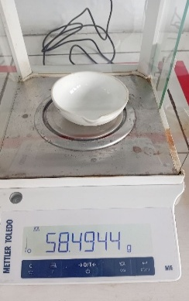 | 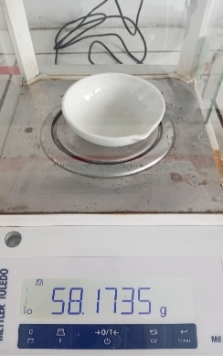
1 | 2 | 3
Cawan berisi
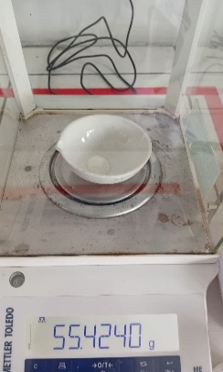 | 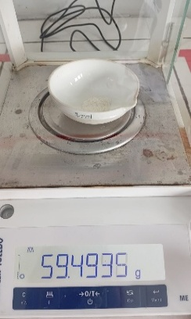 | 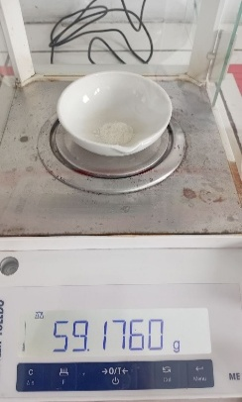
1 | 2 | 3
Cawan berisi setelah dipijar
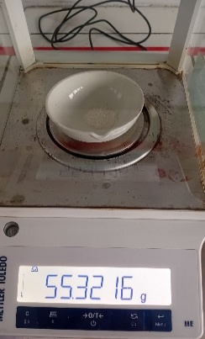 | 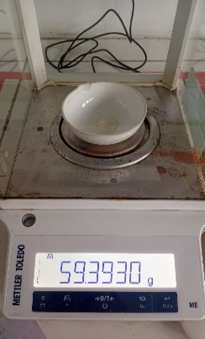 | 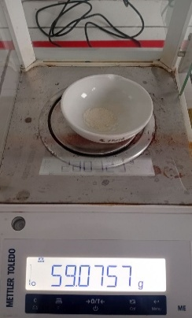
1 | 2 | 3

Lampiran 6. (Lanjutan)
Kadar abu
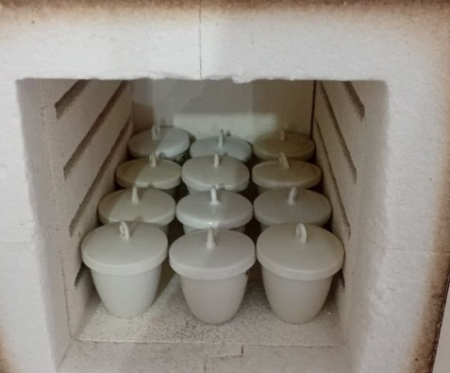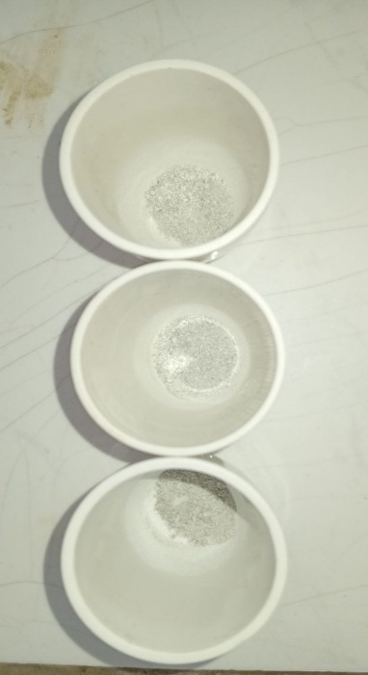
Berat cawan kosong
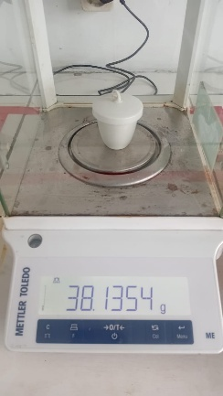 | 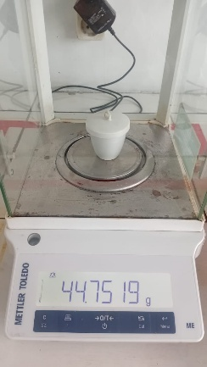 | 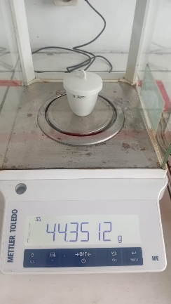
1 | 2 | 3
Berat cawan setelah dipijar
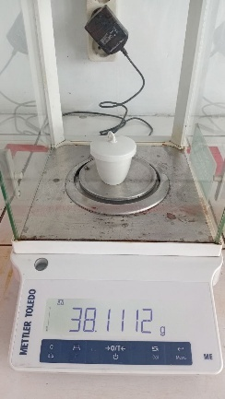 | 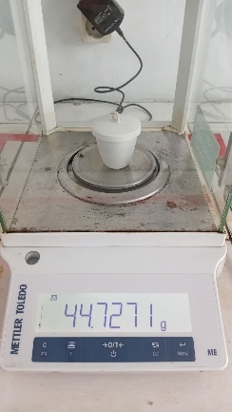 | 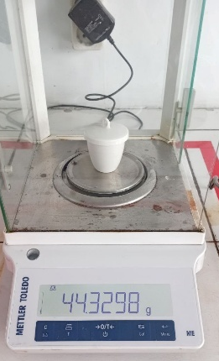
1 | 2 | 3

Lampiran 6. (lanjutan)
Kadar lemak
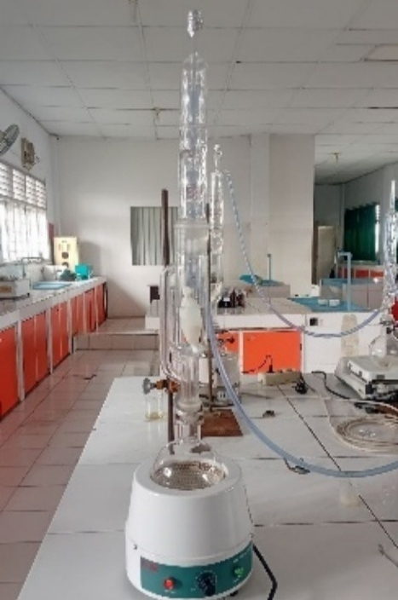
Labu kosong
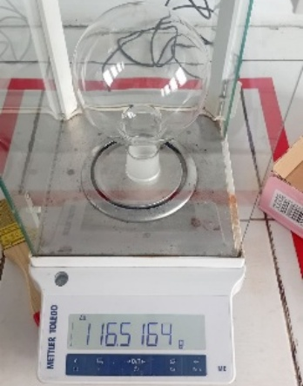 | 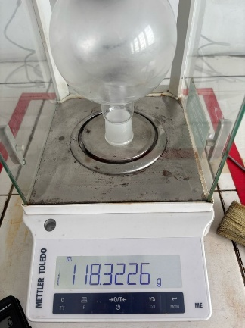 | 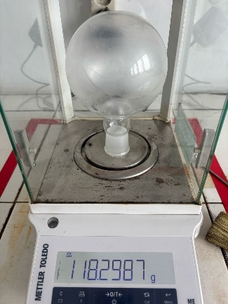
1 | 2 | 3
Labu setelah soxhlet
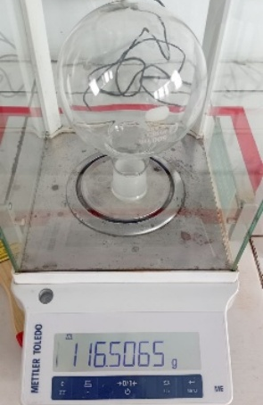 | 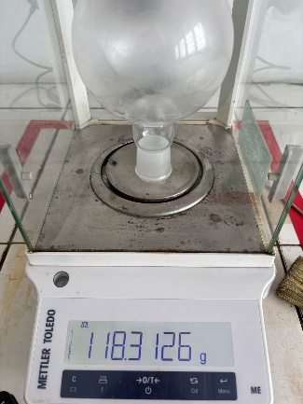 | 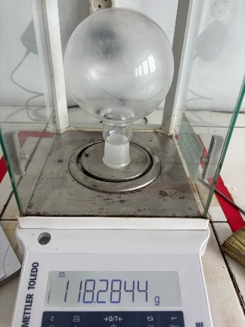
1 | 2 | 3

Lampiran 6. (lanjutan)
Kadar protein
Tahap destruksi
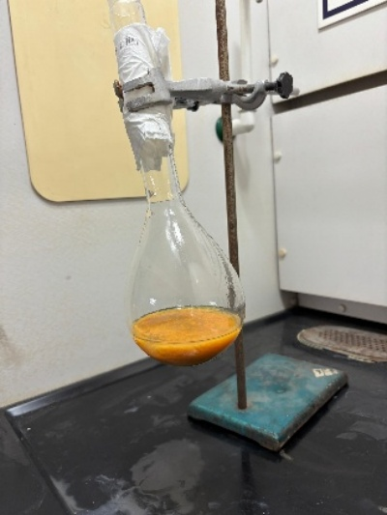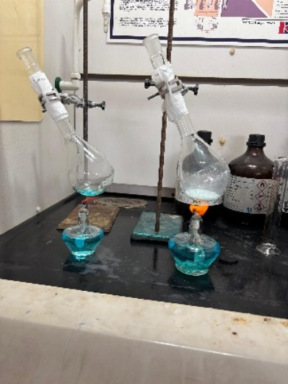
Tahap destilasi
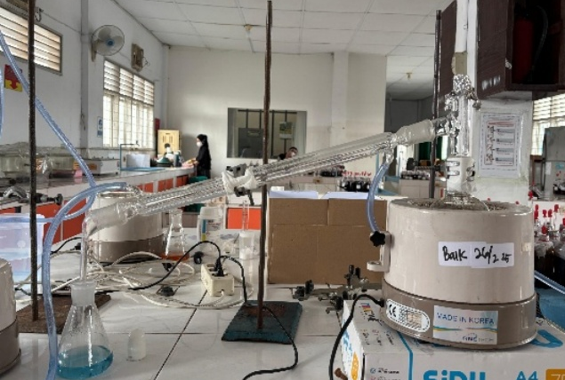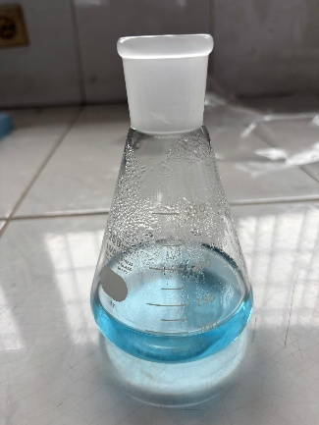
Tahap titrasi
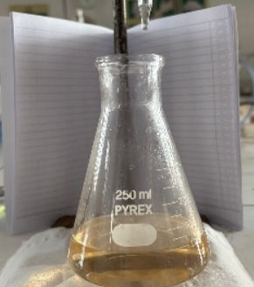 | 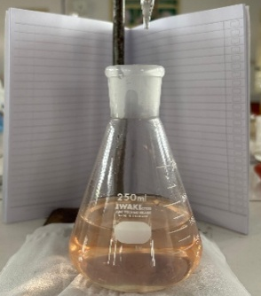 | 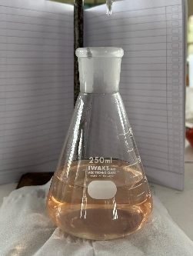 | 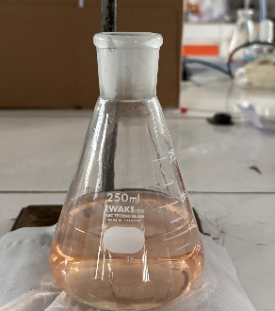
blanko | 1 | 2 | 3
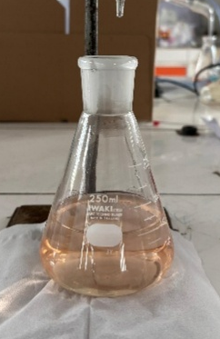
Lampiran 7. Perhitungan Karakterisasi Kolagen Tulang Tuna Sirip Kuning
- Perhitungan hasil penetapan kadar air
% kadar air =$\frac{berat cawan berisi-berat cawan setelah pijar}{berat cawan berisi-berat cawan kosong}$x100%
Pengulangan I
Berat cawan kosong = 54,4310g
Berat cawan berisi = 55,4240g
Berat cawan setelah pijar = 55,3216g
Kadar air = $\frac{55,4240-55,3216}{55,4240-54,4310}$x100%
=10,31%
Pengulangan II
Berat cawan kosong = 58,4944g
Berat cawan berisi = 59,4935g
Berat cawan setelah pijar = 59,3930g
Kadar air =$\frac{59,4935-59,3930}{59,4935-58,4944}$x100%
=10,05%
Pengulangan III
Berat cawan kosong = 58,1735g
Berat cawan berisi = 59,4935g
Berat cawan setelah pijar = 59,0757g
Kadar air =$\frac{59,4935-59,0757}{59,4935-58,1735}$x100%
=10,004%
Kadar air rata-rata =$\frac{10,31+10,05+10,004}{3}$
=10,27%
Kadar air kolagen tulang ikan tuna sirip kuning yaitu 10,27% memenuhi syarat

Lampiran 7. (lanjutan)
- Perhitungan kadar hasil penetapan kadar abu
%kadar abu =$\frac{berat cawan setelah pijar-berat cawan kosong }{berat sampel}$x100%
Pengulangan I
Berat cawan kosong = 38,1112g
Berat cawan setelah pijar = 38,1354g
Berat sampel = 1g
Kadar abu = $\frac{38,1354-38,1112}{1}$x100%
=2,42%
Pengulangan II
Berat cawan kosong = 44,7271g
Berat cawan setelah pijar = 44,7519g
Berat sampel = 1g
Kadar abu = $\frac{44,7519-44,7271}{1}$x100%
=2,44%
Pengulangan III
Berat cawan kosong = 44,3298g
Berat cawan setelah pijar = 44,3512g
Berat sampel = 1g
Kadar abu = $\frac{44,3298-44,3512}{1}$x100%
=2,14%
Kadar abu rata-rata =$\frac{2,42+2,44+2,14}{3}$
=2,333%
Kadar abu kolagen tulang ikan tuna sirip kuning yaitu 2,333% memenuhi syarat
Lampiran 7. (lanjutan)
- Perhitungan kadar lemak kolagen tulang ikan tuna sirip kuning
%lemak=$\frac{labu berisi lemak-labu kosong }{berat sampel}$x100%
Pengulangan I
Berat labu kosong = 116,5065g
Berat labu berisi lemak = 116,5164g
Berat sampel = 2g
Kadar lemak = $\frac{116,5164-116,5065}{2}$x100%
=0,495%
Pengulangan II
Berat labu kosong = 118,3126g
Berat labu berisi lemak = 118,3226g
Berat sampel = 2g
Kadar lemak = $\frac{118,3226-118,3126}{2}$x100%
=0,5%
Pengulangan III
Berat labu kosong = 118,2844g
Berat labu berisi lemak = 118,2987g
Berat sampel = 2g
Kadar lemak = $\frac{118,2987-118,2844}{2}$x100%
=0,715%
Kadar lemak rata-rata =$\frac{0,495+0,5+0,715}{3}$
=0,57%
Kadar lemak kolagen tulang ikan tuna sirip kuning yaitu 0,57% memenuhi syarat
Lampiran 7. (lanjutan)
- Perhitungan kadar protein kolagen tulang ikan tuna sirip kuning
%kadar protein=$\frac{\left(Vsampel-Vblanko\right) x N x 14,007 x 6,25}{w x 1000}$x100%

Pengulangan I
Volume titrasi blanko = 0,3mL
Volume titrasi sampel = 40mL
Berat sampel = 0,5g
Kadar protein = $\frac{(40mL-0,3mL) x 0,2 x 14,007 x 6,25}{0,5 x 1000}$x100%
=69,29%
Pengulangan II
Volume titrasi blanko = 0,3mL
Volume titrasi sampel = 40,3mL
Berat sampel = 0,5g
Kadar protein = $\frac{(40,3mL-0,3mL) x 0,2 x 14,007 x 6,25}{0,5 x 1000}$x100%
=70,03%
Pengulangan III
Volume titrasi blanko = 0,3mL
Volume titrasi sampel = 42,5mL
Berat sampel = 0,5g
Kadar protein = $\frac{(42,5mL-0,3mL) x 0,2 x 14,007 x 6,25}{0,5 x 1000}$x100%
=73,86%
Kadar protein rata-rata =$\frac{69,29+70,03+73,86}{3}$
=71,06%
Kadar protein kolagen tulang ikan tuna sirip kuning yaitu 71,06% memenuhi syarat

Lampiran 8. Spektrum Kolagen Standar dan Hasil Spektrum Kolagen Tulang Tuna Sirip Kuning
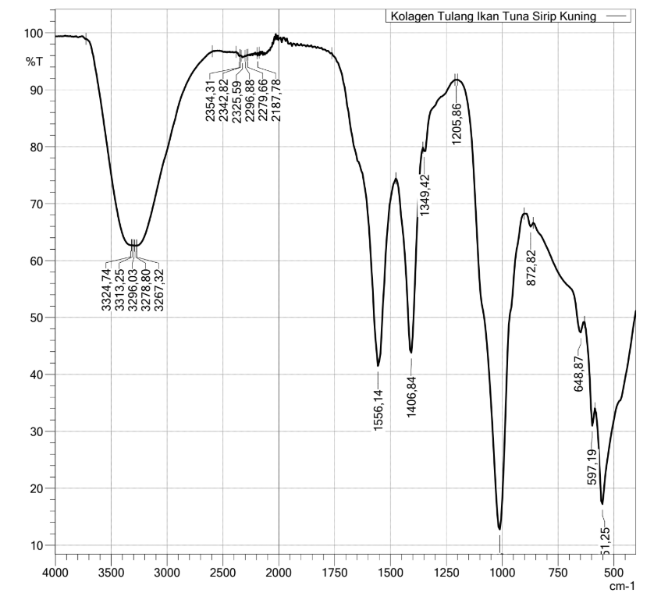
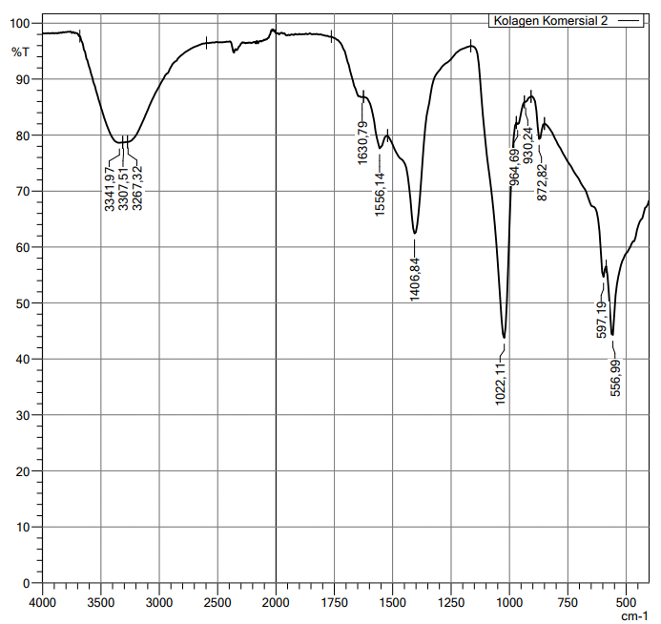

Lampiran 9. Bagan Alir Formulasi Sediaan Nanoserum
  - Pembuatan kolagen berbagai konsentrasi
Kolagen tulang tuna sirip kuning 0,5g; 1g; 1,5g asumsi 100ml
Dilarutkan dengan asam asetat 0,5M
Larutan kolagen berbagai konsentrasi (0,5%;1%;1,5%)

  - Pembuatan Sediaan Nanoserum
Carbopol
Xantan gum

Dilarutkan dengan aquadest 20 kali berat dan aduk dengan magneticstirrer selama 20 menit hingga membentuk massa serum
Massa serum
Dimasukkan phenoxyethanol diaduk ad homogen
Ditambahkan gliserin dan diaduk ad homogen
Diteteskan TEA hingga pH netral
Serum kolagen
Dimasukkan serum ke homogenizer selama 6 jam
Dimasukkan serum ke sonikator selama 6 jam
Analisis ukuran partikel
Dimasukkan kolagen berbagai konsentrasi (0,5%;1%;1,5%)
Evaluasi sediaan nanoserum

Lampiran 10. Sediaan Nanoserum
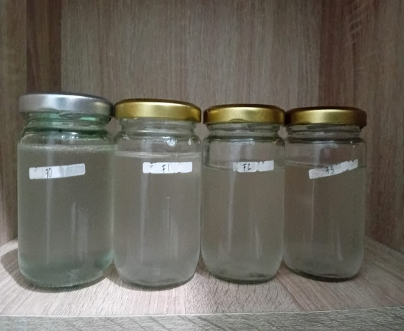

A
B
C
D

Keterangan :
A: Blanko
B: Nanoserum Kolagen Tulang Ikan Tuna Sirip Kuning 0,5%
C: Nanoserum Kolagen Tulang Ikan Tuna Sirip Kuning 1%
D: Nanoserum Kolagen Tulang Ikan Tuna Sirip Kuning 1,5%

Lampiran 11. Hasil Evaluasi Sediaan Nanoserum
Organoleptis | Pengamatan
 | Minggu 0 |  | Minggu 4
 |  |  | 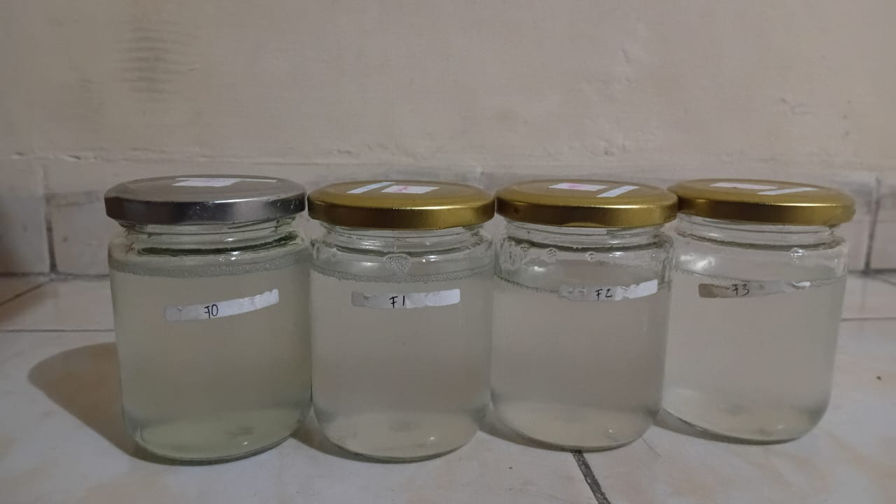
Cycling Test | Pengamatan
 | Suhu 4±2°C | Suhu 40±2°C
 | 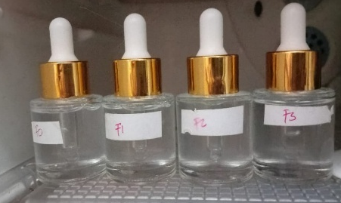 | 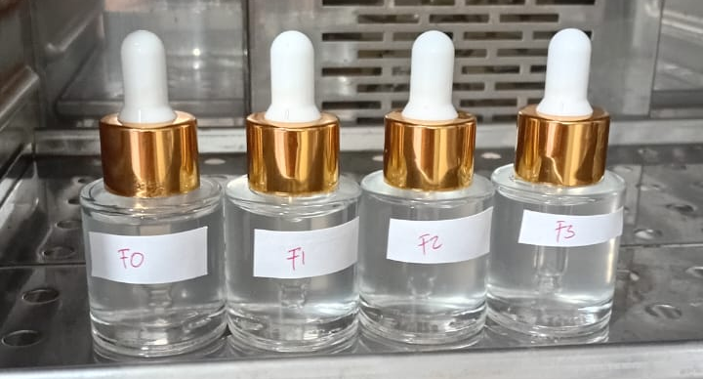
Homogenitas | Pengamatan
 | Minggu 0 |  | Minggu 4
 | 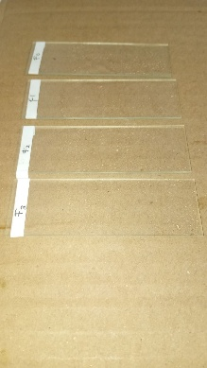 |  | 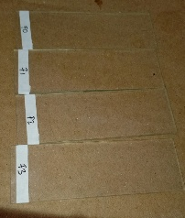

Lampiran 12. Hasil Pengamatan pH Sediaan Nanoserum
Formulasi | Replikasi | Minggu 0 | Minggu 4
F0 | 1 | 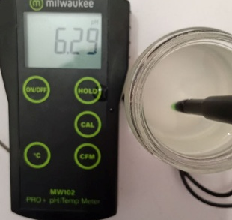 | 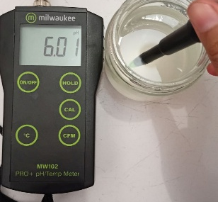
F0 | 2 | 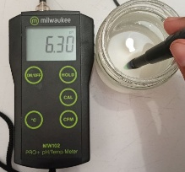 | 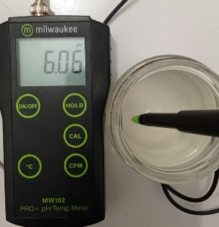
F0 | 3 | 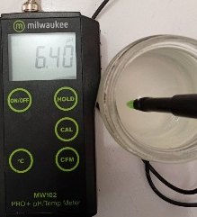 | 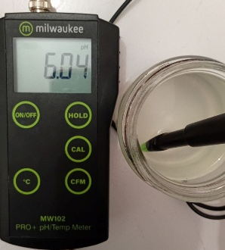
F1 | 1 | 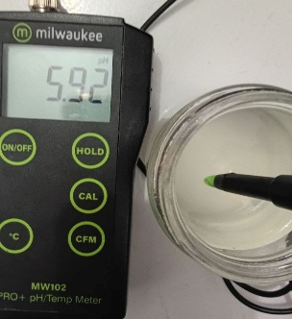 | 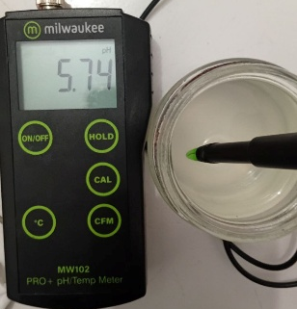
F1 | 2 | 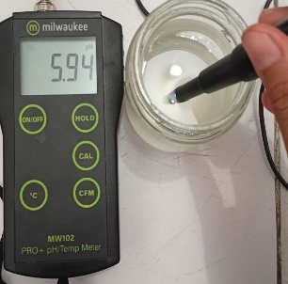 | 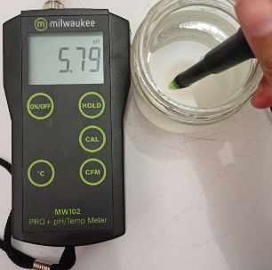
F1 | 3 | 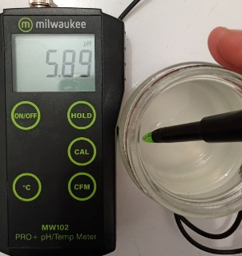 | 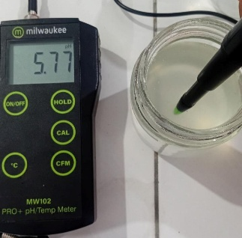

Lampiran 12. (lanjutan)

F2 | 1 | 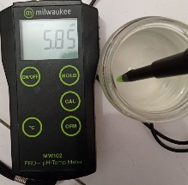 | 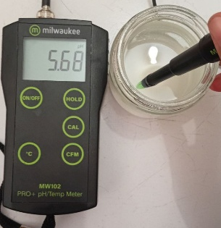
F2 | 2 | 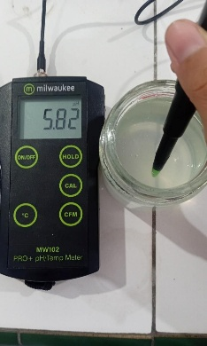 | 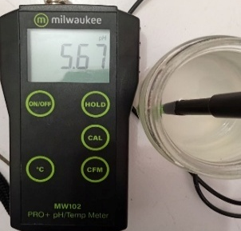
F2 | 3 | 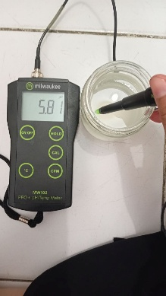 | 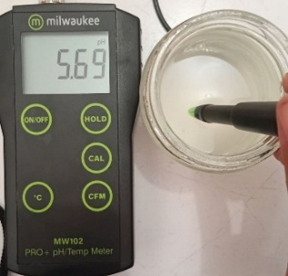
F3 | 1 | 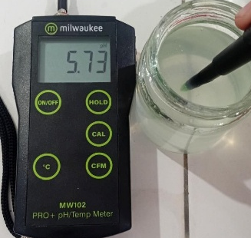 | 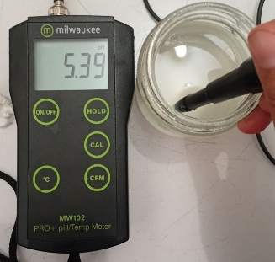
F3 | 2 | 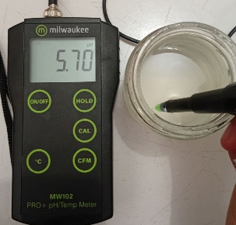 | 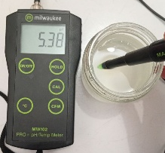
F3 | 3 | 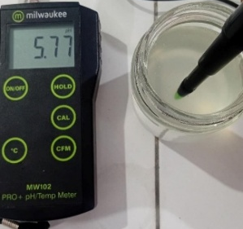 | 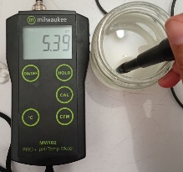

Formulasi | Replikasi | Minggu 0 | Minggu 4 | Syarat pH
F0 | 1  2  3  Rata-rata  (±SD) | 6,29  6,30  6,40  6,33  ±0,06 | 6,01  6,04  6,06  6,03  ±0,02 | 4,5-6,5
F1 | 1  2  3  Rata-rata  (±SD) | 5,92  5,94  5,89  5,91  ±0,03 | 5,74  5,79  5,77  5,76  ±0,02 | 4,5-6,5
F2 | 1  2  3  Rata-rata  (±SD) | 5,85  5,82  5,81  5,82  ±0,02 | 5,68  5,67  5,69  5,67  ±0,01 | 4,5-6,5
F3 | 1  2  3  Rata-rata  (±SD) | 5,73  5,70  5,77  5,73  ±0,03 | 5,39  5,38  5,35  5,36  ±0,02 | 4,5-6,5
Lampiran 12. (lanjutan)
Keterangan :
F0: Blanko
F1: Nanoserum Kolagen Tulang Ikan Tuna Sirip Kuning 0,5%
F2: Nanoserum Kolagen Tulang Ikan Tuna Sirip Kuning 1%
F3: Nanoserum Kolagen Tulang Ikan Tuna Sirip Kuning 1,5%
Lampiran 13. Hasil Pengamatan Daya Sebar Sediaan Nanoserum
Formulasi | Replikasi | Minggu 0 | Minggu 4
F0 | 1 | 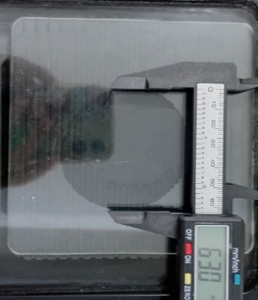 | 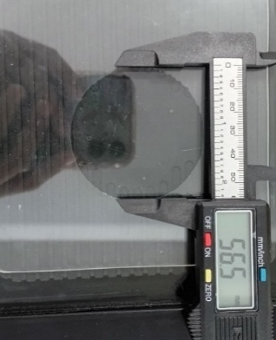
F0 | 2 | 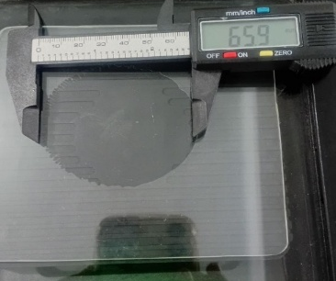 | 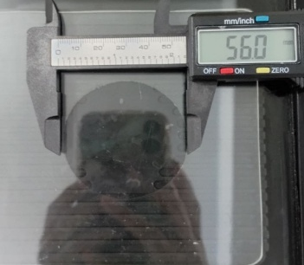
F0 | 3 | 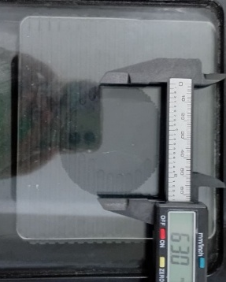 | 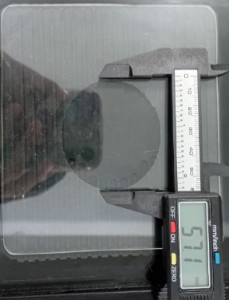
F1 | 1 | 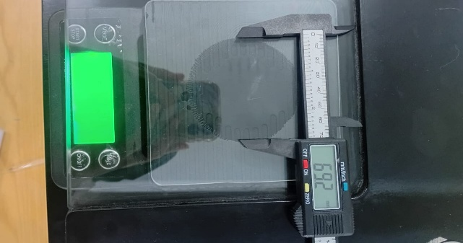 | 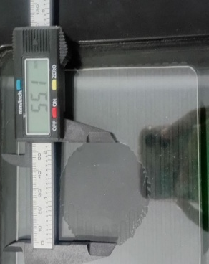
F1 | 2 | 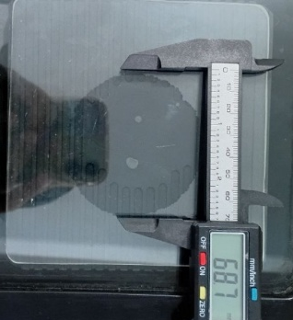 | 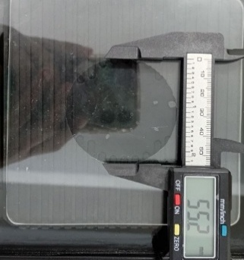
F1 | 3 | 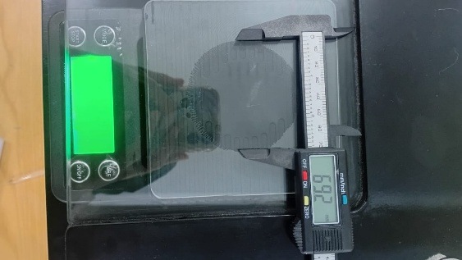 | 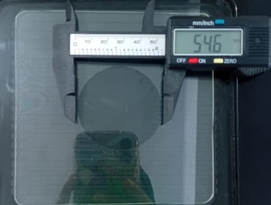

F2 | 1 | 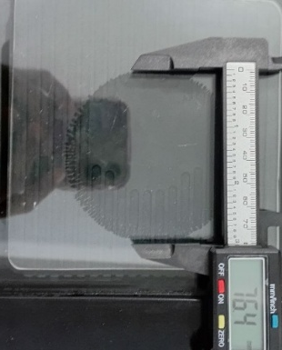 | 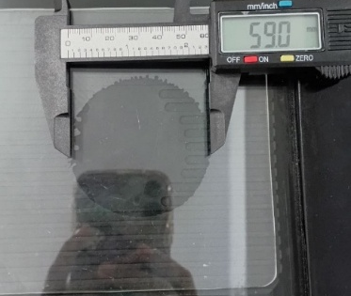
F2 | 2 | 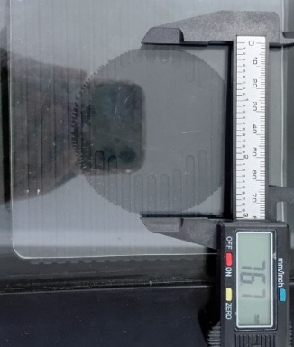 | 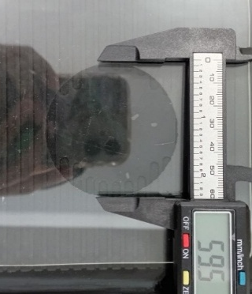
F2 | 3 | 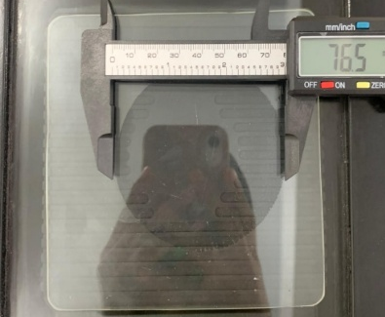 | 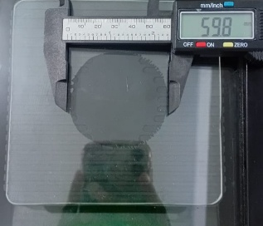
F3 | 1 | 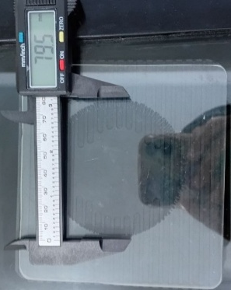 | 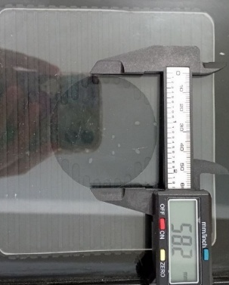
F3 | 2 | 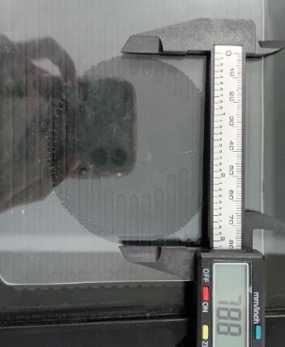 | 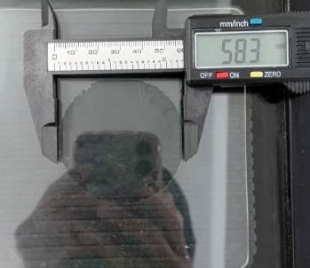
F3 | 3 | 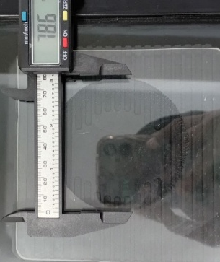 | 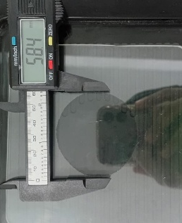
Lampiran 13. (lanjutan)
Formulasi | Replikasi | Minggu 0 | Minggu 4 | Syarat (cm)
Formulasi | Replikasi | Diameter (cm) | Diameter (cm) | Syarat (cm)
F0 | 1  2  3  Rata-rata  (±SD) | 5,65  5,60  5,71  5,65  ±0,05 | 6,30  6,59  6,30  6,39  ±0,1 | 5-7  (Raharjeng et al., 2021).
F1 | 1  2  3  Rata-rata  (±SD) | 5,52  5,51  5,46  5,49  ±0,03 | 6,92  6,87  6,92  6,90  ±0,02 | 5-7  (Raharjeng et al., 2021).
F2 | 1  2  3  Rata-rata  (±SD) | 5,90  5,95  5,98  5,94  ±0,04 | 7,64  7,67  7,65  7,65  ±0,01 | 5-7  (Raharjeng et al., 2021).
F3 | 1  2  3  Rata-rata  (±SD) | 5,82  5,83  5,84  5,83  ±0,01 | 7,95  7,88  7,86  7,89  ±0,02 | 5-7  (Raharjeng et al., 2021).
Keterangan :
F0: Blanko
F1: Nanoserum Kolagen Tulang Ikan Tuna Sirip Kuning 0,5%
F2: Nanoserum Kolagen Tulang Ikan Tuna Sirip Kuning 1%
F3: Nanoserum Kolagen Tulang Ikan Tuna Sirip Kuning 1,5%
Lampiran 14. Hasil Pengamatan Daya Lekat Sediaan Nanoserum
Formulasi | Replikasi | Minggu 0 | Minggu 4
F0 | 1 | 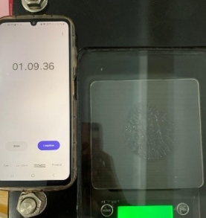 | 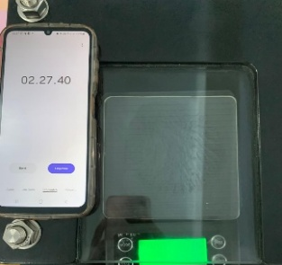
F0 | 2 | 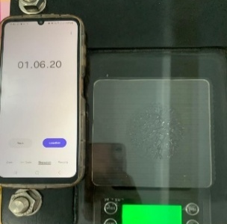 | 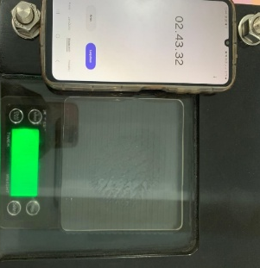
F0 | 3 | 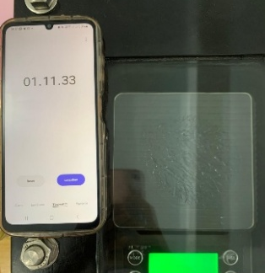 | 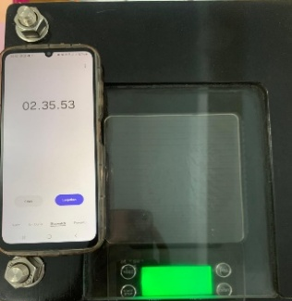
F1 | 1 | 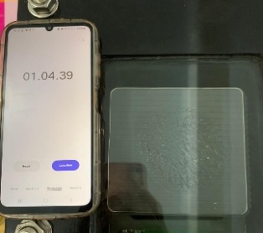 | 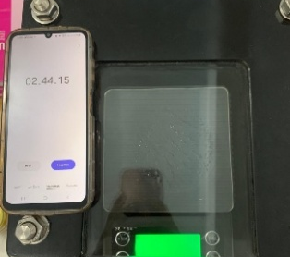
F1 | 2 | 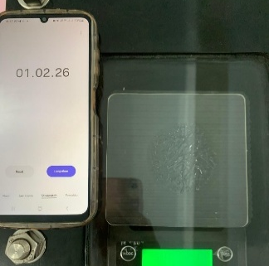 | 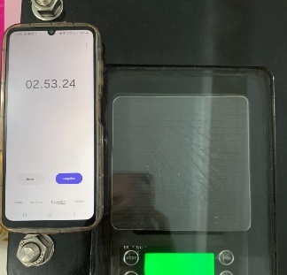
F1 | 3 | 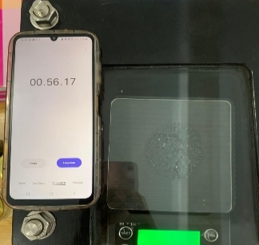 | 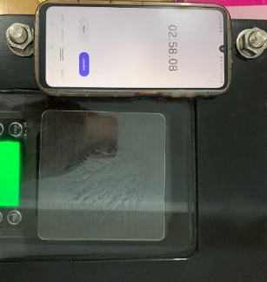

F2 | 1 | 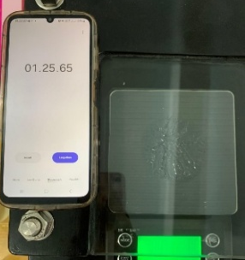 | 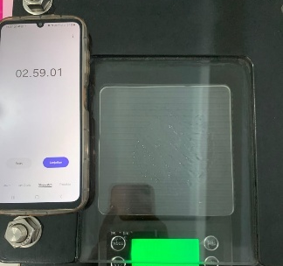
F2 | 2 | 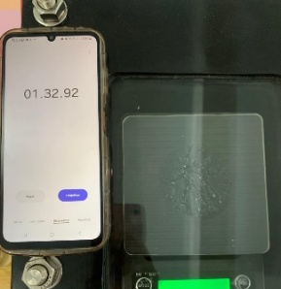 | 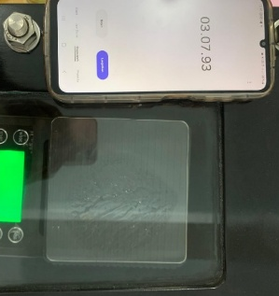
F2 | 3 | 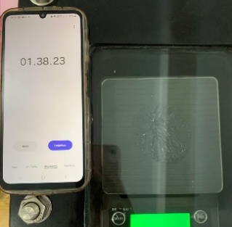 | 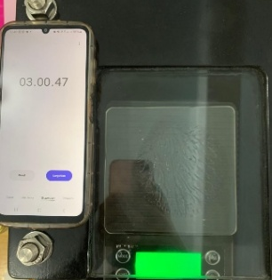
F3 | 1 | 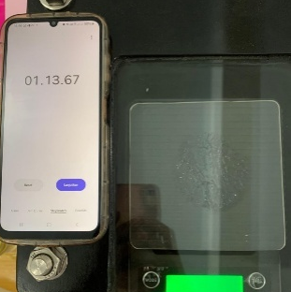 | 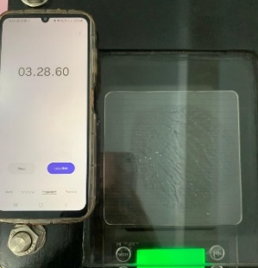
F3 | 2 | 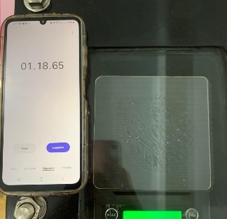 | 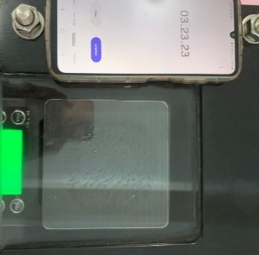
F3 | 3 | 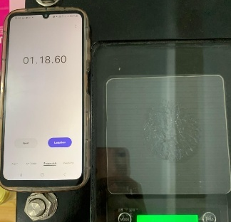 | 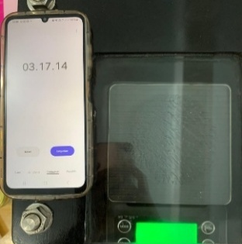
Lampiran 14. (lanjutan)
Lampiran 14. (lanjutan)
Fomulasi | Replikasi | Minggu 0 | Minggu 4 | Syarat (detik)
Fomulasi | Replikasi | Waktu (detik) | Waktu (detik) | Syarat (detik)
F0 | 1  2  3  Rata-rata  (±SD) | 69  66  71  68,3  ±2,55 | 147  163  155  155  ±8 | >1 detik
F1 | 1  2  3  Rata-rata  (±SD) | 64  62  56  60,6  ±4,16 | 164  173  178  171,6  ±7,09 | >1 detik
F2 | 1  2  3  Rata-rata  (±SD) | 85  92  98  91,6  ±6,50 | 179  187  180  182  ±4,35 | >1 detik
F3 | 1  2  3  Rata-rata  (±SD) | 73  78  78  76,3  ±2,88 | 208  203  197  202,6  ±5,50 | >1 detik
Keterangan :
F0: Blanko
F1: Nanoserum Kolagen Tulang Ikan Tuna Sirip Kuning 0,5%
F2: Nanoserum Kolagen Tulang Ikan Tuna Sirip Kuning 1%
F3: Nanoserum Kolagen Tulang Ikan Tuna Sirip Kuning 1,5%

Lampiran 15. Hasil Pengamatan Viskositas Sediaan Nanoserum
Formulasi | Replikasi | Minggu 0 | Minggu 4
F0 | 1 | 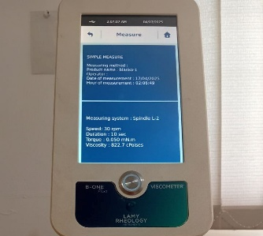 | 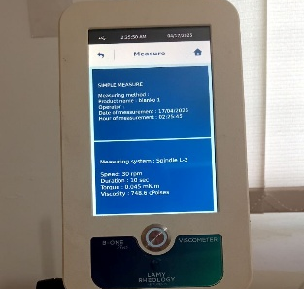
F0 | 2 | 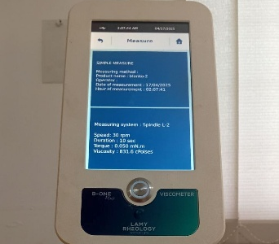 | 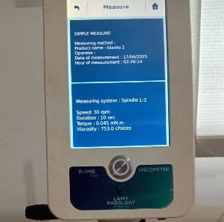
F0 | 3 | 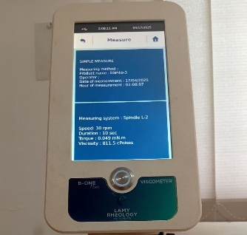 | 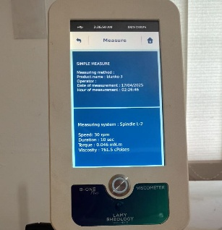
F1 | 1 | 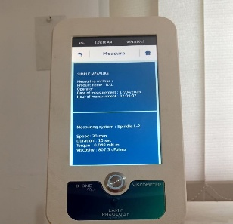 | 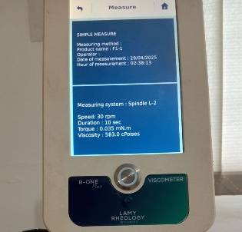
F1 | 2 | 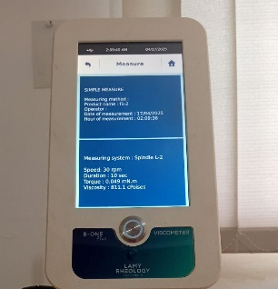 | 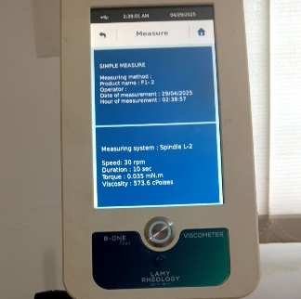
F1 | 3 | 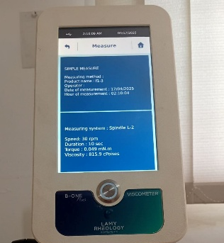 | 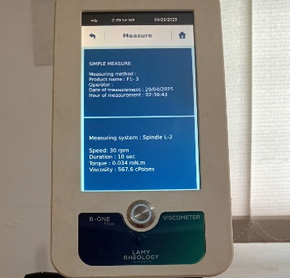
Lampiran 15. (lanjutan)
F2 | 1 | 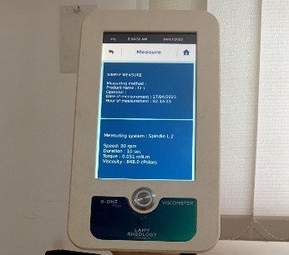 | 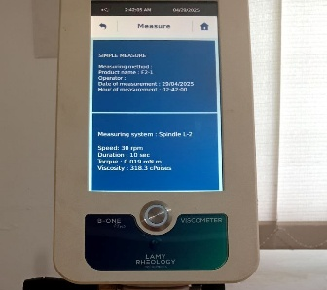
F2 | 2 | 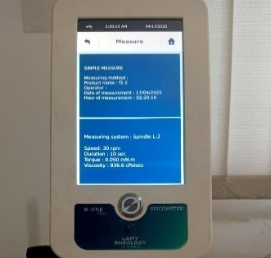 | 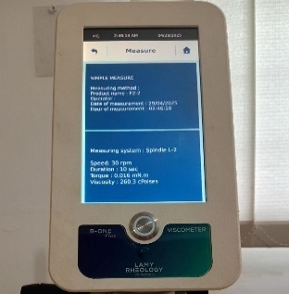
F2 | 3 | 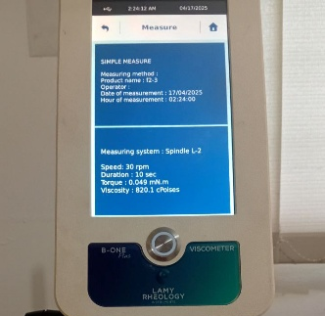 | 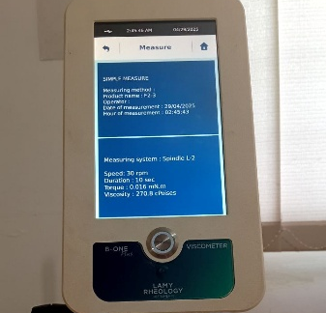
F3 | 1 | 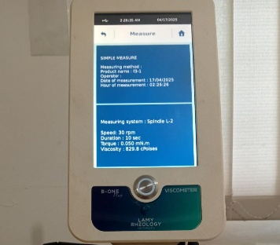 | 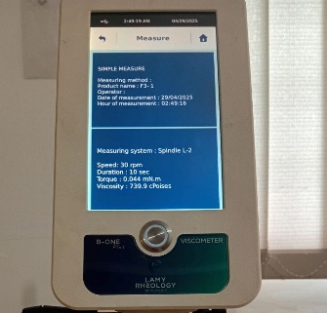
F3 | 2 | 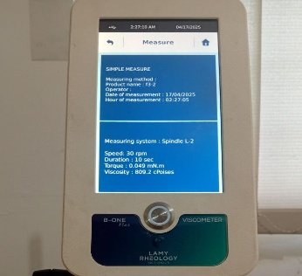 | 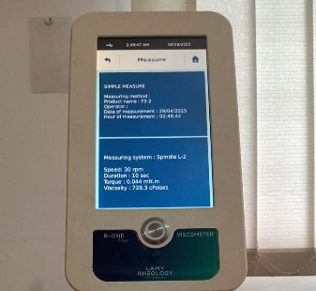
F3 | 3 | 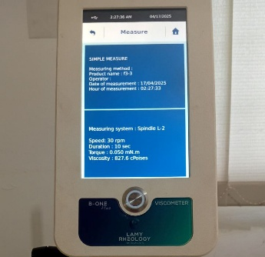 | 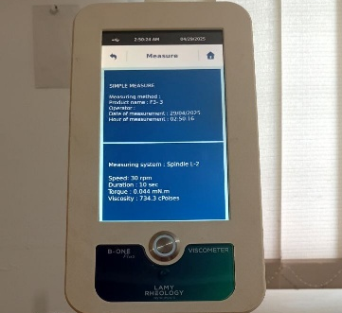
Lampiran 15. (lanjutan)
Fomulasi | Replikasi | Minggu 0 | Minggu 4 | Syarat (cPoises)
Fomulasi | Replikasi | Viskositas (cPoises) | Viskositas (cPoises) | Syarat (cPoises)
F0 | 1  2  3  Rata-rata  (±SD) | 822,7  831,6  811,5  821,9  ±10,07 | 748,6  753,0  761,5  754,3  ±6,55 | 230-1150
F1 | 1  2  3  Rata-rata  (±SD) | 807,3  811,1  815,9  811,4  ±4,45 | 583,0  573,6  567,6  574,7  ±10,96 | 230-1150
F2 | 1  2  3  Rata-rata  (±SD) | 848,0  836,6  820,1  834,9  ±9,34 | 318,3  260,3  270,8  283,4  ±30,90 | 230-1150
F3 | 1  2  3  Rata-rata  (±SD) | 827,6  809,2  827,6  821,4  ±10,86 | 739,9  728,3  734,3  734,1  ±5,80 | 230-1150
Keterangan :
F0: Blanko
F1: Nanoserum Kolagen Tulang Ikan Tuna Sirip Kuning 0,5%
F2: Nanoserum Kolagen Tulang Ikan Tuna Sirip Kuning 1%
F3: Nanoserum Kolagen Tulang Ikan Tuna Sirip Kuning 1,5%

Lampiran 16. Hasil Analisis Distribusi Partikel Menggunakan Alat PSA
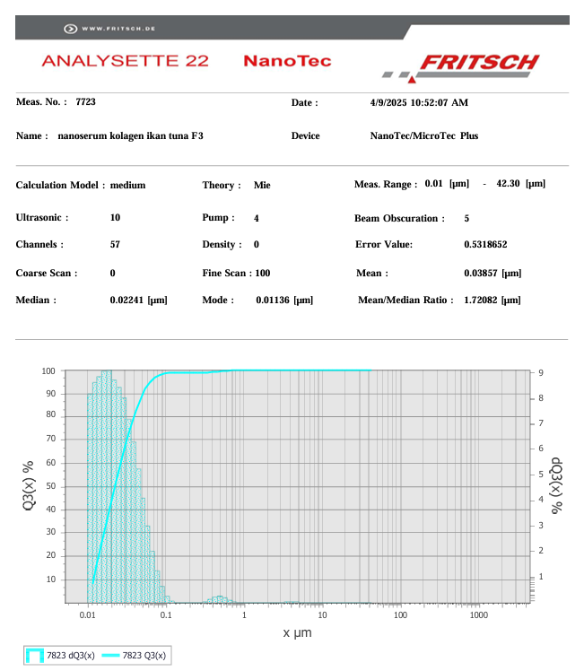
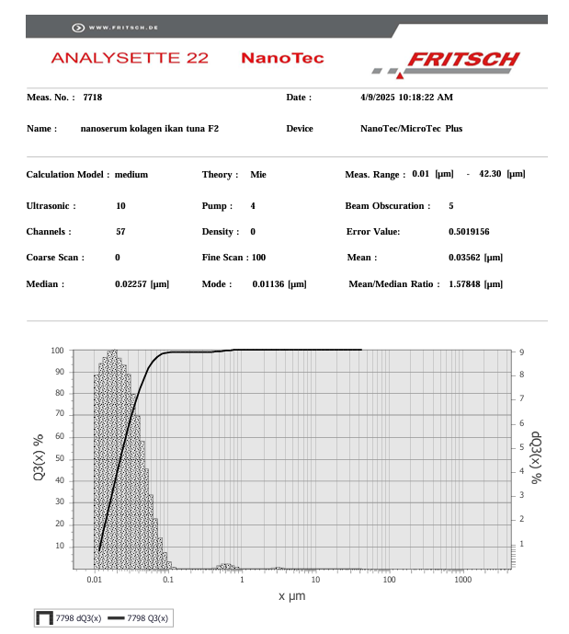
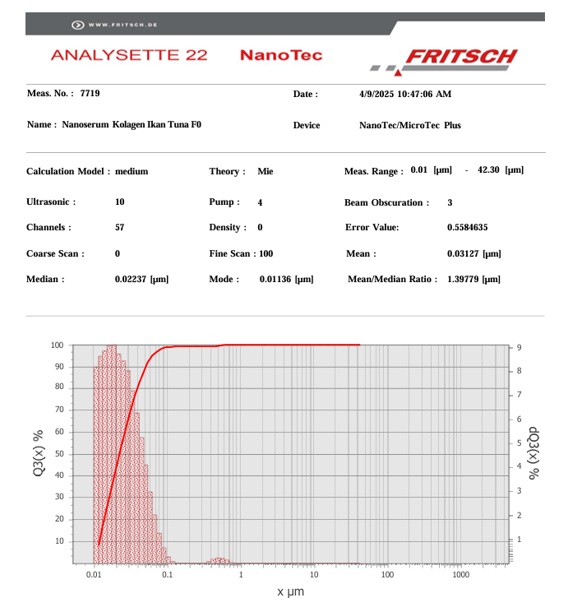
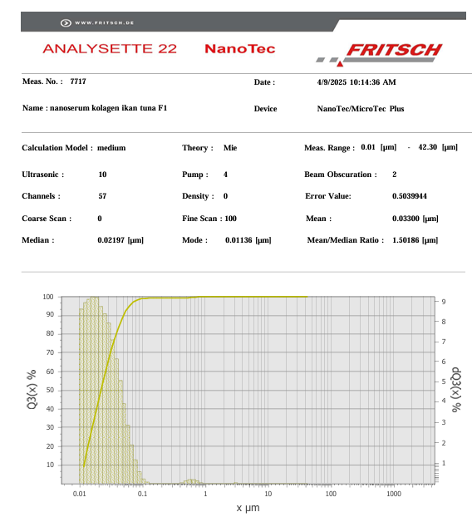
Lampiran 16. (lanjutan)
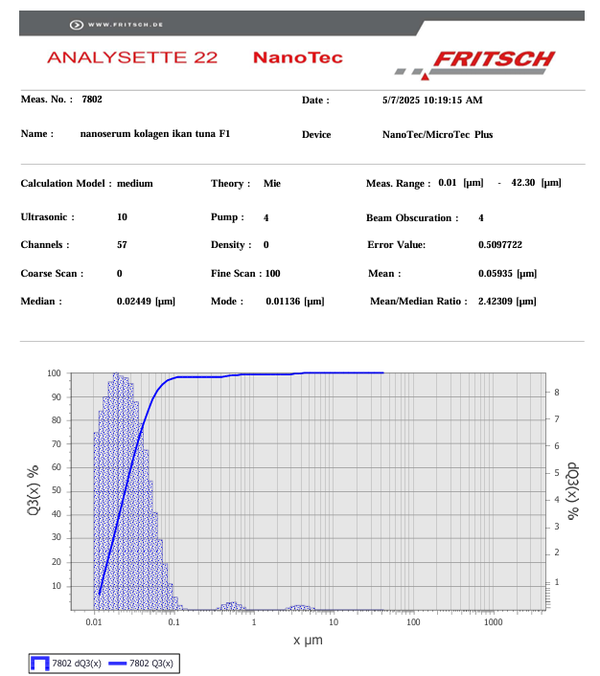
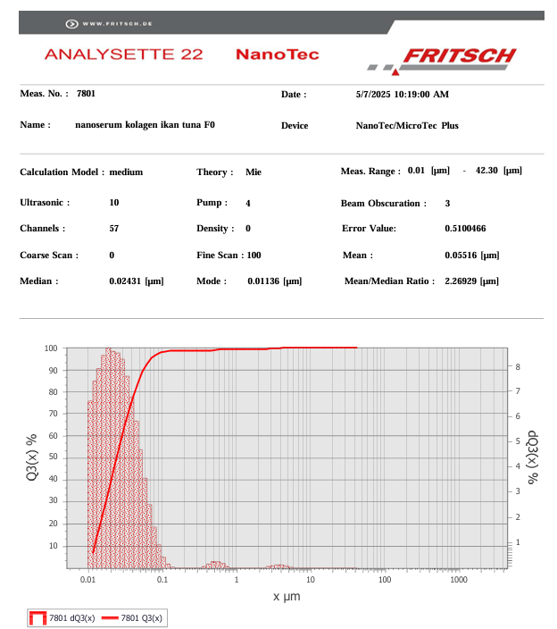
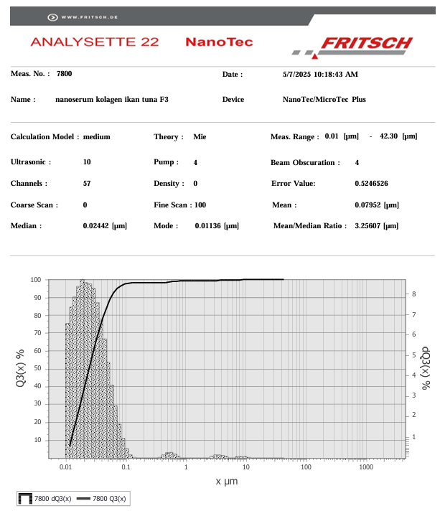
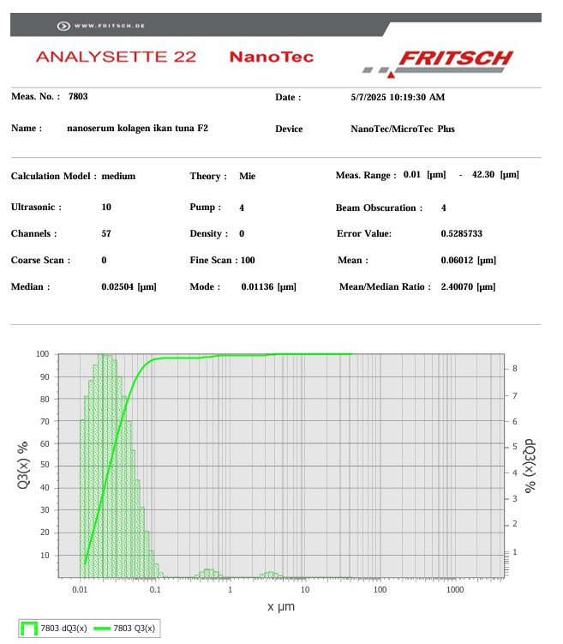
Lampiran 17. Uji iritasi
Uji iritasi
F0 | 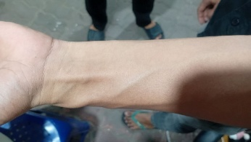
F1 | 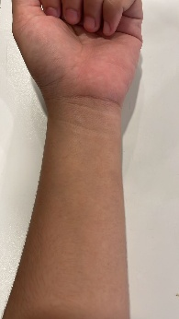
F2 | 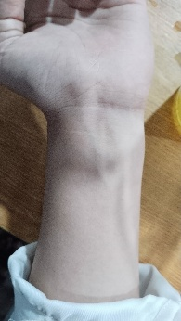
F3 | 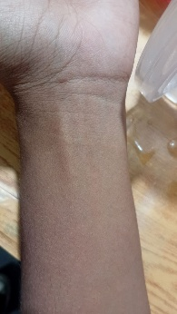

Lampiran 18. Surat Permohonan Izin Penelitian
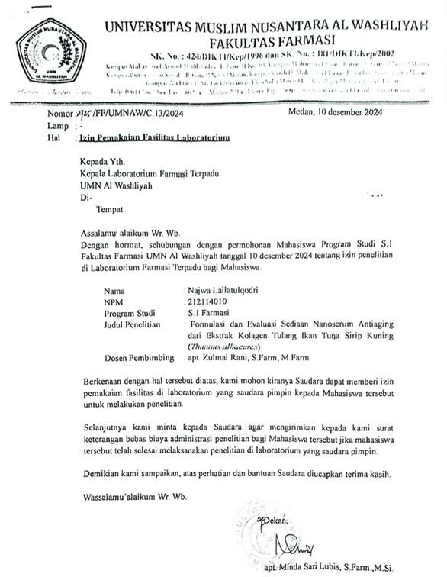
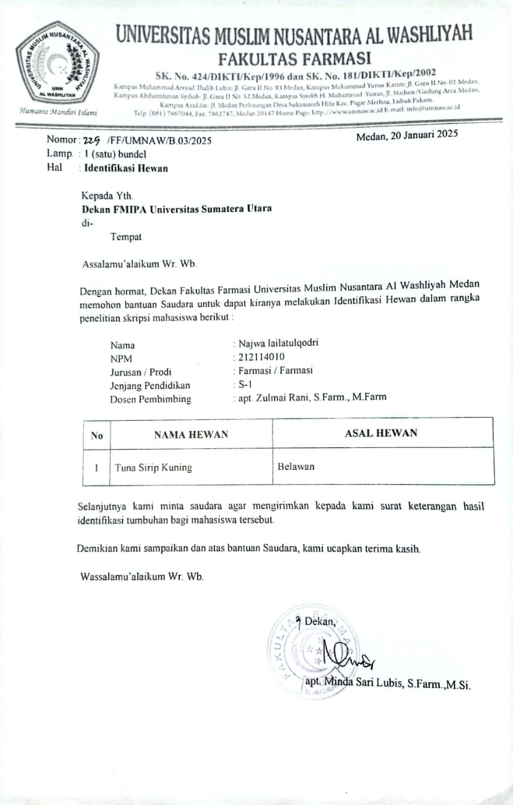
Lampiran 19. Surat Permohonan Identifikasi Hewan

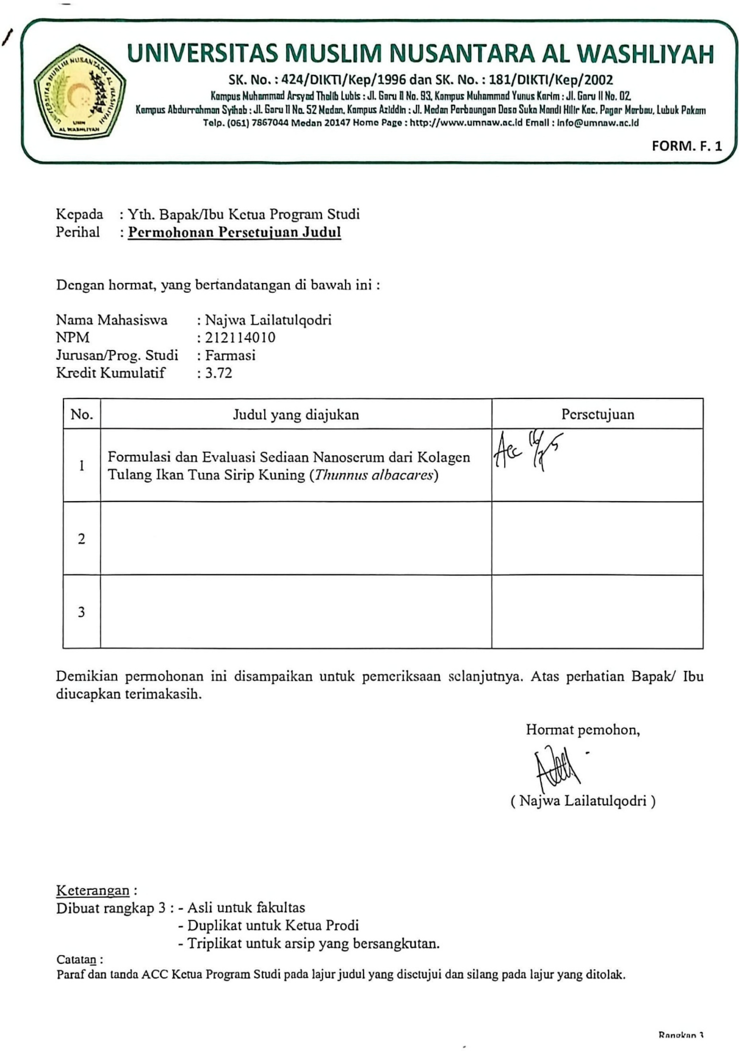

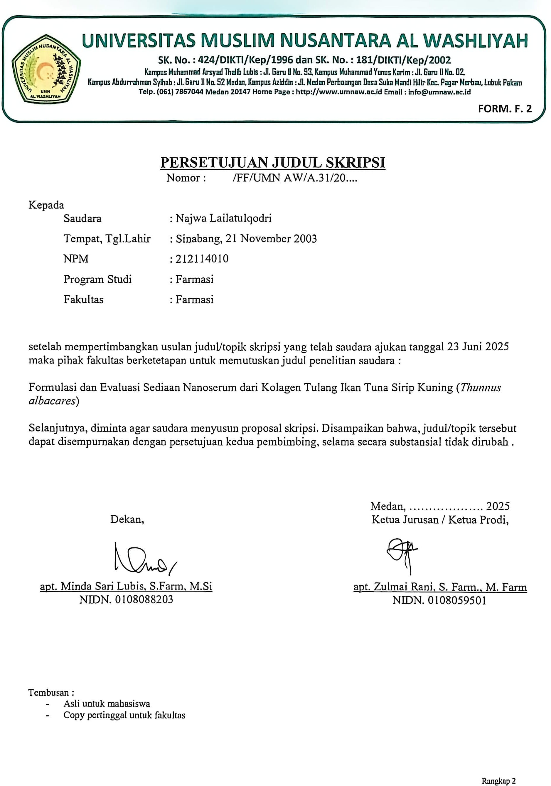

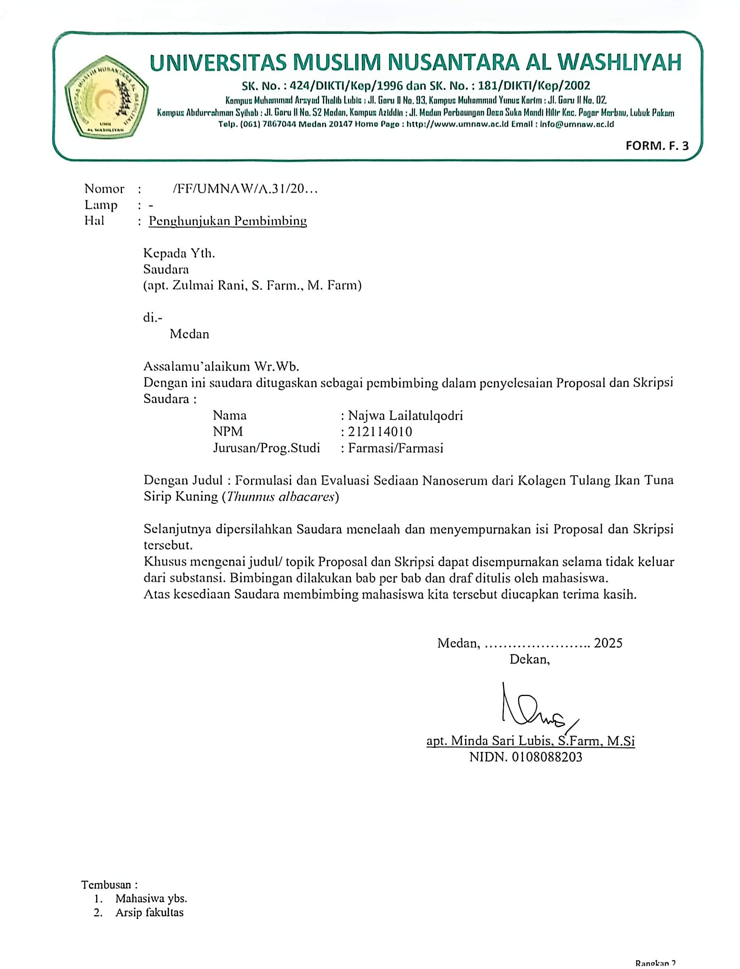

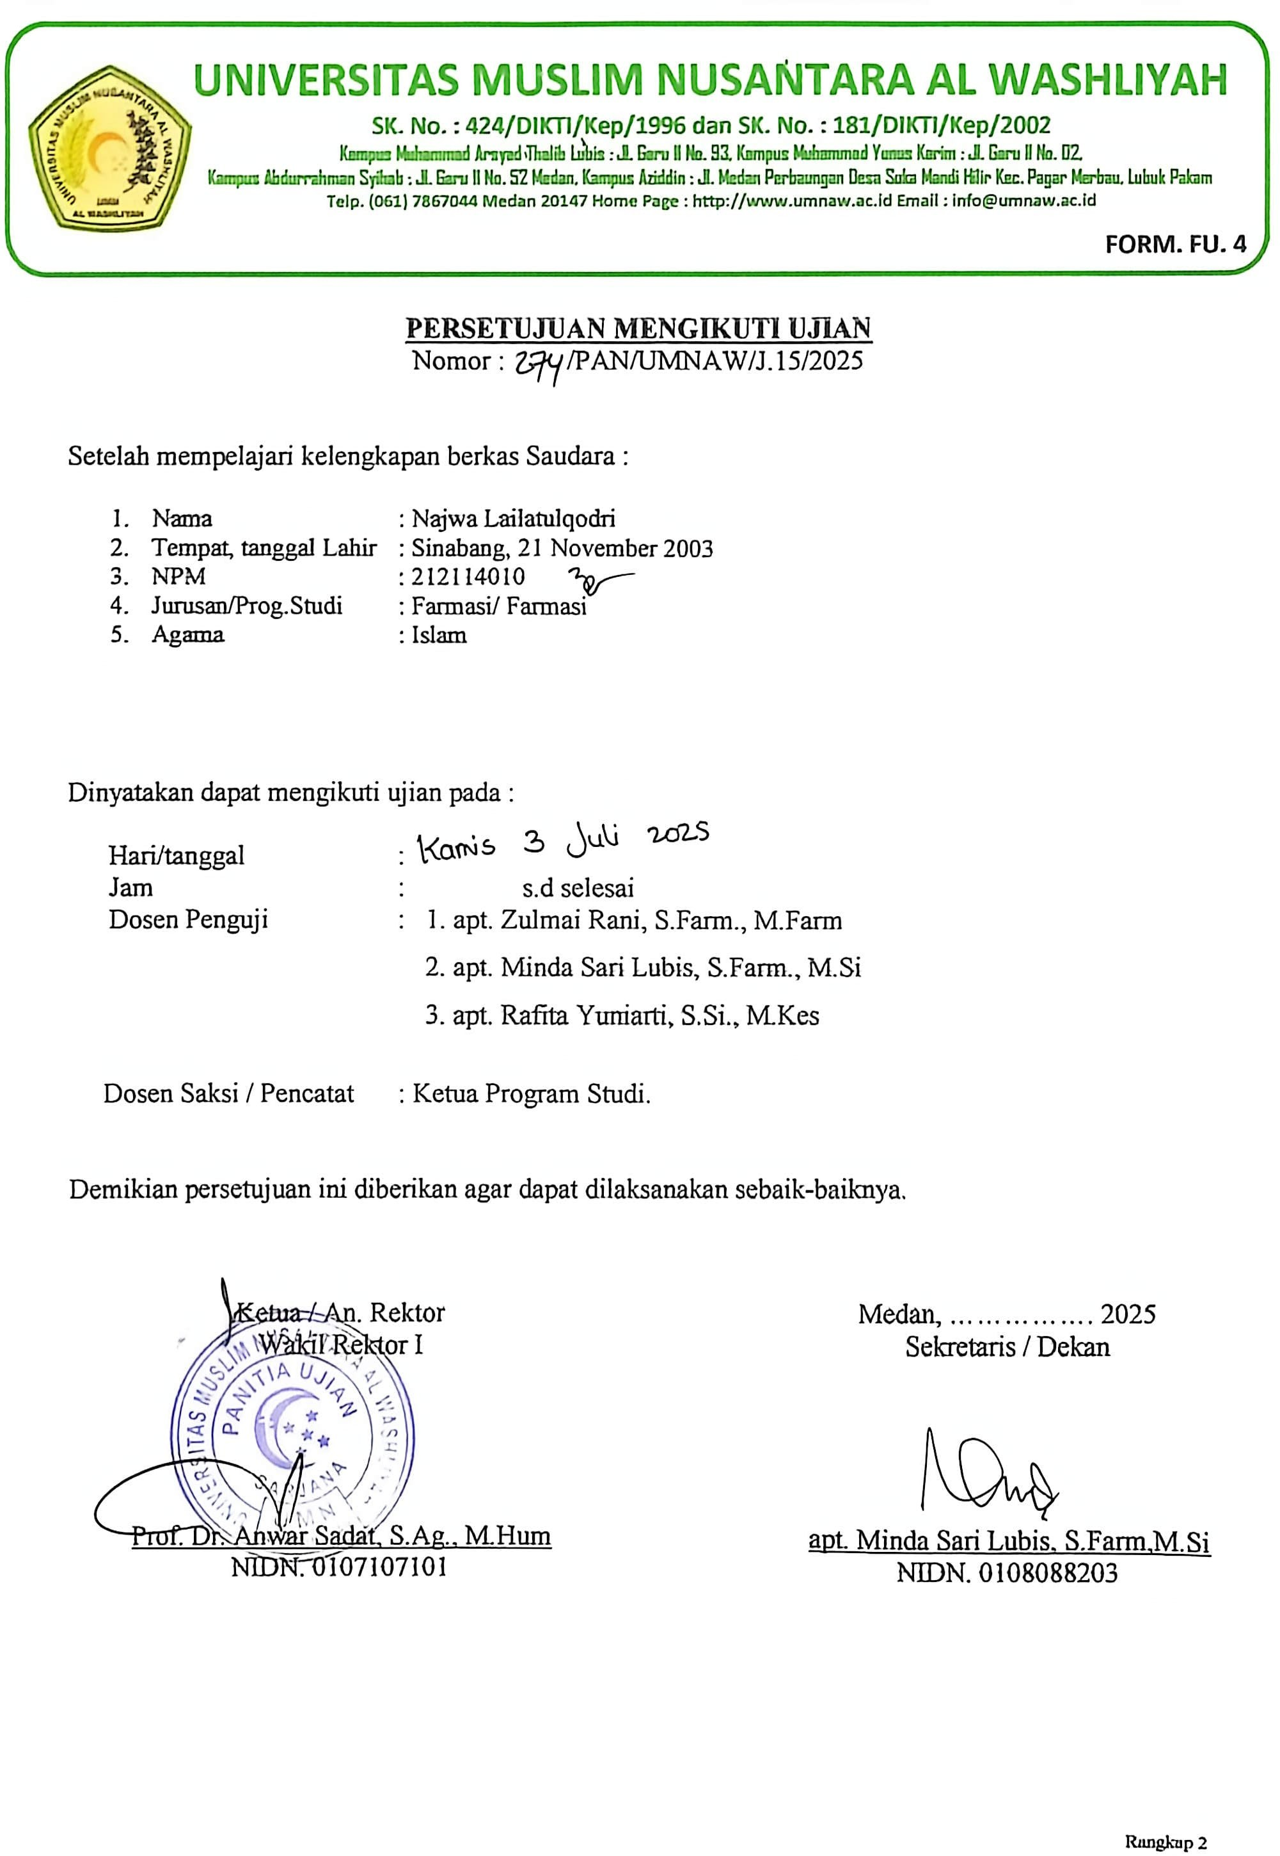

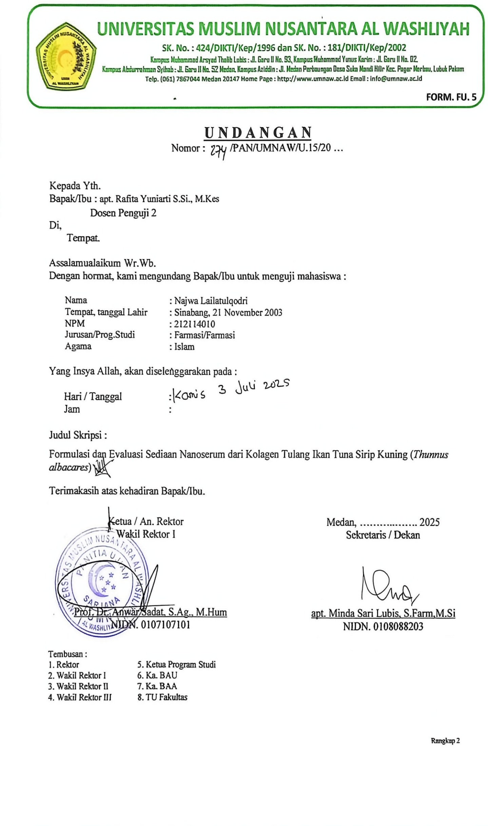

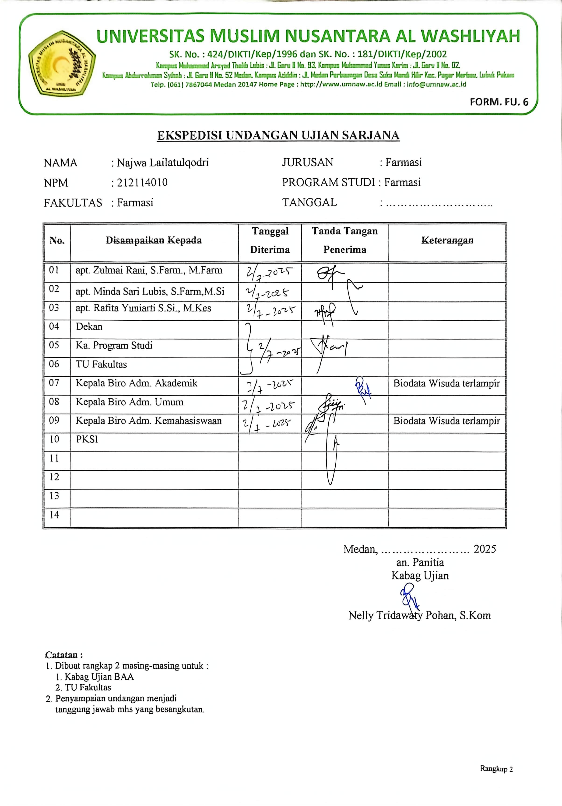
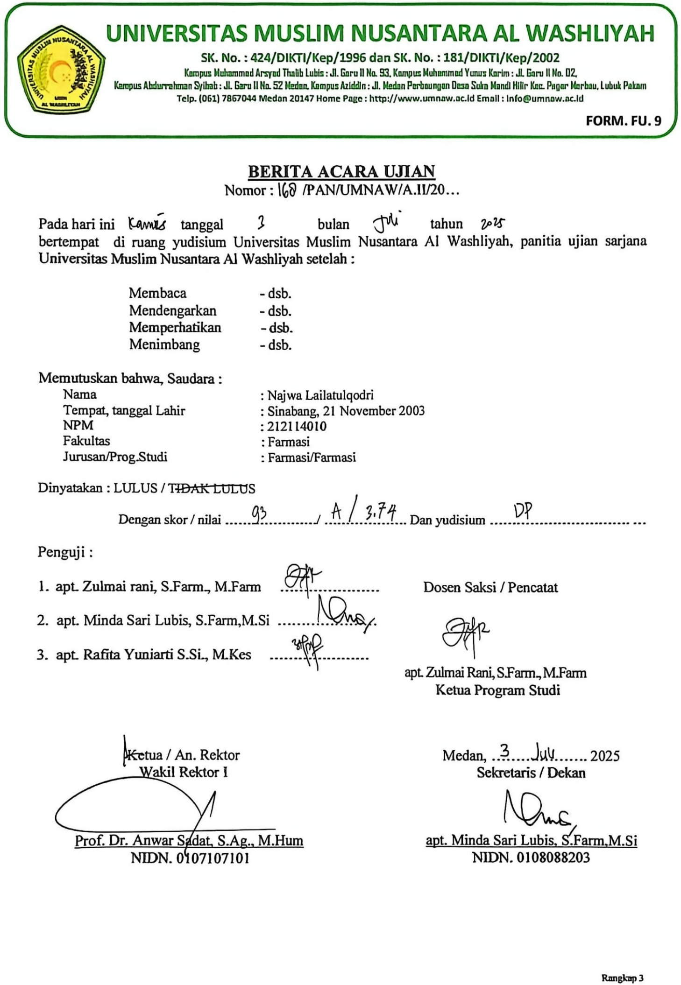
ar

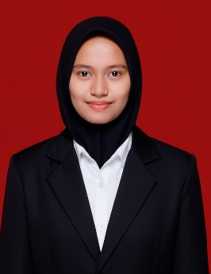
BIODATA MAHASISWA
- IDENTITAS DIRI
Nama : Najwa Lailatulqodri
NPM : 212114010
Tempat/Tgl Lahir : Sinabang, 21 November 2003
Agama : Islam
Anak Ke : 2 (Dua)

Alamat : Jl Ismailiyah No 119, Medan Area
No. Telp/HP : 082258200929
Dosen Pembimbing : apt. Zulmai Rani, S.Farm., M.Farm
Judul Skripsi : Fomulasi dan Evaluasi Sediaan Nanoserum dari
Kolagen Tulang Ikan Tuna Sirip Kuning (Thunnus albacares)

- PENDIDIKAN
SD : SD Negeri 5 Simeulue Timur
SLTP/SMP : SMP Negeri 2 Simeulue Timur
SLTA/SMA : SMA Negeri 1 Sinabang

- ORANG TUA
Nama Ayah : Indra Ajis
Pekerjaan : Wiraswasta
Nama Ibu : Julina Defita
Pekerjaan : PNS
Alamat : Jl Perdagangan, Sinabang, Simeulue Timur

