DAFTAR PUSTAKA

Aini, F., Maulidiyah, R., & Hidayanto, M. F. (2022). Pengaruh gaya hidup dan sikap konsumen terhadap keputusan pembelian. Jurnal manajemen, 14(1), 83-90

Baskora, R., Putra, A., Mulyawati, I., Salsabila, M. D., & Catherine, E. (2024). Pemanfaatan Limbah Minyak Jelantah Menjadi Lilin Aromaterapi Sebagai Solusi Kreatif Serta Ramah Lingkungan. 4, 290–298.

Budiana, M. (2024). International Humanitarian Intervention Ethical Dilemmas and Political Realities. May.

Chiu, T. K. F., Xia, Q., Zhou, X., Chai, C. S., & Cheng, M. (2023). Systematic literature review on opportunities, challenges, and future research recommendations of artificial intelligence in education. Computers and Education: Artificial Intelligence, 4(December 2022), 100118. https://doi.org/10.1016/j.caeai.2022.100118

Cramer, D., & Howitt, D. (2015). Pre-Test-Post-Test Design. The SAGE Dictionary of Statistics, 6, 44–50. https://doi.org/10.4135/9780857020123.n438

Diaty, R., Arisa, A., Cahyani, N., Lestari, A., Utami, S. W., & Purwanti, S. (2022). Jurnal Kebidanan Bestari , Volume 6 ( 1 ), Tahun 2022 EISSN : 2656-2251 Pengaruh Umur Ibu yang Beresiko Kanker Serviks dan Tingkat Pendidikan Ibu dengan Kanker Serviks di Ruang Poli Kandungan RSUD Ulin Banjarmasin ( The Effect of Mother Age that Risk for . 6(1), 19–25.

Donny Arif & Sherly (2024) Enhancing Creative Excellence in the Southern Indian IT Sectors: The Role of Autonomous Motivation in Inclusive Leadership Practices https://www.researchgate.net/publication/385811365

Fajri, Ri., Suryana Nasution, N., & Nurwansyah Sumarsono, R. (2023). Tingkat kemampuan teknik dasar passing atas pada ekstrakulikuler bola voli. Jurnal Porkes, 6(2), 656–669. https://doi.org/10.29408/porkes.v6i2.23065

Febriany, Y., Kosasih, & Yuliaty, F. (2024). Pengaruh Motivasi, Persepsi, Gaya Hidup dan Sikap Pasien Terhadap Keputusan Berobat di Klinik Harum Medika Binuang Kalimantan Selatan. EKOMA : Jurnal Ekonomi, Manajemen, Akuntansi, 4(1), 799–820. https://doi.org/10.56799/ekoma.v4i1.5936.

Haeruddin, Johan, H., Hairah, U., & Budiman, E. (2017). Ethnobotany database: Exploring diversity medicinal plants of Dayak Tribe Borneo. International
Conference on Electrical Engineering, Computer Science and Informatics (EECSI),2017-Decem(September2017). https://doi.org/10.1109/EECSI.2017.8239094

Haryono, A., & Adam, C. (2021). The implementation of mini-research project to train undergraduate students’ scientific writing and communication skills. JPBI (Jurnal Pendidikan Biologi Indonesia), 7(2), 159–170. https://doi.org/10.22219/jpbi.v7i2.15838

Hidayat, E., Marwoto, P., & Widiyatmoko, A. (2024). Journal of Innovative Science Education The Effectiveness of Contextual-Approach Science E-Module Integrated with Local Wisdom on Pressure Topic to Improve Critical Thinking Skills. 13(2), 83–91.

Hidayanto, M. F. (2022). Pengaruh gaya hidup dan sikap konsumen terhadap keputusan pembelian. JURNAL MANAJEMEN, Vol. 14 (1) 2022,89.

Imambachri, S. H., & Purnama Dewi, D. (2022). Pengaruh Disruptive Marketing, Strategi Generik Dan Gaya Hidup Terhadap Keputusan Membeli Pada Generasi Z. Jurnal Sekretari Universitas Pamulang, 9(2), 102. https://doi.org/10.32493/skr.v9i2.21921

Kasus, S., Point, C., Kec, D. I., & Korespondensi, E. (2024). PENGARUH STRATEGI GREEN BUSINESS DAN PERILAKU KONSUMEN TERHADAP VOLUME PENJUALAN YANG DIMEDIASI KEUNGGULAN BERSAING PRODUK. 7, 47–53.

Kim, S., & Rasouli, S. (2022). The influence of latent lifestyle on acceptance of Mobility-as-a-Service (MaaS): A hierarchical latent variable and latent class approach. Transportation Research Part A: Policy and Practice, 159(July 2021), 304–319. https://doi.org/10.1016/j.tra.2022.03.020

Kinasih, A. H. S., & Prabawani, B. (2020). Pengaruh Gaya Hidup Dan Ekuitas Merek Terhadap Keputusan Penggunaan Perawatan Kecantikan (Studi Pada Konsumen Wanita Natasha Skin Care Semarang). Jurnal Ilmu Administrasi Bisnis, 9(3), 250-258..

Kotler, P., & Keller, K. (2021). Manajemen Pemasaran (edisi Global ke-15). Pearson Education Limited. https://www.scirp.org/reference/referencespapers

Lee, T., & Shih, Y. D. (2025). The Application of Wordwall . net in English Language Instruction for Young Learners : The Learning Motivation of Taiwanese Elementary School Third Graders. 11(1), 48–58.

Lauluw&Andalas(2023): Analisis Perseptif atas Penentu Keputusan Konsumen untukMembeliProdukJamuTolakAnginSidoMunculhttps://www.researchgate.net/publication/373464435

Maulina, M., Ignacio, J. F., Bersabe, L. A. C., Serrano, A. J. D., Carpio, N. G., & Santos, E. G. D. (2022). Technology-Based Media Used in Teaching Listening Skills. Exposure : Jurnal Pendidikan Bahasa Inggris, 11(1), 85–99. https://doi.org/10.26618/exposure.v11i1.6564

Maulina, M., Sri Andriyani, A., Amin, S., Nasrullah, R., Asdar, A., & Hamsiah, A. (2022). Students’ Perception in Learning English through Blended Learning. Journal of Education and Teaching (JET), 3(1), 50–68. https://doi.org/10.51454/jet.v3i1.138

Maulina, Titin Rahmiatin Rahim, Angelica Ordanza Cortez, Sheryl Ann V. Narciso, & Anwar Said. (2023). Social Media as Mobile Learning Oral Chat-Based Constructive Communication to Improve Speaking Skills. Decode: Jurnal Pendidikan Teknologi Informasi, 3(1), 139–150. https://doi.org/10.51454/decode.v3i1.144

Meli Makin, G., & Setiyawan, S. (2023). Effect of Promotion Mix on Purchasing Decisions on the Shopee Platform with Lifestyle as an Intervening Variable. The Management Journal of Binaniaga, 8(1), 17–26. https://doi.org/10.33062/mjb.v8i1.17

Nuryakin, R. A., SE, M., Negara, A. K., SE, M., Nurcholifah, I., S EI, M. M., ... & Sudarsono, S. E. (2025). PERILAKU KONSUMEN DAN GAYA HIDUP. Cendikia Mulia Mandiri.

Philosophy, E., Prisko, A., Fua, V., Janggo, W. O., & Sina, M. W. (2025). Alacrity : Journal Of Education. 5(1), 302–313.

Prasetyo, E., Utomo, S., Maulana, A. F., Arifriana, R., & Lestari, P. (2022). Current Distribution of a Luxurious Wood Species, Diospyros spp. with Its Climatic Information, based on Global Biodiversity Website. Jurnal Sylva Lestari, 10(2), 267–277. https://doi.org/10.23960/jsl.v10i2.576

Putu, N., Kumalasari, P., Gama, I. K., Ayu, K., Achjar, H., Suardana, I. W., & Gusti, I. (2024). Health Dynamics The Relationship Between Self-Management and Blood Pressure of Hypertension Sufferers in the Kediri I Health Center Region , Tabanan District Health Dynamics. 1(1), 425–432.

Purnomo, A., Ramadhan, M. A., & Maulana, R. (2025). Liability Of Expedition Servicecompaniesforlossessufferedbyconsumers. JurnalAbdisci, 3(2),213–221. https://doi.org/10.62885/abdisci.v3i2.731

Putro et al. (2023) The Effect of High-Intensity Interval Training on Blood Glucose Levels in Patients with Type 2 Diabetes MellitusTersedia di European Journal of Sport Sciences: https://www.ej-sport.org/index.php/sport/article/view/167

Rahardjo, A., & Maharani, D. A. (2014). A Review of Indonesia’s Dental Health - Past, Present and Future. International Journal of Clinical Preventive Dentistry, 10(3), 121–126. https://doi.org/10.15236/ijcpd.2014.10.3.121

Rusli, K. D. Bin, Lau, Y., Lau, S. T., Tham, L. S., Kee, M. M. N., Ng, Q. W., Ong, S. F., Karen, S., & Liaw, S. Y. (2025). Development and validation of competencies for home-based nursing care: an e-Delphi study. International Journal of Nursing Studies Advances, 8(April), 100330. https://doi.org/10.1016/j.ijnsa.2025.100330

Siqueira, E. H., Larranaga, A. M., Batista, B. B., Lucchesi, S. T., & Cybis, H. B. B. (2023). Factors that influence the use of ride-sourcing services: A São Paulo City case study. Social Sciences & Humanities Open, 8(1), 100560

Spencer, G., & Thompson, J. (2024). Children and young people’s perspectives on disasters – Mental health, agency and vulnerability: A scoping review. International Journal of Disaster Risk Reduction, 108(April), 104495. https://doi.org/10.1016/j.ijdrr.2024.104495

Subhaktiyasa, P. G. (n.d.). Evaluasi Validitas dan Reliabilitas Instrumen Penelitian Kuantitatif : Sebuah Studi Pustaka. 5(4), 5599–5609.

Sugiyono. (2018). Metode Penlelitian Kuantitatif, Kualitatif & Rnd. Bandung: Alfabeta.

Sugiyono. (2019). Metode Penelitian Kuantitatif Kualitatif dan R&D. Bandung : Alfabeta

Supardin, L. (2022). Pengaruh gaya hidup dan kelompok referensi terhadap keputusan pembelian produk berlabel halal. JEMBA: Jurnal Ekonomi, Manajemen, Bisnis Dan Akuntansi, 1(1), 71-82.

Suryani, S., & Rosalina, S. S. (2019). Pengaruh Brand Image, Brand Trust, Dan Kualitas Layanan Terhadap Keputusan Pembelian Ulang Dengan Kepuasan Konsumen Sebagai Variabel Moderating. Administrasi Bisnis, Fakultas Ekonomi Dan Bisnis, Universitas 17 Agustus 1945 Jakarta, 04(1), 41–53.

Syaharullah, Yahya, M., & Syarif, A. (2021). Penggunaan Facebook Dalam Promosi Produk Barang Jadi. Jurnal Kajian Islam Kontemporer, 12(2), 27–38.

Sutarto, A. P. (2019). Probabilitas Statistik Dasar Untuk Sains. Yogyakarta: PT.Pustaka Baru.

Tsani, S., & Overland, I. (2021). In quest of sustainable politics and economics of natural resources: A summary of contributions and future research directions. Handbook of Sustainable Politics and Economics of Natural Resources, December 2021, 1–13. https://doi.org/10.4337/9781789908770.00008

Tjiptono (2020)Principles of Service Marketing and Management (6th Edition) https://www.scirp.org/reference/referencespapers

Tumanggor, M. B., Samosir, S. H., & Satria, D. (2023). Pengaruh Harga, Lokasi Dan Gaya Hidup Terhadap Keputusan Pembelian Rumah Pada CV. Medan properti. Jurnal ilmu manajemen dan kewirausahaan (JIMK), 4(2), 294-302

Wajdi, F., Seplyana, D., Juliastuti, Rumahlewang, E., Fatchiatuzahro, Halisa, N. N., Rusmalinda, S., Kristiana, R., Niam, M. F., Purwanti, E. W., Melinasari, S., & Kusumaningrum, R. (2024). Metode Penelitian Kuantitatif. In Jurnal Ilmu Pendidikan (Vol. 7, Issue 2).

Wirtz, J., & Lovelock, C. (2021). Services Marketing People, Technology, Strategy, Ninth Edition. In Services Marketing: People, Technology, Strategy, Ninth Edition (Issue January). https://doi.org/10.1142/y0024

Yuliani, W., & Supriatna, E. (2023). Metode penelitian bagi pemula. Penerbit Widina.

Zeithaml, Bitner, dan Gremler (2020) Services Marketing: Integrating Customer FocusAcrossthe Firm:https://www.mheducation.com/highered/product/Services-Marketing-Integrating-Customer-Focus-Across-the-Firm-Zeithaml.html

Lampiran 1
LEMBAR KUESIONER
I.IDENTITAS PEMBERI KUESIONER
Nama : Nur Hazizah
NPM : 213114096
Jenis Kelamin : Perempuan
Jurusan : Manajemen
Fakultas : Ekonomi Dan Bisnis
Saya adalah mahasiswa Universitas Muslim Nusantara Al Washliyah Fakultas Ekonomi Dan Bisnis Program Studi Manajemen yang sedang melakukan penelitian “Pengaruh Gaya Hidup,Kelompok Acuan,dan Sikap Terhadap Keputusan Penggunaan Jasa di Rummah Sehat Bio Live Kecamatan Sei Bamban kabupaten Serdang Bedagai”. Data dan Informasi yang Bapak/ibu berikan merupakan hal yang sangat berharga, oleh karena itu partisipasi dan kesediaan Bapak/ibu dalam menjawab kuesioner ini sangat saya hargai. Akhir kata saya ucapkan terima kasih kepada responden yang telah bersedia meluangkan waktunya untuk mengisi kuesioner ini.
Medan, Januari 2025
Peneliti

Nur Hazizah
NPM:213114096

II. IDENTITAS RESPONDEN
Nama : ……………………………………..
Usia : ……………
Jenis Kelamin : Laki-Laki / Perempuan
Pendidikan : ……………………………………..
Pekerjaan : ……………………………………..
Frekuensi Menggunakan Layanan Rumah Sehat Bio Live : 1-2 kali/Lebih dari 2 kali
III. PETUNJUK PENGISIAN
Bacalah baik-baik setiap pertanyaan angket sebelum menjawabnya. Berilah jawaban dengan memberi tanda (√) pada kolom yang tersedia.
Keterangan jawaban:
SS : Sangat Setuju
TS : Tidak Setuju
S : Setuju
STS : Sangat Tidak Setuju
KS : Kurang Setuju

DAFTAR PERNYATAAN
Variabel Gaya Hidup (X₁)
No | Pernyataan | Alteratif Jawaban
No | Pernyataan | SS | S | KS | TS | STS
1. | Saya lebih memilih layanan kesehatan yang bersifat alami atau organik karena saya peduli terhadap kesehatan jangka panjang
2. | Saya terbiasa melakukan pemeriksaan kesehatan secara rutin untuk memantau kondisi kesehatan tubuh saya.
3. | Hidup sehat adalah prinsip penting dalam kehidupan saya
4. | Saya mencari informasi tentang gaya hidup sehat dari media sosial, internet, atau teman
5. | Saya meluangkan waktu untuk berolahraga secara teratur demi menjaga kebugaran tubuh
6. | Saya memanfaatkan berbagai sumber, seperti internet atau media sosial, untuk mendapatkan informasi tentang layanan kesehatan.

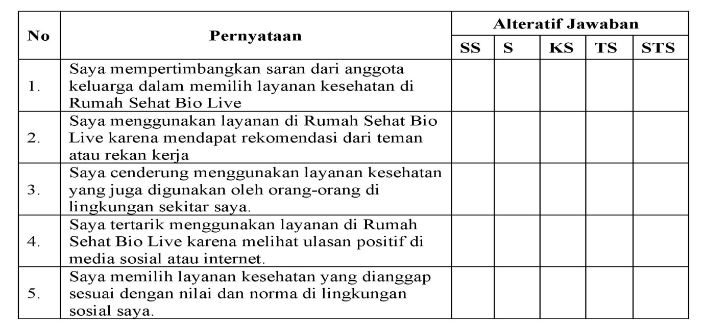
Variabel Kelompok Acuan (X₂)

Sikap (X₃)
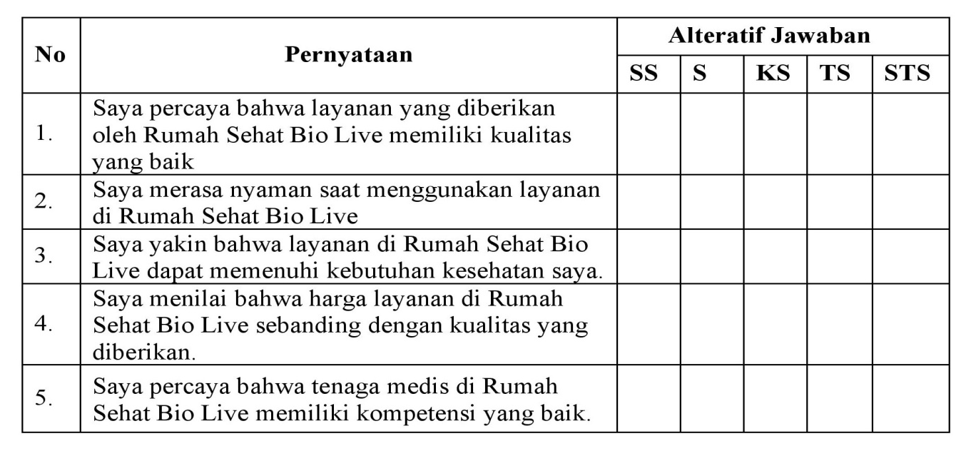

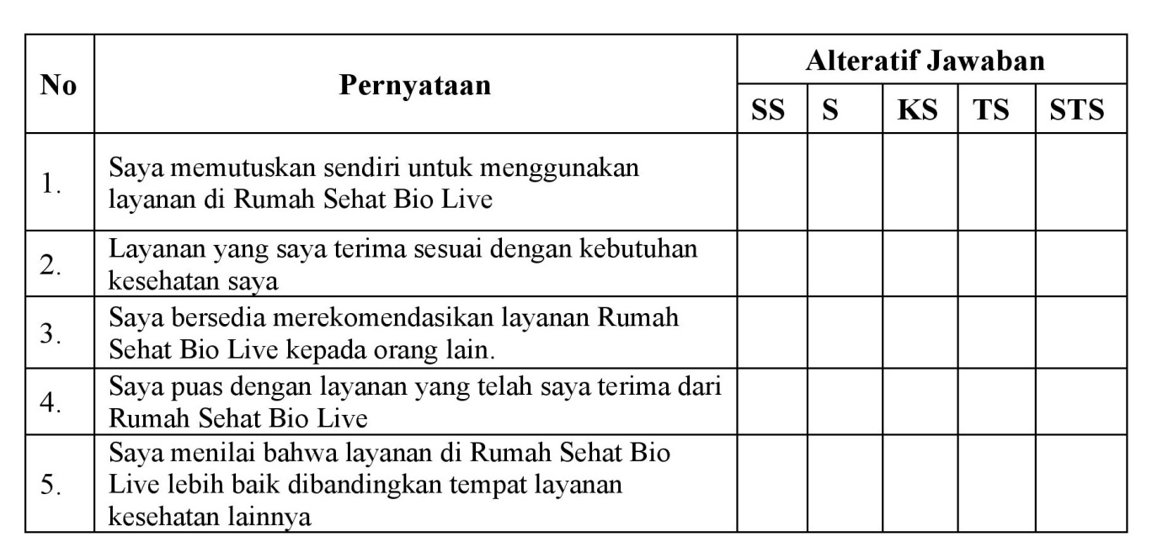
Variabel Keputusan Penggunaan Jasa Y

Lampiran 2
Tabulasi Data Uji Validitas Dan Reliabitas Variabel Gaya Hidup
No | X1.1 | X1.2 | X1.3 | X1.4 | X1.5 | X1.6 | X1.TTL
1 | 5 | 5 | 4 | 3 | 5 | 3 | 25
2 | 4 | 4 | 4 | 5 | 5 | 4 | 26
3 | 4 | 5 | 3 | 5 | 4 | 4 | 25
4 | 5 | 5 | 4 | 5 | 4 | 3 | 26
5 | 5 | 5 | 4 | 4 | 5 | 4 | 27
6 | 4 | 4 | 5 | 5 | 5 | 4 | 27
7 | 5 | 5 | 4 | 4 | 4 | 5 | 27
8 | 4 | 4 | 5 | 4 | 5 | 4 | 26
9 | 4 | 5 | 4 | 5 | 4 | 5 | 27
10 | 4 | 4 | 5 | 4 | 4 | 4 | 25
11 | 5 | 5 | 4 | 5 | 4 | 5 | 28
12 | 4 | 4 | 4 | 4 | 5 | 4 | 25
13 | 3 | 3 | 3 | 3 | 4 | 4 | 20
14 | 4 | 4 | 4 | 4 | 3 | 3 | 22
15 | 4 | 4 | 4 | 4 | 4 | 4 | 24
16 | 4 | 4 | 4 | 4 | 4 | 4 | 24
17 | 5 | 5 | 5 | 5 | 4 | 4 | 28
18 | 5 | 5 | 5 | 5 | 5 | 5 | 30
19 | 5 | 5 | 4 | 5 | 5 | 4 | 28
20 | 4 | 4 | 5 | 4 | 4 | 5 | 26
21 | 5 | 5 | 4 | 5 | 5 | 4 | 28
22 | 4 | 4 | 3 | 4 | 4 | 3 | 22
23 | 3 | 3 | 4 | 3 | 3 | 4 | 20
24 | 4 | 4 | 4 | 4 | 4 | 4 | 24
25 | 4 | 4 | 3 | 4 | 4 | 3 | 22
26 | 3 | 3 | 2 | 3 | 3 | 2 | 16
27 | 2 | 2 | 3 | 2 | 2 | 3 | 14
28 | 3 | 3 | 5 | 3 | 3 | 5 | 22
29 | 5 | 5 | 5 | 5 | 3 | 5 | 28
30 | 4 | 4 | 5 | 4 | 2 | 5 | 24

Tabulasi Data Uji Validitas Dan Reliabitas Variabel Kelompok Acuan
No | X2.1 | X2.2 | X2.3 | X2.4 | X2.5 | X2.TTL
1 | 5 | 4 | 5 | 4 | 5 | 23
2 | 5 | 4 | 4 | 4 | 4 | 21
3 | 4 | 4 | 4 | 4 | 4 | 20
4 | 4 | 5 | 5 | 5 | 5 | 24
5 | 3 | 4 | 4 | 4 | 4 | 19
6 | 4 | 5 | 5 | 5 | 5 | 24
7 | 4 | 5 | 4 | 5 | 4 | 22
8 | 5 | 4 | 3 | 4 | 3 | 19
9 | 4 | 5 | 4 | 5 | 4 | 22
10 | 5 | 4 | 5 | 4 | 5 | 23
11 | 4 | 5 | 4 | 5 | 4 | 22
12 | 5 | 4 | 5 | 4 | 5 | 23
13 | 4 | 5 | 4 | 5 | 4 | 22
14 | 4 | 4 | 4 | 4 | 4 | 20
15 | 3 | 3 | 4 | 3 | 3 | 16
16 | 4 | 4 | 3 | 4 | 4 | 19
17 | 4 | 4 | 4 | 4 | 4 | 20
18 | 4 | 4 | 4 | 4 | 4 | 20
19 | 5 | 5 | 5 | 5 | 5 | 25
20 | 5 | 5 | 5 | 5 | 5 | 25
21 | 4 | 4 | 4 | 4 | 4 | 20
22 | 5 | 5 | 5 | 5 | 5 | 25
23 | 4 | 4 | 4 | 4 | 4 | 20
24 | 3 | 3 | 3 | 3 | 3 | 15
25 | 4 | 4 | 4 | 4 | 4 | 20
26 | 4 | 4 | 4 | 4 | 4 | 20
27 | 3 | 3 | 3 | 3 | 3 | 15
28 | 2 | 2 | 2 | 2 | 2 | 10
29 | 3 | 3 | 3 | 3 | 3 | 15
30 | 5 | 5 | 5 | 5 | 5 | 25

Tabulasi Data Uji Validitas Dan Reliabitas Variabel Sikap
No | X3.1 | X3.2 | X3.3 | X3.4 | X3.5 | X3.TTL
1 | 3 | 3 | 3 | 3 | 3 | 15
2 | 4 | 4 | 4 | 4 | 4 | 20
3 | 4 | 4 | 4 | 4 | 4 | 20
4 | 4 | 4 | 4 | 4 | 4 | 20
5 | 5 | 5 | 5 | 5 | 5 | 25
6 | 5 | 5 | 5 | 5 | 5 | 25
7 | 4 | 4 | 4 | 4 | 4 | 20
8 | 5 | 5 | 5 | 5 | 5 | 25
9 | 4 | 4 | 4 | 4 | 4 | 20
10 | 3 | 3 | 3 | 3 | 3 | 15
11 | 4 | 4 | 4 | 4 | 4 | 20
12 | 4 | 4 | 4 | 4 | 4 | 20
13 | 3 | 3 | 3 | 3 | 3 | 15
14 | 2 | 2 | 2 | 2 | 2 | 10
15 | 3 | 3 | 3 | 3 | 3 | 15
16 | 5 | 5 | 5 | 5 | 5 | 25
17 | 5 | 4 | 5 | 5 | 4 | 23
18 | 5 | 4 | 4 | 4 | 3 | 20
19 | 4 | 3 | 4 | 3 | 4 | 18
20 | 4 | 5 | 3 | 5 | 4 | 21
21 | 3 | 4 | 5 | 5 | 3 | 20
22 | 4 | 5 | 4 | 5 | 4 | 22
23 | 4 | 4 | 5 | 4 | 4 | 21
24 | 5 | 5 | 4 | 5 | 5 | 24
25 | 4 | 4 | 5 | 4 | 4 | 21
26 | 5 | 5 | 4 | 5 | 5 | 24
27 | 4 | 4 | 5 | 4 | 4 | 21
28 | 5 | 5 | 4 | 5 | 5 | 24
29 | 4 | 4 | 5 | 4 | 4 | 21
30 | 4 | 4 | 4 | 4 | 4 | 20

Tabulasi Data Uji Validitas Dan Reliabitas Variabel Keputusan Pengguna Jasa
No | Y.1 | Y.2 | Y.3 | Y.4 | Y.5 | Y.TTL
1 | 4 | 4 | 4 | 4 | 5 | 21
2 | 4 | 4 | 3 | 3 | 4 | 18
3 | 5 | 3 | 5 | 5 | 3 | 21
4 | 4 | 4 | 4 | 5 | 5 | 22
5 | 5 | 4 | 5 | 5 | 5 | 24
6 | 5 | 5 | 4 | 4 | 5 | 23
7 | 4 | 4 | 5 | 5 | 4 | 22
8 | 5 | 5 | 4 | 4 | 5 | 23
9 | 4 | 4 | 5 | 5 | 4 | 22
10 | 5 | 5 | 4 | 4 | 5 | 23
11 | 4 | 4 | 5 | 5 | 4 | 22
12 | 5 | 4 | 4 | 4 | 5 | 22
13 | 4 | 3 | 4 | 4 | 4 | 19
14 | 3 | 4 | 3 | 3 | 4 | 17
15 | 4 | 4 | 4 | 4 | 3 | 19
16 | 4 | 4 | 4 | 4 | 4 | 20
17 | 4 | 5 | 4 | 4 | 4 | 21
18 | 5 | 5 | 5 | 5 | 4 | 24
19 | 5 | 4 | 5 | 5 | 5 | 24
20 | 4 | 5 | 4 | 4 | 5 | 22
21 | 5 | 4 | 5 | 5 | 4 | 23
22 | 4 | 3 | 4 | 4 | 5 | 20
23 | 3 | 4 | 3 | 3 | 4 | 17
24 | 4 | 4 | 4 | 4 | 3 | 19
25 | 4 | 3 | 4 | 4 | 4 | 19
26 | 3 | 2 | 3 | 3 | 4 | 15
27 | 2 | 3 | 2 | 2 | 3 | 12
28 | 3 | 4 | 3 | 3 | 2 | 15
29 | 2 | 3 | 5 | 5 | 3 | 18
30 | 3 | 4 | 4 | 2 | 5 | 18

Tabulasi Data Jawaban Responden Variabel Gaya Hidup
No | X1.1 | X1.2 | X1.3 | X1.4 | X1.5 | X1.6 | X1.TTL
1 | 4 | 4 | 4 | 3 | 4 | 5 | 24
2 | 3 | 4 | 4 | 5 | 5 | 4 | 25
3 | 5 | 5 | 3 | 5 | 5 | 5 | 28
4 | 5 | 4 | 4 | 5 | 4 | 4 | 26
5 | 5 | 5 | 4 | 4 | 5 | 5 | 28
6 | 4 | 4 | 5 | 5 | 4 | 5 | 27
7 | 5 | 5 | 4 | 4 | 5 | 4 | 27
8 | 4 | 5 | 5 | 5 | 4 | 5 | 28
9 | 5 | 4 | 4 | 4 | 5 | 4 | 26
10 | 4 | 5 | 5 | 5 | 4 | 5 | 28
11 | 5 | 4 | 4 | 4 | 3 | 4 | 24
12 | 4 | 5 | 4 | 4 | 4 | 4 | 25
13 | 4 | 4 | 3 | 3 | 4 | 3 | 21
14 | 3 | 4 | 4 | 4 | 4 | 4 | 23
15 | 4 | 3 | 4 | 4 | 5 | 4 | 24
16 | 4 | 4 | 4 | 4 | 5 | 4 | 25
17 | 4 | 4 | 5 | 5 | 4 | 5 | 27
18 | 5 | 4 | 5 | 5 | 5 | 5 | 29
19 | 5 | 5 | 4 | 4 | 4 | 4 | 26
20 | 4 | 5 | 5 | 5 | 3 | 5 | 27
21 | 5 | 4 | 4 | 4 | 4 | 4 | 25
22 | 4 | 5 | 3 | 3 | 4 | 3 | 22
23 | 3 | 4 | 4 | 4 | 3 | 4 | 22
24 | 4 | 3 | 4 | 4 | 2 | 4 | 21
25 | 4 | 4 | 3 | 3 | 3 | 3 | 20
26 | 3 | 4 | 2 | 2 | 4 | 2 | 17
27 | 2 | 3 | 3 | 3 | 3 | 3 | 17
28 | 3 | 2 | 5 | 5 | 4 | 3 | 22
29 | 5 | 3 | 2 | 2 | 4 | 2 | 18
30 | 5 | 2 | 4 | 3 | 3 | 3 | 20
31 | 3 | 4 | 2 | 2 | 4 | 2 | 17
32 | 2 | 3 | 3 | 3 | 3 | 3 | 17
33 | 3 | 2 | 5 | 5 | 4 | 3 | 22
34 | 5 | 3 | 2 | 2 | 4 | 2 | 18
35 | 5 | 2 | 4 | 5 | 5 | 4 | 25
36 | 5 | 5 | 5 | 4 | 4 | 3 | 26
37 | 4 | 4 | 4 | 3 | 3 | 5 | 23
38 | 3 | 3 | 3 | 4 | 4 | 5 | 22
39 | 4 | 4 | 4 | 4 | 4 | 5 | 25
40 | 4 | 4 | 4 | 3 | 3 | 4 | 22
41 | 3 | 3 | 3 | 4 | 4 | 5 | 22
42 | 4 | 4 | 4 | 5 | 5 | 4 | 26
43 | 3 | 3 | 3 | 4 | 4 | 5 | 22
44 | 4 | 4 | 4 | 5 | 4 | 4 | 25
45 | 4 | 4 | 4 | 5 | 1 | 5 | 23
46 | 3 | 5 | 1 | 5 | 4 | 4 | 22
47 | 4 | 4 | 5 | 4 | 4 | 4 | 25
48 | 5 | 3 | 4 | 4 | 4 | 3 | 23
49 | 5 | 4 | 5 | 4 | 5 | 4 | 27
50 | 4 | 4 | 4 | 4 | 5 | 4 | 25
51 | 5 | 3 | 4 | 5 | 4 | 4 | 25
52 | 4 | 5 | 4 | 5 | 5 | 5 | 28
53 | 5 | 3 | 3 | 5 | 4 | 5 | 25
54 | 5 | 5 | 4 | 1 | 5 | 4 | 24
55 | 4 | 4 | 4 | 3 | 4 | 5 | 24
56 | 4 | 5 | 4 | 4 | 4 | 4 | 25
57 | 3 | 5 | 5 | 5 | 5 | 1 | 24
58 | 4 | 5 | 4 | 3 | 3 | 4 | 23
59 | 5 | 5 | 5 | 4 | 4 | 4 | 27
60 | 4 | 5 | 4 | 3 | 5 | 4 | 25
61 | 4 | 4 | 5 | 3 | 4 | 5 | 25
62 | 4 | 5 | 4 | 4 | 5 | 4 | 26
63 | 4 | 4 | 5 | 3 | 4 | 5 | 25
64 | 4 | 5 | 4 | 4 | 5 | 4 | 26
65 | 4 | 4 | 5 | 3 | 4 | 5 | 25
66 | 4 | 5 | 4 | 3 | 5 | 4 | 25
67 | 4 | 4 | 5 | 3 | 4 | 4 | 24
68 | 4 | 4 | 4 | 3 | 4 | 4 | 23
69 | 4 | 4 | 4 | 3 | 5 | 4 | 24
70 | 4 | 4 | 5 | 3 | 4 | 4 | 24
71 | 4 | 4 | 4 | 3 | 4 | 4 | 23
72 | 4 | 4 | 4 | 4 | 4 | 5 | 25
73 | 4 | 5 | 4 | 3 | 5 | 4 | 25
74 | 4 | 4 | 5 | 3 | 4 | 5 | 25
75 | 4 | 5 | 4 | 4 | 5 | 4 | 26
76 | 4 | 4 | 5 | 3 | 4 | 5 | 25
77 | 4 | 5 | 4 | 4 | 5 | 4 | 26
78 | 4 | 4 | 5 | 4 | 4 | 5 | 26
79 | 4 | 5 | 4 | 3 | 5 | 4 | 25
80 | 4 | 4 | 5 | 4 | 4 | 4 | 25
81 | 4 | 4 | 4 | 3 | 4 | 4 | 23
82 | 1 | 5 | 5 | 5 | 4 | 5 | 25
83 | 4 | 5 | 4 | 3 | 5 | 4 | 25
84 | 4 | 4 | 5 | 4 | 4 | 4 | 25
85 | 4 | 4 | 4 | 3 | 4 | 4 | 23
86 | 4 | 4 | 4 | 5 | 5 | 4 | 26
87 | 4 | 4 | 5 | 3 | 4 | 4 | 24
88 | 4 | 4 | 5 | 5 | 5 | 1 | 24
89 | 4 | 1 | 5 | 5 | 5 | 5 | 25
90 | 4 | 5 | 4 | 5 | 5 | 4 | 27
91 | 4 | 4 | 5 | 4 | 4 | 4 | 25
92 | 4 | 4 | 4 | 3 | 4 | 4 | 23

Tabulasi Data Jawaban Responden Variabel Kelompok Acuan
No | X2.1 | X2.2 | X2.3 | X2.4 | X2.5 | X2.TTL
1 | 5 | 5 | 3 | 4 | 5 | 22
2 | 5 | 5 | 5 | 5 | 5 | 25
3 | 5 | 5 | 5 | 4 | 5 | 24
4 | 4 | 4 | 5 | 5 | 4 | 22
5 | 5 | 5 | 4 | 4 | 4 | 22
6 | 4 | 4 | 5 | 5 | 5 | 23
7 | 5 | 5 | 4 | 5 | 5 | 24
8 | 4 | 4 | 5 | 4 | 4 | 21
9 | 5 | 5 | 4 | 5 | 5 | 24
10 | 4 | 4 | 5 | 4 | 4 | 21
11 | 4 | 4 | 4 | 5 | 4 | 21
12 | 3 | 3 | 4 | 4 | 4 | 18
13 | 4 | 4 | 3 | 4 | 5 | 20
14 | 4 | 4 | 4 | 3 | 4 | 19
15 | 4 | 4 | 4 | 4 | 3 | 19
16 | 5 | 5 | 4 | 4 | 4 | 22
17 | 5 | 5 | 5 | 4 | 4 | 23
18 | 4 | 4 | 5 | 5 | 4 | 22
19 | 5 | 5 | 4 | 5 | 5 | 24
20 | 4 | 4 | 5 | 4 | 5 | 22
21 | 3 | 3 | 4 | 5 | 4 | 19
22 | 4 | 4 | 3 | 4 | 5 | 20
23 | 4 | 4 | 4 | 3 | 4 | 19
24 | 3 | 3 | 4 | 4 | 3 | 17
25 | 2 | 2 | 3 | 4 | 4 | 15
26 | 3 | 3 | 2 | 3 | 4 | 15
27 | 5 | 4 | 3 | 2 | 3 | 17
28 | 2 | 4 | 5 | 3 | 2 | 16
29 | 3 | 3 | 5 | 2 | 3 | 16
30 | 2 | 2 | 3 | 4 | 4 | 15
31 | 3 | 3 | 2 | 3 | 4 | 15
32 | 5 | 4 | 3 | 2 | 3 | 17
33 | 2 | 4 | 5 | 3 | 2 | 16
34 | 3 | 3 | 5 | 2 | 3 | 16
35 | 4 | 4 | 5 | 5 | 5 | 23
36 | 4 | 4 | 4 | 4 | 4 | 20
37 | 5 | 5 | 3 | 3 | 3 | 19
38 | 5 | 5 | 4 | 4 | 4 | 22
39 | 4 | 4 | 4 | 4 | 4 | 20
40 | 5 | 5 | 3 | 3 | 3 | 19
41 | 4 | 4 | 4 | 4 | 4 | 20
42 | 1 | 5 | 3 | 3 | 3 | 15
43 | 4 | 4 | 4 | 4 | 4 | 20
44 | 4 | 4 | 4 | 4 | 4 | 20
45 | 5 | 1 | 3 | 3 | 3 | 15
46 | 3 | 4 | 4 | 4 | 3 | 18
47 | 2 | 5 | 5 | 3 | 4 | 19
48 | 3 | 5 | 5 | 4 | 5 | 22
49 | 5 | 4 | 4 | 4 | 5 | 22
50 | 5 | 4 | 4 | 4 | 4 | 21
51 | 5 | 4 | 4 | 5 | 4 | 22
52 | 1 | 5 | 5 | 5 | 4 | 20
53 | 4 | 4 | 4 | 5 | 4 | 21
54 | 5 | 5 | 5 | 1 | 4 | 20
55 | 4 | 5 | 4 | 4 | 4 | 21
56 | 4 | 5 | 4 | 4 | 4 | 21
57 | 4 | 1 | 5 | 5 | 5 | 20
58 | 4 | 5 | 4 | 4 | 4 | 21
59 | 4 | 5 | 4 | 4 | 4 | 21
60 | 5 | 4 | 4 | 5 | 4 | 22
61 | 5 | 5 | 5 | 5 | 1 | 21
62 | 4 | 4 | 4 | 5 | 4 | 21
63 | 4 | 4 | 4 | 4 | 4 | 20
64 | 5 | 4 | 4 | 5 | 4 | 22
65 | 5 | 4 | 4 | 4 | 4 | 21
66 | 4 | 4 | 4 | 5 | 4 | 21
67 | 4 | 4 | 4 | 4 | 4 | 20
68 | 5 | 5 | 4 | 4 | 4 | 22
69 | 4 | 5 | 4 | 4 | 4 | 21
70 | 4 | 4 | 4 | 5 | 4 | 21
71 | 5 | 4 | 4 | 4 | 4 | 21
72 | 5 | 5 | 4 | 4 | 4 | 22
73 | 4 | 5 | 4 | 4 | 4 | 21
74 | 4 | 4 | 4 | 4 | 4 | 20
75 | 5 | 4 | 4 | 4 | 4 | 21
76 | 5 | 5 | 4 | 4 | 4 | 22
77 | 4 | 4 | 4 | 5 | 4 | 21
78 | 4 | 4 | 4 | 4 | 4 | 20
79 | 4 | 5 | 4 | 4 | 4 | 21
80 | 4 | 5 | 4 | 4 | 4 | 21
81 | 5 | 4 | 4 | 5 | 4 | 22
82 | 4 | 4 | 4 | 4 | 4 | 20
83 | 4 | 5 | 4 | 4 | 4 | 21
84 | 5 | 5 | 4 | 4 | 4 | 22
85 | 5 | 4 | 4 | 4 | 4 | 21
86 | 4 | 4 | 5 | 4 | 4 | 21
87 | 4 | 4 | 4 | 5 | 5 | 22
88 | 5 | 4 | 4 | 4 | 4 | 21
89 | 5 | 5 | 4 | 4 | 4 | 22
90 | 4 | 4 | 4 | 5 | 4 | 21
91 | 4 | 4 | 4 | 4 | 4 | 20
92 | 4 | 5 | 4 | 4 | 4 | 21

Tabulasi Data Jawaban Responden Variabel Sikap
No | X3.1 | X3.2 | X3.3 | X3.4 | X3.5 | X3.TTL
1 | 4 | 4 | 5 | 5 | 4 | 22
2 | 5 | 5 | 4 | 4 | 5 | 23
3 | 4 | 5 | 5 | 5 | 4 | 23
4 | 5 | 4 | 4 | 5 | 5 | 23
5 | 4 | 5 | 5 | 4 | 4 | 22
6 | 5 | 4 | 4 | 5 | 5 | 23
7 | 4 | 5 | 5 | 4 | 4 | 22
8 | 4 | 4 | 4 | 5 | 4 | 21
9 | 3 | 4 | 4 | 4 | 3 | 18
10 | 4 | 3 | 3 | 4 | 4 | 18
11 | 4 | 4 | 4 | 3 | 4 | 19
12 | 4 | 4 | 4 | 4 | 4 | 20
13 | 5 | 4 | 4 | 4 | 5 | 22
14 | 5 | 5 | 5 | 4 | 5 | 24
15 | 4 | 5 | 5 | 5 | 4 | 23
16 | 5 | 4 | 4 | 5 | 5 | 23
17 | 4 | 5 | 5 | 4 | 4 | 22
18 | 3 | 4 | 4 | 5 | 3 | 19
19 | 4 | 3 | 3 | 4 | 4 | 18
20 | 4 | 4 | 4 | 3 | 4 | 19
21 | 3 | 4 | 4 | 4 | 3 | 18
22 | 2 | 3 | 3 | 4 | 2 | 14
23 | 3 | 2 | 2 | 3 | 3 | 13
24 | 5 | 3 | 3 | 2 | 5 | 18
25 | 5 | 2 | 5 | 3 | 2 | 17
26 | 3 | 4 | 5 | 2 | 4 | 18
27 | 2 | 3 | 3 | 4 | 2 | 14
28 | 3 | 2 | 2 | 3 | 3 | 13
29 | 5 | 3 | 3 | 2 | 5 | 18
30 | 5 | 2 | 5 | 3 | 2 | 17
31 | 5 | 5 | 5 | 2 | 4 | 21
32 | 4 | 4 | 5 | 5 | 5 | 23
33 | 3 | 3 | 4 | 4 | 4 | 18
34 | 4 | 4 | 3 | 3 | 3 | 17
35 | 4 | 4 | 4 | 4 | 4 | 20
36 | 3 | 3 | 4 | 4 | 4 | 18
37 | 4 | 4 | 3 | 3 | 3 | 17
38 | 3 | 3 | 4 | 4 | 4 | 18
39 | 4 | 4 | 3 | 3 | 3 | 17
40 | 4 | 4 | 4 | 4 | 4 | 20
41 | 3 | 3 | 4 | 4 | 4 | 18
42 | 4 | 4 | 3 | 3 | 3 | 17
43 | 5 | 3 | 4 | 4 | 5 | 21
44 | 5 | 4 | 5 | 3 | 4 | 21
45 | 4 | 4 | 5 | 4 | 5 | 22
46 | 5 | 3 | 4 | 4 | 4 | 20
47 | 4 | 5 | 5 | 3 | 4 | 21
48 | 5 | 3 | 4 | 5 | 4 | 21
49 | 5 | 5 | 5 | 3 | 3 | 21
50 | 4 | 4 | 5 | 5 | 4 | 22
51 | 4 | 5 | 4 | 4 | 4 | 21
52 | 3 | 5 | 4 | 5 | 4 | 21
53 | 4 | 5 | 3 | 5 | 5 | 22
54 | 5 | 5 | 4 | 5 | 4 | 23
55 | 4 | 5 | 5 | 5 | 5 | 24
56 | 4 | 4 | 4 | 5 | 4 | 21
57 | 4 | 5 | 4 | 4 | 5 | 22
58 | 4 | 4 | 4 | 5 | 4 | 21
59 | 4 | 5 | 4 | 4 | 5 | 22
60 | 4 | 4 | 4 | 5 | 4 | 21
61 | 4 | 5 | 4 | 4 | 5 | 22
62 | 4 | 4 | 4 | 5 | 4 | 21
63 | 1 | 5 | 5 | 5 | 5 | 21
64 | 5 | 5 | 5 | 1 | 4 | 20
65 | 4 | 1 | 5 | 5 | 5 | 20
66 | 4 | 4 | 4 | 4 | 5 | 21
67 | 4 | 5 | 1 | 5 | 5 | 20
68 | 4 | 5 | 4 | 4 | 4 | 21
69 | 4 | 4 | 4 | 5 | 4 | 21
70 | 4 | 5 | 4 | 4 | 5 | 22
71 | 4 | 4 | 4 | 5 | 4 | 21
72 | 4 | 5 | 4 | 4 | 5 | 22
73 | 4 | 4 | 4 | 5 | 4 | 21
74 | 4 | 5 | 4 | 4 | 5 | 22
75 | 4 | 4 | 4 | 5 | 4 | 21
76 | 4 | 4 | 4 | 4 | 5 | 21
77 | 4 | 5 | 5 | 5 | 1 | 20
78 | 4 | 5 | 4 | 4 | 4 | 21
79 | 4 | 4 | 4 | 5 | 4 | 21
80 | 4 | 4 | 4 | 4 | 5 | 21
81 | 4 | 4 | 4 | 4 | 4 | 20
82 | 4 | 4 | 4 | 4 | 4 | 20
83 | 4 | 4 | 4 | 4 | 5 | 21
84 | 4 | 4 | 4 | 4 | 4 | 20
85 | 4 | 5 | 4 | 4 | 4 | 21
86 | 4 | 4 | 4 | 5 | 4 | 21
87 | 4 | 4 | 4 | 4 | 5 | 21
88 | 4 | 4 | 4 | 4 | 4 | 20
89 | 4 | 5 | 4 | 4 | 4 | 21
90 | 4 | 4 | 4 | 5 | 4 | 21
91 | 4 | 4 | 4 | 4 | 5 | 21
92 | 4 | 4 | 4 | 4 | 4 | 20

Tabulasi Data Jawaban Responden Variabel Keputusan Pengguna Jasa
No | Y.1 | Y.2 | Y.3 | Y.4 | Y.5 | Y.TTL
1 | 4 | 3 | 4 | 4 | 4 | 19
2 | 5 | 5 | 3 | 4 | 5 | 22
3 | 4 | 5 | 5 | 5 | 4 | 23
4 | 5 | 5 | 5 | 4 | 5 | 24
5 | 4 | 4 | 5 | 5 | 4 | 22
6 | 5 | 5 | 4 | 4 | 5 | 23
7 | 4 | 4 | 5 | 5 | 5 | 23
8 | 4 | 5 | 4 | 5 | 4 | 22
9 | 3 | 4 | 5 | 4 | 5 | 21
10 | 4 | 5 | 4 | 5 | 4 | 22
11 | 4 | 4 | 5 | 4 | 5 | 22
12 | 4 | 4 | 4 | 5 | 4 | 21
13 | 5 | 3 | 4 | 4 | 4 | 20
14 | 5 | 4 | 3 | 4 | 3 | 19
15 | 4 | 4 | 4 | 3 | 4 | 19
16 | 5 | 4 | 4 | 4 | 4 | 21
17 | 4 | 5 | 4 | 4 | 4 | 21
18 | 3 | 5 | 5 | 4 | 5 | 22
19 | 4 | 4 | 5 | 5 | 5 | 23
20 | 4 | 5 | 4 | 5 | 4 | 22
21 | 3 | 4 | 5 | 4 | 5 | 21
22 | 2 | 3 | 4 | 5 | 4 | 18
23 | 3 | 4 | 3 | 4 | 3 | 17
24 | 5 | 4 | 4 | 3 | 4 | 20
25 | 2 | 3 | 4 | 4 | 4 | 17
26 | 3 | 2 | 3 | 4 | 3 | 15
27 | 2 | 3 | 2 | 3 | 2 | 12
28 | 3 | 4 | 3 | 2 | 3 | 15
29 | 5 | 4 | 5 | 3 | 2 | 19
30 | 2 | 3 | 5 | 2 | 4 | 16
31 | 5 | 2 | 3 | 4 | 3 | 17
32 | 4 | 3 | 2 | 3 | 2 | 14
33 | 3 | 4 | 5 | 2 | 1 | 15
34 | 4 | 4 | 5 | 3 | 2 | 18
35 | 4 | 3 | 5 | 2 | 5 | 19
36 | 3 | 4 | 5 | 5 | 4 | 21
37 | 4 | 4 | 4 | 4 | 3 | 19
38 | 5 | 5 | 3 | 3 | 4 | 20
39 | 4 | 5 | 4 | 4 | 4 | 21
40 | 5 | 4 | 4 | 4 | 3 | 20
41 | 3 | 5 | 1 | 5 | 4 | 18
42 | 5 | 4 | 4 | 4 | 3 | 20
43 | 4 | 3 | 3 | 3 | 4 | 17
44 | 4 | 4 | 4 | 4 | 4 | 20
45 | 4 | 4 | 4 | 4 | 3 | 19
46 | 4 | 3 | 5 | 1 | 4 | 17
47 | 5 | 4 | 4 | 4 | 3 | 20
48 | 5 | 5 | 5 | 3 | 4 | 22
49 | 5 | 5 | 5 | 4 | 4 | 23
50 | 3 | 4 | 4 | 4 | 3 | 18
51 | 3 | 5 | 5 | 3 | 5 | 21
52 | 4 | 4 | 4 | 5 | 3 | 20
53 | 5 | 5 | 5 | 3 | 5 | 23
54 | 3 | 4 | 5 | 5 | 4 | 21
55 | 4 | 5 | 4 | 4 | 5 | 22
56 | 3 | 4 | 4 | 5 | 5 | 21
57 | 3 | 5 | 3 | 5 | 5 | 21
58 | 4 | 5 | 4 | 5 | 5 | 23
59 | 3 | 3 | 5 | 5 | 5 | 21
60 | 4 | 4 | 4 | 5 | 4 | 21
61 | 3 | 4 | 4 | 4 | 5 | 20
62 | 3 | 4 | 4 | 5 | 4 | 20
63 | 3 | 4 | 4 | 4 | 5 | 20
64 | 3 | 4 | 4 | 5 | 4 | 20
65 | 3 | 4 | 4 | 4 | 5 | 20
66 | 3 | 4 | 4 | 5 | 4 | 20
67 | 3 | 4 | 4 | 4 | 4 | 19
68 | 4 | 5 | 4 | 4 | 4 | 21
69 | 3 | 5 | 4 | 4 | 4 | 20
70 | 3 | 4 | 4 | 4 | 4 | 19
71 | 4 | 5 | 4 | 4 | 4 | 21
72 | 3 | 5 | 4 | 4 | 5 | 21
73 | 4 | 4 | 4 | 5 | 4 | 21
74 | 1 | 5 | 5 | 5 | 5 | 21
75 | 3 | 4 | 4 | 5 | 4 | 20
76 | 4 | 4 | 4 | 4 | 5 | 21
77 | 3 | 4 | 4 | 5 | 4 | 20
78 | 5 | 5 | 5 | 1 | 5 | 21
79 | 3 | 4 | 4 | 5 | 4 | 20
80 | 4 | 4 | 4 | 4 | 4 | 20
81 | 3 | 5 | 4 | 4 | 4 | 20
82 | 5 | 5 | 4 | 4 | 5 | 23
83 | 3 | 4 | 4 | 5 | 4 | 20
84 | 4 | 4 | 4 | 4 | 4 | 20
85 | 4 | 5 | 4 | 4 | 4 | 21
86 | 5 | 5 | 4 | 4 | 4 | 22
87 | 5 | 5 | 5 | 1 | 4 | 20
88 | 3 | 4 | 4 | 4 | 4 | 19
89 | 4 | 5 | 4 | 4 | 5 | 22
90 | 3 | 4 | 4 | 5 | 4 | 20
91 | 4 | 4 | 4 | 4 | 4 | 20
92 | 3 | 5 | 4 | 4 | 4 | 20

Lampiran 3
Hasil Uji Validitas Dan Reliabitas Variabel Gaya Hidup
Correlations
 |  | X1.1 | X1.2 | X1.3 | X1.4 | X1.5 | X1.6 | X1.TTL
X1.1 | Pearson Correlation | 1 | .559** | .546** | .558** | .719** | .638** | .834**
X1.1 | Sig. (2-tailed) |  | .001 | .002 | .001 | .000 | .000 | .000
X1.1 | N | 30 | 30 | 30 | 30 | 30 | 30 | 30
X1.2 | Pearson Correlation | .559** | 1 | .269 | .292 | .380* | .666** | .654**
X1.2 | Sig. (2-tailed) | .001 |  | .150 | .117 | .038 | .000 | .000
X1.2 | N | 30 | 30 | 30 | 30 | 30 | 30 | 30
X1.3 | Pearson Correlation | .546** | .269 | 1 | .644** | .721** | .641** | .816**
X1.3 | Sig. (2-tailed) | .002 | .150 |  | .000 | .000 | .000 | .000
X1.3 | N | 30 | 30 | 30 | 30 | 30 | 30 | 30
X1.4 | Pearson Correlation | .558** | .292 | .644** | 1 | .820** | .425* | .765**
X1.4 | Sig. (2-tailed) | .001 | .117 | .000 |  | .000 | .019 | .000
X1.4 | N | 30 | 30 | 30 | 30 | 30 | 30 | 30
X1.5 | Pearson Correlation | .719** | .380* | .721** | .820** | 1 | .558** | .871**
X1.5 | Sig. (2-tailed) | .000 | .038 | .000 | .000 |  | .001 | .000
X1.5 | N | 30 | 30 | 30 | 30 | 30 | 30 | 30
X1.6 | Pearson Correlation | .638** | .666** | .641** | .425* | .558** | 1 | .839**
X1.6 | Sig. (2-tailed) | .000 | .000 | .000 | .019 | .001 |  | .000
X1.6 | N | 30 | 30 | 30 | 30 | 30 | 30 | 30
X1.TTL | Pearson Correlation | .834** | .654** | .816** | .765** | .871** | .839** | 1
X1.TTL | Sig. (2-tailed) | .000 | .000 | .000 | .000 | .000 | .000
X1.TTL | N | 30 | 30 | 30 | 30 | 30 | 30 | 30
**. Correlation is significant at the 0.01 level (2-tailed).
*. Correlation is significant at the 0.05 level (2-tailed).
Reliability Statistics
Cronbach's Alpha | N of Items
.883 | 6

Hasil Uji Validitas Dan Reliabitas Variabel Kelompok Acuan
Correlations
 |  | X2.1 | X2.2 | X2.3 | X2.4 | X2.5 | X2.TTL
X2.1 | Pearson Correlation | 1 | .329 | .584** | .595** | .303 | .768**
X2.1 | Sig. (2-tailed) |  | .075 | .001 | .001 | .104 | .000
X2.1 | N | 30 | 30 | 30 | 30 | 30 | 30
X2.2 | Pearson Correlation | .329 | 1 | .559** | .397* | .308 | .709**
X2.2 | Sig. (2-tailed) | .075 |  | .001 | .030 | .097 | .000
X2.2 | N | 30 | 30 | 30 | 30 | 30 | 30
X2.3 | Pearson Correlation | .584** | .559** | 1 | .623** | .409* | .822**
X2.3 | Sig. (2-tailed) | .001 | .001 |  | .000 | .025 | .000
X2.3 | N | 30 | 30 | 30 | 30 | 30 | 30
X2.4 | Pearson Correlation | .595** | .397* | .623** | 1 | .671** | .825**
X2.4 | Sig. (2-tailed) | .001 | .030 | .000 |  | .000 | .000
X2.4 | N | 30 | 30 | 30 | 30 | 30 | 30
X2.5 | Pearson Correlation | .303 | .308 | .409* | .671** | 1 | .677**
X2.5 | Sig. (2-tailed) | .104 | .097 | .025 | .000 |  | .000
X2.5 | N | 30 | 30 | 30 | 30 | 30 | 30
X2.TTL | Pearson Correlation | .768** | .709** | .822** | .825** | .677** | 1
X2.TTL | Sig. (2-tailed) | .000 | .000 | .000 | .000 | .000
X2.TTL | N | 30 | 30 | 30 | 30 | 30 | 30
**. Correlation is significant at the 0.01 level (2-tailed).
*. Correlation is significant at the 0.05 level (2-tailed).

Reliability Statistics
Cronbach's Alpha | N of Items
.783 | 5

Hasil Uji Validitas Dan Reliabitas Variabel Sikap
Correlations
 |  | X3.1 | X3.2 | X3.3 | X3.4 | X3.5 | X3.6 | X3.7 | X3.TTL
X3.1 | Pearson Correlation | 1 | .313 | .676** | .427* | .627** | .667** | .386* | .727**
X3.1 | Sig. (2-tailed) |  | .092 | .000 | .018 | .000 | .000 | .035 | .000
X3.1 | N | 30 | 30 | 30 | 30 | 30 | 30 | 30 | 30
X3.2 | Pearson Correlation | .313 | 1 | .599** | .518** | .375* | .677** | .711** | .760**
X3.2 | Sig. (2-tailed) | .092 |  | .000 | .003 | .041 | .000 | .000 | .000
X3.2 | N | 30 | 30 | 30 | 30 | 30 | 30 | 30 | 30
X3.3 | Pearson Correlation | .676** | .599** | 1 | .849** | .741** | .806** | .699** | .920**
X3.3 | Sig. (2-tailed) | .000 | .000 |  | .000 | .000 | .000 | .000 | .000
X3.3 | N | 30 | 30 | 30 | 30 | 30 | 30 | 30 | 30
X3.4 | Pearson Correlation | .427* | .518** | .849** | 1 | .680** | .609** | .669** | .791**
X3.4 | Sig. (2-tailed) | .018 | .003 | .000 |  | .000 | .000 | .000 | .000
X3.4 | N | 30 | 30 | 30 | 30 | 30 | 30 | 30 | 30
X3.5 | Pearson Correlation | .627** | .375* | .741** | .680** | 1 | .698** | .563** | .782**
X3.5 | Sig. (2-tailed) | .000 | .041 | .000 | .000 |  | .000 | .001 | .000
X3.5 | N | 30 | 30 | 30 | 30 | 30 | 30 | 30 | 30
X3.6 | Pearson Correlation | .667** | .677** | .806** | .609** | .698** | 1 | .744** | .916**
X3.6 | Sig. (2-tailed) | .000 | .000 | .000 | .000 | .000 |  | .000 | .000
X3.6 | N | 30 | 30 | 30 | 30 | 30 | 30 | 30 | 30
X3.7 | Pearson Correlation | .386* | .711** | .699** | .669** | .563** | .744** | 1 | .836**
X3.7 | Sig. (2-tailed) | .035 | .000 | .000 | .000 | .001 | .000 |  | .000
X3.7 | N | 30 | 30 | 30 | 30 | 30 | 30 | 30 | 30
X3.TTL | Pearson Correlation | .727** | .760** | .920** | .791** | .782** | .916** | .836** | 1
X3.TTL | Sig. (2-tailed) | .000 | .000 | .000 | .000 | .000 | .000 | .000
X3.TTL | N | 30 | 30 | 30 | 30 | 30 | 30 | 30 | 30
**. Correlation is significant at the 0.01 level (2-tailed).
*. Correlation is significant at the 0.05 level (2-tailed).

Reliability Statistics
Cronbach's Alpha | N of Items
.902 | 7

Hasil Uji Validitas Dan Reliabitas Variabel Keputusan Penggunaan Jasa
Reliability Statistics
Cronbach's Alpha | N of Items
.749 | 7
Correlations
 |  | Y1 | Y2 | Y3 | Y4 | Y5 | Y6 | Y7 | Y.TTL
Y1 | Pearson Correlation | 1 | .751** | .688** | .913** | .821** | .876** | .758** | .930**
Y1 | Sig. (2-tailed) |  | .000 | .000 | .000 | .000 | .000 | .000 | .000
Y1 | N | 30 | 30 | 30 | 30 | 30 | 30 | 30 | 30
Y2 | Pearson Correlation | .751** | 1 | .832** | .828** | .543** | .807** | .555** | .851**
Y2 | Sig. (2-tailed) | .000 |  | .000 | .000 | .002 | .000 | .001 | .000
Y2 | N | 30 | 30 | 30 | 30 | 30 | 30 | 30 | 30
Y3 | Pearson Correlation | .688** | .832** | 1 | .805** | .491** | .858** | .419* | .826**
Y3 | Sig. (2-tailed) | .000 | .000 |  | .000 | .006 | .000 | .021 | .000
Y3 | N | 30 | 30 | 30 | 30 | 30 | 30 | 30 | 30
Y4 | Pearson Correlation | .913** | .828** | .805** | 1 | .796** | .920** | .770** | .972**
Y4 | Sig. (2-tailed) | .000 | .000 | .000 |  | .000 | .000 | .000 | .000
Y4 | N | 30 | 30 | 30 | 30 | 30 | 30 | 30 | 30
Y5 | Pearson Correlation | .821** | .543** | .491** | .796** | 1 | .802** | .932** | .856**
Y5 | Sig. (2-tailed) | .000 | .002 | .006 | .000 |  | .000 | .000 | .000
Y5 | N | 30 | 30 | 30 | 30 | 30 | 30 | 30 | 30
Y6 | Pearson Correlation | .876** | .807** | .858** | .920** | .802** | 1 | .728** | .961**
Y6 | Sig. (2-tailed) | .000 | .000 | .000 | .000 | .000 |  | .000 | .000
Y6 | N | 30 | 30 | 30 | 30 | 30 | 30 | 30 | 30
Y7 | Pearson Correlation | .758** | .555** | .419* | .770** | .932** | .728** | 1 | .827**
Y7 | Sig. (2-tailed) | .000 | .001 | .021 | .000 | .000 | .000 |  | .000
Y7 | N | 30 | 30 | 30 | 30 | 30 | 30 | 30 | 30
Y.TTL | Pearson Correlation | .930** | .851** | .826** | .972** | .856** | .961** | .827** | 1
Y.TTL | Sig. (2-tailed) | .000 | .000 | .000 | .000 | .000 | .000 | .000
Y.TTL | N | 30 | 30 | 30 | 30 | 30 | 30 | 30 | 30
**. Correlation is significant at the 0.01 level (2-tailed).
*. Correlation is significant at the 0.05 level (2-tailed).

Reliability Statistics
Cronbach's Alpha | N of Items
.926 | 7

Hasil Uji Validitas Dan Reliabitas Variabel Gaya Hidup
Correlations
 |  | Gaya Hidup | Gaya Hidup | Gaya Hidup | Gaya Hidup | Gaya Hidup | Gaya Hidup | Gaya Hidup
Gaya Hidup | Pearson Correlation | 1 | .949** | .381* | .730** | .561** | .282 | .875**
Gaya Hidup | Sig. (2-tailed) |  | <.001 | .038 | <.001 | .001 | .131 | <.001
Gaya Hidup | N | 30 | 30 | 30 | 30 | 30 | 30 | 30
Gaya Hidup | Pearson Correlation | .949** | 1 | .306 | .795** | .541** | .326 | .878**
Gaya Hidup | Sig. (2-tailed) | <.001 |  | .101 | <.001 | .002 | .079 | <.001
Gaya Hidup | N | 30 | 30 | 30 | 30 | 30 | 30 | 30
Gaya Hidup | Pearson Correlation | .381* | .306 | 1 | .361* | .151 | .669** | .634**
Gaya Hidup | Sig. (2-tailed) | .038 | .101 |  | .050 | .425 | <.001 | <.001
Gaya Hidup | N | 30 | 30 | 30 | 30 | 30 | 30 | 30
Gaya Hidup | Pearson Correlation | .730** | .795** | .361* | 1 | .483** | .374* | .841**
Gaya Hidup | Sig. (2-tailed) | <.001 | <.001 | .050 |  | .007 | .042 | <.001
Gaya Hidup | N | 30 | 30 | 30 | 30 | 30 | 30 | 30
Gaya Hidup | Pearson Correlation | .561** | .541** | .151 | .483** | 1 | .050 | .638**
Gaya Hidup | Sig. (2-tailed) | .001 | .002 | .425 | .007 |  | .792 | <.001
Gaya Hidup | N | 30 | 30 | 30 | 30 | 30 | 30 | 30
Gaya Hidup | Pearson Correlation | .282 | .326 | .669** | .374* | .050 | 1 | .596**
Gaya Hidup | Sig. (2-tailed) | .131 | .079 | <.001 | .042 | .792 |  | <.001
Gaya Hidup | N | 30 | 30 | 30 | 30 | 30 | 30 | 30
Gaya Hidup | Pearson Correlation | .875** | .878** | .634** | .841** | .638** | .596** | 1
Gaya Hidup | Sig. (2-tailed) | <.001 | <.001 | <.001 | <.001 | <.001 | <.001
Gaya Hidup | N | 30 | 30 | 30 | 30 | 30 | 30 | 30
**. Correlation is significant at the 0.01 level (2-tailed).
*. Correlation is significant at the 0.05 level (2-tailed).

Reliability Statistics
Cronbach's Alpha | N of Items
.837 | 6

Hasil Uji Validitas Dan Reliabitas Variabel Kelompok Acuan
Correlations
 |  | Kelompok Acuan | Kelompok Acuan | Kelompok Acuan | Kelompok Acuan | Kelompok Acuan | Kelompok Acuan
Kelompok Acuan | Pearson Correlation | 1 | .664** | .720** | .664** | .776** | .845**
Kelompok Acuan | Sig. (2-tailed) |  | <.001 | <.001 | <.001 | <.001 | <.001
Kelompok Acuan | N | 30 | 30 | 30 | 30 | 30 | 30
Kelompok Acuan | Pearson Correlation | .664** | 1 | .721** | 1.000** | .777** | .918**
Kelompok Acuan | Sig. (2-tailed) | <.001 |  | <.001 | <.001 | <.001 | <.001
Kelompok Acuan | N | 30 | 30 | 30 | 30 | 30 | 30
Kelompok Acuan | Pearson Correlation | .720** | .721** | 1 | .721** | .944** | .907**
Kelompok Acuan | Sig. (2-tailed) | <.001 | <.001 |  | <.001 | <.001 | <.001
Kelompok Acuan | N | 30 | 30 | 30 | 30 | 30 | 30
Kelompok Acuan | Pearson Correlation | .664** | 1.000** | .721** | 1 | .777** | .918**
Kelompok Acuan | Sig. (2-tailed) | <.001 | <.001 | <.001 |  | <.001 | <.001
Kelompok Acuan | N | 30 | 30 | 30 | 30 | 30 | 30
Kelompok Acuan | Pearson Correlation | .776** | .777** | .944** | .777** | 1 | .944**
Kelompok Acuan | Sig. (2-tailed) | <.001 | <.001 | <.001 | <.001 |  | <.001
Kelompok Acuan | N | 30 | 30 | 30 | 30 | 30 | 30
Kelompok Acuan | Pearson Correlation | .845** | .918** | .907** | .918** | .944** | 1
Kelompok Acuan | Sig. (2-tailed) | <.001 | <.001 | <.001 | <.001 | <.001
Kelompok Acuan | N | 30 | 30 | 30 | 30 | 30 | 30
**. Correlation is significant at the 0.01 level (2-tailed).

Reliability Statistics
Cronbach's Alpha | N of Items
.946 | 5

Hasil Uji Validitas Dan Reliabitas Variabel Sikap

Correlations
 |  | Sikap | Sikap | Sikap | Sikap | Sikap | Sikap
Sikap | Pearson Correlation | 1 | .832** | .646** | .790** | .865** | .918**
Sikap | Sig. (2-tailed) |  | <.001 | <.001 | <.001 | <.001 | <.001
Sikap | N | 30 | 30 | 30 | 30 | 30 | 30
Sikap | Pearson Correlation | .832** | 1 | .591** | .951** | .865** | .943**
Sikap | Sig. (2-tailed) | <.001 |  | <.001 | <.001 | <.001 | <.001
Sikap | N | 30 | 30 | 30 | 30 | 30 | 30
Sikap | Pearson Correlation | .646** | .591** | 1 | .660** | .623** | .785**
Sikap | Sig. (2-tailed) | <.001 | <.001 |  | <.001 | <.001 | <.001
Sikap | N | 30 | 30 | 30 | 30 | 30 | 30
Sikap | Pearson Correlation | .790** | .951** | .660** | 1 | .778** | .931**
Sikap | Sig. (2-tailed) | <.001 | <.001 | <.001 |  | <.001 | <.001
Sikap | N | 30 | 30 | 30 | 30 | 30 | 30
Sikap | Pearson Correlation | .865** | .865** | .623** | .778** | 1 | .917**
Sikap | Sig. (2-tailed) | <.001 | <.001 | <.001 | <.001 |  | <.001
Sikap | N | 30 | 30 | 30 | 30 | 30 | 30
Sikap | Pearson Correlation | .918** | .943** | .785** | .931** | .917** | 1
Sikap | Sig. (2-tailed) | <.001 | <.001 | <.001 | <.001 | <.001
Sikap | N | 30 | 30 | 30 | 30 | 30 | 30
**. Correlation is significant at the 0.01 level (2-tailed).

Reliability Statistics
Cronbach's Alpha | N of Items
.940 | 5

Hasil Uji Validitas Dan Reliabitas Variabel Keputusan Pengguna Jasa
Correlations
 |  | Keputusan Pengguna Jasa | Keputusan Pengguna Jasa | Keputusan Pengguna Jasa | Keputusan Pengguna Jasa | Keputusan Pengguna Jasa | Keputusan Pengguna Jasa
Keputusan Pengguna Jasa | Pearson Correlation | 1 | .482** | .555** | .578** | .483** | .862**
Keputusan Pengguna Jasa | Sig. (2-tailed) |  | .007 | .001 | <.001 | .007 | <.001
Keputusan Pengguna Jasa | N | 30 | 30 | 30 | 30 | 30 | 30
Keputusan Pengguna Jasa | Pearson Correlation | .482** | 1 | .186 | .161 | .357 | .583**
Keputusan Pengguna Jasa | Sig. (2-tailed) | .007 |  | .325 | .396 | .053 | <.001
Keputusan Pengguna Jasa | N | 30 | 30 | 30 | 30 | 30 | 30
Keputusan Pengguna Jasa | Pearson Correlation | .555** | .186 | 1 | .885** | .200 | .790**
Keputusan Pengguna Jasa | Sig. (2-tailed) | .001 | .325 |  | <.001 | .289 | <.001
Keputusan Pengguna Jasa | N | 30 | 30 | 30 | 30 | 30 | 30
Keputusan Pengguna Jasa | Pearson Correlation | .578** | .161 | .885** | 1 | .136 | .777**
Keputusan Pengguna Jasa | Sig. (2-tailed) | <.001 | .396 | <.001 |  | .475 | <.001
Keputusan Pengguna Jasa | N | 30 | 30 | 30 | 30 | 30 | 30
Keputusan Pengguna Jasa | Pearson Correlation | .483** | .357 | .200 | .136 | 1 | .597**
Keputusan Pengguna Jasa | Sig. (2-tailed) | .007 | .053 | .289 | .475 |  | <.001
Keputusan Pengguna Jasa | N | 30 | 30 | 30 | 30 | 30 | 30
Keputusan Pengguna Jasa | Pearson Correlation | .862** | .583** | .790** | .777** | .597** | 1
Keputusan Pengguna Jasa | Sig. (2-tailed) | <.001 | <.001 | <.001 | <.001 | <.001
Keputusan Pengguna Jasa | N | 30 | 30 | 30 | 30 | 30 | 30
**. Correlation is significant at the 0.01 level (2-tailed).

Reliability Statistics
Cronbach's Alpha | N of Items
.775 | 5

Lampiran 4
Hasil Uji Asumsi Klasik dan Uji Hipotesis

Model Summary^{b}
Model | R | R Square | Adjusted R Square | Std. Error of the Estimate
1 | .793ª | .628 | .616 | 1.324
a. Predictors: (Constant), Sikap, Gaya Hidup, Kelompok Acuan
b. Dependent Variable: Keputusan Pengguna Jasa

ANOVAª
Model |  | Sum of Squares | df | Mean Square | F | Sig.
1 | Regression | 260.564 | 3 | 86.855 | 49.578 | <.001^{b}
1 | Residual | 154.164 | 88 | 1.752
1 | Total | 414.728 | 91
a. Dependent Variable: Keputusan Pengguna Jasa
b. Predictors: (Constant), Sikap, Gaya Hidup, Kelompok Acuan

Coefficientsª
Model |  | Unstandardized Coefficients |  | Standardized Coefficients | t | Sig. | Collinearity Statistics
 |  | B | Std. Error | Beta | t | Sig. | Tolerance | VIF
1 | (Constant) | 1.647 | 1.581 |  | 1.042 | .300
1 | Gaya Hidup | .399 | .074 | .480 | 5.376 | <.001 | .529 | 1.889
1 | Kelompok Acuan | .266 | .087 | .282 | 3.043 | .003 | .492 | 2.032
1 | Sikap | .167 | .069 | .175 | 2.417 | .018 | .805 | 1.242
a. Dependent Variable: Keputusan Pengguna Jasa

One-Sample Kolmogorov-Smirnov Test
 |  |  | Unstandardized Residual
N |  |  | 92
Normal Parameters^{a,b} | Mean |  | .0000000
Normal Parameters^{a,b} | Std. Deviation |  | 1.30157971
Most Extreme Differences | Absolute |  | .048
Most Extreme Differences | Positive |  | .046
Most Extreme Differences | Negative |  | -.048
Test Statistic |  |  | .048
Asymp. Sig. (2-tailed)^{c} |  |  | .200^{d}
Monte Carlo Sig. (2-tailed)^{e} | Sig. |  | .877
Monte Carlo Sig. (2-tailed)^{e} | 99% Confidence Interval | Lower Bound | .869
Monte Carlo Sig. (2-tailed)^{e} | 99% Confidence Interval | Upper Bound | .886
a. Test distribution is Normal.
b. Calculated from data.
c. Lilliefors Significance Correction.
d. This is a lower bound of the true significance.
e. Lilliefors' method based on 10000 Monte Carlo samples with starting seed 299883525.

R TABEL
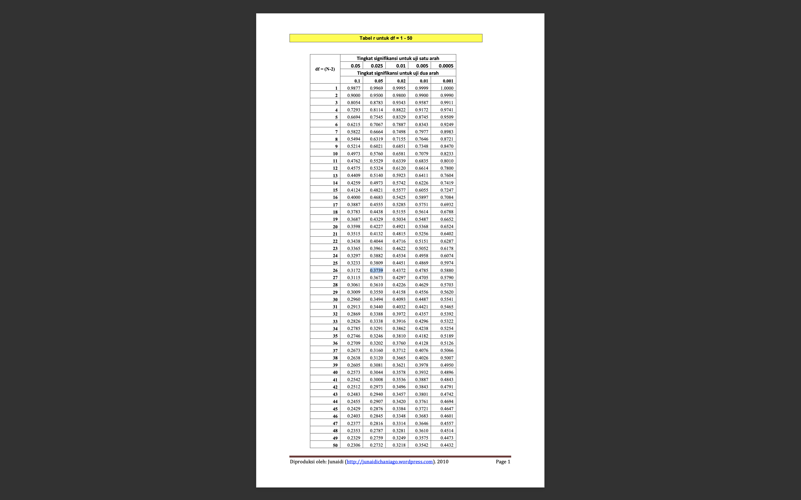

T TABEL
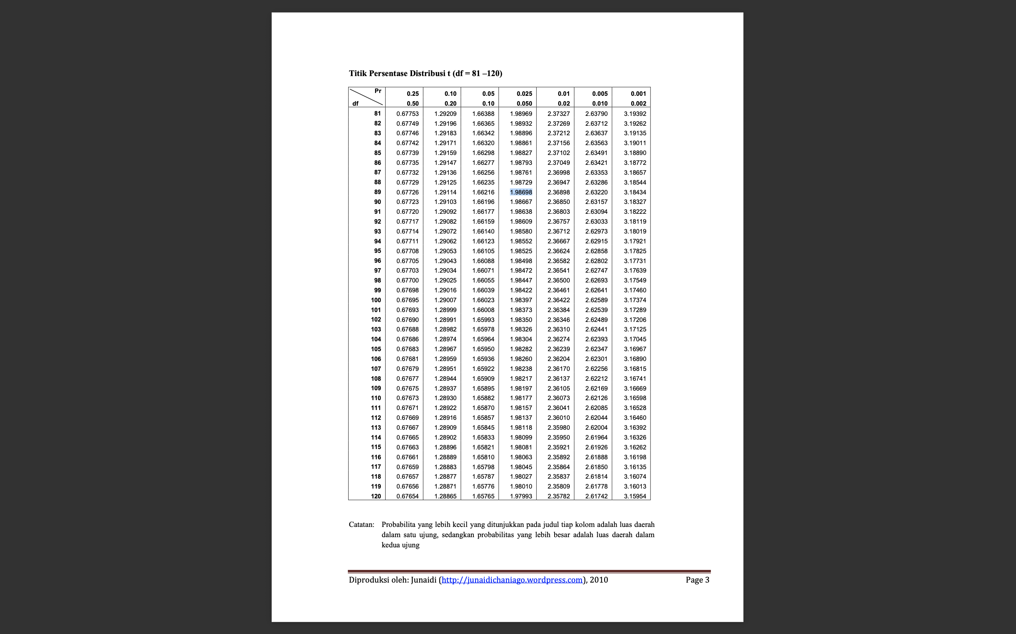

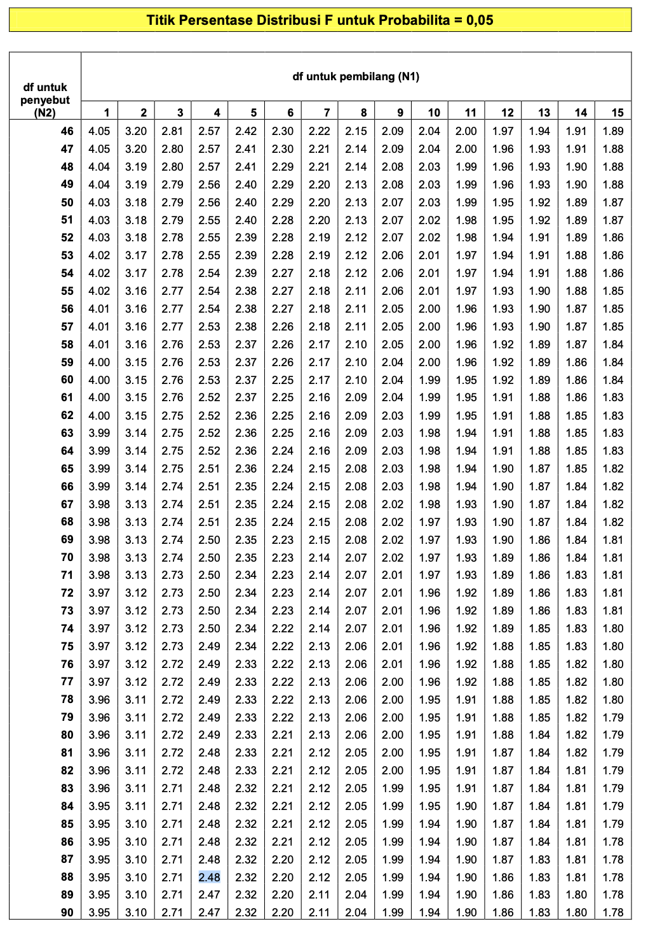
F TABEL

Lampiran 5
DOKUMENTASI PENELITIAN

