ACKNOWLEDGEMENTS
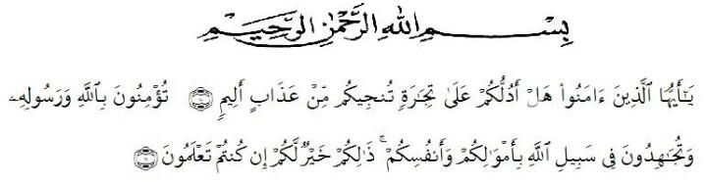
Artinya: “ Hai orang-orang yang beriman, maukah kamu aku tunjukkan suatu perniagaan yang dapat menyelamatkanmu dari azab yang pedih? (10). (yaitu) kamu beriman kepada Allah dan Rasul-nya dan berjihad di jalan Allah dengan harta dan jiwamu. Itulah yang lebih baik bagimu, jika kamu mengetahuinya. (11)”.(Q.S. As-Saff ayat 10-11 )

Praise and gratitude, the researcher say the presence of Allah SWT, which thanks to His grace so the researcher can complete this thesis with the title An Analysis of Students' Self-Confidence in Speaking for Eleventh Grade at SMA Dharma Pancasila Medan in Academic Year 2020/2021. Writing this thesis is one of the duties and obligations of every student, especially the Teaching and Education Faculty of the Universitas Muslim Nusantara Al Washliyah Medan and as a condition for obtaining a Bachelor of Education (S.Pd) degree.
With all humility and sincerity, the researcher would like to thank beloved parents who kept praying for, guiding and providing support both morally and materially.

Furthermore, the researcher would also like to thank:
- Dr. H. Hardi Mulyono Surbakti, SE., MAP as the Rector of the Universitas Muslim Nusantara Al-Washliyah in Medan who accepted the researcher as a student.
- Drs. Samsul Bahri, M.Si, as the Head of the Faculty of Teacher Training and Education at the Universitas Muslim Nusantara Al Washliyah who gave the research permit.
- Zulfitri, SS., M.A as the Head of the English Language Education Department who has given the researcher permission to approve the title of the thesis.
- Rini Fadhillah Putri, S.Pd., M.Hum as the Adviser who has guided and provided constructive suggestions from the beginning to the completion of this thesis writing.
- Beloved sisters, Vina Ikhsani, S.Pd and Dzuliastuti Dewi, S.Pd who have been discussion partners during the writing of this thesis.
- Friends in arms, especially the 2017 English Language Education, who are motivating in this thesis, and other friends who cannot be mentioned one by one.
Finally, the researcher hope that this thesis can be useful for all of us and that Allah SWT will give a reply to the people who participated in this thesis. The researcher is aware of the many shortcomings of the contents of this thesis, therefore the researcher expects constructive criticism and suggestions and apologizes for any mistakes.
Medan, 17 June 2021
Author

Ika Aprilia Putri
171224028

