ACKNOWLEDMENTS

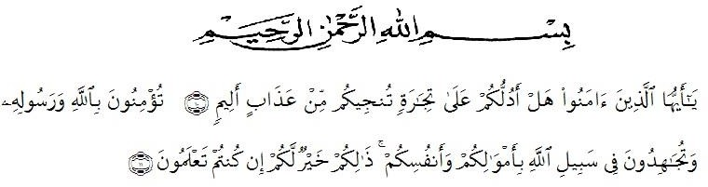
Meaning :
“Oh you who have believed shall I guide you to a transaction that will save you from a painful punishment? {10} that is that you believe in Allah and his Messenger and strive in the cause of Allah with your wealth and your lives. That is best for you. if you should know {11}”. (Surah As-Saff 10-11)

From of all the researcher would like to express her greatest thanks to Allah Subhanallahu wa ta’ala for blessing that has been given to her especially health and luck until this thesis could be complete and also shalawat and salam to our prophet Munammad Shallallahu alaihi wassalam.
In the process of completing this thesis the researcher has received a lot of assistance from many people, she obtains a lot of valuable suggestions and comments from many people ehom she can not mention one by one, but she deserves her very special gratitude to:
- Dr. KRT. Hardi Mulyono K. Surbakti as the rector of University of Muslim Nusantara Al Washliyah Medan.
- Drs. Samsul Bahri, M. Si as the dean of FKIP University of Muslim Nusantara Al Washliyah Medan.
- Zulfitri, S.S., M.A as the head of English Departement.
- Nurlaili, S.Pd.I., M.Hum as the adviser who has contributed his time, knowledge, suggestion and comments to help the researcher on supervising the draft writing this thesis.
- Dr. Azhari Tambusai, M.A and Yusnita Nasution, S.Pd., M.Hum as the examiner who has contributed her time, knowledge, suggestions, and comments to help the researcher on supervising the draft writing this thesis.
- All the lecturers at the English Departement who have dedicated their valuable knowledge for her during the academic year at UMN Al Washliyah Medan.
- Her beloved parents, Abdul Rahman and Nursiah who always give their love, motivation, and support to the researcher to finish her study, your survices cannot be countered, only prayers that are able to be provided in prostration. May Allah give you a blessed age in this world and hereafter.
- Her beloved siblings, Sahmina, S.Pd, Muhammad Ramadhan, Siti Khadijah, and Dinda Aulia who always support the researcher.
- Headmaster and teachers of SMA N 1 Lawe Alas. That school have helped provide research permission at the school.
- The librarians of UMN Al Washliyah thanks for being guide me in completing this thesis.

Medan, 2021
The Researcher

MUNAWARAH

