DAFTAR PUSTAKA

Babbie, E. (2013). The Practice of Social Research (13th ed.). Belmont, CA:
Wadsworth Cengage Learning.
Bartos, m. (2018) peran polisi lalu lintas dalam meningkatkan kesadaran hukum
pengendara sepada motor diwilayah polres dijakarta pusat
Creswell, J. W. (2014). Research Design: Qualitative, Quantitative, and
Euman, W. L. (2006). Social Research Methods: Qualitative and
Gay, L. R., & Airasian, P. (2000). Educational Research: Competencies Analysis
and Applications (6th ed.). Upper Saddle River, NJ: Prentice Hall.
Hutami Sasha, N. & Lubis, M.R.M. (2023) perlindungan hukum terhadap korban
kecelakaan lalu lintas di jalan raya.
Kothari, C. R. (2004). Research Methodology: Methods and Techniques (2nd ed.).
Menurut Sugiyono (2018: 12), Cengage Learning metode pengumpulan
Miles, M. B., & Huberman, A. M. (1994). Qualitative Data Analysis: An
Expanded Sourcebook (2nd ed.). Thousand Oaks, CA: SAGE Publications.
Moleong, L. J. (2013). Metodologi Penelitian Kualitatif. Bandung: PT Remaja
Rosdakarya.
Patton, M. Q. (2015). Qualitative Research & Evaluation Methods (4th ed.). Thousand Oaks, CA: SAGE Publications.
Pemerintah Republik Indonesia. (2009). Undang-Undang Nomor 22 Tahun 2009 tentang Lalu Lintas dan Angkutan Jalan. Jakarta: Departemen Perhubungan.
Quantitative Approaches (6th ed.). Boston: Pearson.
Sekarang, U., & Bougie, R. (2016). Research Methods for Business: A Skill-Building Approach (7th ed.). Chichester: Wiley.
Smith, J. (2021, March 15). The impact of new traffic laws. The New York Times p. A2.
Strauss, A., & Corbin, J. (1998). Basics of Qualitative Research: Techniques and Procedures for Developing Grounded Theory (2nd ed.). Thousand Oaks, CA: SAGE Publications.
Sugiyono. (2015). Metode Penelitian Kuantitatif, Kualitatif, dan R&D. Bandung: Alfabeta.
Tufte, E. R. (2001). The Visual Display of Quantitative Information (2nd ed.). Cheshire, CT: Graphics Press.
Yeltriana Hj., SH,. MH. (20023) pemberian izin pengelenggaraan angkutan orang dalam trayek.
Yin, R. K. (2003). Case Study Research: Design and Methods (3rd ed.). Thousand Oaks, CA: SAGE Publications.
Muhammad Guffar Harahap (2023) pendidikan karakter berbasis kearifal lokal
Kampus Merdeka jurnal of Islamis education
Beta silalahi (2024) pemahaman Pendidikan karakter bangsa dengan pembelajaran kontekstual pada mahasiswa umn al-washlyah akbar pekanbaru
Haidir Muhammad rapono (2023) pelaksanaan model Pendidikan karakter melalui mata kuliah Pendidikan

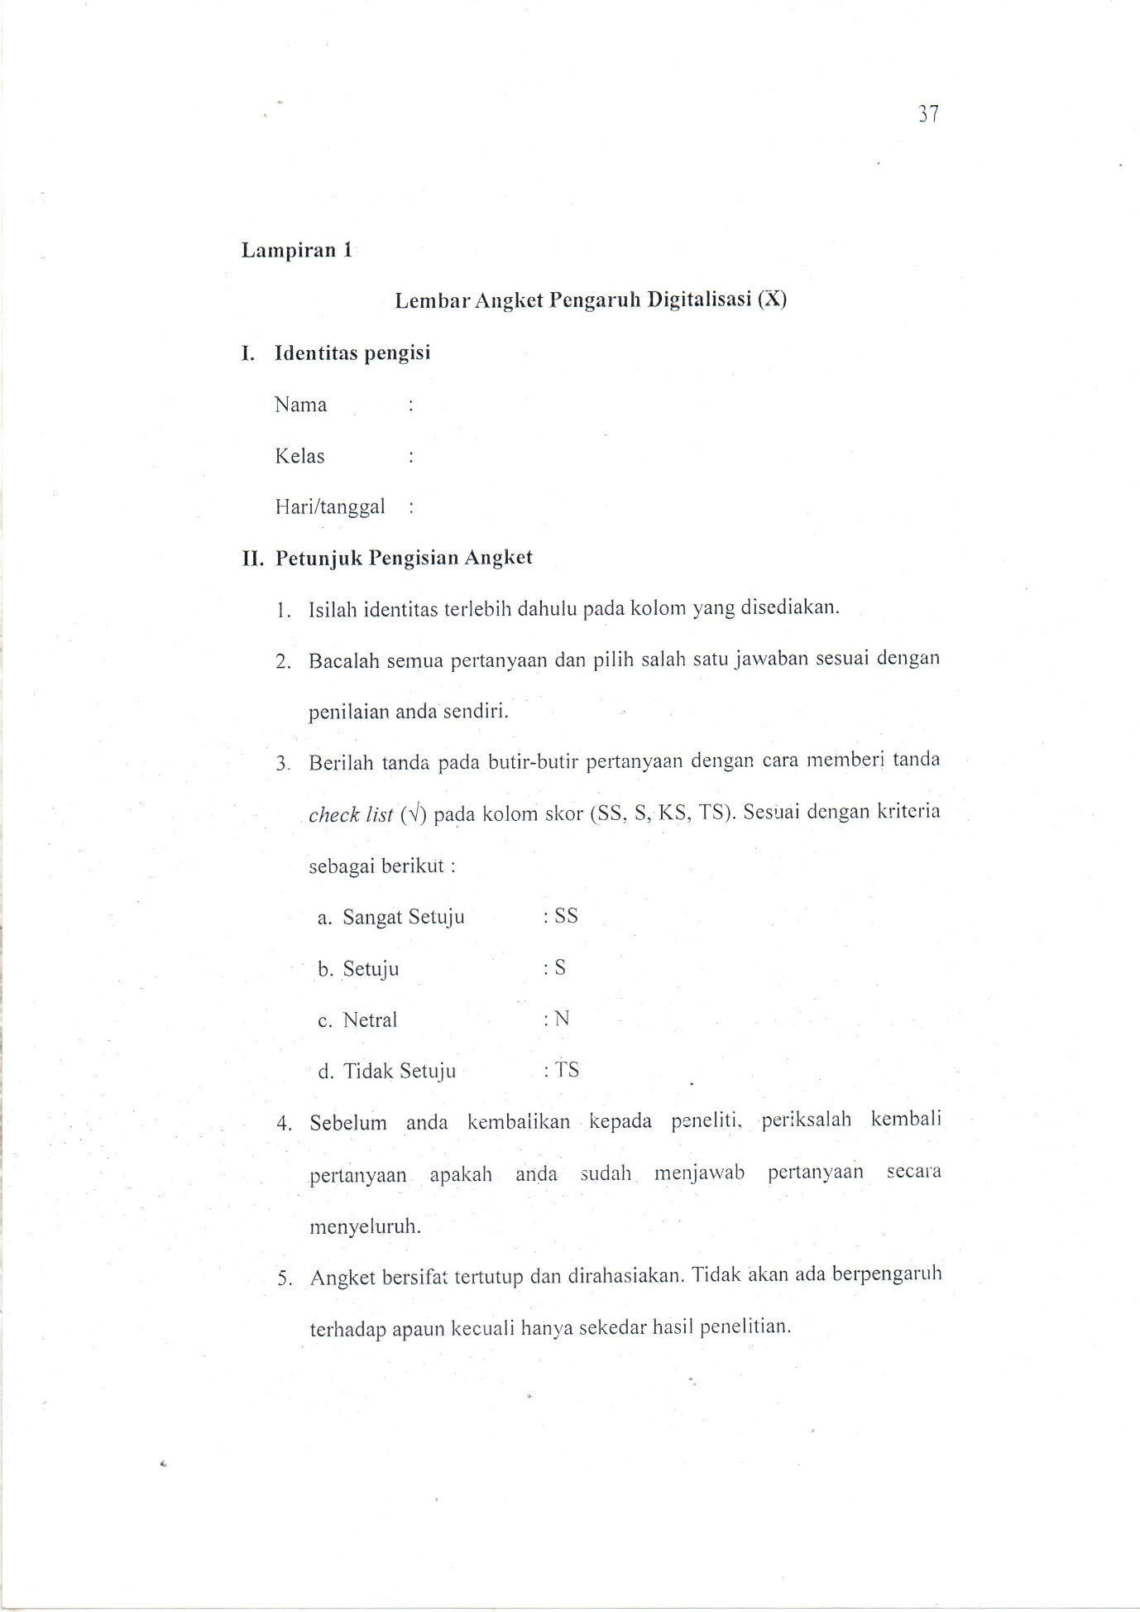
LAMPIRAN
