ACKNOWLEDGEMENT

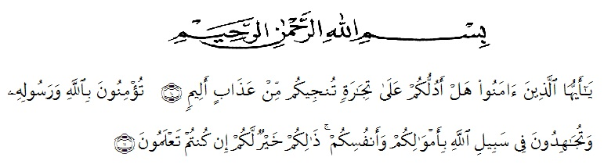
Artinya: “Hai orang-orang yang beriman, sukakah kamu aku tunjukkan suatu perniagaan yang dapat menyelamatkan kamu dari azab yang pedih?(10). (yaitu) kamu beriman kepada Allah dan Rasulnya dan berjihad dijalan Allah dengan harta dan jiwamu, Itulah yang lebih baik bagimu, jika kamu mengetahui.(11) (As-Shaff ayat 10-11)”

First of all, the writer says thank you to Allah for giving the writer a lot of things in life. Because of his guidance, the writer can be able to finish this thesis. The writer cannot also finish it without other people’s help. Therefore, in this opportunity the writer would like to express his deep gratitude to the following people:
- Dr. KRT. Hardi Mulyono K. Surbakti as the Rector of University Muslim Nusantara Alwashliyah Medan
- Drs. Samsul Bahri, M.Pd as the dekan of FKIP UMN Al Washliyah Medan
- Zulfitri, S.S.,M.A as the head of English Department of UMN Al washliyah
- Zulfitri, S.S.,M.A as the first consultant who has given her time during the process of completing the thesis
- Beloved parent, Brother, all family and Friends who have spurred the writer to finish the thesis on time
- My best Senior Rizki Ardiansyah S.Pd who has helped the writer in providing inspiration and motivation to write this thesis
- My best friends, Revi Restu Ayanda, Eka Putri Sitorus and Yen Cornellia who always give the writer a lot of suggestions and advice
- The students at the eleventh grade of SMK Musda Perbaungan who have wanted to be part of finishing this thesis.
- The entire staff at the university who have provided assistance, guidance, and knowledge to the writer.
- All parts who could not be mentioned one by one by the writer that has involved a lot of help so that this script could be completed.
By writing this thesis, the writer realizes that this thesis has not perfect. Therefore, the suggestions and critical from the reader is really needed to make this thesis be better. The writer also hopes that the thesis will be useful for everybody who reads it.

Medan, June 27th ,2021

Annisa Ayu Syaputri Ginting

