ACKNOWLEDGEMENT

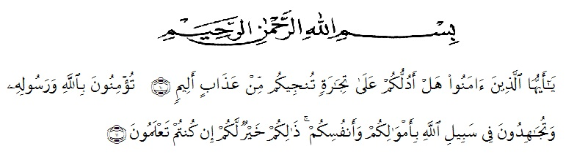

First of all, thanks to Allah SWT, the Most Gracious, the Most Merciful, who has given mercy and grace to the researcher during the research until the completion of this Final Project with the title "The Effect of Reading Aloud Strategy to Increase Students' Pronunciation for The First Grade of Senior High School Al-Manar Medan".
This thesis is a scientific work that was presented as one of the requirements to get the title of "S.Pd." in English Education. In completing this thesis, many parties have helped and supported during the writing of this thesis. The most important and very supportive thing lies in the researcher's family. Furthermore, the researcher would like to thank the Advisor, Dr. Salamuddin Selian, M. Hum., who patiently guided and provided excellent lessons and advice in writing this thesis. The researcher would also like to express her gratitude and highest appreciation to:
- Dr. KRT. Hardi Mulyono K. Surbakti S.E., M.AP., as the rector of Universitas Muslim Nusantara Al- Washliyah
- Drs. Samsul Bahri, M.Si., as a Dean of Teacher Training and Education Department Universitas Muslim Nusantara Al- Washliyah
- Zulfitri, S.S., M.A, as the Head of English Education Department
- Yulia Sari Harahap, S.Pd, M.Hum, as academic advisor
- Dr. Salamuddin Selian, M. Hum., who patiently guided and provided excellent lessons and advice in writing this thesis.
- All the lecturers in the English Education Department who have given much knowledge, the writer deeply thank you all.
- Sutono and Nila Sukma, as parents of researcher who are very loved who are always in the heart until the end of their lives and always give sincere prayer to researcher.
- Eka Setya Wulandari and Reno Alfiansyah, as the research brother and sister who are very dear to the researcher who have always been the support system, uplifting and giving each other help.
- Beloved research friends from the Department of English Education, especially members of class 8A 2017 for their friendship, love, knowledge, support, and time that they have given selflessly.
- The researcher's dear friends are Elvi, Chairunnisa, Adela, Winda, Aina, Windi, Yuni, Adisty and Nurul who always provide support, pray, accompany the researcher in various situations and become good listeners with irreplaceable friendship.
- Rafikah Hasanah Purba, the researcher's best friend, from when she first entered the world of lectures until the end, has accompanied each other in joys and sorrows and supports each other.
- Alfin Putra Hawari, as a very special person who always provides support, selfless assistance, sincere prayers so that researcher can complete this thesis.
- All parties who have helped the researcher, not only in the preparation of this thesis, but through the ups and downs at university life. Researcher cannot mention them one by one. May Allah bless them all.
Finally, the researcher realizes that this thesis is still far from being perfect. Apart from the assistance from the people mentioned above, there are shortcomings and weaknesses in this thesis which remain the responsibility of the researcher. Therefore, all forms of corrections and suggestions for the improvement of this Final Project are always open to pleasure.

Medan, July 2021

Suci Asri Ramadhani
NPM. 171224055

