**APPENDIX 1**

**THE LIST OF RESEARCH SUBJECTS**

|  |  |  |
| --- | --- | --- |
| **No.** | **Initial Name** | **Name** |
| 1. | AIGL | Adhiytia Iman Geraldy Lubis |
| 2. | ACS | Alonso Christian Sitorus |
| 3. | AS | Ananda Sidabalok |
| 4. | ASS | Annisa Solana Siregar |
| 5. | BSS | Betaria Sonata Silaban |
| 6. | CJS | Chandra Jedithya Silalahi |
| 7. | DS | Deliana Sinaga |
| 8. | DFS | Denny Fathurachman Siregar |
| 9. | DN | Difa Nurhaliza |
| 10. | DPS | Dinda Puspita Sari |
| 11. | DS | Dwi Sapitri |
| 12. | FM | Feby mukhairani |
| 13. | FRSW | Fita Ratna Sari Waruwu |
| 14. | GSH | Gabriel Sebastian Hutabarat |
| 15. | GAVT | Greace Angel Vanesha Tinambunan |
| 16. | IRIP | Intan Rafika Indah Purba |
| 17. | JS | Jesica Sitinjak |
| 18. | JBUS | Jesisca Bonita Uliana Br Siburian |
| 19. | KMT | Karenina Margaretha Br Tarigan |
| 20. | KPP | Kelvin Padrevio Pakpahan |
| 21. | KMBG | Kevin March Bernader Gultom |
| 22. | LSH | Lidia Sepebriani Br Hutapea |
| 23. | LWS | Lundu Wijaya Simbolon |
| 24. | MS | Magdalena Situmorang |
| 25. | MA | Mhd.Alfandi |
| 26. | MAR | Mutia Atika Rahma |
| 27. | NA | Nacha Adinda |
| 28. | NZS | Nevi Zeen Sibarani |
| 29. | PDS | Putri Diviana Br Sirait |
| 30. | PRM | Putrid Repalina Manalu |
| 31. | RHBN | Rafael Hasian Banjar Nahor |
| 32. | RT | Rasi Br Timba |
| 33. | RPS | Rodi Parningotan Siregar |
| 34. | SAH | Serli Adelina Haloho |
| 35. | TAS | Tania Aurilia Sinaga |
| 36. | YRS | Yopanki Ronaldo Simbolon |

**APPENDIX 2**

**The Results of The First Writing**

|  |  |  |  |  |  |  |  |
| --- | --- | --- | --- | --- | --- | --- | --- |
| **No** | **Students** | **Score** | | | | | **Total Score** |
| **C** | **O** | **V** | **LU** | **M** |
| 1 | AIGL | 18 | 14 | 14 | 17 | 3 | 66 |
| 2 | ACS | 20 | 14 | 16 | 18 | 3 | 71 |
| 3 | AS | 18 | 14 | 15 | 17 | 2 | 66 |
| 4 | ASS | 24 | 16 | 17 | 20 | 2 | 79 |
| 5 | BSS | 17 | 14 | 14 | 17 | 3 | 65 |
| 6 | CJS | 20 | 15 | 16 | 16 | 3 | 70 |
| 7 | DS | 17 | 14 | 13 | 17 | 2 | 63 |
| 8 | DFS | 20 | 17 | 15 | 16 | 3 | 71 |
| 9 | DN | 17 | 13 | 14 | 16 | 3 | 63 |
| 10 | DPS | 22 | 16 | 15 | 15 | 3 | 71 |
| 11 | DS | 24 | 15 | 16 | 19 | 3 | 77 |
| 12 | FM | 18 | 14 | 13 | 17 | 3 | 65 |
| 13 | FRSW | 18 | 14 | 13 | 17 | 2 | 64 |
| 14 | GSH | 21 | 16 | 15 | 18 | 3 | 73 |
| 15 | GAVT | 19 | 15 | 16 | 17 | 2 | 69 |
| 16 | IRIP | 19 | 16 | 16 | 17 | 2 | 70 |
| 17 | JS | 18 | 16 | 15 | 17 | 2 | 68 |
| 18 | JBUS | 19 | 15 | 16 | 16 | 3 | 69 |
| 19 | KMT | 19 | 16 | 17 | 16 | 2 | 70 |
| 20 | KPP | 20 | 14 | 16 | 18 | 3 | 71 |
| 21 | KMBG | 21 | 16 | 16 | 15 | 3 | 71 |
| 22 | LSH | 22 | 19 | 16 | 21 | 3 | 81 |
| 23 | LWS | 17 | 13 | 14 | 16 | 2 | 62 |
| 24 | MS | 17 | 14 | 13 | 17 | 2 | 63 |
| 25 | MA | 17 | 13 | 13 | 17 | 2 | 62 |
| 26 | MAR | 18 | 14 | 13 | 17 | 3 | 65 |
| 27 | NA | 20 | 17 | 15 | 16 | 3 | 71 |
| 28 | NZS | 17 | 14 | 14 | 17 | 3 | 65 |
| 29 | PDS | 23 | 15 | 16 | 19 | 3 | 76 |
| 30 | PRM | 18 | 13 | 14 | 17 | 3 | 65 |
| 31 | RHBN | 20 | 14 | 16 | 18 | 3 | 71 |
| 32 | RT | 19 | 16 | 15 | 17 | 3 | 70 |
| 33 | RPS | 20 | 16 | 15 | 16 | 3 | 70 |
| 34 | SAH | 19 | 15 | 16 | 17 | 2 | 69 |
| 35 | TAS | 18 | 14 | 13 | 18 | 2 | 65 |
| 36 | YRS | 17 | 14 | 13 | 16 | 2 | 62 |
| **Total Score** | | | | | | | **2.469** |
| **Mean** | | | | | | | **68,5** |

$$\text{M} \text{= } \frac{\sum{X}}{\text{N}}$$

***= $\frac{2.469}{\text{36}}$***

**= 68,5**

**APPENDIX 3**

**The Results of The Second Writing**

|  |  |  |  |  |  |  |  |
| --- | --- | --- | --- | --- | --- | --- | --- |
| **No** | **Students** | **Score** | | | | | **Total Score** |
| **C** | **O** | **V** | **LU** | **M** |
| 1 | AIGL | 21 | 16 | 17 | 20 | 4 | 78 |
| 2 | ACS | 22 | 17 | 17 | 18 | 4 | 78 |
| 3 | AS | 21 | 16 | 17 | 20 | 4 | 78 |
| 4 | ASS | 26 | 19 | 18 | 22 | 4 | 89 |
| 5 | BSS | 23 | 16 | 16 | 20 | 4 | 79 |
| 6 | CJS | 23 | 17 | 17 | 20 | 4 | 81 |
| 7 | DS | 22 | 17 | 16 | 18 | 3 | 76 |
| 8 | DFS | 23 | 17 | 16 | 20 | 4 | 80 |
| 9 | DN | 22 | 17 | 16 | 18 | 3 | 76 |
| 10 | DPS | 26 | 17 | 16 | 17 | 4 | 80 |
| 11 | DS | 26 | 15 | 17 | 21 | 4 | 83 |
| 12 | FM | 23 | 16 | 16 | 20 | 4 | 79 |
| 13 | FRSW | 20 | 17 | 17 | 18 | 3 | 75 |
| 14 | GSH | 23 | 17 | 17 | 20 | 4 | 81 |
| 15 | GAVT | 22 | 17 | 17 | 18 | 3 | 77 |
| 16 | IRIP | 19 | 16 | 16 | 17 | 2 | 70 |
| 17 | JS | 22 | 17 | 16 | 19 | 3 | 77 |
| 18 | JBUS | 22 | 17 | 17 | 18 | 4 | 78 |
| 19 | KMT | 22 | 17 | 16 | 19 | 3 | 77 |
| 20 | KPP | 22 | 16 | 17 | 20 | 4 | 79 |
| 21 | KMBG | 23 | 17 | 16 | 20 | 4 | 80 |
| 22 | LSH | 26 | 19 | 18 | 22 | 4 | 89 |
| 23 | LWS | 21 | 17 | 16 | 18 | 3 | 75 |
| 24 | MS | 20 | 17 | 17 | 18 | 3 | 75 |
| 25 | MA | 21 | 17 | 16 | 18 | 3 | 75 |
| 26 | MAR | 23 | 16 | 16 | 20 | 4 | 79 |
| 27 | NA | 26 | 17 | 16 | 17 | 4 | 80 |
| 28 | NZS | 23 | 16 | 16 | 20 | 4 | 79 |
| 29 | PDS | 26 | 15 | 17 | 21 | 4 | 83 |
| 30 | PRM | 20 | 17 | 16 | 18 | 4 | 75 |
| 31 | RHBN | 22 | 16 | 17 | 20 | 4 | 79 |
| 32 | RT | 22 | 17 | 16 | 20 | 4 | 79 |
| 33 | RPS | 22 | 17 | 16 | 20 | 4 | 79 |
| 34 | SAH | 22 | 17 | 17 | 18 | 3 | 77 |
| 35 | TAS | 22 | 17 | 16 | 20 | 4 | 79 |
| 36 | YRS | 20 | 17 | 16 | 18 | 4 | 75 |
| **Total Score** | | | | | | | **2.829** |
| **Mean** | | | | | | | **78,5** |

$$\text{M} \text{= } \frac{\sum{X}}{\text{N}}$$

***= $\frac{2.829}{\text{36}}$***

**= 78,5**

**APPENDIX 4**

**LESSON PLAN**

School : SMA Negeri 21 Medan

Grade/Semester : X/2

Subject : English

Aspect/Skill : Writing

Material : Recount Text

Time Allocation : 2x30 minutes

Meeting : 1 (First)

1. **Standard of Competency**

* Students are able to understand the meaning of functional written text and simple essay forms of a recount to interact with their surroundings.

1. **Basic of Competency**

* Students are able to express the meaning and rhetorical stages of a simple short essay which use a variety of written language accurately, fluently and acceptable to interact with their surroundings in the form of Recount Text.

1. **Indicators**

* At the end of the lesson, the students are able to:
  1. To understand about Recount text, the social function and the generic structure of Recount text.
  2. To use simple past tense in a paragraph
  3. Write a Recount text based on digital flashcards with their peers.

1. **Learning Material**

* **Social Function**

Social function of Recount text is a text that retells a story, an experience or events in the past which aim to inform or entertain readers of the story.

* **Generic structure of Recount Text**
* Orientation : Orientation is the first paragraph of the recount text. It provides background information needed to be able to understand a text, such as who was involved, where it happened, and when it took place.
* Events : In the events stage, describes the events that took place or a series of events which are then arranged in chronological order.
* Re-orientation : Describes what happens in the end the story or conclusion of the story.
* **Language Features of Recount Text**
* Introducing personal participant : I, my family, etc
* Using chronological connection : then, first, etc
* Using linking verb: was and were
* Using action verb: sent, went, taught, etc
* Using Simple Past Tense
* **Example of Recount Text**

# Meeting My Idol

Afgan has always been my favourite singer. I have always been thinking of how I would feel involved, when I met him. Then I was suddenly hit by lightning when I found out Afgan was coming to town for a concert in a local auditorium. A day before the concert, there would be a meet and greet event at a local radio station. Feeling excited, I packed all my Afgan's CDs to get his signature at the event.

On that bright and sunny Saturday morning, the radio station was full of Afganisme (that’s how Afgan’s fans are called). They sat onthe chairs prepared inside the radio station’s lobby. Some stood in rows in the front yard of the radio station. A spot inside a lobby was prepared with a mini stage for Afgan’s singing performance and a table for Afgan to sign Afganisme’s memorabilia. Finally, after about 40 or 50 minutes wait, Afgan showed up from inside the radio station. He smiled and waved to all Afganisme who had been waiting excitedly saying, “Good morning. How are you all?”. The crowd went crazy, the shouts sounded like a mix of “Fine, thank you” and screams of Afgan’s name. Then, he started the event by singing his hit single “Diadiadia”. Afganisme went even crazier, they sang along with him throughout the song. Of course, I did too. I couldn’t take my eyes off this amazing singer who had released three albums. When he finished with the song, the host announced that it was time for autographing the memorabilia. I prepared my CDs and began to stand in the line. When I arrived at the table, I was speechless. It was unreal just seeing him that close. I thought it was really cool seeing him like that because he really just felt like a normal person, which was awesome. He asked my name so that he could write it on the CD to say “To Mia, Love Afgan”. He was also very friendly, so I didn’t feel too nervous when I had a chance to take pictures with him.

He was just an amazing person and it was the best day ever!

1. **Teaching Method**

* Contextual Teaching and Learning
* Question and Answer
* Exercise

1. **Media**

* Text Book
* Worksheet
* Power Point

1. **Learning Activities**

|  |  |  |
| --- | --- | --- |
| **Learning Stages** | **Activities** | **Time** |
| Opening | * Greeting * The teacher asks the class president to lead the prayer * Teacher checks students attendance * The teacher asks the students’ condition * The teacher stimulates questions for students about the topic of the material * The teacher tells the topic of the lesson to the students | 10 minutes |
| Main Activities | * The teacher explains about Recount Text which includes the definition of recount text, examples, generic structure and language feature of recount text * Give students a test to analyze generic structure and language features of recount text * Asks students to collect their answer sheet | 40 minutes |
| Closing | * Give the students achanceto ask related to the material * Concludes the lesson and tells what will discuss in the next meeting | 10 minutes |

1. **Sources**

Utami Widiati, Z. R.*Buku Guru Bahasa Inggris X* .3rd Edition. Edisi Revisi Jakarta: Kementrian Pendidikan dan Kebudayaan, 2017.

1. **Instrument**

**GOING TO A BOOK STORE**

Last week, I went to a book store with my brother. We wanted to buy some books and comics. We went there by a motorcycle. First we left home at 4 P.M. The traffic to the book store was not crowded. The book store was not so far from our house. After 25 minutes, we arrived at the book store.   
 There were many people at the book store. I saw there were some people choosing kinds of books, magazines, comics, etc. There were many kinds of books at the book store. They were arranged on book shelves. Some people read in front of the shelves. We chose some books and comics we needed and went to cashier. After that we went to a restaurant for having meal. I ordered meat-balls and a soft drink. My brother ordered fried noodle and a soft drink too.   
 Finally we went home in the evening. We arrived home at 7.15 P.M. We left very tired but we were happy.

**Instructions!**

Find **past tense action verbs**, **linking verbs**, and analyze **generic structure** in the sample of Recount Text above!

1. **Assessment**

* Written test

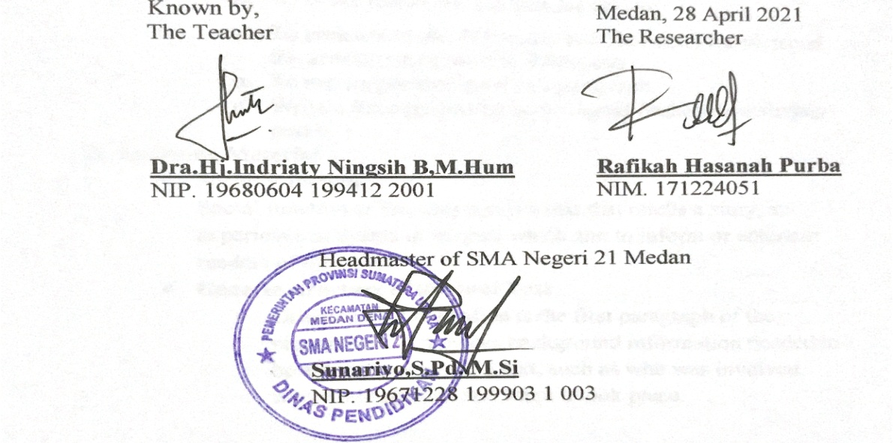

**LESSON PLAN**

School : SMA Negeri 21 Medan

Grade/Semester : X/2

Subject : English

Aspect/Skill : Writing

Material : Recount Text

Time Allocation : 2x30 minutes

Meeting : 2 (Second)

1. **Standard of Competency**

* Students are able to understand the meaning of functional written text and simple essay forms of a recount to interact with their surroundings.

1. **Basic of Competency**

* Students are able to express the meaning and rhetorical stages of a simple short essay which use a variety of written language accurately, fluently and acceptable to interact with their surroundings in the form of Recount Text.

1. **Indicators**

* At the end of the lesson, the students are able to:
  1. To understand about Recount text, the social function and the generic structure of Recount text.
  2. To use simple past tense in a paragraph
  3. Write a Recount text based on digital flashcards with their peers.

1. **Teaching Method**

* Contextual Teaching and Learning

1. **Media**

* Worksheet
* Digital Flashcards

1. **Learning Activities**

|  |  |  |
| --- | --- | --- |
| **Learning Stages** | **Activities** | **Time** |
| Opening | * Greeting * The teacher asks the class president to lead the prayer * Teacher checks students attendance * The teacher asks the students’ condition * The teacher reminds about the previous lesson | 10 minutes |
| Main Activities | * The teacher explains about the application of digital flashcards * Give students the test related to the lesson | 40 minutes |
| Closing | * Asks students to collect their answer sheet * Asks students about their opinion in learning * Concludes the lesson and tells what will discuss in the next meeting | 1. 10 minutes |

1. **Instrument**

**STUDENTS’ WORKSHEET**

Name :

Class :

Score :

**Arrange the following pictures into a story based on chronological order of the Recount Text structure!**

*(Urutkan gambar-gambar berikut menjadi sebuah cerita berdasarkan urutan kronologis struktur teks recount!)*

- Play, Played, Played

- Swim, Swam, Swum



Go, Went, Gone



Arrive, Arrived, Arrived

Answer :

1. **Assessment**

* Written test

1. **Rubric of Assessment**

|  |  |  |  |
| --- | --- | --- | --- |
| **No** | **Level** | **Score** | **Criteria** |
| 1. | Content | 30-27 | Excellent to very good |
| 26-22 | Good to average |
| 21-17 | Fair to poor |
| 16-13 | Very poor |
| 2. | Organization | 20-18 | Excellent to very good |
| 17-14 | Good to average: |
| 13-10 | Fair to poor |
| 9-7 | Very poor |
| 3. | Vocabulary | 20-18 | Excellent to very good |
| 17-14 | Good to average |
| 13-10 | Fair to fair |
| 9-7 | Very poor |
| 4. | Language Use | 25-22 | Excellent to very good |
| 21-18 | Good to average |
| 17-11 | Fair to poor |
| 10-5 | Very poor |
| 5. | Mechanics | 5 | Excellent to very good |
| 4 | Good to average |
| 3 | Fair to poor |
| 2 | Very poor |
| **Total Score** | | **100** |  | |

**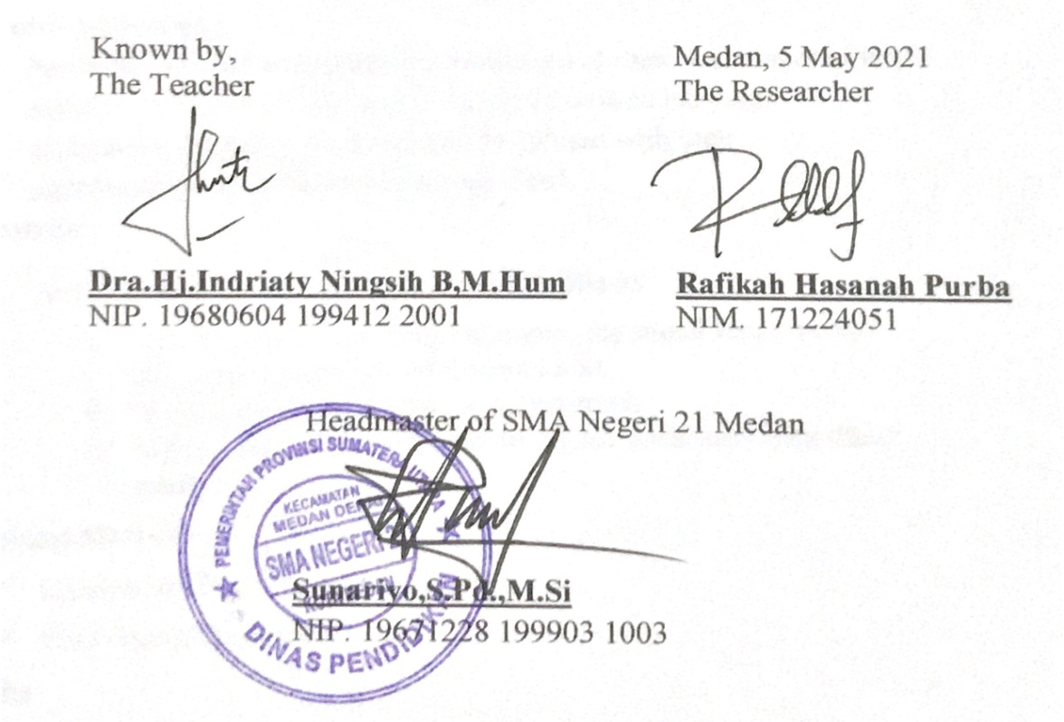**

**LESSON PLAN**

School : SMA Negeri 21 Medan

Grade/Semester : X/2

Subject : English

Aspect/Skill : Writing

Material : Recount Text

Time Allocation : 2x30 minutes

Meeting : 3 (Third)

1. **Standard of Competency**

* Students are able to understand the meaning of functional written text and simple essay forms of a recount to interact with their surroundings.

1. **Basic of Competency**

* Students are able to express the meaning and rhetorical stages of a simple short essay which use a variety of written language accurately, fluently and acceptable to interact with their surroundings in the form of Recount Text.

1. **Indicators**

* At the end of the lesson, the students are able to:
  1. To understand about Recount text, the social function and the generic structure of Recount text.
  2. To use simple past tense in a paragraph
  3. Write a Recount text based on digital flashcards with their peers.

1. **Teaching Method**

* Contextual Teaching and Learning
* Peer Group Discussion

1. **Media**

* Worksheet
* Digital Flashcards

1. **Learning Activities**

|  |  |  |
| --- | --- | --- |
| **Learning Stages** | **Activities** | **Time** |
| Opening | * Greeting * The teacher asks the class president to lead the prayer * Teacher checks students attendance * The teacher asks the students’ condition * The teacher reminds about the previous lesson | 10 minutes |
| Main Activities | * The teacher provides evaluation in the form of things that must be corrected in writing Recount Text such as grammatical errors, sentence structure and correct punctuation * The teacher explains about peer group discussion method and the application of digital flashcards * The teacher divides the students into groups which each group consists of 2 students * Give students the task to do in group * Asks students to collect their answer sheet | 40 minutes |
| Closing | * Asks their opinion about the method * Resume the material * Closing | 10 minutes |

1. **Instrument**

**STUDENTS’ WORKSHEET**

Peer Group Discussion

Name : 1.

2.

Class :

Score :

**Arrange the following pictures into a story based on chronological order of the Recount Text structure!**

*(Urutkan gambar-gambar berikut menjadi sebuah cerita berdasarkan urutan kronologis struktur teks recount!)*

- Walk, Walked, Walked

- See, Saw, Seen



Go, Went, Gone

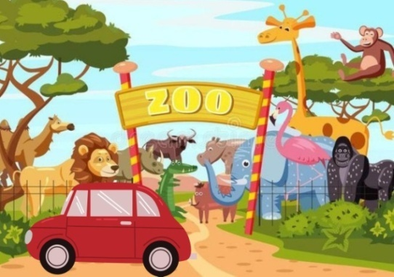

Arrive, Arrived, Arrived

Answer :

1. **Assessment**

* Written Test

1. **Rubric of Assessment**

|  |  |  |  |
| --- | --- | --- | --- |
| **No** | **Level** | **Score** | **Criteria** |
| 1. | Content | 30-27 | Excellent to very good |
| 26-22 | Good to average |
| 21-17 | Fair to poor |
| 16-13 | Very poor |
| 2. | Organization | 20-18 | Excellent to very good |
| 17-14 | Good to average: |
| 13-10 | Fair to poor |
| 9-7 | Very poor |
| 3. | Vocabulary | 20-18 | Excellent to very good |
| 17-14 | Good to average |
| 13-10 | Fair to fair |
| 9-7 | Very poor |
| 4. | Language Use | 25-22 | Excellent to very good |
| 21-18 | Good to average |
| 17-11 | Fair to poor |
| 10-5 | Very poor |
| 5. | Mechanics | 5 | Excellent to very good |
| 4 | Good to average |
| 3 | Fair to poor |
| 2 | Very poor |
| **Total Score** | | **100** |  | |

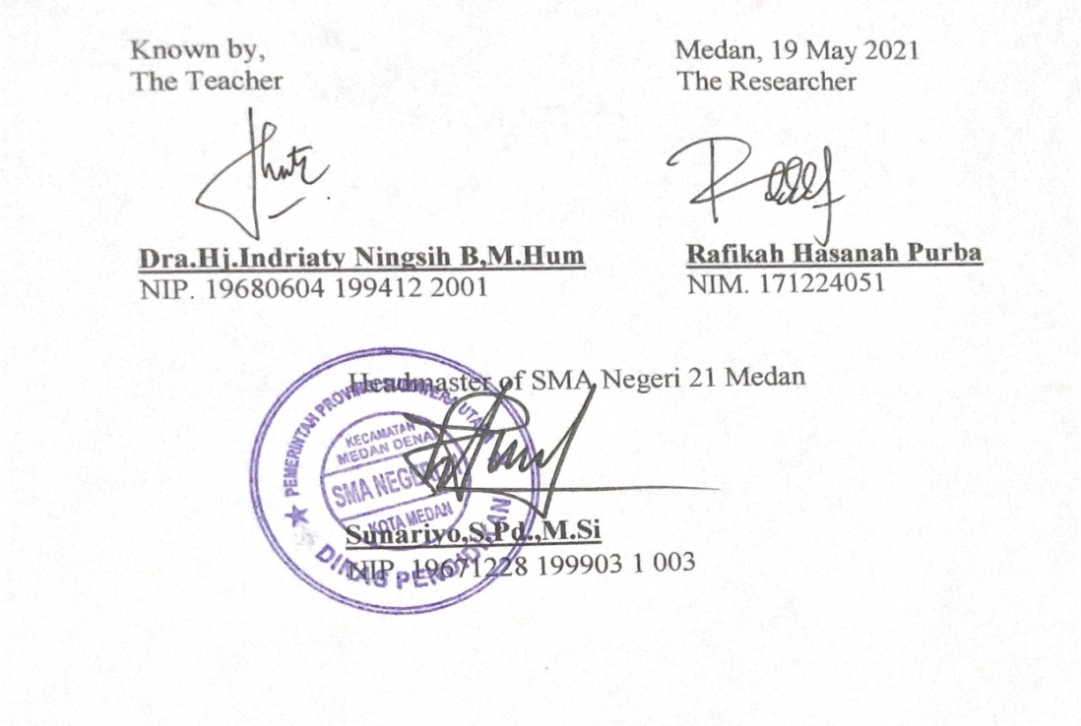

**APPENDIX 5**

**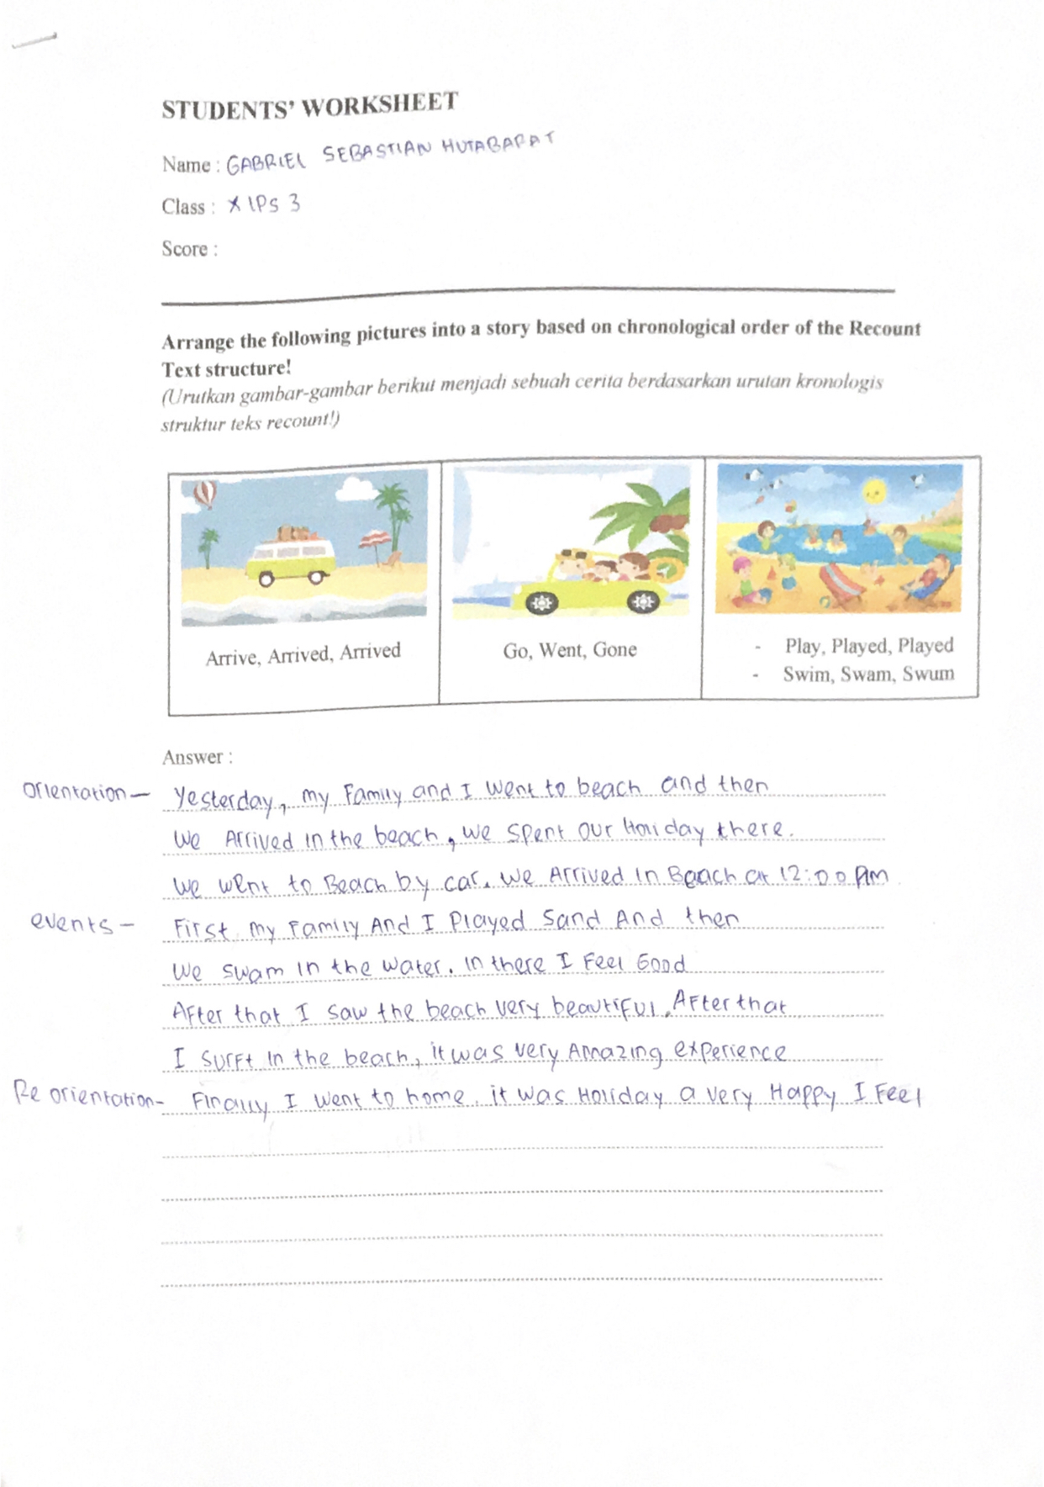**

**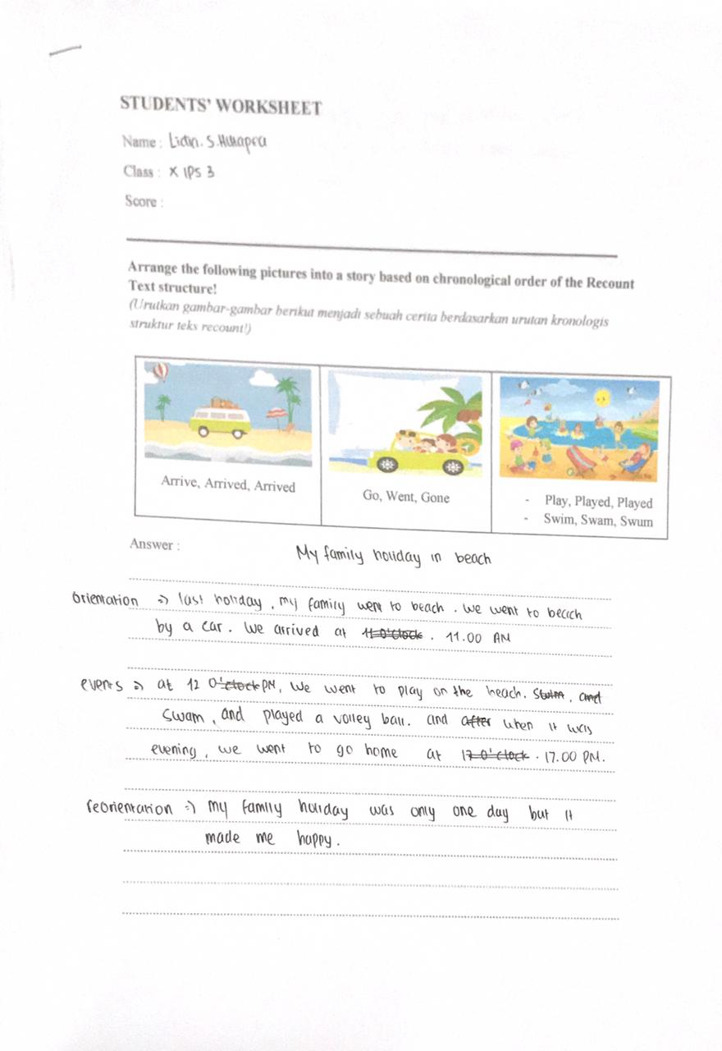**

**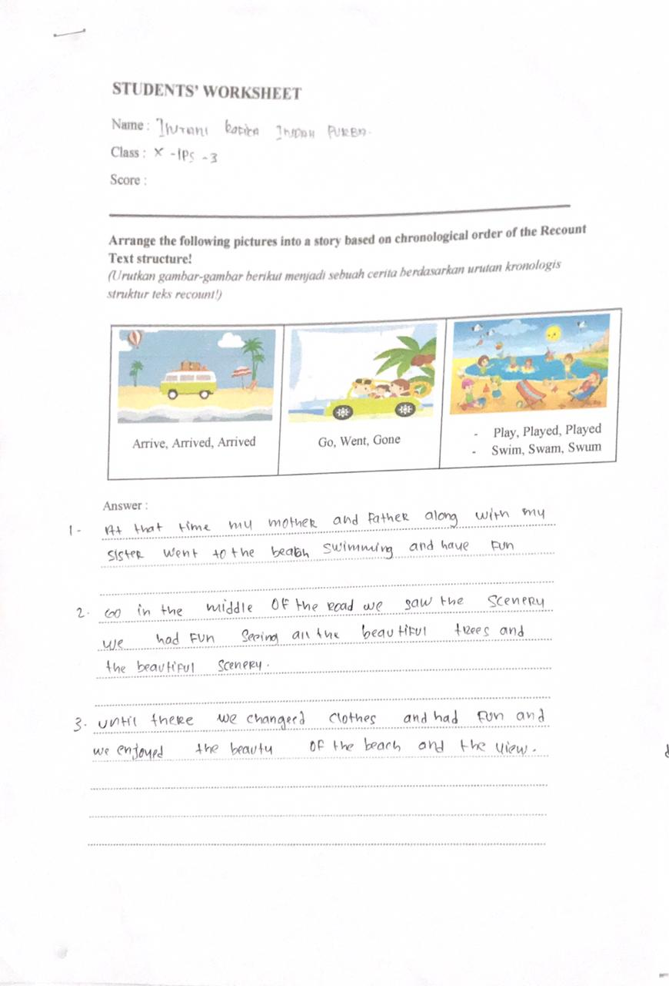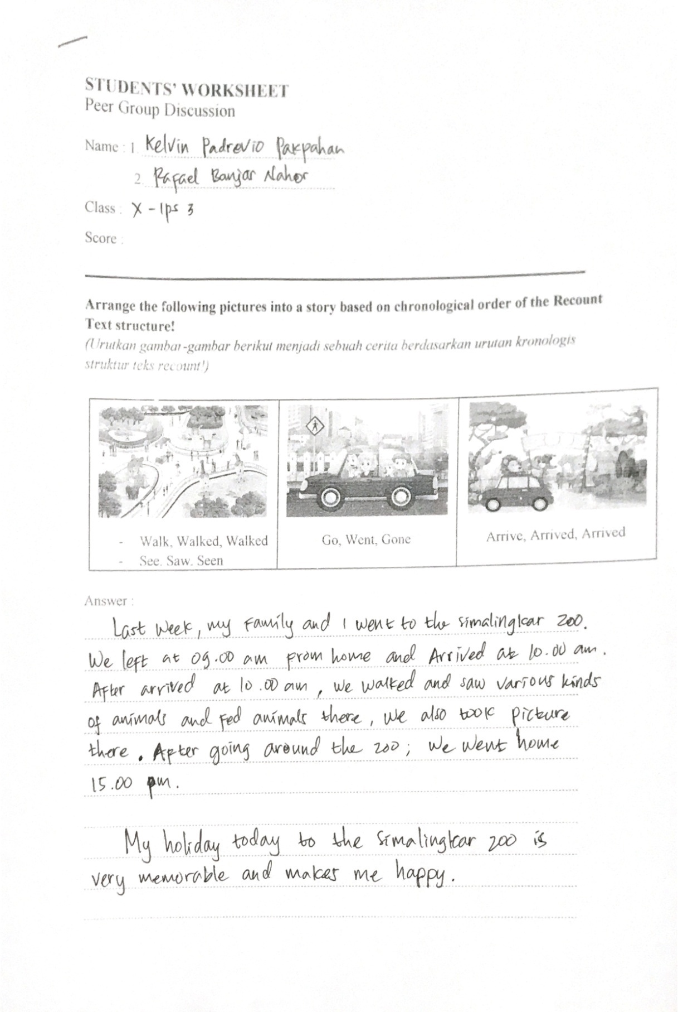**

**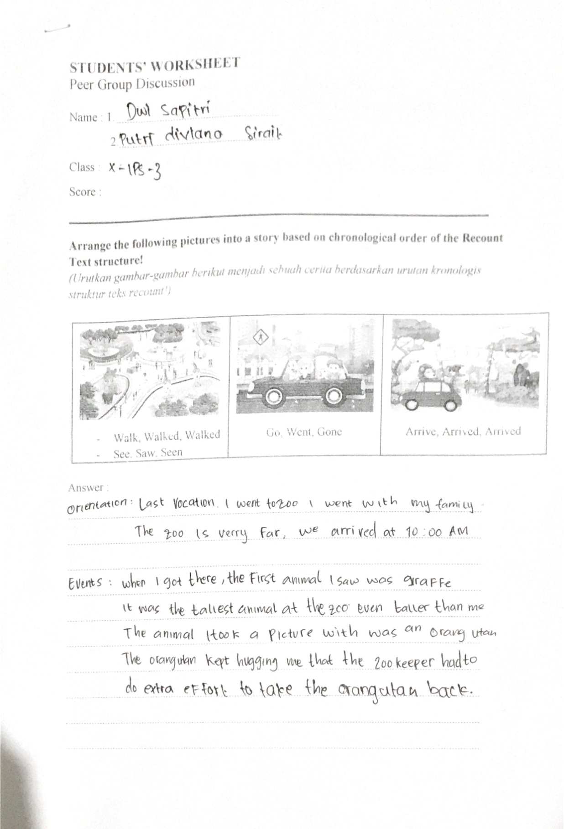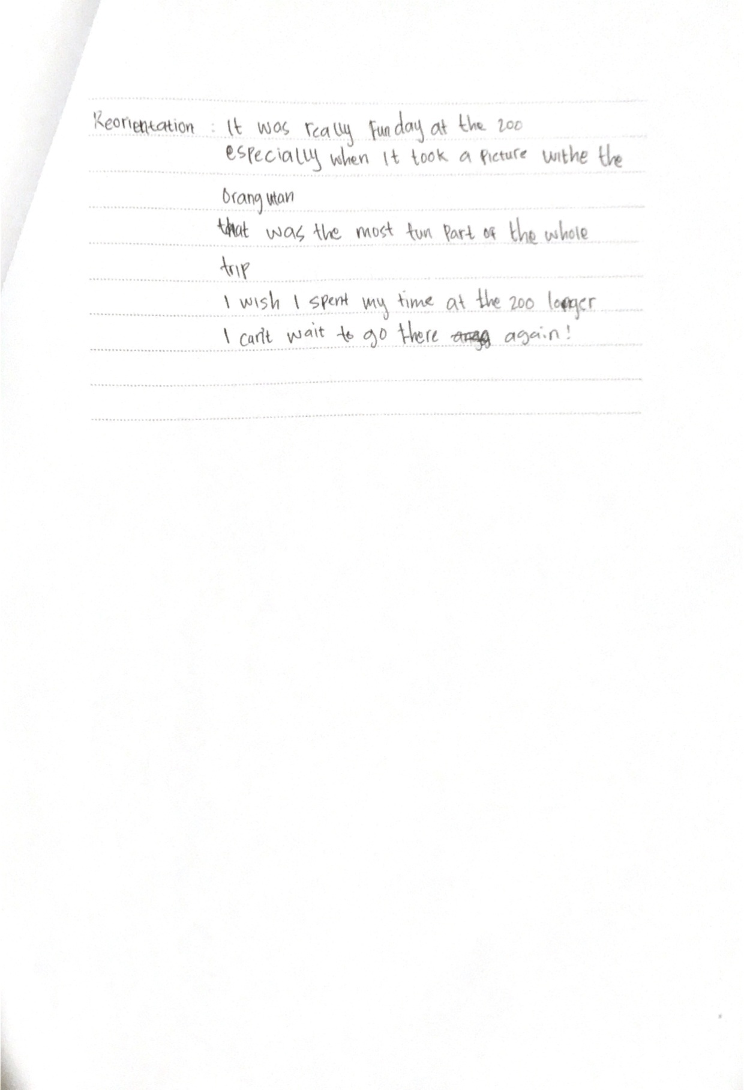**

**APPENDIX 6**

**Table of Students’ Observation Sheet**

Class : X-Social 3

|  |  |  |  |  |  |  |
| --- | --- | --- | --- | --- | --- | --- |
| Number of the students | OBJECT | | | | | NOTE |
| Pay attention | Activeness in asking question | Activeness in responding | Accomplishing task | Enthusiasm in doing test |
| 1 |  |  |  |  |  |  |
| 2 |  |  |  |  |  |  |
| 3 |  |  |  |  |  |  |
| 4 |  |  |  |  |  |  |
| 5 |  |  |  |  |  |  |
| 6 |  |  |  |  |  |  |
| 7 |  |  |  |  |  |  |
| 8 |  |  |  |  |  |  |
| 9 |  |  |  |  |  |  |
| 10 |  |  |  |  |  |  |
| 11 |  |  |  |  |  |  |
| 12 |  |  |  |  |  |  |
| 13 |  |  |  |  |  |  |
| 14 |  |  |  |  |  |  |
| 15 |  |  |  |  |  |  |
| 16 |  |  |  |  |  |  |
| 17 |  |  |  |  |  |  |
| 18 |  |  |  |  |  |  |
| 19 |  |  |  |  |  |  |
| 20 |  |  |  |  |  |  |
| 21 |  |  |  |  |  |  |
| 22 |  |  |  |  |  |  |
| 23 |  |  |  |  |  |  |
| 24 |  |  |  |  |  |  |
| 25 |  |  |  |  |  |  |
| 26 |  |  |  |  |  |  |
| 27 |  |  |  |  |  |  |
| 28 |  |  |  |  |  |  |
| 29 |  |  |  |  |  |  |
| 30 |  |  |  |  |  |  |
| 31 |  |  |  |  |  |  |
| 32 |  |  |  |  |  |  |
| 33 |  |  |  |  |  |  |
| 34 |  |  |  |  |  |  |
| 35 |  |  |  |  |  |  |
| 36 |  |  |  |  |  |  |

**APPENDIX 7**

**Peer Group Discussion Assessment Rubric**

Class : X-Social 3

|  |  |  |  |  |  |  |
| --- | --- | --- | --- | --- | --- | --- |
| No | Name | Aspect | | | Total Score | Value |
| Acknowledging a lack of understanding among peers | Provide problem solving | Support each other |
| 1 | AIGL | 3 | 3 | 3 | 75 | B |
| 2 | ACS | 3 | 3 | 4 | 83,3 | A |
| 3 | AS | 3 | 3 | 3 | 75 | B |
| 4 | ASS | 3 | 3 | 4 | 83,3 | A |
| 5 | BSS | 3 | 2 | 4 | 75 | B |
| 6 | CJS | 3 | 2 | 4 | 75 | B |
| 7 | DS | 3 | 2 | 4 | 75 | B |
| 8 | DFS | 3 | 3 | 4 | 83,3 | A |
| 9 | DN | 3 | 2 | 4 | 75 | B |
| 10 | DPS | 3 | 3 | 4 | 83,3 | A |
| 11 | DS | 3 | 3 | 4 | 83,3 | A |
| 12 | FM | 3 | 2 | 4 | 75 | B |
| 13 | FRSW | 3 | 2 | 4 | 75 | B |
| 14 | GSH | 3 | 3 | 4 | 83,3 | A |
| 15 | GAVT | 3 | 2 | 4 | 75 | B |
| 16 | IRIP | 3 | 3 | 4 | 83,3 | A |
| 17 | JS | 3 | 2 | 4 | 75 | B |
| 18 | JBUS | 3 | 3 | 4 | 83,3 | A |
| 19 | KMT | 3 | 2 | 4 | 75 | B |
| 20 | KPP | 3 | 3 | 4 | 83,3 | A |
| 21 | KMBG | 3 | 3 | 4 | 83,3 | A |
| 22 | LSH | 3 | 3 | 4 | 83,3 | A |
| 23 | LWS | 3 | 2 | 4 | 75 | B |
| 24 | MS | 3 | 2 | 4 | 75 | B |
| 25 | MA | 3 | 3 | 3 | 75 | B |
| 26 | MAR | 3 | 2 | 4 | 75 | B |
| 27 | NA | 3 | 3 | 4 | 83,3 | A |
| 28 | NZS | 3 | 3 | 4 | 83,3 | A |
| 29 | PDS | 3 | 3 | 4 | 83,3 | A |
| 30 | PRM | 3 | 3 | 3 | 75 | B |
| 31 | RHBN | 3 | 3 | 4 | 83,3 | A |
| 32 | RT | 3 | 3 | 3 | 75 | B |
| 33 | RPS | 3 | 2 | 4 | 75 | B |
| 34 | SAH | 3 | 2 | 4 | 75 | B |
| 35 | TAS | 3 | 2 | 4 | 75 | B |
| 36 | YRS | 3 | 3 | 3 | 75 | B |

|  |  |  |
| --- | --- | --- |
| Score Description :  Excellent = 4  Good = 3  Fair = 2  Poor = 1 | Value Criteria :  A = 80 – 100 : Excellent  B = 70 – 79 : Good  C = 60 – 69 : Fair  D = < 60 : Poor | Value = Score acquisition x 100  Maximum score |

**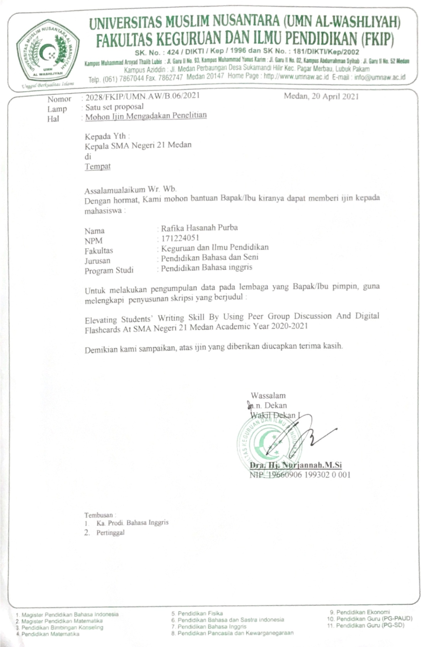**

**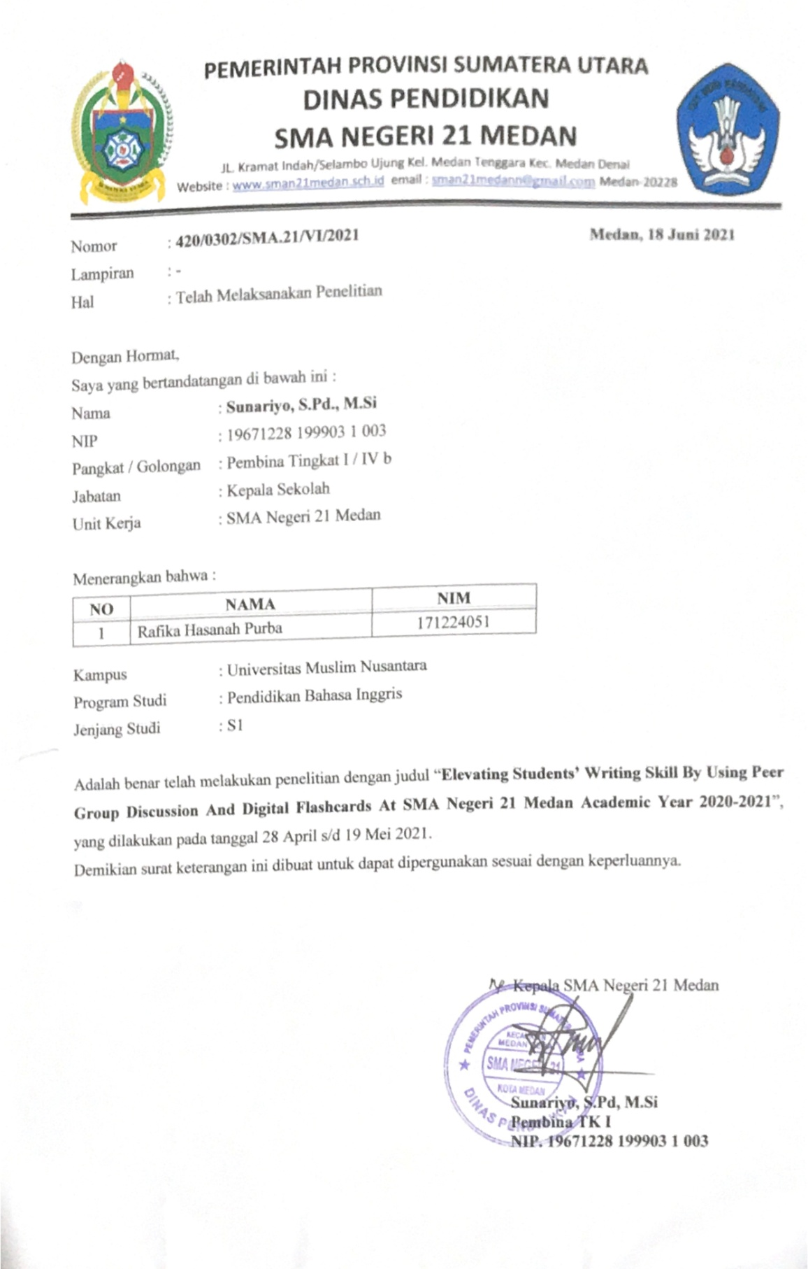**

**Research Documentation**

|  |  |
| --- | --- |
| **WhatsApp Image 2021-06-23 at 17.13.16.jpeg** | **WhatsApp Image 2021-06-23 at 17.13.17.jpeg** |
| **IMG_3256.jpg** | **WhatsApp Image 2021-06-23 at 17.13.17 (1).jpeg** |