**ACKNOWLEDGEMENT**

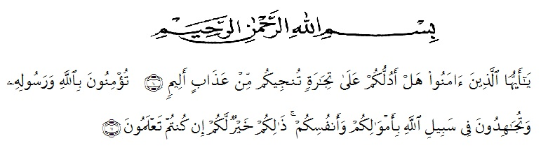

First of all, thanks to Allah SWT the Most Merciful who has always given the researcher strength and convenience in completing this “Thesis” by the title "Elevating Students’ Writing Skill by Using Peer Group Discussion and Digital Flashcards at SMA Negeri 21 Medan In Academic Year Of 2020-2021". Praise and blessing always be given to our last prophet Muhammad SAW who has guided us from the darkness to the brightness.

The researcher would like to thank all those who have supported and helped her. She realized that without their support and help, she could not be Able to finish this “thesis”.

In this opportunity, i owe my deepest appreciation and gratitude to my Adviser, Nazriani Lubis, S.Pd., M.Hum., who always patiently guided and gave advice in writing this thesis. The researcher would like to express her appreciation to:

1. Dr. KRT. Hardi Mulyono K. Surbakti S.E., M.AP., as the rector of Universitas Muslim Nusantara Al- Washliyah
2. Drs. Samsul Bahri, M.Si., as a Dean of Teacher Training and Education Department Universitas Muslim Nusantara Al- Washliyah
3. Zulfitri, S.S., M.A, as the Head of English Education Department
4. Drs. H.M.Khalid, M.Hum, as academic advisor
5. Nazriani Lubis, S.Pd., M.Hum., who always patiently guided and gave advice in writing this thesis.
6. All the lecturersin the English Education Department who have alreasy taught the researcher during herstudy at Universitas Muslim Nusantara Al- Washliyah.
7. All of the staffs who have helped the researcher in processing graduating paper administration.
8. Her beloved parents (H.Syahruddin Purba S,E and Mariani) who gave her love, pray, and support until the Degree of Strata-I (S1), and her beloved sister (Aulia Nisa Khairiyah Purba S,E) who always gave support for her.
9. Her beloved best friends Suci Asri Ramadhani and Puspa Ramadhani who were closed for years till nowadays and always provide motivation, support, and willingness to accompany her in completing this thesis.
10. Her beloved friends Winda Pratika, Windi Anggraini Siregar, Aina Fatahiyah, Elvi Fauziah Siregar, Chairunnisa Lubis and Adela Purnama Rizki Adita who have always given support in finishing this thesis and it is a big thankful to have the opportunity to meet people like them.
11. All of her friends from English Education Department 2017, class 8A. thanks for giving support and their kindness in sharing their various insights and time.
12. All people who have helped her whose name cannot be mentioned one by one, May Allah bless them all.

Finally, the researcher realizes that this thesis is still not perfect. Therefore, the researcher expects criticism and suggestions that can develop this thesis to improve it. The researcher also hopes that this thesis will be useful for the readers, especially the students of English Education Department.

Medan, June 2021

The Researcher

**Rafikah Hasanah Purba**

NPM. 171224051