**APPENDICES**

**Appendix I Lesson Plan**

**RENCANA PELAKSANAAN PEMBELAJARAN (RPP)**

Sekolah : SMK Pembangunan Daerah Pakam

Mata Pelajaran : Bahasa Inggris

Kelas/Semester : XI/Genap

Materi Pokok : Narrative Text

Aspek/Keterampilan : Menulis/Writing Skill

Alokasi Waktu : 2 x 45 Menit

1. **KOMPETENSI INTI**

Memahami makna teks tulis fungsional pendek dan uraian sederhana berbentuk *narrative text* dalam konteks kehidupan sehari-hari dan untuk mengakses ilmu pengetahuan.

1. **KOMPETENSI DASAR**

Mengungkapkan makna secara akurat, lancar dan berterima dengan menggunakan ragam bahasa tulis dalam konteks teks berbentuk *narrative.*

1. **INDIKATOR**
2. Mengidentifikasi dan menjelaskan generic structure dari text *narrative*
3. Mengidentifikasi kata kata dari text *narrative*
4. Menggunakan kalimat bentuk lampau
5. Mendesign teks narrative menggunakan teknik mind mapping.
6. **TUJUAN PEMBELAJARAN**

Pada akhir pembelajaran siswa dapat:

1. Menggunakan kalimat bentuk lampau secara akurat dan efisien dalam menulis teks *narrative*.
2. Menggunakan kosa kata dengan tepat dalam menulis teks *narrative.*
3. Mengaplikasikan teknik mind mapping kedalam teks *narrative*
4. **MATERI PEMBELAJARAN**

Teks *Narrative* (Terlampir)

1. **PENDEKATAN, STRATEGI, METODE**

Pendekatan : *Scientific Approach*

Strategi : *Project Based Learning*

Metode : Teknik Mind Mapping, Tanya Jawab dan Penugasan

1. **KEGIATAN PEMBELAJARAN**

|  |  |  |  |
| --- | --- | --- | --- |
| **Kegiatan** |  | | **Alokasi Waktu** |
| **Peneliti** | **Siswa** |
| Melakukan pendahuluan dengan salam pembuka, berdoa untuk memulai pembelajaran, dan memeriksa kehadiran peserta didik sebagai sikap disiplin. | |
|  | Apersepsi :  Menanyakan pembelajaran sebelumnya kepada peserta didik.  Menginformasikan tema yang akan dipelajari yaitu tentang “ Teks *Narrative*”.  Memberi kesempatan kepada peserta didik untuk mengemukakan pendapatnya mengenai tema yang akan dibahas bersama.  Menjelaskan tujuan pembelajaran | Apersepsi :  Menjawab pertanyaan yang diajukan oleh peneliti.  Mengetahui tema yang akan dipelajari.  Mengemukakan pendapat mengenai tema yang akan di bahas bersama.  Mengetahui apa yang menjadi tujuan pembelajaran. | 15 menit |
|  |
| Pendahuluan |
|  |
|  |
| KegiatanInti | Menjelaskan definisi, tujuan, struktur, ciri-ciri kebahasaan dan contoh dari narrative text . | Peserta didik membaca secara perlahan dan memahami informasi yang disampaikan oleh peneliti. | 65 menit |
| **Mengamati (Observing)** | **Mengamati (Observing)** |
| Memberikan contoh teks narrative dan meminta peserta didik untuk mengamati teks tersebut. | Mengamati teks yang diberikan oleh peneliti. |
| **Menanya (Questioning)** | **Menanya (Questioning)** |
| Peneliti memberikan kesempatan pada peserta didik untuk mengidentifikasi sebanyak mungkin pertanyaan yang berkaitan dengan teknik mind mapping yang disajikan. | Menjawab pertanyaan peneliti |
| Meminta siswa untuk mengklasifikasikan struktur teks narrative |
| **Mengumpulkan Data**  **(Exploring)** | **Mengumpulkan Data**  **(Exploring)** |
| Memberikan latihan stimulasi untuk mendesign narrative text menggunakan teknik mind mapping. | Semua siswa berpartisipasi dalam mengerjakan tugas secara aktif. |
| **Mengasosiasi (assosiating)** | **Mengasosiasi (assosiating)** |
| Peserta didik diminta untuk berkolaborasi atau berdiskusi terkait materi yang disampaikan. | Menyimpulkan hasil diskusi untuk memperoleh kesimpulan |
| **Mengkomunikasikan**  **(communicating)** | **Mengkomunikasikan**  **(communicating)** |
| Peserta didik diberi latihan stimulasi pada pertemuan berikutnya | Mempersiapkan diri untuk melakukan test berikutnya |
| Penutup | Bersama peserta didik membuat rangkuman pembelajaran | Merangkum hasil belajar | 10 menit |
|  |  |
| Bertanya kepada peserta didik tentang materi yang telah dipelajari | Menjawab pertanyaan peneliti tentang materi yang telah dipelajari |
| Menyimpulkan pembelajaran yang telah dipelajari | Mengamati kesimpulan pembelajaran yang telah dipelajari |
| Memberikan arahan tentang kegiatan tindaklanjut pertemuan yang akan dating | Memperhatikan kan arahan tentang kegiatan tindaklanjut pertemuan yang akan datang. |
| Menutup pelajaran, berdoa dan memberikan salam | |

1. **MEDIA/ALAT, BAHAN DAN SUMBER BELAJAR**
2. **Media/alat**

* Laptop
* Handphone
* Gambar
* Aplikasi Pembelajaran: Whatsapp

1. **Sumber Belajar** :

* Buku mata pelajaran Bahasa inggris
* Internet

1. **PENILAIAN PEMBELAJARAN**
2. Jenis/Teknik Penilaian:

* Penilaian Pengetahuan : Tes Tertulis
* Penilaian Sikap : Observasi
* Penilaian Respon : Observasi
* Penilaian Tanggung Jawab : Observasi

1. Bentuk Penilaian:

* Penilaian Sikap : Observasi
* Penilaian Pengetahuan : Uraian
* Penilaian Keterampilan : Observasi

1. Instrumen Penilaian

* Penilaian proses : Kinerja (Terlampir)
* Penilaian hasil : Soal (Terlampir)

**RENCANA PELAKSANAAN PEMBELAJARAN (RPP)**

Sekolah : SMK Pembangunan Daerah Pakam

Mata Pelajaran : Bahasa Inggris

Kelas/Semester : XI/Genap

Materi Pokok : Teks *Narrative* (Past Tense)

Aspek/Keterampilan : Menulis/Writing Skill

Alokasi Waktu : 2 x 45 Menit

**A. KOMPETENSI INTI**

Memahami makna teks tulis fungsional pendek dan uraian sederhana berbentuk tindakan yang terjadi di masa lampaudalam konteks kehidupan sehari-hari dan untuk mengakses ilmu pengetahuan.

1. **KOMPETENSI DASAR**

Mengungkapkan makna secara akurat dengan menggunakan ragam bahasa tulis dalam tindakan yang terjadi di masa lampau.

1. **INDIKATOR**
2. Mengidentifikasi tindakan yang tejadi di masa lampau
3. Mengidentifikasi pola kalimat dari Past Tense
4. Menggunakan kalimat bentuk lampau dalam mendesign teks *narrative* menggunakan teknik mind mapping .
5. **TUJUAN PEMBELAJARAN**

Pada akhir pembelajaran siswa dapat:

1. Menggunakan kalimat bentuk lampau secara akurat dan efisien dalam menulis teks *narrative*.
2. Menggunakan kosa kata dengan tepat dalam menulis teks *narrative.*
3. Mengaplikasikan teknik mind mapping kedalam teks *narrative* menggunakan kalimat past tense.
4. **MATERI PEMBELAJARAN**

Past Tense (Terlampir)

1. **PENDEKATAN, STRATEGI, METODE**

Pendekatan : *Scientific Approach*

Strategi : *Project Based learning*

Metode : Teknik Mind Mapping, Tanya jawab dan Penugasan

1. **KEGIATAN PEMBELAJARAN**

|  |  |  |  |
| --- | --- | --- | --- |
| **Kegiatan** | **Aktivitas** | | **Alokasi Waktu** |
| **Peneliti** | **Siswa** |
| Melakukan pendahuluan dengan salam pembuka, berdoa untuk memulai pembelajaran, dan memeriksa kehadiran peserta didik sebagai sikap disiplin. | |
|  | Apersepsi :  Menanyakan pembelajaran sebelumnya kepada peserta didik.  Menginformasikan tema yang akan dipelajari yaitu tentang “ Teks *Narrative*”.  Memberi kesempatan kepada peserta didik untuk mengemukakan pendapatnya mengenai tema yang akan dibahas bersama.  Menjelaskan tujuan pembelajaran | Apersepsi :  Menjawab pertanyaan yang diajukan oleh peneliti.  Mengetahui tema yang akan dipelajari.  Mengemukakan pendapat mengenai tema yang akan di bahas bersama.  Mengetahui apa yang menjadi tujuan pembelajaran. | 15 menit |
|  |
| Pendahuluan |
|  |
|  |
| KegiatanInti | Memberikan penjelasan tentang kalimat past tense seperti pola kalimat, contoh dan lainnya. | Peserta didik membaca secara perlahan dan memahami informasi yang disampaikan oleh peneliti. | 65 menit |
| **Mengamati (Observing)** | **Mengamati (Observing)** |
| Membimbing siswa untuk mengamati contoh kalimat past tense atau tindakan yang terjadi di masa lampau. | Mengamati contoh kalimat past tense yang diberikan oleh peneliti. |
| **Menanya (Questioning)** | **Menanya (Questioning)** |
| Peneliti memberikan kesempatan pada peserta didik untuk mengidentifikasi sebanyak mungkin pertanyaan yang berkaitan dengan kalimat past tense yang diaplikasikan ke dalam teknik mind mapping. | Menjawab pertanyaan peneliti |
| Meminta siswa untuk membuat kalimat tentang tindakan yang terjadi di masa lampau. |
| **Mengumpulkan Data**  **(Exploring)** | **Mengumpulkan Data**  **(Exploring)** |
| Memberikan latihan stimulasi untuk membuat teknik mind mapping dengan memperhatikan pola kalimat past tense. | Semua siswa berpartisipasi dalam mengerjakan tugas secara aktif. |
| **Mengasosiasi (assosiating)** | **Mengasosiasi (assosiating)** |
| Peserta didik diminta untuk berkolaborasi atau berdiskusi terkait materi yang disampaikan. | Menyimpulkan hasil diskusi untuk memperoleh kesimpulan |
| **Mengkomunikasikan**  **(communicating)** | **Mengkomunikasikan**  **(communicating)** |
| Peserta didik diberi latihan stimulasi pada pertemuan berikutnya | Mempersiapkan diri untuk melakukan test berikutnya |
| Penutup | Bersama peserta didik membuat rangkuman pembelajaran | Merangkum hasil belajar | 10 menit |
|  |  |
| Bertanya kepada peserta didik tentang materi yang telah dipelajari | Menjawab pertanyaan peneliti tentang materi yang telah dipelajari |
| Menyimpulkan pembelajaran yang telah dipelajari | Mengamati kesimpulan pembelajaran yang telah dipelajari |
| Memberikan arahan tentang kegiatan tindaklanjut pertemuan yang akan dating | Memperhatikan kan arahan tentang kegiatan tindaklanjut pertemuan yang akan datang. |
| Menutup pelajaran, berdoa dan memberikan salam | |

1. **MEDIA/ALAT, BAHAN DAN SUMBER BELAJAR**
2. **Media/alat**

* Laptop/Handphone
* Gambar
* Aplikasi Pembelajaran: Whatsapp

1. **Sumber Belajar**

* Buku mata pelajaran Bahasa inggris
* Internet

1. **PENILAIAN PEMBELAJARAN**
2. Jenis/Teknik Penilaian:

* Penilaian Pengetahuan : Tes Tertulis
* Penilaian Sikap : Observasi
* Penilaian Keterampilan : Observasi

1. Bentuk Penilaian:

* Penilaian Sikap : Observasi
* Penilaian Pengetahuan : Uraian
* Penilaian Keterampilan : Observasi

1. Instrumen Penilaian

* Penilaian proses : Kinerja (Terlampir)
* Penilaian hasil : Soal (Terlampir)

**Materi Pembelajaran**

1. **Definition of Narrative Text**

Narrative text is a past story with complication or problematic events and it tries to find the resolutions to solve the problem.

1. **The Purposes of Narrative Text**

The purpose of narrative text is to entertain listener and readers and get moral lesson.

1. **Generic Structure of Narrative Text**
2. Orientation

On the part of orientation contains the characters recognition in the story and also when and where it takes place.

1. Complication

Complication part contains an overview appearing crises or problems experienced by characters in the story to be solved

1. Resolution

The problem is resolved, either in a happy ending or in a sad ending.

**D. Language Features in Narrative Text**

1. Past tense for example: *killed, played, was/were, etc*
2. Adverb of time for example: *once upon a time, a long ago, etc.*
3. Time conjunction for example: *when, then, suddenly, etc.*
4. Specific character for example: *cinderella, snow white, the king, etc.*
5. Action verbs. A verb that shows an action for example: *walked, ran, climbed, etc*.
6. **Kinds of Narrative Text**
7. Legend

Alegend is a short, traditional and historicized narrative performed in a conversational mode. Some define legend as folktale such as tangkuban perahu, malin kundang, etc

1. Fable

A fable is a short allegorical narrative making a moral point, traditionally by means of animal characters who speak and act like human being such as the story of monkey and crocodile, etc.

1. Fairy Tale

A fairy tale typically features such as fairies, goblins, elves, trolls, dwarves, giants or gnomes, and usually magic or enchantments such as Cinderella, snow white, beauty and the beast, etc.

1. Myth

It is a traditional or legendary story, usually concerning some being or hero or event, with or without a determinable basis of fact or a natural explanation such as Dewi Sri, Batara Kala, etc.

1. **Example of Narrative Text**

**CINDERELLA**

**Orientation**

Once upon a time, there was a kind girl named Cinderella. She lived with her stepmother and her two stepsisters. They were very mean to Cinderella, making her work all day cleaning, sewing, and cooking. She tried her best to make them happy.

**Complication**

One day, a messenger arrived with a special invitation. There was going to be a royal ball at the palace. The King wanted his son to find a bride. Every young woman in the kingdom was invited. Her stepmother didn't want Cinderella to go to the ball. She ran away to the garden to cry. Suddenly, the fairy godmother appeared. With a wave of her wand, she changed Cinderella into a beautiful girl and turned a pumpkin into an elegant coach, Cinderella could now go to the ball. She asked to Cinderella that Cinderella must return at home before midnight.

At the ball, the Prince began to dance with the wonderful girl whose name he still didn't know. He fell in love with her. Before midnight, Cinderella ran away and lost one of her glass slipper on the stairs. He found the glass slipper that had come off Cinderella’s foot as she ran home

**Resolution**

The next day, the prince and his servants took the glass slipper and went to all the houses in the kingdom. They wanted to find the lady whose feet would fit in the slipper. All the women in the kingdom tried the slipper but it would not fit any of them. Only Cinderella’s foot fit perfectly. The prince recognized her from the ball. He married Cinderella and they lived happily ever after.

*Sourced on* [*https://princess.disney.com/cinderellas-story*](https://princess.disney.com/cinderellas-story)

**C:\Program Files\Microsoft Office\MEDIA\CAGCAT10\j0299125.wmfWorkseet**

Create your own Mind Mapping based on the Story of Cinderella above

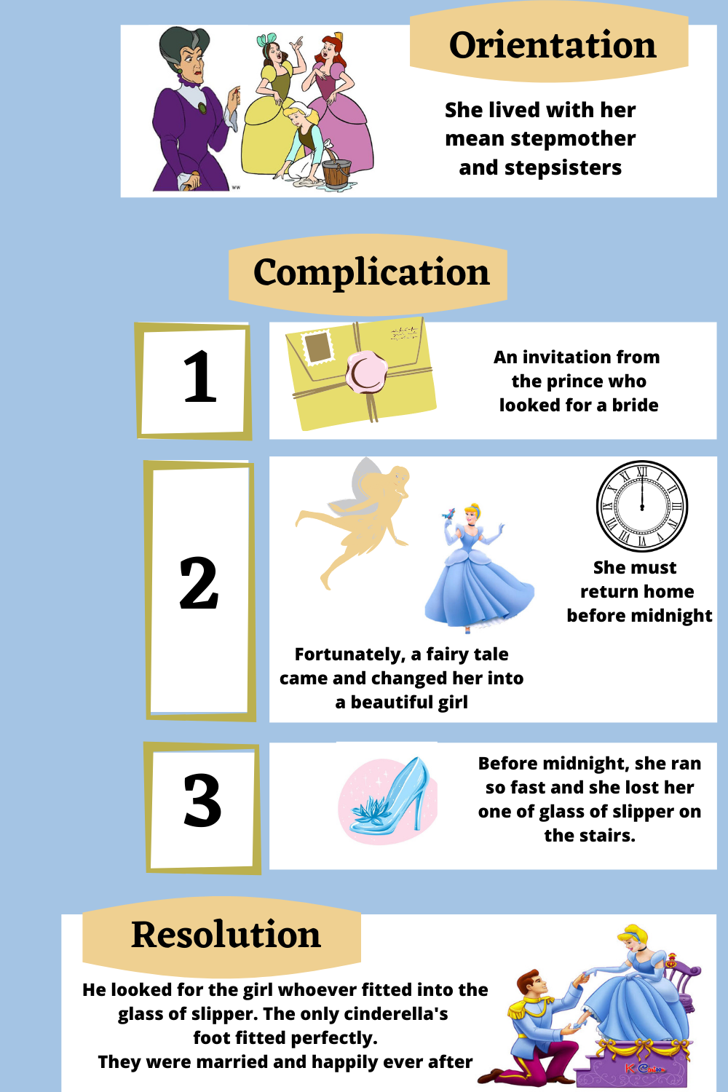

**2. Story of Snow White**

**Snow White**

**Orientation**

Once upon a time there lived a beautiful princess named Snow White. She had a stepmother who was a vain queen. Her stepmother used to look into her mirror and ask “Mirror, mirror on the wall, whose the fairest of them all?” And the mirror would answer her back, “you are the most beautiful of all, oh queen”.

**Complication**

As the years passed one day the queen asked her magic mirror as always, “ Mirror, mirror on the wall whose the fairest of them all? But this time the mirror responded by saying “the fairest of them all is Snow White”, so the queen full of anger and jealous. She ordered the huntsman to kill snow white. The hunter told the truth to the Snow White so he let her go. She walked through the forest and entered the small house. All the furniture was very small. The owners of the house arrived, seven little dwarfs were shocked to find Snow White in their house. Snow White explained her sad story to them and feeling sorry for her, they invited her to stay with them. She agreed and lived with the seven dwarfs and everyone was pleased.

Meanwhile, at the palace, the queen asked her mirror again. “Mirror, mirror on the wall who is the fairest of them all?” “It is still Snow White “. Said the mirror, “Now she lives in the forest with the seven dwarfs “. Absolutely furious, the cruel step mother disguised herself as an innocent old lady and set off for the little house in the forest.

When the queen arrived Snow White was alone, because the dwarfs were out working. The mean old queen offered Snow White a poisonous apple and a soon as Snow White took her first bite she instantly fainted. When the dwarfs returned home that they found Snow White unconscious on the floor.

**Resolution**

A prince riding his faithful horse arrived. As soon as he saw Snow White, he instantly fell in love with her. He gave a kiss and with all of his love, she wake up from her deep sleep. The kiss from the prince had broken the spell of the vain queen.

Snow White married the prince who saved her, and together they drove the queen out of the palace. Since then they have all lived happily ever after.

**Worksheet**

Create your own Mind Mapping based on the Story of Snow White above

**C:\Program Files\Microsoft Office\MEDIA\CAGCAT10\j0299125.wmfWorkseet**

Create your own Mind Mapping based on the Story of Snow White above

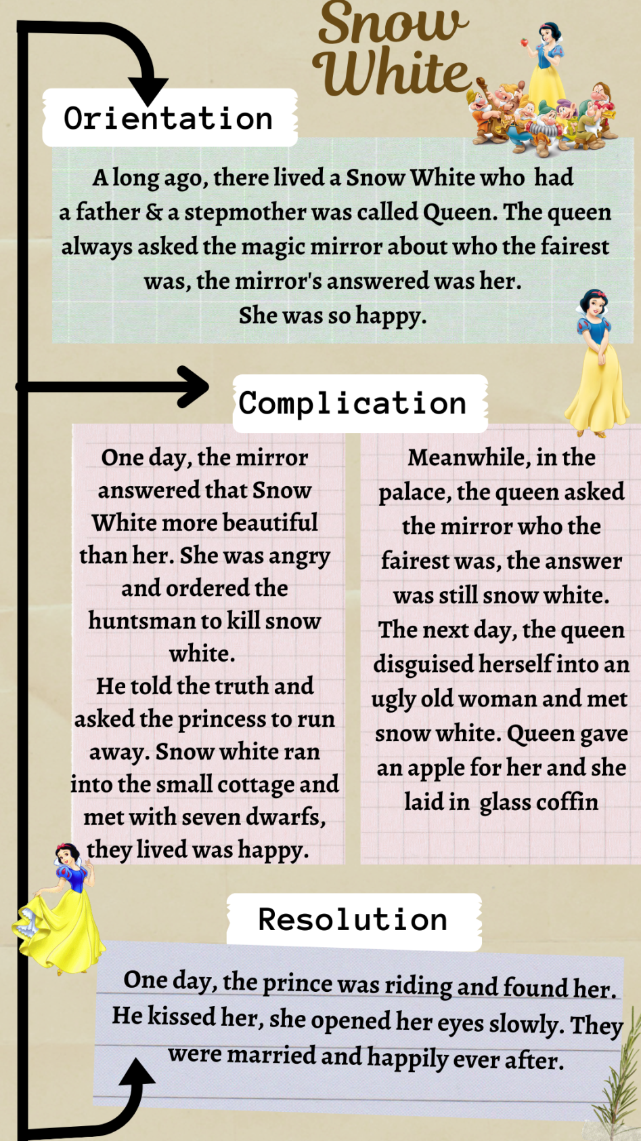

**Past Tense**

1. **Definition of Past Tense**

Simple past tense is used principally to describe events in the past. Regular verbs form the simple past in ed, however there are few hundred irregular verbs with different forms.

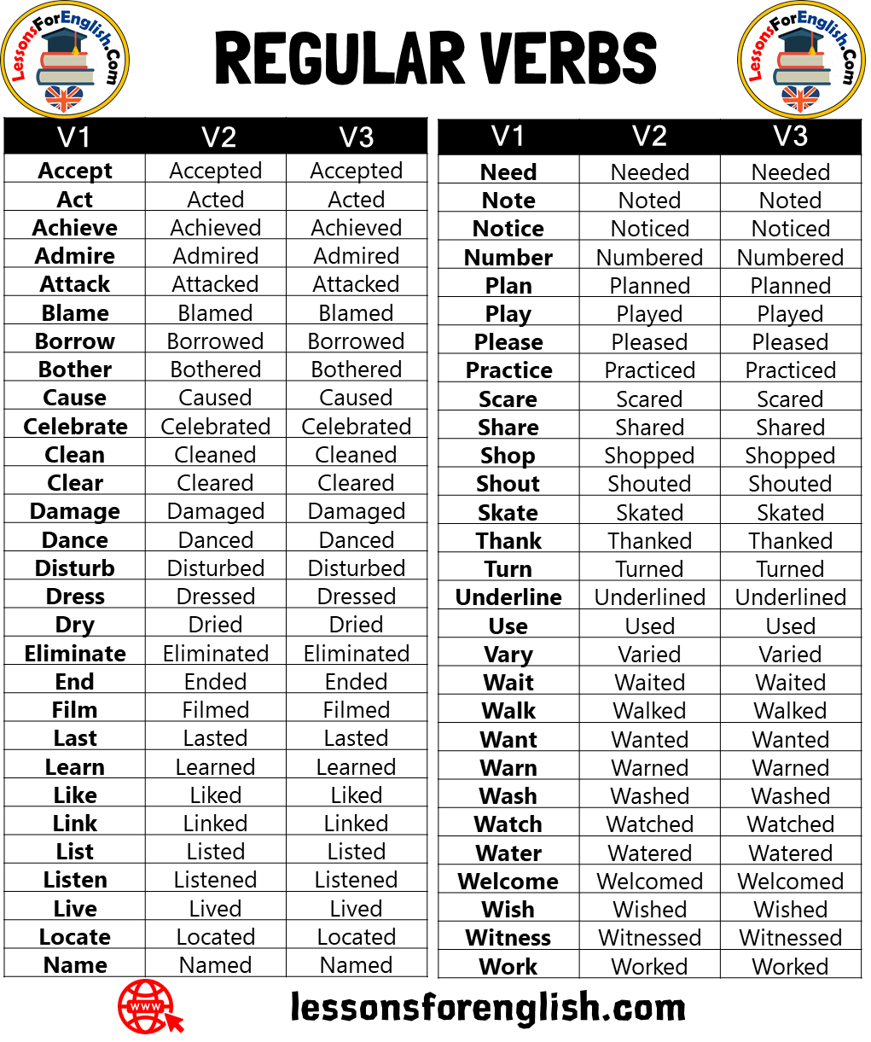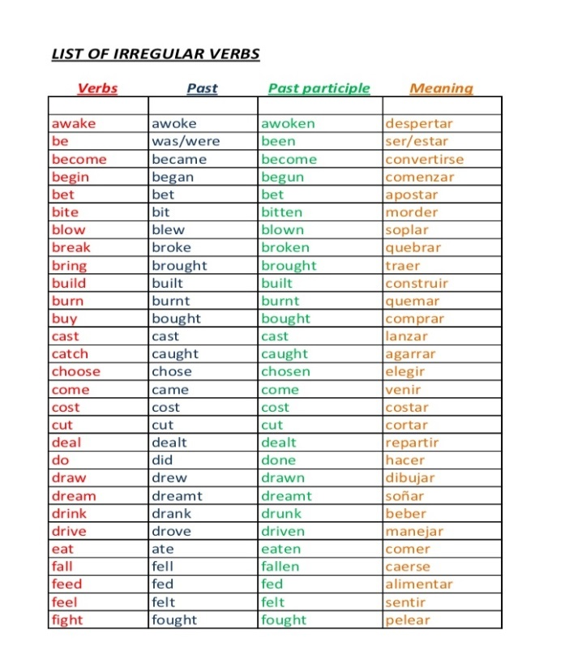

1. **Formula of Past Tense**

Verbal Nominal

**(+) Subject + verb2 + object (+) Subject + to be (was/were) +non verb**

**He saw a movie She was beautiful**

**(-) Subject + did + not + verb1 + object (-) Subject + to be + not + non verb**

**He didn’t see a movie She wasn’t beautiful**

**(?) Did + subject + verb1 + object (?) To be + subject + non verb**

**Did he see a movie? Was she beautiful?**

**Appendix II Rubric of Assessment**

|  |  |  |  |  |
| --- | --- | --- | --- | --- |
| **No** | **Item Analysis** | **Score** | **Criterion of scoring** | |
| 1. | Content | 30-27  26-22  21-17  16-13 | Excellent  Good  Fair  Very Poor | * Knowledgeable * Some knowledge of subject-adequate range * Limited knowledge of subject * Does not show knowledge of subject |
| 2. | Organization | 20-18  17-14  13-10  9-7 | Excellent  Good  Fair  Very Poor | * Fluent expression-ideas clearly stated * Somewhat choppy-loosely organized but main Idea stand out. * Not fluent-ideas confused or disconnected * Does not communicate-no organization |
| 3. | Vocabulary | 20-18  17-14  13-10  9-7 | Excellent  Good  Fair  Very Poor | * Effective word/idiom choice and usage * Occasional errors of word/idiom form, choice, usage, but meaning not obscured * Errors of word/idiom form choice usage * Little knowledge of English vocabulary, idioms, word form |
| 4. | Grammar/  Language  Use | 25-22  21-18  17-11  10-5 | Excellent  Good  Fair  Very Poor | * Effective complex construction, few errors of agreement, tense. * Effective but simple constructive in grammar. * Major problem is simple/complex construction in grammar. * Virtually no mastery of sentence construction rules. |
| 5. | Mechanic | 5  4  3  2 | Excellent  Good  Fair  Very Poor | * Demonstrates mastery of conventions * Occasional errors of spelling, punctuation, capitalization. * Frequent errors of spelling, punctuation, capitalization. * No mastery of conventions, dominated by errors of spelling, punctuation, capitalization, paragraphing. |

**Appendix III Students’ Worksheet**

**C:\Program Files\Microsoft Office\MEDIA\CAGCAT10\j0299125.wmfWorksheet**

Create your own Mind Mapping based on the Story of Cinderella

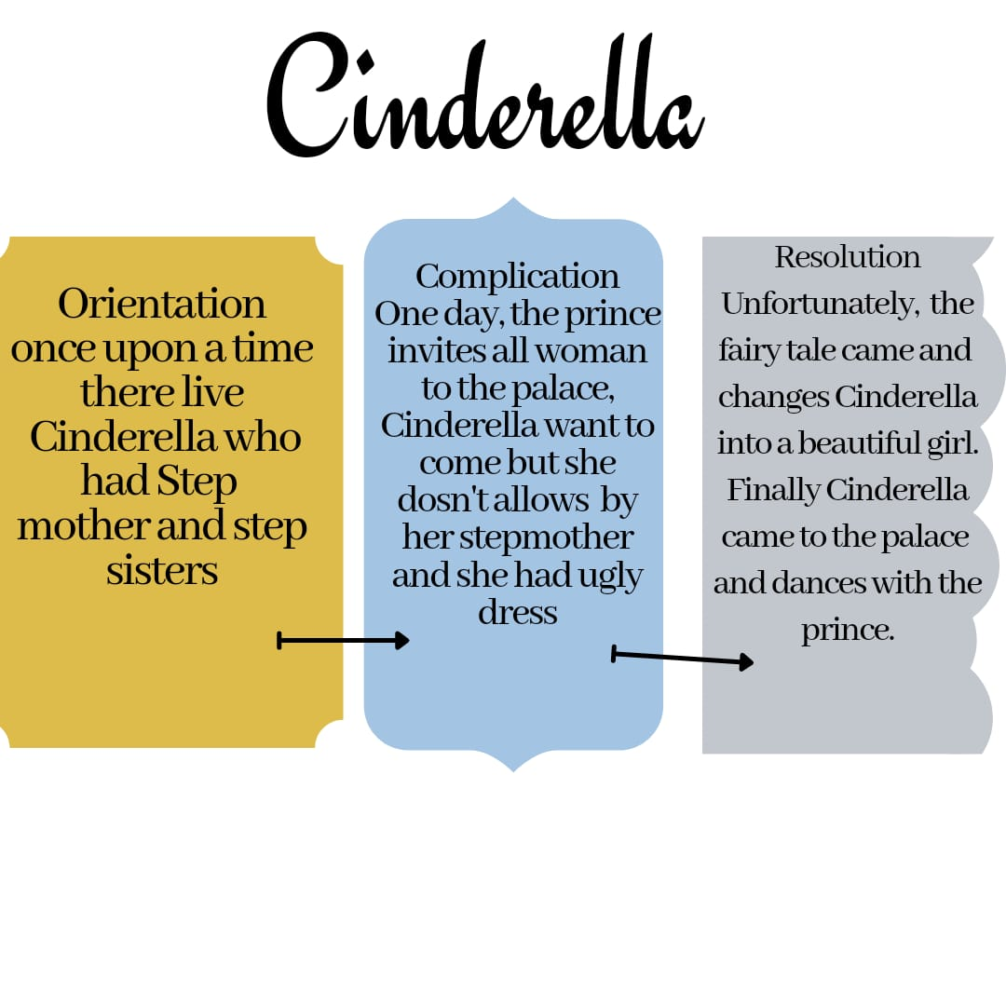

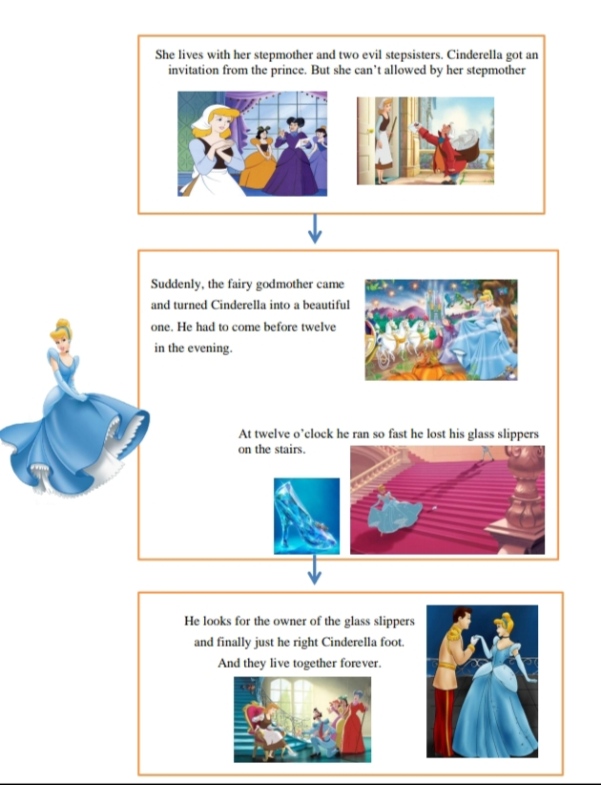

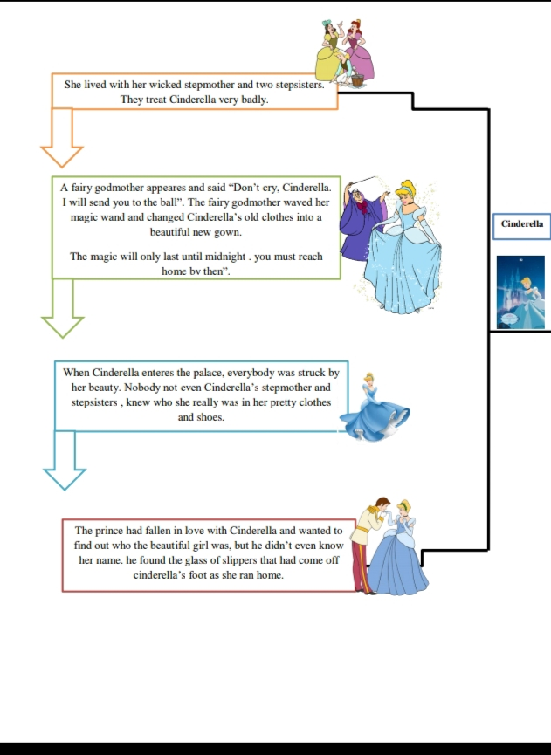

**C:\Program Files\Microsoft Office\MEDIA\CAGCAT10\j0299125.wmfWorksheet**

Create your own Mind Mapping based on the Story of Snow White

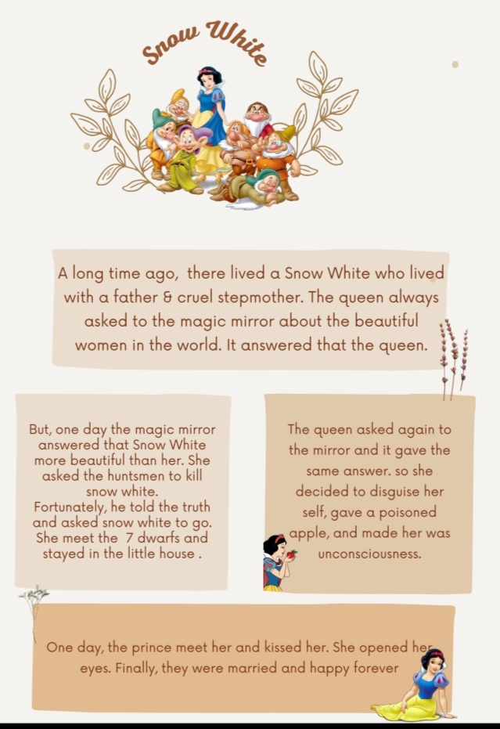

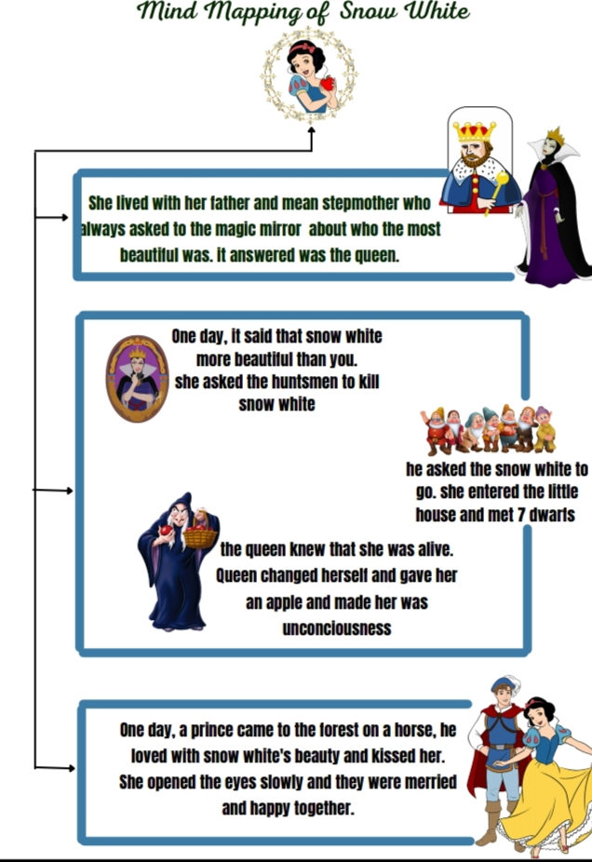**Appendix IV Students’ Test Result**

1. **Students’ Test Result in Cycle I**

|  |  |  |
| --- | --- | --- |
| **No** | **Name of Students** | **Score** |
| 1 | AK | 85 |
| 2 | APS | 76 |
| 3 | DS | 80 |
| 4 | DPS | 85 |
| 5 | DAA | 70 |
| 6 | EW | 74 |
| 7 | FI | 75 |
| 8 | F | 76 |
| 9 | GPPS | 78 |
| 10 | H | 74 |
| 11 | IPS | 84 |
| 12 | JAD | 75 |
| 13 | KT | 76 |
| 14 | M | 80 |
| 15 | MAS | 72 |
| 16 | MF | 74 |
| 17 | MRF | 80 |
| 18 | MYG | 73 |
| 19 | NPS | 89 |
| 20 | NAS | 83 |
| 21 | P | 86 |
| 22 | P | 79 |
| 23 | PK | 80 |
| 24 | RKS | 75 |
| 25 | RJ | 81 |
| 26 | RR | 79 |
| 27 | RPNBN | 90 |
| 28 | SAP | 85 |
| 29 | SAA | 84 |
| 30 | TA | 90 |
| 31 | TL | 82 |
| 32 | VD | 80 |
| 33 | YA | 83 |

M = $\frac{\sum{x}}{N}$

M = 2374 = 71,93

33

1. Students’ Test Result in Cycle II

|  |  |  |
| --- | --- | --- |
| No | Name of Students | Score |
| 1 | AK | 85 |
| 2 | APS | 85 |
| 3 | DS | 93 |
| 4 | DPS | 94 |
| 5 | DAA | 85 |
| 6 | EW | 84 |
| 7 | FI | 83 |
| 8 | F | 84 |
| 9 | GPPS | 86 |
| 10 | H | 85 |
| 11 | IPS | 96 |
| 12 | JAD | 81 |
| 13 | KT | 87 |
| 14 | M | 85 |
| 15 | MAS | 83 |
| 16 | MF | 86 |
| 17 | MRF | 85 |
| 18 | MYG | 89 |
| 19 | NPS | 95 |
| 20 | NAS | 87 |
| 21 | P | 86 |
| 22 | P | 84 |
| 23 | PK | 85 |
| 24 | RKS | 84 |
| 25 | RJ | 93 |
| 26 | RR | 90 |
| 27 | RPNBN | 91 |
| 28 | SAP | 89 |
| 29 | SAA | 90 |
| 30 | TA | 93 |
| 31 | TL | 92 |
| 32 | VD | 87 |
| 33 | YA | 90 |

M = $\frac{\sum{x}}{N}$

M = 2893= 87,66

33

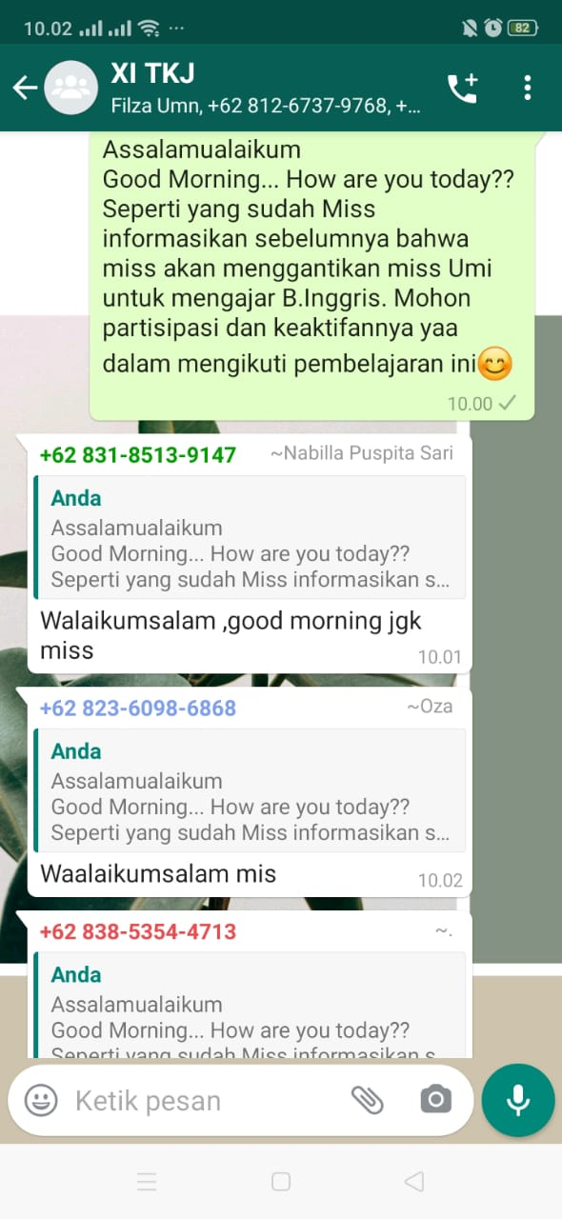**Appendix V Documentation in E-Learning System**

