Appendix A

LESSON PLAN EXPERIMENTAL

School : SMP NEGERI 1 PATUMBAK
Subject : English
Class : VIII
Theme : Noun
Aspect skill : vocabulary
Time : 2 x 40 minutes (3 Pertemuaan)

A.KOMPETENSI INTI
KI-1 : Menghargai dan menghayati ajaran agama yang dianutnya.
KI-2 : Menunjukkan perilaku jujur, disiplin, tanggung jawab, peduli (toleransi, gotong royong), santun, percaya diri, dalam berinteraksi secara efektif dengan lingkungan sosial dan alam dalam jangkauan pergaulan dan keberadaannya.
KI-3 : Memahami pengetahuan (faktual, konseptual, dan prosedural) berdasarkan rasa ingin tahunya tentang ilmu pengetahuan, teknologi, seni, budaya terkait fenomena dan kejadian tampak mata.
KI-4 : Mencoba, mengolah, dan menyaji dalam ranah konkret (menggunakan, mengurai, merangkai, memodifikasi, dan membuat) dan ranah abstrak (menulis, membaca, menghitung, menggambar, dan mengarang) sesuai dengan yang dipelajari di sekolah dan sumber lain yang sama dalam sudut pandang/teori.

B.KOMPETENSI DASAR
3.4 Mengidentifikasi fungsi sosial, struktur teks, dan unsur kebahasaan teks interaksi transaksional lisan dan tulis yang melibatkan tindakan memberidan meminta informasi terkait nama dan jumlah binatang, benda, dan bangunan publik yang dekat dengan kehidupan siswa sehari-hari, sesuai dengan konteks penggunaannya. (Perhatikan unsur kebahasaan dan kosa kata terkait articlea dan the, pluraldan singular)
4.4 Menyusun teks interaksi transaksional lisan dan tulis sangat pendek dan sederhana yang melibatkan tindakan memberi dan meminta informasi terkait nama dan jumlah binatang, benda, dan bangunan publik yang dekat dengan kehidupan siswa sehari-hari, dengan memperhatikan fungsi sosial, struktur teks, dan unsur kebahasaan yang benar dan sesuai konteks

C.INDIKATOR PENCAPAIAN KOMPETENSI
Pertemuan 1
  - perkenalan dan melakukan pre-test
  - penutupan
Pertemuan 2
  - tretment
  - menulis dan menghafal kosa kata
  - mengunggah kosa kata di Facebook
Pertemuan 3
  - melakukan post-test

D.TUJUAN PEMBELAJARAN
Pertemuan 1:
- saling mengenal
- mengetagui seberapa banyak kosa kata yang di miliki siswa
Pertemuan 2
Control : 1. Belajar seperti biasa dengan menghafalkan kosa kata, untuk menambah kosa kata siswa
2.seberapa banyak siswa berminat untuk menghafal.
Experimental: 1. Siswa mengunggah kosa kata setiap hari di Facebook.
2. seberapa banyak siswa berminat untuk mengunggah kosa kata di Facebook.
Pertemuan 3 Melakukan post-test tujuan nya untuk melihat peningkatan kosa kata siswa
Diketahui
Mahasiswa

Agnes Monica Sembiring

Appendix B
Pre-Test

How many nouns are there in this sentence?
1. Please put the heavier books on the desk over there.
A) 1 B) 2 C) 3 D) 4 E) 0
2. Mr. John is a new teacher at my School.
A) 1 B) 2 C) 3 D) 4 E) 0
3. The classroom is clean.
A) 1 B) 2 C) 3 D) 4 E) 0

There are 3 nouns in this sentence:
4. The children are having a great time in the park.
A) True B) False
5. I gave the phone to John
A) True B) False
6. Teacher work in a school
A) True B) False
7. The dog is chasing the cat
A) True B) False

Which word is a noun in this sentence?
8. I’ve been in Singapore for a few years
a) I’ve b) been c) Singapore
9. My name is Clara and I live Jakarta
A) Name B) Clara ` C) live
10. London is very expensive to live in.
A) London B) expensive C) l
Post-Test

Which word is a noun in this sentence?
1. Don't be late for the concert.
A) Late
B) For
C) Concert
2. I need to find something that my brother will like.
A) Need
B) Find
C) Brother
3. London is very expensive to live in.
A) London
B) Expensive
C) Live

Here are 2 nouns in this sentence:
4. Please pass the salt.
A) True
B) False
5. Toni is always late for work.
A) True
B) False
6. Where is the station?
A) True
B) False

Which word is a noun in this sentence?
7. They are forecasting rain later.
A) Rain
B) Later
C) Forecasting

How many nouns are there in this sentence?
8. My brother gave me a book for my birthday.
A) 2
B) 3
C) 4
9. I suggest getting the address from the website.
A) 2
B) 3
C) 4

10. He plural of ‘child’ is:
A) Childs
B) Children
C) Child

The answer Pre-test:
- B.2
- B. 3
- A. 1
- A. True
- B. False
- B. False
- B. False
- C. Singapore
- B. Clara
- A. London

The answer Post-test:
- C) Concert
- C) Brother
- A) London
- B) False
- A) True
- B) False
- A) Rain
- B)3
- A)2
- B) children

Appendix C

Answer pre-test of the experimental group
- Name: MHD. Aulia Rahman (MAR)
Score: 20
Which word is a noun in this sentence?
1. Please put the heavier books on the desk over there.
B) 2
2. Mr. John is a new teacher at my School.
A) 1
3. The classroom is clean.
E) 0
There are 3 nouns in this sentence:
4. The children are having a great time in the park.
B) False
5. I gave the phone to John
B) False
6. Teacher work in a school
A) True
7. The dog is chasing the cat
A) True
Which word is a noun in this sentence?
8. I’ve been in Singapore for a few years
a) I’ve
9. My name is Clara and I live Jakarta
C) live
10. London is very expensive to live in.
B) expensive
- Name: Ratu Dwi Sheila (RDS)
Score: 30
Which word is a noun in this sentence?
1. Please put the heavier books on the desk over there.
A) 1
2. Mr. John is a new teacher at my School.
A) 1
3. The classroom is clean.
A) 1
There are 3 nouns in this sentence:
4. The children are having a great time in the park.
B) False
5. I gave the phone to John
B) False
6. Teacher work in a school
A) True
7. The dog is chasing the cat
B) False
Which word is a noun in this sentence?
8. I’ve been in Singapore for a few years
a) I’ve
9. My name is Clara and I live Jakarta
C) live
10. London is very expensive to live in.
A) London

- Name: Bayu Anggara (BA)
Score: 70
How many nouns are there in this sentence?
1. Please put the heavier books on the desk over there.
B) 2
2. Mr. John is a new teacher at my School.
B) 2
3. The classroom is clean.
B) 2

There are 3 nouns in this sentence:
4. The children are having a great time in the park.
A) True
5. I gave the phone to John
B) False
6. Teacher work in a school
A) True
7. The dog is chasing the cat
B) False
Which word is a noun in this sentence?
8. I’ve been in Singapore for a few years
B) Been
9. My name is Clara and I live Jakarta
B) Clara
10. London is very expensive to live in.
A) London

- Name: Bintang Pratiwi (BP)
Score: 70
How many nouns are there in this sentence?
1. Please put the heavier books on the desk over there.
E.) 0
V
2. Mr. John is a new teacher at my School.
B) 2
3. The classroom is clean.
A) 1
There are 3 nouns in this sentence:
4. The children are having a great time in the park.
B) False
V
5. I gave the phone to John
B) False
6. Teacher work in a school
B) False
7. The dog is chasing the cat
B) False
Which word is a noun in this sentence?
8. I’ve been in Singapore for a few years
C) Singapore
9. My name is Clara and I live Jakarta
B) Clara
10. London is very expensive to live in.
C) l

- Name: Feby Kesya Aulia (FKA)
Scour : 55
How many nouns are there in this sentence?
1. Please put the heavier books on the desk over there.
A) 1 B) 2
2. Mr. John is a new teacher at my School.
B) 2
3. The classroom is clean.
A) 1

There are 3 nouns in this sentence:
4. The children are having a great time in the park.
B) False
5. I gave the phone to John
B) False
6. Teacher work in a school
B) False
7. The dog is chasing the cat
B) False
Which word is a noun in this sentence?
8. I’ve been in Singapore for a few years
a) I’ve
9. My name is Clara and I live Jakarta
A) Name
10. London is very expensive to live in.
C) l

Answer pre-test of the control group
- Name: Airin Kirani(AK)
Score: 70
Which word is a noun in this sentence?
1. Please put the heavier books on the desk over there.
B) 2
2. Mr. John is a new teacher at my School.
A) 1
3. The classroom is clean.
A) 1
There are 3 nouns in this sentence:
4. The children are having a great time in the park.
A) True
5. I gave the phone to john
B) False
6. Teacher work in a school
A) True
7. The dog is chasing the cat
B) False
Which word is a noun in this sentence?
8. I’ve been in Singapore for a few years
C) Singapore
9. My name is Clara and I live Jakarta
B) Clara
10. London is very expensive to live in.
A) London

- Name: Alya Ramadhani (AR)
Score: 60
Which word is a noun in this sentence?
1. Please put the heavier books on the desk over there.
B) 2
2. Mr. John is a new teacher at my School.
B) 3
3. The classroom is clean.
A) 1
There are 3 nouns in this sentence:
4. The children are having a great time in the park.
A) True
5. I gave the phone to john
A) True
6. Teacher work in a school
A) True
7. The dog is chasing the cat
B) False
Which word is a noun in this sentence?
8. I’ve been in Singapore for a few years
C) Singapore
9. My name is Clara and I live Jakarta
B) Clara
10. London is very expensive to live in.
C).1

- Name: Darul Nopal Aiandra (DNA)
Scour : 50
How many nouns are there in this sentence?
1. Please put the heavier books on the desk over there.
A) 1
2. Mr. John is a new teacher at my School.
B) 2
3. The classroom is clean.
A) 1
There are 3 nouns in this sentence:
4. The children are having a great time in the park.
B) False
5. I gave the phone to John
B) False
6. Teacher work in a school
B) False
7. The dog is chasing the cat
B) False
Which word is a noun in this sentence?
8. I’ve been in Singapore for a few years
a) I’ve
9. My name is Clara and I live Jakarta
A) Name
10. London is very expensive to live in.
C) l

- Name: Muhammad Fikri Saragih (MFS)
Scour : 30
How many nouns are there in this sentence?
1. Please put the heavier books on the desk over there.
D) 4
2. Mr. John is a new teacher at my School.
B) 2
3. The classroom is clean.
A) 1
There are 3 nouns in this sentence:
4. The children are having a great time in the park.
B) False
5. I gave the phone to John
A.) True
6. Teacher work in a school
B) False
7. The dog is chasing the cat
A.) True
Which word is a noun in this sentence?
8. I’ve been in Singapore for a few years
a) I’ve
9. My name is Clara and I live Jakarta
A) Name
10. London is very expensive to live in.
C) l

- Name: Nadia Khairunnisa(NK)
Scour : 20
How many nouns are there in this sentence?
1. Please put the heavier books on the desk over there.
E) 0
2. Mr. John is a new teacher at my School.
E) 0
3. The classroom is clean.
A) 1
There are 3 nouns in this sentence:
4. The children are having a great time in the park.
B) False
5. I gave the phone to John
A.) True
6. Teacher work in a school
A.) True
7. The dog is chasing the cat
B) False
Which word is a noun in this sentence?
8. I’ve been in Singapore for a few years
a) I’ve
9. My name is Clara and I live Jakarta
A) Name
10. London is very expensive to live in.
C) l

Answer post-test of the experimental group
- Name : Bayu Anggara (BA)
Score : 100
Which word is a noun in this sentence?
1. Don't be late for the concert.
C) Concert
2. I need to find something that my brother will like.
C) Brother
3. London is very expensive to live in.
A.) London
Here are 2 nouns in this sentence:
4. Please pass the salt.
B) False
5. Toni is always late for work.
A) True
6. Where is the station?
B) False
Which word is a noun in this sentence?
7. They are forecasting rain later.
A) Rain
How many nouns are there in this sentence?
8. My brother gave me a book for my birthday.
B.) 3
9. I suggest getting the address from the website.
A) 2
10. He plural of ‘child’ is:
B) Children

- Name : Bintang Pratiwi (BP)
Score : 100
Which word is a noun in this sentence?
1. Don't be late for the concert.
C) Concert
2. I need to find something that my brother will like.
C) Brother
3. London is very expensive to live in.
A) London
Here are 2 nouns in this sentence:
4. Please pass the salt.
B) False
5. Toni is always late for work.
A) True
6. Where is the station?
B) False
Which word is a noun in this sentence?
7. They are forecasting rain later.
A) Rain
How many nouns are there in this sentence?
8. My brother gave me a book for my birthday.
B.) 3
9. I suggest getting the address from the website.
A) 2
10. He plural of ‘child’ is:
B) Children

- Name : Angga Ardiansyah
Score : 90
Which word is a noun in this sentence?
1. Don't be late for the concert.
B) For
2. I need to find something that my brother will like.
C) Brother
3. London is very expensive to live in.
A) London
Here are 2 nouns in this sentence:
4. Please pass the salt.
B) False
5. Toni is always late for work.
A) True
6. Where is the station?
B) False

Which word is a noun in this sentence?
7. They are forecasting rain later.
A) Rain
How many nouns are there in this sentence?
8. My brother gave me a book for my birthday.
B) 3
9. I suggest getting the address from the website.
A) 2
10. He plural of ‘child’ is:
B) Children

- Name: Selvi (SLV)
Score : 80
Which word is a noun in this sentence?
1. Don't be late for the concert.
C) Concert
2. I need to find something that my brother will like.
C) Brother
3. London is very expensive to live in.
A) London
Here are 2 nouns in this sentence:
4. Please pass the salt.
B) False
5. Toni is always late for work.
A) True
6. Where is the station?
B) False
Which word is a noun in this sentence?
7. They are forecasting rain later.
B) Later
cvv
How many nouns are there in this sentence?
8. My brother gave me a book for my birthday.
C) 4
cvv
9. I suggest getting the address from the website.
A) 2
10. He plural of ‘child’ is:
B) Children

- Name : Ririn Ramahdhani (RR)
Score : 60
Which word is a noun in this sentence?
1. Don't be late for the concert.
C) Concert
2. I need to find something that my brother will like.
cvv
A) Need
3. London is very expensive to live in.
A) London
Here are 2 nouns in this sentence:
4. Please pass the salt.
cvv
A) True
5. Toni is always late for work.
cvv
B) False
6. Where is the station?
A) True
cvv
Which word is a noun in this sentence?
7. They are forecasting rain later.
A) Rain
How many nouns are there in this sentence?
8. My brother gave me a book for my birthday.
B) 3
9. I suggest getting the address from the website.
A) 2
10. He plural of ‘child’ is:
B) Children

Answer post-test of the Control group
- Name: Adelia Nur Annisa (ANA)
Score : 90
Which word is a noun in this sentence?
1. Don't be late for the concert.
C) Concert
2. I need to find something that my brother will like.
C) Brother
3. London is very expensive to live in.
A.) London
Here are 2 nouns in this sentence:
- Please pass the salt.
A) True
cvv
5. Toni is always late for work.
A) True
6. Where is the station?
B) False
Which word is a noun in this sentence?
7. They are forecasting rain later.
A) Rain
How many nouns are there in this sentence?
8. My brother gave me a book for my birthday.
B.) 3
9. I suggest getting the address from the website.
A) 2
10. He plural of ‘child’ is:
B) Children

- Name: Rencus Manalu (RM)
Score : 90
Which word is a noun in this sentence?
1. Don't be late for the concert.
C) Concert
2. I need to find something that my brother will like.
C) Brother
3. London is very expensive to live in.
A.) London
Here are 2 nouns in this sentence:
- Please pass the salt.
B) False
5. Toni is always late for work.
cvv
B) False
6. Where is the station?
B) False
Which word is a noun in this sentence?
7. They are forecasting rain later.
A) Rain
How many nouns are there in this sentence?
8. My brother gave me a book for my birthday.
B.) 3
9. I suggest getting the address from the website.
A) 2
10. He plural of ‘child’ is:
B) Children

- Name:Israqi Syahdinil (IS)
Score : 80
Which word is a noun in this sentence?
1. Don't be late for the concert.
C) Concert
2. I need to find something that my brother will like.
C) Brother
3. London is very expensive to live in.
A) London
Here are 2 nouns in this sentence:
4. Please pass the salt.
B) False
5. Toni is always late for work.
A) True
6. Where is the station?
B) False
Which word is a noun in this sentence?
7. They are forecasting rain later.
A) Rain
How many nouns are there in this sentence?
8. My brother gave me a book for my birthday.
C) 4
cvv
9. I suggest getting the address from the website.
A) 2
10. He plural of ‘child’ is:
cvv
C) Child

- Name: Ega Tasya Keliat (ETK)
Score : 60
Which word is a noun in this sentence?
1. Don't be late for the concert.
C) Concert
2. I need to find something that my brother will like.
cvv
A.) Need
3. London is very expensive to live in.
A) London
Here are 2 nouns in this sentence:
4. Please pass the salt.
B) False
5. Toni is always late for work.
A) True
6. Where is the station?
B) False
Which word is a noun in this sentence?
7. They are forecasting rain later.
cvv
B) Later
How many nouns are there in this sentence?
8. My brother gave me a book for my birthday.
C) 4
cvv
9. I suggest getting the address from the website.
A) 2
10. He plural of ‘child’ is:
cvv
C) Child

- Name: lamhot Pandapotan Sagala (lPS)
Score : 60
Which word is a noun in this sentence?
1. Don't be late for the concert.
C) Concert
2. I need to find something that my brother will like.
cvv
A.) Need
3. London is very expensive to live in.
A) London
Here are 2 nouns in this sentence:
4. Please pass the salt.
B) False
5. Toni is always late for work.
A) True
6. Where is the station?
B) False
Which word is a noun in this sentence?
7. They are forecasting rain later.
cvv
B) Later
How many nouns are there in this sentence?
8. My brother gave me a book for my birthday.
B) 3
9. I suggest getting the address from the website.
C) 4
cvv
10. He plural of ‘child’ is:
cvv
C) Child

Appendix D

Table I
Standard Deviation of Experimental Group
N0 | Initial of students’ | Score X | Score $X^{2}$
1 | ATW | 75 | 5625
2 | APK | 95 | 9025
3 | AA | 90 | 8100
4 | AH | 90 | 8100
5 | AN | 85 | 7225
6 | AN | 70 | 4900
7 | BA | 100 | 10000
8 | BP | 100 | 10000
9 | BP | 75 | 5625
10 | BR | 75 | 5625
11 | SDB | 90 | 8100
12 | DRSM | 80 | 6400
13 | DN | 95 | 9025
14 | FKA | 75 | 5625
15 | KK | 85 | 7225
16 | MFT | 90 | 8100
17 | MAR | 75 | 5625
18 | NL | 80 | 6400
19 | NAC | 85 | 7225
20 | NA | 75 | 5625
21 | RTBG | 80 | 6400
22 | RDS | 85 | 7225
23 | RRS | 70 | 4900
24 | RR | 60 | 3600
25 | RH | 65 | 4225
26 | SK | 75 | 5625
27 | SVI | 80 | 6400
28 | SRP | 80 | 6400
29 | TR | 70 | 4900
30 | TMS | 90 | 8100
31 | WFS | 85 | 7225
32 | ZKN | 85 | 7225
 | Total | 2610 | 215800

$$S_{1}^{ 2}=\frac{n \sum_{x}{2} -(\sum_{x}{2)} }{n(n-1)}$$
=$\frac{ 32.215800 -({2610)}^{2} }{32(32-1)}$
=$\frac{ 6905600 - 6812100 }{992}$
=$\frac{ 93500}{992}$
=94, 25
=$\sqrt{94,25}$
=9, 74

Appendix E

Table II
Standard Deviation of Control Group
N0 | Initial of students’ | Score X | Score $X^{2}$
1 | ANA | 90 | 8100
2 | AK | 80 | 6400
3 | AR | 85 | 7225
4 | AAS | 70 | 4900
5 | AJ | 75 | 5625
6 | ARM | 85 | 7225
7 | AM | 80 | 6400
8 | BA | 75 | 5625
9 | CA | 80 | 6400
10 | DNR | 70 | 4900
11 | DLS | 65 | 4225
12 | DAA | 85 | 7225
13 | ETK | 60 | 3600
14 | FMF | 75 | 5625
15 | IF | 85 | 7225
16 | IDG | 85 | 7225
17 | IR | 70 | 4900
18 | IS | 80 | 6400
19 | JS | 90 | 8100
20 | KFG | 80 | 6400
21 | LPS | 60 | 3600
22 | MRP | 70 | 4900
23 | MR | 60 | 3600
24 | MPF | 85 | 7225
25 | MAK | 75 | 5625
26 | MFM | 80 | 6400
27 | MFS | 85 | 7225
28 | NK | 80 | 6400
29 | NSL | 85 | 7225
30 | NF | 75 | 5625
31 | RM | 90 | 8100
32 | TS | 75 | 5625
 | Total | 2485 | 195275

$$S_{1}^{ 2}=\frac{n \sum_{x}{2} -(\sum_{x}{2)} }{n(n-1)}$$
=$\frac{ 32. 195275 -({2485)}^{2} }{32(32-1)}$
=$\frac{6248800 - 6175225}{992}$
=$\frac{ 73575}{992}$
=74,16
=$\sqrt{74,16}$
=8, 61

Appendix G
EXPERIMENTAL
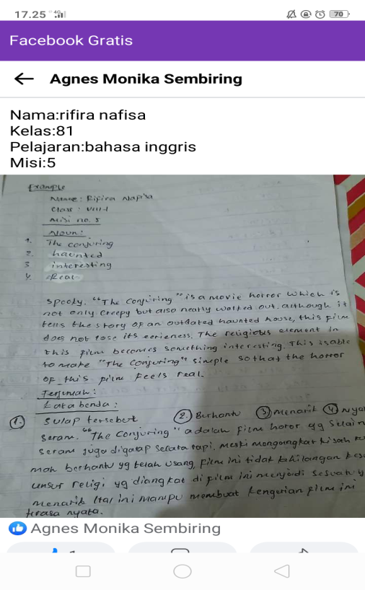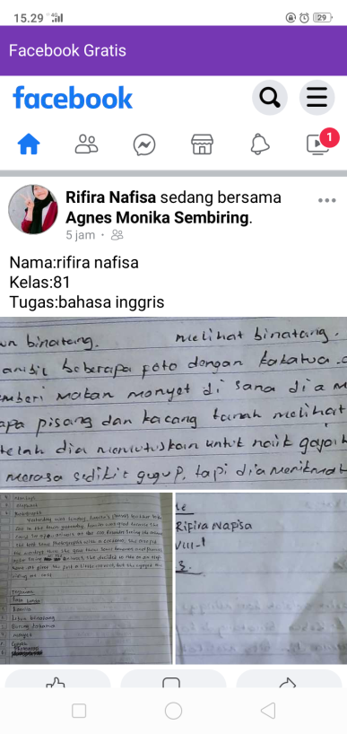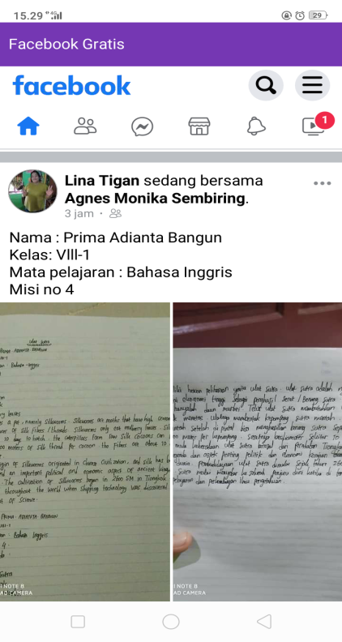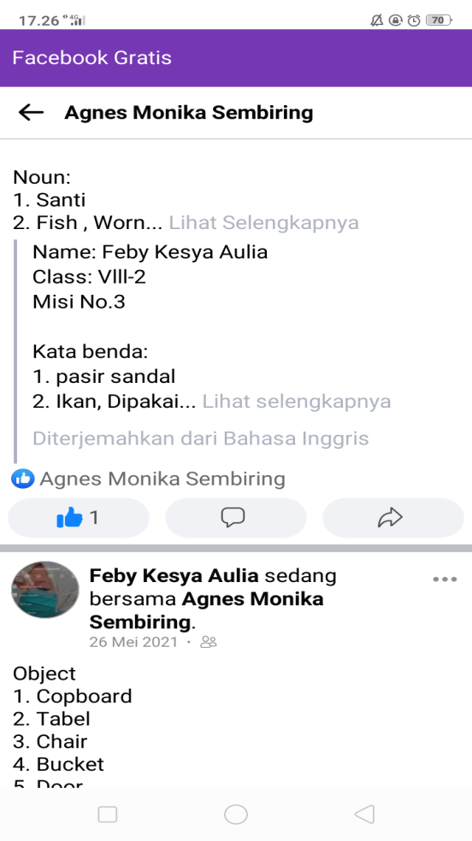
CONTROL
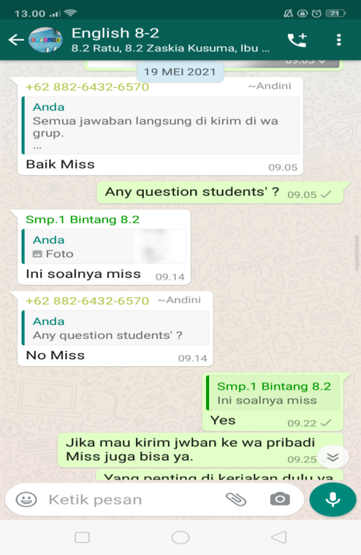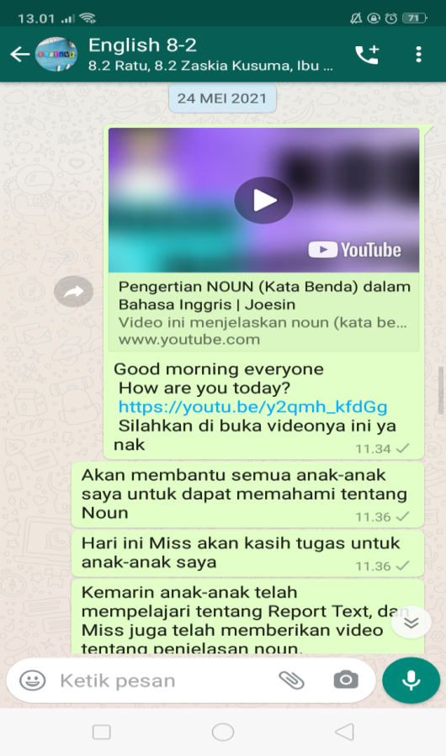
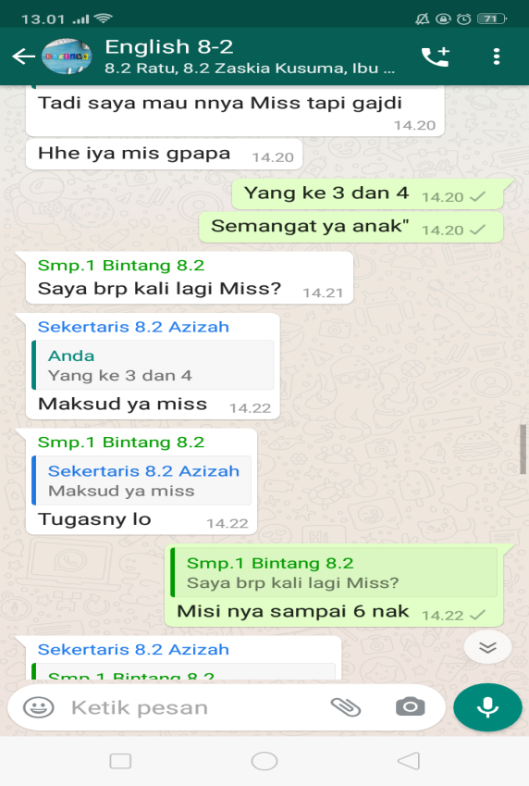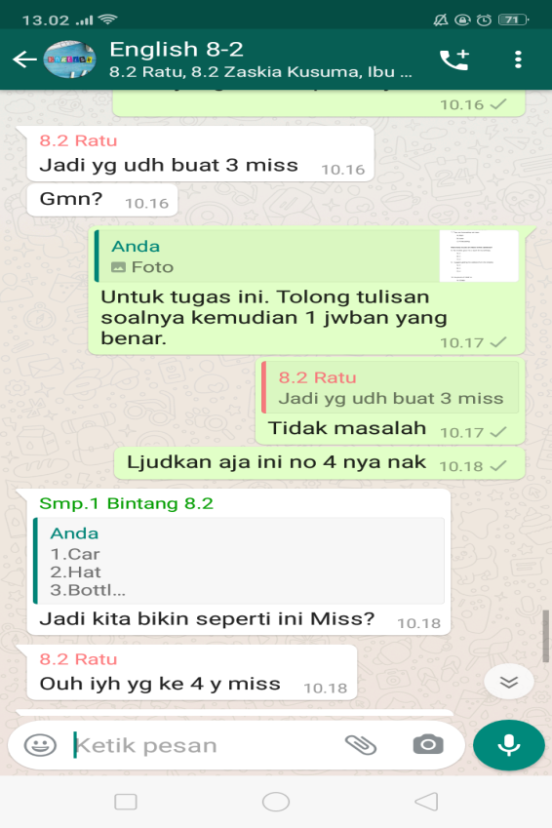
PRE-TEST
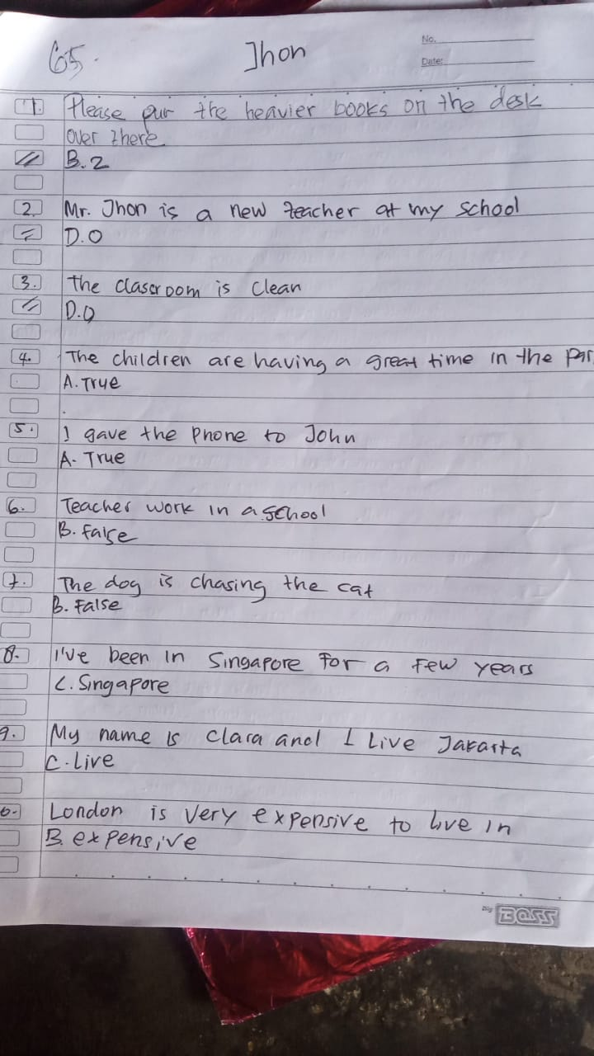
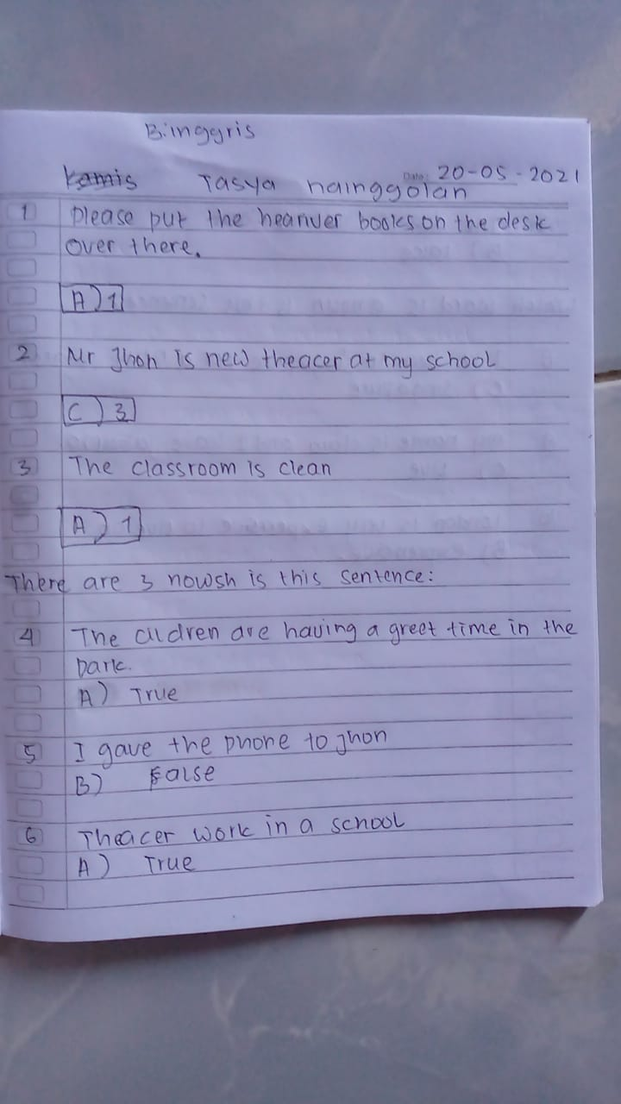
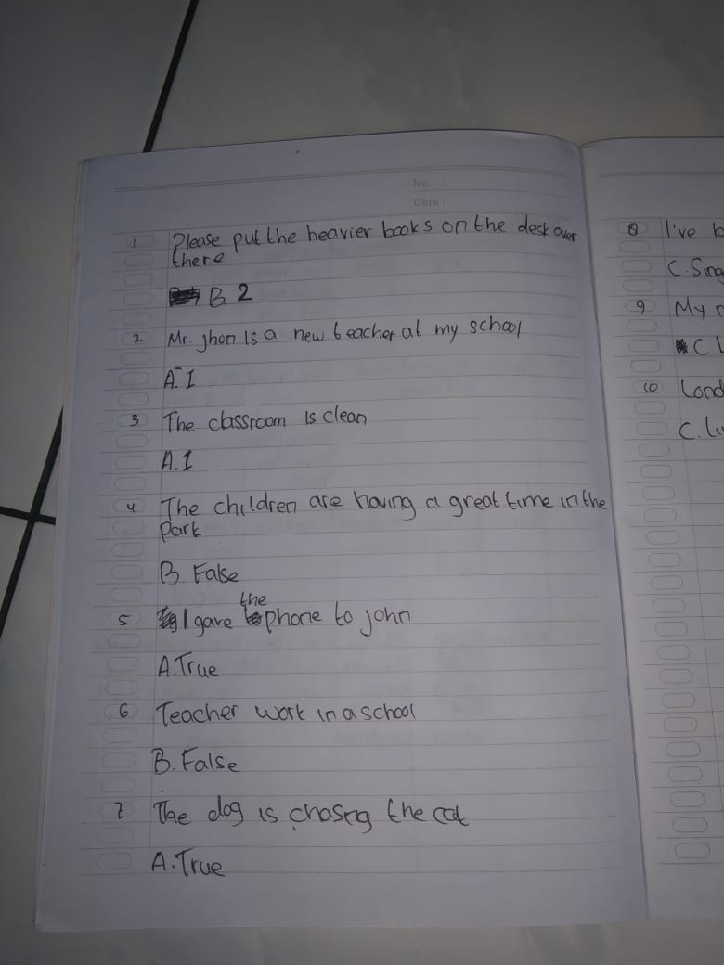
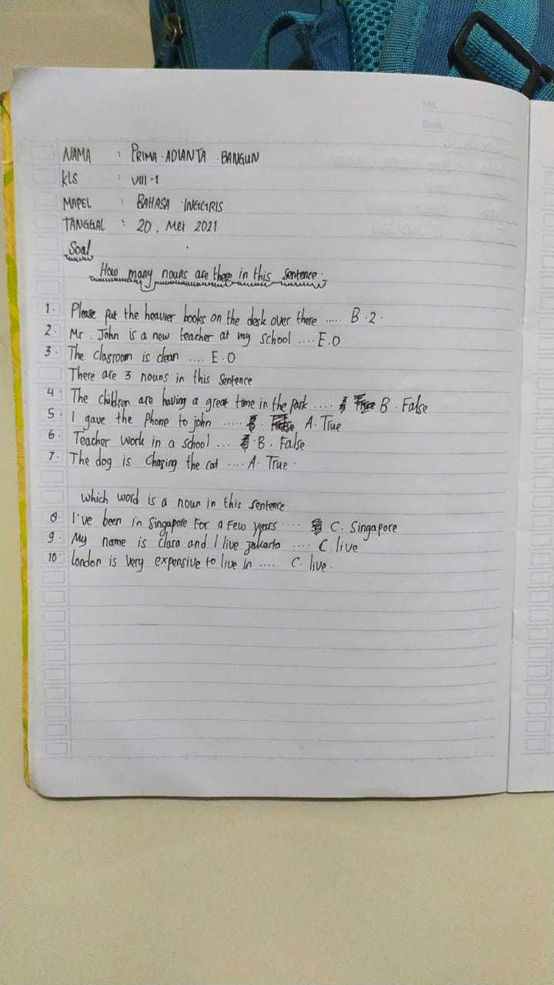

POST-TEST
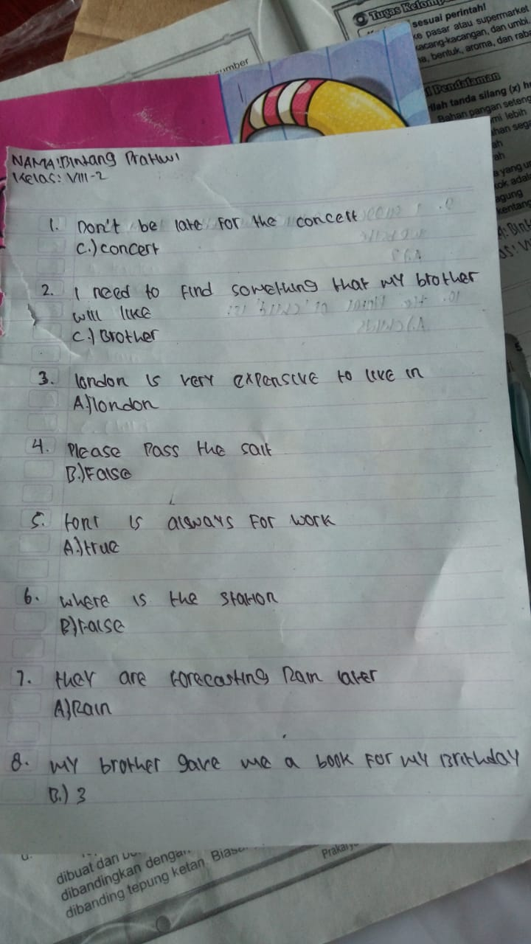
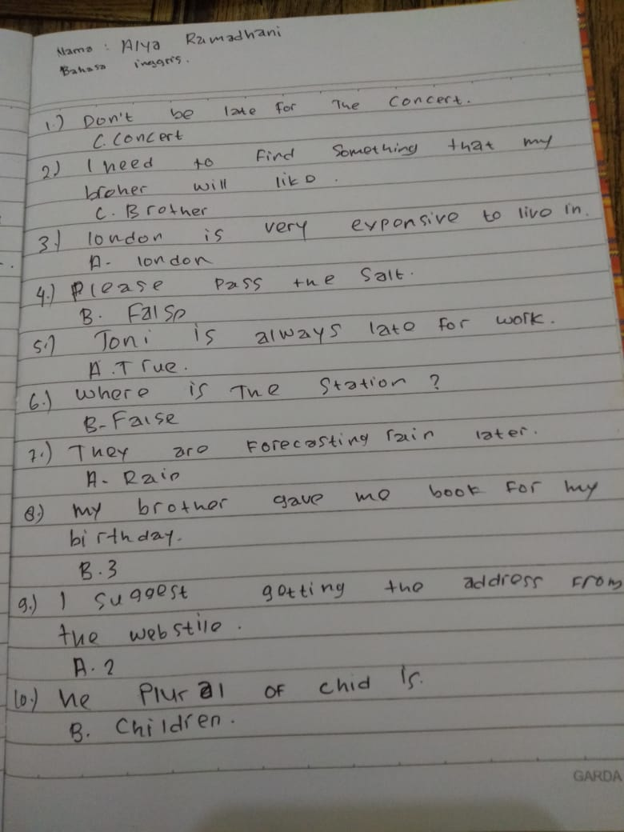

START RESEARCH
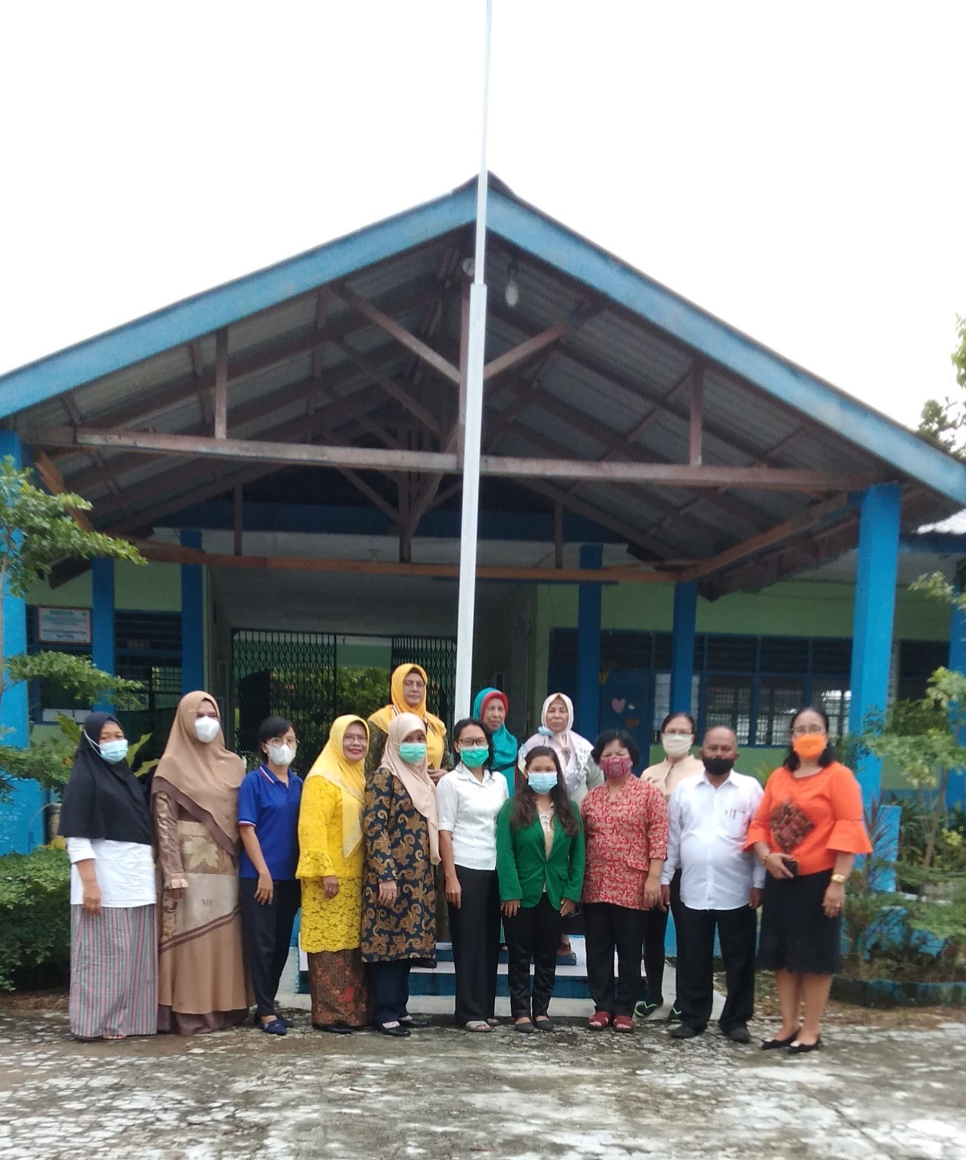

FINISHED RESEARCH
