ACKNOWLEDGEMENT
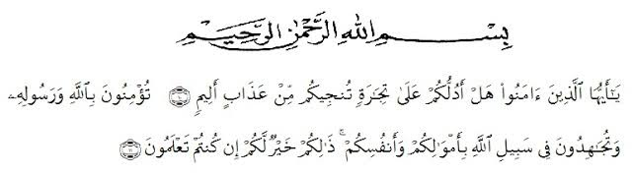
- Shall I show you a commerce that will save you from a painful doom?
- Ye should believe in Allah and His messenger, and should strive for the cause of Allah with your wealth and your lives. That is better for you, if ye did but know.
The meanings:
- Hai orang-orang yang beriman, sukakah kamu aku tunjukkan suatu perniagaan yang dapat menyelamatkanmu dari azab yang pedih?
- (yaitu) kamu beriman kepada Allah dan Rasul-Nya dan berjihad di jalan Allah dengan harta dan jiwamu. Itulah yang lebih baik bagimu, jika kamu mengetahuinya. (QS. Ash-shaff: 10-12)
Praise and great attitude is given to Almighty God, Allah SWT who always give his gracious mercy and blessing for giving the strength and chance to complete this thesis entitled “Improving Students’ Descriptive Text Writing Skill through Web Mapping for Tenth Grade at SMKN.1 Perbaungan”. This thesis in fulfillment of the requirements to obtain the degree of bachelor in the Faculty of Teaching Training and Education at the Department of English Language Education of Universitas Muslim Nusantara.
Sholawat and salaam always be with our prophet Muhammad SAW, the greatest messenger for people over the world, this world became peace because of his hard effort.
In accomplishing this thesis, great appreciation and sincerest gratitude be expressed to all of those who have given the contribution so this thesis able to finished. The researcher would like to deliver this thank to:
- Dr. KRT. H. Hardi Mulyono K Surbakti., the rector of Universitas Muslim Nusantara Al Washliyah Medan.
- Drs. Samsul Bahri, M.Si., the dean of the Teacher’s Training and Education, Faculty of Universitas Muslim Nusantara AL Washliyah Medan,
- Zulfitri, S.S., M.A as the head of english language education department, and Dra. Hj. Nurjannah, M.Si., as the current head of the english language education department.
- Teguh Satria Amin, S.Pd., M.Hum as an adviser who gave the command, critic and suggestion and guided her during the process of completing this thesis became more be better.
- All of the lecturers of the department of english language education of universitas muslim nusantara for teaching precious knowledge and giving wonderful study experience.
- The beloved family who always give an endless love, patience, support, pray and everything you give me to pass this study getting Bachelor degree. Many obstacles can be overcome with your love. May God bless to you.
- Special for the beloved friends: Winda Pratika, Windi Anggraini, Suci Asri Ramadhani, Rafikah Hasanah Purba and all of the friends who help and support her in any situation. The good communication of discussion can brings the alternative solution to answer the problem.
- The last, for the memorable place, SMKN.1 Perbaungan, thank you to all students who have participated actively in conducting this research. She is so glad to teach them in another opportunity.
Eventually, this thesis is expected to provide useful and meaningful information in the field of education, henceforth the researcher will be pleasure to accept some critics and correction to make this thesis more be better. She is pleased to accept any suggestion and contribution for the improvement of this thesis.

Medan, June 28th, 2021
The Researcher

Aina Fatahiyah

