ACKNOWLEDGEMENTS
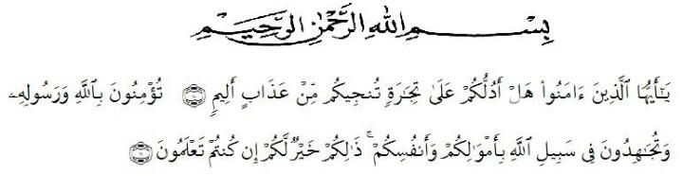
Artinya: “ Hai orang-orang yang beriman, maukah kamu aku tunjukkan suatu perniagaan yang dapat menyelamatkanmu dari azab yang pedih? (10). (yaitu) kamu beriman kepada Allah dan Rasul-nya dan berjihad di jalan Allah dengan harta dan jiwamu. Itulah yang lebih baik bagimu, jika kamu mengetahuinya. (11)”.
Praise and gratitude, the researcher say the presence of Allah SWT, which thanks to His grace the researcher can complete this thesis with the title An Analysis of Students' Ability in Writing Persuasive Text at SMA Swasta Nurul Amaliyah Tanjung Morawa in Academic Year 2020/2021. Writing this thesis is one of the duties and obligations of every student, especially the Teaching and Education Faculty of the Universitas Muslim Nusantara Al Washliyah Medan and as a condition for obtaining a Bachelor of Education (S.Pd) degree.
Furthermore, the researcher would also like to thank:
- Dr. H. Hardi Mulyono Surbakti, SE., MAP as the Rector of the Universitas Muslim Nusantara Al Washliyah in Medan who accepted me as a student.
- Drs. Samsul Bahri, M.Si, as the Head of the Faculty of Teacher Training and Education at the Universitas Muslim Nusantara Al-Washliyah who gave the research permit.
- Zulfitri, SS., M.A as the Head of the English Language Education Department who has given me permission to approve the title of the proposal
- Rini Fadhillah Putri, S.Pd.,M.Hum as the Adviser who has guided and provided constructive suggestions from the beginning to the completion of this proposal writing.
- The headmaster of SMA Swasta Nurul Amaliyah for the facilities given to her in conducting this research
- The lecturers of the English Language Department of FKIP UMN medan for their nice and valuable discussing to enrich the writer’s knowledge.
- Her special beloved parents who have supported her financially and morally during her academic years at FKIP Universitas Muslim Nusantara Al Washliyah Medan. The researcher prays up on God, may they be in peace and be with characteristic of pious and devoted human beings.
- Her beloved thanks to her friends and classmates who have supported her to finish this research.
Finally, the researcher realizes that she could not recompense the contribution of those people mentioned above. She prays upon Allah SWT, may the Almighty bless them all in here after.
Medan, June 2021
Author

Maulidya Mayang Widhari
171224019

