ACKNOWLEDGEMENTS

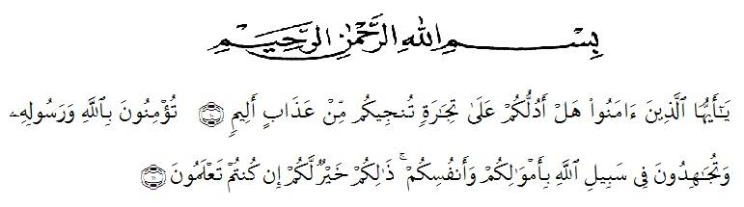
Artinya :
“Hai orang-orang yang beriman, sukakah kamu aku tunjukkan suatu perniagaan yang dapat menyelamatkan kamu dari azab yang pedih? (10). (Yaitu) kamu beriman kepada Allah dan Rasul-Nya dan berjihad di jalan Allah dengan harta dan jiwamu. Itulah yang lebih baik bagi kamu jika kamu mengetahuinya (11).”
(Ash-Shaff : 10-11).
Praise and gratitude to Allah SWT, for the abundance of his grace and love, so that the researcher can complete this thesis with the title : An Analysis Of Students' Language Ability Taught By Using Recitation Method With Different Personality At SD Al Fauzi Medan In 2021/2022 Academic Year. Shalawat along with greetings, researcher also give gifts to the prophet Muhammad SAW, hopefully he will get his intercession in Yaumul Mahsyar in the future. Aamiin ya rabbal 'alamin.
The purpose of writing this thesis is to fulfill part of the requirements for obtaining a Bachelor of Education (S.Pd) degree for undergraduate students at the English Education study program at the Universitas Muslim Nusantara Al Washliyah. The researcher realizes that this thesis is still far from perfection, therefore the researcher expects constructive criticism and suggestions from all parties for the perfection of this thesis.
The preparation of this thesis would not have been successful without the help and cooperation of other parties. Therefore, on this occasion the researcher would like to express his deepest gratitude to all those who have helped and encouraged the realization of this thesis. All humility researcher would like to thank in particular :
- Dr. KRT. Hardi Mulyono K. Surbakti., as the Rector of Universitas Muslim Nusantara Al Washliyah Medan.
- Drs. Samsul Bahri, M.Si., as the Dean of Teacher Training and Education Faculty of Universitas Muslim Nusantara Al Washliyah.
- Zulfitri S.S., M.A., as the Head of English Education Department.
- Nurhafni Siregar, S.Pd., M.Hum as Adviser, who has never stopped give support and helping researcher in guiding and correcting the pattern of this research so that this research complete and perfect.
- The lecturers of English Language Department of FKIP Universitas Muslim Nusantara Al Washliyah for their kind and valuable suggestion to enrich the researcher’s knowledge.
- The headmaster of SD Al Fauzi Medan, all the teachers and students who have participated in the research of this thesis.
- Her beloved parents (Bapak Bebas and Almh Ibu Kartini br surbakti) who raised her through many difficulties. His prayers, his support, and his hard works encourage her to complete her study. And all of her families who have made her days more colorful and her study more meaningful.
- Her beloved friends (Bella Tiara Nur Anggraini, Putri Handayani and all her friends in VIII-H English Department).
Finally, the researcher realizes that could not recompense the contribution of those people mentioned above, the researchers pray upon to Allah SWT, may the almighty bless them all in hereafter.

Medan, June 2021
The Researcher

Agus Fitriana

