ACKNOWLEDGEMENT
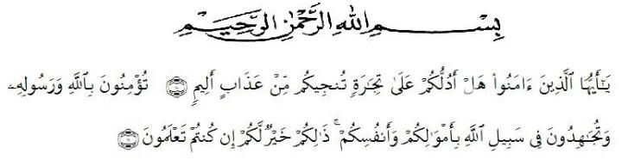
Artinya: “ Hai orang-orang yang beriman, maukah kamu aku tunjukkan suatu perniagaan yang dapat menyelamatkanmu dari azab yang pedih? (10). (yaitu) kamu beriman kepada Allah dan Rasul-nya dan berjihad di jalan Allah dengan harta dan jiwamu. Itulah yang lebih baik bagimu, jika kamu mengetahuinya. (11)”.
By saying Alhamdulillah all the praise and gratitude of the writer for the presence of Allah SWT, because thanks to grace and guidance, the preparation of a proposal entitled “AN ANALYSIS OF THE STUDENTS’ ABILITY IN WRITING RECOUNT TEXT OF THE FIRST GRADE AT SMA SWASTA SATRIA DHARMA PERBAUNGAN” can be completed in order to fulfill one of the requirements in completing education at the Department of English Education Faculty of the Teacher Training and Education, the University of Muslim Nusantara Al Washliyah Medan.
Shalawat and Salam to our beloved Prophet Muhammad SAW, the greatest man ever who teaches us the kindness and good life in order to ben the good Muslim. We hope his salutation in future day.
In the process of finishing this thesis, the writer has been given many supports and valuable knowledge from many people. Therefore, the reseaecher would like to express her great appreciation and thanks:
- Dr. KRT. Hardi Mulyono K. Surbakti, as the Rector of Universitas Muslim Nusantara Al Washliyah Medan.
- Drs. Samsul Bahri, M. Si, as the Dean of FKIP of Universitas Muslim Nusantara Al WAshliyah Medan.
- Dra. Hj. Nurjannah, M. Si, as Plt. of the Head of English Education Department in Universitas Muslim Nusantara Al Wasliyah Medan.
- Zulfitri, S.S., M.A, as the Head of the English Education Department of Universitas Muslim Nusantara Al Washliyah Medan.
- Rini Fadhillah Putri, S.Pd., M.Hum, as the consultant who give the command and suggestion toward the writer in finishing the proposal.
- All of the lectures of the English Education Department of Universitas Muslim Nusantara Al Washliyah Medan.
- All of the Academic Administration Staff of Universitas Muslim Nusantara Al Washliyah Medan.
- The Headmaster of SMA Swasta Satria Dharma Perbaungan who has given permission to the researcher to conduct the research.
- The English teacher, Wahyuningsih, S.Pd, thank you for her contribution to the researcher while she was doing the research.
- Her beloved parents, Ibu Suparni and Bapak Suhermanto, and all her family. Thanks for their support and motivations.
- Her fiance, Muhammad Adji Satria. Thanks for support.
- All her friends in her life, thank you so much for wonderful times.
The researcher knows that this paper needs to be revised in order to get good result. The researcher also hopes that this paper will be useful for us. Amin.

Medan, 2020
The Writer,

Tika Ayunda Herani
NPM. 171224025

