Appendix A

RENCANA PELAKSANAAN PEMBELAJARAN (RPP)
LESSON PLAN
CONTROL GROUP

Sekolah : SMP Negeri 1 Beringin
Mata Pelajaran : Bahasa Inggris
Kelas : VIII-5
Materi Pokok : Recount Text
Alokasi Waktu : 2 x 40 Menit

- Kompetensi Inti:
KI 1 : Menghargai dan menghayati ajaran agama yang dianutnya.
KI 2 : Menghargai dan menghayati perilaku jujur, disiplin, tanggung jawab, peduli( toleransi, gotong royong ),santun ,percaya diri dalam berinteraksi secara efektif dengan lingkungan sosial .
KI 4 : Memahami dan menerapkan pengetahuan ( factual, konseptual ,dan procedural) berdasarkan rasa ingin tahunya tentang ilmu pengetahuan , teknologi, seni budaya terkait fenomena dan kejadian tampak mata.
KI 5: Mengolah , menyaji dan menalar dalam ranah konkrit ( menulis , membaca,dan mengarang)sesuai dengan dipelajari di sekolah dan sumber lain yang sama dengan sudut pandang teori.

- Kompetensi Dasar dan Indikator
3.11 Menerapkan struktur teks dengan unsur kebahasaan untuk melaksanakan fungsi sosial menyatakan dan menanyakan tindakan / kejadian yang dilakukan di waktu lampau, sesuai dengan konteks penggunaannya .
Indikator
3.11.1 Siswa mampu menerapkan struktur unsur kebahasaan tetang kejadian yang terjadi di waktu lampau .
3.11.2 Siswa mampu menyatakan dan menanyakan tindakan yang terjadi di waktu lampau.
1.14 Menangkap makna teks recount lisan tertulis, pendek dan sederhana tentang kegiatan, kejadian, peristiwa.
1.14.1 Siswa mampu menangkap makna yang terdapat dalam teks recount yang disajikan secara lisan.
1.14.2 Siswa mampu menangkap makna yang terdapat dalam teks recount tertulis.
    - Siswa mampu menangkap tentang kegiatan / peristiwa, kejadian.

- Tujuan Pembelajaran
Melalui pembelajaran Discovery Learning peserta didik diharapkan dapat menjelaskan,menganalisis,menyimpulkan dan membuat sebuah teks recount terkait fungsi sosial struktur teks,

- Materi Pembelajaran
- Fungsi sosial
Menceritakan kembali peristwa untuk tujuan menginformasikan dan menghibur.
- Definition of Recount Text
Recount text is a type of text in English that tells about a story, action, or activity. Usually, recount text tells about someone's experience. The purpose of recount text is to entertain the reader, so that there is no conflict in this text. In addition, this text also aims to provide information to the reader.
- Generic structure of Recount Text
- Orientation
Tells about background information about who, where, when the incident or event occurred.
- Events
Tells a series of events that occur in chronological order.
- Re-orientation
It is the conclusion or conclusion of the story. To close a story, we can give our opinion about the story.

- Example of Recount Text

Visiting Uncles’ House
The last semester vacation was an unexpected holiday. Because, I didn’t have any vacation schedule. But, my father gave me a surprise. I was very happy and excited to visit my uncle who had not met for two years.I prepared everything needed to go on vacation. After that, dad invited me to go to the terminal because we did left at 05.00 pm. The trip that must be taken to Panyabungan was around 13 hours. Along the way, I saw such an amazing view from the bus window.The next day, we arrived at 08.00 am. I didn’t expect them to gather to greet us.On the day, I had to take a rest for freshen my body.The second day there, I did taken by my uncle to go to the garden to harvest oranges. The location of garden was not far from Uncle’s house. Arriving there, I was happy to be able to pick oranges directly from the tree. The oranges that had been picked were sold and some were for souvenirs.The third day, I and uncle went to the river for take a bath. I did amazed to see the water that was so clear. There, I found many people busy to washing and bathing.The holiday was over, I had to go back to Medan to continue the routine activities. While there, I got a lot of experience and visited family that I had never met before.Although it was a short vacation, it was a memorable holiday for me. I got a lot of experience there.
E. Metode Pembelajaran
1. Pendekatan : Scientific Approach
2. Model : Discovery Learning
3. Metode learning : Cooperative Learning, Small Group Discussion
F. Media, Alat dan Sumber Pembelajaran
1. Media: Kertas Karton , Lembar Kerja Siswa Spidol, Penghapus, Papan
Tulis
2. Sumber Belajar : Buku Penunjang Kurikulum 2013 Mata Pelajaran Bahasa
Inggris Kelas VIII , Kamus Bahasa Inggris.
G . Langkah Langkah Kegiatan Pembelajaran
KEGIATAN | DESKRIPSI |  | ALOKASI WAKTU
 | SISWA | GURU
Pendahuluan | - Menjawab salam guru dan mengucapkan syukur  - Memberikan respon kehadiran  - Berpartisipasi dalam kegiatan psikis/fisik yang diberikan guru | - Melakukan pembukaan dengan salam pembukaan  - Memeriksa kehadiran peserta didik sebagai sikap disiplin  - Menyiapkan fisik dan psikis peserta didik . | 10 Menit
 | - Menjawab salam guru dan mengucapkan syukur  - Memberikan respon kehadiran  - Berpartisipasi dalam kegiatan psikis/fisik yang diberikan guru  - Menyimak dan merepon guru dalam proses mengkaitkan materi  - Merespon pertanyaan yang diberikan oleh guru yang ada keterkaitan dengan pelajaran yang akan dilakukan. | - Melakukan pembukaan dengan salam pembukaan  - Memeriksa kehadiran peserta didik sebagai sikap disiplin  - Menyiapkan fisik dan psikis peserta didik dan mengawali kegiatan pembelajaran  - Mengkaitkan materi/tema/  kegiatan pembelajran yang akan dilakukan dengan pengalaman peserta didik dengan pengalaman peserta didik dengan materi sebelumnya .  - Mengajukan pertanyaan yang ada keterkaitannya dengan pelajaran yang akan dilakukan.  - Menyampaikan tujuan pembelajaran pada pertemuan berlangsung | 10 Menit
Kegiatan inti | - Observing  Menjelaskan Materi Recount Text baik dalam struktur maupun penggunanya dalam kalimat.  - Question  Guru mengarahkan agar siwa bertanya jika ada yang tidak dimengerti terkait materi yang telah dijelaskan.  - Collecting data  Guru mengarahkan siswa untuk membuka buku lembar kerja siswa . kemudian guru meminta siswa untuk mengerjakan pilihan berganda seuai dengan materi yang baru dijelaskan.  Siswa mengerjakan tugas sesuai dengan intruksi yang diberikan guru. Guru mengevaluasi hasil pembelajaran dan pemahaman siswa dengan menilai hasil pengerjaan asessment siswa. | Menunjukan bahan ajar berkaitan dengan materi yang akan disampaikan melalui media kertas karton.  Memancing siswa untuk bertanya mengenai maeteri yang disampaikan.  Membimbing siswa untuk menyelesaikan tugas pilihan berganda sesuai materi . | 60 Menit
Penutup | - Guru  me-review materi yang telah disampaikan hari ini dengan bertanya kepada para siswa berkaitan tujuan, unsur kebahasaan dan struktur teks recount.  - Guru memberikan motivasi kepada siswa untuk sering berlatih membaca teks recount dengan menghimbau siswa untuk membaca buku bahasa inggris.  - Guru memberikan umpan balik terhadap proses dan hasil pembelajaran serta bertanya kepada siswa bagaimana kesan mereka dalam pembelajaran hari ini.  - Guru memberikan salam penutup. |  | 10 Menit

H. Penilaian Hasil Pembelajaran
Indikator Pencapaian Kompetensi | Teknik Penilaian | Bentuk Instrumen | Instrumen/ Soal
- Mengidentifikasi ciri kebahasaan teks recount  - Menjawab pertanyaan pertanyaan berdasarkan teks bacaan recount text | Tes tertulis  Tes tertulis | Pilihan berganda  Pilihan berganda | - Pilihlah jawaban yang benar berdasarkan bacaan diatas
- Instrumen:
- Pedoman penilaian
- Pilihan ganda
Nomor benar x 5
Nilai maksimal : 100

Classification of Score
NO | Criteria | Score
 | Excellent | 100 -91
 | Good | 90 -81
 | Fair | 80 -71
 | Poor | 70-61
 | Very poor | ≤60

Peneliti

Bella Tiara Nur Anggraini
NIM.171224027

Appendix B

RENCANA PELAKSANAAN PEMBELAJARAN (RPP)
LESSON PLAN
EXPERIMENTAL GROUP

Sekolah : SMP Negeri 1 Beringin
Mata Pelajaran : Bahasa Inggris
Kelas : VIII-2
Materi Pokok : Recount Text
Alokasi Waktu : 2 x 40 Menit

- Kompetensi inti:
KI 1 : Menghargai dan menghayati ajaran agama yang dianutnya.
KI 2 : Menghargai dan menghayati perilaku jujur, disiplin, tanggung jawab, peduli( toleransi, gotong royong ),santun ,percaya diri dalam berinteraksi secara efektif dengan lingkungan sosial .
KI 4 : Memahami dan menerapkan pengetahuan ( factual, konseptual ,dan procedural) berdasarkan rasa ingin tahunya tentang ilmu pengetahuan , teknologi, seni budaya terkait fenomena dan kejadian tampak mata.
KI 5: Mengolah , menyaji dan menalar dalam ranah konkrit ( menulis , membaca,dan mengarang)sesuai dengan dipelajari di sekolah dan sumber lain yang sama dengan sudut pandang teori.

- Kompetensi dasar dan indikator
3.11 Menerapkan struktur teks dengan unsur kebahasaan untuk melaksanakan fungsi sosial menyatakan dan menanyakan tindakan / kejadian yang dilakukan di waktu lampau, sesuai dengan konteks penggunaannya .

Indikator
3.11.1 Siswa mampu menerapkan struktur unsur kebahasaan tetang kejadian yang terjadi di waktu lampau .
3.11.2 Siswa mampu menyatakan dan menanyakan tindakan yang terjadi di waktu lampau.
1.14 Menangkap makna teks recount lisan tertulis, pendek dan sederhana tentang kegiatan, kejadian, peristiwa.
1.14.1 Siswa mampu menangkap makna yang terdapat dalam teks recount yang disajikan secara lisan.
1.14.2 Siswa mampu menangkap makna yang terdapat dalam teks recount tertulis.
1.14.3 Siswa mampu menangkap tentang kegiatan / peristiwa, kejadian.

- Tujuan Pembelajaran
Melalui pembelajaran Discovery Learning peserta didik diharapkan dapat menjelaskan,menganalisis,menyimpulkan dan membuat sebuah teks recount terkait fungsi sosial struktur teks,

- Materi Pembelajaran
- Fungsi Sosial
Menceritakan kembali peristwa untuk tujuan menginformasikan dan menghibur.
- Definition of Recount Text
Recount text is a type of text in English that tells about a story, action, or activity. Usually, recount text tells about someone's experience. The purpose of recount text is to entertain the reader, so that there is no conflict in this text. In addition, this text also aims to provide information to the reader.
- Generic structure of Recount Text
- Orientation
Tells about background information about who, where, when the incident or event occurred.
- Events
Tells a series of events that occur in chronological order.
- Re-orientation
It is the conclusion or conclusion of the story. To close a story, we can give our opinion about the story.
- Example of Recount Text

Visiting Uncles’ House
The last semester vacation was an unexpected holiday. Because, I didn’t have any vacation schedule. But, my father gave me a surprise. I was very happy and excited to visit my uncle who had not met for two years.I prepared everything needed to go on vacation. After that, dad invited me to go to the terminal because we did left at 05.00 pm. The trip that must be taken to Panyabungan was around 13 hours. Along the way, I saw such an amazing view from the bus window.The next day, we arrived at 08.00 am. I didn’t expect them to gather to greet us.On the day, I had to take a rest for freshen my body.The second day there, I did taken by my uncle to go to the garden to harvest oranges. The location of garden was not far from Uncle’s house. Arriving there, I was happy to be able to pick oranges directly from the tree. The oranges that had been picked were sold and some were for souvenirs.The third day, I and uncle went to the river for take a bath. I did amazed to see the water that was so clear. There, I found many people busy to washing and bathing.The holiday was over, I had to go back to Medan to continue the routine activities. While there, I got a lot of experience and visited family that I had never met before.Although it was a short vacation, it was a memorable holiday for me. I got a lot of experience there.

E. Metode Pembelajaran
1. Pendekatan : Scientific Approach
2. Model : Discovery Learning
3. Metode learning : Cooperative Learning, Small Group Discussion.
F. Media, Alat dan Sumber Pembelajaran
1. Media : Kertas Karton , Lembar Kerja Siswa Spidol, Penghapus, Papan Tulis
2. Sumber Belajar : Buku Penunjang Kurikulum 2013 Mata Pelajaran Bahasa Inggris Kelas VIII , Kamus Bahasa Inggris.
G . Langkah Langkah Kegiatan Pembelajaran
Kegiatan | Deskripsi |  | Alokasi waktu
 | Siswa | Guru
Pendahuluan | - Menjawab salam guru dan mengucapkan syukur  - Memberikan respon kehadiran  - Berpartisipasi dalam kegiatan psikis/fisik yang diberikan guru  - Menyimak dan merepon guru dalam proses mengkaitkan materi  - Merespon pertanyaan yang diberikan oleh guru yang ada keterkaitan dengan pelajaran yang akan dilakukan  - Menyimak penjelasan guru mengenai materi yang akan dipelajari  - Menyimak penjelasan guru mengenai tujuan pembelajaran yang akan dicapai  - Menyimak penjelasan guru mengenai mekanisme pelaksanaan pengalaman belajar yang akan dilakukan. | - Melakukan pembukaan dengan salam pembukaan  - Memeriksa kehadiran peserta didik sebagai sikap disiplin  - Menyiapkan fisik dan psikis peserta didik dan mengawali kegiatan pembelajaran  - Mengkaitkan materi/tema/kegiatan pembelajran yang akan dilakukan dengan pengalaman peserta didik dengan pengalaman peserta didik dengan materi sebelumnya .  - Mengajukan pertanyaan yang ada keterkaitannya dengan pelajaran yang akan dilakukan.  - Memberitahukan materi pelajaran yang akan dibahas pada pertemuan saat itu.  - Menyampaikan tujuan pembelajaran pada pertemuan berlangsung  - Menjelaskan mekanisme pelaksanaan pengalaman belajar sesuai dengan langkah langkah pembelajaran. | 10 Menit
Kegiatan inti | - Observing  Menjelaskan Materi Recount text baik dalam struktur maupun penggunanya dalam kalimat.  - Question  Menanyakan berbagai hal yang berkaitan dengan kalimat yang berkaitan dengan judul.  - Collecting data  Dalam meyelesaikan tugas siswa membentuk kelompok . | Menunjukan bahan ajar berkaitan dengan materi yang akan disampaikan melalui media kertas karton.  Memancing siswa untuk bertanya mengenai materi yang disampaikan.  Membimbing siswa untuk menyelesaikan tugas secara perkelompok.  Untuk bagian group siswa harus bekerja sama dengan teman kelompok. | 60 Menit
Penutup | - Guru dan siswa membuat rangkuman / simpulan  - Guru dan siswa melakukan refleksi kegiatan yang sudah dilaksanakan  - Guru memberikan umpan balik terhadap proses dan hasil pembelajaran  - Melakukan penilaian terhadap kegiatan yang sudah dilakukan secara konsisten  - Peserta didik mengucapkan salam saat guru keluar dari ruangan. |  | 10 Menit

H. Penilaian Hasil Pembelajaran

Indikator Pencapaian Kompetensi | Teknik Penilaian | Bentuk Instrumen | Instrumen/ Soal
- Mengidentifikasi ciri kebahasaan teks recount  - Menjawab pertanyaan pertanyaan berdasarkan teks bacaan recount text | Tes tertulis  Tes tertulis | Pilihan berganda  Pilihan berganda | - Pilihlah jawaban yang benar berdasarkan bacaan diatas

- Instrumen:
- Pedoman penilaian
1. Pilihan ganda
Nomor benar x 5
Nilai maksimal : 100

Classification of Score
NO | Criteria | Score
 | Excellent | 100 -91
 | Good | 90 -81
 | Fair | 80 -71
 | Poor | 70-61
 | Very poor | ≤60

Peneliti

Bella Tiara Nur Anggraini
NIM.171224027

Appendix C

Instrument of Pre-test

Choose the correct answer by crossing a,b,c,d !

The holidays had come. At first, I didn't know how to spend my long holiday I didn't have any plans because my parents were very busy. My father was finishing his project, while my mother was taking care of my little sister. She was just five months oid.
Fortunately, one of my friends, Zaky, didn't have any plans either. So we spent the holiday together. During the holiday, he came to my house almost every day.We did a lot of things. On the first day, we rode a bicycle and went around the city. We stopped at some shops and enjoyed window-shopping. The second day, I taught Zaky how to play basketball. We spent three days just to get him able to shoot well. In the last two days, we visited museums. in our city; they were Ronggowarsito and Mandala Bakti We learnt a lot from the collections in the museums.

1. Why didn't the writer have plans for his vacation?
A. He was very busy.
B. His parents were busy.
C. He didn't know that the vacation had come.
D. He wanted to spend the vacation at home.
2. How did the writer feel to learn that Zaky didn't have any plans either?
A. Sad C. Guilty
B. Sory D. Happy

3. Which statement is TRUE according to the text?
A. The writer went around the city by bicycle.
B. Zaky leamed how to play volleyball from the writer.
C. The things displayed in the museums were boring.
D. The writer and Zaky visited three museums during the vacation.
4. How long did the vacation last?
A. Three months C. One month
B. Five months D. Saven days
5. How many days did Zaky practise to serve well?
A. Four C.Two
B. Three D. One

Last Friday, a friend of mine asked me to accompany him to buy a new shirt at a department store. We left home at 03.00 p.m. by motorcycle. As soon as we arrived there, we went to the clothes section. I let him choose one. An hour later, I got bored watching him confused in choosing a shirt. So I left him and went to the cassette counter. Thirty minutes later, I went back to the clothes section but I couldn’t find him there. My cell phone was broken so I couldn’t call him. I went to the parking area. I saw his motorcycle was there but I couldn’t find him. I waited for him for a few moments then finally I gave up and decided to go home.
When I arrived home, my mother told me that my friend called. She said that he was in the department store looking for me. My mother asked me to come back to the department store. Reluctantly, I walked to the department store and you know what? When I arrived there his motorcycle was not in the parking area. He just went home. I was very tired. There was no other choice, I had to walk home again. When I arrived home, I was so tired. I was very angry but when I saw my friend’s broad smile greet me in front of the door, I just could not help laughing.
6. The text above is about …
A. The writer and his friend.
B. The writer friends.
C. An embarrassing day.
D. Shopping with mother.
7. The writer couldn’t contact his friend because …
A. He was in the parking area.
B. His cell phone was broken.
C. He went home alone.
D. His friend was still choosing a shirt.
8. From the story above we can conclude that there was a problem because …
A. The writer’s friend was in the clothes section.
B. The writer and his friend couldn’t ride the motorcycle.
C. The writer couldn’t contact his friend.
D. The writer and his friend decided to go to the department store.

Rina went to a cooking festival in the morning to join the cooking competition. She wanted to cook fried rice. She arrived at eight and directly prepared for the competition. At first, she thought she had brought everything, but suddenly, she realised that she had left the rice in the kitchen at her house. She couldn't cook fried rice and lost the competition. She felt very disappointed.

9. What was the first thing Rina did when she arrived at the cooking festival?
A. Preparing for the competition.
B. Starting the competition.
C. Losing the competition.
D. Leaving the rice.
10. What is the purpose of the writer in writing the text?
A. To persuade the readers to go to cooking festival.
B. To inform the readers about Rina's hobby.
C. To describe past events that happened to Rina.
D. To describe the cooking festival

Holiday to The Zoo

Yesterday my family and I went to the zoo to see the elephant. When we got to the zoo, we went to the shop to buy some food to give to the animals.After getting the food, we went to the nocturnal house where we saw birds and reptiles which only come out at night.
Before having lunch, we went for a ride on the elephant. It was a thrill to ride it. Dad fell off when he let go off the rope, but he was ok.During the lunch we fed some birds in the park. In the afternoon we saw the animals being fed. When we returned home we were very tired but happy. It was because we had so much fun activities at many places at the zoo.
11. What happened to the writer’s dad when he rode an elephant?
A. He felt a thrill C. He fell off
B. He felt fun D.He failed
12. Why did the writer and his family feel very tired after having a trip to the zoo?
A. They had to visit many places in the zoo
B. They took a long time to reach the zoo area
C. They had to feed a lot of animals in the zoo
D. They iii had no time to take a rest in the zoo
13.. … our family felt tired after visiting the zoo, we were still happy.
A. Since C. Although
B. Because D. Nevertheless

Picnic
Last weekend I and my classmates went to the countryside to have a picnic. Before leaving, we made some sandwiches for lunch. We left quite early to avoid the traffic jam.After driving for two hours, we arrived at a very nice place. It was near a river with some big trees around it. The driver parked the car under the tree. Seeing the clear an cool
water of the river, my friends and I decided to swim. After having lunch together, we went around the area to enjoy the scenery. We saw some beautiful birds and butterflies.After walking for about an hour, we decided to return to the car and go home. Unfortunately, we cloud not start up the car. Finally after sometime, we cloud make the car start up by pushing it. We were happy although we felt a bit tired when we got home.

14. What is the main idea of the second paragraph?
A. The writer made sandwiches for lunch
B. The writer did some fun activities during their picnic
C. After doing some activities, the writer went home by car
D. Last weekend the writer prepared to have a picnic in the countryside
15. Why did the writer and his friends decide to swim in the river?
A. They felt hot after having lunch
B. They felt tired after having a walk
C. The water was cool and clear
D. It was a tiring day

16. Because of the trouble they had at the end of their picnic, they probably ….
A. Got home a bit late
B. Decided to swim again
C. Had to spend the night there
D. Decided not to have a picnic again

Preparing Birthday
On my daughter’s 1st birthday, I made a cake for her. I decorated it with the Disney characters, Mickey Mouse and Donald Duck. It was such a wonderful experience for me. My wife inspired me to make this special birthday cake. She is very good at making cakes.
On that day, I went and got all items for the cake. I had never made a cake before, so I felt a little bit nervous. Before I made the cake, I imagined how to decorate it, then I started right away. I chose the flavour. I made a cake with chocolate flavour. I followed the steps in the recipe carefully. And finally I could make it. It was not bad at all.
All the people and the children who were invited to the birthday party liked the cake. I was very prouD. My wife told the guests that I made the birthday cake. I felt satisfied when they were surprised that I could make a cake. Since then making cakes has become one of my hobbies.

17. What does the text talk about?
A. My daughter’s 1st birthday
B. Wonderful experience
C. The first time of making a birthday cake
D. Decorating a birthday cake
18. What’s the main idea of paragraph two?
A. The writer was inspired to make a birthday cake.
B. The writer decorated the cake with Disney characters.
C. The writer got the idea to make a birthday cake.
D. The writer was making the birthday cake

19. It was not bad at all. (Paragraph 2). The word “it” means…
A. A birthday cake
B. Birthday cake decoration
C. The flavour of birthday cake
D. The writer’s daughter’s 1st birthday party
20. The writer was inspired to make a birthday cake for his daughter by ….
A. His guest C. His wife
B. His daughter D. His children

Appendix D
Instrumen of Post-Test

One holiday, Vandra visited his aunt in a village. It was his first experience of traveling by train, but he enjoyed it. He arrived at the railway station at 3 p.m. His uncle’s house was not far from the railways station, so he decided to go there by horse cart.
Vandra stopped a horse cart. To his surprise, the rider was a woman. She was dark skinned and looked strong. Along the journey, they had a chit-chat. The rider told him about her life. She is a wife with three children. She was simple, but had a great dream. She wanted her children to be successful. As a mother, she was willing to work hard for her children’s education. She never gave up. She belived that her hard work would be paid off.

Vandra was amazed at the horse cart rider’s story. What a great woman.
1. What is the text about?
A. A horse cart rider’s hard work.
B. Vandra’s experience on a train.
C. Vandra’s travelling experience.
D. The life story of a horse cart rider.
2. What was the horse cart’s rider like?
A. Honest
B. Generous
C. Kindhearted
D. Hard working
3. Why did Vandra take a great respect to the horse cart’s rider?
A. She struggled for the succes
B. She lived with her three children
C. She was simple, but had a great dream
D. She was the only woman who rode a horse card
4. “She never gave up.“
What is the closest meaning of the bolded phrase?
A. Felt sorry
B. Surrendered
C. Complained
D. Fought against

The following test is for question 5 to 8.
At the frist break, Arin went to the school library. As usual, she walked towrds she fiction section, her favourite one. She took an interesting storybook from the shelf, then sat at the corner. The book was about a handsome and brave prince who tried to free a princess from a giant.
Arin way very sleepy. She didn’t realise that she fell asleep while reading. On her dream, she was the princess who was saved by the prince. The giant didn’t let Arin go. He held her strongly and she struggled to get loose. Consequently she fell down to the ground. Suddenly, Arin heard people laughing. She opened her eyes and saw several students looking and laughing at her.
Arin was confused, but she finaly realised what had happened. She dreamt about the story in the book she read. For matters wors, she tell down from the chair due to her dream.
5. Why is the text written?
A. To relate Arin’s experience
B. To amuse readers by telling a story
C. To describe Arin’s activity during the break
D. To tell readers the story of a giant and a princess
6.In Arins’s dream, the giant …. her.
A. pulled
B. pushed
C. captured
D. released
7 What kind of books does Arin like to read?
A. Storybooks
B. Biography books
C. Science books
D. Engineering books

8.What did Arin probably feel when her schoolmates laughed at her?
A. Bored
B. Upsed
C. Jealous
D. Embarrassed

The following test is for question 9 to 12.
On Monday morning Adi woke up late.. Before leaving for school, his mother reminded him of having breakfast, but he refused. He was afraid of being late. Adi arrived at school only one minute before the bell rang. All students walked towards the school yard. They would have a flag hoisting ceremony.
It was very hot and the sun shone very brightly. During the ceremony, Adi felt dizzy and his eyes were blurred. He tried to stand up still, but he could bot hold on. He trembled and fainted.
He didm’t know what happened next . When he opened her eyes, he was in the medical room with his class teacher and Riski, his best friend. Riski gave him a glass of hot tea and a piece of bread.
9.What is the main idea of paragraph one?
A. Adi woke up late.
B. Adi skipped breakfast.
C. Adi was afraid of arriving late at school.
D. Adi’s mother reminded him of having breakfast.

10.Where did Adi tremble and faint?
A. At home
B. In his classroom
C. At the school yard
D. In the medical room
11What would happen if Adi had breakfast?
A. His mother would be angry with him
B. He could attend the ceremony well
C. He would arrive at school early
D. He missed the hoisting flag ceremony
12. From the text we know that …
A. nobody cared about Adi
B. Adi arrived late at school
C. Adi felt unwell during the ceremony
D. Riski stood up next to Adi during the ceremony

The following test is for question 13 to 16.

I just returned from my holiday in my uncle’s house in Malang. During the time, i visited many interesting places, such as Jatim Park 1 and 2, Museum Angkut, Batu Night Spectacular and Mount Bromo. However, the most memorable is my trip to mount Bromo. However, the most memorable is my trip to Mount Bromo. It is the most exotic place i’ve ever seen.
At that time i went with my uncle’s family. We went there by car in middle of night and arrived at around 3:30 a.m. There were already many people there. They all wore thick jackets, gloves and beanies, so did we. It was so cold that we were going to freeze. Soon, we could adapt to the weather.
Later on we moved to Penanjakan Peak to see the sunrise. Later on we withnessed such a magnificent sunrise. Luckily, the weather was so fine that we all could see that shinning golden ball very clearly. Then, we walked up to the top of Mount Bromo. It was really hard because we had to walk through thick sand desert while it was rather cold. Arriving at the top, it was so amazing! Trush me, you should go there one day. What a wonderful place!Overall my last holiday is the best moment of my life. I wash i have another chance to explore Malang City.
13What is the next mainly about?
A. The writer’s experience in Mount Bromo.
B. The writer’s impression about the sunrise.
C. The writer’s unforgettable holiday in Malang.
D. The writer’s trip to climb a mount for the first time.
14.What is the main idea of the second paragraph?
A. The place was full of visitors.
B. The writer went to Bromo by car.
C. The writer arrived at her destination.
D. The weather at the moment awas very cold.

15. From the text we know that…
A. the writer went Bromo with her cousin
B. the sky was cloudy when the morning broke
C. it is quite easy to pass through the sand
D. the writer wore a thick jacket and beanie
16“They all wore thick jackets, gloves and beanies, so did we.” ( Paragraph 2 )
What does the bolded word refer to?
A. The writer’s uncle family
B. The visitors of Mount Bromo
C. The writer and her uncle’s family
D. The people who the writer saw on her arrival.

The following test is for question 17 to 20.

Last week my friend and i were bored after two weeks of holidays, so we rode our bicycles to a beach, which is only five kilometres from where we live.
When we arrived at the beach, we were surprised to see only a few visitors there. After having a quick dip in the ocean, which was really cold, we realised why there were not many people there. it was also quite windy.
After we bought several hot chips at the take-away store nearby, we rode our bicycles down the beach for a while , on the hard, damp part of the sand. We had the behind us. Unwittingly, we were many miles down the beach.
Before we made the long trip back we decided to paddle our feet in the water for a while, and then sit down for a rest. While we were sitting on the beach, just chatting, we realised that all the way back we would be riding into the strong wind.
When we finally arrived home, we were both totally exhausted!
17.The text mainly tells us about….
A. the situation at the beach
B. the writer and his friend’s reason to a beach
C. the writer and his friend’s long holiday
D. the writer and his friend’s vacation at a beach
18.At that time the beach was ….
A. quiet
B. sunny
C. crowded
D. very clean
19.From the text it can be concluded that ….
A. the water of the beach is quite warm
B. the beach is very close to the writer’s house
C. the writer felt tired because of cycling hard
D. there was no food stall opened at the moment
20.People rarely went to the beach…. the water was very cold.
A. so
B. but
C. and
D. since

Appendix E

THE ANSWER SHEET OF PRE-TEST AND POST-TEST

The Answer Sheet The Answer Sheet
of Post-test
of Pre-test

- B 1.C
- D 2.D
- A 3.C
- D 4.B
- B 5.A
- A 6.C
- C 7.A
- B 8.D
- C 9.A
- D 10.C
- C 11.B
- A 12.C
- C 13.A
- B 14.C
- C 15.D
- A 16.C
- B 17.D
- C 18.A
- B 19.C
- C 20.D

Appendix F

DOCUMENTATION

- The Documentation of Control Group
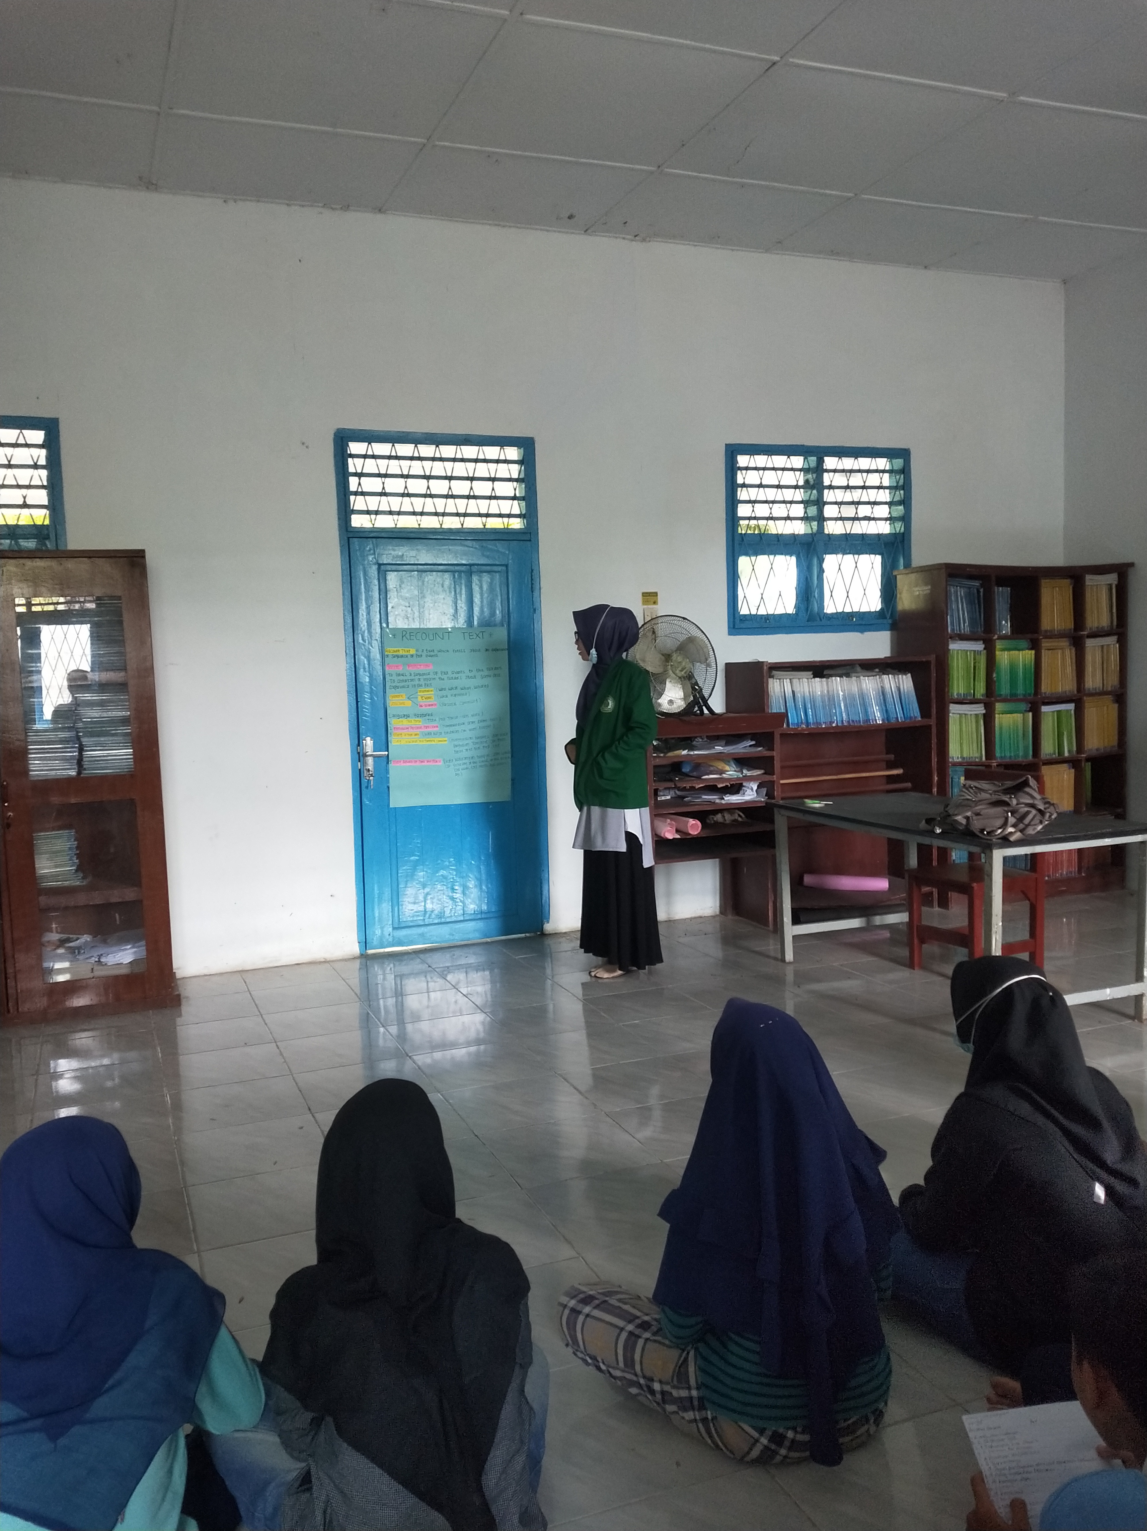

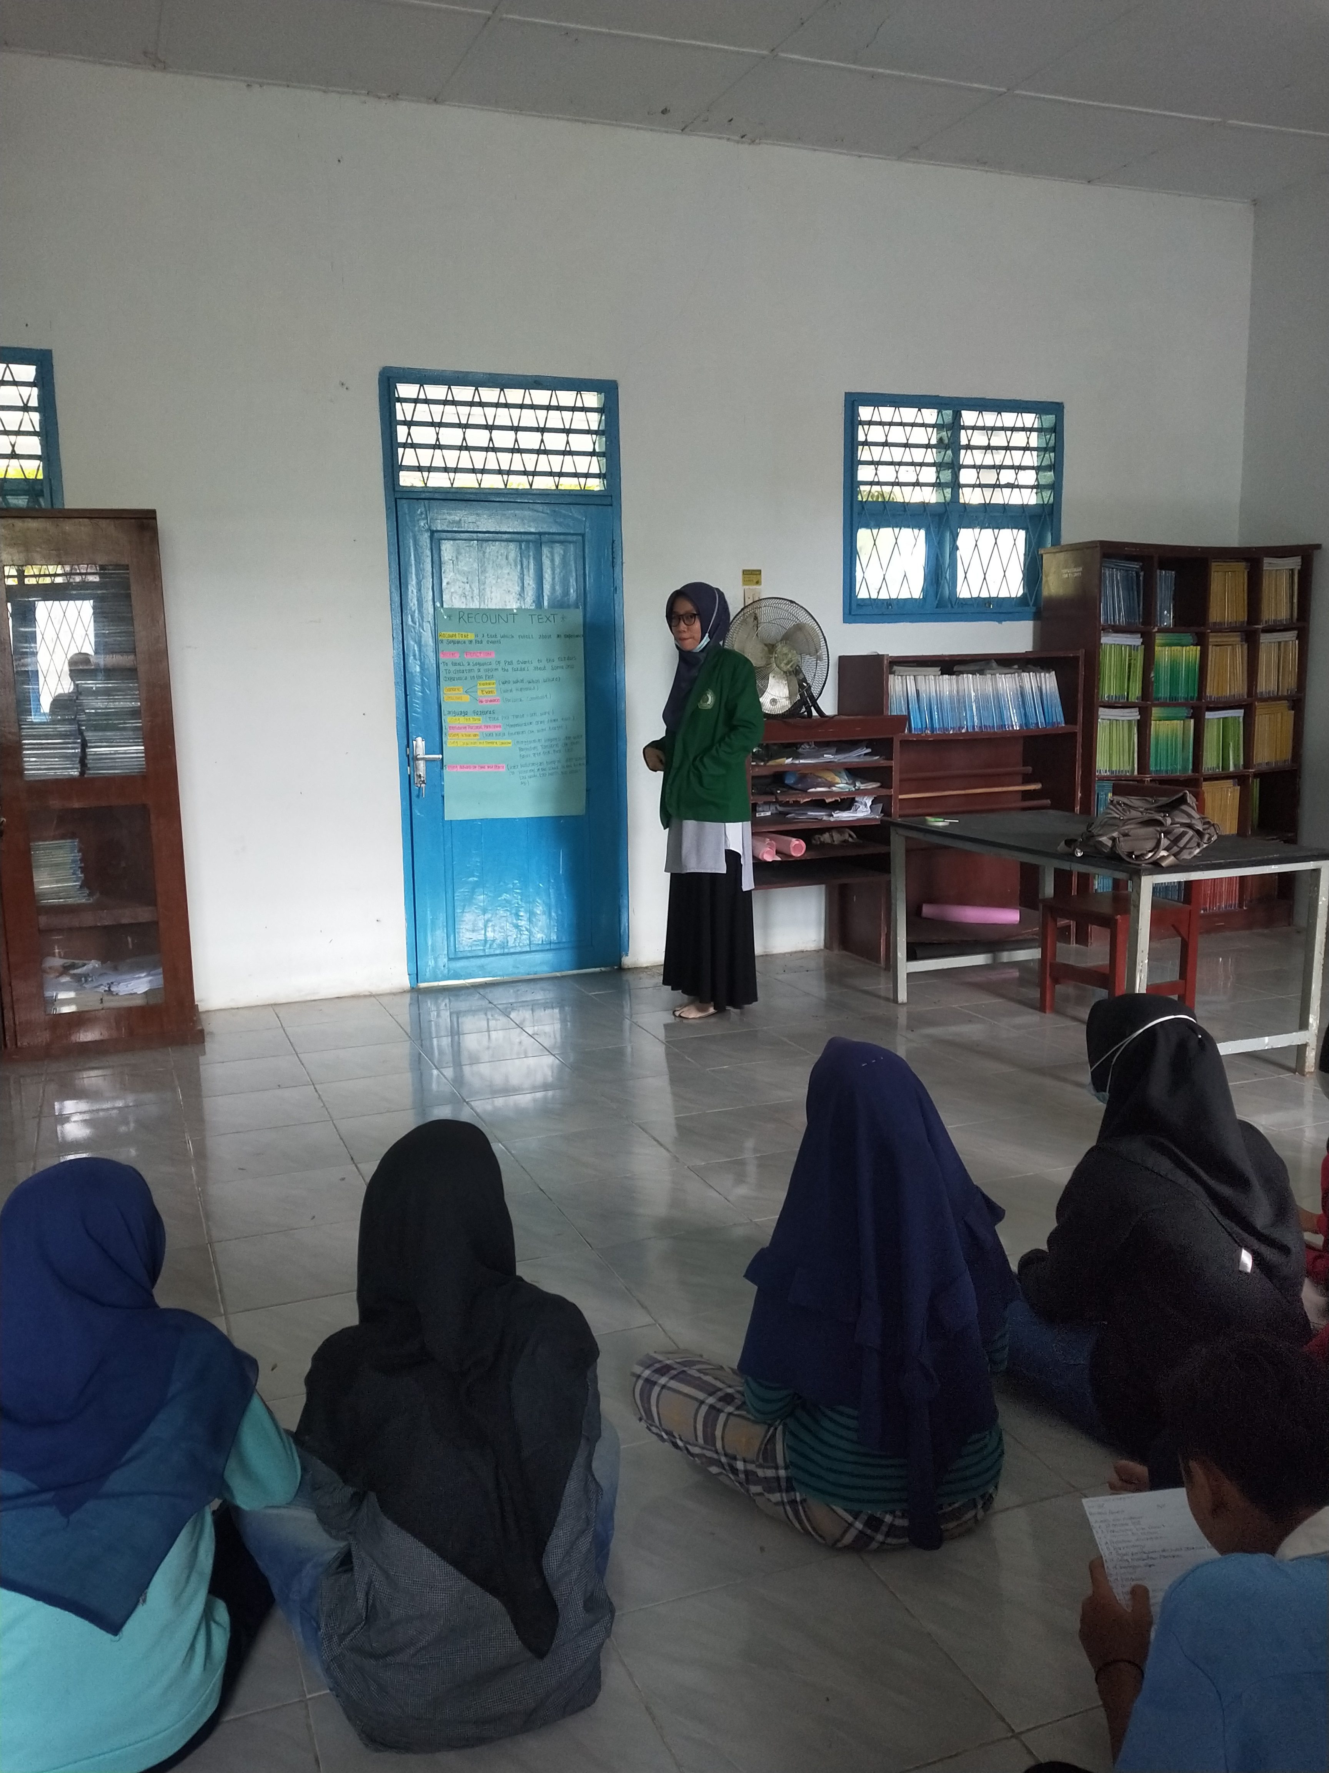

- The Documentation of Experimental Group

