ACKNOWLEDGEMENTS
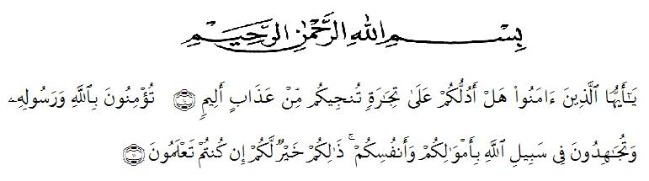

Artinya: ” wahai orang –orang yang beriman! Maukah kamu aku tunjukkan suatu perdagangan yang dapat menyelamatkan kamu dari azab yang pedih?(10) ( yaitu) kamu beriman kepada Allah dan Rasul-Nya dan berjihad di jalan Allah
dengan harta dan jiwamu. Itulah yang lebih baik bagi kamu jika kamu mengetahui,(11)” ( As- Saff ayat 100-11).
All praises belong to Allah, the almighty the merciful for the belssing given to the researcher so that can finish this thesis. Shalawat and salam are delivered to the prophet Muhammad SAW. Hopefully the researcher will get intercession from him in here after later.
On this occasion with great humility , the researcher would like to thank you. to all of those who have given her help and guidance so that this thesis an be finished on time. Completion of writing of this thesis, the researcher would like to thank to:
- Dr.KRT. Hardi Mulyono K. Surbakti as the rector of UMN Al Washliyah.
- Drs. Samsul Bahri,M.Si, as the Dean of FKIP UMN Al Washliyah.
- Zulfitri, S.S.,M.A., as the Head of the English Education Study Program.
- Nurlaili, S.Pd.I.,M.Hum As the Adviser who has provided many valuable suggestions, attention, comments, and motivation and criticism to completing this research.
- The lecturers of the English Department of FKIP UMN Al Washliyah Medan for their nice an valuable discussing to enrich writers’ knowledge.
- Sumarni Sitepu ,M.Pd as the headmaster in SMA Negeri 1 Kuala and all the teachers especially all english teachers as well as the students in the school where the researcher conduct the research.
- The biggest and special thanks to beloved parents Edi Arifin and Hainun for all helps, attention ,always support, hard work, material support and pray which gave the writer spirit to finish Thesis.
- Her beloved Grand Mother Tuminem who has given her support ,attention and motivation finish my Thesis.
- All my big family ,have given time love straight and prays for me, especially always by given a lot of helps to finish my Thesis.
- The researcher’s younger sister Salsa Bila Ramadani who always help and gives support.
- The researcher’s beloved friends, Agus Fitriana and Putri Handayani who always gives support.
- All of her colleguest in 8 H English Department.
The researcher says thank you so much for all who can not be mentioned the names. Hopefully this thesis can be useful for us and become the input for the parties in need.
Medan June 2021
The Researcher

BELLA TIARA NUR ANGGRAINI
171224027

