THE EFFECT OF USING STORYTELLING TECHNIQUE
ON STUDENTS’ SPEAKING SKILL AT
MTS AL-IKHLASIYAH SEI BULUH

A Thesis

By

SEKAR SARI NST
NPM: 171224098

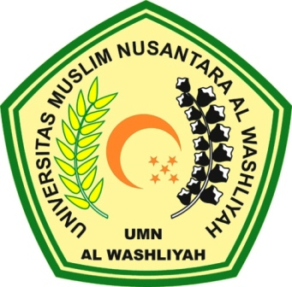

ENGLISH EDUCATION DEPARTEMENT
FACULTY OF TEACHER TRAINING AND EDUCATION
UNIVERSITAS MUSLIM NUSANTARA AL WASHLIYAH
MEDAN
2021

