ACKNOWLEDGEMENT
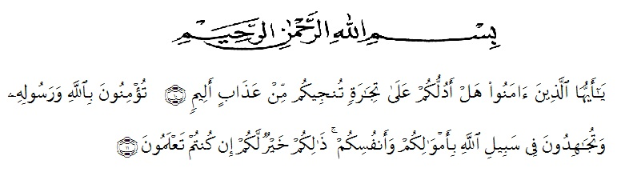

Artinya : “Wahai orang-orang yang beriman! Maukah kamu Aku tunjukkan suatu perdagangan yang dapat menyelamatkan kamu dari azab yang pedih? (10) (Yaitu) kamu beriman kepada Allah dan Rasul-Nya dan berjihad di jalan Allah dengan harta dan jiwamu. Itulah yang lebih baik bagi kamu jika kamu mengetahui,(11)” (As –Saff ayat 100-11)

All praise is to Allah, the Almighty, the Merciful, for the blessing given to the researcher so that can finish this thesis. Shalawat and Salam are delivered to the prophet Muhammad SAW . Hopefully the researcher will get intercession from him in hereafter later
On this ocasion with great humility, the researcher would like to thank you to all of those who have given her help and guidance so that this thesis can be finished on time. Completion of writing of this thesis, the researcher would like to thank to :
- Dr. KRT. Hardi Mulyono K.Surbakti as the Rector of UMN Al Washliyah.
- Drs. Samsul Bahri, M.Si, as the Dean of FKIP UMN Al Washliyah.
- Zulfitri, S.S., M.A., as the Head of the English Education Study Program.
- Drs. M.Khalid., M.Hum., as the Adviser who has given a lot of valuable suggestions, attention, comments, and critism for completing this research
- All lecturers in Teachers’ Training and Education Faculty, especially in English Education Study Program, Thanks for the teaching during this time.
- Sunaryo, S.HI.,S.Pd as the headmaster in MTs Al Ikhlasiyah Sei Buluh and all the teachers especially all English teachers as well as the students in the school where the researcher did the research.
- The biggest and special thanks to the researcher’s beloved parents, Rahmadin Nst and Rahmawati who always motivate, support and pray for her.
- The researcher’s younger sisters, Alya Nasution and Raya Anzara Nst who always help and give support.
- The researcher beloved friends, Armita Sari, Rika Nurwayuni, Firma Afrianti, Rindi Rantika, Ummul Khair, Sarina Puteri and Irmasari who always give support
- All of her Collegues in 8 H English Department.
Final words, the researcher says thank you so much for all and for those who can not be mentioned the names. Hopefully this thesis can be usefull for us and become the input for the parties in need.
Medan, Juni 2021
The Researcher

Sekar Sari Nst
171224098

