IMPROVING STUDENTS’ VOCABULARY BY USING SCIENCE FICTION MOVIE IN SMA SWASTA
BINA MEDAN

A Thesis

By:

NINING HAIRANI
Registration Number: 161244147

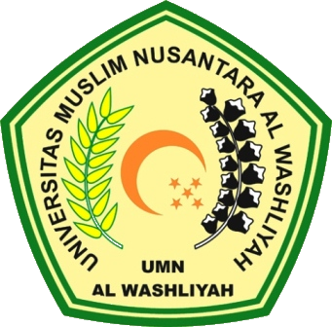

FACULTY OF TEACHER TRAINING AND EDUCATION
UNIVERSITAS MUSLIM NUSANTARA AL WASHLIYAH
MEDAN
2020
IMPROVING STUDENTS’ VOCABULARY BY USING SCIENCEFICTION MOVIE IN SMA SWASTA
BINA MEDAN

SKRIPSI

Submitted to the faculty of Teacher and Education Science University of Muslim Nusantara Al Washliyah in Partial Fulfillment of the Requirement for the
Degree of S.Pd in English Education

By:

NINING HAIRANI
Registration Number: 161244147

FACULTY OF TEACHER TRAINING AND EDUCATION
UNIVERSITAS MUSLIM NUSANTARA AL WASHLIYAH
MEDAN
2020

