ACKNOWLEDGEMENTS

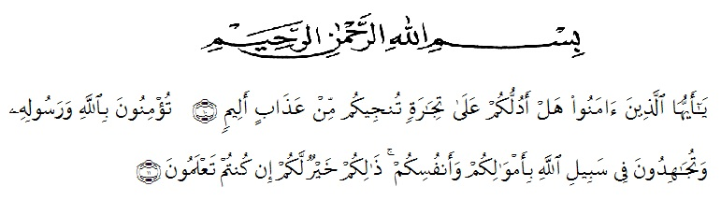
“Wahai orang-orang yang beriman! Maukah kamu Aku tunjukkan suatu perdagangan yang dapat menyelamatkan kamu dari azab yang pedih?(Yaitu) kamu beriman kepada Allah dan Rasul-Nya dan berjihad di jalan Allah dengan harta dan jiwamu. Itulah yang lebih baik bagi kamu jika kamu mengetahui.” (QS. Ash-Shaff : 10-11).

First of all the researchers expresses her highest gratitude to Allah SWT for blessing, love, opportunity, health, and mercy that have been given to the writer so that the finally accomplished her research. Shalawat and salam to our prophet Muhammad SAW with his followers.
In arranging this research, a lot of people have provided motivation, advice, support, and even remark that had helped the researcher aims to express her gratitude and appreciation to all of them.
The writer also would like to give the special thanks for:
- Dr. KRT. Hardi Mulyono K. Surbakti as a rector and to Drs. Samsul Bahri, M.Pd as dean at University of Muslim Nusantara Al Washliyah.
- Rosmita Ambarita, S.Pd., M.Hum as head of English Department at University of Muslim Nusantara Al Washliyah and as the first advisor who has given advise, motivation, kindness, and taugh him about discipline.
- Zulfitri, S. S. M.A as the second advisor tho has helped her patiently finishing this script by giving suggestion, guidance and correction.
- The lecturers of English Department at University of Muslim Nusantara Al Washliyah for their advice, motivation, and useful knowledge.
- All librarians of University of Muslim Nusantara Al Washliyah for their willingness to serve the writer all the time.
- The headmaster at SMA SWASTA BINA SISWA MEDAN for facilities given to her in conducted her research.
- Her special beloved parents, Mr. Suwito and Mrs. Sumitrawati, brothers and sister Mr. Heru Wijaya, Mrs. Suwita Handayani, and also Eko Wahyudi who have supported her financially, morally and motivation, and for their endless love, care, and continuous prayer and patience that will never be forgotten.
- And the last but not least, the researcher thanks to all her friends in English Department 2016 class (E) and her beloved friends Syafira Nadia, Hayati, Indah Agustina, Naser Firdaus Anggarda for cheerful days and togetherness.

Finally, the researcher would like to say thank you very much for all of support which are given so that this research can be finished.

Medan, 26 Juni 2020
The researcher

Nining Hairani
NPM. 161244147

