**IMPROVING STUDENTS’ SPEAKING SKILL THROUGH ICE BREAKING AT FIRST GRADE STUDENTS OF MTS AL-WASHLIYAH JATI REJO**

**A Thesis**

**BY**

**RAISA MAULIA ABDUL**

**Registration Number : 171224100**

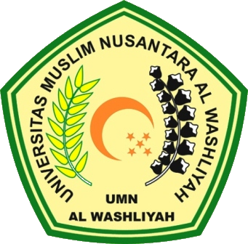

**ENGLISH EDUCATION DEPARTMENT**

**FACULTY OF TEACHER TRAINING AND EDUCATION**

**UNIVERSITAS MUSLIM NUSANTARA AL WASHLIYAH**

**MEDAN**

**2021**