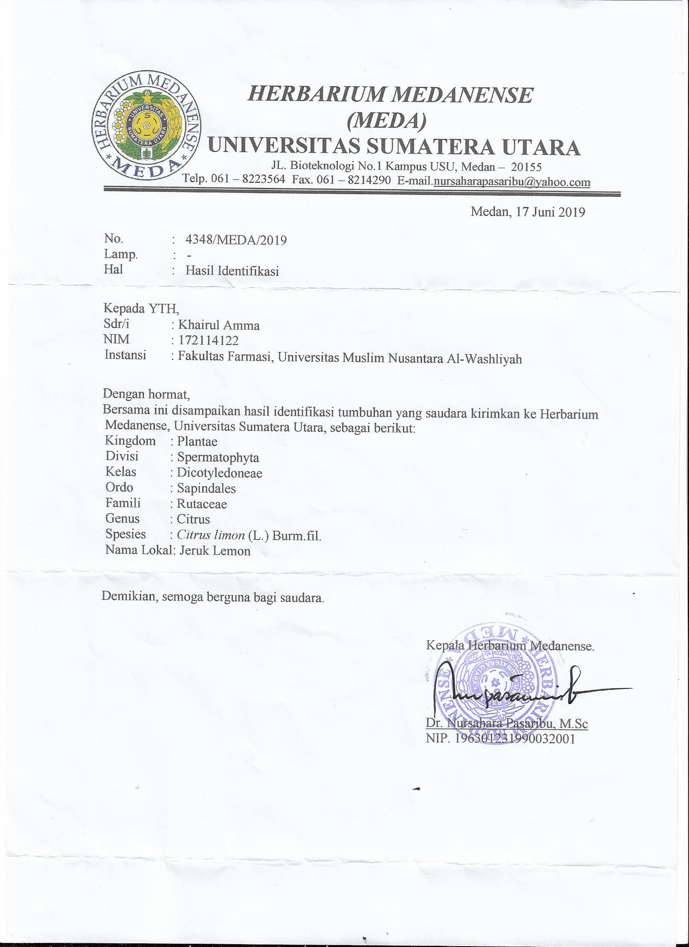
Lampiran 1. Hasil Identifikasi Tanaman

Riska Fatmasari
172114121

:

Lampiran 2. Tumbuhan Lemon
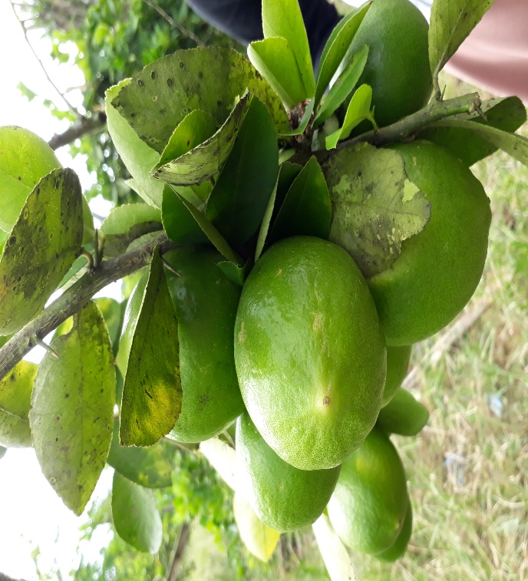

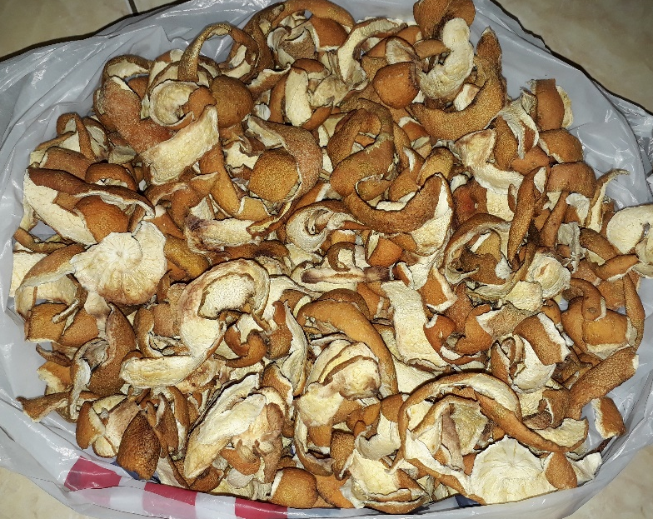
Tanaman Lemon Lemon Pon k4 Segar
Simplisia Kering Tanaman Lemon Pon k4

Lampiran 3 . Bagan Alir Pembuatan Simplisia Kulit Lemom Pon k4
Buah Lemon

Diambil bagian kulitnya,sortir basa
Cuci, tiriskan
Dikeringkan, sortir kering
Dipotong kecil-kecil
Simplisia kulit buah lemon (1000 g)

- pengujian kadar air
- penetapan kadar abu total
- penetapan kadar abu tidak larut asam
- penetapan kadar sari larut air
- penetapan kadar sari larut etanol
- pemeriksaan mikroskopik
- pemeriksaan makroskopik
Karakterisasi Simplisia Kulit Buah Lemon

Lampiran 4 . Bagan Alir Isolasi Minyak Atsiri
Ditambah aquadest secukupnya
870 g Simplisia Kulit Lemon

Aquadest ditambahkan 1:1
Destilat
Dipanaskan dengan destilasi Uap

Suhu 110 ̊C

Destilat dimurnikan
Minyak Atsiri Kulit Lemon

Formulasi Sediaan
Karakterisasi Minyak Atsiri Kulit Lemon

Antinyamuk Elektrik
- Penentapan kadar kotoran
- Penetapan kadar minyak

Lampiran 5. Bagan Alir Pembuatan Sediaan Keping Anti Nyamuk Elektrik
Kardus bekas telor

Ditimmbang, disobek
Direndam selama 1 jam
Dibelender, tambah air secukupnya.
Disaring

Masukkan dalam baskom, ratakan
Ditiriskan, diperas
Ditambahkan amilum

Jemur dibawah sinar matahari

Keeping nyamuk yang sudah kering ditambahkan minyak atsiri lemonkedalamnya

1,5 mL
perkeping
2,25 mL
perkeping
3 mL
perkeping

Direndam selama 10-15 menit
Disimpan dalam tempat tertutup

Lampiran 6. Perhitungan Kadar Abu Total Simplisia Kulit Lemon
Penetapan Kadar Abu Total
Kadar abu total = $\frac{berat abu }{berat sampel }×100\%$

- Sampel 1
Berat sampel = 2,001 gram
Berat abu = 2,02 gram

Kadar Abu Total =$\frac{ 2,02 gram}{2,001 gram } ×100\%=1,00\%$

- Sampel 1
Berat sampel = 2,005 gram
Berat abu = 2,00 gram

Kadar Abu Total =$\frac{ 2,00 gram}{2,005 gram } ×100\%=0,99\%$

- Sampel 1
Berat sampel = 2,008 gram
Berat abu = 1,98 gram

Kadar Abu Total = $\frac{ 1,98 gram}{2,008 gram } ×100\%=0,98\%$

Rata-rata Kadar Abu Total = $\frac{1,00+0,98 +0,99}{3}=0,99\%$

Lampiran 7. Perhitungan Kadar Sari Larut Dalam Air Simplisia Kulit Lemon
Penetapan Kadar Sari Larut Dalam Air
Kadar sari larut dalam air = $\frac{cawan berisi -cawan kosong ×5 }{berat sampel }×100\%$

- Sampel 1
Berat sampel = 5,002 gram
Berat cawan kosng = 62,97 gram
Berat cawan berisi = 63,23 gram
Berat Sari = 0,26 gram

Kadar Sari Larut Air =$\frac{0,26 gr × 5}{5,002 gr } ×100\%=25,98\%$

- Sampel 2
Berat sampel = 5,102 gr
Berat cawan kosong = 42,66 gr
Berat cawan berisi = 42,91 gr
Berat Sari = 25 gr

Kadar Sari arut Air = $\frac{ 25 gr × 5}{5,102 gr } ×100\%=24,50 \%$

- Sampel 3
Berat sampel = 5,200 gr
Berat cawan kosong = 68,52 gr
Berat cawan berisi = 68,70 gr
Berat Sari = 0,18

Kadar Sari Larut Air = $\frac{0,18 gr ×5}{5, 200 gr } ×100\%=17,30 \%$

Rata-rata kadar sari larut air = $\frac{25,98 \%+24,50\%+17,30\% }{3 } =22,59 \%$

Lampiran 8. Pengujian Kadar Sari Larut dalam Etanol
Penetapan Kadar Sari Larut Etanol
Kadar Sari Larut Etanol = $\frac{cawan berisi -cawan kosong ×5 }{berat sampel }×100\%$

- Sampel 1
Berat sampel = 5, 005 gr
Berat cawan kosng = 68,55 gr
Berat cawan berisi = 68,74 gr
Berat Sari = 0,19

Kadar sari larut etanol = $\frac{ 0,19 ×5 }{5,005 gr } ×100\%=18 \%$

- Sampel 2
Berat sampel = 5,006 gr
Berat cawan kosong = 42,72 gr
Berat cawan berisi = 42,96 gr
Berat Sari = 0,24

Kadar sari larut etanol = $\frac{ 0,24 ×5 }{5,006 gr } ×100\%=28 \%$

- Sampel 3
Berat sampel = 5,102 gr
Berat cawan kosong = 68,60 gr
Berat cawan berisi = 68,77 gr
Berat Sari = 0,17

Kadar sari larut etanol = $\frac{0,17 ×5 }{5,102 gr } ×100\%=16,7 \%$

Rata-Rata Kadar Sari Larut Etanol = $\frac{18\%+28\%+16,7\% }{3 } =19,2 \%$

Lampiran 9. Penetapan Kadar Abu Tidak Larut Asam dala Serbuk Simplisia
Penetapan Kadar Abu Tidak Larut Asam

Kadar Abu Tidak Larut Asam = $\frac{berat abu }{berat sampel }×100\%$

- Sampel 1
Berat Sampel = 2,001 gr
Berat Abu = 0,009 gr

Kadar Abu Tidak Larut Asam = $\frac{0,009 }{2,001 }×100\%=0,4\%$

- Sampel 1
Berat Sampel = 2,001 gr
Berat Abu = 0,003 gr

Kadar Abu Tidak Larut Asam = $\frac{0,003 }{2,001 }×100\%=0, 14 \%$

- Sampel 1
Berat Sampel = 2,001 gr
Berat Abu = 0,02 gr

Kadar Abu Tidak Larut Asam = $\frac{0,02 }{2,001 }×100\%=1\%$

Rata- rata = $\frac{0,4 \%+0,14\%+1\%}{3}=0,94\%$

Lampiran 10. Perhitungan Standarisasi Minyak Atsiri Kulit Lemon
- Perhitungan kadar kotoran Minyak Atsiri Kulit Lemon
Kadar kotoran = $\frac{selisih berat penyaring }{berat sampel }×100\%$

- Sampel 1
Berat kertas saring = 0,54 gr
Berat kertas saring+ sampel = 0,552 gr
Berat Sampel =5,002 gr

Kadar Kotoran = $\frac{0,011 }{5,002}×100\%=0,21\%$

- Sampel 1
Berat kertas saring = 0,496 gr
Berat kertas saring+ sampel = 0,509 gr
Berat Sampel =5,002 gr

Kadar Kotoran = $\frac{0,013 }{5,002}×100\%=0,25\%$

- Sampel 1
Berat kertas saring = 0,501 gr
Berat kertas saring+ sampel = 0,510 gr
Berat Sampel = 5,003 gr

Kadar Kotoran = $\frac{0,009 }{5,003}×100\%=0,17\%$

Rata-rata kadar kotoran = $\frac{0,21\% +0,25\%+0,17\%}{3} =0,21\%$

Lampiran 10. (lanjutan)
- Perhitungan kadar minyak atsiri kulit lemon

Kadar minyak atsiri = $\frac{berat minyak }{berat simplisia}×100\%$

- Sampel 1
Berat simplisia = 300 gr
Berat minyak = 10,109 gram

Kadar minyak atsiri =$\frac{10,109}{300}×100 \%=3,36 \%$

- Sampel 1
Berat simplisia = 300 gr
Berat minyak = 10,100 gram

Kadar minyak atsiri =$\frac{10,100}{300}×100 \%=3,33 \%$

- Sampel 1
Berat simplisia = 300 gr
Berat minyak = 10,005 gram

Kadar minyak atsiri =$\frac{10,005}{300}×100 \%=3,33 \%$

Rata-rata = $\frac{3,36\%+3,33\%+3,33\% }{3}=3,34 \%$

Lampiran 11. Nilai Standar Deviasi Kadar Minyak Atsiri Kulit Lemon

Kadar (X) | Xi-X | (X - X̅̅)²
3.36 | 0.020 | 0.0004
3.33 | -0.010 | 0.0001
3.33 | -0.010 | 0.0001
X̅ =3.340 |  | Σ ( X- X̅ )² = 0.0006

SD = $\sqrt{\frac{\left(X-\overline{X}\right)²}{n-1 }}$

= $\sqrt{\frac{\left(0,0006\right)}{3-1}}$

$=\sqrt{\frac{0,0006}{2}}$
$=\sqrt{0,003 }$
= 0,01

Lampiran 12. Perhitungan Bobot Jenis Minyak Atsiri Kulit Lemon

- Bobot pikno + sampel = 16,2249 gr
Berat picno kosong = 11, 8642 gr
Volume sampel = 5 ml

Bj minyak atsiri = $\frac{16,2249 gr -11, 8642 gr}{5 ml }$

=$\frac{4, 3607 gr}{5 ml}$

= 0,87214 gr/ml

- Bobot pikno + sampel = 16,2249 gr
Berat picno kosong = 12,0002 gr
Volume sampel = 5 ml

Bj minyak atsiri = $\frac{16,2249 gr -12,0002 gr}{5 ml }$

=$\frac{4, 2247 gr}{5 ml}$

= 0,8441 gr/ml

- Bobot pikno + sampel = 16,2209 gr
Berat picno kosong = 12,0000 gr
Volume sampel = 5 ml

Bj minyak atsiri = $\frac{16,2209 gr -12,0000 gr}{5 ml }$

=$\frac{4, 2209 gr}{5 ml}$

= 0,8441 gr/ml

Rata- rata Bobot jenis = $\frac{0,8721+0,8441+0,8441}{3}=0,8534$

Lampiran 13. Hasil Analisa Probic LC₅₀ Uji Efektivitas Minyak Atsiri Kulit Kulit Lemon Sebagai Sediaan Anti Nyamuk Elektrik Terhadap Nyamuk Culex

Confidence Limits
 | Probability | 95% Confidence Limits for konsentrasi |  |  | 95% Confidence Limits for log(konsentrasi)ª
 |  | Estimate | Lower Bound | Upper Bound | Estimate | Lower Bound | Upper Bound
PROBIT | .010 | 2.114 | .153 | 3.520 | .325 | -.815 | .547
 | .020 | 2.410 | .231 | 3.814 | .382 | -.636 | .581
 | .030 | 2.618 | .300 | 4.014 | .418 | -.523 | .604
 | .040 | 2.787 | .365 | 4.173 | .445 | -.438 | .620
 | .050 | 2.932 | .428 | 4.308 | .467 | -.368 | .634
 | .060 | 3.062 | .490 | 4.426 | .486 | -.310 | .646
 | .070 | 3.180 | .552 | 4.533 | .502 | -.258 | .656
 | .080 | 3.290 | .614 | 4.632 | .517 | -.212 | .666
 | .090 | 3.393 | .676 | 4.724 | .531 | -.170 | .674
 | .100 | 3.491 | .738 | 4.811 | .543 | -.132 | .682
 | .150 | 3.926 | 1.064 | 5.195 | .594 | .027 | .716
 | .200 | 4.311 | 1.419 | 5.534 | .635 | .152 | .743
 | .250 | 4.671 | 1.813 | 5.857 | .669 | .258 | .768
 | .300 | 5.020 | 2.252 | 6.181 | .701 | .353 | .791
 | .350 | 5.366 | 2.743 | 6.524 | .730 | .438 | .815
 | .400 | 5.717 | 3.288 | 6.906 | .757 | .517 | .839
 | .450 | 6.078 | 3.885 | 7.358 | .784 | .589 | .867
 | .500 | 6.456 | 4.522 | 7.931 | .810 | .655 | .899
 | .550 | 6.857 | 5.168 | 8.704 | .836 | .713 | .940
 | .600 | 7.290 | 5.787 | 9.788 | .863 | .762 | .991
 | .650 | 7.767 | 6.353 | 11.313 | .890 | .803 | 1.054
 | .700 | 8.303 | 6.871 | 13.443 | .919 | .837 | 1.129
 | .750 | 8.923 | 7.369 | 16.433 | .951 | .867 | 1.216
 | .800 | 9.668 | 7.883 | 20.770 | .985 | .897 | 1.317
 | .850 | 10.615 | 8.459 | 27.507 | 1.026 | .927 | 1.439
 | .900 | 11.940 | 9.183 | 39.431 | 1.077 | .963 | 1.596
 | .910 | 12.284 | 9.360 | 43.045 | 1.089 | .971 | 1.634
 | .920 | 12.669 | 9.555 | 47.357 | 1.103 | .980 | 1.675
 | .930 | 13.107 | 9.771 | 52.612 | 1.117 | .990 | 1.721
 | .940 | 13.613 | 10.016 | 59.188 | 1.134 | 1.001 | 1.772
 | .950 | 14.214 | 10.300 | 67.715 | 1.153 | 1.013 | 1.831
 | .960 | 14.955 | 10.640 | 79.341 | 1.175 | 1.027 | 1.899
 | .970 | 15.918 | 11.069 | 96.441 | 1.202 | 1.044 | 1.984
 | .980 | 17.295 | 11.661 | 125.072 | 1.238 | 1.067 | 2.097
 | .990 | 19.712 | 12.648 | 188.578 | 1.295 | 1.102 | 2.275

Lampiran 14. Modifikasi Alat Destilasi Uap

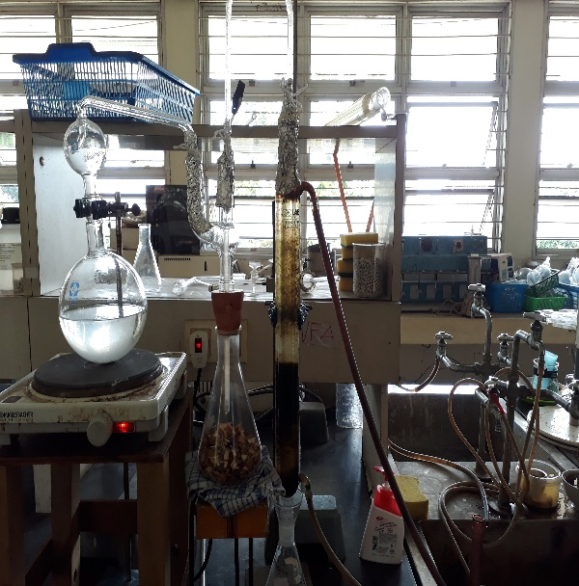

Kondensor

Aquades dan Batu Didih

Sampel + Aquades

Penampung Destilat

Alat Destilasi Uap

Lampiran 15. Minyak Atsiri Kulit Lemon
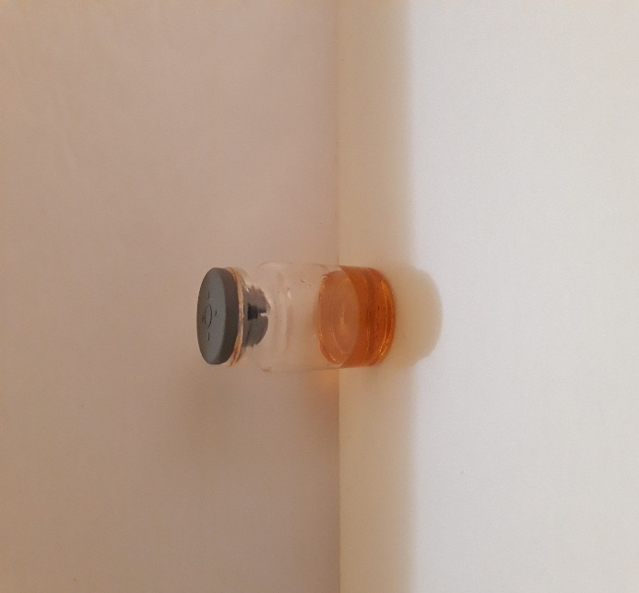
Hasil isolasi minyak atsiri kulit lemon Pon k4

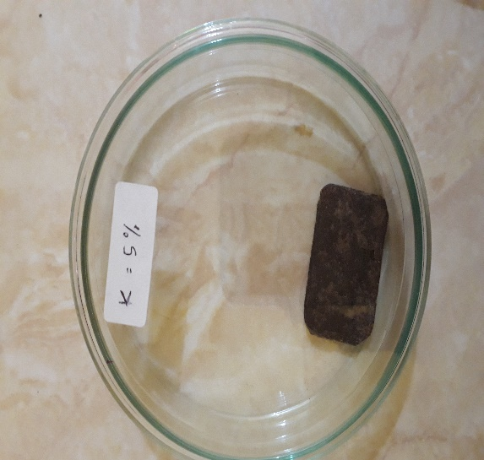
Lampiran 16. Perendaman Keping Nyamuk

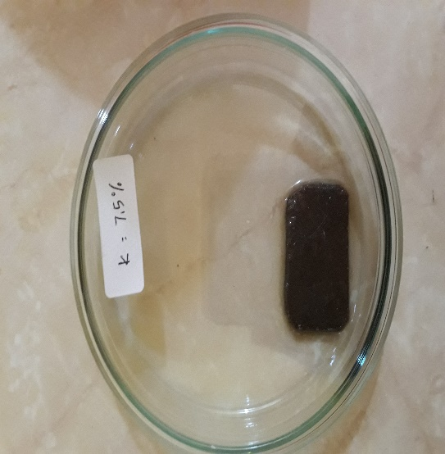
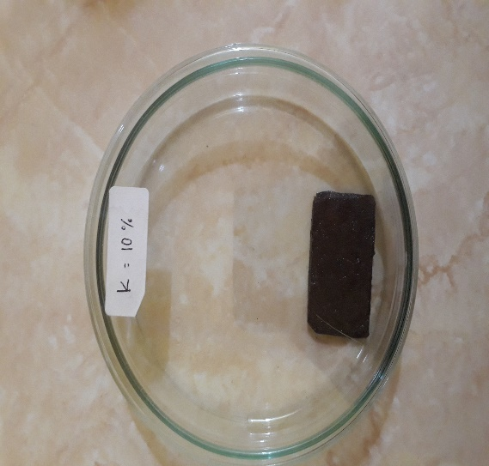

Lampiran 17. Sediaan Antinyamuk Elektrik dari Minyak Lemon Pon k4
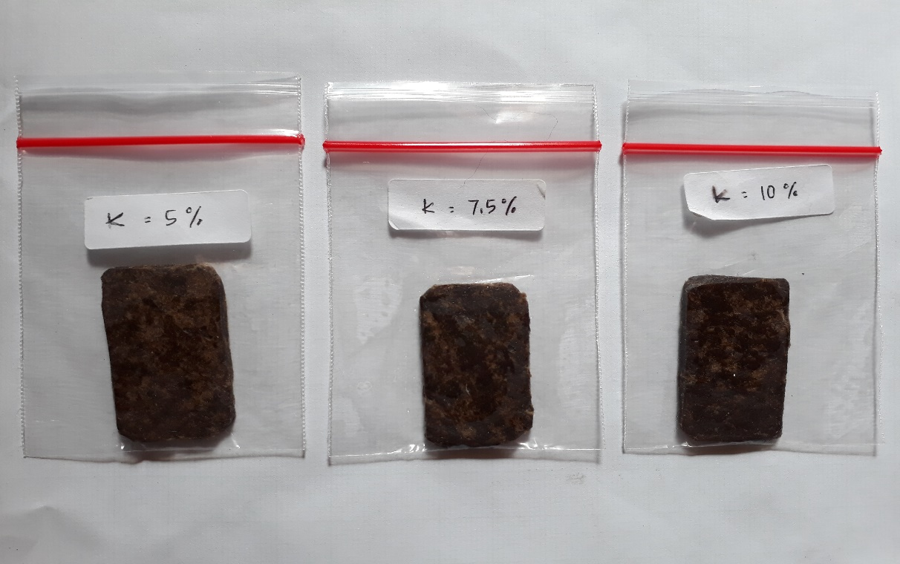

Keterangan:
K 5 % = volume 1,5 mL
K 7,5% = Volume 2,25 mL
K 10% = Volume 3 mL

Lampiran 18. Pertumbuhan jentik-jentik nyamuk
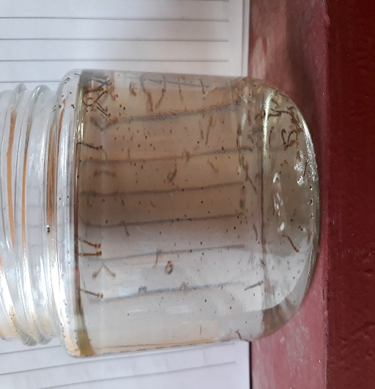
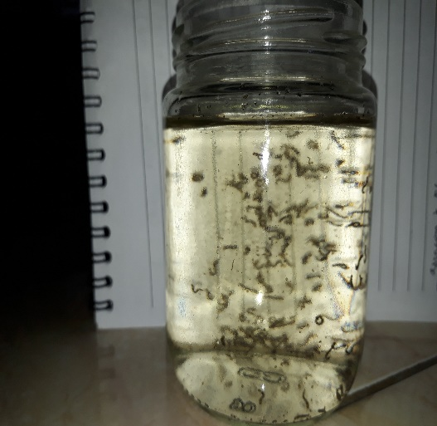

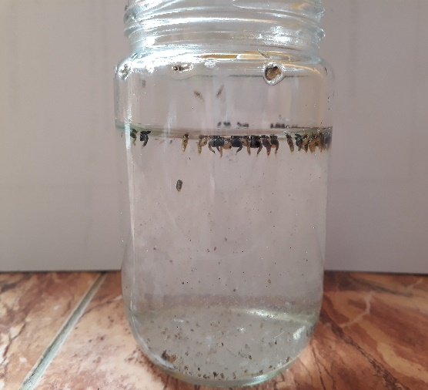

Lampiran 19. Pengujian Keping Antinyamuk
Volume 1,5 mL

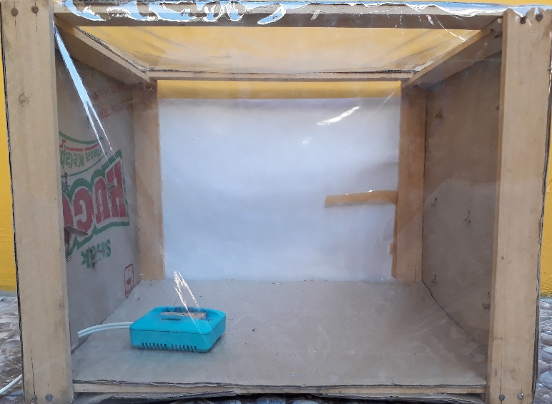
sebelum pengujian
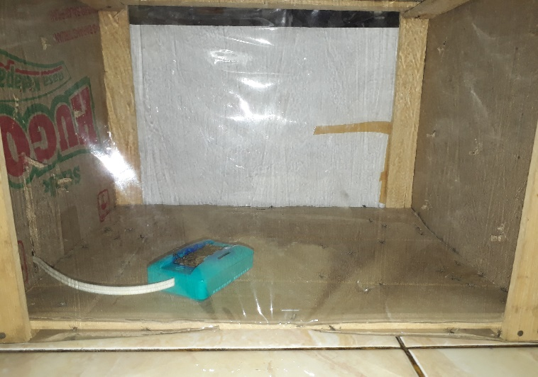
sesudah pengujian

Lampiran 19. (Lanjutan)
Volume 2,25 mL
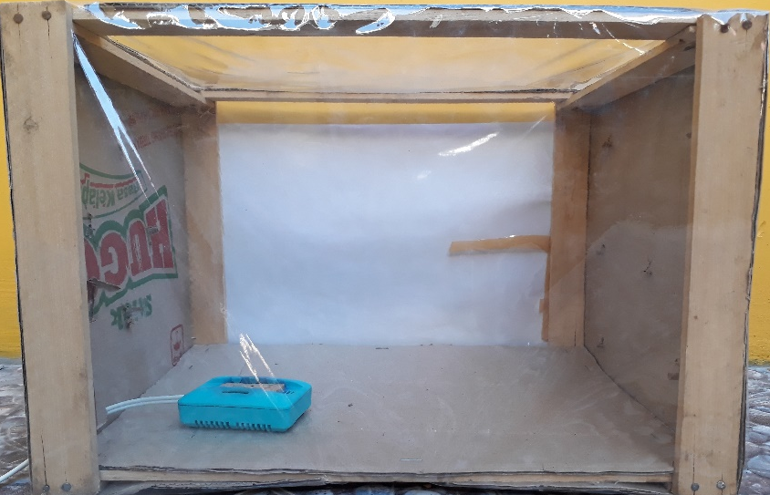
Sebelum Pengujian
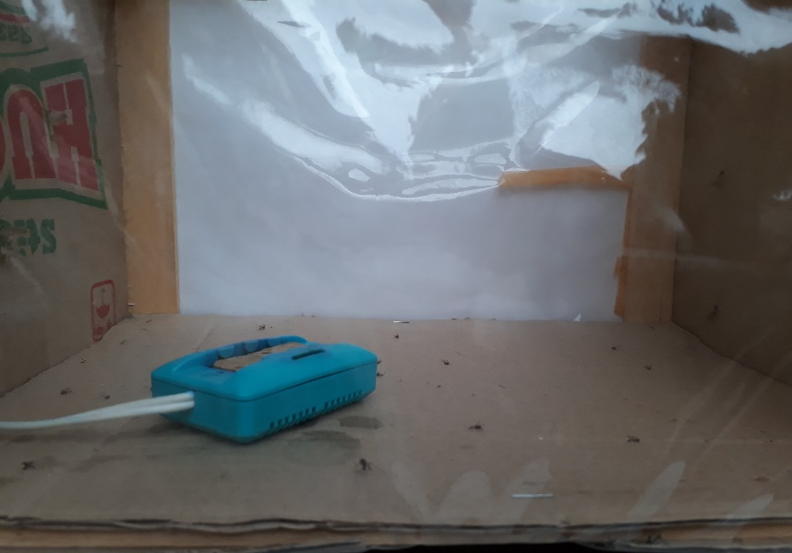
Sesudah pengujian

Lampiran 19. (Lanjutan)
Volume 3 mL
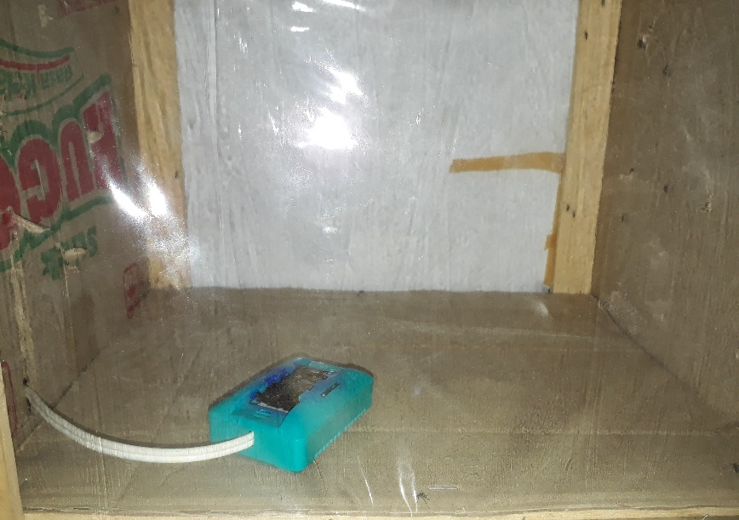
Sebelum pengujian
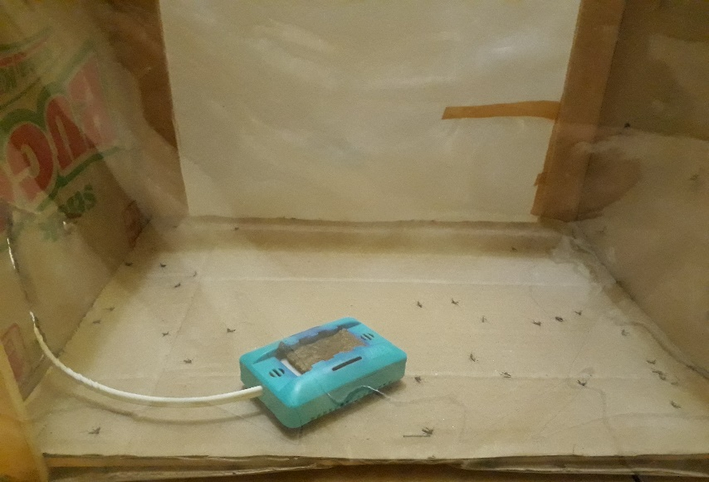
Sesudah pengujian

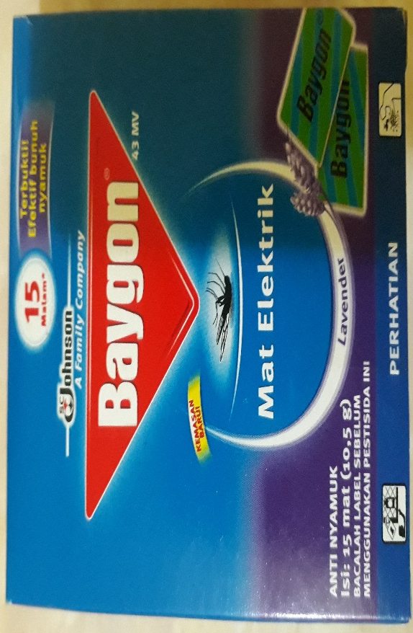
Lampiran 19. (Lanjutan)
Pembanding sediaan dipasaran

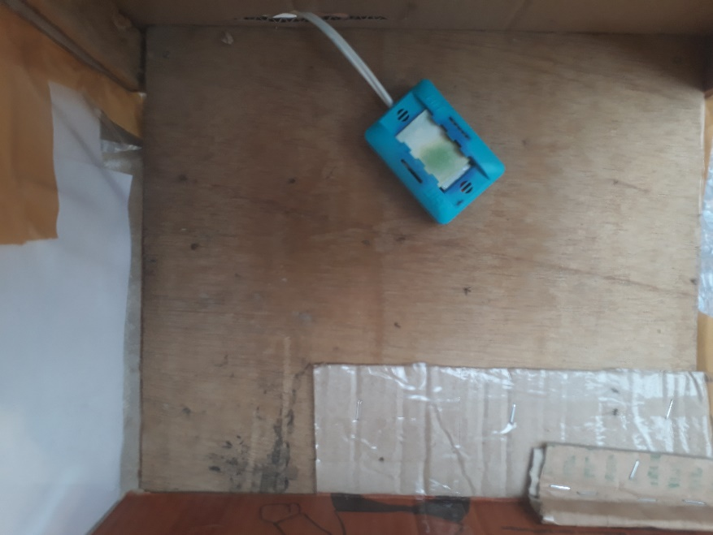

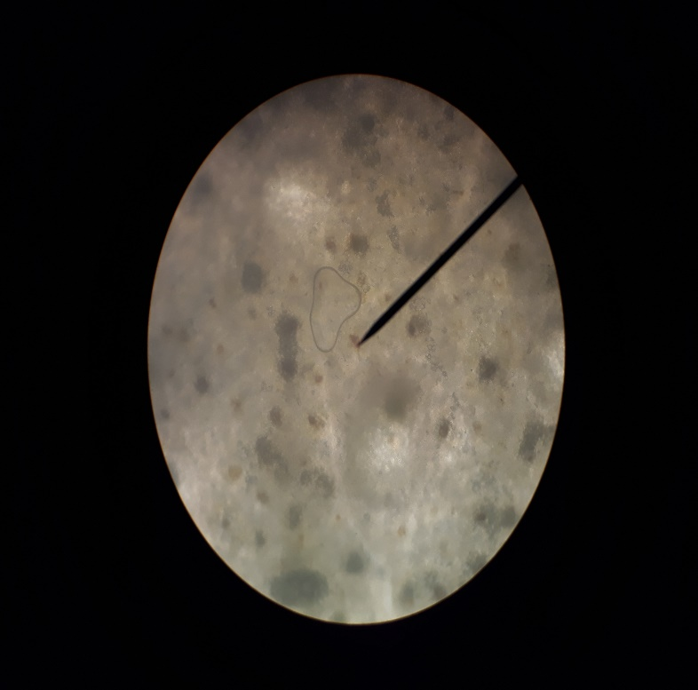
Lampiran 20. Mikroskopik Kulit Lemon
Mikroskopik Kulit lemon
Minyak atsiri

