**Lampiran 2.** Tumbuhan Daun Ubi (*Manihot Esculenta* Crantz)

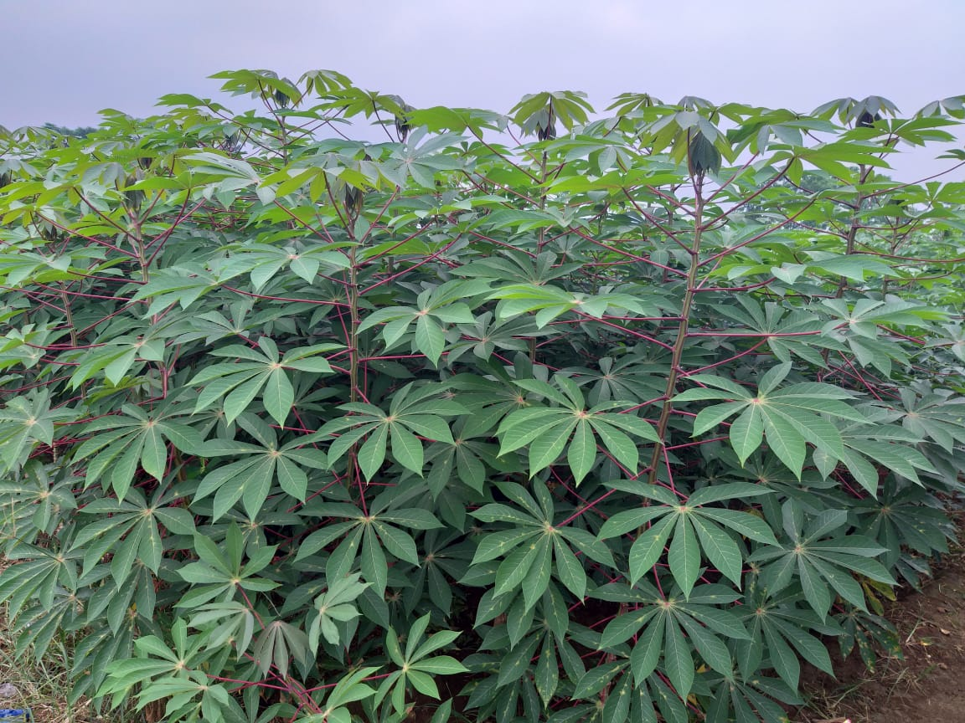

Tumbuhan Segar Daun Ubi (*Manihot esculenta* Crantz)

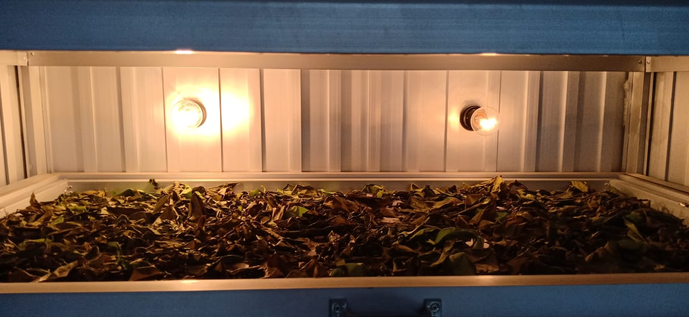

Tumbuhan Simplisia Daun Ubi (*Manihot esculenta* Crantz)

**Lampiran 3.** Serbuk Simplisia dan Ekstrak Etanol Daun Ubi

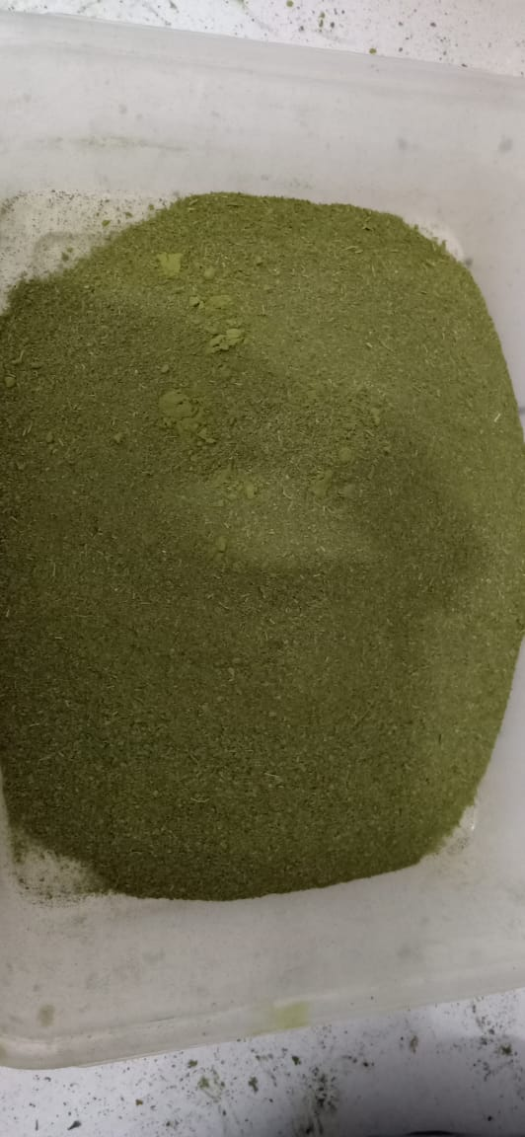

Serbuk Simplisia Daun Ubi(*Manihot esculenta* Crantz)

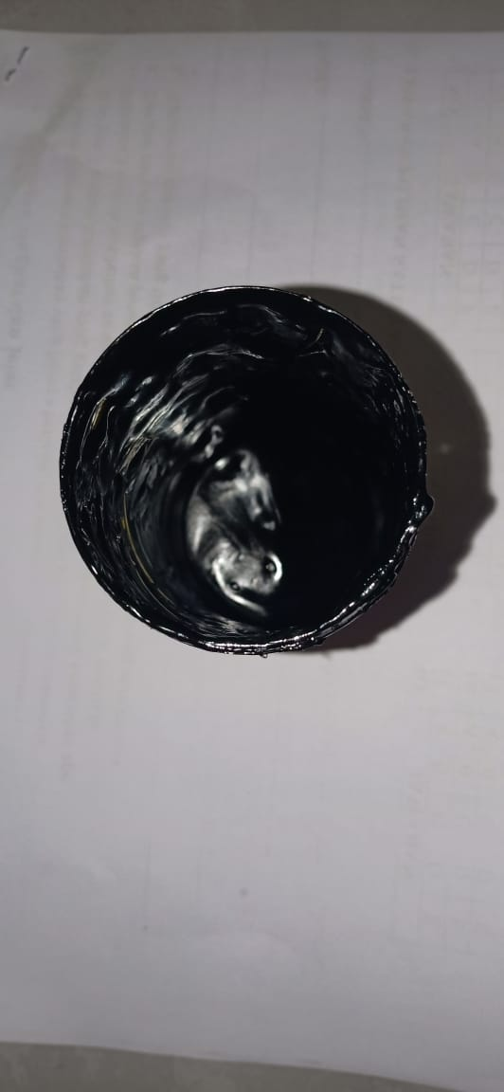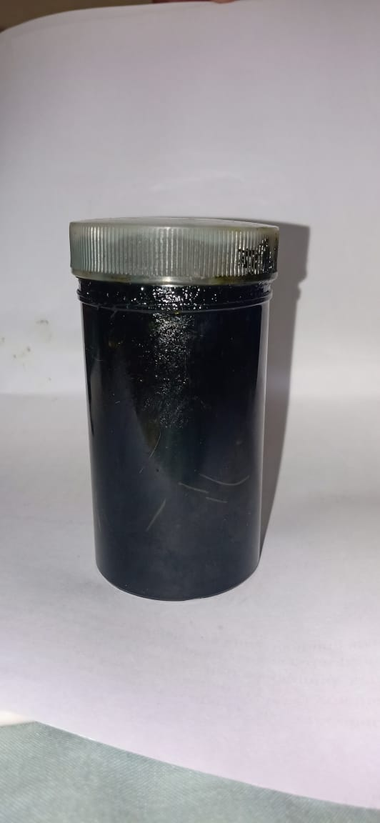

Ekstrak Etanol Daun Ubi (*Manihot esculenta* Crantz)

**Lampiran 4**. Makroskopik dan mikroskopik daun ubi (*Manihot esculenta* Crantz)

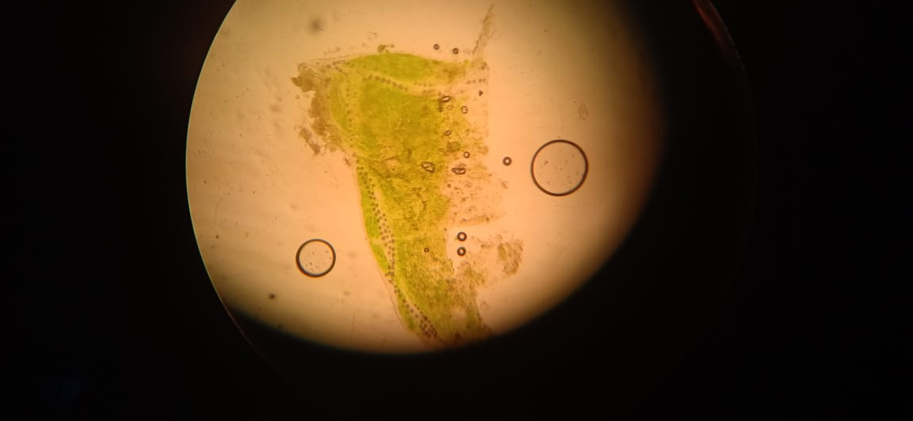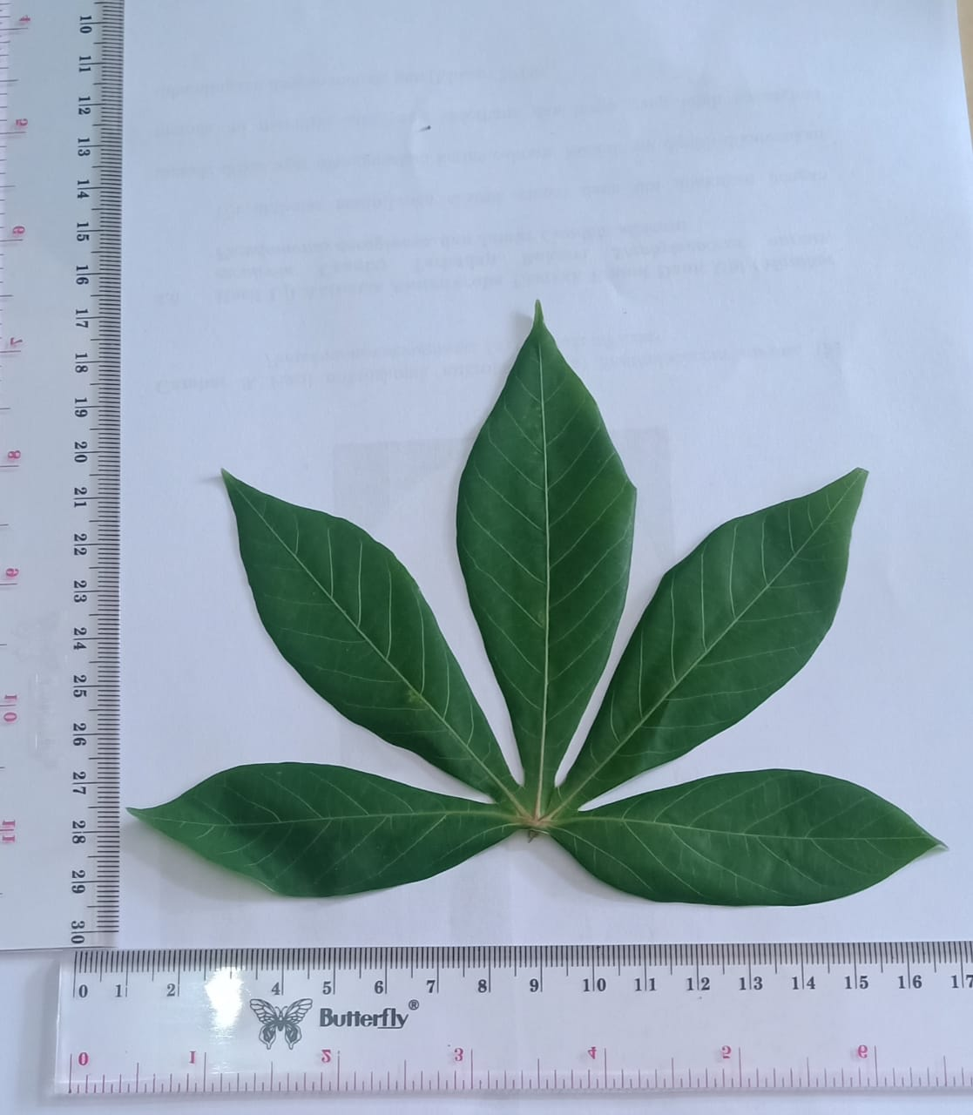

Penampakan makroskopik daun ubi segar

a b c

Penampakan mikroskopik daun ubi segar

Keterangan :

a. Hablur kalsium oksalat

b. Stomata

c. Lapisan epidermis

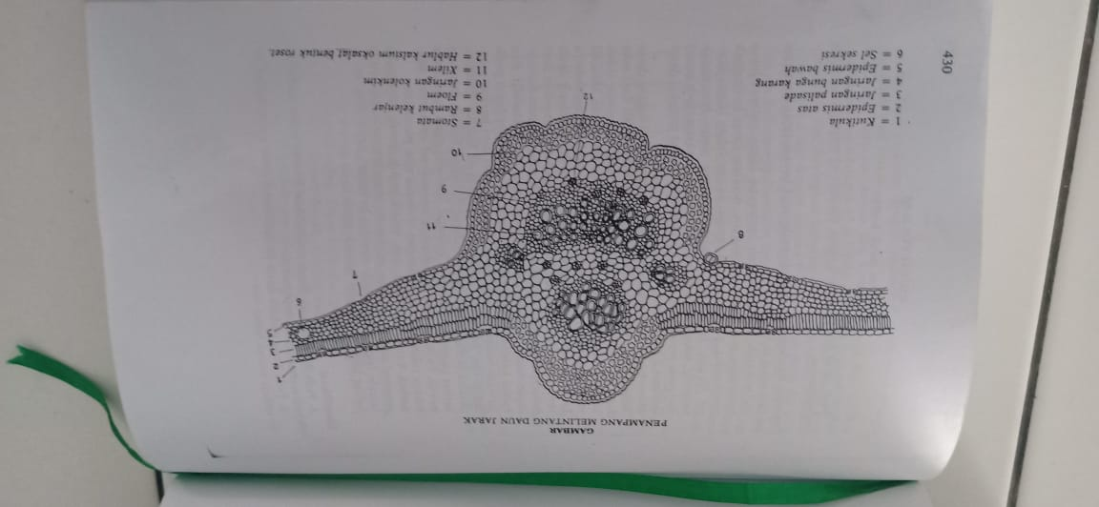

Penampang melintang famili *euphorbiaceae*

**Lampiran 5.** Perhitungan Karakterisasi

1. Penetapan Kadar Air

Kadar air = $\frac{v2-v1}{Beratsampel (g)}$ x 100%

1. Sampel l

* Berat sampel = 5 gram
* V1 = 1,6
* V2 = 1,9

Kadar air = $\frac{1,9-1,6}{5 g}x 100\%$ = 6%

1. sampel 2

* Berat sampel = 5 gram
* V1 = 1,7
* v2 = 1,8

Kadar air = $\frac{1,8-1,7}{5 g} 100\%$ = 2%

1. Sampel 3

* Berat sampel = 5 gram
* V1 = 1,5
* V2 = 1,9

Kadar air = $\frac{1,9-1,5}{5 g}x 100\%$ = 8%

Kadar air rata-rata = $\frac{6\%+2\%+8\%}{3} =5,3\%$

**Lampiran 5**. (Lanjutan)

1. Penetapan Kadar Sari Larut Air

Kadar sari larut air = $\frac{(Beratcawanberisi-Beratcawan)×5}{Beratsampel\left(g\right)}x 100\%$

1. Sampel l

* Berat sampel = 5 gram
* Kadar sari larut air = $\frac{\left(48,52-48,24\right)x 5}{5 g}x 100 \%=28$%

1. Sampel 2

* Berat sampel = 5 gram
* Kadar sari larut air = $\frac{\left(48,76-48,46\right)x 5}{5 g}x 100\%=29\%$

1. Sampel 3

* Berat sampel = 5 gram
* Kadar sari larut air = $\frac{\left(48,70-48,43\right)x 5}{5 g}x 100 \%=27\%$

Kadar sari larut air rata-rata = $\frac{28+29+37}{3} =28\%$

**Lampiran 5.** (Lanjutan)

1. Penetapan kadar sari larut etanol
2. Sampel l

Kadar sari larut etanol = $\frac{(Beratcawanberisi-Beratcawan)×5}{Beratsampel\left(g\right)}x 100\%$

* Berat sampel : 5 g
* Kadar sari larut etanol = $\frac{\left(58,63-58,46\right)x 5}{5 g}x 100 \%=17$%

1. Sampel 2

* Berat sampel : 5 g
* Kadar sari larut etanol = $\frac{\left(60,54-60,34\right)x 5}{5 g}x 100\%=20\%$

1. Sampel 3

* Berat sampel : 5 g
* Kadar sari larut etanol = $\frac{\left(67,58-67,37\right)x 5}{5 g}x 100 \%=21 \%$

Kadar sari larut etanol rata-rata = $\frac{17\%+20\%+21\%}{3} =19,33\%$

**Lampiran 5. (**Lanjutan)

1. Penetapan Kadar abu total

Kadar abu total = $\frac{Beratcawanberisi-beratcawankosong}{Beratsampel}x 100\%$

1. sampel l

* Berat sampel = 2g
* Kadar abu total = $\frac{32,03-31,99}{2 g}x 10\%=2\%$

1. Sampel 2

* Berat sampel = 2 g
* Kadar abu total = $\frac{33,78-33,73}{2 g}x 100\%=2,5\%$

1. Sampel 3

* Berat sampel = 2 g
* Kadar abu total = $\frac{51,18-51,15}{2 g}x 100 \%=1,5\%$

Kadar abu total rata-rata = $\frac{2+2,5+1,5}{3}x 100\%=2\%$

**Lampiran 5.** (Lanjutan)

1. Penetapan Kadar Abu Tidak Larut Asam

% Kadar abu tidak larut asam = $\frac{Beratcawabberisi-beratcawankosong}{Beratsampel}x 100\%$

1. Sampel 1

* Berat sampel = 2 g
* Kadar tidak larut asam = $\frac{32.09-31,97}{2 g}x 100\%=0,5\%$

1. Sampel 2

* Berat sampel = 2 g
* Kadar tidak larut asam = $\frac{33,74-33,73}{2 g}x 100\%=0,5\%$

1. Sampel 3

* Berat sampel = 2 g
* Kadar tidak larut asam = $\frac{51,16-51-15}{2 g}x 100 \%=0,5 \%$

% kadar abu tidak larut asam rata-rata = $\frac{0,5+0,5+0,5}{3}=0,5\%$

**Lampiran 6.** Hasil skrining fitokimia daun ubi

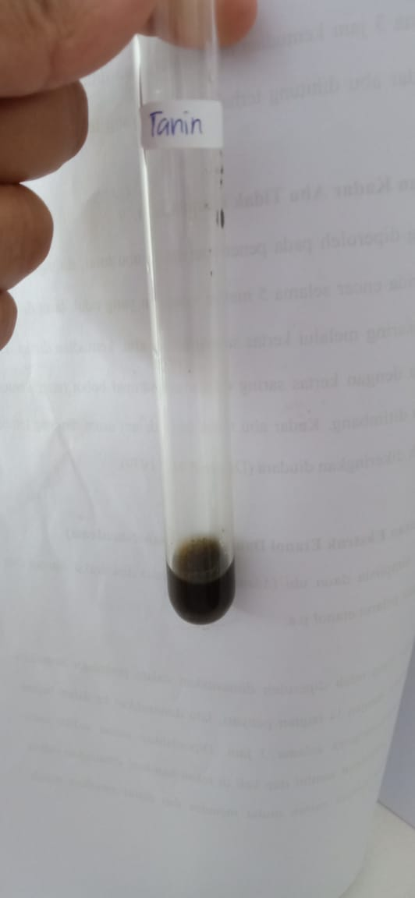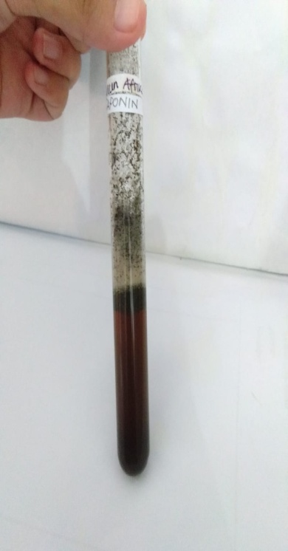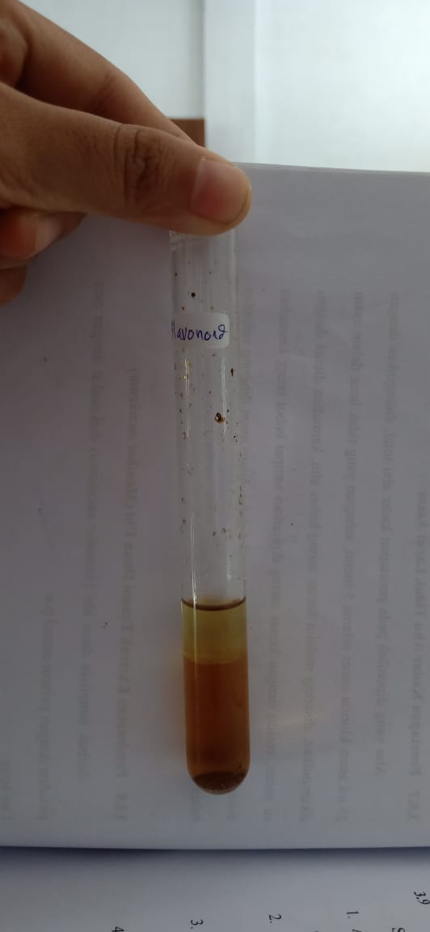

Pemeriksaan Pemeriksaan Pemeriksaan

Flavonoid Saponin Tanin

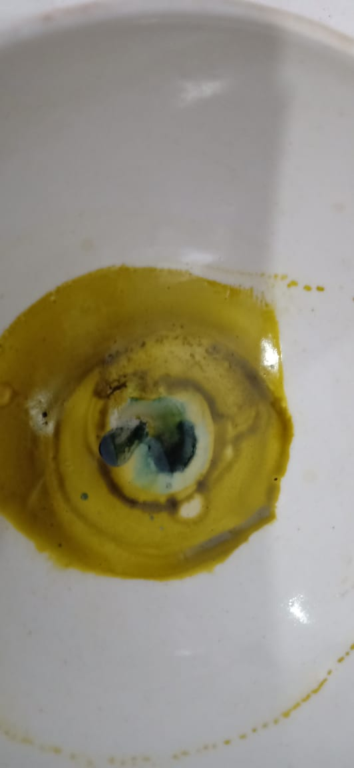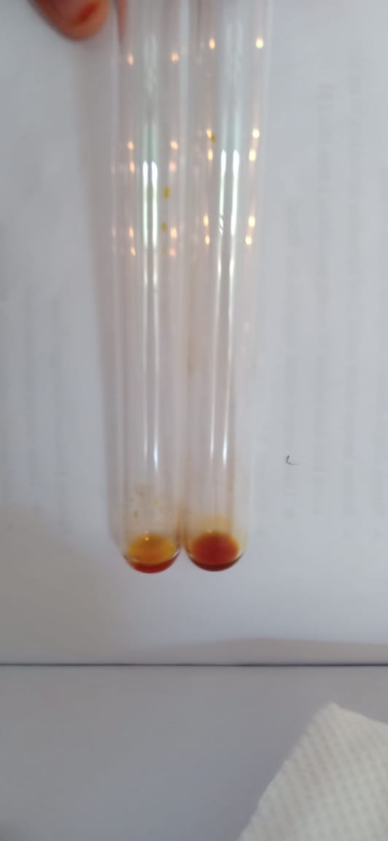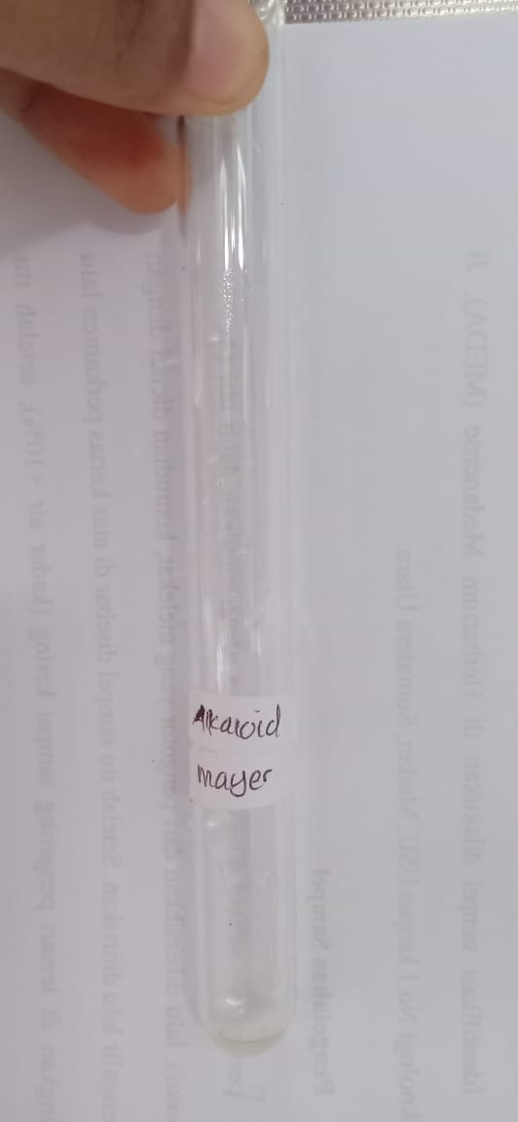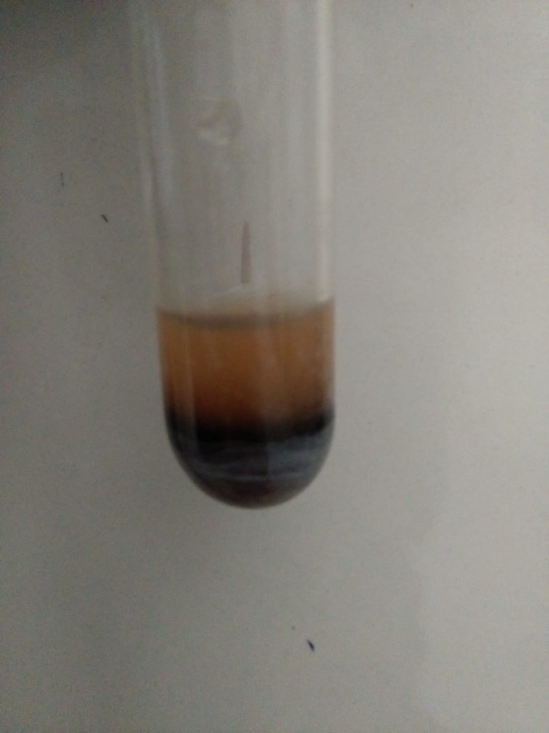

` Pemeriksaan Pemeriksaan Pemeriksaan

Steroid Alkaloid Glikosida

**Lampiran 7.** Bagan alir pembuatan serbuk simplisia daun ubi

Daun ubi segar

Disortasi basah

Dicuci dengan air yang mengalir

ditiriskan

8 kg

Daun ubi basah

dikeringkan dalam lemari pengering pada suhu 40oC

4 kg

Daun ubi kering

sortasi kering

4 kg

Daun ubi kering

dihaluskan dengan menggunakan blender

disaring dengan ayakan

dimasukkan dalam wadah tertutup

2 kg

Serbuk Daun ubi

**Lampiran 8.** Bagan Alir Pembuatan Ekstrak Etanol Daun Ubi dengan Metode Perkolasi

300 Gram Serbuk Simplisia Daun Ubi

Diekstraksi dengan cara perkolasi menggunakan pelarut etanol pro analisis

Skrining Fitokimia :



1. Alkaloid

2. Flavonoid

3.Saponin

4. Tanin

5. Steroid/Triterpenoid

6. Glikosida

Dipekatkan dengan alat rotary evaporator

Dikeringkan dengan alat frezee dryer

Ekstrak kental 67,7 gram

Pemeriksaan dan Karakterisasi

1. Mikroskopik

2. Makroskopik

3. Penetapan kadar air

4. Penetapan kadar sari larut dalam air

5. Penetapan kadar sari larut etanol

6. Penetapan kadar abu total

7. Penetapan kadar abu tidak larut asam

Pengujian Aktivitas Terhadap Bakteri *Staphylococcus aureus, Pseudomonas aeruginosa,* dan jamur *Candida albicans*

**Lampiran 9.** Bagan Alir Pengujian Antimikroba

Biakan Murni

Jamur *Candida albicans*

Bakteri *Staphylococcus aureus* dan *Pseudomonas aeruginosa*

Diambil 1 ose steril Diambil 1 ose steril

Ditanam pada media Ditanam pada media

MHA PDA

Diinkubasi pada suhu Diinkubasi pada suhu

35-36oC 25-30oC

Stock Kultur Mikroba

Diambil dengan jarum ose steril

Disuspensikan dalam 10 ml

NaCl 0,9% steril

Dihomogenkan sampai kekeruhan yang sama dengan Mc. Farland

Suspensi mikroba 108 CFU/ml

Dipipet 0,1 ml kedalam tabung reaksi

Ditambahkan 9,9 ml NaCl 0,9%

steril dan dihomogenkan

Suspensi mikroba 106 CFU/ml

digoreskan keatas permukaan media

yang telah memadat menggunakan

cotton bud steril

dimasukkan kertas cakram yang telah

ditetesi ekstrak etanol daun ubi

diinkubasi pada suhu 35-36oC selama

18-24 jam (pada bakteri) dan suhu

25-36oC selama 24-48 jam (pada

jamur)

Hasil inkubasi

diukur diameter zona hambat

Diameter Daya Hambat Mikroba

**Lampiran 10.** Rangkaian alat azeotrop, mikropipet dan *Rotary evaporator*

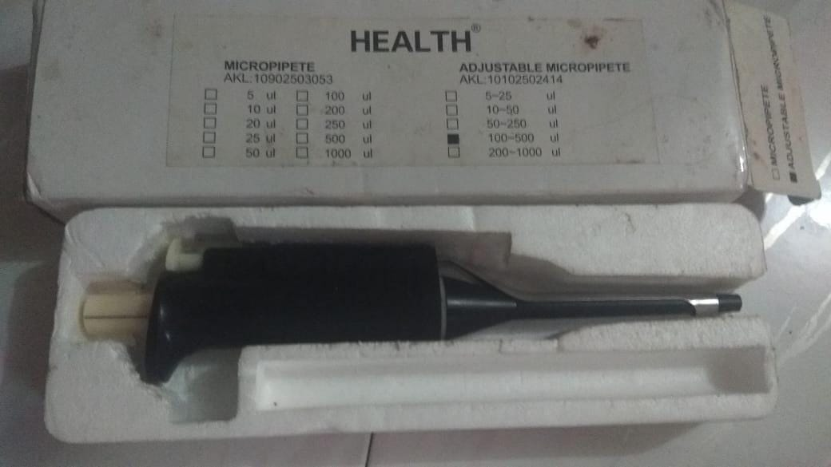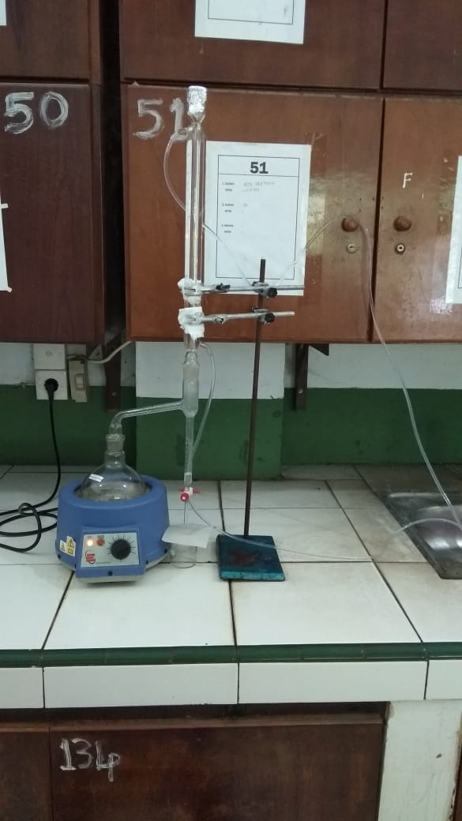

Rangkaian alat Azeotrop Alat Mikropipet

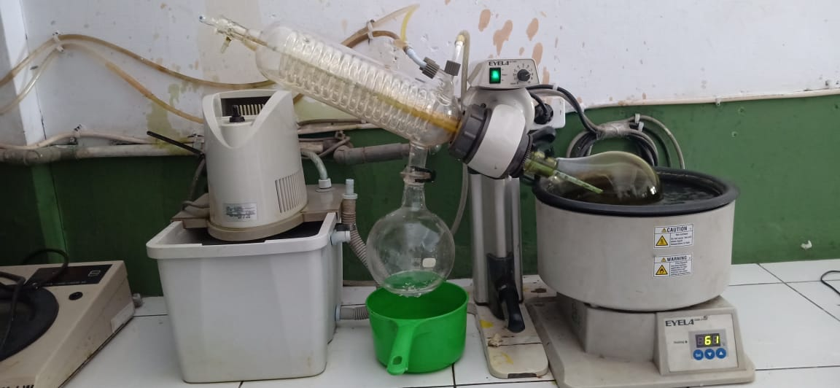

Alat *Rotary evaporator*

**Lampiran 11.** Hasil Uji Aktivitas Antimikroba Ekstrak etanol Daun Ubi (*Manihot esculenta* Crantz) Terhadap *Staphylococcus aureus*, *Pseudomonas aeruginosa,* dan *Candida albicans*

**a. Bakteri *Staphylococcus aureus***

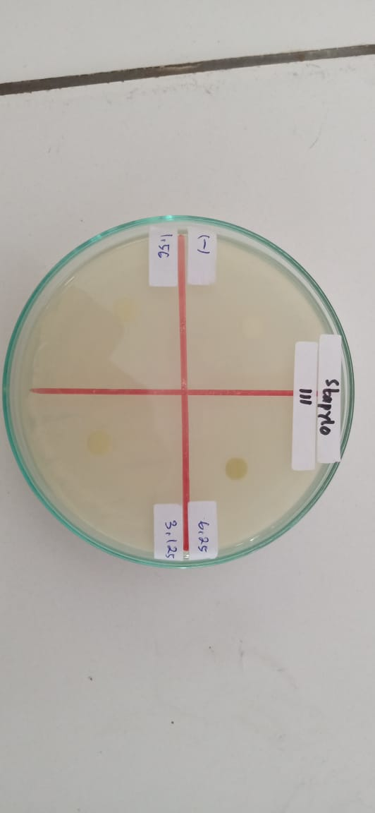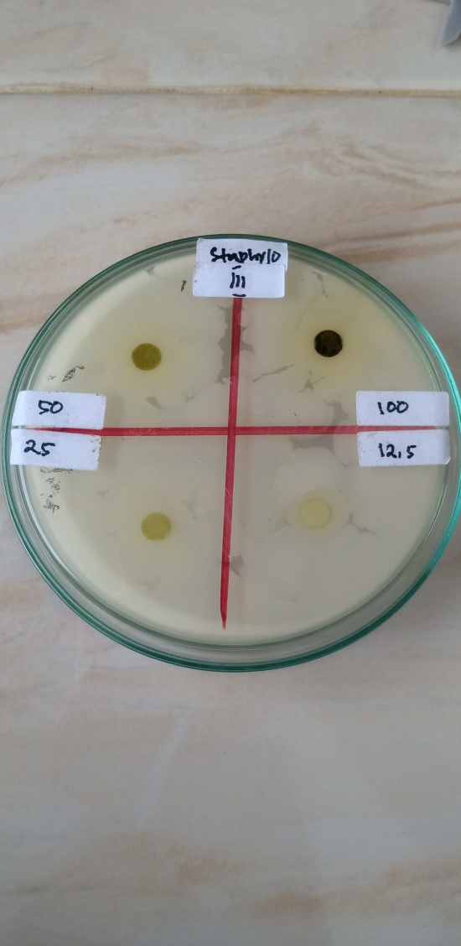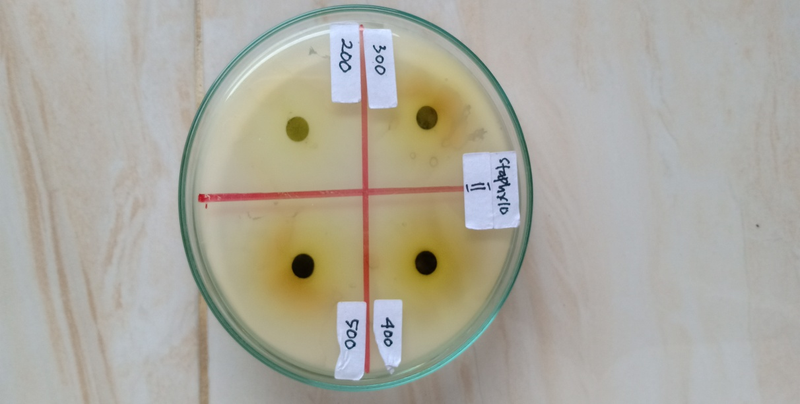

**Lampiran 11.** (lanjutan)

**b. Bakteri *Pseudomonas aeruginosa***

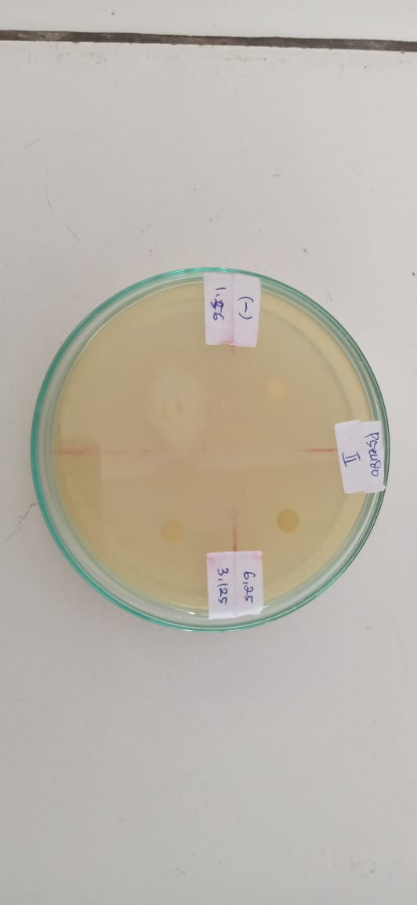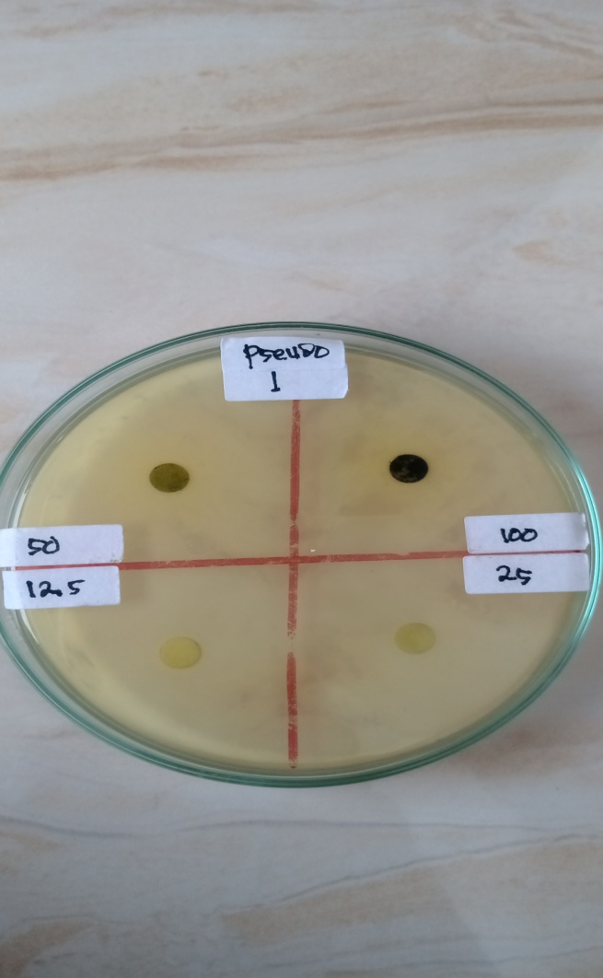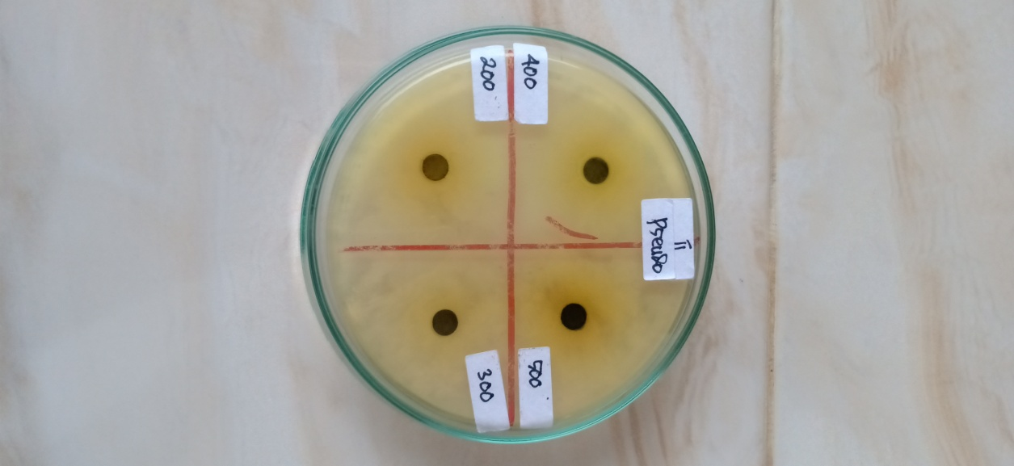

**Lampiran 11.** (lanjutan)

**c. Jamur *Candida albicans***

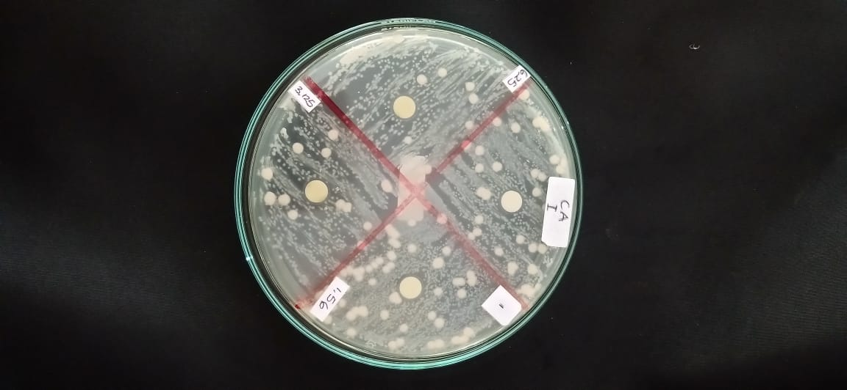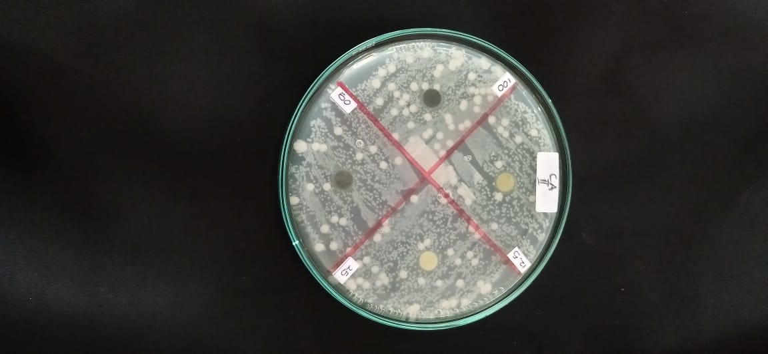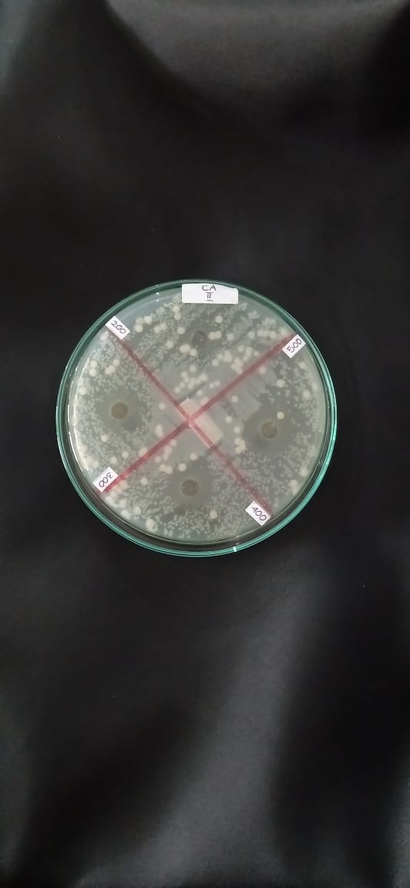

**Lampiran 12.** Hasil ANOVA dan Uji Duncan per Konsentrasi

|  |  |  |  |  |  |  |  |  |  |
| --- | --- | --- | --- | --- | --- | --- | --- | --- | --- |
| **Descriptives** | | | | | | | | | |
|  | | N | Mean | Std. Deviation | Std. Error | 95% Confidence Interval for Mean | | Minimum | Maximum |
| Lower Bound | Upper Bound |
| KBM Bakteri  Staphylococcus aureus | Kontrol Negatif | 3 | ,000 | ,0000 | ,0000 | ,000 | ,000 | ,0 | ,0 |
| Kons. 500 | 3 | 22,333 | 1,6073 | ,9280 | 18,341 | 26,326 | 20,5 | 23,5 |
| Kons. 400 | 3 | 20,333 | 1,0408 | ,6009 | 17,748 | 22,919 | 19,5 | 21,5 |
| Kons. 300 | 3 | 18,667 | 1,2583 | ,7265 | 15,541 | 21,792 | 17,5 | 20,0 |
| Kons. 200 | 3 | 17,000 | 1,3229 | ,7638 | 13,714 | 20,286 | 16,0 | 18,5 |
| Kons. 100 | 3 | 15,500 | ,5000 | ,2887 | 14,258 | 16,742 | 15,0 | 16,0 |
| Kons. 50 | 3 | 13,333 | ,7638 | ,4410 | 11,436 | 15,231 | 12,5 | 14,0 |
| Kons. 25 | 3 | 12,500 | 2,0000 | 1,154 | 7,532 | 17,468 | 10,5 | 14,5 |
| Kons. 12,5 | 3 | ,000 | ,0000 | ,0000 | ,000 | ,000 | ,0 | ,0 |
| Kons. 6,25 | 3 | ,000 | ,0000 | ,0000 | ,000 | ,000 | ,0 | ,0 |
| Kons. 3,125 | 3 | ,000 | ,0000 | ,0000 | ,000 | ,000 | ,0 | ,0 |
| Kons. 1,56 | 3 | ,000 | ,0000 | ,0000 | ,000 | ,000 | ,0 | ,0 |
| Total | 36 | 9,972 | 8,9689 | 1,494 | 6,938 | 13,007 | ,0 | 23,5 |
| KBM Bakteri Pseudomonas aeruginosa | Kontrol Negatif | 3 | ,000 | ,0000 | ,0000 | ,000 | ,000 | ,0 | ,0 |
| Kons. 500 | 3 | 16,167 | 3,2532 | 1,878 | 8,085 | 24,248 | 13,0 | 19,5 |
| Kons. 400 | 3 | 17,500 | 1,3229 | ,7638 | 14,214 | 20,786 | 16,5 | 19,0 |
| Kons. 300 | 3 | 15,000 | 1,3229 | ,7638 | 11,714 | 18,286 | 14,0 | 16,5 |
| Kons. 200 | 3 | 18,333 | 3,6856 | 2,127 | 9,178 | 27,489 | 15,5 | 22,5 |
| Kons. 100 | 3 | 12,667 | 1,8930 | 1,092 | 7,964 | 17,369 | 10,5 | 14,0 |
| Kons. 50 | 3 | 11,500 | 2,5000 | 1,443 | 5,290 | 17,710 | 9,0 | 14,0 |
| Kons. 25 | 3 | ,000 | ,0000 | ,0000 | ,000 | ,000 | ,0 | ,0 |
| Kons. 12,5 | 3 | ,000 | ,0000 | ,0000 | ,000 | ,000 | ,0 | ,0 |
| Kons. 6,25 | 3 | ,000 | ,0000 | ,0000 | ,000 | ,000 | ,0 | ,0 |
| Kons. 3,125 | 3 | ,000 | ,0000 | ,0000 | ,000 | ,000 | ,0 | ,0 |
| Kons. 1,56 | 3 | ,000 | ,0000 | ,0000 | ,000 | ,000 | ,0 | ,0 |
| Total | 36 | 7,597 | 8,0381 | 1,339 | 4,878 | 10,317 | ,0 | 22,5 |
| KHM Jamur  Candida albicans | Kontrol Negatif | 3 | ,000 | ,0000 | ,0000 | ,000 | ,000 | ,0 | ,0 |
| Kons. 500 | 3 | 16,000 | ,5000 | ,2887 | 14,758 | 17,242 | 15,5 | 16,5 |
| Kons. 400 | 3 | 14,500 | ,5000 | ,2887 | 13,258 | 15,742 | 14,0 | 15,0 |
| Kons. 300 | 3 | 13,333 | 1,0408 | ,6009 | 10,748 | 15,919 | 12,5 | 14,5 |
| Kons. 200 | 3 | ,000 | ,0000 | ,0000 | ,000 | ,000 | ,0 | ,0 |
| Kons. 100 | 3 | ,000 | ,0000 | ,0000 | ,000 | ,000 | ,0 | ,0 |
| Kons. 50 | 3 | ,000 | ,0000 | ,0000 | ,000 | ,000 | ,0 | ,0 |
| Kons. 25 | 3 | ,000 | ,0000 | ,0000 | ,000 | ,000 | ,0 | ,0 |
| Kons. 12,5 | 3 | ,000 | ,0000 | ,0000 | ,000 | ,000 | ,0 | ,0 |
| Kons. 6,25 | 3 | ,000 | ,0000 | ,0000 | ,000 | ,000 | ,0 | ,0 |
| Kons. 3,125 | 3 | ,000 | ,0000 | ,0000 | ,000 | ,000 | ,0 | ,0 |
| Kons. 1,56 | 3 | ,000 | ,0000 | ,0000 | ,000 | ,000 | ,0 | ,0 |
| Total | 36 | 3,653 | 6,4474 | 1,074 | 1,471 | 5,834 | ,0 | 16,5 |

|  |  |  |  |  |  |  |  |  |  |  |  |  |  |  |  |  |  |  |  |  |  |  |  |  |  |  |  |  |  |  |  |  |  |  |  |  |  |  |  |  |  |  |  |  |  |  |  |  |  |  |  |  |  |  |  |  |  |  |  |  |  |  |  |  |  |  |  |  |  |  |  |  |  |  |  |  |  |  |  |  |  |  |  |  |  |  |  |  |  |  |  |  |  |  |  |  |  |  |  |  |  |  |  |  |  |  |  |  |  |  |  |  |  |  |  |  |  |  |  |  |  |  |  |  |  |  |  |  |  |  |  |  |  |  |  |  |  |  |
| --- | --- | --- | --- | --- | --- | --- | --- | --- | --- | --- | --- | --- | --- | --- | --- | --- | --- | --- | --- | --- | --- | --- | --- | --- | --- | --- | --- | --- | --- | --- | --- | --- | --- | --- | --- | --- | --- | --- | --- | --- | --- | --- | --- | --- | --- | --- | --- | --- | --- | --- | --- | --- | --- | --- | --- | --- | --- | --- | --- | --- | --- | --- | --- | --- | --- | --- | --- | --- | --- | --- | --- | --- | --- | --- | --- | --- | --- | --- | --- | --- | --- | --- | --- | --- | --- | --- | --- | --- | --- | --- | --- | --- | --- | --- | --- | --- | --- | --- | --- | --- | --- | --- | --- | --- | --- | --- | --- | --- | --- | --- | --- | --- | --- | --- | --- | --- | --- | --- | --- | --- | --- | --- | --- | --- | --- | --- | --- | --- | --- | --- | --- | --- | --- | --- | --- | --- | --- | --- |
| |  |  |  |  |  |  |  |  | | --- | --- | --- | --- | --- | --- | --- | --- | | **Tests of Normality** | | | | | | | | |  | perlakuan | Kolmogorov-Smirnovb | | | Shapiro-Wilk | | | |  | Statistic | df | Sig. | Statistic | df | Sig. | | KBM Bakteri Staphylococcus aureus | Kons. 500 | ,328 | 3 | . | ,871 | 3 | ,298 | | Kons. 400 | ,292 | 3 | . | ,923 | 3 | ,463 | | Kons. 300 | ,219 | 3 | . | ,987 | 3 | ,780 | | Kons. 200 | ,314 | 3 | . | ,893 | 3 | ,363 | | Kons. 100 | ,175 | 3 | . | 1,000 | 3 | 1,000 | | Kons. 50 | ,253 | 3 | . | ,964 | 3 | ,637 | | Kons. 25 | ,175 | 3 | . | 1,000 | 3 | 1,000 | | KBM Bakteri Pseudomonas aeruginosa | Kons. 500 | ,187 | 3 | . | ,998 | 3 | ,915 | | Kons. 400 | ,314 | 3 | . | ,893 | 3 | ,363 | | Kons. 300 | ,314 | 3 | . | ,893 | 3 | ,363 | | Kons. 200 | ,308 | 3 | . | ,902 | 3 | ,391 | | Kons. 100 | ,337 | 3 | . | ,855 | 3 | ,253 | | Kons. 50 | ,175 | 3 | . | 1,000 | 3 | 1,000 | | KHM Jamur Candida albicans | Kons. 500 | ,175 | 3 | . | 1,000 | 3 | 1,000 | | Kons. 400 | ,175 | 3 | . | 1,000 | 3 | 1,000 | | Kons. 300 | ,292 | 3 | . | ,923 | 3 | ,463 | |

|  |  |  |  |  |
| --- | --- | --- | --- | --- |
| **Test of Homogeneity of Variances** | | | | |
|  | Levene Statistic | df1 | df2 | Sig. |
| KBM Bakteri Staphylococcus aureus | 3,600 | 11 | 24 | ,004 |
| KBM Bakteri Pseudomonas aeruginosa | 4,378 | 11 | 24 | ,001 |
| KHM Jamur Candida albicans | 6,241 | 11 | 24 | ,000 |

|  |  |  |  |  |  |  |
| --- | --- | --- | --- | --- | --- | --- |
| **ANOVA** | | | | | | |
|  | | Sum of Squares | df | Mean Square | F | Sig. |
| KBM Bakteri Staphylococcus aureus | Between Groups | 2791,806 | 11 | 253,801 | 257,375 | ,000 |
| Within Groups | 23,667 | 24 | ,986 |  |  |
| Total | 2815,472 | 35 |  |  |  |
| KBM Bakteri Pseudomonas aeruginosa | Between Groups | 2186,410 | 11 | 198,765 | 63,605 | ,000 |
| Within Groups | 75,000 | 24 | 3,125 |  |  |
| Total | 2261,410 | 35 |  |  |  |
| KHM Jamur Candida albicans | Between Groups | 1451,743 | 11 | 131,977 | 1000,244 | ,000 |
| Within Groups | 3,167 | 24 | ,132 |  |  |
| Total | 1454,910 | 35 |  |  |  |

|  |  |  |  |  |  |  |  |
| --- | --- | --- | --- | --- | --- | --- | --- |
| **KBM Bakteri Staphylococcus aureus** | | | | | | | |
| Duncana | | | | | | | |
| perlakuan | N | Subset for alpha = 0.05 | | | | | |
| 1 | 2 | 3 | 4 | 5 | 6 |
| Kontrol Negatif | 3 | ,000 |  |  |  |  |  |
| Kons. 12,5 | 3 | ,000 |  |  |  |  |  |
| Kons. 6,25 | 3 | ,000 |  |  |  |  |  |
| Kons. 3,125 | 3 | ,000 |  |  |  |  |  |
| Kons. 1,56 | 3 | ,000 |  |  |  |  |  |
| Kons. 25 | 3 |  | 12,500 |  |  |  |  |
| Kons. 50 | 3 |  | 13,333 |  |  |  |  |
| Kons. 100 | 3 |  |  | 15,500 |  |  |  |
| Kons. 200 | 3 |  |  | 17,000 | 17,000 |  |  |
| Kons. 300 | 3 |  |  |  | 18,667 | 18,667 |  |
| Kons. 400 | 3 |  |  |  |  | 20,333 |  |
| Kons. 500 | 3 |  |  |  |  |  | 22,333 |
| Sig. |  | 1,000 | ,314 | ,077 | ,051 | ,051 | 1,000 |

|  |  |  |  |  |  |  |
| --- | --- | --- | --- | --- | --- | --- |
| **KBM Bakteri Pseudomonas aeruginosa** | | | | | | |
| Duncana | | | | | | |
| perlakuan | N | Subset for alpha = 0.05 | | | | |
| 1 | 2 | 3 | 4 | 5 |
| Kontrol Negatif | 3 | ,000 |  |  |  |  |
| Kons. 25 | 3 | ,000 |  |  |  |  |
| Kons. 12,5 | 3 | ,000 |  |  |  |  |
| Kons. 6,25 | 3 | ,000 |  |  |  |  |
| Kons. 3,125 | 3 | ,000 |  |  |  |  |
| Kons. 1,56 | 3 | ,000 |  |  |  |  |
| Kons. 50 | 3 |  | 11,500 |  |  |  |
| Kons. 100 | 3 |  | 12,667 | 12,667 |  |  |
| Kons. 300 | 3 |  |  | 15,000 | 15,000 |  |
| Kons. 500 | 3 |  |  |  | 16,167 | 16,167 |
| Kons. 400 | 3 |  |  |  | 17,500 | 17,500 |
| Kons. 200 | 3 |  |  |  |  | 18,333 |
| Sig. |  | 1,000 | ,427 | ,119 | ,114 | ,168 |
| Means for groups in homogeneous subsets are displayed. | | | | | | |
| a. Uses Harmonic Mean Sample Size = 3,000. | | | | | | |

|  |  |  |  |  |  |  |  |  |  |  |  |
| --- | --- | --- | --- | --- | --- | --- | --- | --- | --- | --- | --- |
| **KHM Jamur Candida albicans** | | | | | | | | | | | |
| Duncana | | | | | | | | | | | |
| perlakuan | | N | | Subset for alpha = 0.05 | | | | | | | |
| 1 | | 2 | 3 | | | 4 | |
| Kontrol Negatif | | 3 | | ,000 | |  |  | | |  | |
| Kons. 200 | | 3 | | ,000 | |  |  | | |  | |
| Kons. 100 | | 3 | | ,000 | |  |  | | |  | |
| Kons. 50 | | 3 | | ,000 | |  |  | | |  | |
| Kons. 25 | | 3 | | ,000 | |  |  | | |  | |
| Kons. 12,5 | | 3 | | ,000 | |  |  | | |  | |
| Kons. 6,25 | | 3 | | ,000 | |  |  | | |  | |
| Kons. 3,125 | | 3 | | ,000 | |  |  | | |  | |
| Kons. 1,56 | | 3 | | ,000 | |  |  | | |  | |
| Kons. 300 | | 3 | |  | | 13,333 |  | | |  | |
| Kons. 400 | | 3 | |  | |  | 14,500 | | |  | |
| Kons. 500 | | 3 | |  | |  |  | | | 16,000 | |
| **Sig.** | |  | | **1,000** | | **1,000** | **1,000** | | | **1,000** | |
|  | | | | | | | | | | | |
| **Lampiran 13.** Hasil ANOVA dan Uji Duncan per Mikroba  **Descriptives** | | | | | | | | | | | | | | | |
|  | | | | N | | Mean | Std. Deviation | | Std. Error | 95% Confidence Interval for Mean | | | | Minimum | Maximum |
| Lower Bound | | Upper Bound | |
| Kontrol Negatif | | Staphylococcus  aureus | | 3 | | ,000 | ,0000 | | ,0000 | ,000 | | ,000 | | ,0 | ,0 |
| Pseudomonas  aeruginosa | | 3 | | ,000 | ,0000 | | ,0000 | ,000 | | ,000 | | ,0 | ,0 |
| Candida albicans | | 3 | | ,000 | ,0000 | | ,0000 | ,000 | | ,000 | | ,0 | ,0 |
| Total | | 9 | | ,000 | ,0000 | | ,0000 | ,000 | | ,000 | | ,0 | ,0 |
| Kons. 500 mg/ml | | Staphylococcus aureus | | 3 | | 22,333 | 1,6073 | | ,9280 | 18,341 | | 26,326 | | 20,5 | 23,5 |
| Pseudomonas aeruginosa | | 3 | | 16,167 | 3,2532 | | 1,8782 | 8,085 | | 24,248 | | 13,0 | 19,5 |
| Candida albicans | | 3 | | 16,000 | ,5000 | | ,2887 | 14,758 | | 17,242 | | 15,5 | 16,5 |
| Total | | 9 | | 18,167 | 3,6228 | | 1,2076 | 15,382 | | 20,951 | | 13,0 | 23,5 |
| Kons. 400 mg/ml | | Staphylococcus aureus | | 3 | | 20,333 | 1,0408 | | ,6009 | 17,748 | | 22,919 | | 19,5 | 21,5 |
| Pseudomonas aeruginosa | | 3 | | 18,000 | 1,3229 | | ,7638 | 14,714 | | 21,286 | | 16,5 | 19,0 |
| Candida albicans | | 3 | | 14,500 | ,5000 | | ,2887 | 13,258 | | 15,742 | | 14,0 | 15,0 |
| Total | | 9 | | 17,611 | 2,6900 | | ,8967 | 15,543 | | 19,679 | | 14,0 | 21,5 |
| Kons. 300 mg/ml | | Staphylococcus aureus | | 3 | | 18,667 | 1,2583 | | ,7265 | 15,541 | | 21,792 | | 17,5 | 20,0 |
| Pseudomonas aeruginosa | | 3 | | 15,000 | 1,3229 | | ,7638 | 11,714 | | 18,286 | | 14,0 | 16,5 |
| Candida albicans | | 3 | | 13,333 | 1,0408 | | ,6009 | 10,748 | | 15,919 | | 12,5 | 14,5 |
| Total | | 9 | | 15,667 | 2,5860 | | ,8620 | 13,679 | | 17,654 | | 12,5 | 20,0 |

|  |  |  |  |  |  |  |  |
| --- | --- | --- | --- | --- | --- | --- | --- |
| **Tests of Normality** | | | | | | | |
|  | Perlakuan | Kolmogorov-Smirnovd | | | Shapiro-Wilk | | |
|  | Statistic | df | Sig. | Statistic | df | Sig. |
| Kons. 500 mg/ml | Staphylococcus aureus | ,328 | 3 | . | ,871 | 3 | ,298 |
| Pseudomonas aeruginosa | ,187 | 3 | . | ,998 | 3 | ,915 |
| Candida albicans | ,175 | 3 | . | 1,000 | 3 | 1,000 |
| Kons. 400 mg/ml | Staphylococcus aureus | ,292 | 3 | . | ,923 | 3 | ,463 |
| Pseudomonas aeruginosa | ,314 | 3 | . | ,893 | 3 | ,363 |
| Candida albicans | ,175 | 3 | . | 1,000 | 3 | 1,000 |
| Kons. 300 mg/ml | Staphylococcus aureus | ,219 | 3 | . | ,987 | 3 | ,780 |
| Pseudomonas aeruginosa | ,314 | 3 | . | ,893 | 3 | ,363 |
| Candida albicans | ,292 | 3 | . | ,923 | 3 | ,463 |

|  |  |  |  |  |
| --- | --- | --- | --- | --- |
| **Test of Homogeneity of Variances** | | | | |
|  | Levene Statistic | df1 | df2 | Sig. |
| Kontrol Negatif | . | 2 | . | . |
| Kons. 500 mg/ml | 2,231 | 2 | 6 | ,189 |
| Kons. 400 mg/ml | 2,036 | 2 | 6 | ,211 |
| Kons. 300 mg/ml | ,135 | 2 | 6 | ,876 |

|  |  |  |  |  |  |  |  |  |
| --- | --- | --- | --- | --- | --- | --- | --- | --- |
| **ANOVA** | | | | | | | | |
|  | | | | Sum of Squares | df | Mean Square | F | Sig. |
| Kontrol Negatif | Between Groups | (Combined) | | ,000 | 2 | ,000 | . | . |
| Linear Term | Contrast | ,000 | 1 | ,000 | . |  |
| Deviation | ,000 | 1 | ,000 | . |  |
| Within Groups | | | ,000 | 6 | ,000 |  |  |
| Total | | | ,000 | 8 |  |  |  |
| Kons. 500 mg/ml | Between Groups | (Combined) | | 78,167 | 2 | 39,083 | 8,739 | ,017 |
| Linear Term | Contrast | 60,167 | 1 | 60,167 | 13,453 | ,010 |
| Deviation | 18,000 | 1 | 18,000 | 4,025 | ,092 |
| Within Groups | | | 26,833 | 6 | 4,472 |  |  |
| Total | | | 105,000 | 8 |  |  |  |
| Kons. 400 mg/ml | Between Groups | (Combined) | | 51,722 | 2 | 25,861 | 25,162 | ,001 |
| Linear Term | Contrast | 51,042 | 1 | 51,042 | 49,662 | ,000 |
| Deviation | ,681 | 1 | ,681 | ,662 | ,447 |
| Within Groups | | | 6,167 | 6 | 1,028 |  |  |
| Total | | | 57,889 | 8 |  |  |  |
| Kons. 300 mg/ml | Between Groups | (Combined) | | 44,667 | 2 | 22,333 | 15,170 | ,005 |
| Linear Term | Contrast | 42,667 | 1 | 42,667 | 28,981 | ,002 |
| Deviation | 2,000 | 1 | 2,000 | 1,358 | ,288 |
| Within Groups | | | 8,833 | 6 | 1,472 |  |  |
| Total | | | 53,500 | 8 |  |  |  |

|  |  |  |  |
| --- | --- | --- | --- |
| **Kons. 500 mg/ml** | | | |
| Duncana | | | |
| perlakuan | N | Subset for alpha = 0.05 | |
| 1 | 2 |
| Candida albicans | 3 | 16,000 |  |
| Pseudomonas aeruginosa | 3 | 16,167 |  |
| Staphylococcus aureus | 3 |  | 22,333 |
| Sig. |  | ,926 | 1,000 |

|  |  |  |  |  |  |  |  |
| --- | --- | --- | --- | --- | --- | --- | --- |
| **Kons. 400 mg/ml** | | | | | | | |
| Duncana | | | | | | | |
| Perlakuan | N | Subset for alpha = 0.05 | | | | | |
| 1 | | 2 | | 3 | |
| Candida albicans | 3 | 14,500 | |  | |  | |
| Pseudomonas aeruginosa | 3 |  | | 18,000 | |  | |
| Staphylococcus aureus | 3 |  | |  | | 20,333 | |
| Sig. |  | 1,000 | | 1,000 | | 1,000 | |
| **Kons. 300 mg/ml** | | | | | | |
| Duncana | | | | | | |
| Perlakuan | N | | Subset for alpha = 0.05 | | | |
| 1 | | 2 | |
| Candida albicans | 3 | | 13,333 | |  | |
| Pseudomonas aeruginosa | 3 | | 15,000 | |  | |
| Staphylococcus aureus | 3 | |  | | 18,667 | |
| Sig. |  | | ,143 | | 1,000 | |
|  | | | | | | |