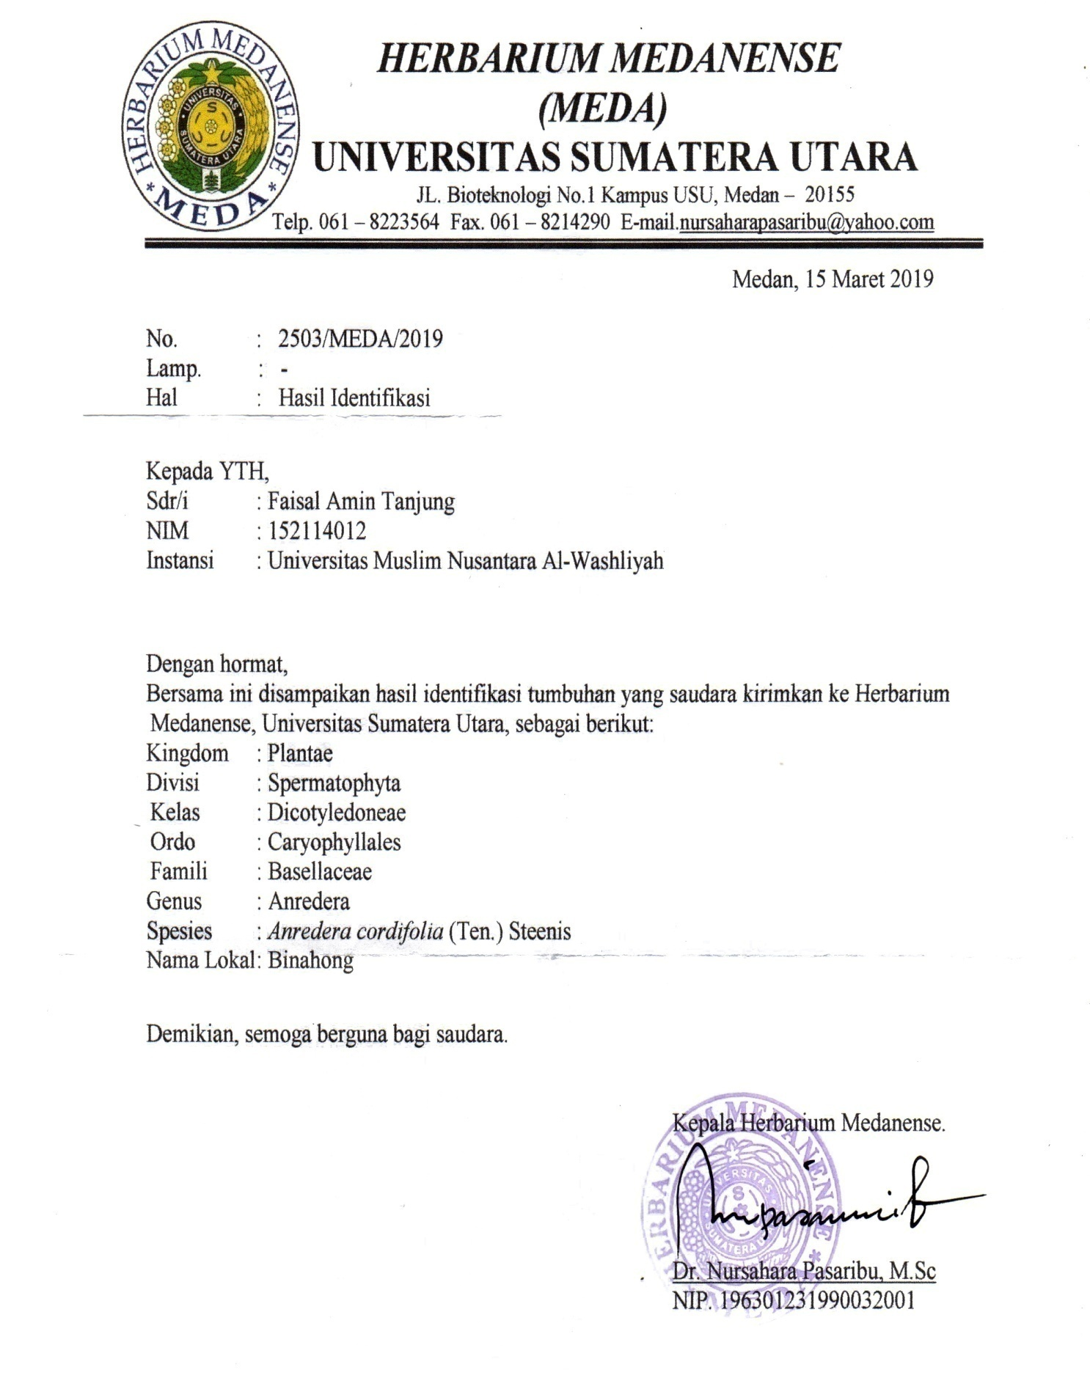
Lampiran 1. Herbarium Medanense
Lampiran 2. Persetujuan Etik Penelitian Kesehatan
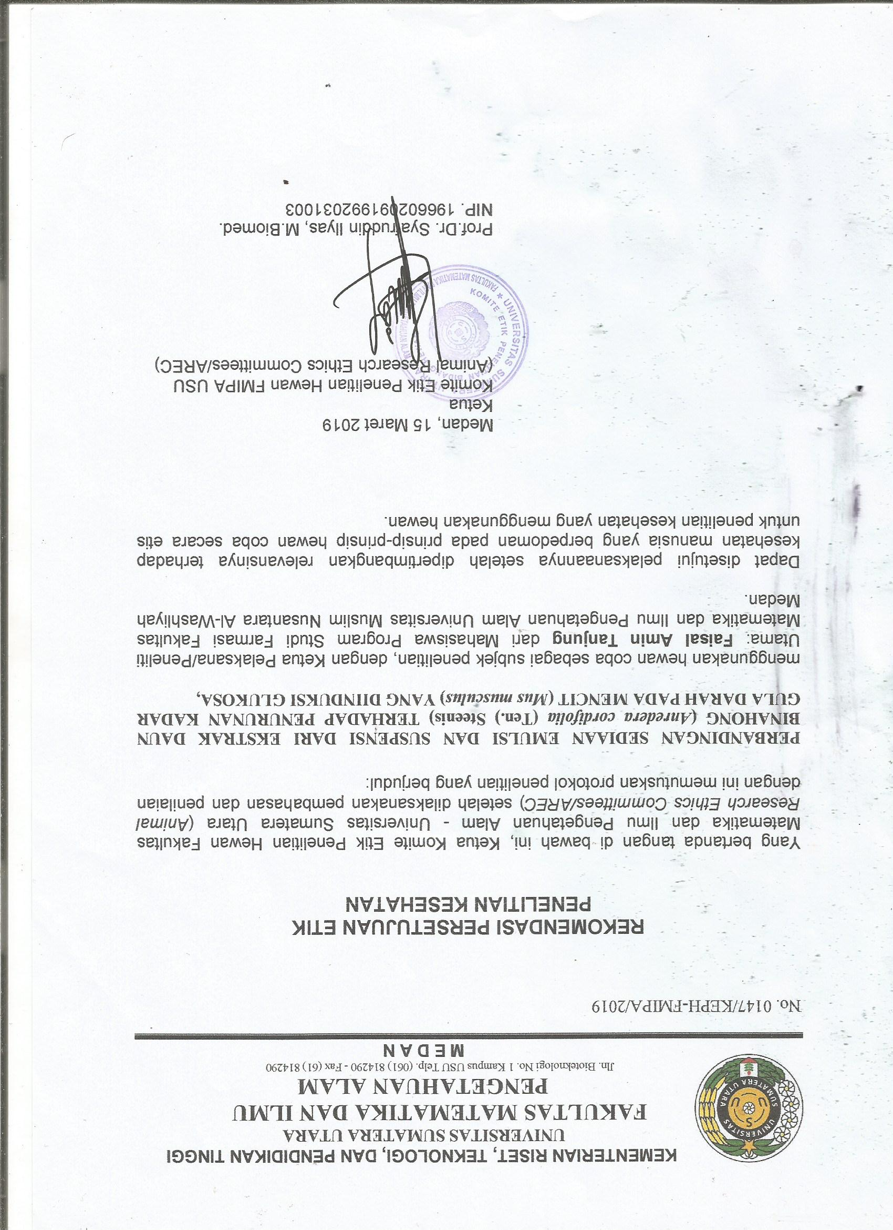

Lampiran 3. Certificate of Analysis
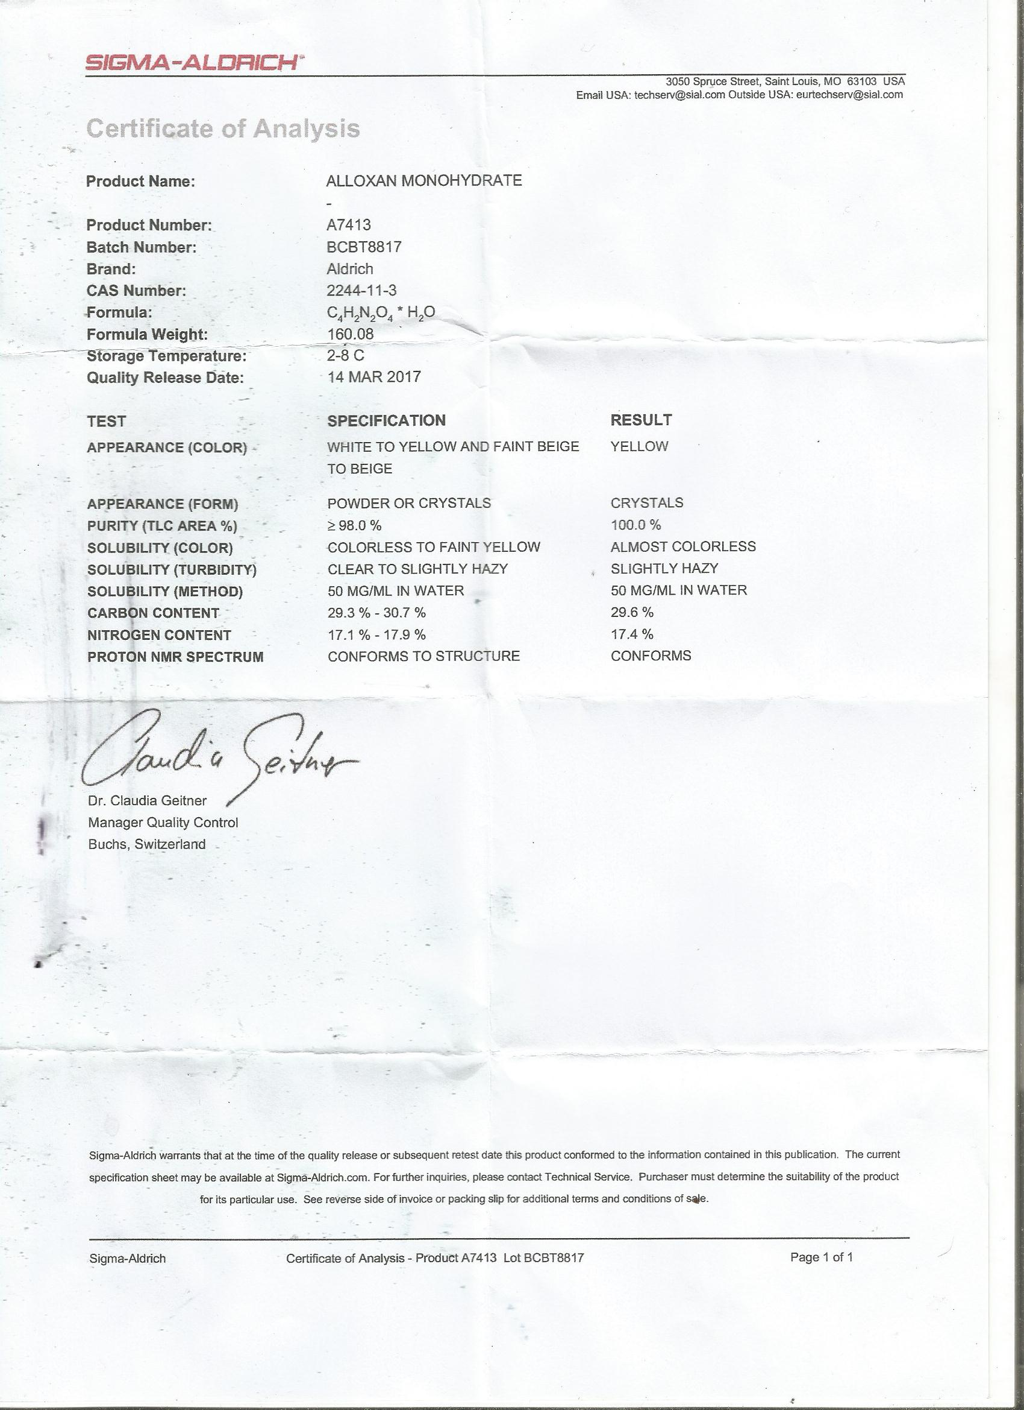

Lampiran 4. Tumbuhan Daun Binahong (Anredera cordifolia (Ten.) Steenis)
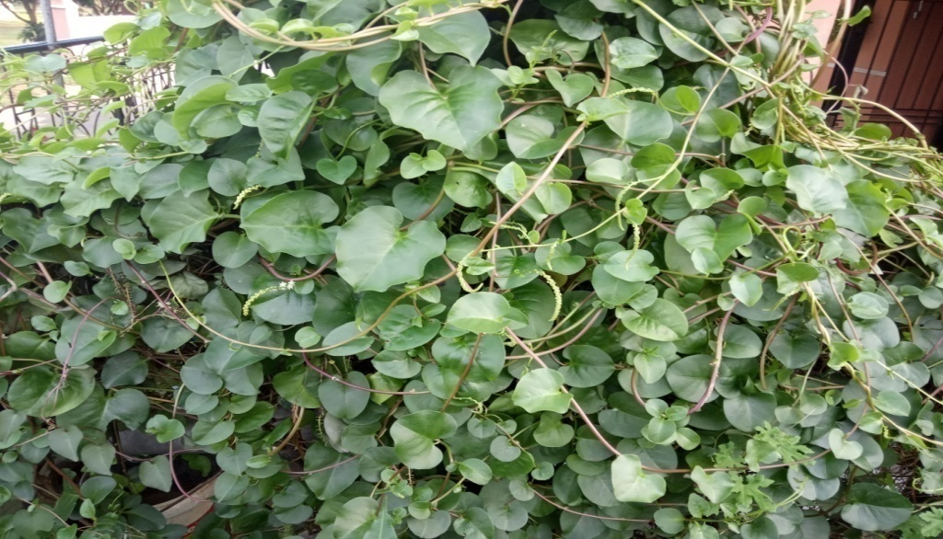

Gambar 1. Tumbuhan Segar Daun Binahong (Anredera cordifolia (Ten.) Steenis)
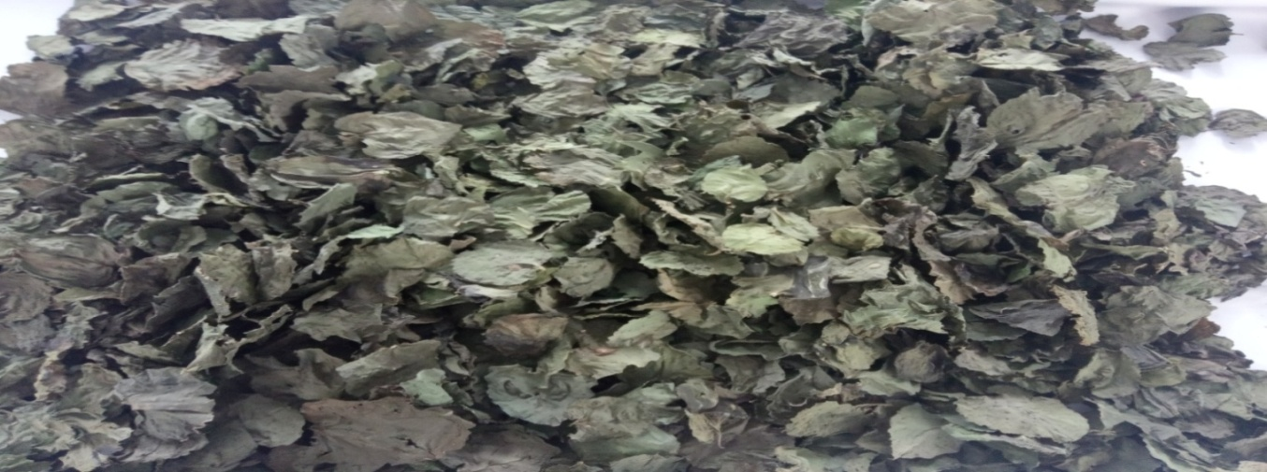

Gambar 2. Tumbuhan simplisia Daun Binahong (Anredera cordifolia (Ten.) Steenis)

Lampiran 5. Serbuk Simplisia dan Ekstrak Daun Binahong (Anredera cordifolia (Ten.) Steenis)
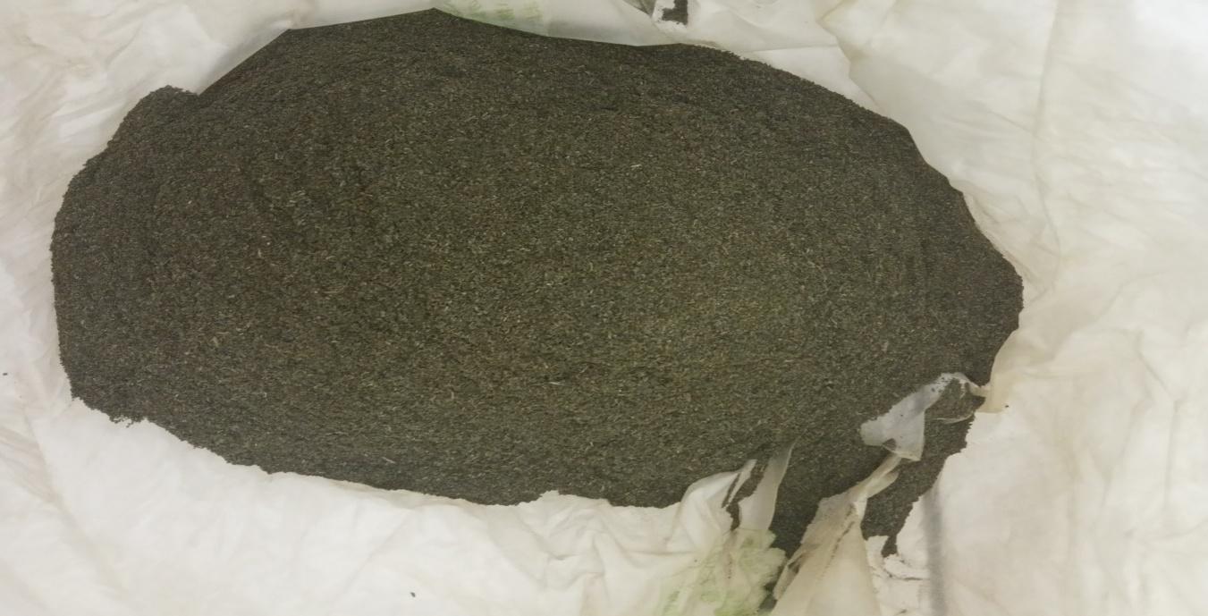

Gambar 3. Serbuk Simplisia Daun Binahong (Anredera cordifolia (Ten.) Steenis)

Gambar 4. Serbuk Simplisia Daun Binahong (Anredera cordifolia (Ten.) Steenis)

Lampiran 6. Makroskopik dan Mikroskopik Daun Binahong (Anredera cordifolia (Tan.) Steenis)
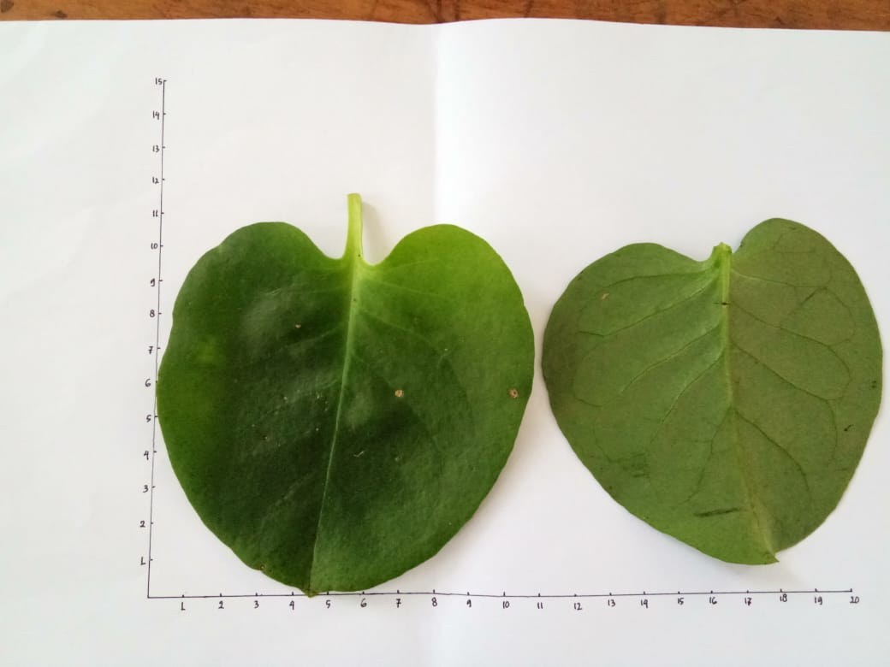
Gambar 5. Penampakan makroskopik Daun Binahong (Anredera cordifolia (Tan.) Steenis)

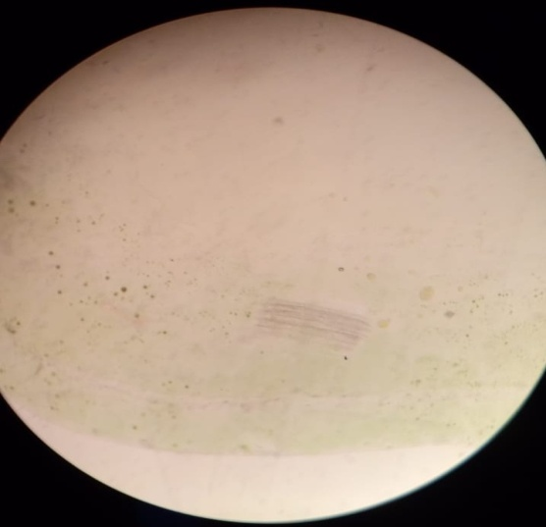
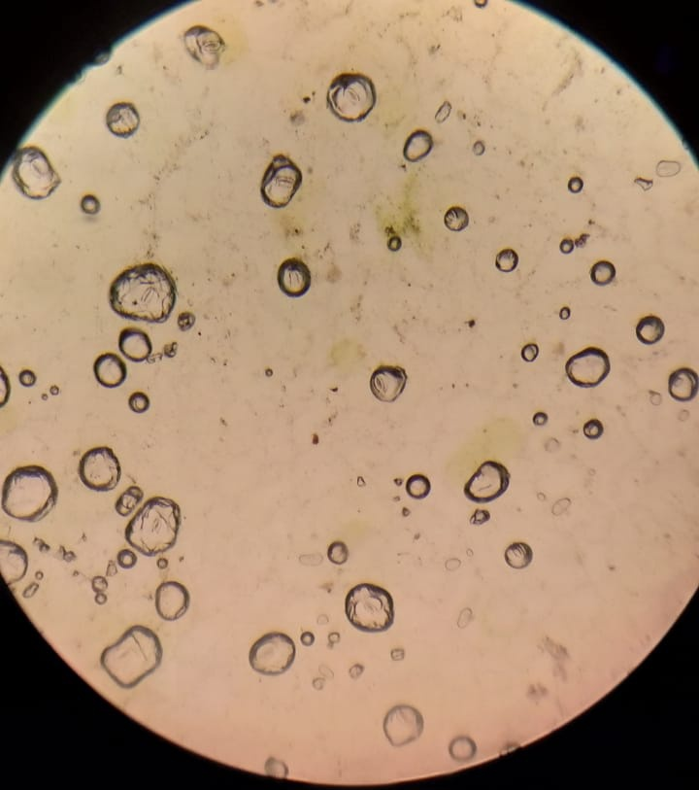
a

b c
Gambar 6. Penampakan mikroskopik daun ubi segar

Keterangan Gambar :
- Xylem
- Floem
- Epidermis

Lampiran 7. Bagan Alir Penelitian
Daun Binahong 12 kg

Dibersihkan dari pengotor
Dicuci bersih dan ditiriskan
Diangin-anginkan
Ditimbang
Daun binahong

Dikeringkan pada suhu 40˚C
Ditimbang
Simplisia kering 610 g
Dihaluskan
Ditimbang
Serbuk simplisia 600 g

Dimaserasi dengan etanol 96%
Karakterisasi simplisia :
- Peemeriksaan makroskopik dan mikroskopik
- Penetapan kadar air
- Penetapan kadar abu
- Penetepan kadar abu tidak larut asam
- Penetapan kadar sari larut dalam air
Ekstrak cair

Dipekatkan dengan rotary evaporator
Skrining fitokimia
- Alkaloid
- Flavonoid
- Steroid/triterpenoid
- Saponin
- Tanin
- Antrakuinon

Ekstrak kental

Pengujian antidiabetes

Lampiran 8. Bagan Alir Penelitian Lanjutan
Mencit jantan 25 ekor
Adaptasi selama 7 hari
Adaptasi selama 7 hari
Pengukuran KGD sebelum induksi
Pengukuran KGD

Induksi aloksan dosis 120 mg/KgBB

Pengukuran KGD setelah induksi
Dibagi menjdi 5/kelompok
Mencit diabetes

EDB dosis 400 mg/KgBB
EDB dosis 200 mg/KgBB
EDB dosis 100 mg/KgBB
Kontrol positif
Kontrol negatif

Pengamatan selama 7 jam

Analisis Data

Ket : EDB = Ekstrak Daun Binahong

Lampiran 9. Bagan Alir Pembuatan Serbuk Simplisia
Daun Binahong

Dibersihkan dari pengotor
Dicuci bersih dengan air
mengalir
Ditiriskan
Diangin-anginkan
Ditimbang
Berat daun binahong setelah dibersihkan

Dikeringkan didalam
lemari pengering
pada suhu 40ºC
Disortasi kering
Ditimbang
Berat simplisia 5,30 kg

Dihaluskan menggunakan
blender
Ditimbang
Berat serbuk simplisia 5,19kg

Dimasukkan kedalam
wadah
Tertutup rapat
Serbuk simplisia

Lampiran 10. Bagan Alir Pembuatan Ekstrak
5 kg serbuk simplisia daun binahong

Dimasukkan kedalam bejana
Ditambahkan etanol 96%
sebanyak 75 bagian (37.500ml) diaduk
Didiamkan selama 5 hari sambil diaduk
Disaring
Ampas
Maserat I

Dimasukkan dengan etanol 96% sebanyak 25 bagian (12.500 ml) dan diaduk
Dimaserasi kembali selama 2 hari sambil diaduk
Disaring
Maserat II

Maserat daun binahong

Diperlukan dengan rotary evaporator pada
suhu 60˚C Diuapkan dengan penangas air
Ekstrak etanol daun binahong

Lampiran 11. Perhitungan Hasil Pemeriksaan Karakterisasi Simplisia
- Penetapan Kadar Air
Kadar Air = $\frac{\left(Volume Akhir Air-Volume Awal Air\right)ml}{Bobot Simplisia} x 100\%$
- Sampel 1
Berat Sampel = 7,961 gr
Volume I = 0,5 ml
Kadar Air = $\frac{0,5 ml}{7,961 g } x 100\%$ = 6,28 %
- Sampel 2
Berat Sampel = 7,968 gr
Volume I = 0,5 ml
Kadar Air = $\frac{0,5 ml}{7,968 g } x 100\%$ = 6,2%
- Sampel 3
Berat Sampel = 7,967 gr
Volume I = 0,2 ml
Kadar Air = $\frac{0,5 ml}{7,967 g} x 100\%$ = 6,27%
Maka, kadar air rata-rata =$\frac{6,28\%+6,27\%+6,27\%}{3}$ = 6,273%
- Penetapan Kadar Sari Larut Dalam Air
Kadar Sari Larut Air = $\frac{Berat Sari Larut Air (g)}{Bobot Sampel (g)} x 100\%$
Berat Sampel = 5,0221 gr
Berat Sari Larut Air = 0,2334 gr
Kadar Sari Larut Air = $\frac{0,2334 g}{2,0201 g} x 100\%$ = 12%

- Penetapan Kadar Sari Larut Dalam Etanol
Kadar Sari Larut Etanol = $\frac{Berat Sari Larut Etanol (g)}{Bobot Sampel (g)} x 100$
Berat Sampel = 5,0221 gr
Berat Cawan + Sari = 63,8645 gr
Kadar Cawan = 62,7986 gr
Kadar Sari Larut Etanol = $\frac{63,8645-62,7986 g}{5,0221 g} x 100\%$ = 21,22%
- Penetapan Kadar Abu Total
Kadar Abu Total = $\frac{Berat Abu (g)}{Bobot Sampel (g)} x 100\%$
Berat Sampel = 2,0201 gr
Berat Abu = 0,2032 gr
Kadar Abu Total = $\frac{0,2032 g}{2,0201 g} x 100\%$ = 10,06%

- Penetapan Kadar Abu Tidak Larut Dalam Asam
Kadar Abu Larut Asam = $\frac{Berat Abu Larut Asam (g)}{Bobot Sampel (g)} x 100\%$
Berat Sampel = 2,0201gr
Berat Abu Larut Asam = 0,0980 gr
Kadar Abu Larut Asam = $\frac{0,0980 g}{2,0201 g} x 100\%$ = 4,85 %

Lampiran 12. Alat Rotary Evaporator, Alat Azeotrop, Alat pengukur gula darah
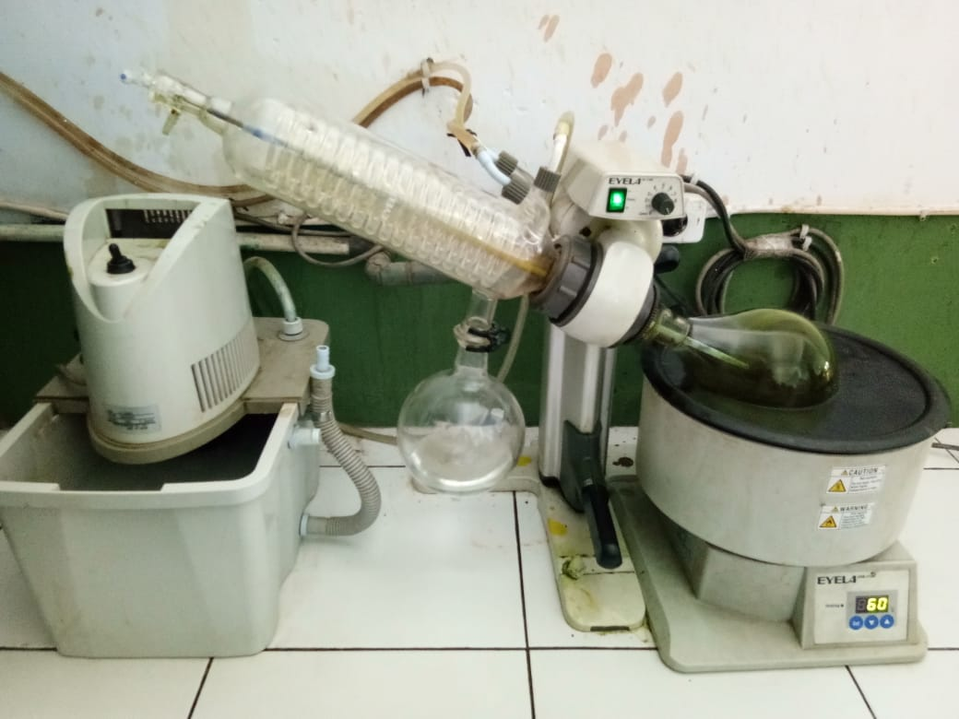

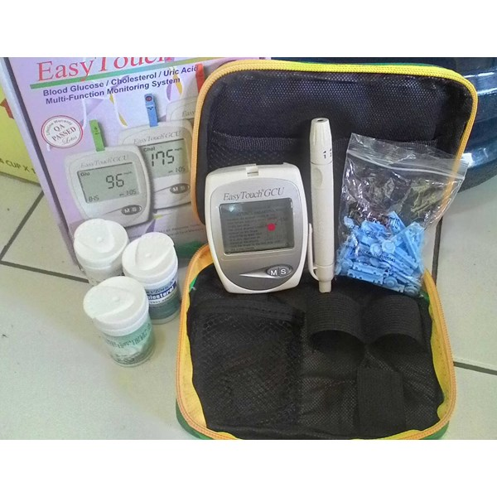

Gambar 7. Alat Rotary Evaporator

Gambar 8. Alat Azeotrop Gambar 9. Alat pengukur gula darah

Lampiran 13. Skrining Fitokimia Daun Binahong
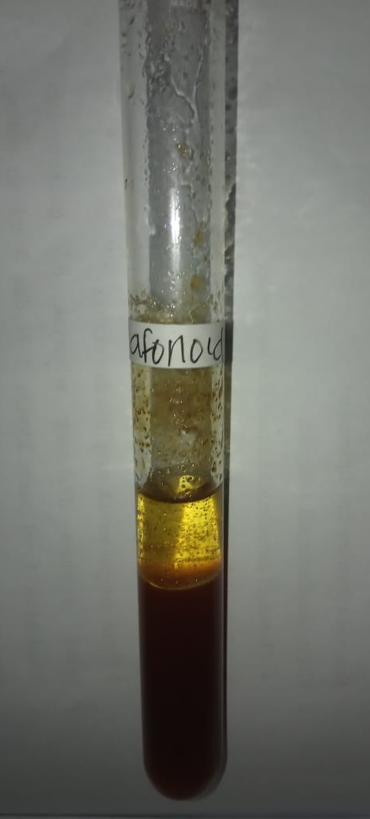
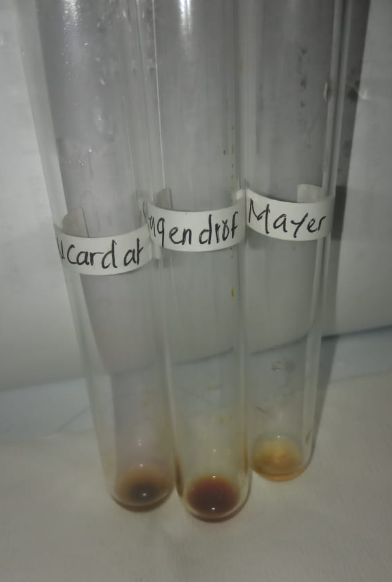
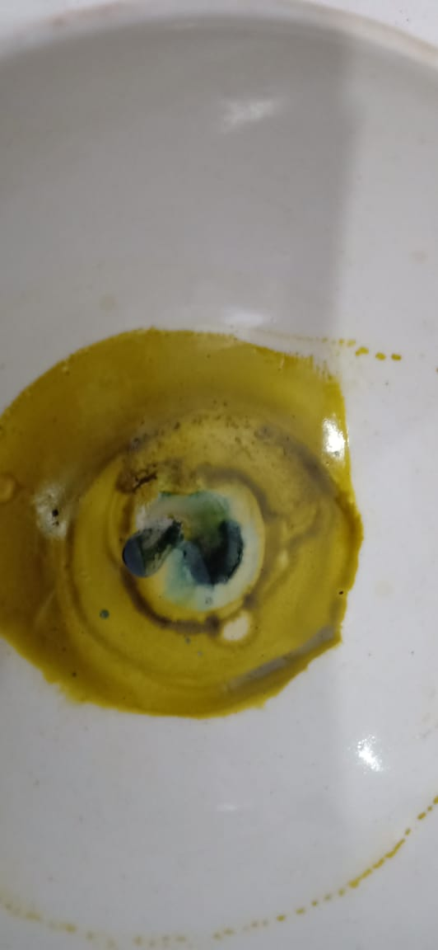
Pemeriksaan Steroit Alkaloid
Flavonoid
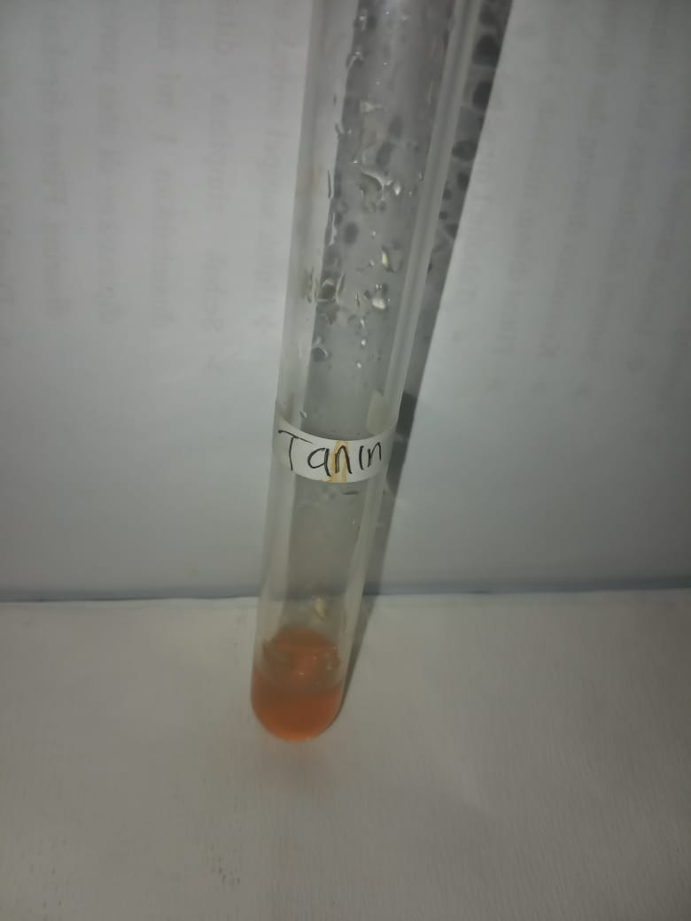
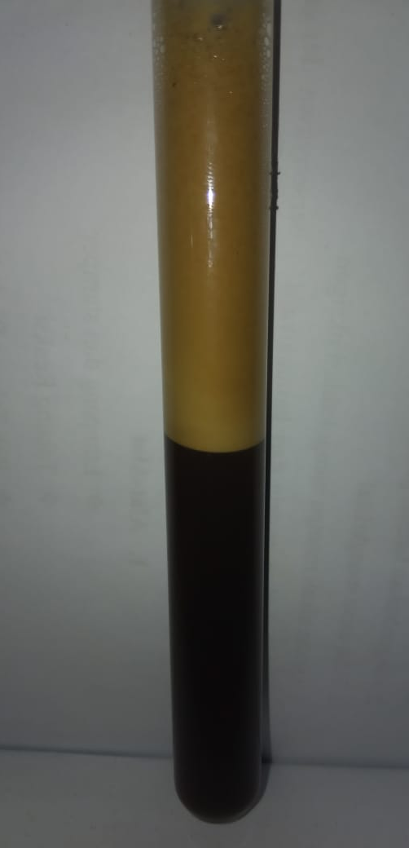

Saponin Tanin

Lampiran 14. Hewan Percobaan dan NovoRapid

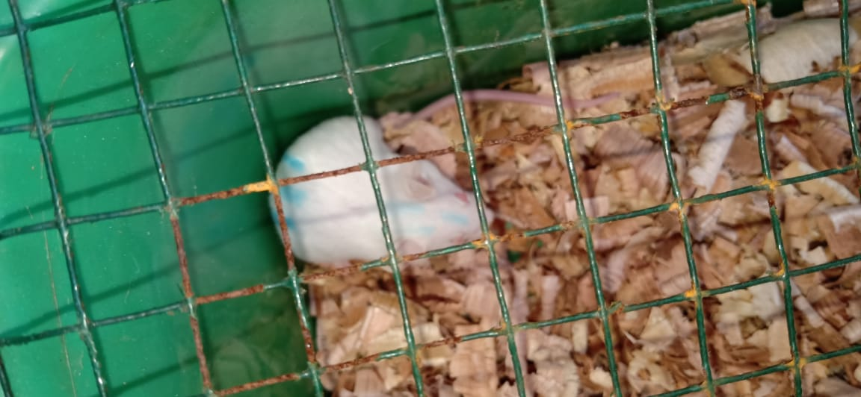
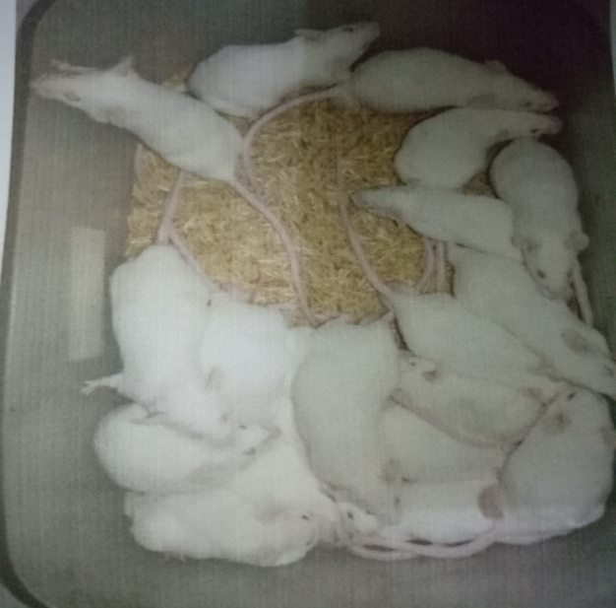
Hewan Percobaan
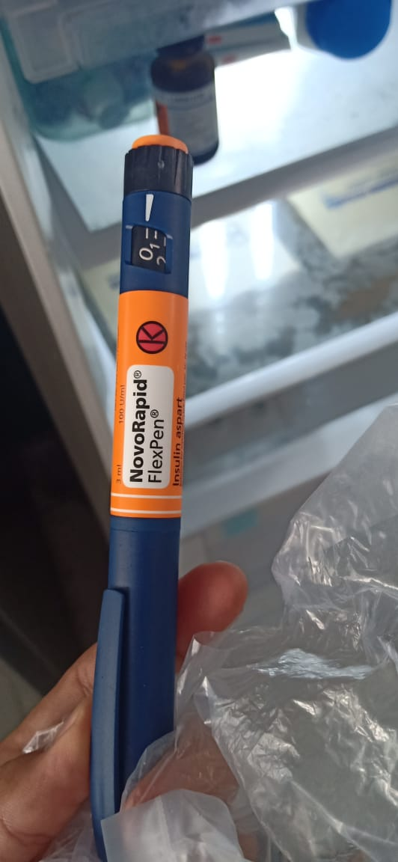
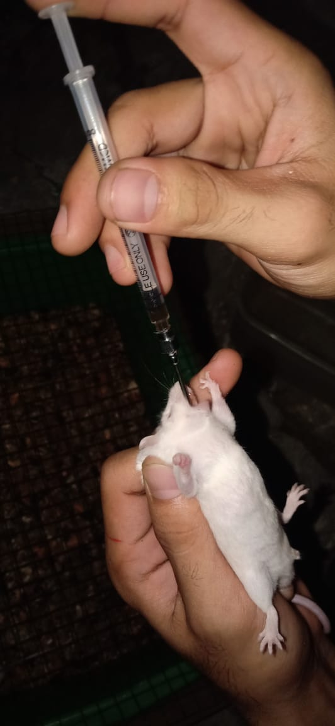

NovoRapid Pemberian Suspensi EDB

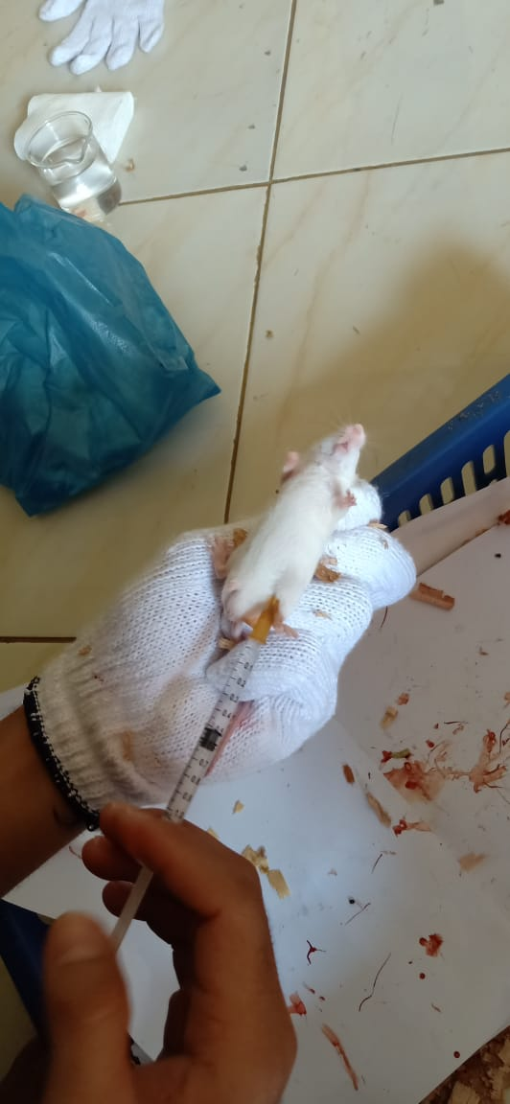
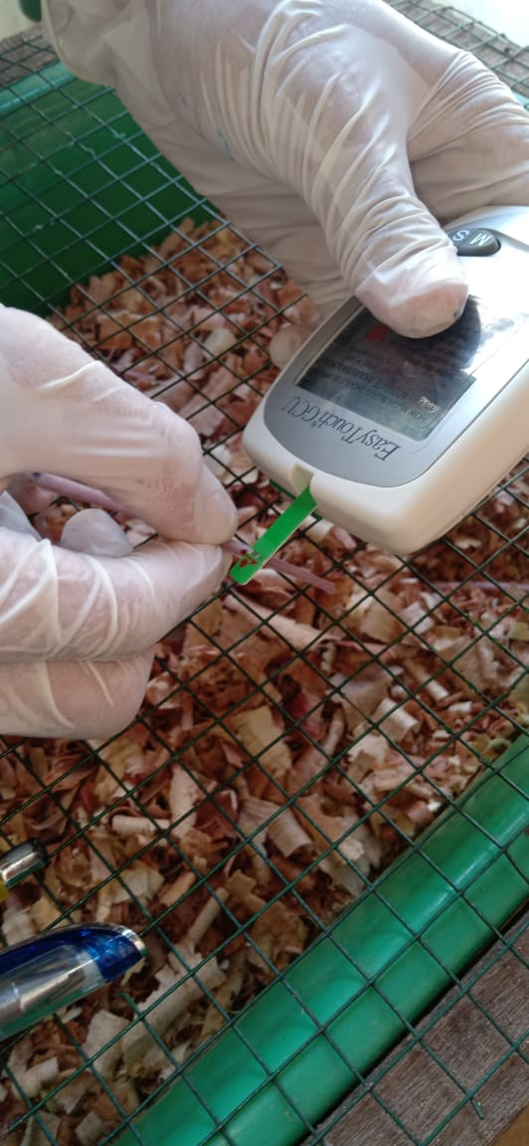
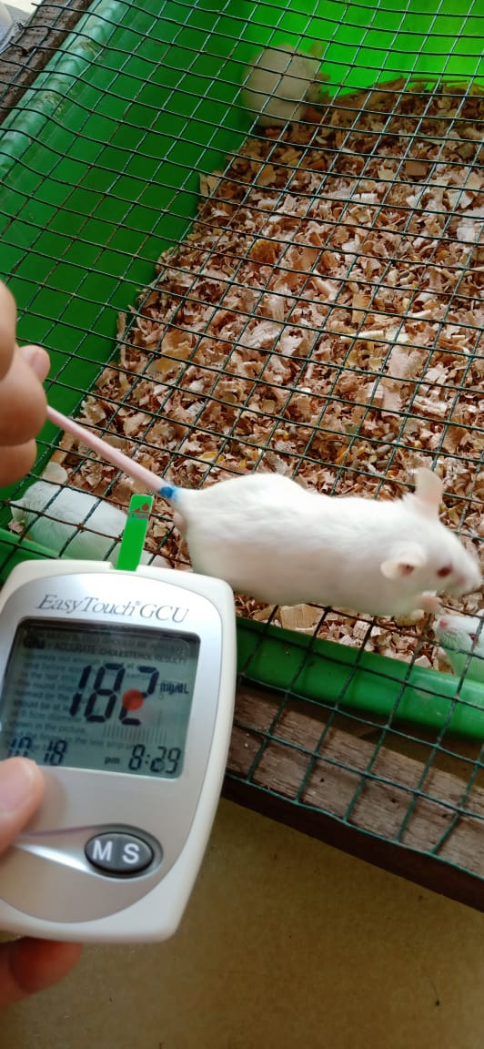

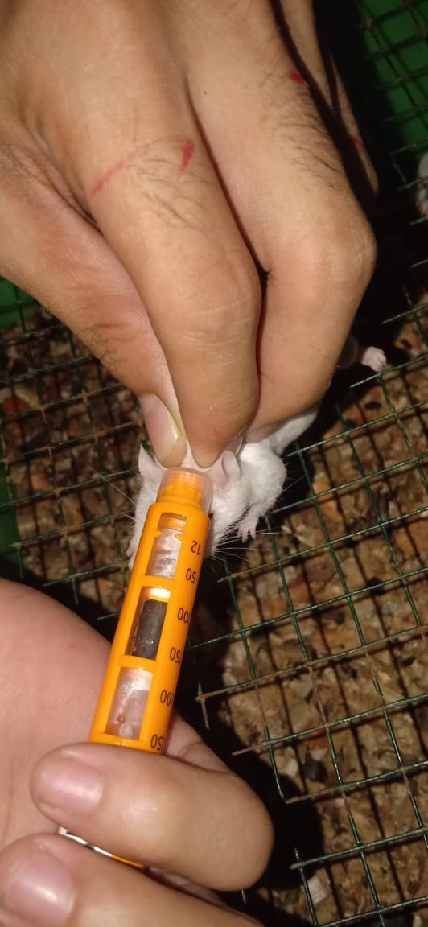
Hasil Kadar Gula Darah
Pengukuran Kadar Gula Darah
Hewan uji yang diinduksi aloksan

Pemberian NovoRapid (insulin)

Lampiran 15. Tabel Pemberian Insulin Pada Mencit Diabetes

No | Dosis NovoRapid (Unit) | Mencit 1 | Mencit 2 | Mencit 3
1. | 1 Unit | 60 mg/dL | 65 mg/dL | 59 mg/dL
2. | 2 Unit | 20 mg/dl | 20 mg/dL | -
3. | 3 Unit | - | - | -
Ket: ­ = Mencit mati

Lampiran 16. Penentuan jumlah hewan uji menggunakan Rumus Federer
Jumlah mencit didapat dari rumus federer
(n-1) (t-1) > 15

Ket : n = jumlah mencit tiap kelompok
t = jumlah kelompok
Dalam penelitian ini hewan uji dibagi dalam 5 kelompok. jadi jumlah hewan uji yang digunakan dalam 1 kelompok adalah :
(n-1) (t-1) > 15
(n-1) (5-1) > 15
(n-1) 4 > 15
4n-4 > 15
4n > 19
n > 4,75
jadi, jumlah hewan uji dalam 1 kelompok terdiri dari 5 ekor mencit

Lampiran 17. Tabel konversi dosis (g), volume maksimum lambung hewan (ml) dan contoh perhitungan dosis
Konversi | Mencit  20 g | Tikus  200 g | Marmut  400 g | Kelinci  1,5 kg | Kucing  1,5 kg | Kera  4 kg | Anjing  12 kg | Manusia  70 kg
Mencit  20 g | 1,0 | 7,0 | 12,23 | 27,80 | 29,70 | 64,10 | 124,20 | 387,9
Tikus  200 g | 0,14 | 1,0 | 1,74 | 3,90 | 4,20 | 9,20 | 17,80 | 56,0
Marmut  400 g | 0,08 | 0,57 | 1,0 | 2,25 | 2,40 | 5,20 | 10,20 | 31,50
Kelinci  1,5 kg | 0,04 | 0,25 | 0,44 | 1,0 | 1,08 | 2,40 | 4,50 | 14,20
Kucing  1,5 kg | 0,03 | 0,23 | 0,41 | 0,92 | 1,0 | 2,20 | 4,10 | 13,0
Kera  4 kg | 0,016 | 0,11 | 0,19 | 0,42 | 0,43 | 0,1 | 1,9 | 6,1
Anjing  12 kg | 0,008 | 0,06 | 0,10 | 0,22 | 1,24 | 0,52 | 1,0 | 3,10
Manusia  70 kg | 0,0026 | 0,018 | 0,031 | 0,07 | 0,076 | 0,16 | 0,32 | 1,0
Tabel konversi dosis hewan percobaan dengan manusia

Tabel volume maksimum larutan yang dapat diberikan pada hewan
Jenis hewan  Uji | Volume maksimum (ml) sesuai jalur pemberian
 | i.v | i.m | i.p | s.c | p.o
Mencit (20-30 g) | 0,5 | 0,05 | 1,0 | 0,5-1,0 | 1-0
Tikus (200 g) | 1,0 | 0,1 | 2-5 | 2-5 | 5,0
Hamster (50 g) | - | 0,1 | 1-2 | 2-5 | 2-5
Marmut (250 g) | - | 0,25 | 2-5 | 5,0 | 10,0
Kelinci (3 kg) | 5-10 | 0,5 | 10-20 | 5-10 | 20,0
Kucing (3 kg) | 5-10 | 1,0 | 10-20 | 5-10 | 50,0
Anjing (3 kg) | 10-20 | 5,0 | 20-50 | 10,0 | 100,0

- Perhitungan dosis suspensi CMC 0,5%
Suspensi CMC dibuat dengan cara melarutkan 500 mg CMC dalam 100 ml aquades panas
Konsentrasi 0,5% = $\frac{0,5 gram}{100 ml}= \frac{500 mg}{100 ml}$
Volume pemberian : 0,5 ml

- Perhitungan dosis suspensi ekstrak daun binahong 100 mg/kgBB
Dosis = $\frac{Dosis (mg)}{1000gram} x BB$
= $\frac{100 mg}{1000gram} x 25 gram=2,5 mg$
Konsentrasi 5% = ${5 g}/{100 ml}=50 mg/ml$
Volume pemberian = $\frac{Dosis}{Konsentrasi} = \frac{2,5 mg}{50 mg/ml}=0,05 ml$

- Perhitungan dosis suspensi ekstrak daun binahong 200 mg/kgBB
Dosis = $\frac{200}{1000gram} x 25 gram=5 mg$
Volume pemberian = $\frac{5mg}{50 mg/ml}=0,1 ml$

- Perhitungan dosis suspensi ekstrak daun binahong 400 mg/kgBB
Dosis = $\frac{400 mg}{1000gram} x 25 gram=10 mg$
Volume pemberian = $\frac{10 mg}{50 mg/ml}=0,2ml$

Lampiran 18. Data pengamatan penelitian kadar gula darah
Tabel hasil pengamatan kadar gula darah
No | Kelompok | Berat  Badan  (gram) | Sebelum induksi | Sesudah induksi | Waktu pengamatan KGD (mg/dL)
 |  |  |  |  | 30’ | 60’ | 90’ | 120’ | 180’ | 240’ | 300’ | 360’ | 420’
1 | CMC | 31 | 72 | 178 | 180 | 200 | 201 | 260 | 250 | 261 | 260 | 265 | 266
2 |  | 30 | 80 | 160 | 176 | 179 | 200 | 240 | 300 | 280 | 286 | 290 | 287
3 |  | 29 | 92 | 182 | 190 | 186 | 197 | 196 | 267 | 268 | 259 | 255 | 262
4 |  | 30 | 82 | 181 | 190 | 195 | 215 | 189 | 205 | 222 | 230 | 241 | 230
5 |  | 30 | 81 | 192 | 198 | 215 | 210 | 221 | 240 | 249 | 243 | 242 | 246
Rata-rata |  | 30 | 81,4 | 178,6 | 186,8 | 195 | 204,6 | 221,2 | 252,4 | 256 | 255,6 | 258,6 | 258,2
1 | NovoRapid | 31 | 60 | 204 | 176 | 145 | 136 | 124 | 115 | 99 | 112 | 113 | 115
2 |  | 31 | 76 | 197 | 160 | 136 | 129 | 125 | 119 | 97 | 97 | 120 | 105
3 |  | 29 | 83 | 180 | 140 | 147 | 140 | 121 | 109 | 96 | 98 | 121 | 104
4 |  | 28 | 96 | 212 | 173 | 140 | 136 | 132 | 100 | 98 | 102 | 115 | 121
5 |  | 30 | 84 | 209 | 174 | 157 | 150 | 140 | 122 | 89 | 107 | 99 | 113
Rata-rata |  | 29,8 | 79,8 | 200,4 | 164,6 | 145 | 138,2 | 128,4 | 113 | 95,8 | 103,2 | 113,6 | 111,6
1 | EDB 100 mg/KgBB | 29 | 84 | 190 | 160 | 149 | 136 | 118 | 114 | 94 | 102 | 110 | 109
2 |  | 30 | 81 | 192 | 173 | 138 | 136 | 115 | 108 | 95 | 96 | 92 | 114
3 |  | 30 | 98 | 174 | 168 | 122 | 131 | 119 | 112 | 93 | 90 | 97 | 115
4 |  | 32 | 99 | 201 | 170 | 130 | 128 | 121 | 103 | 90 | 89 | 115 | 110
5 |  | 31 | 102 | 204 | 150 | 149 | 127 | 122 | 119 | 92 | 99 | 102 | 113
Rata-rata |  | 30,4 | 92,8 | 192,2 | 164,2 | 137,6 | 131,6 | 119 | 111,2 | 92,8 | 95,2 | 103,2 | 112,2
1 | EDB 200 mg/KgBB | 28 | 97 | 176 | 160 | 138 | 125 | 118 | 110 | 76 | 99 | 86 | 120
2 |  | 28 | 98 | 203 | 160 | 140 | 121 | 115 | 107 | 96 | 100 | 87 | 109
3 |  | 31 | 74 | 198 | 140 | 129 | 115 | 110 | 102 | 73 | 84 | 115 | 98
4 |  | 31 | 83 | 176 | 153 | 130 | 130 | 112 | 111 | 62 | 90 | 104 | 115
5 |  | 30 | 90 | 180 | 146 | 127 | 133 | 114 | 107 | 75 | 89 | 100 | 119
Rata-rata |  | 29,6 | 88,4 | 186,6 | 151,8 | 132,8 | 124,8 | 113,8 | 107,4 | 76,4 | 92,4 | 98,4 | 112,2
1 | EDB 400 mg/KgBB | 31 | 96 | 197 | 44 | 55 | 55 | 90 | 103 | 103 | 112 | 120 | 124
2 |  | 29 | 97 | 201 | 55 | 70 | 73 | 74 | 104 | 110 | 120 | 120 | 138
3 |  | 29 | 101 | 173 | 57 | 58 | 60 | 71 | 96 | 96 | 115 | 126 | 131
4 |  | 28 | 97 | 189 | 56 | 59 | 59 | 75 | 99 | 100 | 118 | 121 | 125
5 |  | 30 | 86 | 211 | 50 | 60 | 65 | 80 | 100 | 105 | 119 | 124 | 129
Rata-rata |  | 29,4 | 95,4 | 194,2 | 52,4 | 60,4 | 62,4 | 78 | 100,4 | 102,8 | 116,8 | 122,2 | 129,4

Lampiran 19. Tabel Hasil Test Normalitas

Tests of Normality
 | Perlakuan | Kolmogorov-Smirnovª |  |  | Shapiro-Wilk
 |  | Statistic | df | Sig. | Statistic | df | Sig.
sebelum induksi | Cmc | ,266 | 5 | ,200* | ,934 | 5 | ,623
 | 100 mg/kgBB | ,196 | 5 | ,200* | ,960 | 5 | ,805
 | 200 mg/kgBB | ,306 | 5 | ,141 | ,842 | 5 | ,172
 | 400 mg/kgBB | ,204 | 5 | ,200* | ,922 | 5 | ,544
 | Pembanding | ,343 | 5 | ,055 | ,833 | 5 | ,146
setelah induksi | Cmc | ,279 | 5 | ,200* | ,910 | 5 | ,468
 | 100 mg/kgBB | ,211 | 5 | ,200* | ,899 | 5 | ,407
 | 200 mg/kgBB | ,226 | 5 | ,200* | ,923 | 5 | ,553
 | 400 mg/kgBB | ,295 | 5 | ,177 | ,811 | 5 | ,099
 | Pembanding | ,178 | 5 | ,200* | ,975 | 5 | ,907
menit 30 | Cmc | ,242 | 5 | ,200* | ,940 | 5 | ,665
 | 100 mg/kgBB | ,311 | 5 | ,129 | ,815 | 5 | ,106
 | 200 mg/kgBB | ,259 | 5 | ,200* | ,909 | 5 | ,459
 | 400 mg/kgBB | ,225 | 5 | ,200* | ,900 | 5 | ,410
 | Pembanding | ,285 | 5 | ,200* | ,868 | 5 | ,260
menit 60 | Cmc | ,159 | 5 | ,200* | ,979 | 5 | ,926
 | 100 mg/kgBB | ,201 | 5 | ,200* | ,964 | 5 | ,835
 | 200 mg/kgBB | ,232 | 5 | ,200* | ,905 | 5 | ,436
 | 400 mg/kgBB | ,285 | 5 | ,200* | ,867 | 5 | ,256
 | Pembanding | ,328 | 5 | ,084 | ,846 | 5 | ,181
menit 90 | Cmc | ,283 | 5 | ,200* | ,902 | 5 | ,420
 | 100 mg/kgBB | ,213 | 5 | ,200* | ,940 | 5 | ,669
 | 200 mg/kgBB | ,248 | 5 | ,200* | ,855 | 5 | ,212
 | 400 mg/kgBB | ,166 | 5 | ,200* | ,976 | 5 | ,910
 | Pembanding | ,236 | 5 | ,200* | ,941 | 5 | ,671
menit 120 | Cmc | ,318 | 5 | ,111 | ,780 | 5 | ,055
 | 100 mg/kgBB | ,213 | 5 | ,200* | ,939 | 5 | ,656
 | 200 mg/kgBB | ,237 | 5 | ,200* | ,961 | 5 | ,814
 | 400 mg/kgBB | ,281 | 5 | ,200* | ,821 | 5 | ,118
 | Pembanding | ,173 | 5 | ,200* | ,958 | 5 | ,794
menit 180 | Cmc | ,211 | 5 | ,200* | ,968 | 5 | ,864
 | 100 mg/kgBB | ,167 | 5 | ,200* | ,961 | 5 | ,815
 | 200 mg/kgBB | ,179 | 5 | ,200* | ,962 | 5 | ,823
 | 400 mg/kgBB | ,258 | 5 | ,200* | ,925 | 5 | ,563
 | Pembanding | ,191 | 5 | ,200* | ,958 | 5 | ,794
menit 240 | Cmc | ,167 | 5 | ,200* | ,961 | 5 | ,815
 | 100 mg/kgBB | ,241 | 5 | ,200* | ,903 | 5 | ,427
 | 200 mg/kgBB | ,237 | 5 | ,200* | ,961 | 5 | ,814
 | 400 mg/kgBB | ,184 | 5 | ,200* | ,978 | 5 | ,921
 | Pembanding | ,138 | 5 | ,200* | ,997 | 5 | ,998
menit 300 | Cmc | ,310 | 5 | ,131 | ,871 | 5 | ,272
 | 100 mg/kgBB | ,220 | 5 | ,200* | ,889 | 5 | ,350
 | 200 mg/kgBB | ,259 | 5 | ,200* | ,888 | 5 | ,345
 | 400 mg/kgBB | ,227 | 5 | ,200* | ,910 | 5 | ,468
 | Pembanding | ,243 | 5 | ,200* | ,922 | 5 | ,544
menit 360 | Cmc | ,195 | 5 | ,200* | ,894 | 5 | ,378
 | 100 mg/kgBB | ,273 | 5 | ,200* | ,855 | 5 | ,211
 | 200 mg/kgBB | ,166 | 5 | ,200* | ,968 | 5 | ,860
 | 400 mg/kgBB | ,225 | 5 | ,200* | ,921 | 5 | ,538
 | Pembanding | ,273 | 5 | ,200* | ,852 | 5 | ,201
menit 420 | Cmc | ,231 | 5 | ,200* | ,853 | 5 | ,204
 | 100 mg/kgBB | ,223 | 5 | ,200* | ,925 | 5 | ,565
 | 200 mg/kgBB | ,221 | 5 | ,200* | ,915 | 5 | ,501
 | 400 mg/kgBB | ,242 | 5 | ,200* | ,954 | 5 | ,763
 | Pembanding | ,187 | 5 | ,200* | ,924 | 5 | ,553
*. This is a lower bound of the true significance.
a. Lilliefors Significance Correction

Lampiran 20. Tabel Hasil Deskriptif
Descriptives
 |  | N | Mean | Std. Deviation | Std. Error | 95% Confidence Interval for Mean |  | Minimum | Maximum
 |  |  |  |  |  | Lower Bound | Upper Bound
sebelum induksi | cmc | 5 | 81,40 | 7,127 | 3,187 | 72,55 | 90,25 | 72 | 92
 | 100 mg/kgBB | 5 | 79,80 | 13,198 | 5,903 | 63,41 | 96,19 | 60 | 96
 | 200 mg/kgBB | 5 | 92,80 | 9,576 | 4,283 | 80,91 | 104,69 | 81 | 102
 | 400 mg/kgBB | 5 | 88,40 | 10,065 | 4,501 | 75,90 | 100,90 | 74 | 98
 | pembanding | 5 | 95,40 | 5,595 | 2,502 | 88,45 | 102,35 | 86 | 101
 | Total | 25 | 87,56 | 10,677 | 2,135 | 83,15 | 91,97 | 60 | 102
setelah induksi | cmc | 5 | 178,60 | 11,653 | 5,212 | 164,13 | 193,07 | 160 | 192
 | 100 mg/kgBB | 5 | 200,40 | 12,740 | 5,697 | 184,58 | 216,22 | 180 | 212
 | 200 mg/kgBB | 5 | 192,20 | 11,756 | 5,257 | 177,60 | 206,80 | 174 | 204
 | 400 mg/kgBB | 5 | 186,60 | 12,915 | 5,776 | 170,56 | 202,64 | 176 | 203
 | pembanding | 5 | 194,20 | 14,255 | 6,375 | 176,50 | 211,90 | 173 | 211
 | Total | 25 | 190,40 | 13,817 | 2,763 | 184,70 | 196,10 | 160 | 212
menit 30 | cmc | 5 | 186,80 | 8,786 | 3,929 | 175,89 | 197,71 | 176 | 198
 | 100 mg/kgBB | 5 | 164,60 | 15,126 | 6,765 | 145,82 | 183,38 | 140 | 176
 | 200 mg/kgBB | 5 | 164,20 | 9,284 | 4,152 | 152,67 | 175,73 | 150 | 173
 | 400 mg/kgBB | 5 | 151,80 | 8,786 | 3,929 | 140,89 | 162,71 | 140 | 160
 | pembanding | 5 | 52,40 | 5,413 | 2,421 | 45,68 | 59,12 | 44 | 57
 | Total | 25 | 143,96 | 48,978 | 9,796 | 123,74 | 164,18 | 44 | 198
menit 60 | cmc | 5 | 195,00 | 13,802 | 6,173 | 177,86 | 212,14 | 179 | 215
 | 100 mg/kgBB | 5 | 145,00 | 7,969 | 3,564 | 135,11 | 154,89 | 136 | 157
 | 200 mg/kgBB | 5 | 137,60 | 11,845 | 5,297 | 122,89 | 152,31 | 122 | 149
 | 400 mg/kgBB | 5 | 132,80 | 5,805 | 2,596 | 125,59 | 140,01 | 127 | 140
 | pembanding | 5 | 60,40 | 5,683 | 2,542 | 53,34 | 67,46 | 55 | 70
 | Total | 25 | 134,16 | 44,818 | 8,964 | 115,66 | 152,66 | 55 | 215
menit 90 | cmc | 5 | 204,60 | 7,570 | 3,385 | 195,20 | 214,00 | 197 | 215
 | 100 mg/kgBB | 5 | 138,20 | 7,694 | 3,441 | 128,65 | 147,75 | 129 | 150
 | 200 mg/kgBB | 5 | 131,60 | 4,278 | 1,913 | 126,29 | 136,91 | 127 | 136
 | 400 mg/kgBB | 5 | 124,80 | 7,155 | 3,200 | 115,92 | 133,68 | 115 | 133
 | pembanding | 5 | 62,40 | 6,914 | 3,092 | 53,82 | 70,98 | 55 | 73
 | Total | 25 | 132,32 | 46,529 | 9,306 | 113,11 | 151,53 | 55 | 215
menit 120 | cmc | 5 | 223,20 | 4,550 | 2,035 | 217,55 | 228,85 | 220 | 231
 | 100 mg/kgBB | 5 | 129,20 | 2,775 | 1,241 | 125,75 | 132,65 | 125 | 132
 | 200 mg/kgBB | 5 | 120,60 | 1,140 | ,510 | 119,18 | 122,02 | 119 | 122
 | 400 mg/kgBB | 5 | 116,20 | 3,834 | 1,715 | 111,44 | 120,96 | 110 | 119
 | pembanding | 5 | 78,40 | 3,209 | 1,435 | 74,42 | 82,38 | 75 | 83
 | Total | 25 | 133,52 | 49,181 | 9,836 | 113,22 | 153,82 | 75 | 231
menit 180 | cmc | 5 | 252,80 | 9,731 | 4,352 | 240,72 | 264,88 | 240 | 267
 | 100 mg/kgBB | 5 | 115,60 | 4,930 | 2,205 | 109,48 | 121,72 | 110 | 122
 | 200 mg/kgBB | 5 | 111,80 | 2,864 | 1,281 | 108,24 | 115,36 | 108 | 115
 | 400 mg/kgBB | 5 | 108,00 | 2,449 | 1,095 | 104,96 | 111,04 | 105 | 111
 | pembanding | 5 | 100,40 | 3,209 | 1,435 | 96,42 | 104,38 | 96 | 104
 | Total | 25 | 137,72 | 59,153 | 11,831 | 113,30 | 162,14 | 96 | 267
menit 240 | cmc | 5 | 261,60 | 4,930 | 2,205 | 255,48 | 267,72 | 256 | 268
 | 100 mg/kgBB | 5 | 96,40 | 2,702 | 1,208 | 93,05 | 99,75 | 92 | 99
 | 200 mg/kgBB | 5 | 93,40 | 1,140 | ,510 | 91,98 | 94,82 | 92 | 95
 | 400 mg/kgBB | 5 | 75,00 | 3,391 | 1,517 | 70,79 | 79,21 | 71 | 80
 | pembanding | 5 | 102,80 | 5,263 | 2,354 | 96,27 | 109,33 | 96 | 110
 | Total | 25 | 125,84 | 70,005 | 14,001 | 96,94 | 154,74 | 71 | 268
menit 300 | cmc | 5 | 257,80 | 2,168 | ,970 | 255,11 | 260,49 | 255 | 260
 | 100 mg/kgBB | 5 | 102,40 | 5,030 | 2,249 | 96,15 | 108,65 | 97 | 108
 | 200 mg/kgBB | 5 | 95,40 | 3,912 | 1,749 | 90,54 | 100,26 | 89 | 99
 | 400 mg/kgBB | 5 | 92,00 | 6,364 | 2,846 | 84,10 | 99,90 | 84 | 99
 | pembanding | 5 | 116,80 | 3,271 | 1,463 | 112,74 | 120,86 | 112 | 120
 | Total | 25 | 132,88 | 64,462 | 12,892 | 106,27 | 159,49 | 84 | 260
menit 360 | cmc | 5 | 258,60 | 20,157 | 9,014 | 233,57 | 283,63 | 241 | 290
 | 100 mg/kgBB | 5 | 113,60 | 8,820 | 3,945 | 102,65 | 124,55 | 99 | 121
 | 200 mg/kgBB | 5 | 103,20 | 9,365 | 4,188 | 91,57 | 114,83 | 92 | 115
 | 400 mg/kgBB | 5 | 98,40 | 12,178 | 5,446 | 83,28 | 113,52 | 86 | 115
 | pembanding | 5 | 122,20 | 2,683 | 1,200 | 118,87 | 125,53 | 120 | 126
 | Total | 25 | 139,20 | 62,489 | 12,498 | 113,41 | 164,99 | 86 | 290
menit 420 | cmc | 5 | 259,40 | 8,112 | 3,628 | 249,33 | 269,47 | 246 | 266
 | 100 mg/kgBB | 5 | 111,60 | 7,127 | 3,187 | 102,75 | 120,45 | 104 | 121
 | 200 mg/kgBB | 5 | 112,20 | 2,588 | 1,158 | 108,99 | 115,41 | 109 | 115
 | 400 mg/kgBB | 5 | 110,20 | 8,228 | 3,680 | 99,98 | 120,42 | 98 | 120
 | pembanding | 5 | 129,40 | 5,595 | 2,502 | 122,45 | 136,35 | 124 | 138
 | Total | 25 | 144,56 | 59,354 | 11,871 | 120,06 | 169,06 | 98 | 266

Lampiran 21. Tabel Hasil Homogenitas

Test of Homogeneity of Variances
 | Levene Statistic | df1 | df2 | Sig.
sebelum induksi | 1,181 | 4 | 20 | ,349
setelah induksi | ,224 | 4 | 20 | ,922
menit 30 | 1,547 | 4 | 20 | ,227
menit 60 | 1,344 | 4 | 20 | ,288
menit 90 | ,441 | 4 | 20 | ,778
menit 120 | 1,161 | 4 | 20 | ,358
menit 180 | 1,746 | 4 | 20 | ,179
menit 240 | 1,943 | 4 | 20 | ,143
menit 300 | 2,259 | 4 | 20 | ,099
menit 360 | 2,728 | 4 | 20 | ,058
menit 420 | ,960 | 4 | 20 | ,451

Lampiran 22. Tabel Hasil Anova
ANOVA
 |  | Sum of Squares | df | Mean Square | F | Sig.
sebelum induksi | Between Groups | 938,960 | 4 | 234,740 | 2,612 | ,066
 | Within Groups | 1797,200 | 20 | 89,860
 | Total | 2736,160 | 24
setelah induksi | Between Groups | 1356,800 | 4 | 339,200 | 2,103 | ,118
 | Within Groups | 3225,200 | 20 | 161,260
 | Total | 4582,000 | 24
menit 30 | Between Groups | 55578,160 | 4 | 13894,540 | 139,308 | ,000
 | Within Groups | 1994,800 | 20 | 99,740
 | Total | 57572,960 | 24
menit 60 | Between Groups | 46366,160 | 4 | 11591,540 | 125,913 | ,000
 | Within Groups | 1841,200 | 20 | 92,060
 | Total | 48207,360 | 24
menit 90 | Between Groups | 51024,240 | 4 | 12756,060 | 272,799 | ,000
 | Within Groups | 935,200 | 20 | 46,760
 | Total | 51959,440 | 24
menit 120 | Between Groups | 57831,440 | 4 | 14457,860 | 1321,559 | ,000
 | Within Groups | 218,800 | 20 | 10,940
 | Total | 58050,240 | 24
menit 180 | Between Groups | 83403,040 | 4 | 20850,760 | 726,507 | ,000
 | Within Groups | 574,000 | 20 | 28,700
 | Total | 83977,040 | 24
menit 240 | Between Groups | 117326,960 | 4 | 29331,740 | 2034,101 | ,000
 | Within Groups | 288,400 | 20 | 14,420
 | Total | 117615,360 | 24
menit 300 | Between Groups | 99342,640 | 4 | 24835,660 | 1286,822 | ,000
 | Within Groups | 386,000 | 20 | 19,300
 | Total | 99728,640 | 24
menit 360 | Between Groups | 90806,800 | 4 | 22701,700 | 156,068 | ,000
 | Within Groups | 2909,200 | 20 | 145,460
 | Total | 93716,000 | 24
menit 420 | Between Groups | 83660,960 | 4 | 20915,240 | 470,428 | ,000
 | Within Groups | 889,200 | 20 | 44,460
 | Total | 84550,160 | 24

Lampiran 23. Tabel Hasil Post Hoc Tests
Multiple Comparisons
Tukey HSD
Dependent Variable | (I) perlakuan | (J) perlakuan | Mean Difference (I-J) | Std. Error | Sig. | 95% Confidence Interval
 |  |  |  |  |  | Lower Bound | Upper Bound
sebelum induksi | cmc | 100 mg/kgBB | 1,600 | 5,995 | ,999 | -16,34 | 19,54
 |  | 200 mg/kgBB | -11,400 | 5,995 | ,348 | -29,34 | 6,54
 |  | 400 mg/kgBB | -7,000 | 5,995 | ,769 | -24,94 | 10,94
 |  | pembanding | -14,000 | 5,995 | ,175 | -31,94 | 3,94
 | 100 mg/kgBB | Cmc | -1,600 | 5,995 | ,999 | -19,54 | 16,34
 |  | 200 mg/kgBB | -13,000 | 5,995 | ,232 | -30,94 | 4,94
 |  | 400 mg/kgBB | -8,600 | 5,995 | ,614 | -26,54 | 9,34
 |  | pembanding | -15,600 | 5,995 | ,108 | -33,54 | 2,34
 | 200 mg/kgBB | Cmc | 11,400 | 5,995 | ,348 | -6,54 | 29,34
 |  | 100 mg/kgBB | 13,000 | 5,995 | ,232 | -4,94 | 30,94
 |  | 400 mg/kgBB | 4,400 | 5,995 | ,946 | -13,54 | 22,34
 |  | pembanding | -2,600 | 5,995 | ,992 | -20,54 | 15,34
 | 400 mg/kgBB | Cmc | 7,000 | 5,995 | ,769 | -10,94 | 24,94
 |  | 100 mg/kgBB | 8,600 | 5,995 | ,614 | -9,34 | 26,54
 |  | 200 mg/kgBB | -4,400 | 5,995 | ,946 | -22,34 | 13,54
 |  | pembanding | -7,000 | 5,995 | ,769 | -24,94 | 10,94
 | pembanding | Cmc | 14,000 | 5,995 | ,175 | -3,94 | 31,94
 |  | 100 mg/kgBB | 15,600 | 5,995 | ,108 | -2,34 | 33,54
 |  | 200 mg/kgBB | 2,600 | 5,995 | ,992 | -15,34 | 20,54
 |  | 400 mg/kgBB | 7,000 | 5,995 | ,769 | -10,94 | 24,94
setelah induksi | cmc | 100 mg/kgBB | -21,800 | 8,031 | ,087 | -45,83 | 2,23
 |  | 200 mg/kgBB | -13,600 | 8,031 | ,460 | -37,63 | 10,43
 |  | 400 mg/kgBB | -8,000 | 8,031 | ,854 | -32,03 | 16,03
 |  | pembanding | -15,600 | 8,031 | ,328 | -39,63 | 8,43
 | 100 mg/kgBB | Cmc | 21,800 | 8,031 | ,087 | -2,23 | 45,83
 |  | 200 mg/kgBB | 8,200 | 8,031 | ,843 | -15,83 | 32,23
 |  | 400 mg/kgBB | 13,800 | 8,031 | ,446 | -10,23 | 37,83
 |  | pembanding | 6,200 | 8,031 | ,936 | -17,83 | 30,23
 | 200 mg/kgBB | Cmc | 13,600 | 8,031 | ,460 | -10,43 | 37,63
 |  | 100 mg/kgBB | -8,200 | 8,031 | ,843 | -32,23 | 15,83
 |  | 400 mg/kgBB | 5,600 | 8,031 | ,955 | -18,43 | 29,63
 |  | pembanding | -2,000 | 8,031 | ,999 | -26,03 | 22,03
 | 400 mg/kgBB | Cmc | 8,000 | 8,031 | ,854 | -16,03 | 32,03
 |  | 100 mg/kgBB | -13,800 | 8,031 | ,446 | -37,83 | 10,23
 |  | 200 mg/kgBB | -5,600 | 8,031 | ,955 | -29,63 | 18,43
 |  | pembanding | -7,600 | 8,031 | ,875 | -31,63 | 16,43
 | pembanding | Cmc | 15,600 | 8,031 | ,328 | -8,43 | 39,63
 |  | 100 mg/kgBB | -6,200 | 8,031 | ,936 | -30,23 | 17,83
 |  | 200 mg/kgBB | 2,000 | 8,031 | ,999 | -22,03 | 26,03
 |  | 400 mg/kgBB | 7,600 | 8,031 | ,875 | -16,43 | 31,63
menit 30 | cmc | 100 mg/kgBB | 22,200* | 6,316 | ,017 | 3,30 | 41,10
 |  | 200 mg/kgBB | 22,600* | 6,316 | ,014 | 3,70 | 41,50
 |  | 400 mg/kgBB | 35,000* | 6,316 | ,000 | 16,10 | 53,90
 |  | pembanding | 134,400* | 6,316 | ,000 | 115,50 | 153,30
 | 100 mg/kgBB | Cmc | -22,200* | 6,316 | ,017 | -41,10 | -3,30
 |  | 200 mg/kgBB | ,400 | 6,316 | 1,000 | -18,50 | 19,30
 |  | 400 mg/kgBB | 12,800 | 6,316 | ,290 | -6,10 | 31,70
 |  | pembanding | 112,200* | 6,316 | ,000 | 93,30 | 131,10
 | 200 mg/kgBB | Cmc | -22,600* | 6,316 | ,014 | -41,50 | -3,70
 |  | 100 mg/kgBB | -,400 | 6,316 | 1,000 | -19,30 | 18,50
 |  | 400 mg/kgBB | 12,400 | 6,316 | ,319 | -6,50 | 31,30
 |  | pembanding | 111,800* | 6,316 | ,000 | 92,90 | 130,70
 | 400 mg/kgBB | Cmc | -35,000* | 6,316 | ,000 | -53,90 | -16,10
 |  | 100 mg/kgBB | -12,800 | 6,316 | ,290 | -31,70 | 6,10
 |  | 200 mg/kgBB | -12,400 | 6,316 | ,319 | -31,30 | 6,50
 |  | pembanding | 99,400* | 6,316 | ,000 | 80,50 | 118,30
 | pembanding | Cmc | -134,400* | 6,316 | ,000 | -153,30 | -115,50
 |  | 100 mg/kgBB | -112,200* | 6,316 | ,000 | -131,10 | -93,30
 |  | 200 mg/kgBB | -111,800* | 6,316 | ,000 | -130,70 | -92,90
 |  | 400 mg/kgBB | -99,400* | 6,316 | ,000 | -118,30 | -80,50
menit 60 | cmc | 100 mg/kgBB | 50,000* | 6,068 | ,000 | 31,84 | 68,16
 |  | 200 mg/kgBB | 57,400* | 6,068 | ,000 | 39,24 | 75,56
 |  | 400 mg/kgBB | 62,200* | 6,068 | ,000 | 44,04 | 80,36
 |  | pembanding | 134,600* | 6,068 | ,000 | 116,44 | 152,76
 | 100 mg/kgBB | Cmc | -50,000* | 6,068 | ,000 | -68,16 | -31,84
 |  | 200 mg/kgBB | 7,400 | 6,068 | ,741 | -10,76 | 25,56
 |  | 400 mg/kgBB | 12,200 | 6,068 | ,297 | -5,96 | 30,36
 |  | pembanding | 84,600* | 6,068 | ,000 | 66,44 | 102,76
 | 200 mg/kgBB | Cmc | -57,400* | 6,068 | ,000 | -75,56 | -39,24
 |  | 100 mg/kgBB | -7,400 | 6,068 | ,741 | -25,56 | 10,76
 |  | 400 mg/kgBB | 4,800 | 6,068 | ,930 | -13,36 | 22,96
 |  | pembanding | 77,200* | 6,068 | ,000 | 59,04 | 95,36
 | 400 mg/kgBB | Cmc | -62,200* | 6,068 | ,000 | -80,36 | -44,04
 |  | 100 mg/kgBB | -12,200 | 6,068 | ,297 | -30,36 | 5,96
 |  | 200 mg/kgBB | -4,800 | 6,068 | ,930 | -22,96 | 13,36
 |  | pembanding | 72,400* | 6,068 | ,000 | 54,24 | 90,56
 | pembanding | Cmc | -134,600* | 6,068 | ,000 | -152,76 | -116,44
 |  | 100 mg/kgBB | -84,600* | 6,068 | ,000 | -102,76 | -66,44
 |  | 200 mg/kgBB | -77,200* | 6,068 | ,000 | -95,36 | -59,04
 |  | 400 mg/kgBB | -72,400* | 6,068 | ,000 | -90,56 | -54,24
menit 90 | cmc | 100 mg/kgBB | 66,400* | 4,325 | ,000 | 53,46 | 79,34
 |  | 200 mg/kgBB | 73,000* | 4,325 | ,000 | 60,06 | 85,94
 |  | 400 mg/kgBB | 79,800* | 4,325 | ,000 | 66,86 | 92,74
 |  | pembanding | 142,200* | 4,325 | ,000 | 129,26 | 155,14
 | 100 mg/kgBB | Cmc | -66,400* | 4,325 | ,000 | -79,34 | -53,46
 |  | 200 mg/kgBB | 6,600 | 4,325 | ,558 | -6,34 | 19,54
 |  | 400 mg/kgBB | 13,400* | 4,325 | ,040 | ,46 | 26,34
 |  | pembanding | 75,800* | 4,325 | ,000 | 62,86 | 88,74
 | 200 mg/kgBB | Cmc | -73,000* | 4,325 | ,000 | -85,94 | -60,06
 |  | 100 mg/kgBB | -6,600 | 4,325 | ,558 | -19,54 | 6,34
 |  | 400 mg/kgBB | 6,800 | 4,325 | ,531 | -6,14 | 19,74
 |  | pembanding | 69,200* | 4,325 | ,000 | 56,26 | 82,14
 | 400 mg/kgBB | Cmc | -79,800* | 4,325 | ,000 | -92,74 | -66,86
 |  | 100 mg/kgBB | -13,400* | 4,325 | ,040 | -26,34 | -,46
 |  | 200 mg/kgBB | -6,800 | 4,325 | ,531 | -19,74 | 6,14
 |  | pembanding | 62,400* | 4,325 | ,000 | 49,46 | 75,34
 | pembanding | Cmc | -142,200* | 4,325 | ,000 | -155,14 | -129,26
 |  | 100 mg/kgBB | -75,800* | 4,325 | ,000 | -88,74 | -62,86
 |  | 200 mg/kgBB | -69,200* | 4,325 | ,000 | -82,14 | -56,26
 |  | 400 mg/kgBB | -62,400* | 4,325 | ,000 | -75,34 | -49,46
menit 120 | cmc | 100 mg/kgBB | 94,000* | 2,092 | ,000 | 87,74 | 100,26
 |  | 200 mg/kgBB | 102,600* | 2,092 | ,000 | 96,34 | 108,86
 |  | 400 mg/kgBB | 107,000* | 2,092 | ,000 | 100,74 | 113,26
 |  | pembanding | 144,800* | 2,092 | ,000 | 138,54 | 151,06
 | 100 mg/kgBB | Cmc | -94,000* | 2,092 | ,000 | -100,26 | -87,74
 |  | 200 mg/kgBB | 8,600* | 2,092 | ,004 | 2,34 | 14,86
 |  | 400 mg/kgBB | 13,000* | 2,092 | ,000 | 6,74 | 19,26
 |  | pembanding | 50,800* | 2,092 | ,000 | 44,54 | 57,06
 | 200 mg/kgBB | Cmc | -102,600* | 2,092 | ,000 | -108,86 | -96,34
 |  | 100 mg/kgBB | -8,600* | 2,092 | ,004 | -14,86 | -2,34
 |  | 400 mg/kgBB | 4,400 | 2,092 | ,257 | -1,86 | 10,66
 |  | pembanding | 42,200* | 2,092 | ,000 | 35,94 | 48,46
 | 400 mg/kgBB | Cmc | -107,000* | 2,092 | ,000 | -113,26 | -100,74
 |  | 100 mg/kgBB | -13,000* | 2,092 | ,000 | -19,26 | -6,74
 |  | 200 mg/kgBB | -4,400 | 2,092 | ,257 | -10,66 | 1,86
 |  | pembanding | 37,800* | 2,092 | ,000 | 31,54 | 44,06
 | pembanding | Cmc | -144,800* | 2,092 | ,000 | -151,06 | -138,54
 |  | 100 mg/kgBB | -50,800* | 2,092 | ,000 | -57,06 | -44,54
 |  | 200 mg/kgBB | -42,200* | 2,092 | ,000 | -48,46 | -35,94
 |  | 400 mg/kgBB | -37,800* | 2,092 | ,000 | -44,06 | -31,54
menit 180 | cmc | 100 mg/kgBB | 137,200* | 3,388 | ,000 | 127,06 | 147,34
 |  | 200 mg/kgBB | 141,000* | 3,388 | ,000 | 130,86 | 151,14
 |  | 400 mg/kgBB | 144,800* | 3,388 | ,000 | 134,66 | 154,94
 |  | pembanding | 152,400* | 3,388 | ,000 | 142,26 | 162,54
 | 100 mg/kgBB | Cmc | -137,200* | 3,388 | ,000 | -147,34 | -127,06
 |  | 200 mg/kgBB | 3,800 | 3,388 | ,793 | -6,34 | 13,94
 |  | 400 mg/kgBB | 7,600 | 3,388 | ,205 | -2,54 | 17,74
 |  | pembanding | 15,200* | 3,388 | ,002 | 5,06 | 25,34
 | 200 mg/kgBB | Cmc | -141,000* | 3,388 | ,000 | -151,14 | -130,86
 |  | 100 mg/kgBB | -3,800 | 3,388 | ,793 | -13,94 | 6,34
 |  | 400 mg/kgBB | 3,800 | 3,388 | ,793 | -6,34 | 13,94
 |  | pembanding | 11,400* | 3,388 | ,023 | 1,26 | 21,54
 | 400 mg/kgBB | Cmc | -144,800* | 3,388 | ,000 | -154,94 | -134,66
 |  | 100 mg/kgBB | -7,600 | 3,388 | ,205 | -17,74 | 2,54
 |  | 200 mg/kgBB | -3,800 | 3,388 | ,793 | -13,94 | 6,34
 |  | pembanding | 7,600 | 3,388 | ,205 | -2,54 | 17,74
 | pembanding | Cmc | -152,400* | 3,388 | ,000 | -162,54 | -142,26
 |  | 100 mg/kgBB | -15,200* | 3,388 | ,002 | -25,34 | -5,06
 |  | 200 mg/kgBB | -11,400* | 3,388 | ,023 | -21,54 | -1,26
 |  | 400 mg/kgBB | -7,600 | 3,388 | ,205 | -17,74 | 2,54
menit 240 | cmc | 100 mg/kgBB | 165,200* | 2,402 | ,000 | 158,01 | 172,39
 |  | 200 mg/kgBB | 168,200* | 2,402 | ,000 | 161,01 | 175,39
 |  | 400 mg/kgBB | 186,600* | 2,402 | ,000 | 179,41 | 193,79
 |  | pembanding | 158,800* | 2,402 | ,000 | 151,61 | 165,99
 | 100 mg/kgBB | Cmc | -165,200* | 2,402 | ,000 | -172,39 | -158,01
 |  | 200 mg/kgBB | 3,000 | 2,402 | ,724 | -4,19 | 10,19
 |  | 400 mg/kgBB | 21,400* | 2,402 | ,000 | 14,21 | 28,59
 |  | pembanding | -6,400 | 2,402 | ,096 | -13,59 | ,79
 | 200 mg/kgBB | Cmc | -168,200* | 2,402 | ,000 | -175,39 | -161,01
 |  | 100 mg/kgBB | -3,000 | 2,402 | ,724 | -10,19 | 4,19
 |  | 400 mg/kgBB | 18,400* | 2,402 | ,000 | 11,21 | 25,59
 |  | pembanding | -9,400* | 2,402 | ,007 | -16,59 | -2,21
 | 400 mg/kgBB | Cmc | -186,600* | 2,402 | ,000 | -193,79 | -179,41
 |  | 100 mg/kgBB | -21,400* | 2,402 | ,000 | -28,59 | -14,21
 |  | 200 mg/kgBB | -18,400* | 2,402 | ,000 | -25,59 | -11,21
 |  | pembanding | -27,800* | 2,402 | ,000 | -34,99 | -20,61
 | pembanding | Cmc | -158,800* | 2,402 | ,000 | -165,99 | -151,61
 |  | 100 mg/kgBB | 6,400 | 2,402 | ,096 | -,79 | 13,59
 |  | 200 mg/kgBB | 9,400* | 2,402 | ,007 | 2,21 | 16,59
 |  | 400 mg/kgBB | 27,800* | 2,402 | ,000 | 20,61 | 34,99
menit 300 | cmc | 100 mg/kgBB | 155,400* | 2,778 | ,000 | 147,09 | 163,71
 |  | 200 mg/kgBB | 162,400* | 2,778 | ,000 | 154,09 | 170,71
 |  | 400 mg/kgBB | 165,800* | 2,778 | ,000 | 157,49 | 174,11
 |  | pembanding | 141,000* | 2,778 | ,000 | 132,69 | 149,31
 | 100 mg/kgBB | Cmc | -155,400* | 2,778 | ,000 | -163,71 | -147,09
 |  | 200 mg/kgBB | 7,000 | 2,778 | ,126 | -1,31 | 15,31
 |  | 400 mg/kgBB | 10,400* | 2,778 | ,010 | 2,09 | 18,71
 |  | pembanding | -14,400* | 2,778 | ,000 | -22,71 | -6,09
 | 200 mg/kgBB | Cmc | -162,400* | 2,778 | ,000 | -170,71 | -154,09
 |  | 100 mg/kgBB | -7,000 | 2,778 | ,126 | -15,31 | 1,31
 |  | 400 mg/kgBB | 3,400 | 2,778 | ,738 | -4,91 | 11,71
 |  | pembanding | -21,400* | 2,778 | ,000 | -29,71 | -13,09
 | 400 mg/kgBB | Cmc | -165,800* | 2,778 | ,000 | -174,11 | -157,49
 |  | 100 mg/kgBB | -10,400* | 2,778 | ,010 | -18,71 | -2,09
 |  | 200 mg/kgBB | -3,400 | 2,778 | ,738 | -11,71 | 4,91
 |  | pembanding | -24,800* | 2,778 | ,000 | -33,11 | -16,49
 | pembanding | Cmc | -141,000* | 2,778 | ,000 | -149,31 | -132,69
 |  | 100 mg/kgBB | 14,400* | 2,778 | ,000 | 6,09 | 22,71
 |  | 200 mg/kgBB | 21,400* | 2,778 | ,000 | 13,09 | 29,71
 |  | 400 mg/kgBB | 24,800* | 2,778 | ,000 | 16,49 | 33,11
menit 360 | cmc | 100 mg/kgBB | 145,000* | 7,628 | ,000 | 122,17 | 167,83
 |  | 200 mg/kgBB | 155,400* | 7,628 | ,000 | 132,57 | 178,23
 |  | 400 mg/kgBB | 160,200* | 7,628 | ,000 | 137,37 | 183,03
 |  | pembanding | 136,400* | 7,628 | ,000 | 113,57 | 159,23
 | 100 mg/kgBB | Cmc | -145,000* | 7,628 | ,000 | -167,83 | -122,17
 |  | 200 mg/kgBB | 10,400 | 7,628 | ,657 | -12,43 | 33,23
 |  | 400 mg/kgBB | 15,200 | 7,628 | ,305 | -7,63 | 38,03
 |  | pembanding | -8,600 | 7,628 | ,790 | -31,43 | 14,23
 | 200 mg/kgBB | Cmc | -155,400* | 7,628 | ,000 | -178,23 | -132,57
 |  | 100 mg/kgBB | -10,400 | 7,628 | ,657 | -33,23 | 12,43
 |  | 400 mg/kgBB | 4,800 | 7,628 | ,969 | -18,03 | 27,63
 |  | pembanding | -19,000 | 7,628 | ,133 | -41,83 | 3,83
 | 400 mg/kgBB | Cmc | -160,200* | 7,628 | ,000 | -183,03 | -137,37
 |  | 100 mg/kgBB | -15,200 | 7,628 | ,305 | -38,03 | 7,63
 |  | 200 mg/kgBB | -4,800 | 7,628 | ,969 | -27,63 | 18,03
 |  | pembanding | -23,800* | 7,628 | ,038 | -46,63 | -,97
 | pembanding | Cmc | -136,400* | 7,628 | ,000 | -159,23 | -113,57
 |  | 100 mg/kgBB | 8,600 | 7,628 | ,790 | -14,23 | 31,43
 |  | 200 mg/kgBB | 19,000 | 7,628 | ,133 | -3,83 | 41,83
 |  | 400 mg/kgBB | 23,800* | 7,628 | ,038 | ,97 | 46,63
menit 420 | cmc | 100 mg/kgBB | 147,800* | 4,217 | ,000 | 135,18 | 160,42
 |  | 200 mg/kgBB | 147,200* | 4,217 | ,000 | 134,58 | 159,82
 |  | 400 mg/kgBB | 149,200* | 4,217 | ,000 | 136,58 | 161,82
 |  | pembanding | 130,000* | 4,217 | ,000 | 117,38 | 142,62
 | 100 mg/kgBB | Cmc | -147,800* | 4,217 | ,000 | -160,42 | -135,18
 |  | 200 mg/kgBB | -,600 | 4,217 | 1,000 | -13,22 | 12,02
 |  | 400 mg/kgBB | 1,400 | 4,217 | ,997 | -11,22 | 14,02
 |  | pembanding | -17,800* | 4,217 | ,003 | -30,42 | -5,18
 | 200 mg/kgBB | Cmc | -147,200* | 4,217 | ,000 | -159,82 | -134,58
 |  | 100 mg/kgBB | ,600 | 4,217 | 1,000 | -12,02 | 13,22
 |  | 400 mg/kgBB | 2,000 | 4,217 | ,989 | -10,62 | 14,62
 |  | pembanding | -17,200* | 4,217 | ,005 | -29,82 | -4,58
 | 400 mg/kgBB | Cmc | -149,200* | 4,217 | ,000 | -161,82 | -136,58
 |  | 100 mg/kgBB | -1,400 | 4,217 | ,997 | -14,02 | 11,22
 |  | 200 mg/kgBB | -2,000 | 4,217 | ,989 | -14,62 | 10,62
 |  | pembanding | -19,200* | 4,217 | ,002 | -31,82 | -6,58
 | pembanding | Cmc | -130,000* | 4,217 | ,000 | -142,62 | -117,38
 |  | 100 mg/kgBB | 17,800* | 4,217 | ,003 | 5,18 | 30,42
 |  | 200 mg/kgBB | 17,200* | 4,217 | ,005 | 4,58 | 29,82
 |  | 400 mg/kgBB | 19,200* | 4,217 | ,002 | 6,58 | 31,82
*. The mean difference is significant at the 0.05 level.

Lampiran 24. Tabel Hasil tukey
sebelum induksi
Tukey HSDª
Perlakuan |  |  |  |  | N |  |  |  |  | Subset for alpha = 0.05
 |  |  |  |  |  |  |  |  |  | 1
100 mg/kgBB |  |  |  |  | 5 |  |  |  |  | 79,80
Cmc |  |  |  |  | 5 |  |  |  |  | 81,40
400 mg/kgBB |  |  |  |  | 5 |  |  |  |  | 88,40
200 mg/kgBB |  |  |  |  | 5 |  |  |  |  | 92,80
Pembanding |  |  |  |  | 5 |  |  |  |  | 95,40
Sig. |  |  |  |  |  |  |  |  |  | ,108
setelah induksi
Tukey HSDª
Perlakuan |  |  |  |  | N |  |  |  |  | Subset for alpha = 0.05
 |  |  |  |  |  |  |  |  |  | 1
Cmc |  |  |  |  | 5 |  |  |  |  | 178,60
400 mg/kgBB |  |  |  |  | 5 |  |  |  |  | 186,60
200 mg/kgBB |  |  |  |  | 5 |  |  |  |  | 192,20
Pembanding |  |  |  |  | 5 |  |  |  |  | 194,20
100 mg/kgBB |  |  |  |  | 5 |  |  |  |  | 200,40
Sig. |  |  |  |  |  |  |  |  |  | ,087
menit 30
Tukey HSDª
Perlakuan |  | N |  |  |  | Subset for alpha = 0.05
 |  |  |  |  |  | 1 |  |  |  |  | 2 |  |  |  |  | 3
Pembanding |  | 5 |  |  |  | 52,40
400 mg/kgBB |  | 5 |  |  |  |  |  |  |  |  | 151,80
200 mg/kgBB |  | 5 |  |  |  |  |  |  |  |  | 164,20
100 mg/kgBB |  | 5 |  |  |  |  |  |  |  |  | 164,60
Cmc |  | 5 |  |  |  |  |  |  |  |  |  |  |  |  |  | 186,80
Sig. |  |  |  |  |  | 1,000 |  |  |  |  | ,290 |  |  |  |  | 1,000
menit 60
Tukey HSDª
Perlakuan | N |  |  |  |  |  | Subset for alpha = 0.05
 |  |  |  |  |  |  | 1 |  |  |  |  | 2 |  |  |  | 3
Pembanding | 5 |  |  |  |  |  | 60,40
400 mg/kgBB | 5 |  |  |  |  |  |  |  |  |  |  | 132,80
200 mg/kgBB | 5 |  |  |  |  |  |  |  |  |  |  | 137,60
100 mg/kgBB | 5 |  |  |  |  |  |  |  |  |  |  | 145,00
Cmc | 5 |  |  |  |  |  |  |  |  |  |  |  |  |  |  | 195,00
Sig. |  |  |  |  |  |  | 1,000 |  |  |  |  | ,297 |  |  |  | 1,000
menit 90
Tukey HSDª
perlakuan |  | N |  |  |  | Subset for alpha = 0.05
 |  |  |  |  |  | 1 |  |  |  |  | 2 |  |  |  | 3 |  |  |  | 4
pembanding |  | 5 |  |  |  | 62,40
400 mg/kgBB |  | 5 |  |  |  |  |  |  |  |  | 124,80
200 mg/kgBB |  | 5 |  |  |  |  |  |  |  |  | 131,60 |  |  |  | 131,60
100 mg/kgBB |  | 5 |  |  |  |  |  |  |  |  |  |  |  |  | 138,20
cmc |  | 5 |  |  |  |  |  |  |  |  |  |  |  |  |  |  |  |  | 204,60
Sig. |  |  |  |  |  | 1,000 |  |  |  |  | ,531 |  |  |  | ,558 |  |  |  | 1,000
menit 120
Tukey HSDª
perlakuan |  | N |  |  |  | Subset for alpha = 0.05
 |  |  |  |  |  | 1 |  |  |  |  | 2 |  |  |  | 3 |  |  |  | 4
pembanding |  | 5 |  |  |  | 78,40
400 mg/kgBB |  | 5 |  |  |  |  |  |  |  |  | 116,20
200 mg/kgBB |  | 5 |  |  |  |  |  |  |  |  | 120,60
100 mg/kgBB |  | 5 |  |  |  |  |  |  |  |  |  |  |  |  | 129,20
cmc |  | 5 |  |  |  |  |  |  |  |  |  |  |  |  |  |  |  |  | 223,20
Sig. |  |  |  |  |  | 1,000 |  |  |  |  | ,257 |  |  |  | 1,000 |  |  |  | 1,000
menit 180
Tukey HSDª
perlakuan |  |  | N |  |  |  |  | Subset for alpha = 0.05
 |  |  |  |  |  |  |  | 1 |  |  |  |  | 2 |  |  |  | 3
pembanding |  |  | 5 |  |  |  |  | 100,40
400 mg/kgBB |  |  | 5 |  |  |  |  | 108,00 |  |  |  |  | 108,00
200 mg/kgBB |  |  | 5 |  |  |  |  |  |  |  |  |  | 111,80
100 mg/kgBB |  |  | 5 |  |  |  |  |  |  |  |  |  | 115,60
cmc |  |  | 5 |  |  |  |  |  |  |  |  |  |  |  |  |  | 252,80
Sig. |  |  |  |  |  |  |  | ,205 |  |  |  |  | ,205 |  |  |  | 1,000
menit 240
Tukey HSDª
perlakuan |  | N |  |  |  | Subset for alpha = 0.05
 |  |  |  |  |  | 1 |  |  |  |  | 2 |  |  |  | 3 |  |  |  | 4
400 mg/kgBB |  | 5 |  |  |  | 75,00
200 mg/kgBB |  | 5 |  |  |  |  |  |  |  |  | 93,40
100 mg/kgBB |  | 5 |  |  |  |  |  |  |  |  | 96,40 |  |  |  | 96,40
pembanding |  | 5 |  |  |  |  |  |  |  |  |  |  |  |  | 102,80
cmc |  | 5 |  |  |  |  |  |  |  |  |  |  |  |  |  |  |  |  | 261,60
Sig. |  |  |  |  |  | 1,000 |  |  |  |  | ,724 |  |  |  | ,096 |  |  |  | 1,000
menit 300
Tukey HSDª
perlakuan |  | N |  |  |  | Subset for alpha = 0.05
 |  |  |  |  |  | 1 |  |  |  |  | 2 |  |  |  | 3 |  |  |  | 4
400 mg/kgBB |  | 5 |  |  |  | 92,00
200 mg/kgBB |  | 5 |  |  |  | 95,40 |  |  |  |  | 95,40
100 mg/kgBB |  | 5 |  |  |  |  |  |  |  |  | 102,40
pembanding |  | 5 |  |  |  |  |  |  |  |  |  |  |  |  | 116,80
cmc |  | 5 |  |  |  |  |  |  |  |  |  |  |  |  |  |  |  |  | 257,80
Sig. |  |  |  |  |  | ,738 |  |  |  |  | ,126 |  |  |  | 1,000 |  |  |  | 1,000
menit 360
Tukey HSDª
perlakuan |  |  |  | N |  |  |  |  | Subset for alpha = 0.05
 |  |  |  |  |  |  |  |  | 1 |  |  |  |  | 2 |  |  |  | 3
400 mg/kgBB |  |  |  | 5 |  |  |  |  | 98,40
200 mg/kgBB |  |  |  | 5 |  |  |  |  | 103,20 |  |  |  |  | 103,20
100 mg/kgBB |  |  |  | 5 |  |  |  |  | 113,60 |  |  |  |  | 113,60
pembanding |  |  |  | 5 |  |  |  |  |  |  |  |  |  | 122,20
cmc |  |  |  | 5 |  |  |  |  |  |  |  |  |  |  |  |  |  | 258,60
Sig. |  |  |  |  |  |  |  |  | ,305 |  |  |  |  | ,133 |  |  |  | 1,000
menit 420
Tukey HSDª
perlakuan |  |  |  | N |  |  |  |  | Subset for alpha = 0.05
 |  |  |  |  |  |  |  |  | 1 |  |  |  |  | 2 |  |  |  | 3
400 mg/kgBB |  |  |  | 5 |  |  |  |  | 110,20
100 mg/kgBB |  |  |  | 5 |  |  |  |  | 111,60
200 mg/kgBB |  |  |  | 5 |  |  |  |  | 112,20
pembanding |  |  |  | 5 |  |  |  |  |  |  |  |  |  | 129,40
cmc |  |  |  | 5 |  |  |  |  |  |  |  |  |  |  |  |  |  | 259,40
Sig. |  |  |  |  |  |  |  |  | ,989 |  |  |  |  | 1,000 |  |  |  | 1,000

