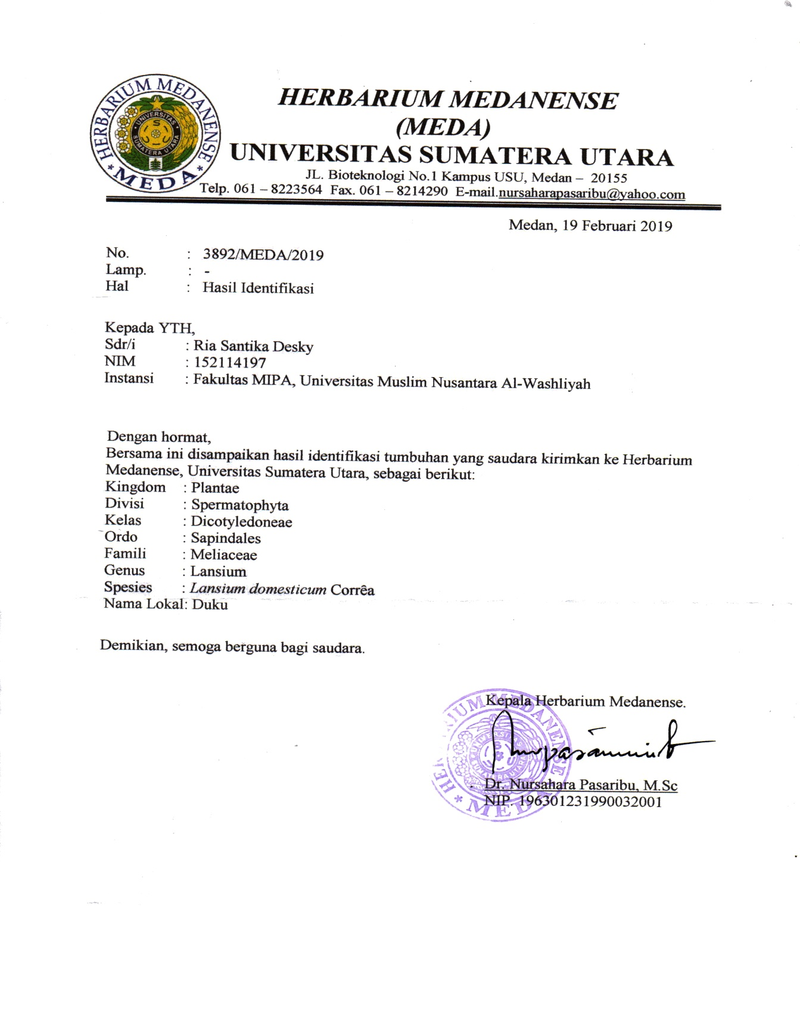**Lampiran 1.** Hasil Identifikasi Tumbuhan Kulit Buah Duku

**Lampiran 2.** Gambar Bahan Uji (Buah duku)



1. Gambar buah duku

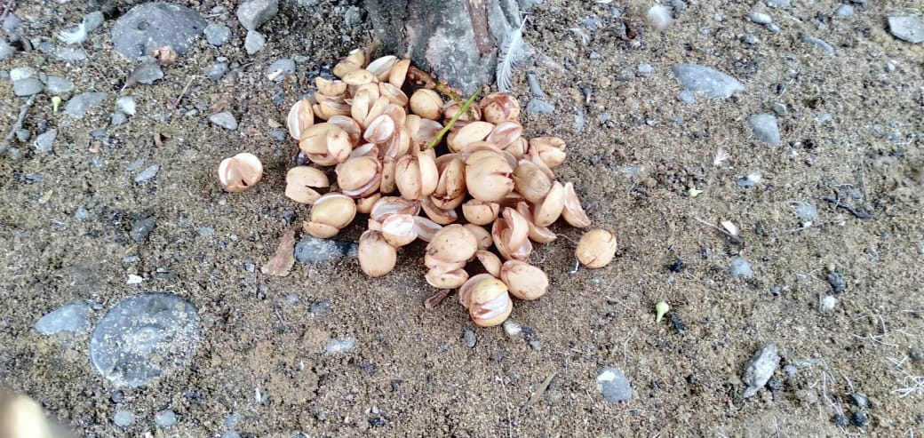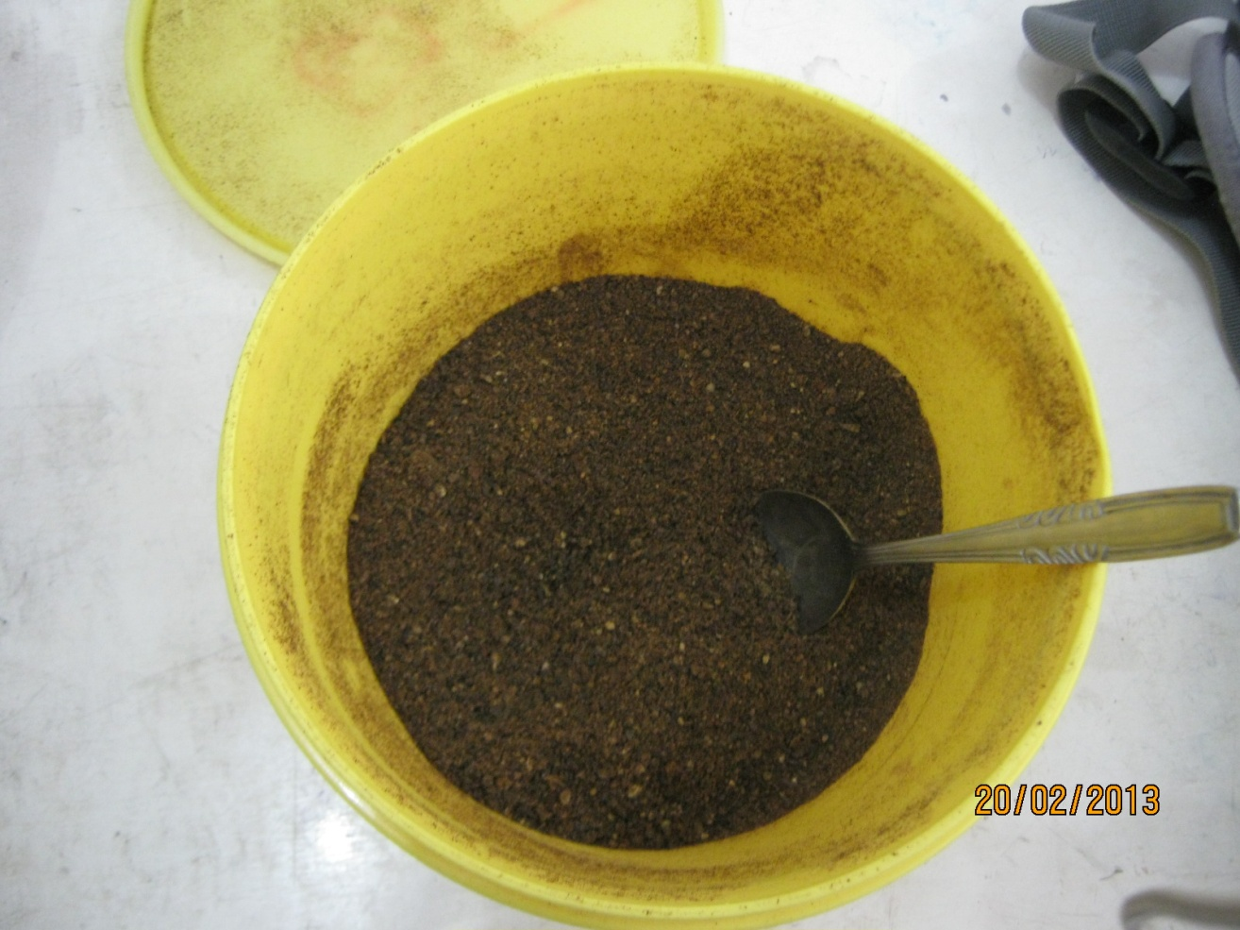

B. Gambar serbuk simplisia kulit buah duku C.Limbah kulit duku

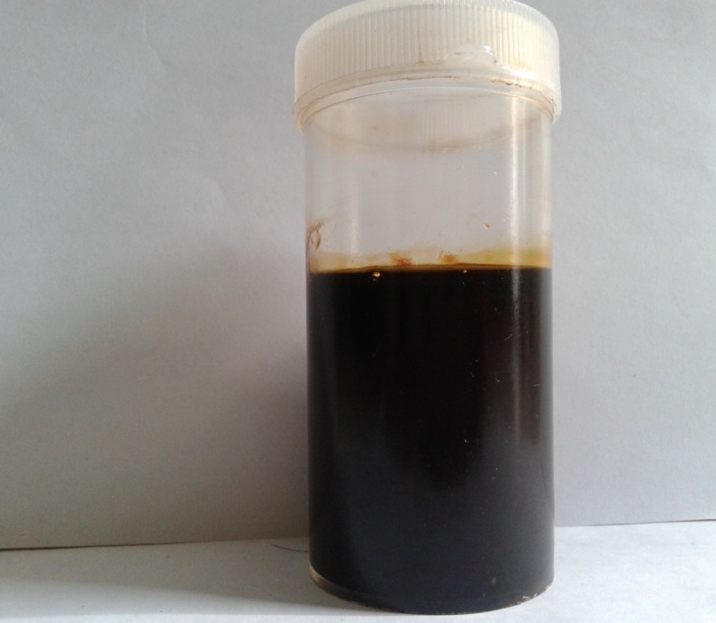

D. Gambar ekstrak etanol kulit buah duku

**Lampiran 3.** Bagan Kerja Penelitian

Kulit buah duku

Dibersihkan dari pengotoran

Dihaluskan dengan blender.

Dikeringkan di lemari

pengering suhu ± 600C

Simplisia kulit buah duku

Dihaluskan dengan blander

Serbuk simplisia kulit buah duku

Uji karakteristik simplisia:

Penentuan kadar air, kadar sari larut dalam air, sari larut dalam etanol, kadar abu, abu tidak larut dalam asam

Pembuatan Ekstrak

Skrining Fitokimia

Skrining Fiokimia

1. Alkaloida
2. Tanin
3. Flavonoida
4. Saponin
5. Glikosida
6. Triterpenoida

/Steroida

Diekstraksi dengan etanol 96%

Ekstrak cair

Didetilasi dengan rotary evaporator

Ekstrak kental

Diformulasikan ke dalam krim cair konsentrasi ekstrak kulit buah duku 2,5%, 5%,7,5%,10%

Sediaan krim

Dilakukan uji sediaan krim:

1. Homogenitas
2. pH
3. Stabilitas
4. Tipe emulsi
5. Uji iritasi pada kulit sukarelawan
6. Uji Anti-aging pada kulit sukarelawan

Hasil Penelitian

**Lampiran 4.** Perhitungan Penentuan Kadar Air Simplisia Kulit Buah Duku

1. **Perhitungan Penetapan Kadar Air**

Kadar air simplisia = $\frac{(volume air akhir-volume air awal) ml}{berat sampel (g)}$ x 100%

1. Sampel I

Berat sampel = 5,0002 g

Volume air awal = 1,7 mL

Volume air awal = 2,0 mL

Kadar air simplisia = $\frac{(2,0-1,7 )mL}{5,0002 g}$ x 100% = 5,99%

1. Sampel II

Berat sampel = 5,0002 g

Volume air awal = 1,7 mL

Volume air awal = 2,1 mL

Kadar air simplisia = $\frac{(2,1-1,7 )mL}{5,0002 g}$ x 100% = 5,99%

1. Sampel III

Berat sampel = 5,0026 g

Volume air awal = 1,7 mL

Volume air awal = 2,1 mL

Kadar air simplisia = $\frac{(2,1-1,7 )mL}{5,0012 g}$ x 100% = 5,99%

Kadar air rata-rata = $\frac{Kadar air \left(sampel I+sampel II+sampel III\right)\%}{3}$

= $\frac{(5,99+5,99+5,99)\%}{3}$

= $\frac{17,97\%}{3}$

= 5,99%

**Lampiran 5**. Gambar Hasil Skrining Fitokimia

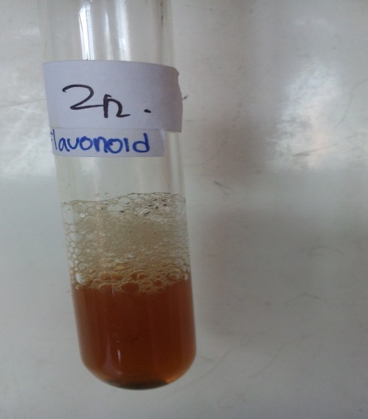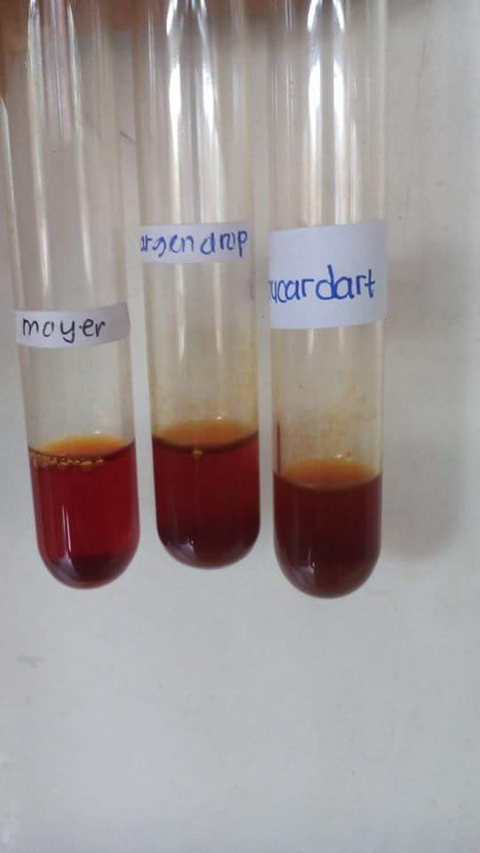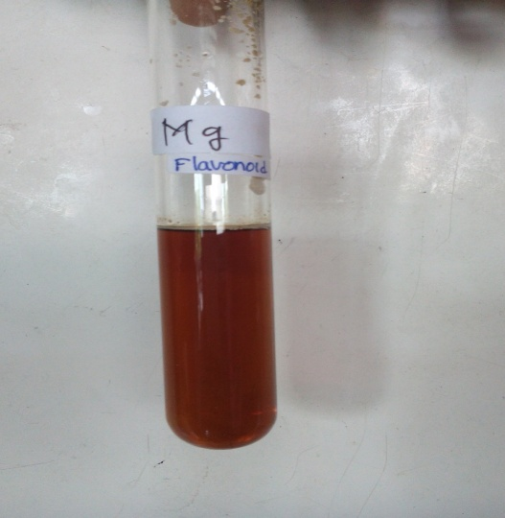

Flavonoid

+ serbuk Zn

Flavonoid

+ serbuk Mg

Alkaloid

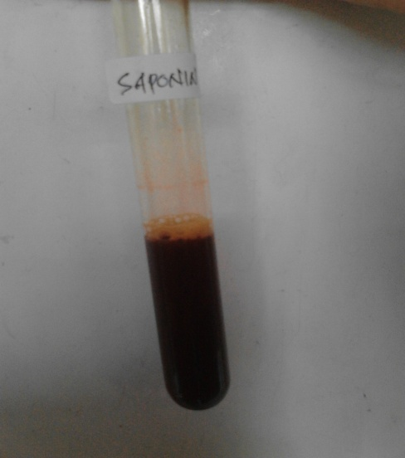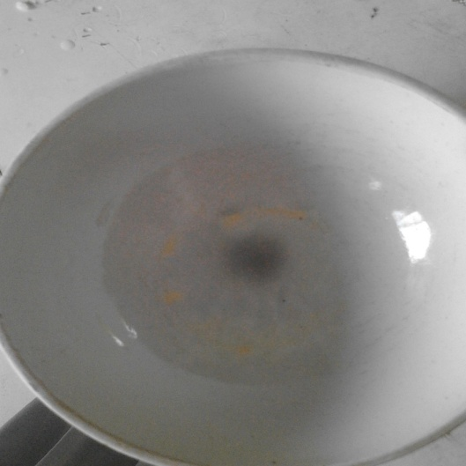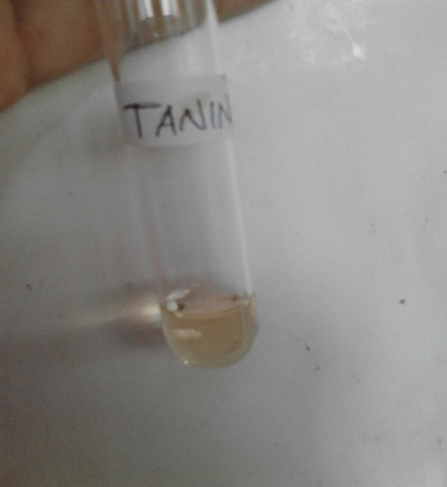

Saponin

Tannin

Steroid

**Lampiran 6.** Bagan Kerja Pembuatan Krim

Asam stearat,Setil slkoho.

Nipasol,nipagin natrium metabisulfit, dan trietanolamin

Dilarutkan dalam akkuades panas

Dilebur di atas penangas air

Masa II

Masa I

Campuran masa 1+ masa II

Digerus homogen

Basis krim

Ditambah ekstrak etanol kulit buah duku 2,5%,5%, 7,5%, 10%

- Uji Stabilitas

- Uji pH

- Uji homogenitas

- Uji tipe emulsi

- Uji iritasi

- Uji anti-aging

-

Sediaan krim EEKD 2,5%,5%, 7,5%, 10%

Hasil Penelitian

**Lampiran 7.** Gambar Sediaan Krim Ekstrak Etanol Kulit Buah Duku

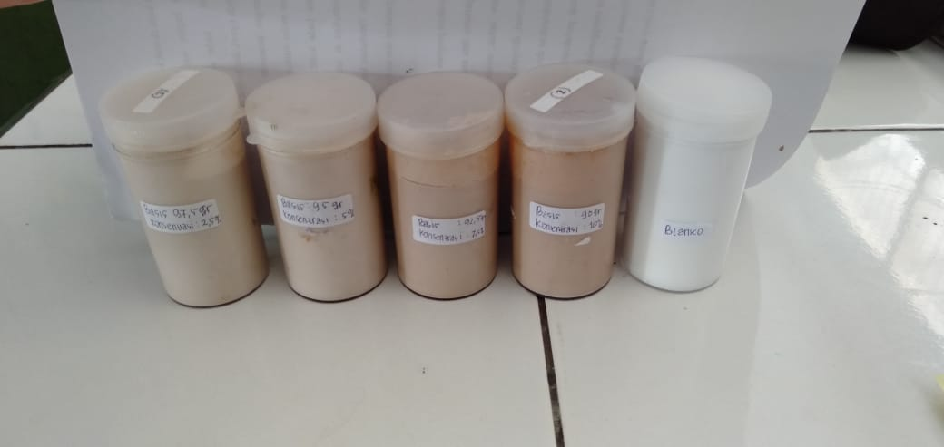

**Lampiran 8.** Contoh Gambar Hasil Uji Anti-Aging

Uji anti-aging dilakukan pada kulit punggung tangan sukarelawan menggunakan alat *skin analyzer,* dengan beberapa parameter yaitu kadar air (*moisture*), kehalusan (*evenness*), pori (*pore*), noda (*spot*), keriput (*Wrinkle*) dan kedalaman keriput (*wrinkle’s depth*).

1. 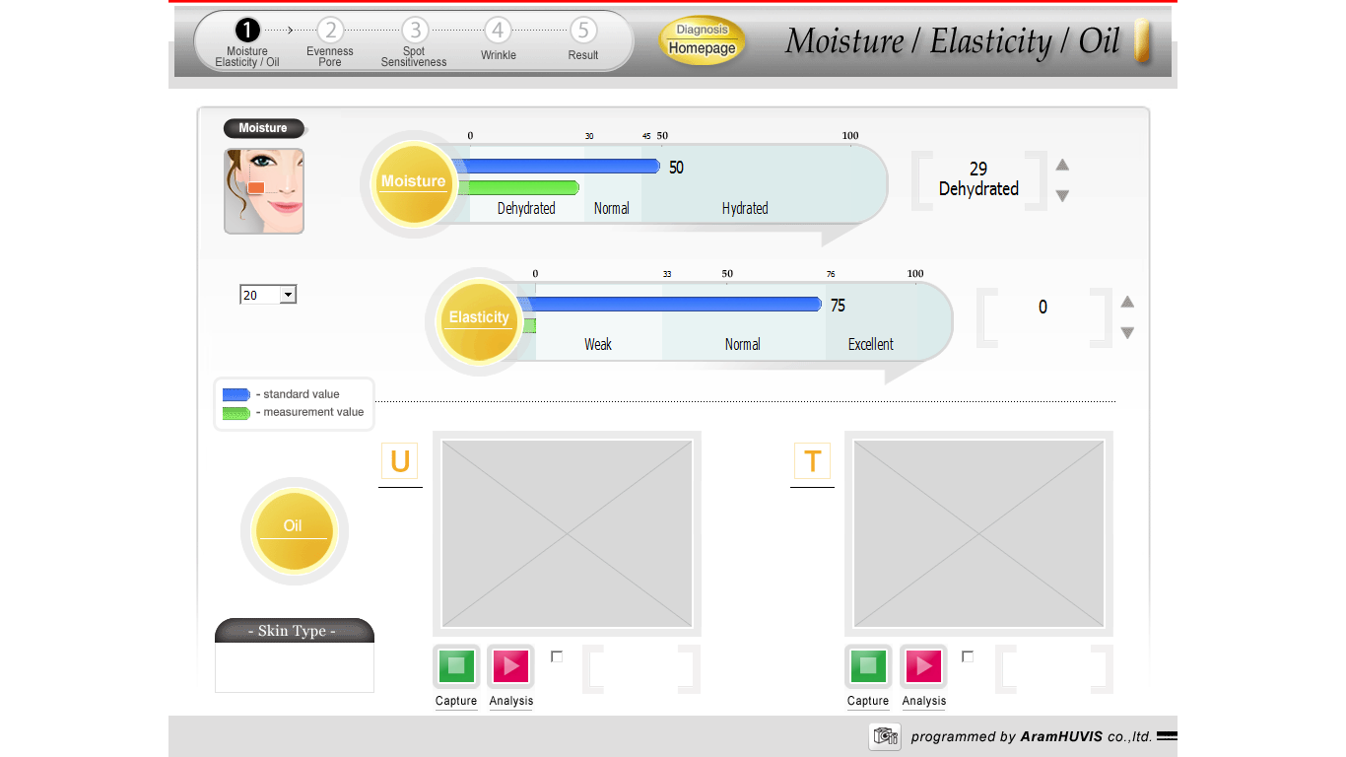kadar air (*moisture*)
2. Kehalusan dan besar pori (*Evenness/ Pore*)

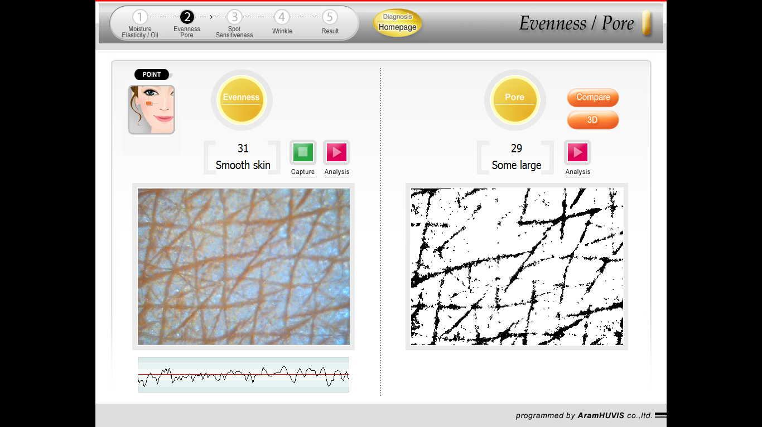

1. Noda (*spot)*

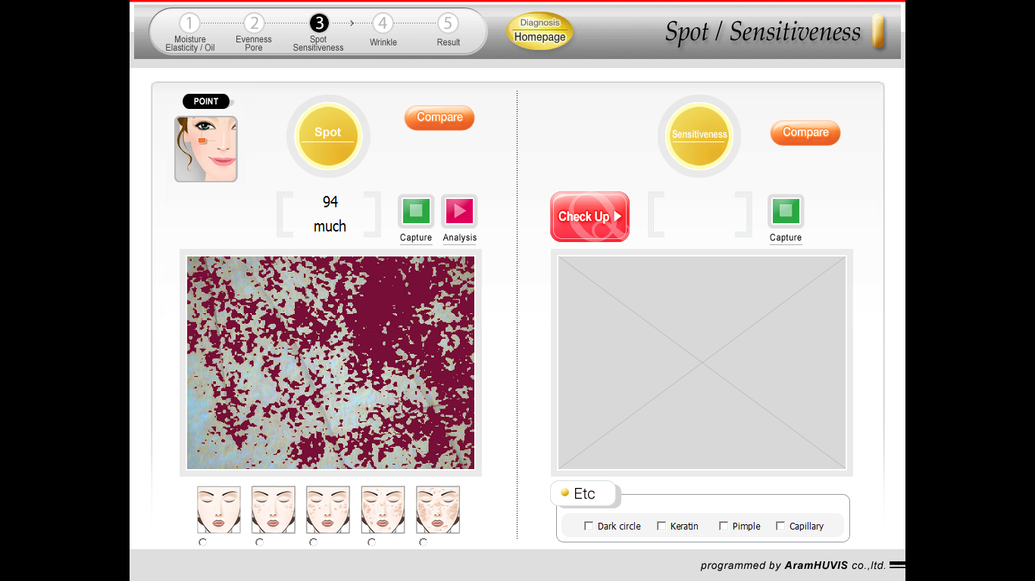

1. Keriput (*Wrinkle*) dan kedalaman keriput (*Wrinkle’s Depth*)



**Lampiran 9.** ContohPerhitungan Statistik Peningkatan Kadar Air (*Moisture*)

Diambil data dari formula EEKD 10% minggu I

|  |  |  |  |
| --- | --- | --- | --- |
| **No.** | Kadar  Air (%) (X) | **X -** |  |
| 1. | 8,62 | 0,4413 | 0,1947 |
| 2. | 10,34 | -1,2828 | 1,6457 |
| 3. | 10,71 | -1,6523 | 2,7301 |
| 4. | 7,14 | 1,9191 | 3,6831 |
| 5. | 8,62 | 0,4413 | 0,1947 |
| 6. | 8,93 | 0,1334 | 0,0178 |
| **N = 6** | **∑ X =** 54,37 %  **=** 9,06 % | |  |

Standar deviasi (SD) = $\sqrt{\frac{\sum{({X-\overline{X})}^{2}}}{n-1}}$ = $\sqrt{\frac{8,4661}{5}}$ = 1,30

Dasar penolakan data adalah apabila thitung > ttabel dengan tingkat kepercayaan 99%, α = 0,01; n = 6, dk = 5 dan ttabel = 4,032

1. thitung = = = 0,83
2. thitung = = = 2,41
3. thitung = = = 3,11
4. thitung = = = 3,61
5. thitung = = = 0,82
6. thitung = = = 0,25

Seluruh thitung dari ke-6 perlakuan < ttabel, berarti semua data ini bisa diterima.

**Menghitung kadar air sebenarnya =**

Peningkatan kadar air rata-rata ± t (1 – ½ α).dk x 

Peningkatan kadar air rata-rata () = 9,06 %

Standar deviasi (SD) = 1,30

Peningkatan kadar air sebenarnya =  ± t (1 – 1/ 2 α). dk x 

Peningkatan kadar air sebenarnya = 9,06 ± 4,032 x $\frac{1,30}{2,449}$

Peningkatan kadar air sebenarnya = (9,06 ± 2,14) %.

Dengan cara yang sama dihitung peningkatan kadar air untuk formula lainnya. Data selengkapnya dapat dilihat pada lampiran 10

**Lampiran 10.** Data Pengukuran Peningkatan Kadar Air (*Moisture*)

|  |  |  |  |  |  |  |  |  |  |
| --- | --- | --- | --- | --- | --- | --- | --- | --- | --- |
| Formula | Kadar air sebelum penggunaan krim EEKS | Peningkatan kadar air (*Moisture*) setelah penggunaan krim EEKD | | | | | | | |
| Minggu I | | Minggu II | | Minggu III | | Minggu IV | |
| Kadar air | % perbedaan kadar air | Kadar air | % perbedaan kadar air | Kadar air | % perbedaan kadar air | Kadar air | % perbedaan kadar air |
| Dasar Krim (Blanko) | 29,0 | 29,0 | 0,00 | 29,5 | 1,72 | 29,5 | 1,72 | 29,5 | 1,72 |
| 28,0 | 28,0 | 0,00 | 28,5 | 1,79 | 28,5 | 1,79 | 29,0 | 3,57 |
| 22,0 | 22,0 | 0,00 | 22,5 | 2,27 | 23,0 | 4,55 | 22,5 | 2,27 |
| 27,0 | 27,0 | 0,00 | 27,5 | 1,85 | 27,5 | 1,85 | 27,5 | 1,85 |
| 26,0 | 26,0 | 0,00 | 26,5 | 1,92 | 26,5 | 1,92 | 27,0 | 3,85 |
| 27,0 | 27,0 | 0,00 | 27,5 | 1,85 | 27,5 | 1,85 | 28,0 | 3,70 |
| Rata-rata % peningkatan kadar air = | | 0,00% | | 1,90 % | | 2,28 % | | 2,83 % | |
| St. Deviasi = | | 0,00% | | 0,19 % | | 1,11 % | | 0,98 % | |
| % Peningkatan kadar air sebenarnya = | | (0,00 ± 0,00) % | | (1,90 ± 0,32) % | | (2,28 ± 1,83) % | | (2,83 ± 1,62) % | |
| Krim EEKD 2,5% | 27,0 | 27,5 | 1,85 | 28,0 | 3,70 | 28,5 | 5,56 | 28,5 | 5,56 |
| 26,0 | 26,5 | 1,92 | 26,5 | 1,92 | 27,0 | 3,85 | 27,0 | 3,85 |
| 28,0 | 28,5 | 1,79 | 28,5 | 1,79 | 29,0 | 3,57 | 29,0 | 3,57 |
| 27,0 | 27,0 | 0,00 | 28,0 | 3,70 | 28,0 | 3,70 | 28,0 | 3,70 |
| 27,0 | 27,5 | 1,85 | 27,5 | 1,85 | 27,5 | 1,85 | 28,0 | 3,70 |
| 28,0 | 28,5 | 1,79 | 28,5 | 1,79 | 29,0 | 3,57 | 29,0 | 3,57 |
| Rata-rata % peningkatan kadar air = | | 1,53 % | | 2,46 % | | 3,68 % | | 3,99 % | |
| St. Deviasi = | | 0,75 % | | 0,97 % | | 1,18 % | | 0,77 % | |
| % Peningkatan kadar air sebenarnya = | | (1,53 ± 1,24) % | | (2,46 ± 1,59) % | | (3,68 ± 1,94) % | | (3,99 ± 1,27) % | |

**Lampiran 10 (Lanjutan)** Data Pengukuran Kadar Air (*Moisture*)

|  |  |  |  |  |  |  |  |  |  |
| --- | --- | --- | --- | --- | --- | --- | --- | --- | --- |
| Formula | Kadar air sebelum penggunaan krim EEKS | Peningkatan kadar air (*Moisture*) setelah penggunaan krim EEKD | | | | | | | |
| Minggu I | | Minggu II | | Minggu III | | Minggu IV | |
| Kadar air | % perbedaan kadar air | Kadar air | % perbedaan kadar air | Kadar air | % perbedaan kadar air | Kadar air | % perbedaan kadar air |
| Krim EEKD 5% | 28,0 | 30,0 | 7,14 | 31,5 | 12,50 | 32,0 | 14,29 | 32,5 | 16,07 |
| 25,0 | 27,0 | 8,00 | 28,5 | 14,00 | 29,0 | 16,00 | 29,0 | 16,00 |
| 28,0 | 30,0 | 7,14 | 32,0 | 14,29 | 32,0 | 14,29 | 32,0 | 14,29 |
| 28,0 | 30,5 | 8,93 | 31,5 | 12,50 | 32,0 | 14,29 | 31,5 | 12,50 |
| 25,0 | 27,0 | 8,00 | 29,0 | 16,00 | 29,0 | 16,00 | 29,5 | 18,00 |
| 28,0 | 30,0 | 7,14 | 32,0 | 14,29 | 32,0 | 14,29 | 32,0 | 14,29 |
| Rata-rata % peningkatan kadar air = | | 7,73 % | | 13,93 % | | 14,86 % | | 15,19% | |
| St. Deviasi = | | 0,72 % | | 0,31 % | | 0,89 % | | 1,91 % | |
| % Peningkatan kadar air sebenarnya = | | (7,73 ± 1,19) % | | (13,93 ± 2,16) % | | (14,86 ± 1,46) % | | (15,19 ± 3,14) % | |
| Krim EEKD 7,5% | 29 | 31,5 | 8,62 | 33,5 | 15,52 | 34,0 | 17,24 | 34,5 | 18,97 |
| 28 | 30,5 | 8,93 | 32,0 | 14,29 | 33,0 | 17,86 | 33,0 | 17,86 |
| 29 | 31,5 | 8,62 | 33,5 | 15,52 | 33,5 | 15,52 | 34,0 | 17,24 |
| 29 | 31,0 | 6,90 | 34,0 | 17,24 | 34,0 | 17,24 | 34,5 | 18,97 |
| 29 | 31,0 | 6,90 | 33,0 | 13,79 | 33,5 | 15,52 | 34,5 | 18,97 |
| 28 | 30,0 | 7,14 | 32,5 | 16,07 | 32,5 | 16,07 | 33,0 | 17,86 |
| Rata-rata % peningkatan kadar air = | | 7,85 % | | 15,40 % | | 16,57 % | | 16,31 % | |
| St. Deviasi = | | 0,97 % | | 1,24 % | | 1,00 % | | 1,24 % | |
| % Peningkatan kadar air sebenarnya = | | (7,85 ± 1,59) % | | (15,40 ± 2,04) % | | (16,57 ± 1,65) % | | (16,31 ± 1,24) % | |

**Lampiran 10 (Lanjutan)** Data Pengukuran Kadar Air (*Moisture*)

|  |  |  |  |  |  |  |  |  |  |
| --- | --- | --- | --- | --- | --- | --- | --- | --- | --- |
| Formula | Kadar air sebelum penggunaan krim EEKS | Peningkatan kadar air (*Moisture*) setelah penggunaan krim EEKD | | | | | | | |
| Minggu I | | Minggu II | | Minggu III | | Minggu IV | |
| Kadar air | % perbedaan kadar air | Kadar air | % perbedaan kadar air | Kadar air | % perbedaan kadar air | Kadar air | % perbedaan kadar air |
| Krim EEKD 10 % | 29 | 31,5 | 8,62 | 33,5 | 15,52 | 34,0 | 17,24 | 34,5 | 18,97 |
| 29 | 32,0 | 10,34 | 33,5 | 15,52 | 34,5 | 18,97 | 34,0 | 17,24 |
| 28 | 31,0 | 10,71 | 32,5 | 16,07 | 33,0 | 17,86 | 33,0 | 17,86 |
| 28 | 30,0 | 7,14 | 32,5 | 16,07 | 33,5 | 19,64 | 33,5 | 19,64 |
| 29 | 31,5 | 8,62 | 33,5 | 15,52 | 34,0 | 17,24 | 34,5 | 18,97 |
| 28 | 30,5 | 8,93 | 32,5 | 16,07 | 33,0 | 17,86 | 33,0 | 17,86 |
| Rata-rata % peningkatan kadar air = | | 9,06 % | | 15,79 % | | 18,13 % | | 18,42 % | |
| St. Deviasi = | | 1,30 % | | 0,30 % | | 0,97 % | | 1,91 % | |
| % Peningkatan kadar air sebenarnya = | | (9,06 ± 2,14) % | | (15,79 ± 0,50) % | | (18,13 ± 1,49) % | | (18,42 ± 1,49) % | |
| Krim Komersil di pasaran | 26,0 | 28,0 | 7,69 | 30,5 | 17,31 | 31,0 | 19,23 | 31,0 | 19,23 |
| 25,0 | 27,0 | 8,00 | 29,0 | 16,00 | 29,5 | 18,00 | 30,0 | 20,00 |
| 27,0 | 29,5 | 9,26 | 31,0 | 14,81 | 32,0 | 18,52 | 32,0 | 18,52 |
| 28,0 | 30,5 | 8,93 | 32,5 | 16,07 | 33,0 | 17,86 | 33,0 | 17,86 |
| 27,0 | 30,0 | 11,11 | 32,0 | 18,52 | 32,0 | 18,52 | 32,0 | 18,52 |
| 27,0 | 30,0 | 11,11 | 31,5 | 16,67 | 32,0 | 18,52 | 32,0 | 18,52 |
| Rata-rata % peningkatan kadar air = | | 9,35 % | | 16,56 % | | 18,44 % | | 18,77 % | |
| St. Deviasi = | | 1,48 % | | 1,27 % | | 0,49 % | | 0,74 % | |
| % Peningkatan kadar air sebenarnya = | | (9,35 ± 2,44) % | | (16,56 ± 2,08) % | | (18,44 ± 0,80) % | | (18,77 ± 1,22) % | |

**Lampiran 11.** ContohPerhitungan Statistik Data Kehalusan (*evenness*)

Diambil data dari formula EEKD 10% minggu I

|  |  |  |  |
| --- | --- | --- | --- |
| **No.** | Kehalusan  (%) (X) | **X -** |  |
| 1. | 3,23 | 0,0988 | 0,0098 |
| 2. | 3,13 | -0,0020 | 0,0000 |
| 3. | 3,23 | 0,0988 | 0,0098 |
| 4. | 3,03 | -0,0967 | 0,0094 |
| 5. | 3,13 | -0,0020 | 0,0000 |
| 6. | 3,03 | -0,0967 | 0,0094 |
| **N = 6** | **∑ X =** 18,76  **=** 3,13 | |  |

Standar deviasi (SD) = $\sqrt{\frac{\sum{({X-\overline{X})}^{2}}}{n-1}}$ = $\sqrt{\frac{0,03823}{5}}$ = 0,09

Dasar penolakan data adalah apabila thitung > ttabel dengan tingkat kepercayaan 99%, α = 0,01; n = 6, dk = 5 dan ttabel = 4,032

1. thitung = = = = 2,77
2. thitung = = = = 0,06
3. thitung = = = = 2,77
4. thitung = = = = 2,71
5. thitung = = = = 0,06
6. thitung = = = = 2,71

Seluruh thitung dari ke-6 perlakuan < ttabel, berarti semua data ini bisa diterima.

**Menghitung peningkatan kehalusan sebenarnya =**

Peningkatan kehalusan (evenness)rata-rata ± t (1 – ½ α).dk x 

Peningkatan kehalusan (evenness) rata-rata () = 3,13 %

Standar deviasi (SD) = 0,09

Peningkatan kehalusan (evenness)sebenarnya =  ± t (1 – 1/ 2 α). dk x 

Peningkatan kehalusan (evenness)sebenarnya = 3,13 ± 4,032 x $\frac{0,09}{2,449}$

Peningkatan kehalusan (evenness) sebenarnya = (3,13 ± 0,14) %

Dengan cara yang sama dihitung data peningkatan kehalusan (evenness) untuk formula lainnya. Data selengkapnya dapat dilihat pada lampiran 12

**Lampiran 12** Data Pengukuran Peningkatan Kehalusan *(Evenness*) Kulit

|  |  |  |  |  |  |  |  |  |  |
| --- | --- | --- | --- | --- | --- | --- | --- | --- | --- |
| Formula | Kehalusan sebelum penggunaan krim EEKS | Peningkatan Kehalusan *(Evenness*) setelah penggunaan krim EEKD | | | | | | | |
| Minggu I | | Minggu II | | Minggu III | | Minggu IV | |
| Kehalu san | % perbedaan kehalusan | Kehalu san | % perbedaan kehalusan | Kehalu san | % perbedaan kehalusan | Kehalu san | % perbedaan kehalusan |
| Dasar Krim (Blanko | 33,0 | 33,0 | 0,00 | 32,0 | 3,03 | 32,0 | 3,03 | 30,0 | 9,09 |
| 30,0 | 30,0 | 0,00 | 29,0 | 3,33 | 29,0 | 3,33 | 28,0 | 6,67 |
| 30,0 | 30,0 | 0,00 | 30,0 | 0,00 | 29,0 | 3,33 | 28,0 | 6,67 |
| 32,0 | 32,0 | 0,00 | 31,0 | 3,13 | 31,0 | 3,13 | 29,0 | 9,38 |
| 31,0 | 31,0 | 0,00 | 30,0 | 3,23 | 29,0 | 6,45 | 28,0 | 9,68 |
| 31,0 | 31,0 | 0,00 | 30,0 | 3,23 | 30,0 | 3,23 | 28,0 | 9,68 |
| % rata-rata peningkatan kehalusan = | | 0,00 | | 2,66 | | 3,75 | | 8,53 | |
| St. Deviasi = | | 0,00 | | 1,31 | | 1,33 | | 1,46 | |
| % peningkatan kehalusan sebenarnya = | | 0,00 ± 0,00 | | 2,66 ± 2,15 | | 3,75 ± 2,19 | | 8,53 ± 2,40 | |
| Krim EEKD 2,5% | 32,0 | 31,0 | 3,13 | 31,0 | 3,13 | 30,0 | 6,25 | 28,0 | 12,50 |
| 30,0 | 30,0 | 0,00 | 29,0 | 3,33 | 28,0 | 6,67 | 27,0 | 10,00 |
| 32,0 | 31,0 | 3,13 | 31,0 | 3,13 | 29,0 | 9,38 | 28,0 | 12,50 |
| 32,0 | 31,0 | 3,13 | 30,0 | 6,25 | 29,0 | 9,38 | 28,0 | 12,50 |
| 31,0 | 30,0 | 3,23 | 29,0 | 6,45 | 28,0 | 9,68 | 27,0 | 12,90 |
| 32,0 | 31,0 | 3,13 | 30,0 | 6,25 | 29,0 | 9,38 | 28,0 | 12,50 |
| % rata-rata peningkatan kehalusan = | | 2,62 | | 4,76 | | 8,45 | | 12,15 | |
| St. Deviasi = | | 1,28 | | 1,71 | | 1,56 | | 1,07 | |
| % peningkatan kehalusan sebenarnya = | | 2,62 ± 2,12 | | 4,76 ± 2,82 | | 8,45 ± 2,56 | | 12,15 ± 1,75 | |

**Lampiran 12 (Lanjutan)** Data Pengukuran Kehalusan *(Evenness*)

|  |  |  |  |  |  |  |  |  |  |
| --- | --- | --- | --- | --- | --- | --- | --- | --- | --- |
| Formula | Kehalusan sebelum penggunaan krim EEKS | Peningkatan Kehalusan *(Evenness*) setelah penggunaan krim EEKD | | | | | | | |
| Minggu I | | Minggu II | | Minggu III | | Minggu IV | |
| Kehalu san | % perbedaan kehalusan | Kehalu san | % perbedaan kehalusan | Kehalu san | % perbedaan kehalusan | Kehalu san | % perbedaan kehalusan |
| Krim EEKD 5% | 31,0 | 30,0 | 3,23 | 29,0 | 6,45 | 28,0 | 9,68 | 25,0 | 19,35 |
| 31,0 | 31,0 | 0,00 | 30,0 | 3,23 | 29,0 | 6,45 | 26,0 | 16,13 |
| 32,0 | 31,0 | 3,13 | 31,0 | 3,13 | 30,0 | 6,25 | 27,0 | 15,63 |
| 31,0 | 30,0 | 3,23 | 29,0 | 6,45 | 28,0 | 9,68 | 25,0 | 19,35 |
| 31,0 | 30,0 | 3,23 | 29,0 | 6,45 | 28,0 | 9,68 | 26,0 | 16,13 |
| 30,0 | 29,0 | 3,33 | 28,0 | 6,67 | 28,0 | 6,67 | 25,0 | 16,67 |
| % rata-rata peningkatan kehalusan = | | 2,69 | | 5,40 | | 8,07 | | 17,21 | |
| St. Deviasi = | | 1,32 | | 1,72 | | 1,77 | | 1,69 | |
| % peningkatan kehalusan sebenarnya = | | 2,69 ± 2,17 | | 5,40 ± 2,83 | | 8,07 ± 2,91 | | 17,21 ± 1,69 | |
| Krim EEKD 7,5% | 31,0 | 30,0 | 3,23 | 29,0 | 6,45 | 28,0 | 9,68 | 25,0 | 19,35 |
| 32,0 | 31,0 | 3,13 | 30,0 | 6,25 | 29,0 | 9,38 | 26,0 | 18,75 |
| 31,0 | 30,0 | 3,23 | 29,0 | 6,45 | 28,0 | 9,68 | 25,0 | 19,35 |
| 33,0 | 31,0 | 6,06 | 30,0 | 9,09 | 30,0 | 9,09 | 26,0 | 21,21 |
| 32,0 | 31,0 | 3,13 | 30,0 | 6,25 | 29,0 | 9,38 | 26,0 | 18,75 |
| 33,0 | 32,0 | 3,03 | 30,0 | 9,09 | 30,0 | 9,09 | 26,0 | 21,21 |
| % rata-rata peningkatan kehalusan = | | 3,63 | | 7,26 | | 9,38 | | 19,77 | |
| St. Deviasi = | | 1,19 | | 1,42 | | 0,26 | | 1,15 | |
| % peningkatan kehalusan sebenarnya = | | 3,63 ± 1,96 | | 7,26 ± 2,33 | | 9,38 ± 0,43 | | 19,77 ± 1,89 | |

**Lampiran 12 (Lanjutan)** Data Pengukuran Kehalusan *(Evenness*)

|  |  |  |  |  |  |  |  |  |  |
| --- | --- | --- | --- | --- | --- | --- | --- | --- | --- |
| Formula | Kehalusan sebelum penggunaan krim EEKS | Peningkatan Kehalusan *(Evenness*) setelah penggunaan krim EEKD | | | | | | | |
| Minggu I | | Minggu II | | Minggu III | | Minggu IV | |
| Kehalu san | % perbedaan kehalusan | Kehalu san | % perbedaan kehalusan | Kehalu san | % perbedaan kehalusan | Kehalu san | % perbedaan kehalusan |
| Krim EEKD 10% | 31,0 | 30,0 | 3,23 | 28,0 | 9,68 | 27,0 | 12,90 | 25,0 | 19,35 |
| 32,0 | 31,0 | 3,13 | 29,0 | 9,38 | 28,0 | 12,50 | 26,0 | 18,75 |
| 31,0 | 30,0 | 3,23 | 28,0 | 9,68 | 27,0 | 12,90 | 25,0 | 19,35 |
| 33,0 | 32,0 | 3,03 | 30,0 | 9,09 | 29,0 | 12,12 | 26,0 | 21,21 |
| 32,0 | 31,0 | 3,13 | 29,0 | 9,38 | 28,0 | 12,50 | 25,0 | 21,88 |
| 33,0 | 32,0 | 3,03 | 31,0 | 6,06 | 30,0 | 9,09 | 26,0 | 21,21 |
| % rata-rata peningkatan kehalusan = | | 3,13 | | 8,88 | | 12,00 | | 20,29 | |
| St. Deviasi = | | 0,09 | | 1,40 | | 1,46 | | 1,29 | |
| % peningkatan kehalusan sebenarnya = | | 3,13 ± 0,14 | | 8,88 ± 2,30 | | 12,00 ± 2,40 | | 20,29 ± 2,13 | |
| Krim Komersil di pasaran | 30,0 | 29,0 | 3,33 | 27,0 | 10,00 | 27,0 | 10,00 | 24,0 | 20,00 |
| 30,0 | 29,0 | 3,33 | 27,0 | 10,00 | 26,0 | 13,33 | 24,0 | 20,00 |
| 31,0 | 30,0 | 3,23 | 28,0 | 9,68 | 27,0 | 12,90 | 25,0 | 19,35 |
| 31,0 | 30,0 | 3,23 | 28,0 | 9,68 | 27,0 | 12,90 | 24,0 | 22,58 |
| 33,0 | 32,0 | 3,03 | 30,0 | 9,09 | 29,0 | 12,12 | 26,0 | 21,21 |
| 33,0 | 32,0 | 3,03 | 30,0 | 9,09 | 29,0 | 12,12 | 26,0 | 21,21 |
| % rata-rata peningkatan kehalusan = | | 3,20 | | 9,59 | | 12,23 | | 20,73 | |
| St. Deviasi = | | 0,14 | | 0,41 | | 1,19 | | 1,17 | |
| % peningkatan kehalusan sebenarnya = | | 3,20 ± 0,23 | | 9,59 ± 0,68 | | 12,23 ± 1,98 | | 20,73 ± 1,93 | |

**Lampiran 13.** ContohPerhitungan Statistik Persen Penurunan pori (*pore*)

Diambil data dari formula EEKD 10% minggu I

|  |  |  |  |
| --- | --- | --- | --- |
| **No.** | % Penurunan Pori  (%) (X) | **X -** |  |
| 1. | 8,70 | 0,0549 | 0,0030 |
| 2. | 8,70 | 0,0549 | 0,0030 |
| 3. | 8,33 | -0,3074 | 0,0945 |
| 4. | 8,33 | -0,3074 | 0,0945 |
| 5. | 8,70 | 0,0549 | 0,0030 |
| 6. | 9,09 | 0,4502 | 0,2026 |
| **N = 6** | **∑ X =** 51,8445 %  **=** 8,64 % | | 0,4006960 |

Standar deviasi (SD) = $\sqrt{\frac{\sum{({X-\overline{X})}^{2}}}{n-1}}$ = $\sqrt{\frac{0,40069}{5}}$ = 0,28

Dasar penolakan data adalah apabila thitung > ttabel dengan tingkat kepercayaan 99%, α = 0,01; n = 6, dk = 5 dan ttabel = 4,032

1. thitung = = = = 0,47
2. thitung = = = = 0,47
3. thitung = = = = 2,66
4. thitung = = = = 2,66
5. thitung = = = = 0,47
6. thitung = = = = 3,89

Seluruh thitung dari ke-6 perlakuan < ttabel, berarti semua data ini bisa diterima.

**Menghitung penurunan pori (pore) sebenarnya =**

Persen penurunan pori (pore) rata-rata ± t (1 – ½ α).dk x 

Persen penurunan pori (pore) rata-rata () = 8,64 %

Standar deviasi (SD) = 0,28

Persen penurunan pori (pore) sebenarnya =  ± t (1 – 1/ 2 α). dk x 

Persen penurunan pori (pore )sebenarnya = 8,64 ± 4,032 x $\frac{0,28}{2,449}$

Persen penurunan pore (pore) sebenarnya = (8,64 ± 0,47) %

Dengan cara yang sama dihitung data penurunan pori (pore) untuk formula lainnya. Data selengkapnya dapat dilihat pada lampiran 14

**Lampiran 14** Data PengukuranPersen Penurunan Pori (Pore)

|  |  |  |  |  |  |  |  |  |  |
| --- | --- | --- | --- | --- | --- | --- | --- | --- | --- |
| Formula | Pori (pore) penggunaan krim EEKS | Penurunan pori (pore) setelah penggunaan krim EEKD | | | | | | | |
| Minggu I | | Minggu II | | Minggu III | | Minggu IV | |
| Pori | % perbedaan Pori | Pori | % perbedaan Pori | Pori | % perbedaan Pori | Pori | % perbedaan Pori |
| Dasar Krim (Blanko) | 22,0 | 22,0 | 0,00 | 22,0 | 0,00 | 21,0 | 4,55 | 21,0 | 4,55 |
| 22,0 | 22,0 | 0,00 | 22,0 | 0,00 | 21,0 | 4,55 | 21,0 | 4,55 |
| 24,0 | 24,0 | 0,00 | 24,0 | 0,00 | 23,0 | 4,17 | 22,0 | 8,33 |
| 29,0 | 29,0 | 0,00 | 29,0 | 0,00 | 28,0 | 3,45 | 27,0 | 6,90 |
| 23,0 | 23,0 | 0,00 | 23,0 | 0,00 | 22,0 | 4,35 | 22,0 | 4,35 |
| 24,0 | 24,0 | 0,00 | 24,0 | 0,00 | 23,0 | 4,17 | 23,0 | 4,17 |
| % rata-rata penurunan pori (pore) = | | 0,00 | | 0,00 | | 4,20 | | 5,47 | |
| St. Deviasi = | | 0,00 | | 0,00 | | 0,41 | | 1,73 | |
| % penurunan pori (pore) sebenarnya = | | 0,00 ± 0,00 | | 0,00 ± 0,00 | | 4,20 ± 0,67 | | 5,47 ± 2,84 | |
| Krim EEKD 2,5% | 21,0 | 20,0 | 4,76 | 20,0 | 4,76 | 19,0 | 9,52 | 18,0 | 14,29 |
| 21,0 | 20,0 | 4,76 | 20,0 | 4,76 | 19,0 | 9,52 | 18,0 | 14,29 |
| 24,0 | 23,0 | 4,17 | 22,0 | 8,33 | 22,0 | 8,33 | 20,0 | 16,67 |
| 22,0 | 21,0 | 4,55 | 20,0 | 9,09 | 20,0 | 9,09 | 19,0 | 13,64 |
| 24,0 | 23,0 | 4,17 | 22,0 | 8,33 | 22,0 | 8,33 | 21,0 | 12,50 |
| 22,0 | 21,0 | 4,55 | 20,0 | 9,09 | 20,0 | 9,09 | 19,0 | 13,64 |
| % rata-rata penurunan pori (pore) = | | 4,49 | | 7,40 | | 8,98 | | 14,17 | |
| St. Deviasi = | | 0,27 | | 2,07 | | 0,54 | | 1,39 | |
| % penurunan pori (pore) sebenarnya = | | 4,49 ± 0,44 | | 7,40 ± 2,40 | | 8,98 ± 0,89 | | 14,17 ± 2,28 | |

**Lampiran 14 (Lanjutan)** Data Pengukuran **Persen Penurunan** Pori (Pore)

|  |  |  |  |  |  |  |  |  |  |
| --- | --- | --- | --- | --- | --- | --- | --- | --- | --- |
| Formula | Pori (pore) penggunaan krim EEKS | Penurunan pori (pore) setelah penggunaan krim EEKD | | | | | | | |
| Minggu I | | Minggu II | | Minggu III | | Minggu IV | |
| Pori | % perbedaan Pori | Pori | % perbedaan Pori | Pori | % perbedaan Pori | Pori | % perbedaan Pori |
| Krim EEKD 5% | 20,0 | 19,0 | 5,00 | 19,0 | 5,00 | 17,0 | 15,00 | 17,0 | 15,00 |
| 23,0 | 22,0 | 4,35 | 21,0 | 8,70 | 20,0 | 13,04 | 19,0 | 17,39 |
| 22,0 | 21,0 | 4,55 | 20,0 | 9,09 | 19,0 | 13,64 | 18,0 | 18,18 |
| 22,0 | 21,0 | 4,55 | 20,0 | 9,09 | 19,0 | 13,64 | 18,0 | 18,18 |
| 21,0 | 20,0 | 4,76 | 19,0 | 9,52 | 18,0 | 14,29 | 17,0 | 19,05 |
| 23,0 | 22,0 | 4,35 | 21,0 | 8,70 | 19,0 | 17,39 | 18,0 | 21,74 |
| % rata-rata penurunan pori (pore) = | | 4,59 | | 8,35 | | 14,50 | | 18,26 | |
| St. Deviasi = | | 0,25 | | 1,67 | | 1,57 | | 2,20 | |
| % penurunan pori (pore) sebenarnya = | | 4,59 ± 0,42 | | 8,35 ± 2,75 | | 14,50 ± 2,58 | | 18,26 ± 3,62 | |
| Krim EEKD 7,5% | 24,0 | 22,0 | 8,33 | 21,0 | 12,50 | 20,0 | 16,67 | 19,0 | 20,83 |
| 24,0 | 22,0 | 8,33 | 21,0 | 12,50 | 21,0 | 12,50 | 19,0 | 20,83 |
| 22,0 | 20,0 | 9,09 | 20,0 | 9,09 | 19,0 | 13,64 | 17,0 | 22,73 |
| 23,0 | 21,0 | 8,70 | 20,0 | 13,04 | 20,0 | 13,04 | 18,0 | 21,74 |
| 23,0 | 21,0 | 8,70 | 20,0 | 13,04 | 20,0 | 13,04 | 18,0 | 21,74 |
| 23,0 | 21,0 | 8,70 | 20,0 | 13,04 | 20,0 | 13,04 | 18,0 | 21,74 |
| % rata-rata penurunan pori (pore) = | | 8,64 | | 12,20 | | 13,66 | | 21,60 | |
| St. Deviasi = | | 0,28 | | 1,55 | | 1,52 | | 0,71 | |
| % penurunan pori (pore) sebenarnya = | | 8,64 ± 0,47 | | 12,20 ± 2,55 | | 13,66 ± 2,50 | | 21,60 ± 1,17 | |

**Lampiran 14 (Lanjutan)** Data Pengukuran Persen Penurunan Pori (Pore)

|  |  |  |  |  |  |  |  |  |  |
| --- | --- | --- | --- | --- | --- | --- | --- | --- | --- |
| Formula | Pori (pore) penggunaan krim EEKS | Penurunan pori (pore) setelah penggunaan krim EEKD | | | | | | | |
| Minggu I | | Minggu II | | Minggu III | | Minggu IV | |
| Pori | % perbedaan Pori | Pori | % perbedaan Pori | Pori | % perbedaan Pori | Pori | % perbedaan Pori |
| Krim EEKD 10% | 23,0 | 21,0 | 8,70 | 20,0 | 13,04 | 20,0 | 13,04 | 18,0 | 21,74 |
| 23,0 | 21,0 | 8,70 | 20,0 | 13,04 | 20,0 | 13,04 | 18,0 | 21,74 |
| 24,0 | 22,0 | 8,33 | 20,0 | 16,67 | 20,0 | 16,67 | 18,0 | 25,00 |
| 24,0 | 22,0 | 8,33 | 20,0 | 16,67 | 21,0 | 12,50 | 18,0 | 25,00 |
| 23,0 | 21,0 | 8,70 | 20,0 | 13,04 | 19,0 | 17,39 | 18,0 | 21,74 |
| 22,0 | 20,0 | 9,09 | 19,0 | 13,64 | 19,0 | 13,64 | 17,0 | 22,73 |
| % rata-rata penurunan pori (pore) = | | 8,64 | | 14,35 | | 14,38 | | 22,99 | |
| St. Deviasi = | | 0,28 | | 1,81 | | 2,10 | | 1,60 | |
| % penurunan pori (pore) sebenarnya = | | 8,64 ± 0,47 | | 14,35 ± 2,98 | | 14,38 ± 2,45 | | 22,99 ± 2,64 | |
| Krim Komersil di pasaran | 23,0 | 20,0 | 13,04 | 20,0 | 13,04 | 19,0 | 17,39 | 17,0 | 26,09 |
| 22,0 | 20,0 | 9,09 | 19,0 | 13,64 | 19,0 | 13,64 | 17,0 | 22,73 |
| 22,0 | 20,0 | 9,09 | 19,0 | 13,64 | 19,0 | 13,64 | 17,0 | 22,73 |
| 22,0 | 20,0 | 9,09 | 19,0 | 13,64 | 19,0 | 13,64 | 17,0 | 22,73 |
| 21,0 | 19,0 | 9,52 | 18,0 | 14,29 | 18,0 | 14,29 | 16,0 | 23,81 |
| 22,0 | 20,0 | 9,09 | 19,0 | 13,64 | 19,0 | 13,64 | 17,0 | 22,73 |
| % rata-rata perbedaan pori (pore) = | | 9,82 | | 13,65 | | 14,37 | | 23,47 | |
| St. Deviasi = | | 1,59 | | 0,39 | | 1,50 | | 1,35 | |
| % perbedaan pori (pore) sebenarnya = | | 9,82 ± 2,61 | | 13,65 ± 0,65 | | 14,37 ± 2,47 | | 23,47 ± 2,23 | |

**Lampiran 15.** ContohPerhitungan Statistik Pengurangan Noda (*spot*)

Diambil data dari formula EEKD 10% minggu I

|  |  |  |  |
| --- | --- | --- | --- |
| **No.** | % Noda (Spot)  (%) (X) | **X -** |  |
| 1. | 2,13 | -0,9982 | 0,9963 |
| 2. | 4,26 | 1,1295 | 1,2758 |
| 3. | 2,27 | -0,8531 | 0,7278 |
| 4. | 4,00 | 0,8742 | 0,7642 |
| 5. | 3,77 | 0,6478 | 0,4196 |
| 6. | 2,33 | -0,8002 | 0,6404 |
| **N = 6** | **∑ X =** 18,75 %  **=** 3.13 % | |  |

Standar deviasi (SD) = $\sqrt{\frac{\sum{({X-\overline{X})}^{2}}}{n-1}}$ = $\sqrt{\frac{4,82403}{5}}$ = 0,98

Dasar penolakan data adalah apabila thitung > ttabel dengan tingkat kepercayaan 99%, α = 0,01; n = 6, dk = 5 dan ttabel = 4,032

1. thitung = = = = 2,49
2. thitung = = = = 2,82
3. thitung = = = = 2,13
4. thitung = = = = 2,18
5. thitung = = = = 1,62
6. thitung = = = = 2,00

Seluruh thitung dari ke-6 perlakuan < ttabel, berarti semua data ini bisa diterima.

**Menghitung pengurangan noda (Spot) sebenarnya =**

Pengurangan noda (Spot) rata-rata ± t (1 – ½ α).dk x 

Pengurangan noda (Spot) rata-rata () = 3.13 %

Standar deviasi (SD) = 0,98

Persen penurunan noda (Spot) sebenarnya =  ± t (1 – 1/ 2 α). dk x 

Persen penurunan noda (Spot) sebenarnya = 3,13 ± 4,032 x $\frac{0,98}{2,449}$

Pengurangan noda (Spot) sebenarnya = (3,13 ± 1,62) %

Dengan cara yang sama dihitung Data Noda (Spot) untuk formula lainnya. Data selengkapnya dapat dilihat pada lampiran 16

**Lampiran 16** Data PengukuranPengurangan noda (Spot)

|  |  |  |  |  |  |  |  |  |  |
| --- | --- | --- | --- | --- | --- | --- | --- | --- | --- |
| Formula | Noda (Spot) sebelum penggunaan krim EEKD | Pengrangan noda (Spot) setelah penggunaan krim EEKD | | | | | | | |
| Minggu I | | Minggu II | | Minggu III | | Minggu IV | |
| Jumlah Noda | % perbedaan Noda | Jumlah Noda | % perbedaan Noda | Jumlah Noda | % perbedaan Noda | Jumlah Noda | % perbedaan Noda |
| Dasar Krim (Blanko) | 54,0 | 54,0 | 0,00 | 52,0 | 3,70 | 52,0 | 3,70 | 51,0 | 5,56 |
| 52,0 | 52,0 | 0,00 | 51,0 | 1,92 | 50,0 | 3,85 | 49,0 | 5,77 |
| 51,0 | 51,0 | 0,00 | 50,0 | 1,96 | 50,0 | 1,96 | 49,0 | 3,92 |
| 51,0 | 51,0 | 0,00 | 50,0 | 1,96 | 49,0 | 3,92 | 49,0 | 3,92 |
| 50,0 | 50,0 | 0,00 | 49,0 | 2,00 | 49,0 | 2,00 | 48,0 | 4,00 |
| 51,0 | 51,0 | 0,00 | 50,0 | 1,96 | 49,0 | 3,92 | 48,0 | 5,88 |
| % rata-rata pengurangan noda (spot) = | | 0,00 | | 2,25 | | 3,23 | | 4,84 | |
| St. Deviasi = | | 0,00 | | 0,71 | | 0,97 | | 0,99 | |
| % pengurangan noda sebenarnya = | | 0,00 ± 0,00 | | 2,25 ± 1,17 | | 3,23 ± 1,59 | | 4,84 ± 1,62 | |
| Krim EEKD 2,5% | 46,0 | 0,00 | 0,00 | 45,0 | 2,17 | 44,0 | 4,35 | 43,0 | 6,52 |
| 48,0 | 2,04 | 2,04 | 47,0 | 4,08 | 47,0 | 4,08 | 45,0 | 8,16 |
| 50,0 | 1,96 | 1,96 | 50,0 | 1,96 | 49,0 | 3,92 | 47,0 | 7,84 |
| 47,0 | 2,08 | 0,00 | 47,0 | 2,08 | 46,0 | 4,17 | 45,0 | 6,25 |
| 48,0 | 2,04 | 0,00 | 48,0 | 2,04 | 47,0 | 4,08 | 45,0 | 8,16 |
| 50,0 | 1,96 | 1,96 | 49,0 | 3,92 | 48,0 | 5,88 | 47,0 | 7,84 |
| % rata-rata pengurangan noda (spot) = | | 1,68 | | 2,71 | | 4,41 | | 7,46 | |
| St. Deviasi = | | 0,83 | | 1,00 | | 0,73 | | 0,85 | |
| % pengurangan noda sebenarnya = | | 1,68 ± 1,36 | | 2,71 ± 1,65 | | 4,41 ± 1,21 | | 7,46 ± 1,40 | |

**Lampiran 16 (Lanjutan)** Data PengukuranPengurangan Noda (Spot)

|  |  |  |  |  |  |  |  |  |  |
| --- | --- | --- | --- | --- | --- | --- | --- | --- | --- |
| Formula | Noda (Spot) sebelum penggunaan krim EEKD | Pengrangan noda (Spot) setelah penggunaan krim EEKD | | | | | | | |
| Minggu I | | Minggu II | | Minggu III | | Minggu IV | |
| Jumlah Noda | % perbedaan Noda | Jumlah Noda | % perbedaan Noda | Jumlah Noda | % perbedaan Noda | Jumlah Noda | % perbedaan Noda |
| Krim EEBD 5% | 49,0 | 48,0 | 2,04 | 47,0 | 4,08 | 44,0 | 10,20 | 43,0 | 12,24 |
| 51,0 | 50,0 | 1,96 | 49,0 | 3,92 | 46,0 | 9,80 | 44,0 | 13,73 |
| 51,0 | 50,0 | 1,96 | 49,0 | 3,92 | 46,0 | 9,80 | 44,0 | 13,73 |
| 50,0 | 49,0 | 2,00 | 47,0 | 6,00 | 45,0 | 10,00 | 44,0 | 12,00 |
| 48,0 | 47,0 | 2,08 | 46,0 | 4,17 | 44,0 | 8,33 | 41,0 | 14,58 |
| 48,0 | 47,0 | 2,08 | 46,0 | 4,17 | 43,0 | 10,42 | 41,0 | 14,58 |
| % rata-rata pengurangan noda (spot) = | | 2,02 | | 4,38 | | 9,76 | | 13,48 | |
| St. Deviasi = | | 0,06 | | 0,80 | | 0,74 | | 1,12 | |
| % pengurangan noda sebenarnya = | | 2,02 ± 0,09 | | 4,38 ± 1,32 | | 9,76 ± 1,22 | | 13,48 ± 1,12 | |
| Krim EEBD 7,5% | 50,0 | 49,0 | 2,00 | 47,0 | 6,00 | 45,0 | 10,00 | 43,0 | 14,00 |
| 53,0 | 51,0 | 3,77 | 48,0 | 9,43 | 48,0 | 9,43 | 46,0 | 13,21 |
| 43,0 | 42,0 | 2,33 | 41,0 | 4,65 | 39,0 | 9,30 | 37,0 | 13,95 |
| 47,0 | 46,0 | 2,13 | 44,0 | 6,38 | 42,0 | 10,64 | 41,0 | 12,77 |
| 47,0 | 45,0 | 4,26 | 43,0 | 8,51 | 42,0 | 10,64 | 40,0 | 14,89 |
| 44,0 | 43,0 | 2,27 | 41,0 | 6,82 | 40,0 | 9,09 | 38,0 | 13,64 |
| % rata-rata pengurangan noda (spot) = | | 2,79 | | 6,97 | | 9,85 | | 13,74 | |
| St. Deviasi = | | 0,97 | | 1,74 | | 0,68 | | 0,73 | |
| % pengurangan noda sebenarnya = | | 2,79 ± 1,59 | | 6,97 ± 2,86 | | 9,85 ± 1,12 | | 13,74 ± 1,21 | |

**Lampiran 16 (Lanjutan)** Data PengukuranNoda (Spot)

|  |  |  |  |  |  |  |  |  |  |
| --- | --- | --- | --- | --- | --- | --- | --- | --- | --- |
| Formula | Noda (Spot) sebelum penggunaan krim EEKD | Pengrangan noda (Spot) setelah penggunaan krim EEKD | | | | | | | |
| Minggu I | | Minggu II | | Minggu III | | Minggu IV | |
| Jumlah Noda | % perbedaan Noda | Jumlah Noda | % perbedaan Noda | Jumlah Noda | % perbedaan Noda | Jumlah Noda | % perbedaan Noda |
| Krim EEBD 10% | 47,0 | 46,0 | 2,13 | 44,0 | 6,38 | 42,0 | 10,64 | 40,0 | 14,89 |
| 47,0 | 45,0 | 4,26 | 43,0 | 8,51 | 42,0 | 10,64 | 40,0 | 14,89 |
| 44,0 | 43,0 | 2,27 | 41,0 | 6,82 | 40,0 | 9,09 | 38,0 | 13,64 |
| 50,0 | 48,0 | 4,00 | 47,0 | 6,00 | 45,0 | 10,00 | 43,0 | 14,00 |
| 53,0 | 51,0 | 3,77 | 48,0 | 9,43 | 48,0 | 9,43 | 46,0 | 13,21 |
| 43,0 | 42,0 | 2,33 | 40,0 | 6,98 | 38,0 | 11,63 | 37,0 | 13,95 |
| % rata-rata pengurangan noda (spot) = | | 3,13 | | 7,35 | | 10,24 | | 14,10 | |
| St. Deviasi = | | 0,98 | | 1,33 | | 0,92 | | 0,68 | |
| % pengurangan noda sebenarnya = | | 3,13 ± 1,62 | | 7,35 ± 2,19 | | 10,24 ± 1,52 | | 14,10 ± 1,12 | |
| Krim komersil di pasaran | 47,0 | 45,0 | 4,26 | 44,0 | 6,38 | 42,0 | 10,64 | 40,0 | 14,89 |
| 50,0 | 48,0 | 4,00 | 46,0 | 8,00 | 44,0 | 12,00 | 43,0 | 14,00 |
| 48,0 | 45,0 | 6,25 | 44,0 | 8,33 | 42,0 | 12,50 | 41,0 | 14,58 |
| 45,0 | 43,0 | 4,44 | 41,0 | 8,89 | 40,0 | 11,11 | 39,0 | 13,33 |
| 45,0 | 43,0 | 4,44 | 42,0 | 6,67 | 40,0 | 11,11 | 39,0 | 13,33 |
| 51,0 | 48,0 | 5,88 | 47,0 | 7,84 | 44,0 | 13,73 | 44,0 | 13,73 |
| % rata-rata pengurangan noda (spot) = | | 4,88 | | 7,69 | | 11,85 | | 13,98 | |
| St. Deviasi = | | 0,94 | | 0,97 | | 1,14 | | 0,65 | |
| % pengurangan noda sebenarnya = | | 4,88 ± 1,55 | | 7,69 ± 1,60 | | 11,85 ± 1,88 | | 13,98 ± 1,07 | |

**Lampiran 17.** ContohPerhitungan Statistik Pengurangan Keriput (*Wrinkle*)

Diambil data dari formula EEKD 10% minggu I

|  |  |  |  |
| --- | --- | --- | --- |
| **No.** | % keriput  (%) (X) | **X -** |  |
| 1. | 4,76 | 0,4305 | 0,1853 |
| 2. | 4,55 | 0,2140 | 0,0458 |
| 3. | 4,17 | -0,1648 | 0,0271 |
| 4. | 4,17 | -0,1648 | 0,0271 |
| 5. | 4,00 | -0,3314 | 0,1098 |
| 6. | 4,35 | 0,0164 | 0,0003 |
| **N = 6** | **∑ X =** 25,99 %  **=** 4.33 % | |  |

Standar deviasi (SD) = $\sqrt{\frac{\sum{({X-\overline{X})}^{2}}}{n-1}}$ = $\sqrt{\frac{0,3955}{5}}$ = 0,28

Dasar penolakan data adalah apabila thitung > ttabel dengan tingkat kepercayaan 99%, α = 0,01; n = 6, dk = 5 dan ttabel = 4,032

1. thitung = = = = 3,75
2. thitung = = = = 1,86
3. thitung = = = = 1,43
4. thitung = = = = 1,43
5. thitung = = = = 2,89
6. thitung = = = = 0,14

Seluruh thitung dari ke-6 perlakuan < ttabel, berarti semua data ini bisa diterima.

**Menghitung pengurangan keriput (*wrinkle*)**  **sebenarnya =**

Pengurangan keriput (*wrinkle*) rata-rata ± t (1 – ½ α).dk x 

Pengurangan keriput (*wrinkle*) rata-rata () = 4.33 %

Standar deviasi (SD) = 0,28

Persen penurunan keriput (*wrinkle*) sebenarnya =  ± t (1 – 1/ 2 α). dk x 

Persen penurunan keriput (*wrinkle*) sebenarnya = 4.33 ± 4,032 x $\frac{0,28}{2,449}$

Pengurangan keriput (*wrinkle*) sebenarnya = (4.33 ± 0,46) %

Dengan cara yang sama dihitung data pengurangan keriput (*wrinkle*) untuk formula lainnya. Data selengkapnya dapat dilihat pada lampiran 18

**Lampiran 18** Data Pengukuran pengurangan keriput (*wrinkle*)

|  |  |  |  |  |  |  |  |  |  |
| --- | --- | --- | --- | --- | --- | --- | --- | --- | --- |
| Formula | Keriput sebelum penggunaan krim EEKD | Pengurangan keriput (*wrinkle*) setelah penggunaan krim EEKD | | | | | | | |
| Minggu I | | Minggu II | | Minggu III | | Minggu IV | |
| Jumlah Keriput | % perbedaan Keriput | Jumlah Keriput | % perbedaan Keriput | Jumlah Keriput | % perbedaan Keriput | Jumlah Keriput | % perbedaan Keriput |
| Dasar Krim (Blanko | 28,0 | 28,0 | 0,00 | 28,0 | 0,00 | 28,0 | 0,00 | 28,0 | 0,00 |
| 28,0 | 28,0 | 0,00 | 28,0 | 0,00 | 28,0 | 0,00 | 28,0 | 0,00 |
| 28,0 | 28,0 | 0,00 | 28,0 | 0,00 | 28,0 | 0,00 | 28,0 | 0,00 |
| 27,0 | 27,0 | 0,00 | 27,0 | 0,00 | 27,0 | 0,00 | 27,0 | 0,00 |
| 27,0 | 27,0 | 0,00 | 27,0 | 0,00 | 27,0 | 0,00 | 27,0 | 0,00 |
| 20,0 | 20,0 | 0,00 | 20,0 | 0,00 | 20,0 | 0,00 | 20,0 | 0,00 |
| % rata-rata pengurangan keriput = | | 0,00 % | | 0,00 % | | 0,00 % | | 0,00 % | |
| St. Deviasi = | | 0,00 % | | 0,00 % | | 0,00 % | | 0,00 % | |
| % pengurangan noda sebenarnya = | | (0,00 ± 0,00) % | | (0,00 ± 0,00) % | | (0,00 ± 0,00) % | | (0,00 ± 0,00) % | |
| Krim EEKD 2,5% | 27,0 | 27,0 | 0,00 | 27,0 | 0,00 | 27,0 | 0,00 | 26,0 | 3,70 |
| 28,0 | 28,0 | 0,00 | 28,0 | 0,00 | 28,0 | 0,00 | 27,0 | 3,57 |
| 29,0 | 29,0 | 0,00 | 29,0 | 0,00 | 29,0 | 0,00 | 28,0 | 3,45 |
| 28,0 | 28,0 | 0,00 | 28,0 | 0,00 | 28,0 | 0,00 | 27,0 | 3,57 |
| 27,0 | 27,0 | 0,00 | 27,0 | 0,00 | 27,0 | 0,00 | 26,0 | 3,70 |
| 27,0 | 27,0 | 0,00 | 27,0 | 0,00 | 27,0 | 0,00 | 26,0 | 3,70 |
| % rata-rata pengurangan keriput = | | 0,00 % | | 0,00 % | | 0,00 % | | 3,62 % | |
| St. Deviasi = | | 0,00 % | | 0,00 % | | 0,00 % | | 0,11 v | |
| % pengurangan noda sebenarnya = | | (0,00 ± 0,00) % | | (0,00 ± 0,00) % | | (0,00 ± 0,00) % | | (3,62 ± 0,17) % | |

**Lampiran 18 (Lanjutan)** Data PengukuranPengukuran pengurangan keriput (*wrinkle*)

|  |  |  |  |  |  |  |  |  |  |
| --- | --- | --- | --- | --- | --- | --- | --- | --- | --- |
| Formula | Keriput sebelum penggunaan krim EEKD | Pengrangan noda (Spot) setelah penggunaan krim EEKD | | | | | | | |
| Minggu I | | Minggu II | | Minggu III | | Minggu IV | |
| Jumlah Keriput | % perbedaan Keriput | Jumlah Keriput | % perbedaan Keriput | Jumlah Keriput | % perbedaan Keriput | Jumlah Keriput | % perbedaan Keriput |
| Krim EEBD 5% | 28,0 | 28,0 | 0,00 | 27,0 | 3,57 | 26,0 | 7,14 | 25,0 | 10,71 |
| 27,0 | 27,0 | 0,00 | 26,0 | 3,70 | 25,0 | 7,41 | 23,0 | 14,81 |
| 26,0 | 26,0 | 0,00 | 25,0 | 3,85 | 24,0 | 7,69 | 22,0 | 15,38 |
| 28,0 | 28,0 | 0,00 | 27,0 | 3,57 | 26,0 | 7,14 | 24,0 | 14,29 |
| 27,0 | 27,0 | 0,00 | 26,0 | 3,70 | 25,0 | 7,41 | 23,0 | 14,81 |
| 27,0 | 27,0 | 0,00 | 26,0 | 3,70 | 25,0 | 7,41 | 23,0 | 14,81 |
| % rata-rata pengurangan keriput = | | 0,00 % | | 3,68 % | | 7,37 % | | 14,14 % | |
| St. Deviasi = | | 0,00 % | | 0,10 % | | 0,21 % | | 1,71 % | |
| % pengurangan noda sebenarnya = | | (0,00 ± 0,00) % | | (3,68 ± 0,17) % | | (7,37 ± 0,34) % | | (14,14 ± 2,82) % | |
| Krim EEBD 7,5% | 27,0 | 27,0 | 0,00 | 26,0 | 3,70 | 25,0 | 7,41 | 23,0 | 14,81 |
| 25,0 | 25,0 | 0,00 | 24,0 | 4,00 | 23,0 | 8,00 | 21,0 | 16,00 |
| 25,0 | 25,0 | 0,00 | 24,0 | 4,00 | 23,0 | 8,00 | 22,0 | 12,00 |
| 25,0 | 25,0 | 0,00 | 24,0 | 4,00 | 23,0 | 8,00 | 21,0 | 16,00 |
| 20,0 | 20,0 | 0,00 | 19,0 | 5,00 | 18,0 | 10,00 | 17,0 | 15,00 |
| 22,0 | 22,0 | 0,00 | 21,0 | 4,55 | 20,0 | 9,09 | 19,0 | 13,64 |
| % rata-rata pengurangan keriput = | | 0,00 % | | 4,21 % | | 8,42 % | | 14,58 % | |
| St. Deviasi = | | 0,00 % | | 0,47 % | | 0,95 % | | 1,54 % | |
| % pengurangan noda sebenarnya = | | (0,00 ± 0,00) % | | (4,21 ± 0,78) % | | (8,42 ± 1,56) % | | (14,58 ± 2,53) % | |

**Lampiran 18 (Lanjutan)** Data PengukuranPengukuran pengurangan keriput (*wrinkle*)

|  |  |  |  |  |  |  |  |  |  |
| --- | --- | --- | --- | --- | --- | --- | --- | --- | --- |
| Formula | Keriput sebelum penggunaan krim EEKD | Pengrangan noda (Spot) setelah penggunaan krim EEKD | | | | | | | |
| Minggu I | | Minggu II | | Minggu III | | Minggu IV | |
| Jumlah Keriput | % perbedaan Keriput | Jumlah Keriput | % perbedaan Keriput | Jumlah Keriput | % perbedaan Keriput | Jumlah Keriput | % perbedaan Keriput |
| Krim EEBD 10% | 21,0 | 20,0 | 4,76 | 19,0 | 9,52 | 18,0 | 14,29 | 17,0 | 19,05 |
| 22,0 | 21,0 | 4,55 | 21,0 | 4,55 | 19,0 | 13,64 | 18,0 | 18,18 |
| 24,0 | 23,0 | 4,17 | 22,0 | 8,33 | 21,0 | 12,50 | 20,0 | 16,67 |
| 24,0 | 23,0 | 4,17 | 22,0 | 8,33 | 20,0 | 16,67 | 20,0 | 16,67 |
| 25,0 | 24,0 | 4,00 | 23,0 | 8,00 | 22,0 | 12,00 | 21,0 | 16,00 |
| 23,0 | 22,0 | 4,35 | 21,0 | 8,70 | 20,0 | 13,04 | 19,0 | 17,39 |
| % rata-rata pengurangan keriput = | | 4,33 % | | 7,91 % | | 13,69 % | | 17,33 % | |
| St. Deviasi = | | 0,28 % | | 1,73 % | | 1,67 % | | 1,13 % | |
| % pengurangan noda sebenarnya = | | (4,33 ± 0,46) % | | (7,91 ± 2,84) % | | (13,69 ± 2,75) % | | (17,33 ± 1,85)% | |
| Krim komersil di pasaran | 28,0 | 27,0 | 3,57 | 26,0 | 7,14 | 24,0 | 14,29 | 23,0 | 17,86 |
| 29,0 | 28,0 | 3,45 | 27,0 | 6,90 | 25,0 | 13,79 | 24,0 | 17,24 |
| 27,0 | 26,0 | 3,70 | 25,0 | 7,41 | 23,0 | 14,81 | 22,0 | 18,52 |
| 28,0 | 27,0 | 3,57 | 26,0 | 7,14 | 24,0 | 14,29 | 23,0 | 17,86 |
| 27,0 | 26,0 | 3,70 | 25,0 | 7,41 | 23,0 | 14,81 | 22,0 | 18,52 |
| 26,0 | 25,0 | 3,85 | 24,0 | 7,69 | 22,0 | 15,38 | 21,0 | 19,23 |
| % rata-rata pengurangan keriput = | | 3,64 % | | 7,28 % | | 14,56 % | | 18,20 % | |
| St. Deviasi = | | 0,14 % | | 0,28 % | | 0,56 % | | 0,70 % | |
| % pengurangan noda sebenarnya = | | (3,64 ± 0,23) % | | (7,28 ± 0,46) % | | (14,56 ± 0,93) % | | (18,20 ± 1,15) % | |