Lampiran 1. Hasil Identifikasi Tanaman Daun Cincau Hijau
(Premna trichostoma Miq.)

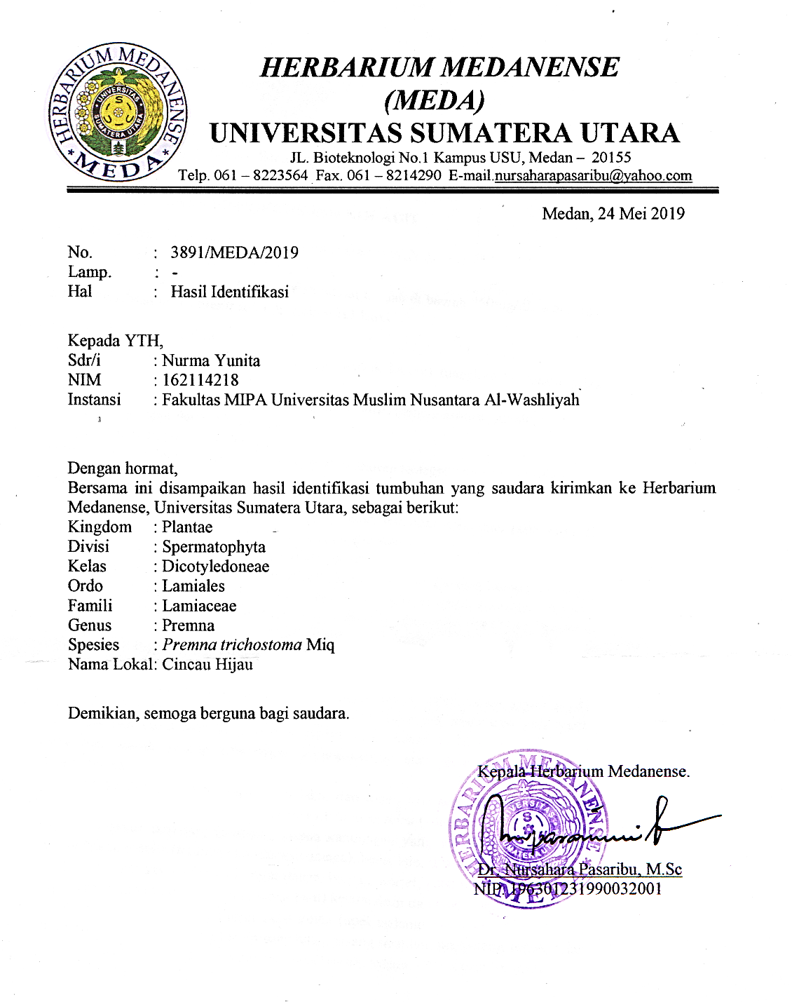

Lampiran 2. Hasil Pemeriksaan Makroskopik Daun Cincau Hijau (Premna trichostoma Miq.)

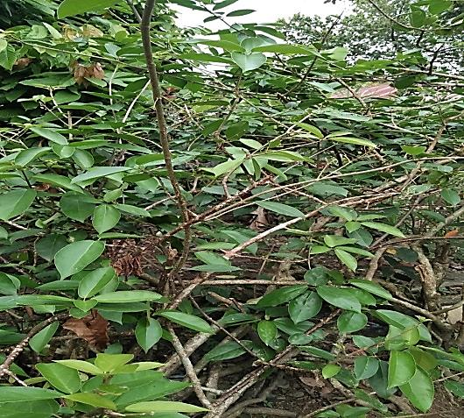
Tumbuhan cincau hijau

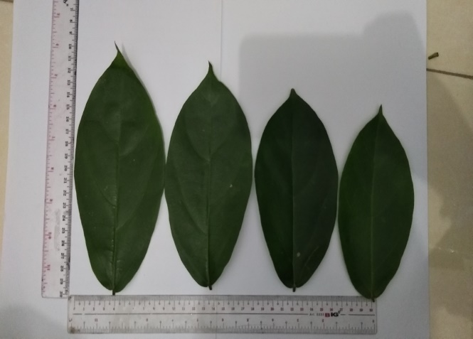
Daun Cincau Hijau

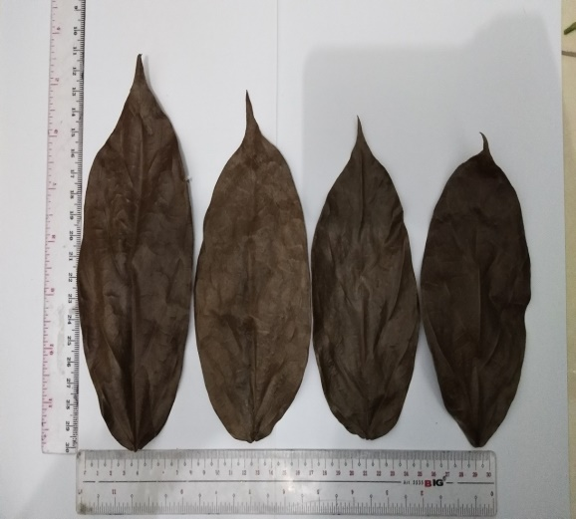
Simplisia Daun Cincau Hijau

Lampiran 3. Serbuk, Maserasi Daun Cincau Hijau

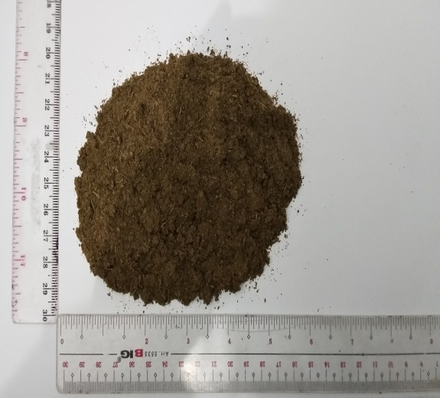

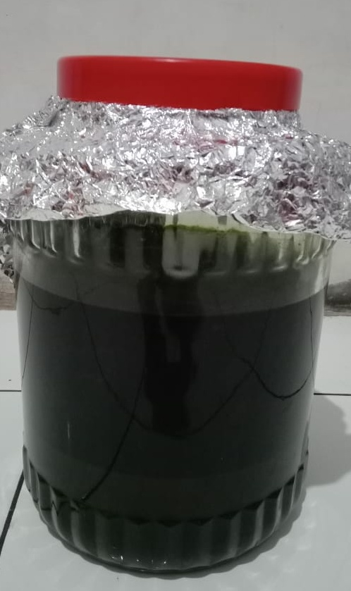
Maserasi Daun cincau Hijau
Lampiran 4. Hasil Identifikasi Bakteri dan Penanaman dalam Media Selektif

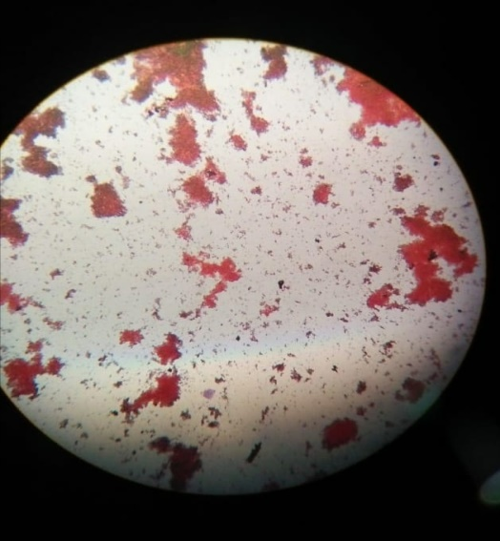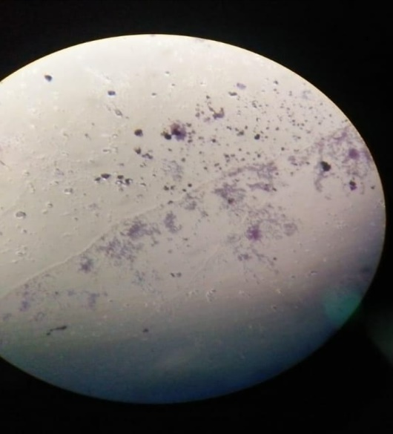

Mikroskopik Bakteri gram positif
Bakteri Sthapylococcus aureus

Mikroskopik Bakteri gram negatif Bakteri Escherichia coli

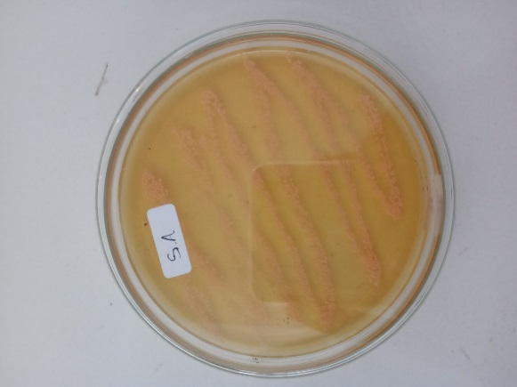
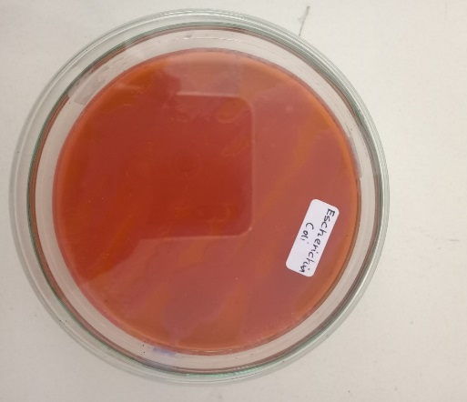

MEDIA EMB MEDIA MSA
(Bakteri Escherichia coli) (Bakteri Sthapylococcus aureus)

Lampiran 5. Ekstrak Etanol, Fraksi N-Heksan, Fraksi Kloroform

Lampiran 6. Rangkaian Alat Penetapan Kadar Air dan Rangkaian Alat Rotary Evaporator

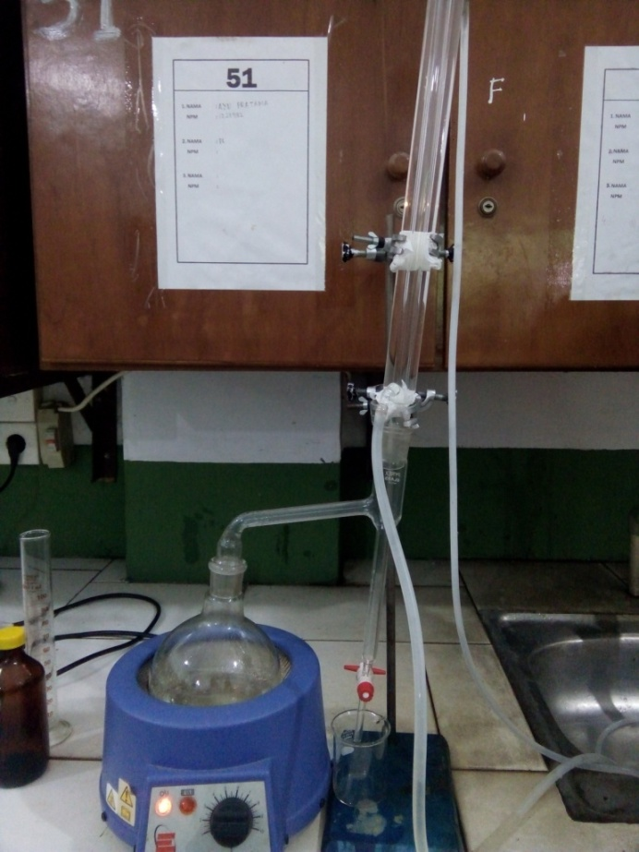
Gambar: Alat Penetapan Kadar Air

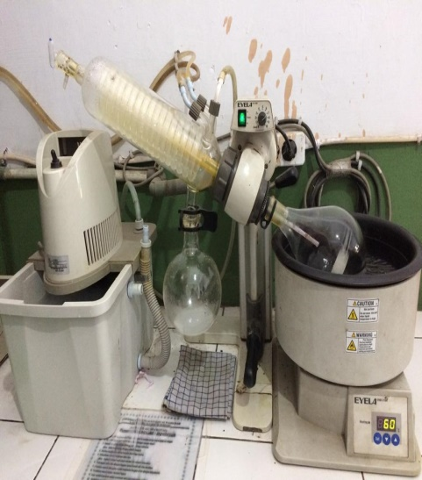
Gambar: Alat Rotary Evaporator

Lampiran 7. Oven, Inkubator, Autoklaf dan Mikropipet

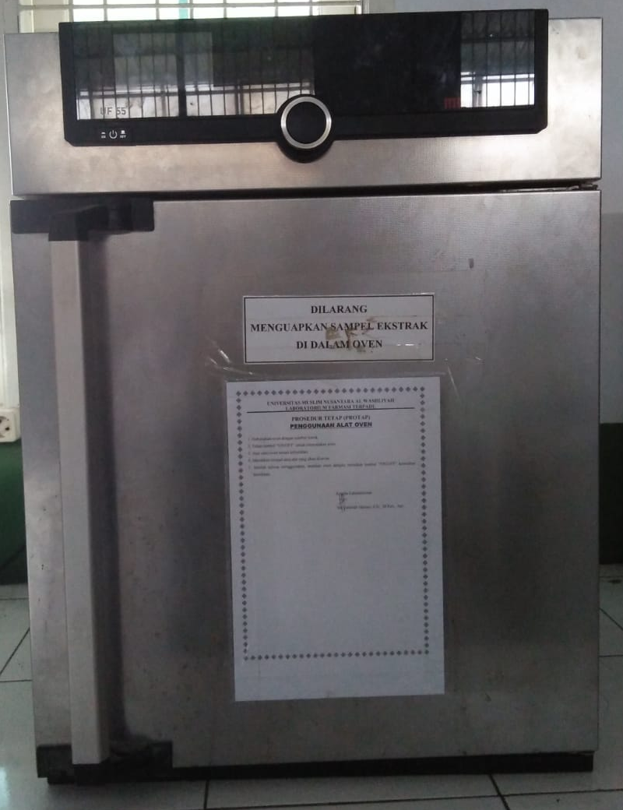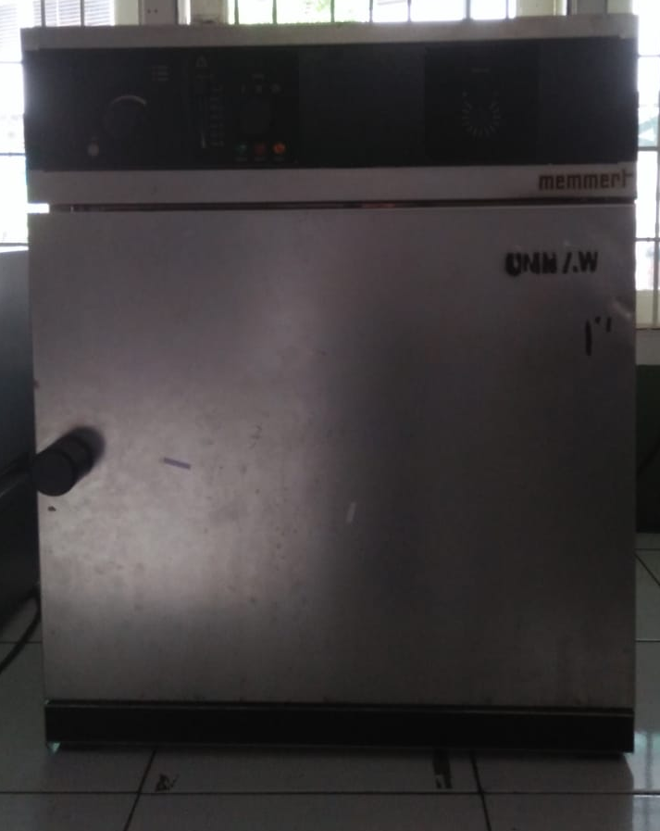
Oven Inkubator

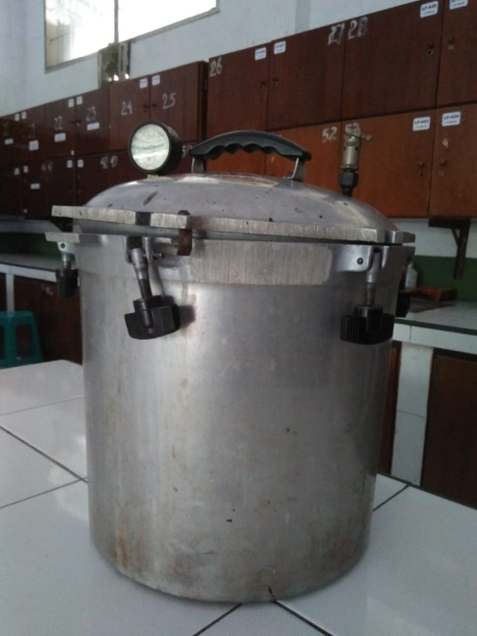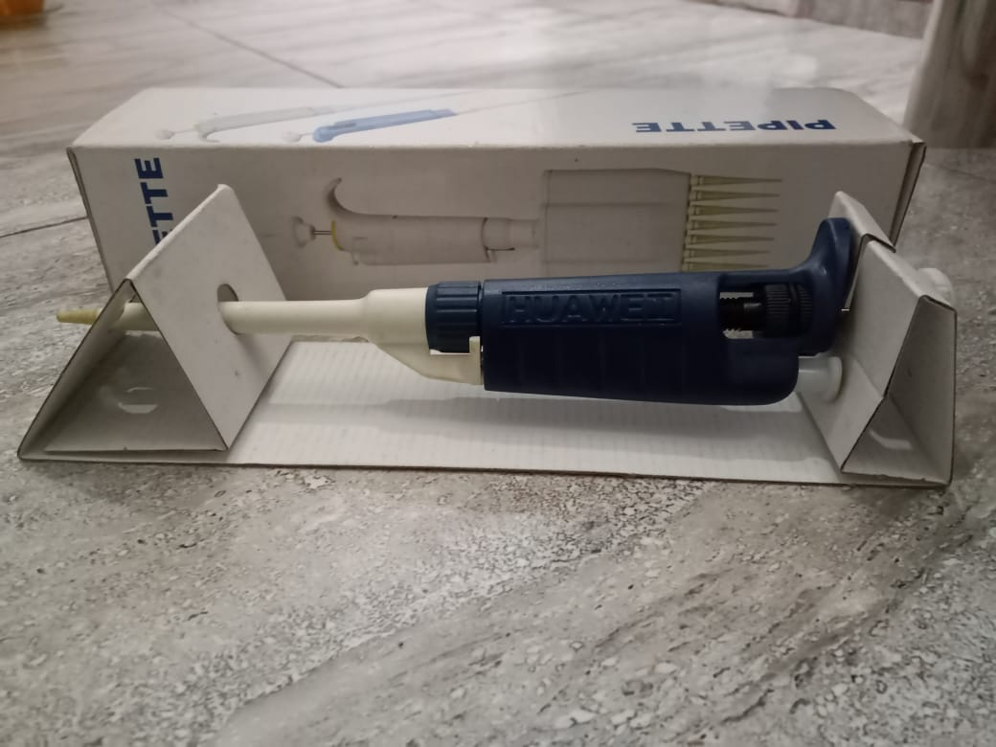
Autoklaf Mikropipet

Lampiran 8. Perhitungan Kadar Air
Kadar Air = $\frac{\left(Volume Akhir Air-Volume Awal Air\right)ml}{Bobot Simplisia (g)} x 100\%$

- Sampel 1
Berat Sampel = 5 g
Volume I = 1,6, ml
Volume II = 1,9 ml
Kadar Air = $\frac{\left(1,9-1,6\right)}{5 g} x 100\%$ = 6,00 %
- Sampel 2
Berat Sampel = 5 g
Volume I = 1,7 ml
Volume II = 1,8 ml
Kadar Air = $\frac{\left(1,8-1,7\right)}{5 g} x 100\%$ = 2,00 %
- Sampel 3
Berat Sampel = 5 g
Volume I = 1,5 ml
Volume II = 1,9 ml
Kadar Air = $\frac{\left(1,9-1,5\right)}{5 g} x 100\%$ = 8,00 %
Maka, kadar air rata-rata =$\frac{6,00 \%+2,00 \%+8,00 \%}{3}$ = 5,33%

Lampiran 9. Bagan Alir Pembuatan Simplisia Daun Cincau Hijau
Daun Cincau Hijau segar

Disortasi basah
Dicuci dengan air mengalir
Ditiriskan
Ditimbang berat basahnya

Berat basah daun cincau hijau 5000 g

Dikeringkan dalam lemari pengering dengan suhu 40-60 ° C
Disortasi kering kemudian ditimbang kembali
Berat simplisia daun cincau hijau 1500 g

Dihaluskan daun cincau hijau kering, disimpan wadah tertutup
Berat serbuk simplisia 1370 g

Karakterisasi simplisia
Skrining Fitokimia

Lampiran 10. Bagan Alir Pembuatan Ekstrak
Serbuk Simplisia 800 g

Dimasukkan dalam bejana
Dibasahi dengan pelarut etanol 96 % sebanyak 1 L sambil diaduk hingga sampel basah merata
Diamkan 10 menit
Ditambahkan pelarut etanol 96 % sebanyak 5 L
Ditutup dan dibiarkan selama 5 hari sambil diaduk-aduk sesekali

Setelah 5 hari maserat diserkai dan ampasnya diperas

Ampas
Maserat

Dibilas dengan etanol 96 % sebanyak 2 L

Dimasukkan ke dalam bejana tertutup, selama 2 hari dan dienaptuangkan

Dipekatkan dengan rotary evaporator
pada suhu 60°C

Ekstrak kental : 162,6 g

Lampiran 11. Bagan Alir Fraksinasi N- heksan dan Klorofom
Ekstrak Etanol 130 gr

Ditambahkan sedikit pelarut etanol, diaduk hingga larut
Ditambahkan aquadest sebanyak 1,3 L , diaduk hingga larut
Ditambahkan N-heksan sebanyak 1,3 L, masukkan kedalam corong pisah, digojlok dan diamkan 24 jam hingga terbentuk 2 lapisan (3 kali pelakuan)

Lapisan Atas (Lapisan n-heksann)
Lapisan Bawah (Lapisan Air)

Dipekatkan dengan Rotary evaporator dengan suhu 68°C

Ditambahkan Klorofom sebanyak 1,3 L
Ekstrak kental Fraksi N-heksan 13,5 g
Digojlok, kemudian didiamkan selama 24 jam hingga terbentuk 2 lapisan (3 kali pengulangan)
Lapisan Bawah (Lapisan Kloroform)
Dipekatkan dengan Rotary evaporator dengan suhu 68°C

Ekstrak kental Fraksi Kloroform 14,50 g

Lampiran 12. Bagan Alir Identifikasi Bakteri
Bakteri Uji

Diambil sedikit, diletakkan diatas objek glass
Difiksasi diatas api bunsen
Ditetesi kristal violet, diamkan 30 detik, dibilas dengan air mengalir
Ditetesi larutan Iodium, diamkan 30 detik, dibilas dengan air mengalir, dikeringkan
Ditetesi alkohol, diamkan 20 detik, dibilas dengan air mengalir, dikeringkan
Ditetesi Safranin, diamkan 30 detik, dibilas dengan air mengalir, dikeringkan
Bakteri Gram positif berwarna ungu dan bakteri Gram negatif berwarna merah

Preparat diamati dibawah mikroskop
Bakteri Sthapylococcus aureus Gram positif berbentuk kokus tidak beraturan dan mirip karangan aggur dan bakteri Escherichia coli Gram negatif berbentuk batang

Lampiran 13. Bagan Alir Aktivitas Antibakteri
20 ml media MHA

Dimasukkan kedalam cawan petri steril

Didiamkan hingga memadat

Media Padat

Digoreskan suspensi bakteri Escherichia coli dan Staphylococcus aureus sampai merata

Dimasukkan Disk cakram yang telah ditetesi larutan uji dengan konsentrasi (500 mg/ml, 400 mg/ml, 300 mg/ml, 200 mg/ml, 100 mg/ml, 50 mg/ml, 25 mg/ml, 12,5 mg/ml, 6,25 mg/ml, 3,125 mg/ml) serta kontrol positif dan kontrol negatif
Diinkubasi pada suhu 36-37 ˚C selama 18-24 jam
Diukur diameter zona bening
disekitar disk dengan jangka sorong

Hasil Diameter Hambat

Lampiran 14. Hasil uji aktivitas antibakteri ekstrak etanol daun cincau
hijau terhadap bakteri Escherichia coli

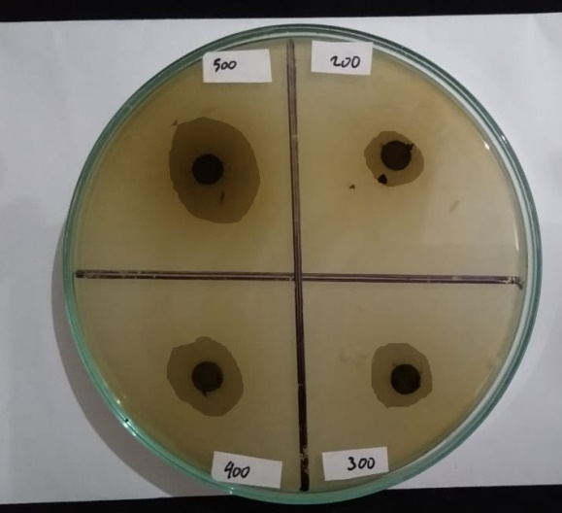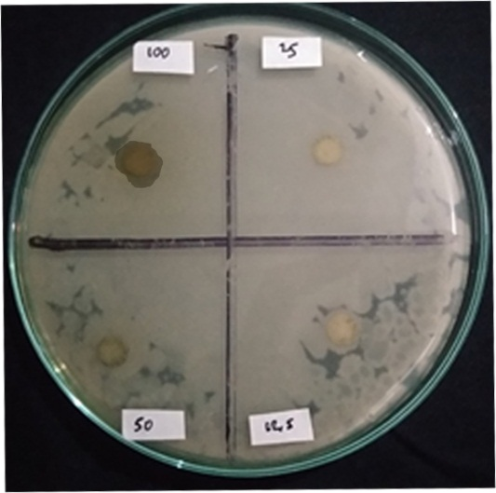
A B

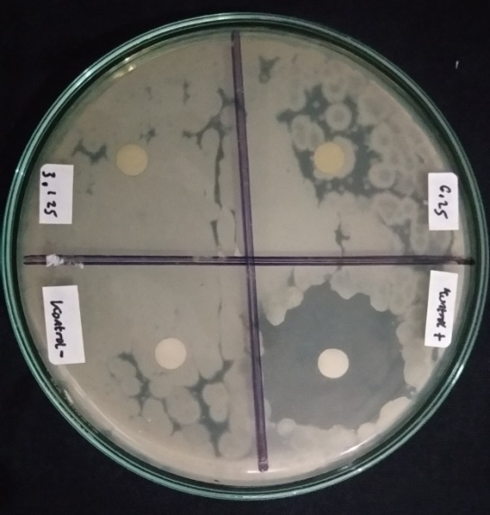
C

Keterangan : A = Konsentrasi 500 mg/ml, 400 mg/ml, 300 mg/ml, 200 mg/ml
B = Konsentrasi 100 mg/ml, 50 mg/ml, 25 mg/ml, 12,5 mg/ml
C = Konsentrasi 6,25 mg/ml, 3,125 mg/ml, kontrol positif
(Kloroform), kontrol negatif (etanol)

Lampiran 15. Hasil uji aktivitas antibakteri ekstrak etanol daun cincau
hijau terhadap bakteri Staphylococcus aureus

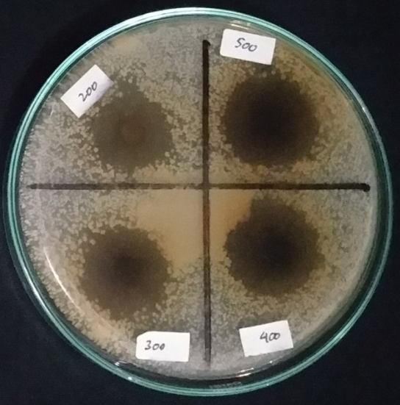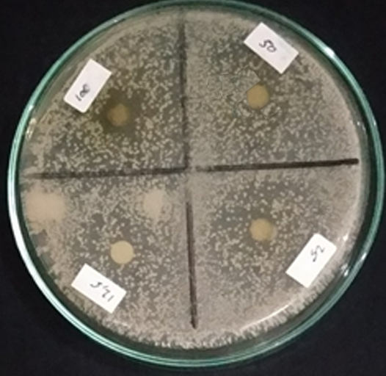
A B

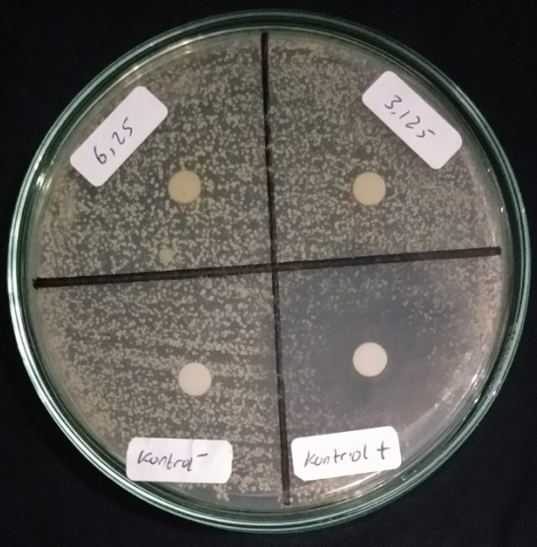
C

Keterangan : A = Konsentrasi 500 mg/ml, 400 mg/ml, 300 mg/ml, 200 mg/ml
B = Konsentrasi 100 mg/ml, 50 mg/ml, 25 mg/ml, 12,5 mg/ml
C = Konsentrasi 6,25 mg/ml, 3,125 mg/ml, kontrol positif
(Kloroform), kontrol negatif (etanol)

Lampiran 16. Hasil uji aktivitas antibakteri fraksi n-heksan daun cincau
hijau terhadap bakteri Escherichia coli.

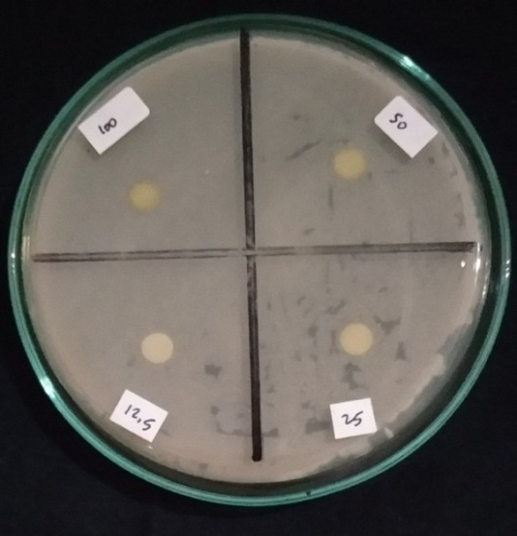
A B

C

Keterangan : A = Konsentrasi 500 mg/ml, 400 mg/ml, 300 mg/ml, 200 mg/ml
B = Konsentrasi 100 mg/ml, 50 mg/ml, 25 mg/ml, 12,5 mg/ml
C = Konsentrasi 6,25 mg/ml, 3,125 mg/ml, kontrol positif
(Kloramfenikol), kontrol negatif (n-heksan)

Lampiran 17. Hasil uji aktivitas antibakteri fraksi n-heksan daun cincau
hijau terhadap bakteri Staphylococcus aureus

A B

C

Keterangan : A = Konsentrasi 500 mg/ml, 400 mg/ml, 300 mg/ml, 200 mg/ml
B = Konsentrasi 100 mg/ml, 50 mg/ml, 25 mg/ml, 12,5 mg/ml
C = Konsentrasi 6,25 mg/ml, 3,125 mg/ml, kontrol positif
(Kloramfenikol), kontrol negatif (n-heksan)

Lampiran 18. Hasil uji aktivitas antibakteri fraksi kloroform daun cincau
hijau terhadap bakteri Escherichia coli.

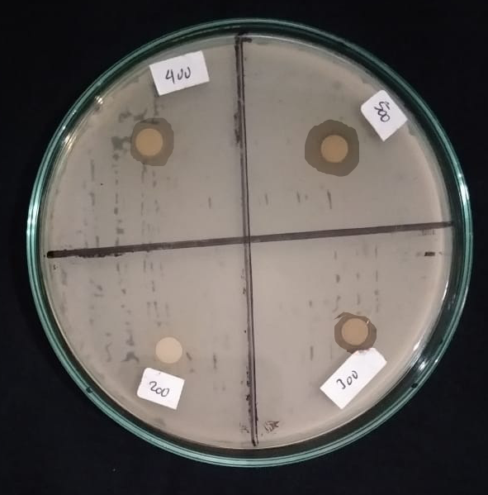
A B

C

Keterangan : A = Konsentrasi 500 mg/ml, 400 mg/ml, 300 mg/ml, 200 mg/ml
B = Konsentrasi 100 mg/ml, 50 mg/ml, 25 mg/ml, 12,5 mg/ml
C = Konsentrasi 6,25 mg/ml, 3,125 mg/ml, kontrol positif
(Kloramfenikol), kontrol negatif (kloroform)

Lampiran 19. Hasil uji aktivitas antibakteri fraksi kloroform daun cincau
hijau terhadap bakteri Staphylococcus aureus.

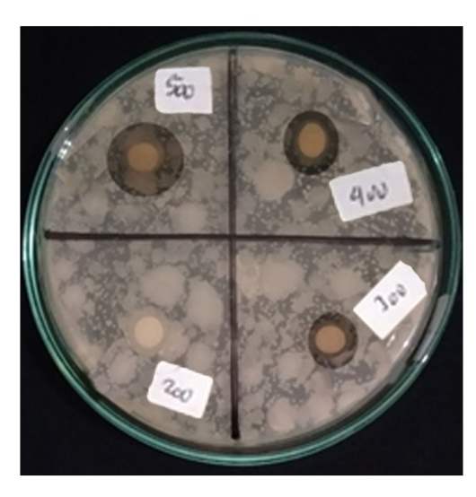

A B

C

Keterangan : A = Konsentrasi 500 mg/ml, 400 mg/ml, 300 mg/ml, 200 mg/ml
B = Konsentrasi 100 mg/ml, 50 mg/ml, 25 mg/ml, 12,5 mg/ml
C = Konsentrasi 6,25 mg/ml, 3,125 mg/ml, kontrol positif
(Kloramfenikol), kontrol negatif (kloroform)

Lampiran 20. Hasil Analisis Data

Tests of Normality
 | Perlakuan | Kolmogorov-Smirnovª |  |  | Shapiro-Wilk
 |  | Statistic | df | Sig. | Statistic | df | Sig.
KHM Escherichia coli Ekstrak Etanol | kontrol Positif | .309 | 3 | . | .901 | 3 | .388
 | Kontrol Negatif | . | 3 | . | . | 3 | .
 | Konsentrasi 500 mg/ml | .323 | 3 | . | .879 | 3 | .322
 | Konsentrasi 400 mg/ml | .301 | 3 | . | .912 | 3 | .424
 | Konsentrasi 300 mg/ml | .202 | 3 | . | .994 | 3 | .854
 | Konsentrasi 200 mg/ml | .339 | 3 | . | .851 | 3 | .243
 | Konsentrasi 100 mg/ml | .224 | 3 | . | .985 | 3 | .763
 | Konsentrasi 50 mg/ml | . | 3 | . | . | 3 | .
 | Konsentrasi 25 mg/ml | . | 3 | . | . | 3 | .
 | Konsentrasi 12,5 mg/ml | . | 3 | . | . | 3 | .
 | Konsentrasi 6,25 mg/ml | . | 3 | . | . | 3 | .
 | Konsentrasi 3,125 mg/ml | . | 3 | . | . | 3 | .
KHM Staphylococcus aureus Ekstrak Etanol | kontrol Positif | .223 | 3 | . | .985 | 3 | .763
 | Kontrol Negatif | . | 3 | . | . | 3 | .
 | Konsentrasi 500 mg/ml | .190 | 3 | . | .997 | 3 | .902
 | Konsentrasi 400 mg/ml | .227 | 3 | . | .982 | 3 | .746
 | Konsentrasi 300 mg/ml | .319 | 3 | . | .886 | 3 | .341
 | Konsentrasi 200 mg/ml | .350 | 3 | . | .828 | 3 | .184
 | Konsentrasi 100 mg/ml | .293 | 3 | . | .922 | 3 | .459
 | Konsentrasi 50 mg/ml | . | 3 | . | . | 3 | .
 | Konsentrasi 25 mg/ml | . | 3 | . | . | 3 | .
 | Konsentrasi 12,5 mg/ml | . | 3 | . | . | 3 | .
 | Konsentrasi 6,25 mg/ml | . | 3 | . | . | 3 | .
 | Konsentrasi 3,125 mg/ml | . | 3 | . | . | 3 | .
KHM Escherichia coli Fraksi Kloroform | kontrol Positif | .298 | 3 | . | .915 | 3 | .435
 | Kontrol Negatif | . | 3 | . | . | 3 | .
 | Konsentrasi 500 mg/ml | .288 | 3 | . | .928 | 3 | .482
 | Konsentrasi 400 mg/ml | .235 | 3 | . | .978 | 3 | .714
 | Konsentrasi 300 mg/ml | .231 | 3 | . | .981 | 3 | .733
 | Konsentrasi 200 mg/ml | . | 3 | . | . | 3 | .
 | Konsentrasi 100 mg/ml | . | 3 | . | . | 3 | .
 | Konsentrasi 50 mg/ml | . | 3 | . | . | 3 | .
 | Konsentrasi 25 mg/ml | . | 3 | . | . | 3 | .
 | Konsentrasi 12,5 mg/ml | . | 3 | . | . | 3 | .
 | Konsentrasi 6,25 mg/ml | . | 3 | . | . | 3 | .
 | Konsentrasi 3,125 mg/ml | . | 3 | . | . | 3 | .
KHM Staphylococcus aureus Fraksi Kloroform | kontrol Positif | .306 | 3 | . | .904 | 3 | .399
 | Kontrol Negatif | . | 3 | . | . | 3 | .
 | Konsentrasi 500 mg/ml | .330 | 3 | . | .867 | 3 | .288
 | Konsentrasi 400 mg/ml | .300 | 3 | . | .913 | 3 | .429
 | Konsentrasi 300 mg/ml | .280 | 3 | . | .938 | 3 | .518
 | Konsentrasi 200 mg/ml | . | 3 | . | . | 3 | .
 | Konsentrasi 100 mg/ml | . | 3 | . | . | 3 | .
 | Konsentrasi 50 mg/ml | . | 3 | . | . | 3 | .
 | Konsentrasi 25 mg/ml | . | 3 | . | . | 3 | .
 | Konsentrasi 12,5 mg/ml | . | 3 | . | . | 3 | .
 | Konsentrasi 6,25 mg/ml | . | 3 | . | . | 3 | .
 | Konsentrasi 3,125 mg/ml | . | 3 | . | . | 3 | .
a. Lilliefors Significance Correction

Lampiran 20. (Lanjutan)

Test of Homogeneity of Variances
 |  | Levene Statistic | df1 | df2 | Sig.
KHM Escherichia coli Ekstrak Etanol | Based on Mean | 5.758 | 11 | 24 | .000
 | Based on Median | 1.403 | 11 | 24 | .235
 | Based on Median and with adjusted df | 1.403 | 11 | 6.520 | .344
 | Based on trimmed mean | 5.291 | 11 | 24 | .000
KHM Staphylococcus aureus Ekstrak Etanol | Based on Mean | 4.292 | 11 | 24 | .001
 | Based on Median | 1.538 | 11 | 24 | .182
 | Based on Median and with adjusted df | 1.538 | 11 | 8.906 | .265
 | Based on trimmed mean | 4.059 | 11 | 24 | .002
KHM Escherichia coli Fraksi Kloroform | Based on Mean | 5.479 | 11 | 24 | .000
 | Based on Median | 2.416 | 11 | 24 | .034
 | Based on Median and with adjusted df | 2.416 | 11 | 6.165 | .141
 | Based on trimmed mean | 5.236 | 11 | 24 | .000
KHM Staphylococcus aureus Fraksi Kloroform | Based on Mean | 7.960 | 11 | 24 | .000
 | Based on Median | 1.600 | 11 | 24 | .162
 | Based on Median and with adjusted df | 1.600 | 11 | 6.984 | .274
 | Based on trimmed mean | 7.165 | 11 | 24 | .000

ANOVA
 |  |  |  | Sum of Squares | df | Mean  Square | F | Sig.
KHM Escherichia coli Ekstrak Etanol | Between Groups | (Combined) |  | 2817.221 | 11 | 256.111 | 632.972 | .000
 |  | Linear Term | Contrast | 1454.742 | 1 | 1454.742 | 3595.358 | .000
 |  |  | Deviation | 1362.480 | 10 | 136.248 | 336.733 | .000
 | Within Groups |  |  | 9.711 | 24 | .405
 | Total |  |  | 2826.932 | 35
KHM Staphylococcus aureus Ekstrak Etanol | Between Groups | (Combined) |  | 3486.684 | 11 | 316.971 | 912.366 | .000
 |  | Linear Term | Contrast | 1727.158 | 1 | 1727.158 | 4971.431 | .000
 |  |  | Deviation | 1759.526 | 10 | 175.953 | 506.460 | .000
 | Within Groups |  |  | 8.338 | 24 | .347
 | Total |  |  | 3495.022 | 35
KHM Escherichia coli Fraksi Kloroform | Between Groups | (Combined) |  | 1742.580 | 11 | 158.416 | 570.253 | .000
 |  | Linear Term | Contrast | 852.486 | 1 | 852.486 | 3068.704 | .000
 |  |  | Deviation | 890.094 | 10 | 89.009 | 320.408 | .000
 | Within Groups |  |  | 6.667 | 24 | .278
 | Total |  |  | 1749.247 | 35
KHM Staphylococcus aureus Fraksi Kloroform | Between Groups | (Combined) |  | 1947.026 | 11 | 177.002 | 363.034 | .000
 |  | Linear Term | Contrast | 961.085 | 1 | 961.085 | 1971.197 | .000
 |  |  | Deviation | 985.941 | 10 | 98.594 | 202.218 | .000
 | Within Groups |  |  | 11.702 | 24 | .488
 | Total |  |  | 1958.728 | 35

Lampiran 20. (Lanjutan)

KHM Escherichia coli Ekstrak Etanol
Duncanª
Perlakuan | N | Subset for alpha = 0.05
 |  | 1 | 2 | 3 | 4 | 5 | 6 | 7
Kontrol Negatif | 3 | .0000
Konsentrasi 50 mg/ml | 3 | .0000
Konsentrasi 25 mg/ml | 3 | .0000
Konsentrasi 12,5 mg/ml | 3 | .0000
Konsentrasi 6,25 mg/ml | 3 | .0000
Konsentrasi 3,125 mg/ml | 3 | .0000
Konsentrasi 100 mg/ml | 3 |  | 10.0430
Konsentrasi 200 mg/ml | 3 |  |  | 14.3200
Konsentrasi 300 mg/ml | 3 |  |  |  | 15.6633
Konsentrasi 400 mg/ml | 3 |  |  |  |  | 18.4267
Konsentrasi 500 mg/ml | 3 |  |  |  |  |  | 19.9367
kontrol Positif | 3 |  |  |  |  |  |  | 22.1900
Sig. |  | 1.000 | 1.000 | 1.000 | 1.000 | 1.000 | 1.000 | 1.000
Means for groups in homogeneous subsets are displayed.
a. Uses Harmonic Mean Sample Size = 3.000.

KHM Staphylococcus aureus Ekstrak Etanol
Duncanª
Perlakuan | N | Subset for alpha = 0.05
 |  | 1 | 2 | 3 | 4 | 5 | 6
Kontrol Negatif | 3 | .0000
Konsentrasi 50 mg/ml | 3 | .0000
Konsentrasi 25 mg/ml | 3 | .0000
Konsentrasi 12,5 mg/ml | 3 | .0000
Konsentrasi 6,25 mg/ml | 3 | .0000
Konsentrasi 3,125 mg/ml | 3 | .0000
Konsentrasi 100 mg/ml | 3 |  | 10.0533
Konsentrasi 200 mg/ml | 3 |  |  | 17.4267
Konsentrasi 300 mg/ml | 3 |  |  |  | 19.2667
Konsentrasi 400 mg/ml | 3 |  |  |  |  | 20.9633
Konsentrasi 500 mg/ml | 3 |  |  |  |  |  | 22.0133
kontrol Positif | 3 |  |  |  |  |  | 22.7067
Sig. |  | 1.000 | 1.000 | 1.000 | 1.000 | 1.000 | .163
Means for groups in homogeneous subsets are displayed.
a. Uses Harmonic Mean Sample Size = 3.000.
Lampiran 20. (Lanjutan)

KHM Escherichia coli Fraksi Kloroform
Duncanª
Perlakuan | N | Subset for alpha = 0.05
 |  | 1 | 2 | 3 | 4 | 5
Kontrol Negatif | 3 | .0000
Konsentrasi 200 mg/ml | 3 | .0000
Konsentrasi 100 mg/ml | 3 | .0000
Konsentrasi 50 mg/ml | 3 | .0000
Konsentrasi 25 mg/ml | 3 | .0000
Konsentrasi 12,5 mg/ml | 3 | .0000
Konsentrasi 6,25 mg/ml | 3 | .0000
Konsentrasi 3,125 mg/ml | 3 | .0000
Konsentrasi 300 mg/ml | 3 |  | 8.9667
Konsentrasi 400 mg/ml | 3 |  |  | 9.9000
Konsentrasi 500 mg/ml | 3 |  |  |  | 11.3967
kontrol Positif | 3 |  |  |  |  | 22.4533
Sig. |  | 1.000 | 1.000 | 1.000 | 1.000 | 1.000
Means for groups in homogeneous subsets are displayed.
a. Uses Harmonic Mean Sample Size = 3.000.

KHM Staphylococcus aureus Fraksi Kloroform
Duncanª
Perlakuan | N | Subset for alpha = 0.05
 |  | 1 | 2 | 3 | 4
Kontrol Negatif | 3 | .0000
Konsentrasi 200 mg/ml | 3 | .0000
Konsentrasi 100 mg/ml | 3 | .0000
Konsentrasi 50 mg/ml | 3 | .0000
Konsentrasi 25 mg/ml | 3 | .0000
Konsentrasi 12,5 mg/ml | 3 | .0000
Konsentrasi 6,25 mg/ml | 3 | .0000
Konsentrasi 3,125 mg/ml | 3 | .0000
Konsentrasi 300 mg/ml | 3 |  | 9.6733
Konsentrasi 400 mg/ml | 3 |  | 10.5467
Konsentrasi 500 mg/ml | 3 |  |  | 12.7500
kontrol Positif | 3 |  |  |  | 23.3700
Sig. |  | 1.000 | .139 | 1.000 | 1.000
Means for groups in homogeneous subsets are displayed.
a. Uses Harmonic Mean Sample Size = 3.000.

Lampiran 21. Hasil Analisis T-test Ekstrak Etanol Terhadap Bakteri Escherichia coli dan Staphylococcus aureus

Group Statistics
 | Konsentrasi | N | Mean | Std. Deviation | Std. Error Mean
daya hambat e.coli dan sa ekstrak etanol | 500 | 3 | 19.9367 | .35726 | .20626
 | 500 | 3 | 22.0133 | 1.06641 | .61569

Independent Samples Test
 |  | Levene's Test for Equality of Variances |  | t-test for Equality of Means
 |  | F | Sig. | t
daya hambat e.coli dan sa ekstrak etanol | Equal variances assumed | 1.799 | .251 | -3.198
 | Equal variances not assumed |  |  | -3.198

Independent Samples Test
 |  | t-test for Equality of Means
 |  | Df | Sig. (2-tailed) | Mean Difference
daya hambat e.coli dan sa ekstrak etanol | Equal variances assumed | 4 | .033 | -2.07667
 | Equal variances not assumed | 2.443 | .035 | -2.07667

Independent Samples Test
 |  | t-test for Equality of Means
 |  | Std. Error Difference | 95% Confidence Interval of the Difference
 |  |  | Lower | Upper
daya hambat e.coli dan sa ekstrak etanol | Equal variances assumed | .64932 | -3.87948 | -.27385
 | Equal variances not assumed | .64932 | -4.43674 | .28341

Group Statistics
 | Konsentrasi | N | Mean | Std. Deviation | Std. Error Mean
daya hambat e.coli dan sa ekstrak etanol | 400 | 3 | 18.4267 | 1.08910 | .62879
 | 400 | 3 | 20.9633 | 1.08960 | .62908

Independent Samples Test
 |  | Levene's Test for Equality of Variances |  | t-test for Equality of Means
 |  | F | Sig. | T
daya hambat e.coli dan sa ekstrak etanol | Equal variances assumed | .011 | .920 | -2.852
 | Equal variances not assumed |  |  | -2.852

Lampiran 21. (Lanjutan)

Independent Samples Test
 |  | t-test for Equality of Means
 |  | Df | Sig. (2-tailed) |  | Mean Difference
daya hambat e.coli dan sa ekstrak etanol | Equal variances assumed | 4 | .046 |  | -2.53667
 | Equal variances not assumed | 4.000 | .046 |  | -2.53667
Independent Samples Test
 |  | t-test for Equality of Means
 |  | Std. Error Difference |  | 95% Confidence Interval of the Difference
 |  |  |  | Lower |  | Upper
daya hambat e.coli dan sa ekstrak etanol | Equal variances assumed | .88945 |  | -5.00618 |  | -.06716
 | Equal variances not assumed | .88945 |  | -5.00618 |  | -.06716

Group Statistics
 | Konsentrasi | N | Mean | Std. Deviation | Std. Error Mean
daya hambat e.coli dan sa ekstrak etanol | 300 | 3 | 15.6633 | 1.16843 | .67459
 | 300 | 3 | 19.2667 | .47816 | .27606

Independent Samples Test
 |  | Levene's Test for Equality of Variances |  | t-test for Equality of Means
 |  | F | Sig. | t
daya hambat e.coli dan sa ekstrak etanol | Equal variances assumed | 1.474 | .292 | -4.944
 | Equal variances not assumed |  |  | -4.944

Independent Samples Test
 |  | t-test for Equality of Means
 |  | Df | Sig. (2-tailed) | Mean Difference
daya hambat e.coli dan sa ekstrak etanol | Equal variances assumed | 4 | .008 | -3.60333
 | Equal variances not assumed | 2.652 | .021 | -3.60333

Independent Samples Test
 |  | t-test for Equality of Means
 |  | Std. Error Difference | 95% Confidence Interval of the Difference
 |  |  | Lower | Upper
daya hambat e.coli dan sa ekstrak etanol | Equal variances assumed | .72890 | -5.62707 | -1.57959
 | Equal variances not assumed | .72890 | -6.10534 | -1.10133

Group Statistics
 | Konsentrasi | N | Mean | Std. Deviation | Std. Error Mean
daya hambat e.coli dan sa ekstrak etanol | 200 | 3 | 14.3200 | 1.30088 | .75107
 | 200 | 3 | 17.4200 | .93872 | .54197
Lampiran 21. (Lanjutan)

Independent Samples Test
 |  | Levene's Test for Equality of Variances |  | t-test for Equality of Means
 |  | F | Sig. | t
daya hambat e.coli dan sa ekstrak etanol | Equal variances assumed | .710 | .447 | -3.347
 | Equal variances not assumed |  |  | -3.347

Independent Samples Test
 |  | t-test for Equality of Means
 |  | Df | Sig. (2-tailed) | Mean Difference
daya hambat e.coli dan sa ekstrak etanol | Equal variances assumed | 4 | .029 | -3.10000
 | Equal variances not assumed | 3.639 | .033 | -3.10000

Independent Samples Test
 |  | t-test for Equality of Means
 |  | Std. Error Difference | 95% Confidence Interval of the Difference
 |  |  | Lower | Upper
daya hambat e.coli dan sa ekstrak etanol | Equal variances assumed | .92619 | -5.67152 | -.52848
 | Equal variances not assumed | .92619 | -5.77547 | -.42453

Group Statistics
 | Konsentrasi | N | Mean | Std. Deviation | Std. Error Mean
daya hambat e.coli dan sa ekstrak etanol | 100 | 3 | 10.0430 | .48877 | .28219
 | 100 | 3 | 10.0533 | .69256 | .39985

Independent Samples Test
 |  | Levene's Test for Equality of Variances |  | t-test for Equality of Means
 |  | F | Sig. | t
daya hambat e.coli dan sa ekstrak etanol | Equal variances assumed | .645 | .467 | .770
 | Equal variances not assumed |  |  | .770

Independent Samples Test
 |  | t-test for Equality of Means
 |  | df | Sig. (2-tailed) | Mean Difference
daya hambat e.coli dan sa ekstrak etanol | Equal variances assumed | 4 | .484 | .37667
 | Equal variances not assumed | 3.596 | .489 | .37667

Independent Samples Test
 |  | t-test for Equality of Means
 |  | Std. Error Difference | 95% Confidence Interval of the Difference
 |  |  | Lower | Upper
daya hambat e.coli dan sa ekstrak etanol | Equal variances assumed | .48940 | -.98212 | 1.73546
 | Equal variances not assumed | .48940 | -1.04444 | 1.79777

Lampiran 22. Hasil Analisis T-test Fraksi Kloroform Terhadap Bakteri Escherichia coli dan Staphylococcus aureus

Group Statistics
 | Konsentrasi | N | Mean | Std. Deviation | Std. Error Mean
daya hambat e.coli dan sa fraksi kloroform | 500 | 3 | 11.3967 | .70059 | .40449
 | 500 | 3 | 12.7500 | 1.16503 | .67263

Independent Samples Test
 |  | Levene's Test for Equality of Variances |  | t-test for Equality of Means
 |  | F | Sig. | t
daya hambat e.coli dan sa fraksi kloroform | Equal variances assumed | 1.534 | .283 | -1.724
 | Equal variances not assumed |  |  | -1.724

Independent Samples Test
 |  | t-test for Equality of Means
 |  | df | Sig. (2-tailed) | Mean Difference
daya hambat e.coli dan sa fraksi kloroform | Equal variances assumed | 4 | .160 | -1.35333
 | Equal variances not assumed | 3.279 | .175 | -1.35333

Independent Samples Test
 |  | t-test for Equality of Means
 |  | Std. Error Difference | 95% Confidence Interval of the Difference
 |  |  | Lower | Upper
daya hambat e.coli dan sa fraksi kloroform | Equal variances assumed | .78488 | -3.53252 | .82586
 | Equal variances not assumed | .78488 | -3.73507 | 1.02841

Group Statistics
 | Konsentrasi | N | Mean | Std. Deviation | Std. Error Mean
daya hambat e.coli dan sa fraksi kloroform | 400 | 3 | 9.9000 | 1.16297 | .67144
 | 400 | 3 | 10.5467 | 1.07784 | .62229

Independent Samples Test
 |  | Levene's Test for Equality of Variances |  | t-test for Equality of Means
 |  | F | Sig. | t
daya hambat e.coli dan sa fraksi kloroform | Equal variances assumed | .004 | .955 | -.706
 | Equal variances not assumed |  |  | -.706
Lampiran 22. (Lanjutan)

Independent Samples Test
 |  | t-test for Equality of Means
 |  | df | Sig. (2-tailed) | Mean Difference
daya hambat e.coli dan sa fraksi kloroform | Equal variances assumed | 4 | .519 | -.64667
 | Equal variances not assumed | 3.977 | .519 | -.64667

Independent Samples Test
 |  | t-test for Equality of Means
 |  | Std. Error Difference | 95% Confidence Interval of the Difference
 |  |  | Lower | Upper
daya hambat e.coli dan sa fraksi kloroform | Equal variances assumed | .91547 | -3.18841 | 1.89507
 | Equal variances not assumed | .91547 | -3.19419 | 1.90086

Group Statistics
 | Konsentrasi | N | Mean | Std. Deviation | Std. Error Mean
daya hambat e.coli dan sa fraksi kloroform | 300 | 3 | 8.9667 | 1.16131 | .67048
 | 300 | 3 | 9.6733 | 1.60594 | .92719

Independent Samples Test
 |  | Levene's Test for Equality of Variances |  | t-test for Equality of Means
 |  | F | Sig. | t
daya hambat e.coli dan sa fraksi kloroform | Equal variances assumed | .512 | .514 | -.618
 | Equal variances not assumed |  |  | -.618

Independent Samples Test
 |  | t-test for Equality of Means
 |  | df | Sig. (2-tailed) | Mean Difference
daya hambat e.coli dan sa fraksi kloroform | Equal variances assumed | 4 | .570 | -.70667
 | Equal variances not assumed | 3.643 | .573 | -.70667

Independent Samples Test
 |  | t-test for Equality of Means
 |  | Std. Error Difference | 95% Confidence Interval of the Difference
 |  |  | Lower | Upper
daya hambat e.coli dan sa fraksi kloroform | Equal variances assumed | 1.14421 | -3.88351 | 2.47018
 | Equal variances not assumed | 1.14421 | -4.01032 | 2.59699

