LAMPIRAN 01
No | Nama Perusahaan Asuransi | Link Website Perusahaan
1 | Asuransi Jiwa Bersama Bumiputera 1912 | http://ajb.bumiputera.com
2 | PT AIA Financial | https://www.aia-financial.co.id/id/index.html
3 | PT Asuransi Allianz Life Indonesia | https://www.allianz.co.id
4 | PT Asuransi Jiwa Bringin Jiwa Sejahtera | http://www.bringinlife.co.id
5 | PT Asuransi Jiwa Central Asia Raya | http://www.car.co.id
6 | PT Asuransi Jiwa Manulife Indonesia | https://www.manulife-indonesia.com
7 | PT Asuransi Jiwa PFI Mega Life | https://www.pfimegalife.co.id
8 | PT Asuransi Jiwa Sinar Mas MSIG | https://www.sinarmasmsiglife.co.id
9 | PT Avrist Assurance | http://avrist.com/
10 | PT Axa Financial Indonesia | https://axa.co.id
11 | PT Axa Mandiri Financial Services | https://www.axa-mandiri.co.id/
12 | PT BNI Life Insurance | https://www.bni-life.co.id
13 | PT Great Eastern Life Indonesia | https://www.greateasternlife.com
14 | PT Panin Daichi Life (d/h PT Panin Life) | https://www.panindai-ichilife.co.id
15 | PT Prudential Life Assurance | https://www.prudential.co.id
16 | PT Sun Life Financial Indonesia | https://www.sunlife.co.id
17 | PT Tokio Marine Life Insurance Indonesia (d/h PT MAA Life Assurance) | https://www.tokiomarine.com
18 | PT ACE Life Assurance | https://www2.chubb.com
19 | PT Financial Wiramitra Danadyaksa | https://www.fwd.co.id
20 | PT Asuransi Takaful Keluarga | http://www.takaful.co.id
21 | PT Asuransi Jiwa Syariah Al-Amin | www.alamin-insurance.com
22 | PT Asuransi Jiwa Syariah Amanah jiwa Giri Artha | www.amanahgitha.com
23 | PT Asuransi Jiwa Syariah Jasa Mitra Abadi | www.jmasyariah.com
24 | PT Asuransi Syariah Keluarga Indonesia | www.asyki.com
25 | PT Asuransi Adira Dinamika | www.asuransi.adira.co.id
26 | PT Asuransi Allianz Utama Indonesia | www.allianz.co.id
27 | PT Asuransi Astra Buana | www.asuransiastra.com
28 | PT Asuransi Bangun Askrida | www.askrida.com
29 | PT Asuransi Bintang, Tbk | www.asuransibintang.com
30 | PT Asuransi Bringin Sejahtera Artamakmur | www.brins.co.id
31 | PT Asuransi Central Asia | www.aca.co.id
32 | PT Asuransi Ekspor Indonesia (Persero) | www.asei.co.id)
33 | PT Asuransi Jasa Indonesia | www.jasindo.co.id
34 | PT Asuransi Jasa Raharja Putera | www.jasaraharja-putera.co.id
35 | PT Asuransi Parolamas | www.parolamas.co.id
36 | PT Asuransi Ramayana Tbk | www.ramayanains.com
37 | PT Asuransi Sinar Mas | www.sinarmas.co.id
38 | PT Asuransi Staco Mandiri (d/h PT Staco Jasa Pratama) | www.stacoinsurance.com
39 | PT Asuransi Tri Pakarta | www.tripakarta.co.id
40 | PT Asuransi Umum Bumiputera Muda 1967 | www.bumida.co.id
41 | PT Asuransi Umum Mega | www.megainsurance.co.id
42 | PT Tugu Pratama Indonesia | www.tugu.com
43 | PT Asuransi Bina Dana Arta | www.abda.co.id
44 | PT Asuransi Mitra Maparya | www.asuransimitra.com
45 | PT Asuransi Wahana Tata | www.aswata.co.id
46 | PT Pan Pacific Insurance | www.panfic.com
47 | PT Mandiri AXA General Insurance | www.axa-mandiri.co.id/general
48 | PT Asuransi Reliace Indonesia | www.reliance-insurance.com
49 | PT Asuransi Takaful Umum | https://www.takafulumum.co.id/
50 | PT Jaya Proteksi Takaful | https://www.chubbsyariah.co.id/
51 | PT Asuransi Sonwelis Takaful | https://www.sonwelis.co.id/
52 | PT Sompo Insurance Indonesia | www.sompo.co.id

LAMPIRAN 02
No | Nama Perusahaan | Tahun | Y | X1 | X2 | X3
 |  |  | Rasio Likuiditas | Dewan Komisaris | DPS | Dewan Direksi
1 | PT AIA Financial | 2015 | 1,85 | 4 | 8 | 5
 |  | 2016 | 2,04 | 4 | 7 | 5
 |  | 2017 | 4,57 | 4 | 7 | 5
2 | PT Asuransi Jiwa Manulife Indonesia | 2015 | 1,76 | 6 | 8 | 8
 |  | 2016 | 2,43 | 4 | 8 | 5
 |  | 2017 | 1,93 | 4 | 7 | 5
3 | PT Asuransi Jiwa Sinar Mas MSIG | 2015 | 1,97 | 4 | 8 | 5
 |  | 2016 | 2,11 | 5 | 7 | 8
 |  | 2017 | 1,94 | 4 | 7 | 5
4 | PT Axa Financial Indonesia | 2015 | 1,62 | 8 | 8 | 8
 |  | 2016 | 3,00 | 8 | 8 | 8
 |  | 2017 | 11,74 | 8 | 8 | 8
5 | PT Axa Mandiri Financial Services | 2015 | 26,27 | 4 | 8 | 8
 |  | 2016 | 6,41 | 4 | 6 | 8
 |  | 2017 | 21,86 | 8 | 8 | 8
6 | PT BNI Life Insurance | 2015 | 2,08 | 5 | 8 | 4
 |  | 2016 | 2,15 | 5 | 8 | 5
 |  | 2017 | 2,26 | 4 | 8 | 4
7 | PT Panin Daichi Life (d/h PT Panin Life) | 2015 | 2,13 | 8 | 7 | 5
 |  | 2016 | 13,51 | 8 | 7 | 5
 |  | 2017 | 8,52 | 8 | 7 | 5
8 | PT Prudential Life Assurance | 2015 | 6,16 | 4 | 7 | 6
 |  | 2016 | 7,74 | 6 | 7 | 6
 |  | 2017 | 7,10 | 6 | 7 | 8
9 | PT Chubb Life Assurance (D/H PT ACE Life Assurance) | 2015 | 19,27 | 4 | 7 | 8
 |  | 2016 | 24,12 | 4 | 7 | 4
 |  | 2017 | 44,85 | 5 | 7 | 4
10 | PT Asuransi Takaful Keluarga | 2015 | 2,21 | 8 | 7 | 8
 |  | 2016 | 2,39 | 8 | 6 | 8
 |  | 2017 | 1,73 | 8 | 6 | 8
11 | PT Asuransi Jiwa Syariah Al-Amin | 2015 | 1,68 | 8 | 8 | 8
 |  | 2016 | 2,63 | 8 | 8 | 8
 |  | 2017 | 10,18 | 8 | 8 | 8
12 | PT Asuransi Adira Dinamika | 2015 | 1,78 | 6 | 8 | 4
 |  | 2016 | 1,66 | 7 | 8 | 4
 |  | 2017 | 1,54 | 8 | 8 | 4
13 | PT Asuransi Allianz Utama Indonesia | 2015 | 5,00 | 5 | 8 | 4
 |  | 2016 | 6,94 | 5 | 7 | 4
 |  | 2017 | 11,35 | 5 | 7 | 8
14 | PT Asuransi Astra Buana | 2015 | 1,58 | 4 | 8 | 6
 |  | 2016 | 1,57 | 4 | 7 | 6
 |  | 2017 | 1,50 | 4 | 7 | 7
15 | PT Asuransi Sinar Mas | 2015 | 1,03 | 4 | 7 | 6
 |  | 2016 | 2,31 | 4 | 7 | 6
 |  | 2017 | 1,68 | 4 | 7 | 6
16 | PT Asuransi Staco Mandiri (d/h PT Staco Jasa Pratama | 2015 | 2,90 | 4 | 7 | 8
 |  | 2016 | 3,59 | 4 | 7 | 8
 |  | 2017 | 3,50 | 4 | 7 | 8
17 | PT Asuransi Tri Pakarta | 2015 | 1,96 | 5 | 8 | 4
 |  | 2016 | 1,96 | 4 | 7 | 4
 |  | 2017 | 1,46 | 8 | 7 | 4
18 | PT Asuransi Wahana Tata | 2015 | 4,18 | 4 | 7 | 6
 |  | 2016 | 2,91 | 4 | 7 | 6
 |  | 2017 | 1,96 | 4 | 7 | 6
19 | PT Asuransi Sonwelis Takaful (d/h PT Maskapai Asuransi Sonwelis) | 2015 | 18,13 | 4 | 7 | 8
 |  | 2016 | 12,81 | 4 | 7 | 8
 |  | 2017 | 5,70 | 4 | 7 | 8

Lampiran 03

Descriptive Statistics
 | Mean | Std. Deviation | N
IFPI | 6.0147 | 8.06001 | 57
DK | 4.07 | .961 | 57
DPS | 4.21 | .921 | 57
DD | 4.44 | 1.570 | 57

Correlations
 |  | IFPI | DK | DPS | DD
Pearson Correlation | IFPI | 1.000 | .056 | .135 | -.269
 | DK | .056 | 1.000 | .366 | .453
 | DPS | .135 | .366 | 1.000 | -.139
 | DD | -.269 | .453 | -.139 | 1.000
Sig. (1-tailed) | IFPI | . | .338 | .158 | .021
 | DK | .338 | . | .003 | .000
 | DPS | .158 | .003 | . | .151
 | DD | .021 | .000 | .151 | .
N | IFPI | 57 | 57 | 57 | 57
 | DK | 57 | 57 | 57 | 57
 | DPS | 57 | 57 | 57 | 57
 | DD | 57 | 57 | 57 | 57

Variables Entered/Removed^{b}
Model | Variables Entered | Variables Removed | Method
1 | DD, DPS, DKª | . | Enter
a. All requested variables entered.
b. Dependent Variable: IFPI

Model Summary^{b}
Model | R | R Square | Adjusted R Square | Std. Error of the Estimate | Change Statistics |  |  |  |  | Durbin-Watson
 |  |  |  |  | R Square Change | F Change | df1 | df2 | Sig. F Change
1 | .335ª | .112 | .062 | 7.80549 | .112 | 2.237 | 3 | 53 | .095 | 1.403
a. Predictors: (Constant), DD, DPS, DK
b. Dependent Variable: IFPI

ANOVA^{b}
Model |  | Sum of Squares | df | Mean Square | F | Sig.
1 | Regression | 408.912 | 3 | 136.304 | 2.237 | .095ª
 | Residual | 3229.057 | 53 | 60.926
 | Total | 3637.969 | 56
a. Predictors: (Constant), DD, DPS, DK
b. Dependent Variable: IFPI
LAMPIRAN 4
Coefficientsª
Model |  | Unstandardized Coefficients |  | Standardized Coefficients | T | Sig. | 95% Confidence Interval for B |  | Correlations |  |  | Collinearity Statistics
 |  | B | Std. Error | Beta |  |  | Lower Bound | Upper Bound | Zero-order | Partial | Part | Tolerance | VIF
1 | (Constant) | 6.755 | 6.182 |  | 1.093 | .279 | -5.645 | 19.156
 | DK | 1.872 | 1.393 | .223 | 1.344 | .185 | -.922 | 4.666 | .056 | .182 | .174 | .607 | 1.647
 | DPS | .016 | 1.309 | .002 | .012 | .990 | -2.610 | 2.642 | .135 | .002 | .002 | .749 | 1.336
 | DD | -1.899 | .801 | -.370 | -2.370 | .021 | -3.506 | -.292 | -.269 | -.310 | -.307 | .688 | 1.454
a. Dependent Variable: IFPI

Collinearity Diagnosticsª
Model | Dimension | Eigenvalue | Condition Index | Variance Proportions
 |  |  |  | (Constant) | DK | DPS | DD
1 | 1 | 3.865 | 1.000 | .00 | .00 | .00 | .00
 | 2 | .093 | 6.452 | .01 | .00 | .11 | .52
 | 3 | .026 | 12.305 | .37 | .78 | .00 | .08
 | 4 | .017 | 15.270 | .61 | .22 | .88 | .40
a. Dependent Variable: IFPI

Casewise Diagnosticsª
Case Number | Std. Residual | IFPI | Predicted Value | Residual
27 | 4.877 | 44.80 | 6.7291 | 3.80709E1
a. Dependent Variable: IFPI

Residuals Statisticsª
 | Minimum | Maximum | Mean | Std. Deviation | N
Predicted Value | -.8831 | 12.3885 | 6.0147 | 2.70222 | 57
Std. Predicted Value | -2.553 | 2.359 | .000 | 1.000 | 57
Standard Error of Predicted Value | 1.134 | 3.950 | 1.983 | .590 | 57
Adjusted Predicted Value | -1.2457 | 14.5734 | 6.0707 | 2.87762 | 57
Residual | -1.06285E1 | 38.07093 | .00000 | 7.59353 | 57
Std. Residual | -1.362 | 4.877 | .000 | .973 | 57
Stud. Residual | -1.495 | 4.962 | -.003 | 1.000 | 57
Deleted Residual | -1.28134E1 | 39.40584 | -.05594 | 8.03510 | 57
Stud. Deleted Residual | -1.513 | 6.717 | .032 | 1.176 | 57
Mahal. Distance | .199 | 13.360 | 2.947 | 2.470 | 57
Cook's Distance | .000 | .216 | .015 | .035 | 57
Centered Leverage Value | .004 | .239 | .053 | .044 | 57
a. Dependent Variable: IFPI
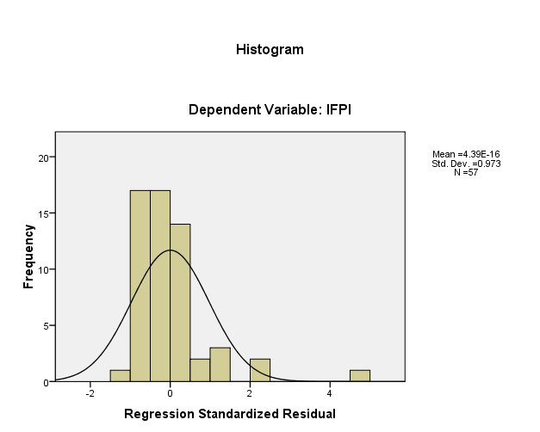
LAMPIRAN 05

Descriptive Statistics
 | Mean | Std. Deviation | N
LN_IFPI | 1.2308 | .98685 | 57
LN_DK | 1.3759 | .23972 | 57
LN_DPS | 1.4125 | .23101 | 57
LN_DD | 1.4256 | .37550 | 57

Variables Entered/Removed^{b}
Model | Variables Entered | Variables Removed | Method
1 | LN_DD, LN_DPS, LN_DKª | . | Enter
a. All requested variables entered.
b. Dependent Variable: LN_IFPI

Model Summary^{b}
Model | R | R Square | Adjusted R Square | Std. Error of the Estimate | Change Statistics |  |  |  |  | Durbin-Watson
 |  |  |  |  | R Square Change | F Change | df1 | df2 | Sig. F Change
1 | .452ª | .204 | .159 | .90475 | .204 | 4.541 | 3 | 53 | .007 | 1.161
a. Predictors: (Constant), LN_DD, LN_DPS, LN_DK
b. Dependent Variable: LN_IFPI
LAMPIRAN 06

Coefficientsª
Model |  | Unstandardized Coefficients |  | Standardized Coefficients | t | Sig. | 95% Confidence Interval for B |  | Correlations |  |  | Collinearity Statistics
 |  | B | Std. Error | Beta |  |  | Lower Bound | Upper Bound | Zero-order | Partial | Part | Tolerance | VIF
1 | (Constant) | 1.609 | .951 |  | 1.691 | .097 | -.299 | 3.516
 | LN_DK | 1.759 | .688 | .427 | 2.557 | .013 | .379 | 3.139 | .086 | .331 | .313 | .537 | 1.861
 | LN_DPS | -.483 | .608 | -.113 | -.795 | .430 | -1.703 | .736 | .110 | -.109 | -.097 | .741 | 1.349
 | LN_DD | -1.484 | .417 | -.565 | -3.556 | .001 | -2.321 | -.647 | -.319 | -.439 | -.436 | .595 | 1.680
a. Dependent Variable: LN_IFPI

One-Sample Kolmogorov-Smirnov Test
 |  | DK | DPS | DD | IFPI | Unstandardized Residual
N |  | 57 | 57 | 57 | 57 | 57
Normal Parametersª | Mean | 4.07 | 4.21 | 4.44 | 6.0147 | .0000000
 | Std. Deviation | .961 | .921 | 1.570 | 8.06001 | 7.59353237
Most Extreme Differences | Absolute | .231 | .204 | .206 | .268 | .190
 | Positive | .231 | .204 | .206 | .259 | .190
 | Negative | -.173 | -.190 | -.162 | -.268 | -.160
Kolmogorov-Smirnov Z |  | 1.743 | 1.544 | 1.557 | 2.024 | 1.436
Asymp. Sig. (2-tailed) |  | .005 | .017 | .016 | .001 | .032
a. Test distribution is Normal.

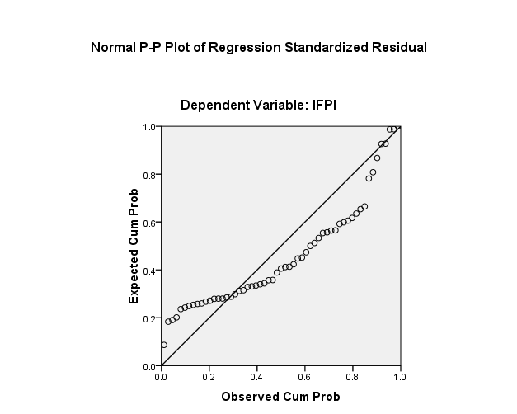

LAMPIRAN 07
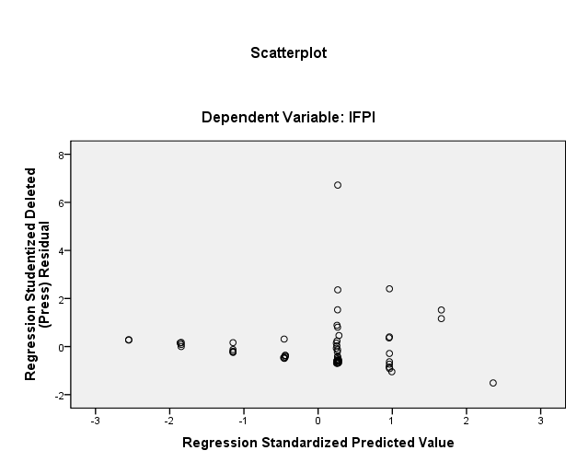

One-Sample Kolmogorov-Smirnov Test
 |  | DK | DPS | DD | IFPI | Unstandardized Residual
N |  | 57 | 57 | 57 | 57 | 57
Normal Parametersª | Mean | 4.07 | 4.21 | 4.44 | 6.0147 | .0000000
 | Std. Deviation | .961 | .921 | 1.570 | 8.06001 | 7.59353237
Most Extreme Differences | Absolute | .231 | .204 | .206 | .268 | .190
 | Positive | .231 | .204 | .206 | .259 | .190
 | Negative | -.173 | -.190 | -.162 | -.268 | -.160
Kolmogorov-Smirnov Z |  | 1.743 | 1.544 | 1.557 | 2.024 | 1.436
Asymp. Sig. (2-tailed) |  | .005 | .017 | .016 | .001 | .032
a. Test distribution is Normal.

LAMPIRAN 08

Descriptive Statistics
 | Mean | Std. Deviation | N
LN_IFPI | 1.2308 | .98685 | 57
LN_DK | 1.3759 | .23972 | 57
LN_DPS | 1.4125 | .23101 | 57
LN_DD | 1.4256 | .37550 | 57

Variables Entered/Removed^{b}
Model | Variables Entered | Variables Removed | Method
1 | LN_DD, LN_DPS, LN_DKª | . | Enter
a. All requested variables entered.
b. Dependent Variable: LN_IFPI

Model Summary^{b}
Model | R | R Square | Adjusted R Square | Std. Error of the Estimate | Change Statistics |  |  |  |  | Durbin-Watson
 |  |  |  |  | R Square Change | F Change | df1 | df2 | Sig. F Change
1 | .452ª | .204 | .159 | .90475 | .204 | 4.541 | 3 | 53 | .007 | 1.161
a. Predictors: (Constant), LN_DD, LN_DPS, LN_DK
b. Dependent Variable: LN_IFPI

Coefficientsª
Model |  | Unstandardized Coefficients |  | Standardized Coefficients | t | Sig. | 95% Confidence Interval for B |  | Correlations |  |  | Collinearity Statistics
 |  | B | Std. Error | Beta |  |  | Lower Bound | Upper Bound | Zero-order | Partial | Part | Tolerance | VIF
1 | (Constant) | 1.609 | .951 |  | 1.691 | .097 | -.299 | 3.516
 | LN_DK | 1.759 | .688 | .427 | 2.557 | .013 | .379 | 3.139 | .086 | .331 | .313 | .537 | 1.861
 | LN_DPS | -.483 | .608 | -.113 | -.795 | .430 | -1.703 | .736 | .110 | -.109 | -.097 | .741 | 1.349
 | LN_DD | -1.484 | .417 | -.565 | -3.556 | .001 | -2.321 | -.647 | -.319 | -.439 | -.436 | .595 | 1.680
a. Dependent Variable: LN_IFPI

Coefficient Correlationsª
Model |  |  | LN_DD | LN_DPS | LN_DK
1 | Correlations | LN_DD | 1.000 | .404 | -.627
 |  | LN_DPS | .404 | 1.000 | -.494
 |  | LN_DK | -.627 | -.494 | 1.000
 | Covariances | LN_DD | .174 | .102 | -.180
 |  | LN_DPS | .102 | .370 | -.207
 |  | LN_DK | -.180 | -.207 | .473
a. Dependent Variable: LN_IFPI

LAMPIRAN 09
Residuals Statisticsª
 | Minimum | Maximum | Mean | Std. Deviation | N
Predicted Value | .2913 | 2.2642 | 1.2308 | .44626 | 57
Std. Predicted Value | -2.105 | 2.316 | .000 | 1.000 | 57
Standard Error of Predicted Value | .124 | .537 | .229 | .073 | 57
Adjusted Predicted Value | .2930 | 2.7521 | 1.2462 | .49126 | 57
Residual | -1.69886 | 2.59005 | .00000 | .88018 | 57
Std. Residual | -1.878 | 2.863 | .000 | .973 | 57
Stud. Residual | -2.042 | 2.911 | -.008 | 1.018 | 57
Deleted Residual | -2.24524 | 2.67750 | -.01548 | .96825 | 57
Stud. Deleted Residual | -2.107 | 3.145 | -.002 | 1.041 | 57
Mahal. Distance | .071 | 18.718 | 2.947 | 2.952 | 57
Cook's Distance | .000 | .542 | .027 | .077 | 57
Centered Leverage Value | .001 | .334 | .053 | .053 | 57
a. Dependent Variable: LN_IFPI

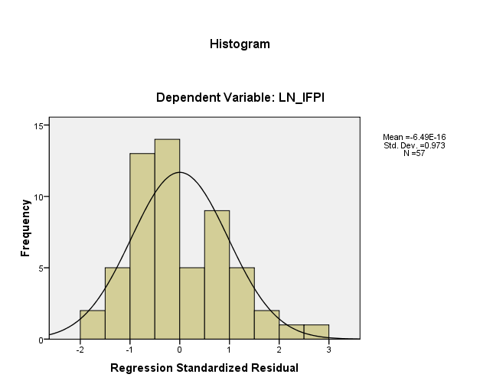

LAMPIRAN 10
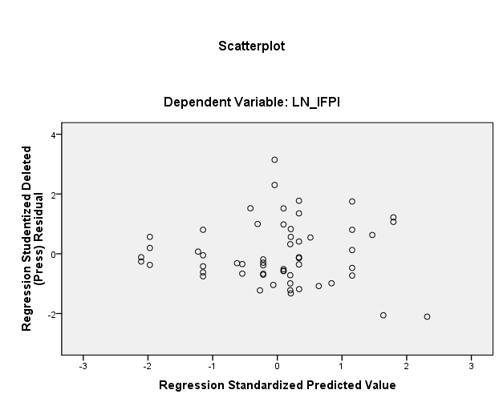

One-Sample Kolmogorov-Smirnov Test
 |  | LN_DK | LN_DPS | LN_DD | LN_IFPI | Unstandardized Residual
N |  | 57 | 57 | 57 | 57 | 57
Normal Parametersª | Mean | 1.3759 | 1.4125 | 1.4256 | 1.2308 | .0000000
 | Std. Deviation | .23972 | .23101 | .37550 | .98685 | .88018498
Most Extreme Differences | Absolute | .219 | .227 | .194 | .186 | .124
 | Positive | .185 | .159 | .194 | .186 | .124
 | Negative | -.219 | -.227 | -.174 | -.112 | -.073
Kolmogorov-Smirnov Z |  | 1.653 | 1.712 | 1.465 | 1.404 | .940
Asymp. Sig. (2-tailed) |  | .008 | .006 | .027 | .039 | .340
a. Test distribution is Normal.

LAMPIRAN 11
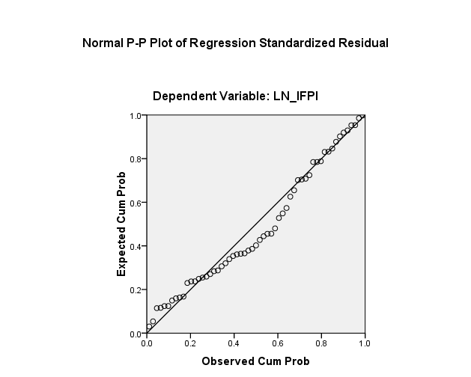

Collinearity Diagnosticsª
Model | Dimension | Eigenvalue | Condition Index | Variance Proportions
 |  |  |  | (Constant) | LN_DK | LN_DPS | LN_DD
1 | 1 | 3.924 | 1.000 | .00 | .00 | .00 | .00
 | 2 | .054 | 8.551 | .02 | .00 | .12 | .43
 | 3 | .013 | 17.205 | .52 | .62 | .01 | .07
 | 4 | .009 | 20.960 | .46 | .37 | .87 | .49
a. Dependent Variable: LN_IFPI

LAMPIRAN 12
Coefficient Correlationsª
Model |  |  | DD | DPS | DK
1 | Correlations | DD | 1.000 | .368 | -.547
 |  | DPS | .368 | 1.000 | -.486
 |  | DK | -.547 | -.486 | 1.000
 | Covariances | DD | .642 | .386 | -.610
 |  | DPS | .386 | 1.714 | -.887
 |  | DK | -.610 | -.887 | 1.941
a. Dependent Variable: IFPI

ANOVA^{b}
Model |  | Sum of Squares | df | Mean Square | F | Sig.
1 | Regression | 11.152 | 3 | 3.717 | 4.541 | .007ª
 | Residual | 43.385 | 53 | .819
 | Total | 54.537 | 56
a. Predictors: (Constant), LN_DD, LN_DPS, LN_DK
b. Dependent Variable: LN_IFPI

Correlations
 |  | LN_IFPI | LN_DK | LN_DPS | LN_DD
Pearson Correlation | LN_IFPI | 1.000 | .086 | .110 | -.319
 | LN_DK | .086 | 1.000 | .338 | .537
 | LN_DPS | .110 | .338 | 1.000 | -.139
 | LN_DD | -.319 | .537 | -.139 | 1.000
Sig. (1-tailed) | LN_IFPI | . | .263 | .208 | .008
 | LN_DK | .263 | . | .005 | .000
 | LN_DPS | .208 | .005 | . | .152
 | LN_DD | .008 | .000 | .152 | .
N | LN_IFPI | 57 | 57 | 57 | 57
 | LN_DK | 57 | 57 | 57 | 57
 | LN_DPS | 57 | 57 | 57 | 57
 | LN_DD | 57 | 57 | 57 | 57

