APPENDIX 1

LESSON PLAN

Education Unit : Junior High School
Subject : English
Class / Semester : VIII / 2
Subject : Describing the Frozen Film
Time allocation : 4 meetings

A. CORE COMPETENCIES (KI)
KI-1: Respect and appreciate the teachings of the religion he adheres to.
KI-2: Respect and appreciate honest behavior, discipline, responsibility, caring (tolerance, mutual cooperation), courtesy, self-confidence, in interacting effectively with the social and natural environment within the range of relationships and whereabouts
KI-3: Understand and apply knowledge (factual, conceptual, and procedural) based on the curiosity about science, technology, art, culture related to phenomena and events that appear to the eye.
KI-4: Processing, presenting, and reasoning in concrete realms (using, parsing, arranging, modifying, and making) and abstract realms (writing, reading, counting, drawing, and making) in accordance with what is learned in school and other sources same in perspective / theory

B. BASIC COMPETENCY (KD)
3.10 Applying text structure and linguistic elements to carry out social functions of descriptive text by stating and asking about descriptions of people, animals, and objects, short and simple, according to the context of their use.
4.11 Capture meaning in oral and written descriptive texts, short and simple.
4.12 Arrange oral and written descriptive texts, short and simple, about people, animals and objects, taking into account social functions, text structures, and elements of language that are correct and in context.

C. COMPETENCE ACHIEVEMENT INDICATORS
3.10.1 Identify social functions of descriptive text.

3.10.2 Identify text structures and linguistic elements in oral and written descriptive texts about people.
3.10.3 Identify meaning in oral and written descriptive texts, short and simple
3.10.4 Identify text structures and linguistic elements in oral and written descriptive texts about animals according to the context of their use.
3.10.5 Identify text structures and linguistic elements in oral descriptive texts and write about objects according to the context of their use.
4.11.1 Completing written descriptive text is very short and simple
4.12.1 Compose very short and simple oral and written texts, about people by paying attention to social functions, text structures, and linguistic elements, correctly and in context.
4.12.2 Arrange very short and simple descriptive and oral texts, about animals by paying attention to social functions, structures, and linguistic elements, correctly and in context.
4.12.3 Arrange very short and simple oral and written text, about objects with regard to social functions, text structure, and linguistic elements, correctly and in context.
4.12.4 Completing very short and simple oral and written texts, about people with regard to social functions, structure, and linguistic elements, correctly and in context.
4.12.5 Completing very short and simple oral and written texts, about animals, taking into account social functions, structures and elements of language, correctly and in context.
4.12.6 Completing very short and simple oral and written text, about objects, taking into account social functions, text structures, and linguistic elements, correctly and in context.

D. LEARNING MATERIALS
• Short and simple descriptive text about frozen
• The Social function of the expression:
- Pride, sell, introduce, identify, criticize, etc.
• Text structure (main ideas and detailed information)
- Mention frozen movie players to be described.
- mention the character traits in frozen films.
- mentions actions from or related to people, animals, objects that are all in accordance with the social functions to be achieved.
• Language Elements from greeting and farewell expressions, namely:
- Mention of singular nouns with a and the, and plural (-s).
- pronoun it, they, she, we, etc.; our, my, your, their, etc.
- Adjectives about people, animals, objects in the lives of students at home, school, and surrounding areas, with or without adverbs quite, very.
- Nominal phrases like straight hair, big eyes, white skin
- Verbs to state the circumstances and routine actions in simple present tense: be, have, go, play, get, take, etc.
- Nominal singular and plural usage appropriately, with or without a, the, this, those, my, their, etc. correctly in nominal terms
- Speech, word pressure, intonation
- Spelling and punctuation
- Handwriting

E. MEDIA TOOLS AND SOURCES OF LEARNING
1) media / tools
• video / frozen films
• computer & lcd
• infocus
2) learning resources
• lesson plan

F. LEARNING STEPS
1st meeting
A. Preliminary activities
• the teacher prepares students psychologically and physically to take part in the learning process by giving greetings, inviting students to tidy up their classes and performances, inviting students to start activities by praying, and checking the attendance of students.
• the teacher invites students to sing the song "good morning" to generate motivation to learn english.
• the teacher asks questions about the english material being studied or has been known before.
• the teacher conveys the learning objectives or basic competencies to be achieved.
• the teacher delivers material coverage and description of activities according to the lesson plan.

B. Core Activities
- Observe
• Students observe the explanation from the teacher
- Ask
• With the guidance of teachers the students formulate questions related to the content, social functions, and structure of the text, as well as elements of language in the text that has been witnessed.
• With the guidance of the teacher formulating questions about the adjective (physical appearance)
• With teacher guidance students formulate questions about how to describe people
- Explore
• Individually students answer questions about the content of the text
• Individually students answer questions about the social function of the text from examples of texts that are displayed (descriptive texts about people)Secara individu peserta didik menjawab pertanyaan tentang struktur teks dari contoh teks yany ditayangkan ( teks deskriptif tentang orang)
• Individually students describe frozen films
Associate
- Students describe frozen films
- Students ask for help from teachers if they need it.
Communicate
- Students present the results of their writing
- Students receive feedback and / or reinforcement (content, social functions, structure, and linguistic elements of the text) from the teacher.

c. Closing Activity
- Teachers and students collectively summarize the material that has been learned at this meeting.
- The teacher asks questions to students to help them reflect on the learning activities they have done.
- The teacher gives assignments to students to practice greeting expressions and record to whom the students say the phrase.
- The teacher explains the plan for future learning activities.

2nd MEETING
a. Preliminary activities
• The teacher prepares students psychologically and physically to take part in the learning process by giving greetings, inviting students to tidy up their classes and performances, inviting students to start activities by praying, and checking the attendance of students.
• The teacher asks questions about the material learned beforehand.
• The teacher explains about the learning objectives or basic competencies to be achieved.
• The teacher delivers material coverage and description of activities according to the lesson plan.

b. Core activities
Create
• The teacher gives treatment to experimental class students
• The teacher provides treatment in the form of frozen films

c. Closing Activity
• Teachers and students collectively summarize the material that has been learned at this meeting.
• The teacher asks questions to students to help them reflect on the learning activities they have done.
• The teacher explains the plan for future learning activities.
3rd MEETING
a. Preliminary activities
• The teacher prepares students psychologically and physically to take part in the learning process by giving greetings, inviting students to tidy up their classes and performances, inviting students to start activities by praying, and checking the attendance of students.
• The teacher asks questions about English material that has been studied or previously known.
• The teacher conveys the learning objectives or basic competencies to be achieved.
• The teacher delivers material coverage and description of activities according to the lesson plan.

b. Core activities
Create
• Individually the students complete the descriptive text aboard about the characteristics of frozen characters
• Individually students make descriptive texts using key words given by the teacher
• Individually the students reveal a description of the character of frozen characters using key words given by the teacher

c. Closing Activity
• Teachers and students collectively summarize the material that has been learned at this meeting.
• The teacher asks questions to students to help them reflect on the learning activities they have done.
• The teacher explains the plan for future learning activities.

G. ASSESSMENT OF LEARNING RESULTS
1. Spiritual Attitude Competence
a. Assessment Techniques: Writing Test
b. Form of Instrument: Text Writing
No | Assessment Indicator | Score
1. | Writing Idea | 0-20
2. | Grammatical | 0-20
3. | Vocabulary | 0-20
4. | Content | 0-20
5. | Spelling | 0-20
 | Skor maksimum | 100

Guru Bahasa Inggris

( Indri Octa Miransyah)

APPENDIX 2
LESSON PLAN

Education Unit : Junior High School
Subject : English
Class / Semester : VIII / 2
Subject : Describing the Frozen Film
Time allocation : 4 meetings

A. CORE COMPETENCIES (KI)
KI-1: Respect and appreciate the teachings of the religion he adheres to.
KI-2: Respect and appreciate honest behavior, discipline, responsibility, caring (tolerance, mutual cooperation), courtesy, self-confidence, in interacting effectively with the social and natural environment within the range of relationships and whereabouts
KI-3: Understand and apply knowledge (factual, conceptual, and procedural) based on the curiosity about science, technology, art, culture related to phenomena and events that appear to the eye.
KI-4: Processing, presenting, and reasoning in concrete realms (using, parsing, arranging, modifying, and making) and abstract realms (writing, reading, counting, drawing, and making) in accordance with what is learned in school and other sources same in perspective / theory

B. BASIC COMPETENCY (KD)
3.10 Applying text structure and linguistic elements to carry out social functions of descriptive text by stating and asking about descriptions of people, animals, and objects, short and simple, according to the context of their use.
4.11 Capture meaning in oral and written descriptive texts, short and simple.
4.12 Arrange oral and written descriptive texts, short and simple, about people, animals and objects, taking into account social functions, text structures, and elements of language that are correct and in context.

C. COMPETENCE ACHIEVEMENT INDICATORS
3.10.1 Identify social functions of descriptive text.
3.10.2 Identify text structures and linguistic elements in oral and written descriptive texts about people.
3.10.3 Identify meaning in oral and written descriptive texts, short and simple
3.10.4 Identify text structures and linguistic elements in oral and written descriptive texts about animals according to the context of their use.
3.10.5 Identify text structures and linguistic elements in oral descriptive texts and write about objects according to the context of their use.
4.11.1 Completing written descriptive text is very short and simple
4.12.1 Compose very short and simple oral and written texts, about people by paying attention to social functions, text structures, and linguistic elements, correctly and in context.
4.12.2 Arrange very short and simple descriptive and oral texts, about animals by paying attention to social functions, structures, and linguistic elements, correctly and in context.
4.12.3 Arrange very short and simple oral and written text, about objects with regard to social functions, text structure, and linguistic elements, correctly and in context.
4.12.4 Completing very short and simple oral and written texts, about people with regard to social functions, structure, and linguistic elements, correctly and in context.
4.12.5 Completing very short and simple oral and written texts, about animals, taking into account social functions, structures and elements of language, correctly and in context.
4.12.6 Completing very short and simple oral and written text, about objects, taking into account social functions, text structures, and linguistic elements, correctly and in context.

D. LEARNING MATERIALS
• Short and simple descriptive text about frozen
• The Social function of the expression:
- Pride, sell, introduce, identify, criticize, etc.
• Text structure (main ideas and detailed information)
- Mention frozen movie players to be described.
- mention the character traits in frozen films.
- mentions actions from or related to people, animals, objects that are all in accordance with the social functions to be achieved.
• Language Elements from greeting and farewell expressions, namely:
- Mention of singular nouns with a and the, and plural (-s).
- pronoun it, they, she, we, etc.; our, my, your, their, etc.
- Adjectives about people, animals, objects in the lives of students at home, school, and surrounding areas, with or without adverbs quite, very.
- Nominal phrases like straight hair, big eyes, white skin
- Verbs to state the circumstances and routine actions in simple present tense: be, have, go, play, get, take, etc.
- Nominal singular and plural usage appropriately, with or without a, the, this, those, my, their, etc. correctly in nominal terms
- Speech, word pressure, intonation
- Spelling and punctuation
- Handwriting

E. MEDIA TOOLS AND SOURCES OF LEARNING
1) media / tools
• video / frozen films
• computer & lcd
• infocus
2) learning resources
• lesson plan

F. LEARNING STEPS
1st meeting
A. Preliminary activities
• the teacher prepares students psychologically and physically to take part in the learning process by giving greetings, inviting students to tidy up their classes and performances, inviting students to start activities by praying, and checking the attendance of students.
• the teacher invites students to sing the song "good morning" to generate motivation to learn english.
• the teacher asks questions about the english material being studied or has been known before.
• the teacher conveys the learning objectives or basic competencies to be achieved.
• the teacher delivers material coverage and description of activities according to the lesson plan.

B. Core Activities
- Observe
• Students observe the explanation from the teacher
- Ask
• With the guidance of teachers the students formulate questions related to the content, social functions, and structure of the text, as well as elements of language in the text that has been witnessed.
• With the guidance of the teacher formulating questions about the adjective (physical appearance)
• With teacher guidance students formulate questions about how to describe people
- Explore
• Individually students answer questions about the content of the text
• Individually students answer questions about the social function of the text from examples of texts that are displayed (descriptive texts about people)Secara individu peserta didik menjawab pertanyaan tentang struktur teks dari contoh teks yany ditayangkan ( teks deskriptif tentang orang)
• Individually students describe frozen films
Associate
- Students describe frozen films
- Students ask for help from teachers if they need it.
Communicate
- Students present the results of their writing
- Students receive feedback and / or reinforcement (content, social functions, structure, and linguistic elements of the text) from the teacher.

c. Closing Activity
- Teachers and students collectively summarize the material that has been learned at this meeting.
- The teacher asks questions to students to help them reflect on the learning activities they have done.
- The teacher gives assignments to students to practice greeting expressions and record to whom the students say the phrase.
- The teacher explains the plan for future learning activities.

3rd MEETING
a. Preliminary activities
• The teacher prepares students psychologically and physically to take part in the learning process by giving greetings, inviting students to tidy up their classes and performances, inviting students to start activities by praying, and checking the attendance of students.
• The teacher asks questions about English material that has been studied or previously known.
• The teacher conveys the learning objectives or basic competencies to be achieved.
• The teacher delivers material coverage and description of activities according to the lesson plan.

b. Core activities
Create
• Individually the students complete the descriptive text aboard about the characteristics of frozen characters
• Individually students make descriptive texts using key words given by the teacher
• Individually the students reveal a description of the character of frozen characters using key words given by the teacher

c. Closing Activity
• Teachers and students collectively summarize the material that has been learned at this meeting.
• The teacher asks questions to students to help them reflect on the learning activities they have done.
• The teacher explains the plan for future learning activities.

G. ASSESSMENT OF LEARNING RESULTS
1. Spiritual Attitude Competence
a. Assessment Techniques: Writing Test
b. Form of Instrument: Text Writing
No | Assessment Indicator | Score
1. | Writing Idea | 0-20
2. | Grammatical | 0-20
3. | Vocabulary | 0-20
4. | Content | 0-20
5. | Spelling | 0-20
 | Skor maksimum | 100

Guru Bahasa Inggris

( Indri Octa Miransyah)

APPENDIX 3
DOCUMENTATIONS
Experimental group
Pre-Test
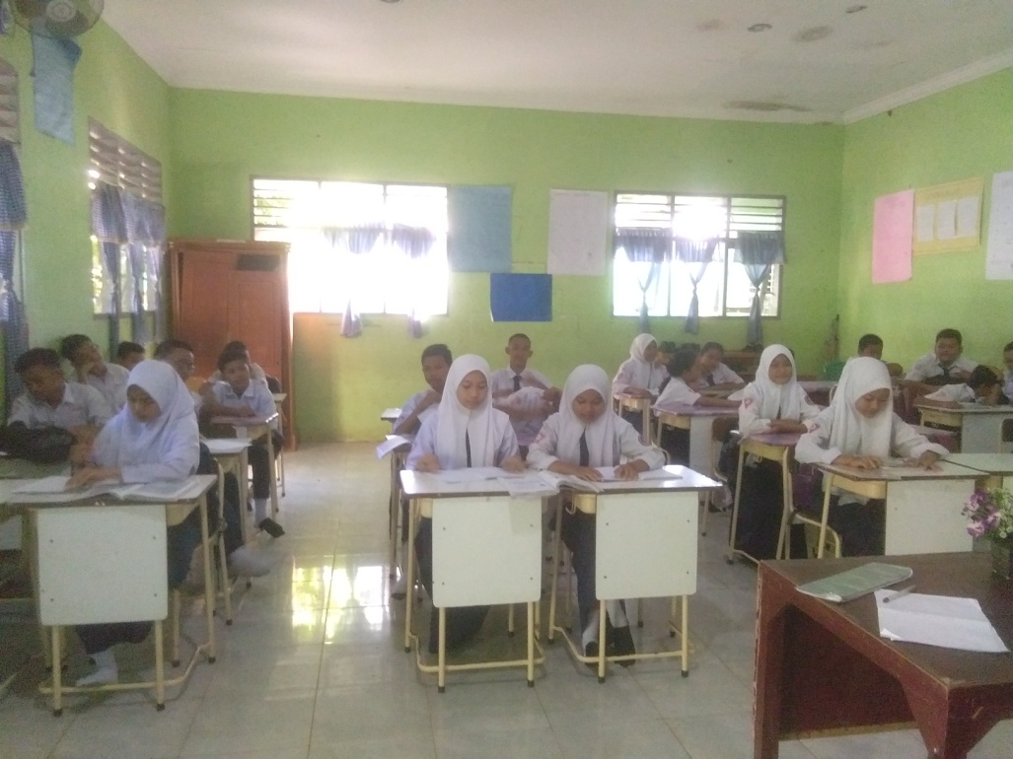
Post-Test
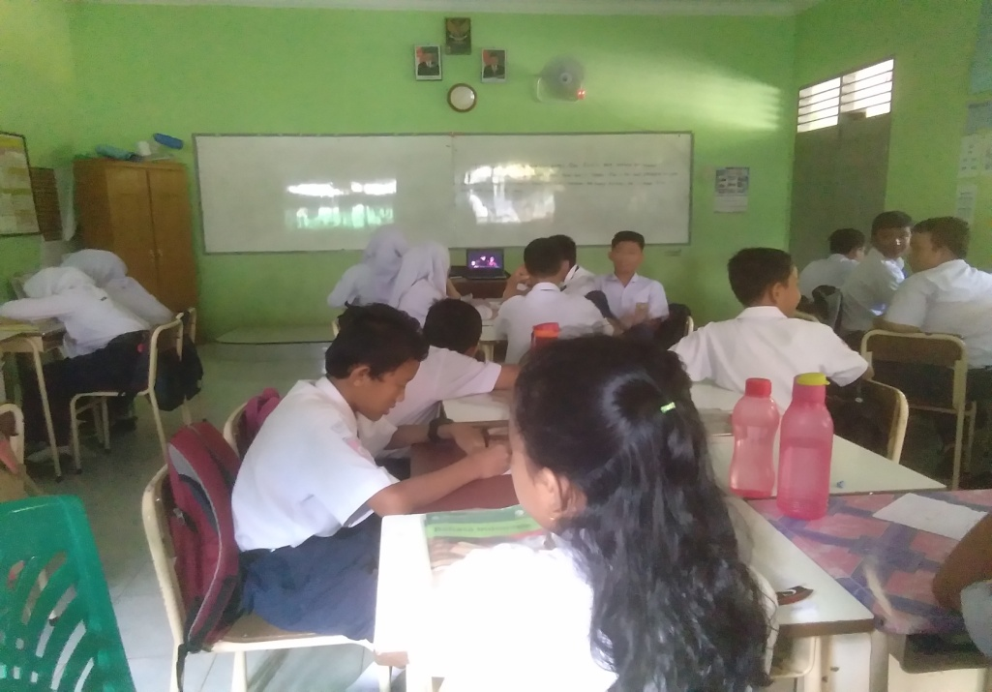
Control Group
Pre-Test
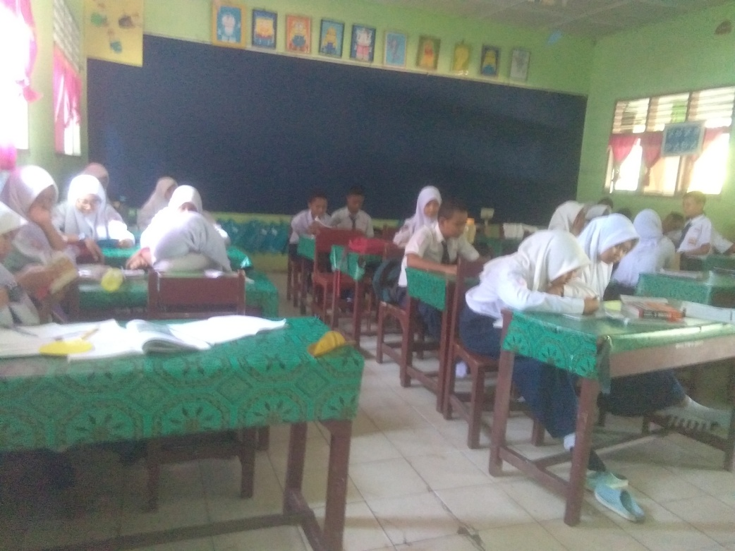
Post-Test
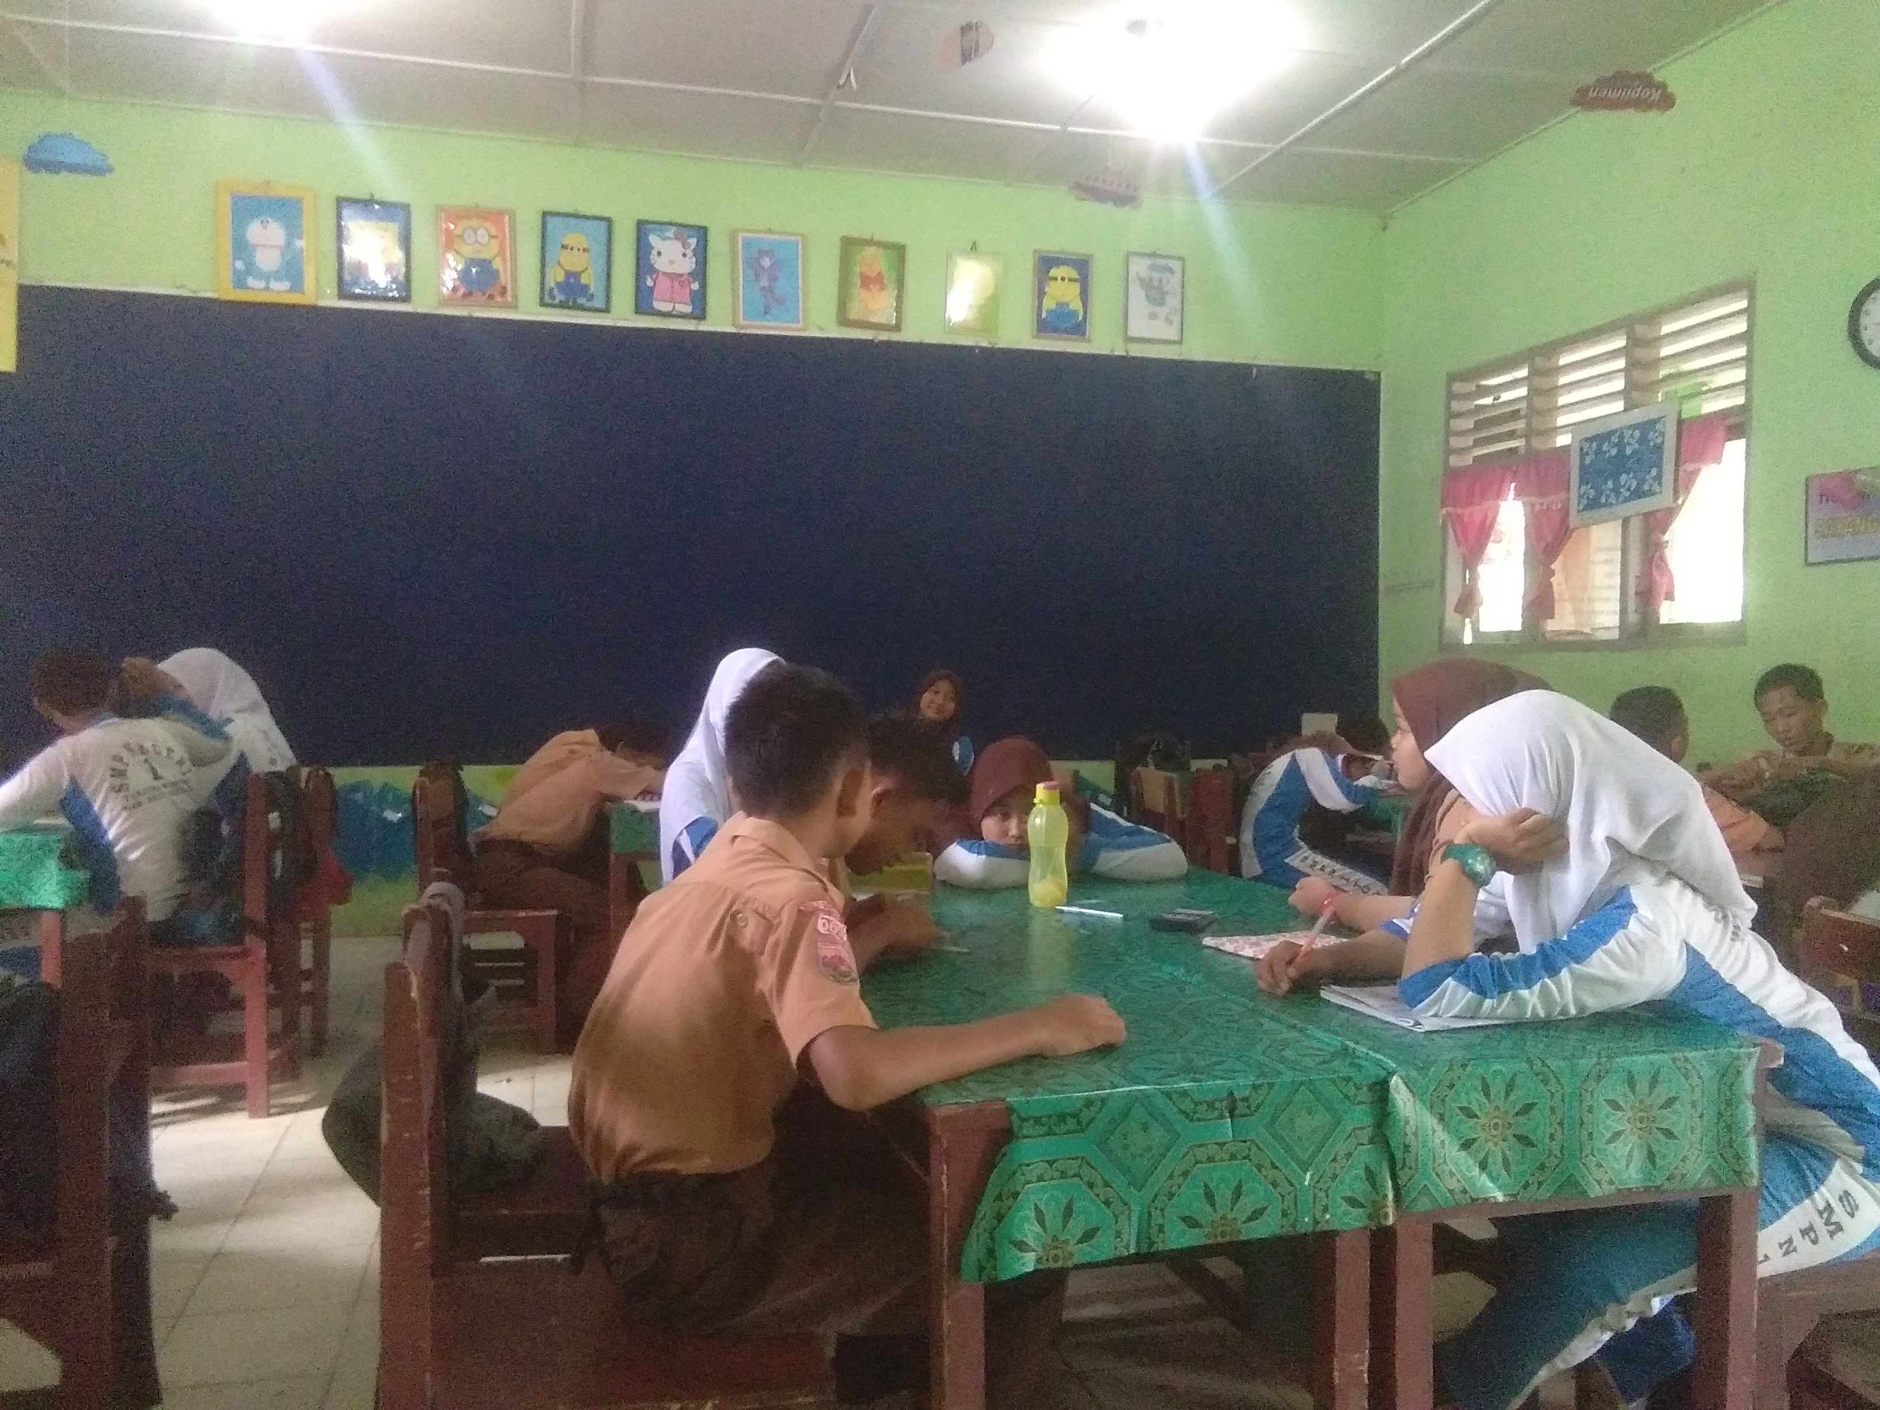
APPENDIX 4
STUDENTS’ ASSESSMENT SHEETS
Experimental group (Pre-Test)

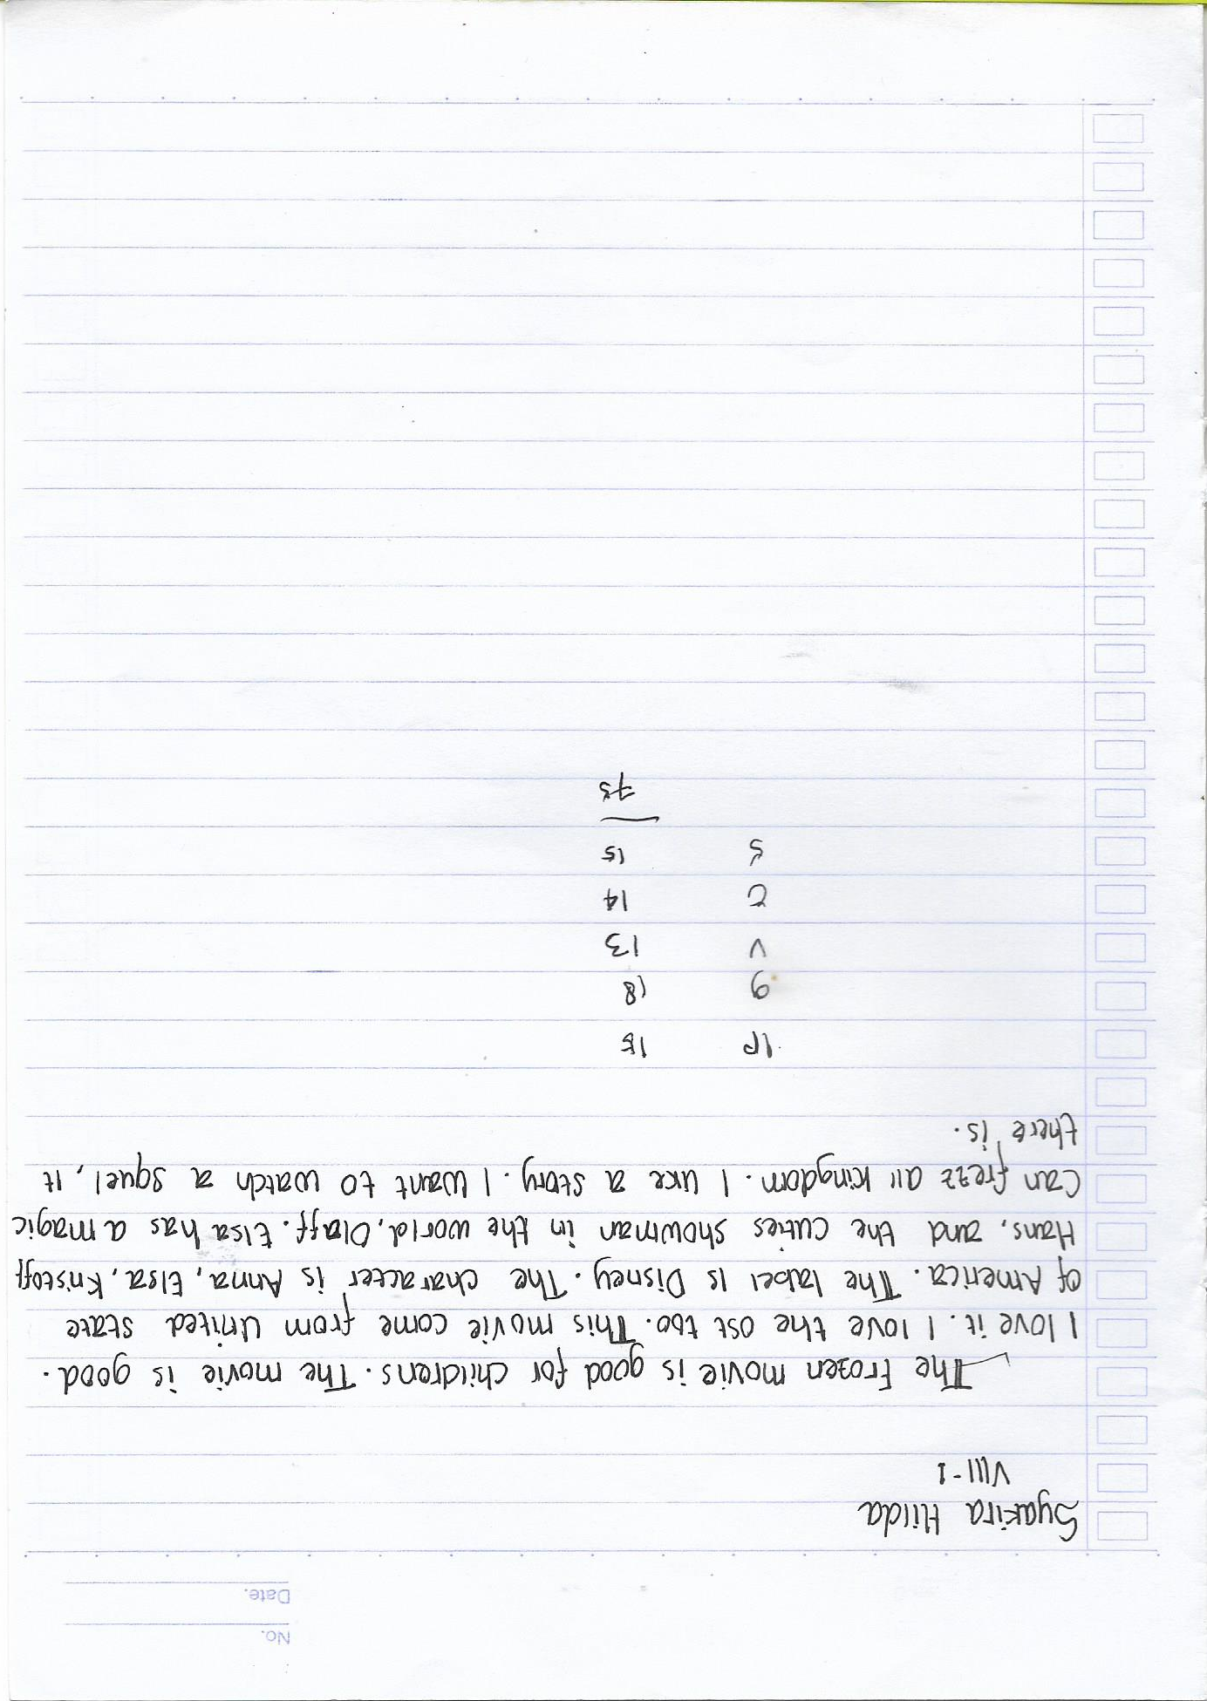

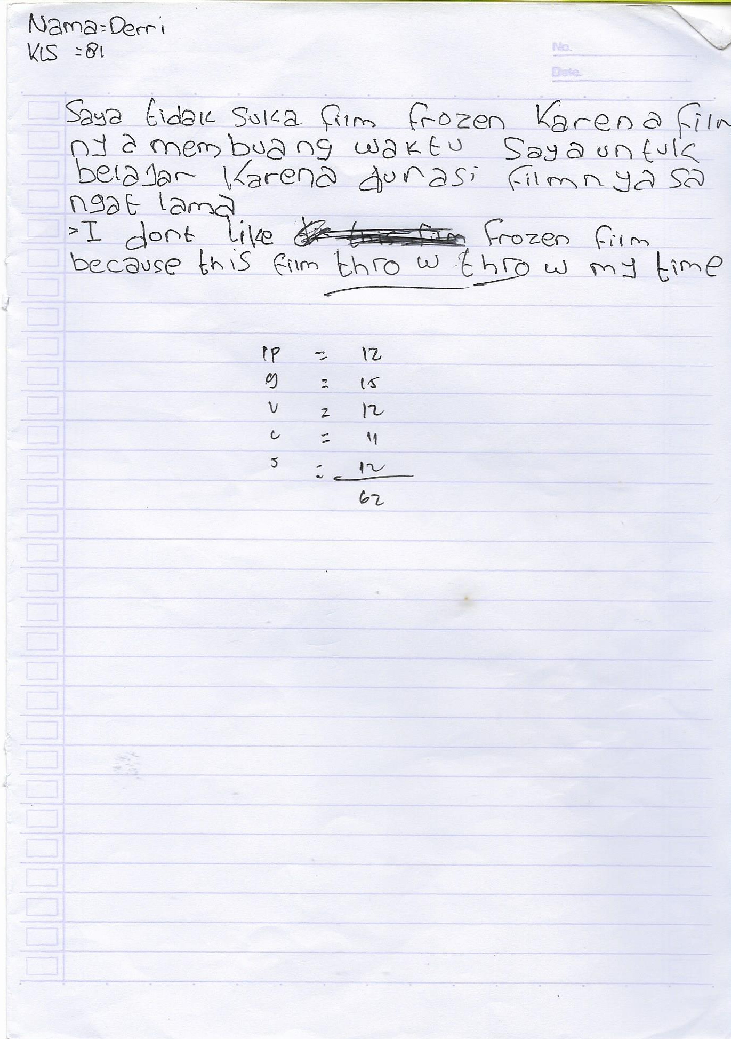

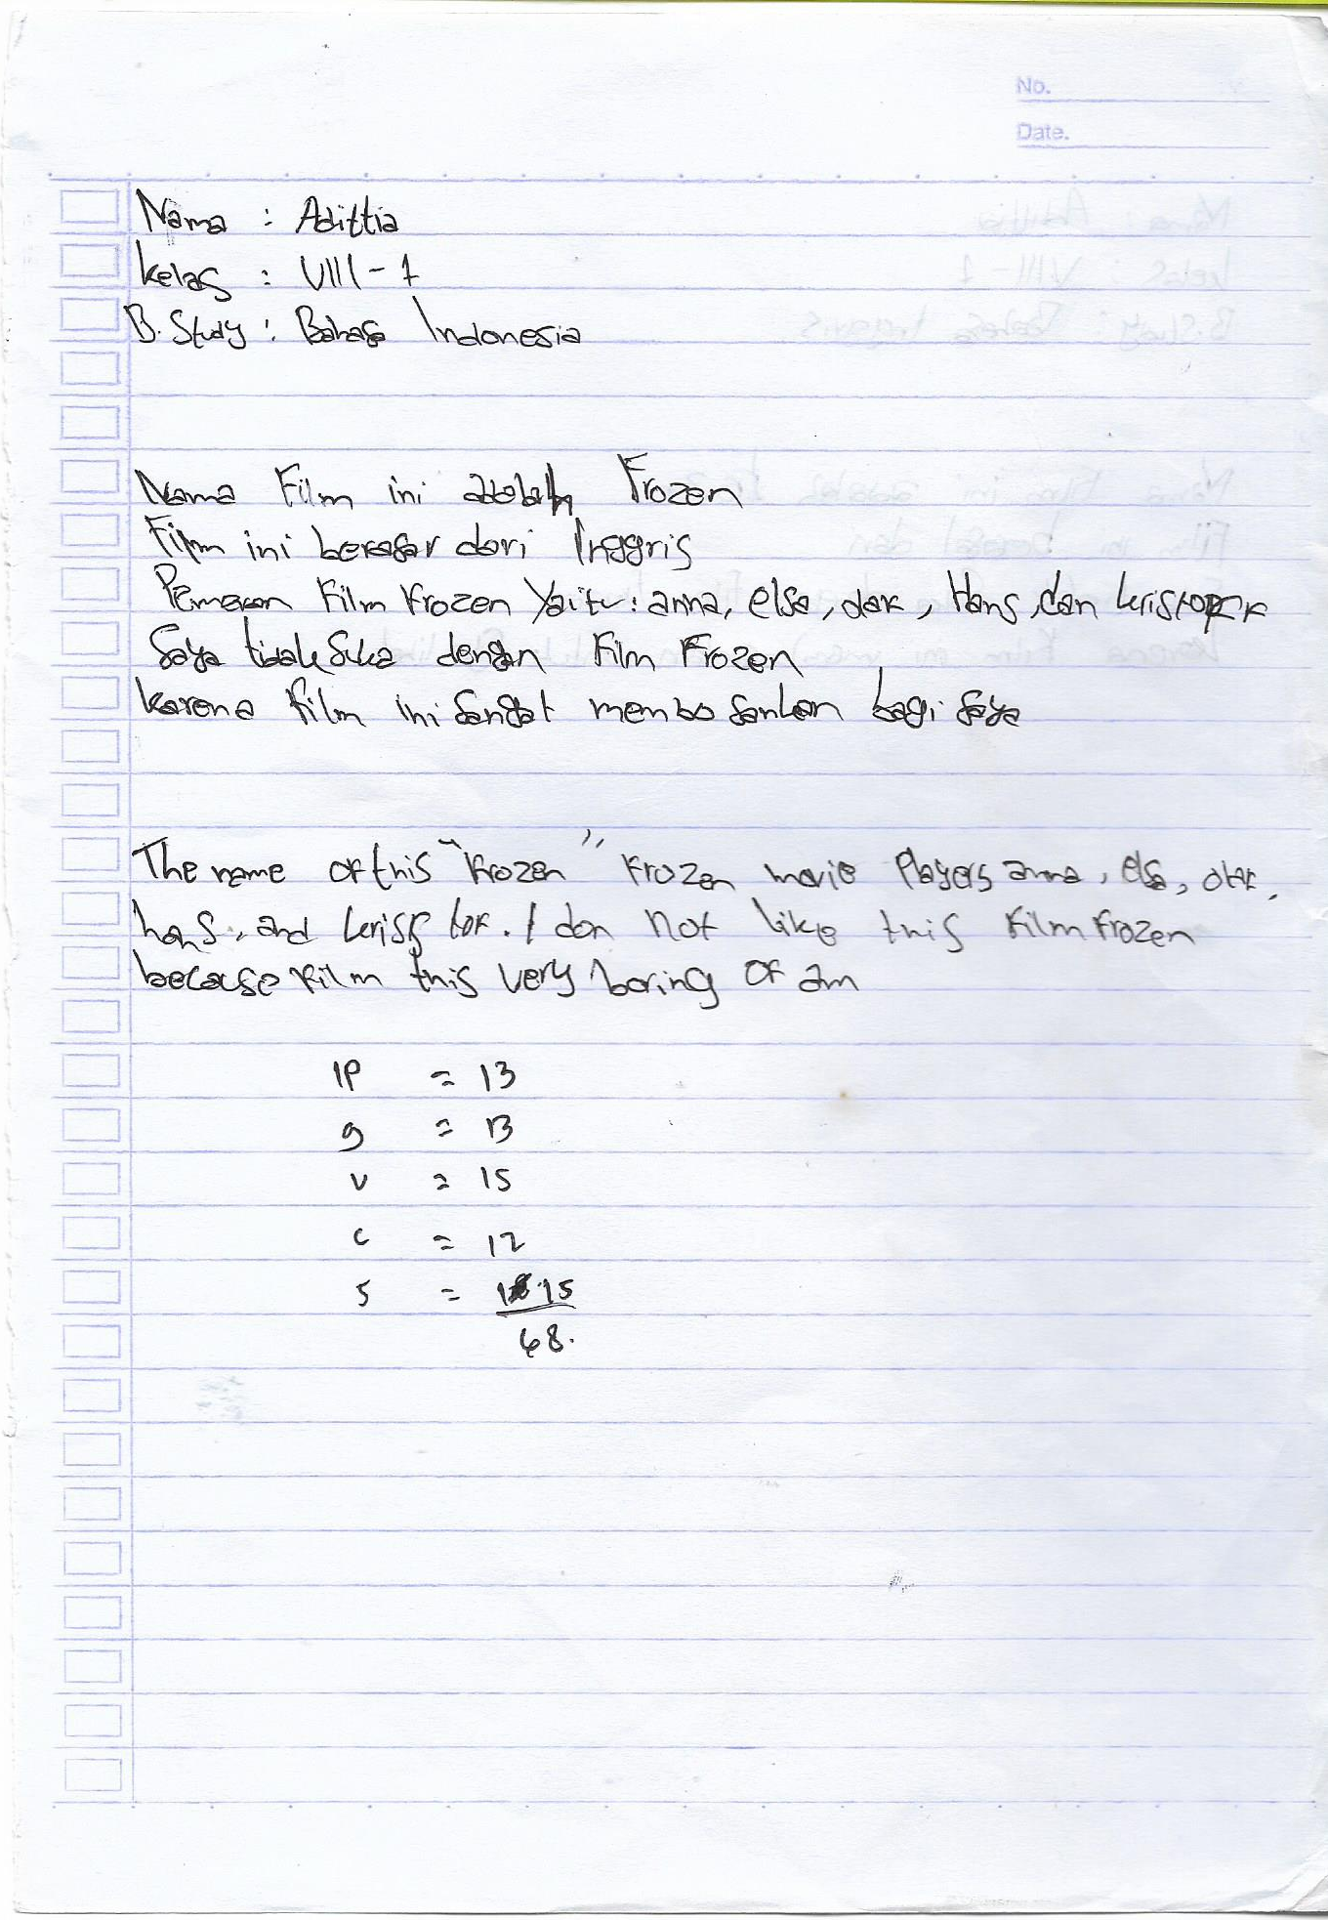

Experimental Group (Pot-test)
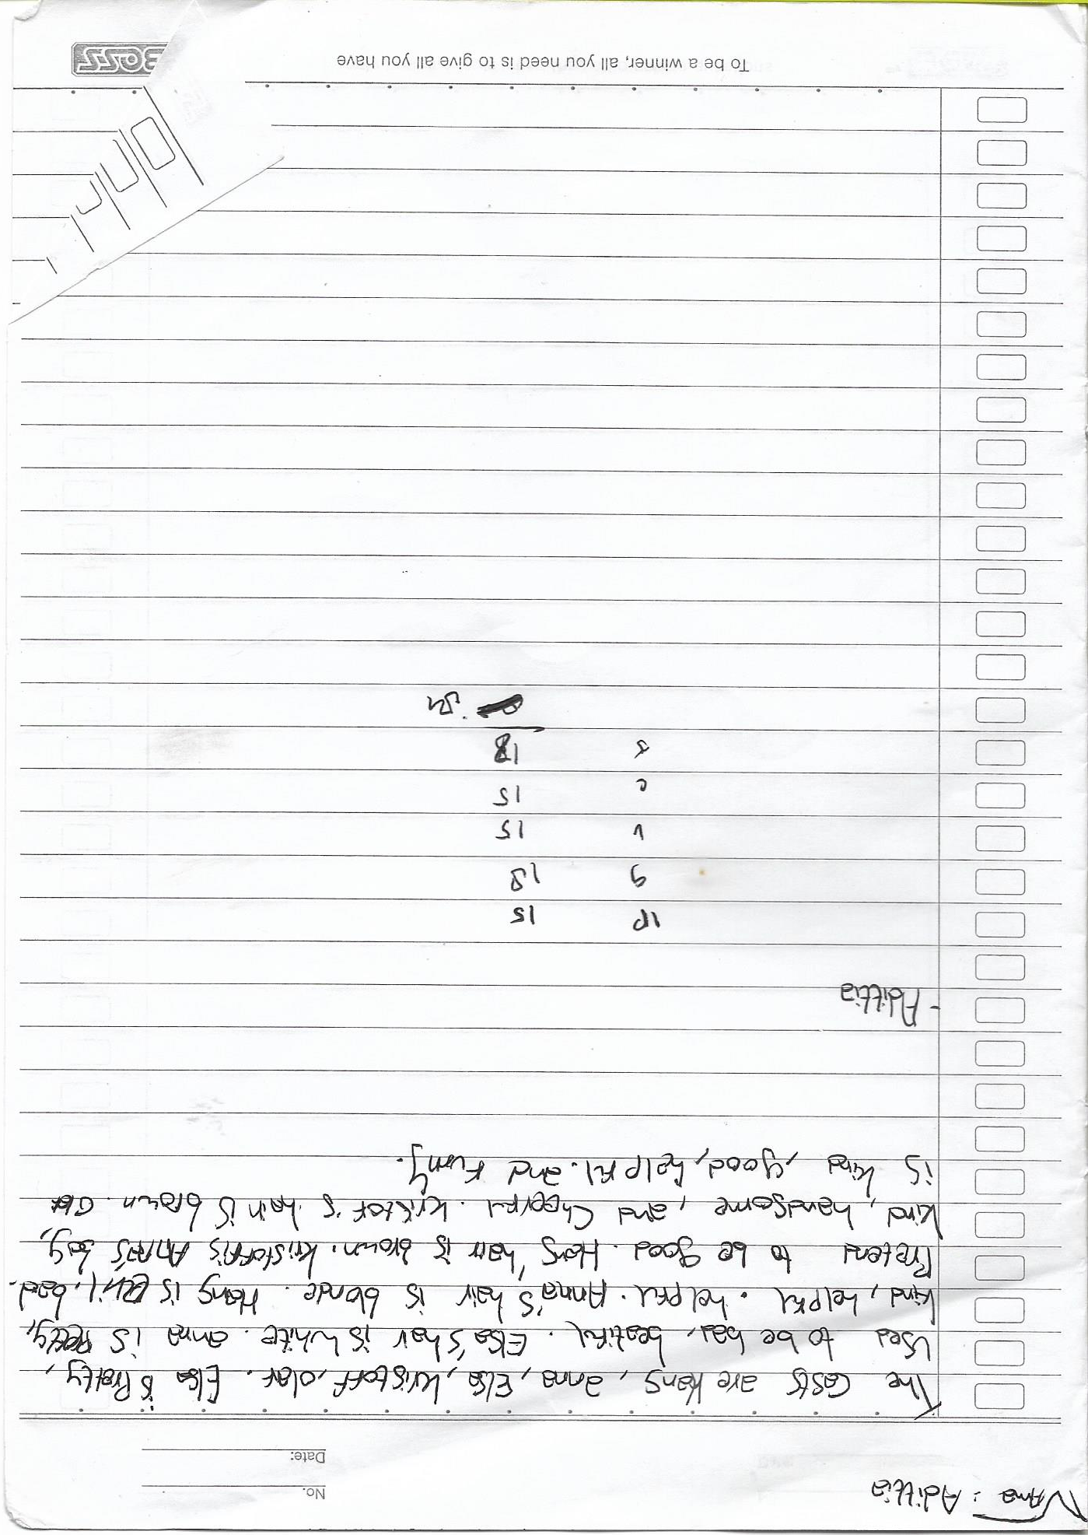

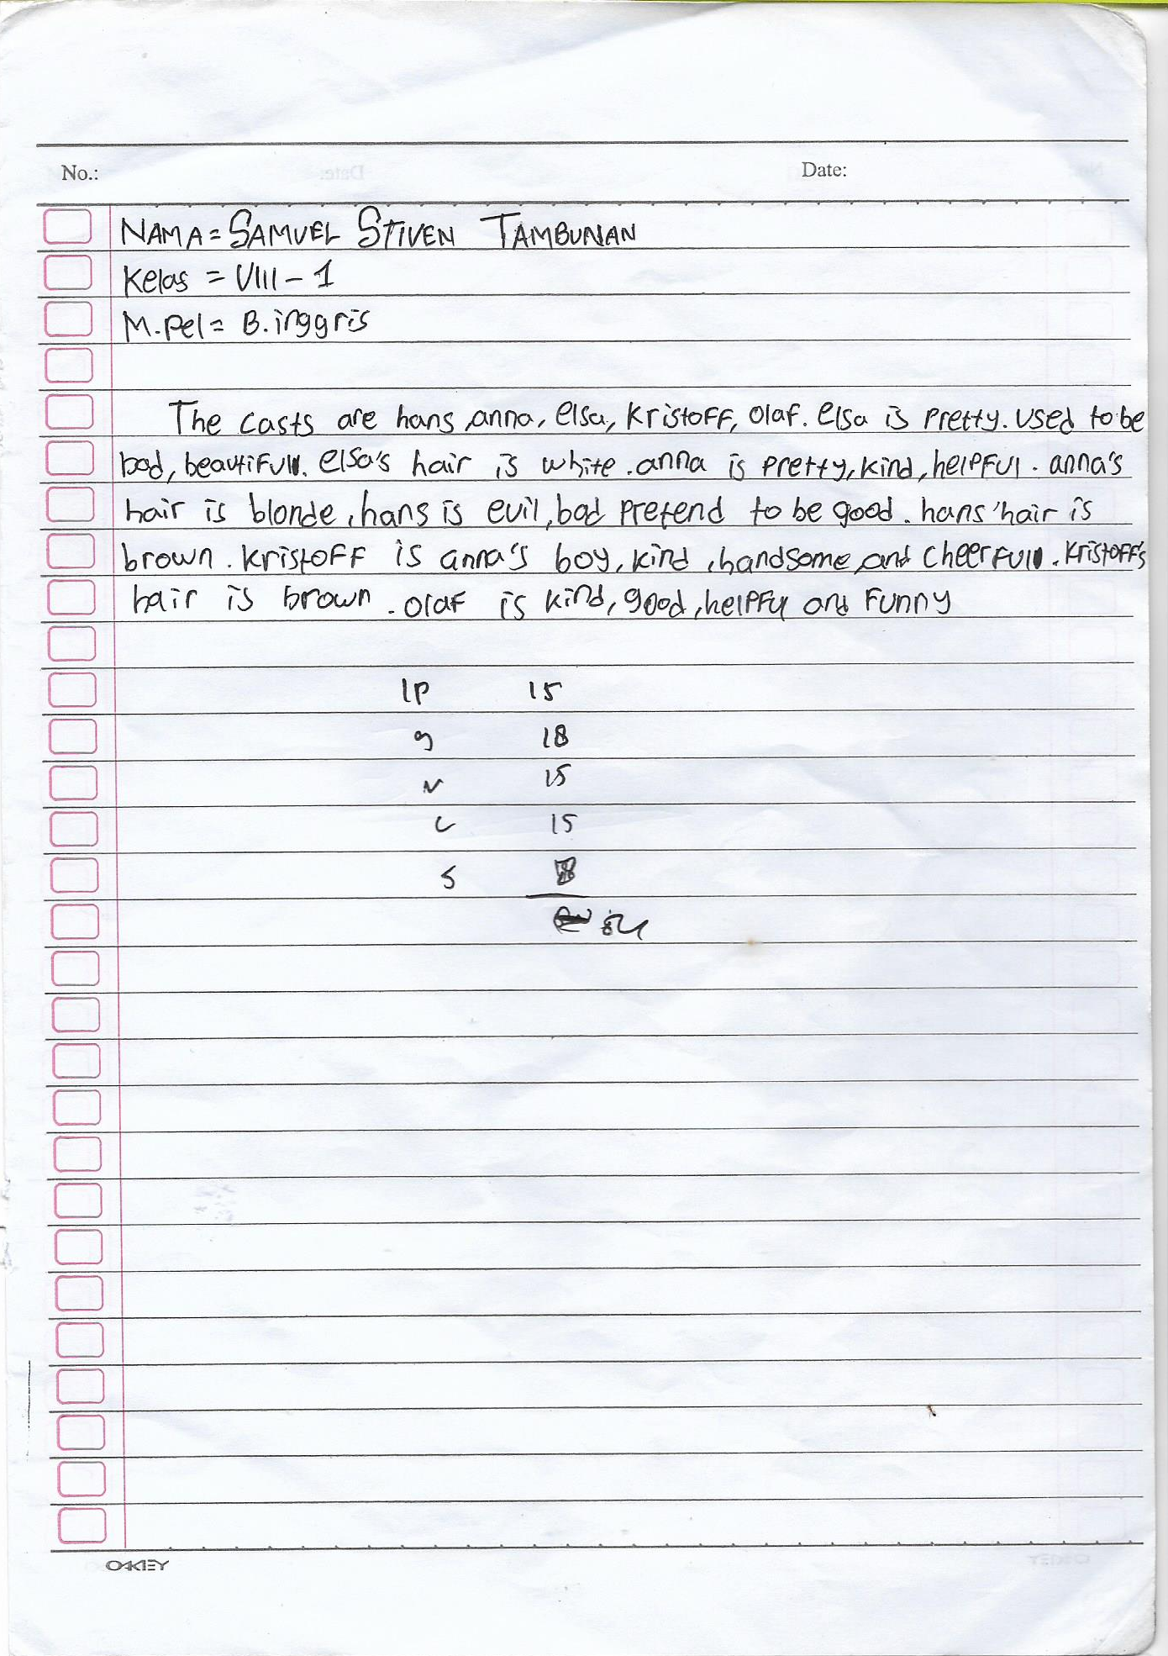

Control Group (Pre-test)

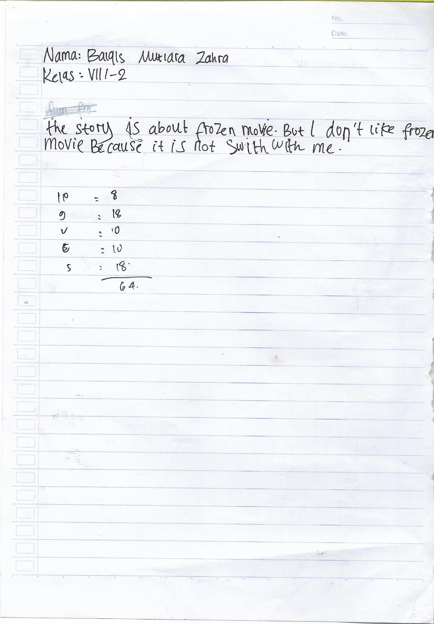

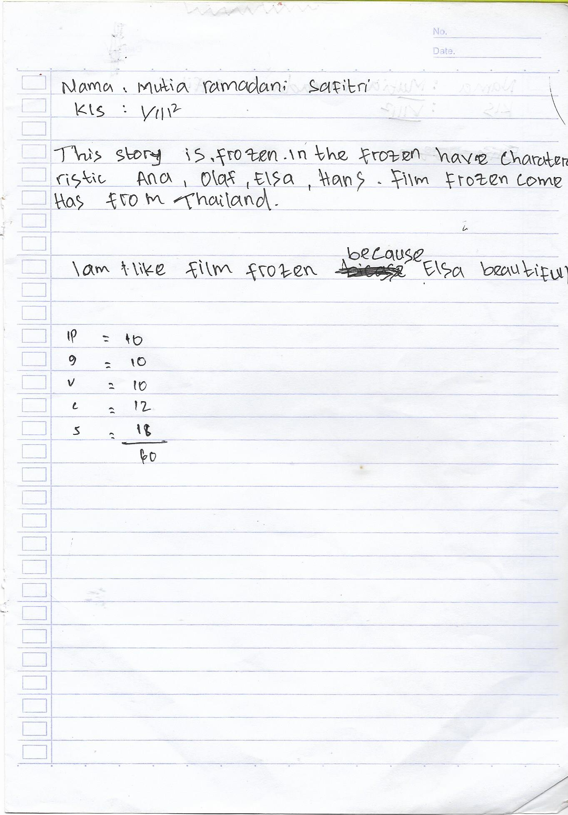

Control Group (Post-test)

