ACKNOWLEDGEMENT
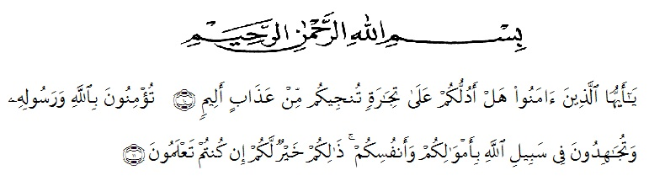
O ye who believe! Shall I show you a commerce that will save you from a painful doom? Ye should believe in Allah and His messenger, and should strive for the cause of Allah with your wealth and your lives. That is better for you, if ye did but know. (Q.S Ash-Shaff: 10-11)
All praises be to Allah, king of the king, the Lord of the world, and the master of the day after, who has given us blessing and guidance. Because of His graciousness and mercifulness the researcher can write well. Blessing and peace upon to our prophet Muhammad SAW who has brought the dark into the bright era.
On this opportunity, the researcher herewith would like to express her profound gratitude, more than she can express, to:
- H. Hardi Mulyono, S.E., M.AP as the Rector of Muslim Nusantara University Al-Washlisyah Medan.
- Drs. Mhd. Ayyub Lubis, M.Pd., Ph.D. as the Dean of FKIP Muslim Nusantara University Medan.
- Junaidi, S.S., S.Pd., M.Si as the Head of English Education Department FKIP Muslim Nusantara University Medan.

- Dr. Salamuddin Selian, M.Hum as the first consultant, who never stopped helping in guiding, correcting and giving support.
- Rosmita Ambarita, S.Pd., M.Hum as the second consultant, who also never stopped helping in guiding, correcting and giving support.
- Syahril Mutarno and Salmiyati D, the researcher’s beloved parents. They always support, love, feed and pray for the researcher.
- The headmaster of SMPN 1 Tanjung Morawa.
- The teachers and staffs of SMPN 1 Tanjung, who were very kind when the researcher was doing her research in SMPN 1 Tanjung Morawa.
- Drs. Mulawarman as the teacher of VIII-1 and VIII-2
- Deliana Lubis, S.Pd, the teacher of SMPN 1 Tanjung Morawa
- Pramudya Nugraha, the researcher’s supporter, who had given support, help, and love.
- English Department A-2015, who had given support and help the researcher.
Finally, the researcher realizes that this thesis has been perfect. The researcher hopes that this thesis can be useful for the reader and the researcher itself.
Aamiin ya Rabbal ‘Alamin
Medan, 2019
The Researcher

Indri Octa Miransyah
151244019

