Students’ writing achievement of experimental group
Post-test
Name : Putri Annisa
Class : X AP1
Score : 90 with higher score
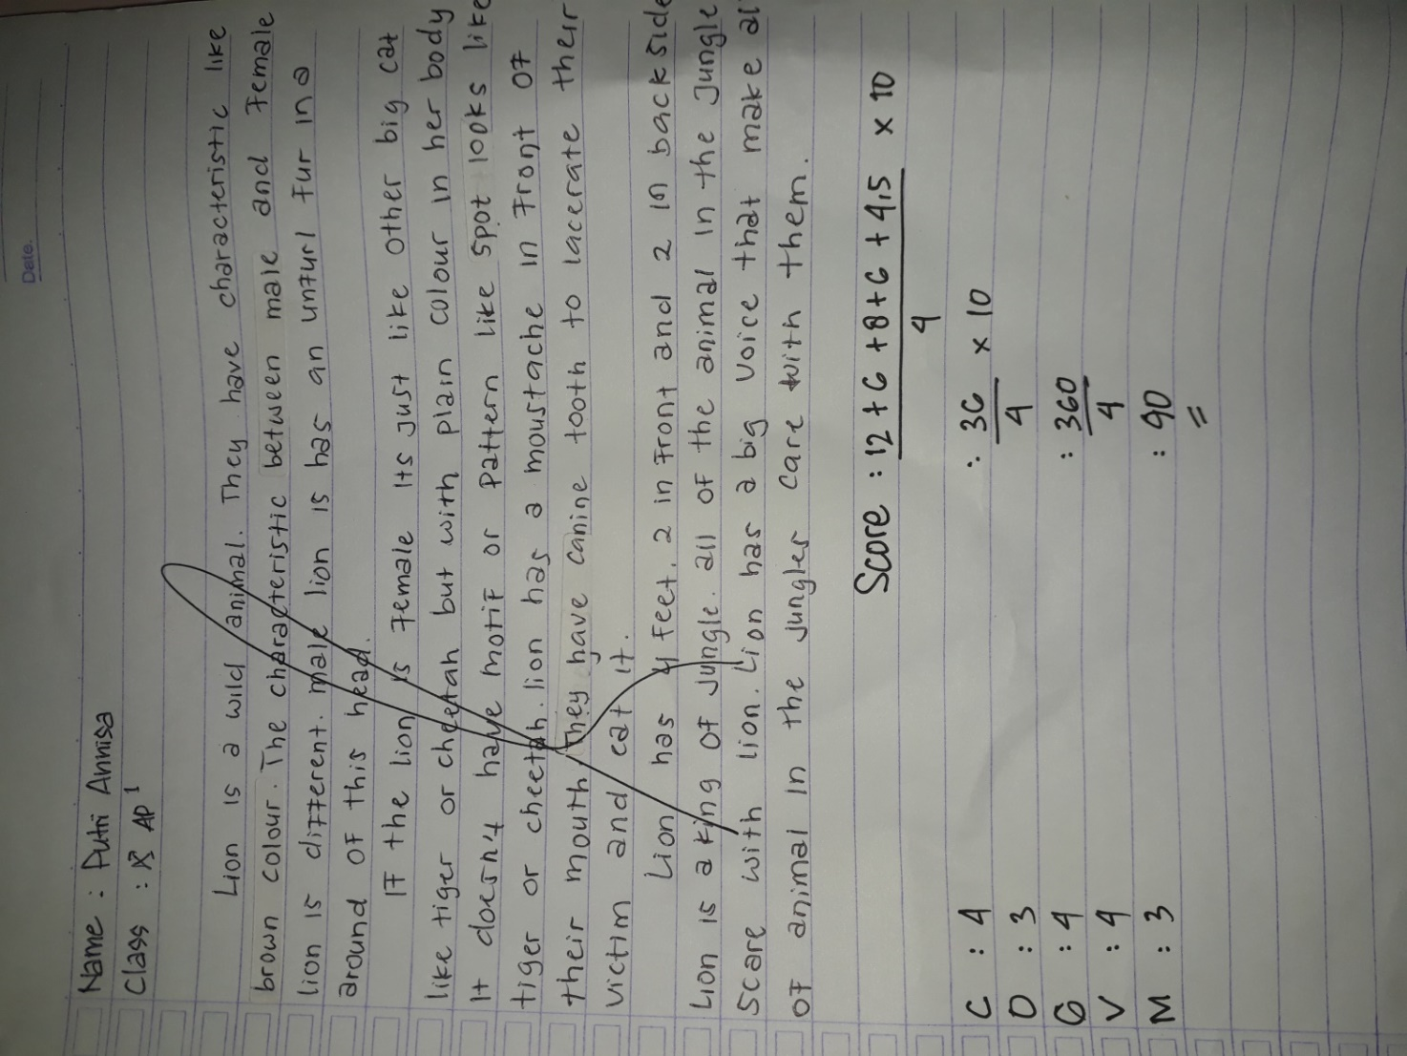
The Score of the writing descriptive text
Content : The topic is complete and clear and the details are relating to the
topic.
Organization : Identification is almost complete and descriptions are arranged
with almost proper connectives
Grammar : Very few grammatical or agreement inaccuracies
Vocabulary : Effective choice of words and word forms
Mechanics : It has occasional errors of spelling, punctuation, and
capitalization

Score = $\frac{3C + 20+2G+1.5V+1.5M}{4}×10$

