Post-test
Name : Wahyudi
Class : X AP 1
Score : 70 with lower score
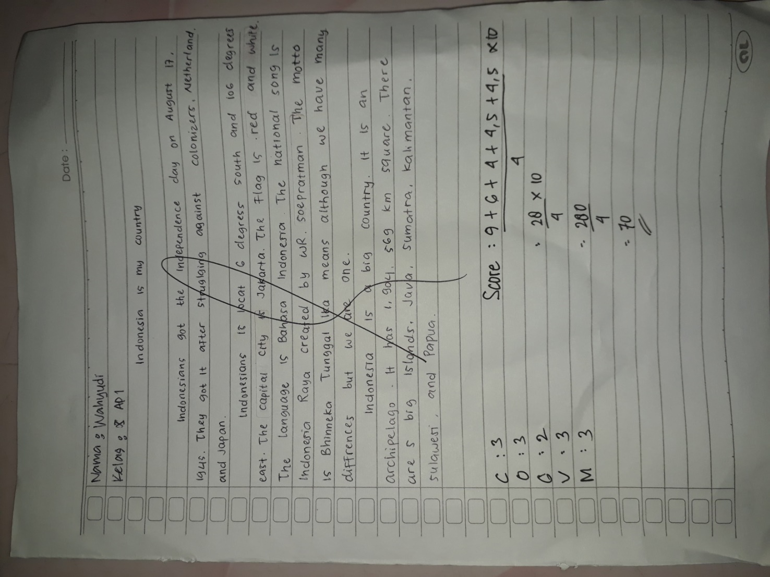

The Score of the writing descriptive text
Content : The topic is complete and clear but the details are almost relating
to the topic
Organization : Identification is almost complete and descriptions are arranged
are arranged with almost proper connectives
Grammar : Numerous grammatical or agreement inaccuracies
Vocabulary : Few use of vocabularies, word forms, but not change the meaning Mechanics : It has occasional errors of spelling, punctuation and capitalization

Score = $\frac{3C + 20+2G+1.5V+1.5M}{4}×10$

