Pre-test
Name : Jerry Nicola
Class : X AP 1
Score : 25 with lower score
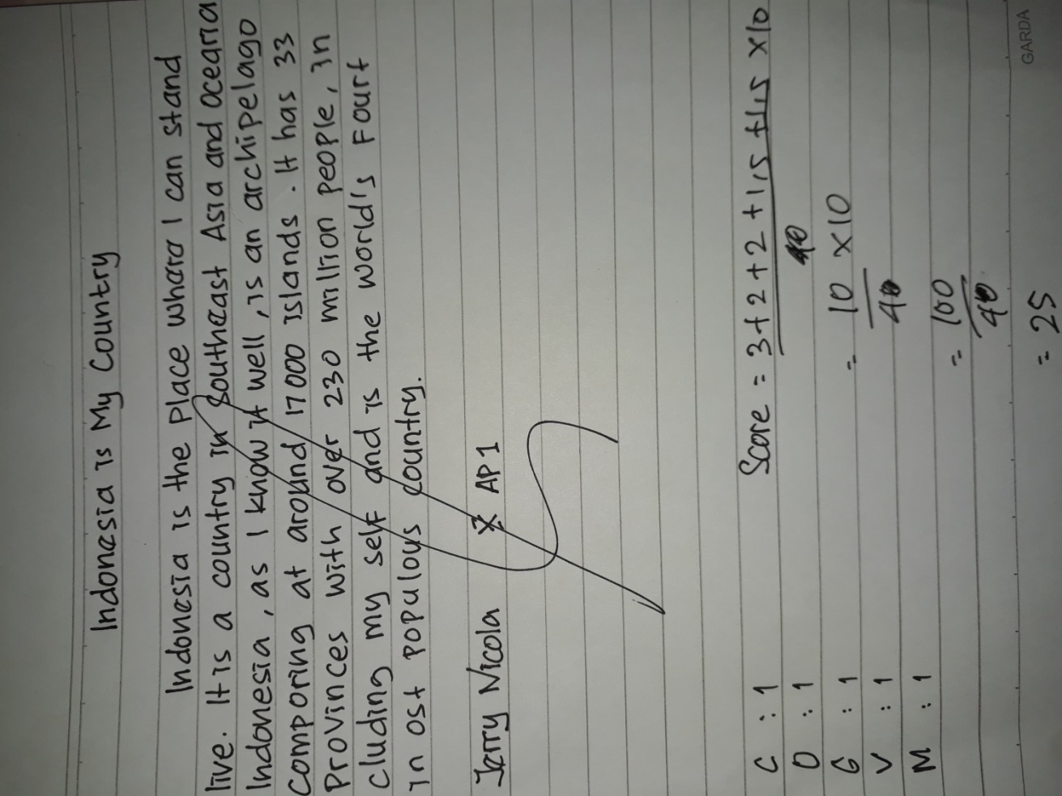

The Score of the writing descriptive text
Content : The topic is not clear and the details
Organization : Identification is not complete and descriptions
Grammar : Frequent grammatical or agreement inaccuracies
Vocabulary : Very poor knowledge of words
Mechanics : It is dominated by errors of spelling

