ACKNOWLEDGEMENTS

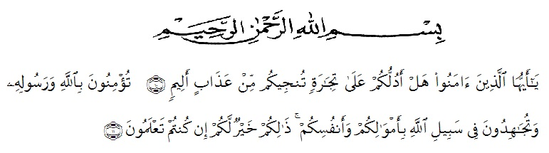
Artinya :
10. Hai orang-orang yang beriman, sukakah kamu aku tunjukkan suatu perniagaan yang dapat menyelamatkanmu dari azab yang pedih?
11. (yaitu) kamu beriman kepada Allah dan RasulNya dan berjihad di jalan Allah dengan harta dan jiwamu. Itulah yang lebih baik bagimu, jika kamu mengetahui.
The writer wishes to express her great thanks to Allah SWT, the Merciful and Beneficent. Then Selawat and Salam to Noble Prophet Mohammed SAW with his followers.
In conducting this research, the writer received suggestions, assistance, criticisms and guidances from some persons. The writer, therefore, would like to thank them. Especially she would like to thank
- H. Hardi Mulyono, SE, M.A.P as the Rector of UMN Al Washliyah, who has given facilities to her during her study at the university,
- Drs. M. Ayyub Lubis, M.Pd, Ph.D, Dean of FKIP UMN Medan and his staffs for guidance and counseling during the study,
- Junaidi, SS, S.Pd, M.Si as the Head of English Education Department FKIP University of Muslim Nusantara Al Washliyah Medan
- Harianto, SS, MS the first consultant, who has never stopped helping her in guiding and correcting the pattern of this research so that this research is complete and perfect,
- Nazriani Lubis, S.Pd., M.Hum, the second consultant, who has given her a lot of valuable suggestions, comments and criticism for completing this research,
- The Headmaster of SMK Negeri 1 Beringin for the facilities given to her in conducting this research,
- Classmates and friends who have encourages her in finishing the research,
- The lecturers of the English Language Department of FKIP Medan for their nice and valuable discussing to enrich the writer’s knowledge.
- Special sincere thanks are fully addressed to her beloved parents Sakimin and Suhartaty for their endless love, pray, advices, spirit, support and financial support that have enable to finish her thesis, and also beloved sister Lili Heriyati Amd.Keb and brother Edy Wisnu Syahputra S.Kom,
- Her beloved boyfriend Dio Sahputra S.T and her beloved friends, may Allah bless them all.
Finally, she realizes that she could not recompense the contribution of those people mentioned above. She prays to God, may the Almighty blesses them all in here after.
Medan, ^{th} 2019
The writer
Lista Putri Hardiyanti
151244140

