ACKNOWLEDGEMENTS
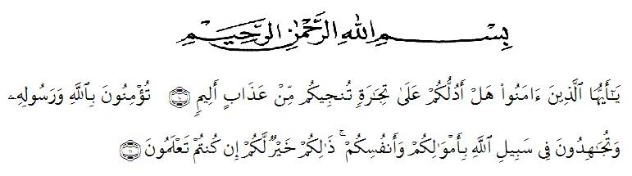
Artinya: ‘’Hai orang-orang yang beriman, maukah kamu aku tunjukkan suatu perniagaan yang dapat menyelamatkanmu dari azab yang pedih? (10). (Yaitu) kamu beriman kepada Allah dan Rasul-Nya dan berjihad di jalan Allah dengan harta dan jiwamu. Itulah yang lebih baik bagimu, jika kamu mengetahui (11). (QS. ash-Shaff: 10-11)’’

Alhamdulillahirabbil’alamin, all praises to Allah SWT, The Almighty, Who has given her the health and opportunity to write and to finish this thesis. Shalawat and Salam to our prophet Muhammad SAW, who has brought human beings from the darkness into the lightness. In conducting this research, the researcher receives so many suggestion and guidance from many people. The researcher would like to express her gratitude and high appreciation to:

- The Rector of Universitas Muslim Nusantara Al Washliyah Medan, H. Hardi Mulyono Surbakti, SE, M.AP who facilities in conducting this research.
- The Dean of FKIP UMN Al Washliyah Medan, Drs. Mhd. Ayyub Lubis M.Pd, Ph.D and his staff for the facilities given to her.
- The Head of English Department, Junaidi, S.S, S.Pd, M.Si for suggestions in accomplishing this research.
- The First Consultant, Dr. Hj. Risnawaty, M.Hum who has never stopped helping, guiding and correcting the formula and contents of this research.
- The Second Consultant, Mrs. Yusnita Nasution, S.Pd, M.Hum who for suggestion in finishing this research.
- The librarians of FKIP UMN Al-Washliyah Medan for the books method in writing research
- All the lecture of UMN Al-Wahliyah Especially English Department Lecture who gave guidance and knowledge that have given during academic time
- The Headmaster of SMP Swasta Nusantara Lubuk Pakam, Mr. Elwin Rezapahlepi, S. Pd who support and provided facilities in the
- Special to my beloved parents My mom is Ida Nurmala has endless love, and to be my beloved motivator, financial support, prays, inspiring and all of facilities has given to me. So that have anable to finish my thesis.
- Special for my beloved sister’ Ristia Dwi Ananda has given me prays, suggestion, take care and support of me who has been a pleasure growing up for me.
- All my big family, have given time, love, straight and prays for me, espisially always by given a lot of helps to finish my thesis until now.
- Her my beloved friend’s Novia Angraini, Kiki Ramadanti, Nur’aini, Hari Fuza Sartika, Ryan Panigoro, Uzna Marahani, Siti Carolina, Linda Lestari, Ummu, Hadis Permana, Shandy Kurniawan, thank for all helps.
Medan, Juni 2019
The Writer

Nur Khairunnisa
NPM. 151244080

