Appendixe I
EXPERIMENTAL GROUP
LESSON PLAN

School : SMP IT UMMI A’YUNI PERBAUNGAN
Class : VIII
Material Title : Narrative Text
Topic : Snow White
Subject : English
Skill : Reading
Time Allotment : 2 x 40 minutes

I. Standard Competency
Reading: Understanding the meaning of short functional text and simple essay in reports, narrative, and analytical exposition in daily life context and to get an access of knowledge.

II. Basic Competency
Responding the meaning and rhetoric steps in essay using various of written languages accurately, fluently and accepted in daily life context and to get access the knowledge in the form of report, narrative and analytical exposition.

III.Indicators
Indicator of Achieving Competence | Culture Value and Nation Character
a. Identifying word meaning of the narrative text  b. Identifying the certain information of the narrative text  c. Identifying rhetoric steps of the narrative text | Religious, tolerance, creative, curious, self-supporting, communicative, responsibility.

IV. Aims of Learning
In the end of study, students are able to:
- Identify word meaning of the narrative text
- Identify the certain information of the narrative text
- Identify rhetoric steps of the narrative text

V. Teaching Method
Method that is used: Teacher Reading Guide
Strategy that is used : Spore Strategy.

VI. Learning Material
Narrative text
Kinds of Narrative:
- Legend
- Affection
- Attention
- Love
- Family
- Punishment

- Social function : To amuse or entertain, to deal with actual/imaginative experiences in different ways
- Generic structure :
- Setting
- Problem
- Order of action
- Resolution
- End
Language features :
- A narrative focuses on specific participants.
- There are many action verbs, verbal and mental processes
- It usually uses Past Tense
- The use of direct and indirect speech in form of dialogues
- Descriptive language is used to create listener’s or reader’s imagination
- Use temporal conjunction and temporal circumstances,

Learning Activity
Learning activity | Activities | Character Building  (Values)
a. Pre-activity  (10 minutes) | • The teacher greets the students  • The teacher checks attendance list  • The teacher asks the previous materials and check students homework  • The teacher prepares the students’ physically and psychology to follow the teaching learning process  • The teacher gives motivation to students. | Religious, honest, discipline, communicative, creative, and independent.
b. Main activity  (60 minutes)  •Exploration steps : | • The students study and read the narrative text  • The teacher asks the students about the text  • The teacher responds to the students’ answer | Communicative, independent, discipline, creative, hard work, curious, honesty, friendship.
•Elaboration steps : | • The teacher explains about narrative text  • The students do the tasks from the teacher  • The teacher asks the students to collect the task
• Confirmation steps: | • The teacher gives the confirmation about the result of exploration and elaboration of the students
c. Post-activity  (10 minutes) | • The teacher together with students make a conclusion about the material.  • The teacher makes a reflection about the teaching learning process consistently.  • The teacher gives homework.  • The teacher informs about the material in the next meeting. | Communicative, honesty, responsible.

VIII. Questions,Sources and Media
Questions :

Snow White
Once upon a time there lived a little girl named Snow White. She lived with her aunt and uncle because her parents were dead.
One day she heard her uncle and aunt talking about leaving Snow White in the castle because they both wanted to go to America and they didn’t have enough money to take Snow White.
Snow White didn’t want her uncle and aunt to do that so she decided that it would be best if she ran away. The next morning she ran away into the woods. She was very tired and hungry. Then she saw a little cottage. She knocked but no one answered so she went inside and fell asleep.
Meanwhile, the seven dwarfs were coming home from work. There they found Snow White sleeping. Then Snow White woke up. She saw the dwarfs.
The dwarfs said, “What is your name?”
Snow White said, “My name is Snow White.”
Then, Snow White told the dwarfs the whole story.
The dwarfs said, “If you want, you may live here with us.”
Snow White answered, “Oh, could I? Thank you.”
Finally, Snow White and the seven dwarfs lived happily ever after.
- What type of the text is used by the witer?
- Narrative
- Report
- Anecdote
- Comprarative
- What does the story tell us about?
- It tells about Snow white and her parents
- It tells about Snow white and the seven dwarfs
- It tells about a reach little girl
- It tells about the fighting of a little girl to see her parents
- To tell the plot, the writers uses………
- a rhetorical question and an exclamation
- time sequences
- contrastive evidences
- past tense
- Why Snow White ran away to the woods?
- Her parents passed away
- Her uncle was angry with her
- Her uncle and aunt would go to America
- Snow White was happy to run away
- When did Snow White run away to the woods?
- In the afternoon
- In the morning
- In the evening
- In the full moon
- Where did Snow White live after she ran away to the woods?
- She lived in the cave
- She lived in the lion nest
- She lived everywhere in the woods
- She lived in the dwarfs’ cottage
- How many dwarfs that lived with Snow white?
- Four dwarfs
- Five dwarfs
- Six dwarfs
- Seven dwarfs
- The communicative purpose of this text is………
- to inform the readers about important and newsworthy events
- to entertain readers with fairy tale
- to share an account of an unusual event
- to persuade readers to accept his/her opinions
- According to the text, before she ran away into the woods, why did Snow White live with her uncle and aunt?
- because she loved them very much
- as a result of forcing attitude from them
- because her parents were dead
- because she were afraid of the dwarfs
- The organization of the text above is………
- abstract, orientatin, crisis, incident,coda.
- thesis, argument: plot-elaboration, argument: plot-elaboration, argument: plot-elaboration, conclusion.
- orientation, major complication, resolution, complication, resolution, complication, major complication.
- description, background events, sources.
-GOOD LUCK-

ANSWER
SNOW WHITE
- A 6) D
- D 7) D
- B 8) B
- C 9) C
- C 10) C

List of Appendixes II
CONTROL GROUP
LESSON PLAN

School : SMP IT UMMI A’YUNI PERBAUNGAN
Class : VIII
Material Title : Narrative Text
Topic : Sangkuriang
Subject : English
Skill : Reading
Time Allotment : 2 x 40 minutes

I. Standard Competency
Reading: Understanding the meaning of short functional text and simple essay in reports, narrative, and analytical exposition in daily life context and to get an access of knowledge.

II. Basic Competency
Responding the meaning and rhetoric steps in essay using various of written languages accurately, fluently and accepted in daily life context and to get access the knowledge in the form of report, narrative and analytical exposition.

III.Indicators
Indicator of Achieving Competence | Culture Value and Nation Character
a. Identifying word meaning of the narrative text  b. Identifying the certain information of the narrative text  c. Identifying rhetoric steps of the narrative text | Religious, tolerance, creative, curious, self-supporting, communicative, responsibility.

IV. Aims of Learning
In the end of study, students are able to:
- Identify word meaning of the narrative text
- Identify the certain information of the narrative text
- Identify rhetoric steps of the narrative text.
V. Teaching Method
Method that is used: Teacher Reading Guide
Strategy that is used : Spore Strategy.
- Social function : To amuse or entertain, to deal with actual/imaginative experiences in different ways
- Generic structure :
- Setting
- Problem
- Order of action
- Resolution
- End
Language features :
- A narrative focuses on specific participants.
- There are many action verbs, verbal and mental processes
- It usually uses Past Tense
- The use of direct and indirect speech in form of dialogues
- Descriptive language is used to create listener’s or reader’s imagination
- Use temporal conjunction and temporal circumstances,
Learning Activity
Learning activity | Activities | Character Building  (Values)
a. Pre-activity  (10 minutes) | • The teacher greets the students  • The teacher checks attendance list  • The teacher asks the previous materials and check students homework  • The teacher prepares the students’ physically and psychology to follow the teaching learning process  • The teacher gives motivation to students. | Religious, honest, discipline, communicative, creative, and independent.
b. Main activity  (60 minutes)  •Exploration steps : | • The students study and read the narrative text  • The teacher asks the students about the text  • The teacher responds to the students’ answer | Communicative, independent, discipline, creative, hard work, curious, honesty, friendship.
•Elaboration steps : | • The teacher explains about narrative text  • The students do the tasks from the teacher  • The teacher asks the students to collect the task
• Confirmation steps: | • The teacher gives the confirmation about the result of exploration and elaboration of the students
c. Post-activity  (10 minutes) | • The teacher together with students make a conclusion about the material.  • The teacher makes a reflection about the teaching learning process consistently.  • The teacher gives homework.  • The teacher informs about the material in the next meeting. | Communicative, honesty, responsible.

VII. Questions,Sources and Media
Questions :

Sangkuriang
Once upon a time in west java, lived a writer king who had a beautiful daughter. Her name was Dayang Sumbi. She liked weaving very much. Once she was weaving a cloth when one of her tools fell to the ground. She was very tired, at the same time she was too lazy to take it. Then she just shouted out loudly.
Anybody there! Bring me my tool. I will give you special present. If you are female. I will consider you as my sister if you are male, I will marry you sunddenly a male dog, its name was Tumang came. He brought her the falling tool. Dayang Sumbi was very surprised. She regretted her words but she could not deny it. So she had marry Tumang and leave her father. Then they lived in a small village. Several months later they had a son. His name was Sangkuriang. He was a handsome and healthy boy.
Sangkuriang liked hunting very much, especially deer. He often hunting to the wood usying his arrow. When he went hunting , Tumang was always with him.
One day Dayang Sumbi wanted to have deer’s heart so she asked Sangkuriang to hunt for a deer. Then Sangkuriang when to the wood with his arrow and his faithful dog. Tumang, but afher several days in the wood Sangkuriang could not find any deer. Then where all disappeared. Sangkuriang was exhausted and desperate. He did not want to disappoint her mother so he killed Tumang. He did not know that Tumang was his father. Tumang’s heart to her mother. But Dayang Sumbi knew that it was Tumang’s heart. She was so angry that she could not control her emotion. She hit Sangkuriang at his head Sangkuriang was wounded. There was a scar in his head. She also repelled her son. Sangkuriang left her mother in sadness.
Many years passed and Sangkuriang became a strong young man. He wandered everywhere. One day he arrived. at his own village but he did not realize it. There he met Dayang Sumbi. At the time Dayang Sumbi was given an eternal beauty by God so she stayed young forever. Both of them did know each other. So they fall in love and then they decided to marry. But then Dayang Sumbi recognized a scar on Sangkuriang’s head. She knew that Sangkuriang was his son. It was impossible for them to marry. She told him but he did not beliave her. He wished that they marry soon. So Dayang Sumbi gave very difficult condition. She asked Sangkuriang to build a lake and a boat in one night! She said she needed that for honeymoon.
Sangkuriang agreed. With the help of genie and spiritis, Sangkuriang tired to build them. By midnight he had completed the lake by building a dam in Citarum river. Then he started making the boat. It was almost dawn when he almost finished it. Meanwhile Dayang Sumbi kept watching on him. She was very worried when she knew this. So she made lights in the east. Then the spiritis thought that was already dawn. It was time for them to leave. They left Sangkuriang alone. Without their help he could not finish the boat.Sangkuriang was angry. He kicked the boat. Then the boat turned upside down. It, leter, became Mounth Tangkuban Perahu. Which means an upside-down boat. From a distant the mount really looks like an upside down boat.

NAME :
CLASS :
- What is the story about?
- A wrath son
- West java’s tales
- Tumang a Dog husband
- The legend of Tangkuban Perah
- According to he story, Tumang was….
- Actually a handsome prince
- Married to Dayang Sumbi
- Sangkuriang pet dog
- Good at hunting deer
- What did Dayang Sumbi look like?
- She liked weaving clothers
- She looked for the heart of a deer
- She was beautiful
- She was looking at her fallen tool
- What made Dayang Sumbi stay young?
- She set up conditions in doing things
- A young man fall in love with her
- She knew how to take care her body
- God gave her an eternal beauty
- Who are the main caracthers in the story?
- Dayang Sumbi and Sangkuriang
- The king Dayang Sumbi, the dog and Sangkuriang
- The king, Dayang Sumbi, the dog, Sangkuriang, the ganie, and the spiritis
- The king, Dayang Sumbi, the dog, Sangkuriang, the mount, the boat, the genie, and the spiritis
- What moral value can we learn from the story?
- People must keep their words all the time
- Do not make a promise to easily
- Never be reluctant to do good things
- We should not hate our decendants
- “He brought her the falling tool”
The underline word refers to……
- Sangkuriang
- Tumang
- Dayang Sumbi
- The king
- “ if you are male, I will marry you’ (paragraph 2)
the sentence mean that the one who helped Dayang Sumbi became her…
- Husband
- Maid
- Boss
- Son
- The complication starts when….
- Sangkuriang arrived at his own village
- Dayang Sumbi asked Sangkuriang to find deer’s heart
- Dayang Sumbi and Sangkuriang fellinlove and decided to mrry
- Dayang Sumbi asked Sangkuriang to build a lake and a boat in one night
- “once upon a time in west java, Indonesia lived a wise king who had beautiful daughter.” (paragraph 1)
What is the function of the above sentence?
- A resolution
- A complication
- An orientation
- A reorientation
-GOOD LUCK-

SANGKURIANG
- D 6) A
- B 7) B
- D 8) A
- D 9) D
- A 10) C

Appendixe III
Documentation of Research

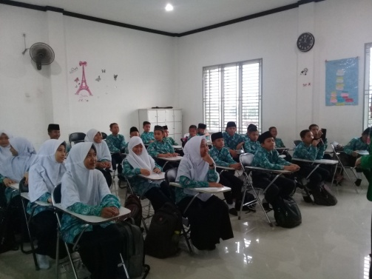
Pre-test in Experimental Class Pre-test in Control Class
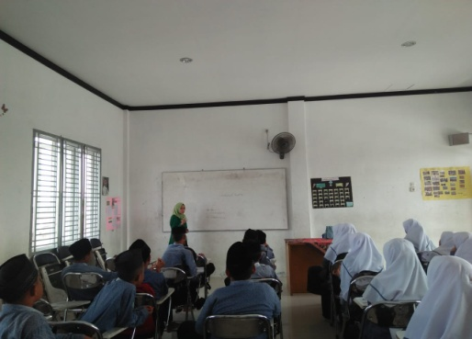

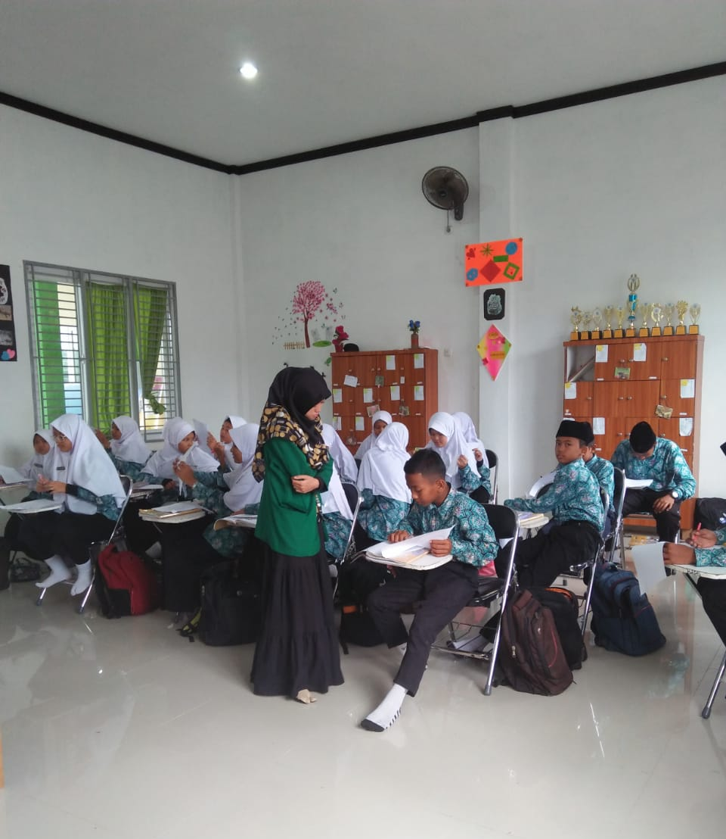
Treatment in Experimental Class

Treatment in Control Class
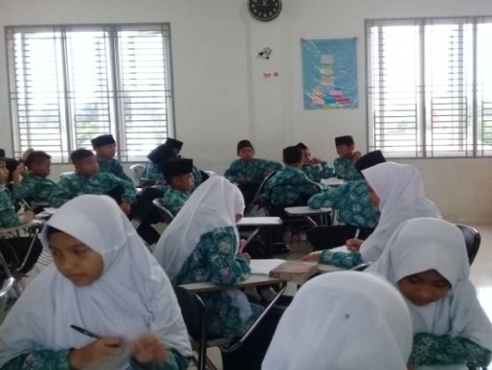
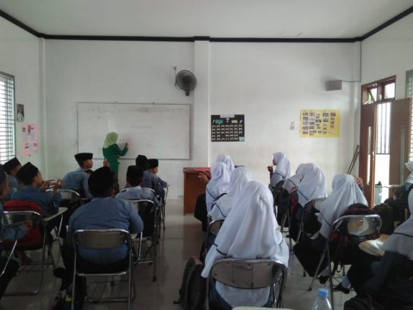

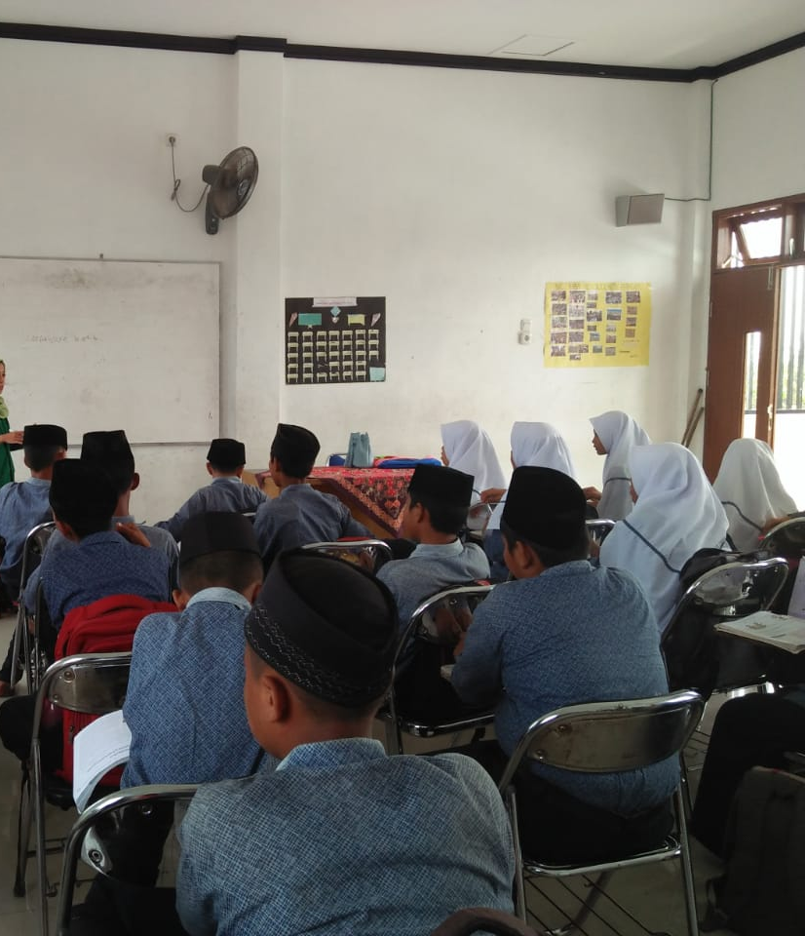
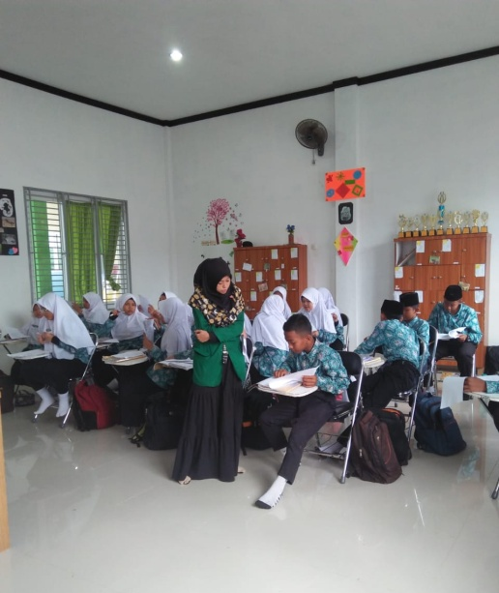
Post-test in Experimental Class Post-test in Control Class

