**ACKNOWLEDGEMENTS**

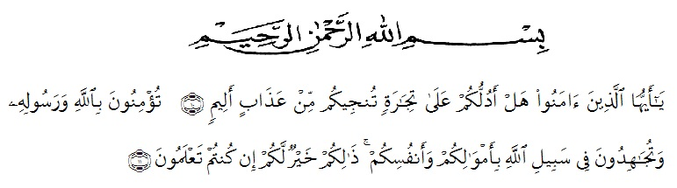

Artinya : “Hai orang-orang yang beriman, sukakah kamu aku tunjukkan suatu perniagaan yang dapat menyelamatkanmu dari azab yang pedih?(10). (yaitu) kamu beriman kepada Allah dan RasulNya dan berjihad di jalan Allah dengan harta dan jiwamu. Itulah yang lebih baik bagimu, jika kamu mengetahui.(11) (As-Shaff Ayat 10-11)

The writers say *Alhamdulillah* all praises to Allah who gave Taufik and guidance so that he can finish this thesis entitled “Error Analysis on the Use of Possesive Pronoun and Possesive Adjective” It is impossible for him to create this thesis without helping and supporting. In Conducting research, He received many suggestions, assistances, critics, and guidance from a lot of people. Therefore, he would like to give especially thanks to:

1. H. Hardi Mulyono, SE. MAP. the Rector of UMN-AW, for the facilities given during his study in English Department of University of Muslim Nusantara Al Washliyah Medan.
2. Drs. Mhd. Ayyub Lubis, M.Pd, Ph.D. as a dean of University of Muslim Nusantara Al Washliyah Medan.
3. Junaidi, S.Pd. M.Si, the head of English Department and his staff.
4. Yuda Setiawan S.Pd, M. Hum, the first consultant, who has given him a lot of valuable suggestions, comments and criticism for completing this research.
5. Irpan Apandi Batubara S.Pd, M.S, his second consultant, who has never stopped helping him in guiding and correcting the pattern of this research.
6. The librarians of UMN-Al Washliyah for the knowledge and facility they have given to him.
7. The headmaster of SMA Al Washliyah Tanjung Morawa for facilities given to him in conducting this research.
8. For his beloved father , his beloved mother, and his young sister and all his family who have given him the supports.
9. His friends in English Department Al Washliyah Medan.
10. The lectures of the English section in language Department FKIP UMN Al Washliyah Medan for their nice valuable discussing.

Finally the writer render thanks to various side which have given him and contribution so that finally this research can be finished. Hopefully this research can reach the target expected.

Medan 25 Agustus 2018

The Writer

Ulul Azmi Lubis