Lampiran 3

- Validitas Angket variabel kebijakan pemberian pinjaman (X1)

Correlations
 |  | X11 | X12 | X13 | X14 | X15 | X16 | X17 | TotalX1
X11 | Pearson Correlation | 1 | ,517** | ,665** | ,432** | ,643** | ,460** | ,182 | ,732**
 | Sig. (2-tailed) |  | ,000 | ,000 | ,000 | ,000 | ,000 | ,080 | ,000
 | N | 93 | 93 | 93 | 93 | 93 | 93 | 93 | 93
X12 | Pearson Correlation | ,517** | 1 | ,339** | ,594** | ,400** | ,621** | ,000 | ,686**
 | Sig. (2-tailed) | ,000 |  | ,001 | ,000 | ,000 | ,000 | 1,000 | ,000
 | N | 93 | 93 | 93 | 93 | 93 | 93 | 93 | 93
X13 | Pearson Correlation | ,665** | ,339** | 1 | ,584** | ,945** | ,601** | ,422** | ,844**
 | Sig. (2-tailed) | ,000 | ,001 |  | ,000 | ,000 | ,000 | ,000 | ,000
 | N | 93 | 93 | 93 | 93 | 93 | 93 | 93 | 93
X14 | Pearson Correlation | ,432** | ,594** | ,584** | 1 | ,610** | ,916** | ,181 | ,843**
 | Sig. (2-tailed) | ,000 | ,000 | ,000 |  | ,000 | ,000 | ,083 | ,000
 | N | 93 | 93 | 93 | 93 | 93 | 93 | 93 | 93
X15 | Pearson Correlation | ,643** | ,400** | ,945** | ,610** | 1 | ,625** | ,437** | ,866**
 | Sig. (2-tailed) | ,000 | ,000 | ,000 | ,000 |  | ,000 | ,000 | ,000
 | N | 93 | 93 | 93 | 93 | 93 | 93 | 93 | 93
X16 | Pearson Correlation | ,460** | ,621** | ,601** | ,916** | ,625** | 1 | ,234* | ,868**
 | Sig. (2-tailed) | ,000 | ,000 | ,000 | ,000 | ,000 |  | ,024 | ,000
 | N | 93 | 93 | 93 | 93 | 93 | 93 | 93 | 93
X17 | Pearson Correlation | ,182 | ,000 | ,422** | ,181 | ,437** | ,234* | 1 | ,425**
 | Sig. (2-tailed) | ,080 | 1,000 | ,000 | ,083 | ,000 | ,024 |  | ,000
 | N | 93 | 93 | 93 | 93 | 93 | 93 | 93 | 93
TotalX1 | Pearson Correlation | ,732** | ,686** | ,844** | ,843** | ,866** | ,868** | ,425** | 1
 | Sig. (2-tailed) | ,000 | ,000 | ,000 | ,000 | ,000 | ,000 | ,000
 | N | 93 | 93 | 93 | 93 | 93 | 93 | 93 | 93
**. Correlation is significant at the 0.01 level (2-tailed).
*. Correlation is significant at the 0.05 level (2-tailed).

- Validitas angket variabel jaminan BPKB (X2)

Correlations
 |  | X21 | X22 | X23 | TotalX2
X21 | Pearson Correlation | 1 | ,482** | ,068 | ,764**
 | Sig. (2-tailed) |  | ,000 | ,519 | ,000
 | N | 93 | 93 | 93 | 93
X22 | Pearson Correlation | ,482** | 1 | ,154 | ,800**
 | Sig. (2-tailed) | ,000 |  | ,141 | ,000
 | N | 93 | 93 | 93 | 93
X23 | Pearson Correlation | ,068 | ,154 | 1 | ,532**
 | Sig. (2-tailed) | ,519 | ,141 |  | ,000
 | N | 93 | 93 | 93 | 93
TotalX2 | Pearson Correlation | ,764** | ,800** | ,532** | 1
 | Sig. (2-tailed) | ,000 | ,000 | ,000
 | N | 93 | 93 | 93 | 93
**. Correlation is significant at the 0.01 level (2-tailed).

- Validitas angket variabel pemberian kredit (Y)

Correlations
 |  | Y11 | Y12 | Y13 | TotalY
Y11 | Pearson Correlation | 1 | ,234* | -,259* | ,571**
 | Sig. (2-tailed) |  | ,024 | ,012 | ,000
 | N | 93 | 93 | 93 | 93
Y12 | Pearson Correlation | ,234* | 1 | ,186 | ,712**
 | Sig. (2-tailed) | ,024 |  | ,074 | ,000
 | N | 93 | 93 | 93 | 93
Y13 | Pearson Correlation | -,259* | ,186 | 1 | ,531**
 | Sig. (2-tailed) | ,012 | ,074 |  | ,000
 | N | 93 | 93 | 93 | 93
TotalY | Pearson Correlation | ,571** | ,712** | ,531** | 1
 | Sig. (2-tailed) | ,000 | ,000 | ,000
 | N | 93 | 93 | 93 | 93
*. Correlation is significant at the 0.05 level (2-tailed).
**. Correlation is significant at the 0.01 level (2-tailed).

- Hasil Uji Reliabilitas Kebijakan Pemberian Pinjaman (X1)

Reliability Statistics
Cronbach's Alpha | Cronbach's Alpha Based on Standardized Items | N of Items
,786 | ,910 | 8

Item Statistics
 | Mean | Std. Deviation | N
X11 | 3,9462 | ,64884 | 93
X12 | 3,9355 | ,73435 | 93
X13 | 3,8172 | ,60696 | 93
X14 | 3,9355 | ,76338 | 93
X15 | 3,8387 | ,63057 | 93
X16 | 3,9677 | ,75831 | 93
X17 | 4,0000 | ,55168 | 93
TotalX1 | 27,4409 | 3,57364 | 93

Inter-Item Correlation Matrix
 | X11 | X12 | X13 | X14 | X15 | X16 | X17 | TotalX1
X11 | 1,000 | ,517 | ,665 | ,432 | ,643 | ,460 | ,182 | ,732
X12 | ,517 | 1,000 | ,339 | ,594 | ,400 | ,621 | ,000 | ,686
X13 | ,665 | ,339 | 1,000 | ,584 | ,945 | ,601 | ,422 | ,844
X14 | ,432 | ,594 | ,584 | 1,000 | ,610 | ,916 | ,181 | ,843
X15 | ,643 | ,400 | ,945 | ,610 | 1,000 | ,625 | ,437 | ,866
X16 | ,460 | ,621 | ,601 | ,916 | ,625 | 1,000 | ,234 | ,868
X17 | ,182 | ,000 | ,422 | ,181 | ,437 | ,234 | 1,000 | ,425
TotalX1 | ,732 | ,686 | ,844 | ,843 | ,866 | ,868 | ,425 | 1,000

Scale Statistics
Mean | Variance | Std. Deviation | N of Items
54,8817 | 51,084 | 7,14729 | 8

- Hasil Uji Reliabilitas Jaminan BPKB (X2)
Reliability Statistics
Cronbach's Alpha | Cronbach's Alpha Based on Standardized Items | N of Items
,777 | ,778 | 4

Inter-Item Correlation Matrix
 | X21 | X22 | X23 | TotalX2
X21 | 1,000 | ,482 | ,068 | ,764
X22 | ,482 | 1,000 | ,154 | ,800
X23 | ,068 | ,154 | 1,000 | ,532
TotalX2 | ,764 | ,800 | ,532 | 1,000

 |  | Summary Item Statistics
 | Mean |  | Minimum | Maximum | Range | Maximum / Minimum |  | Variance | N of Items
Item Means | 5,860 |  | 3,774 | 11,720 | 7,946 | 3,105 |  | 15,279 | 4

Item-Total Statistics
 | Scale Mean if Item Deleted | Scale Variance if Item Deleted | Corrected Item-Total Correlation | Squared Multiple Correlation | Cronbach's Alpha if Item Deleted
X21 | 19,5699 | 6,074 | ,624 | . | ,718
X22 | 19,6667 | 5,920 | ,677 | . | ,697
X23 | 19,3656 | 7,300 | ,354 | . | ,818
TotalX2 | 11,7204 | 2,225 | 1,000 | . | ,495

Scale Statistics
Mean | Variance | Std. Deviation | N of Items
23,4409 | 8,901 | 2,98351 | 4

- Hasil Uji Reliabilitas Permintaan Kredit (Y)

Reliability Statistics
Cronbach's Alpha | Cronbach's Alpha Based on Standardized Items | N of Items
,679 | ,662 | 4

Inter-Item Correlation Matrix
 | Y11 | Y12 | Y13 | TOTAL_Y
Y11 | 1,000 | ,234 | -,259 | ,571
Y12 | ,234 | 1,000 | ,186 | ,712
Y13 | -,259 | ,186 | 1,000 | ,531
TOTAL_Y | ,571 | ,712 | ,531 | 1,000

Summary Item Statistics
 | Mean | Minimum | Maximum | Range | Maximum / Minimum | Variance | N of Items
Item Means | 5,919 | 3,871 | 11,839 | 7,968 | 3,058 | 15,576 | 4

Item-Total Statistics
 | Scale Mean if Item Deleted | Scale Variance if Item Deleted | Corrected Item-Total Correlation | Squared Multiple Correlation | Cronbach's Alpha if Item Deleted
Y11 | 19,71 | 4,404 | ,301 | . | ,704
Y12 | 19,68 | 4,330 | ,568 | . | ,596
Y13 | 19,81 | 4,571 | ,259 | . | ,724
TOTAL_Y | 11,84 | 1,485 | 1,000 | . | ,057

Scale Statistics
Mean | Variance | Std. Deviation | N of Items
23,68 | 5,938 | 2,437 | 4

- Hasil Uji Normalitas
One-Sample Kolmogorov-Smirnov Test
 |  | Unstandardized Residual
N |  | 93
Normal Parameters^{a,b} | Mean | 0E-7
 | Std. Deviation | ,69468899
Most Extreme Differences | Absolute | ,092
 | Positive | ,053
 | Negative | -,092
Kolmogorov-Smirnov Z |  | ,889
Asymp. Sig. (2-tailed) |  | ,408
a. Test distribution is Normal.
b. Calculated from data.

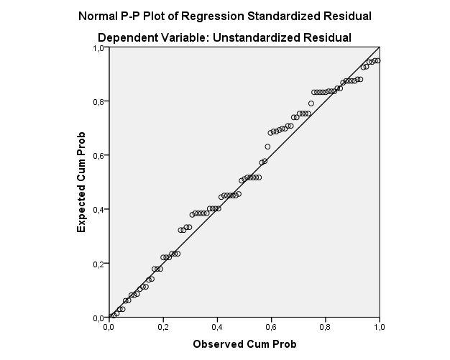

Uji Normalitas Data
Sumber : Output SPSS, diolah Peneliti, 2018

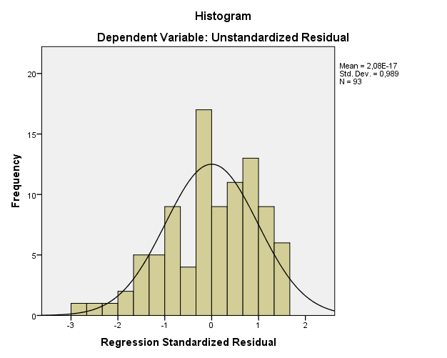

- Hasil Uji Multikolinieritas
Coefficientsª
Model |  | Unstandardized Coefficients |  | Standardized Coefficients | t | Sig. | Collinearity Statistics
 |  | B | Std. Error | Beta |  |  | Tolerance | VIF
1 | (Constant) | ,477 | ,840 |  | ,568 | ,571
 | kebijakan pemberian pinjaman (X1) | ,226 | ,021 | ,662 | 10,982 | ,000 | ,994 | 1,006
 | Jaminan BPKB (X2) | ,441 | ,049 | ,540 | 8,957 | ,000 | ,994 | 1,006
- Dependent Variable: Permintaan Kredit (Y)

- Hasil Uji Heteroskedastisitas
Model Summary^{b}
Model | R | R Square | Adjusted R Square | Std. Error of the Estimate
1 | ,822ª | ,675 | ,668 | ,70237
a. Predictors: (Constant), Jaminan BPKB (X2), Kebijakan Pemberian Pinjaman (X1)
b. Dependent Variable: Permintaan kredit (Y)

ANOVAª
Model |  | Sum of Squares | Df | Mean Square | F | Sig.
1 | Regression | 92,182 | 2 | 46,091 | 93,431 | ,000^{b}
 | Residual | 44,399 | 90 | ,493
 | Total | 136,581 | 92
a. Dependent Variable: Permintaan kredit (Y)
b. Predictors: (Constant), Jaminan BPKB (X2), Kebijakan Pemberian Pinjaman (X1)

Coefficientsª
Model |  | Unstandardized Coefficients |  | Standardized Coefficients | t | Sig.
 |  | B | Std. Error | Beta
1 | (Constant) | ,477 | ,840 |  | ,568 | ,571
 | Kebijakan Pemberian Pinjaman | ,226 | ,021 | ,662 | 10,982 | ,000
 | Jaminan BPKB | ,441 | ,049 | ,540 | 8,957 | ,000
a. Dependent Variable: Permintaan Kredit

Residuals Statisticsª
 | Minimum | Maximum | Mean | Std. Deviation | N
Predicted Value | 9,8521 | 13,6472 | 11,8387 | 1,00099 | 93
Residual | -1,97016 | 1,14786 | ,00000 | ,69469 | 93
Std. Predicted Value | -1,985 | 1,807 | ,000 | 1,000 | 93
Std. Residual | -2,805 | 1,634 | ,000 | ,989 | 93
a. Dependent Variable: Permintaan Kredit

Model Summary
Model | R | R Square | Adjusted R Square | Std. Error of the Estimate
1 | ,181ª | ,033 | ,011 | ,40540
a. Predictors: (Constant), Jaminan BPKB (X2), Kebijakan Pemberian Pinjaman (X1)

ANOVAª
Model |  | Sum of Squares | df | Mean Square | F | Sig.
1 | Regression | ,501 | 2 | ,251 | 1,525 | ,223^{b}
 | Residual | 14,792 | 90 | ,164
 | Total | 15,293 | 92
a. Dependent Variable: RES2
b. Predictors: (Constant), Jaminan BPKB (X2), Kebijakan Pemberian Pinjaman (X1)

Coefficientsª
Model |  | Unstandardized Coefficients |  | Standardized Coefficients | t | Sig.
 |  | B | Std. Error | Beta
1 | (Constant) | 1,211 | ,485 |  | 2,496 | ,014
 | Kebijakan Pemberian Pinjaman | -,003 | ,012 | -,022 | -,215 | ,830
 | Jaminan BPKB | -,050 | ,028 | -,181 | -1,745 | ,084
a. Dependent Variable: RES2

J. Hasil Uji Regresi Linier Berganda
Coefficientsª
Model |  | Unstandardized Coefficients |  | Standardized Coefficients | t | Sig.
 |  | B | Std. Error | Beta
1 | (Constant) | ,477 | ,840 |  | ,568 | ,571
 | Kebijakan Pemberian Pinjaman (X1) | ,226 | ,021 | ,662 | 10,982 | ,000
 | Jaminan BPKB (X2) | ,441 | ,049 | ,540 | 8,957 | ,000
a. Dependent Variable: Permintaan Kredit (Y)

K. Hasil Uji Secara Parsial (Uji-t)
Coefficientsª
Model |  | Unstandardized Coefficients |  | Standardized Coefficients | t | Sig.
 |  | B | Std. Error | Beta
1 | (Constant) | ,477 | ,840 |  | ,568 | ,571
 | Kebijakan Pemberian Pinjaman (X1) | ,226 | ,021 | ,662 | 10,982 | ,000
 | Jaminan BPKB (X2) | ,441 | ,049 | ,540 | 8,957 | ,000
a. Dependent Variable: Permintaan kredit (Y)

L. Hasil Uji Secara Simultan (Uji-F)
Tabel 4.7
Uji Signifikan F

ANOVAª
Model |  | Sum of Squares | df | Mean Square | F | Sig.
1 | Regression | 92,182 | 2 | 46,091 | 93,431 | ,000^{b}
 | Residual | 44,399 | 90 | ,493
 | Total | 136,581 | 92
a. Dependent Variable: Permintaan Kredit (Y)
- Predictors: (Constant), Jaminan BPKB (X2), Kebijakan Pemberian Pinjaman (X1)

