Lampiran 1 : Kriteria Penentuan Sampel
No. | Kode Perusahaan | Kriteria
 |  | 1 | 2 | 3
1 | AALI |  |  | 
2 | ABBA |  |  | 
3 | ACES |  |  | 
4 | ACST |  |  | 
5 | ADES |  |  | 
6 | ADHI |  |  | 
7 | ADMG |  |  | 
8 | ADRO |  |  | 
9 | AGII |  |  | 
10 | AKKU |  |  | 
11 | AKPI |  |  | 
12 | AKRA |  |  | 
13 | AKSI |  |  | 
14 | ALDO |  |  | 
15 | ALKA |  |  | 
16 | AMFG |  |  | 
17 | AMIN |  |  | 
18 | ANJT |  |  | 
19 | ANTM |  |  | 
20 | APII |  |  | 
21 | APLI |  |  | 
22 | APLN |  |  | 
23 | ARII |  |  | 
24 | ARMY |  |  | 
25 | ARNA |  |  | 
26 | ARTA |  |  | 
27 | ARTI |  |  | 
28 | ASGR |  |  | 
29 | ASII |  |  | 
30 | ASRI |  |  | 
31 | ATIC |  |  | 
32 | ATPK |  |  | 
33 | AUTO |  |  | 
34 | BAPA |  |  | 
35 | BATA |  |  | 
36 | BAYU |  |  | 
37 | BCIP |  |  | 
38 | BEEF |  |  | 
39 | BELL |  |  | 
40 | BEST |  |  | 
41 | BIPP |  |  | 
42 | BIRD |  |  | 
43 | BISI |  |  | 
44 | BKDP |  |  | 
45 | BKSL |  |  | 
46 | BLTZ |  |  | 
47 | BMSR |  |  | 
48 | BMTR |  |  | 
49 | BOGA |  |  | 
50 | BOLT |  |  | 
51 | BOSS |  |  | 
52 | BRAM |  |  | 
53 | BRIS |  |  | 
54 | BRMS |  |  | 
55 | BRNA |  |  | 
56 | BRPT |  |  | 
57 | BSDE |  |  | 
58 | BSSR |  |  | 
59 | BTEK |  |  | 
60 | BTON |  |  | 
61 | BTPS |  |  | 
62 | BUDI |  |  | 
63 | BUKK |  |  | 
64 | BULL |  |  | 
65 | BUVA |  |  | 
66 | BWPT |  |  | 
67 | BYAN |  |  | 
68 | CAKK |  |  | 
69 | CAMP |  |  | 
70 | CANI |  |  | 
71 | CASS |  |  | 
72 | CEKA |  |  | 
73 | CENT |  |  | 
74 | CINT |  |  | 
75 | CKRA |  |  | 
76 | CLEO |  |  | 
77 | CLPI |  |  | 
78 | CMNP |  |  | 
79 | CMPP |  |  | 
80 | CPIN |  |  | 
81 | CSAP |  |  | 
82 | CSIS |  |  | 
83 | CTBN |  |  | 
84 | CTRA |  |  | 
85 | CTTH |  |  | 
86 | DART |  |  | 
87 | DAYA |  |  | 
88 | DEWA |  |  | 
89 | DGIK |  |  | 
90 | DIGI |  |  | 
91 | DILD |  |  | 
92 | DKFT |  |  | 
93 | DMAS |  |  | 
94 | DPNS |  |  | 
95 | DPUM |  |  | 
96 | DSFI |  |  | 
97 | DSSA |  |  | 
98 | DUCK |  |  | 
99 | DUTI |  |  | 
100 | DVLA |  |  | 
101 | DWGL |  |  | 
102 | DYAN |  |  | 
103 | ECII |  |  | 
104 | EKAD |  |  | 
105 | ELSA |  |  | 
106 | EMDE |  |  | 
107 | EMTK |  |  | 
108 | EPMT |  |  | 
109 | ERAA |  |  | 
110 | EXCL |  |  | 
111 | FAST |  |  | 
112 | FASW |  |  | 
113 | FILM |  |  | 
114 | FIRE |  |  | 
115 | FISH |  |  | 
116 | FMII |  |  | 
117 | FOOD |  |  | 
118 | FORZ |  |  | 
119 | FPNI |  |  | 
120 | FREN |  |  | 
121 | GAMA |  |  | 
122 | GDST |  |  | 
123 | GDYR |  |  | 
124 | GEMA |  |  | 
125 | GEMS |  |  | 
126 | GHON |  |  | 
127 | GIAA |  |  | 
128 | GJTL |  |  | 
129 | GMCW |  |  | 
130 | GMFI |  |  | 
131 | GMTD |  |  | 
132 | GOLD |  |  | 
133 | GOOD |  |  | 
134 | GPRA |  |  | 
135 | GTBO |  |  | 
136 | GWSA |  |  | 
137 | GZCO |  |  | 
138 | HADE |  |  | 
139 | HEAL |  |  | 
140 | HERO |  |  | 
141 | HEXA |  |  | 
142 | HITS |  |  | 
143 | HKMU |  |  | 
144 | HOKI |  |  | 
145 | HOME |  |  | 
146 | HRTA |  |  | 
147 | HRUM |  |  | 
148 | IATA |  |  | 
149 | IBST |  |  | 
150 | ICBP |  |  | 
151 | ICON |  |  | 
152 | IDPR |  |  | 
153 | IGAR |  |  | 
154 | IIKP |  |  | 
155 | IKBI |  |  | 
156 | IMPC |  |  | 
157 | INAF |  |  | 
158 | INCI |  |  | 
159 | INCO |  |  | 
160 | INDF |  |  | 
161 | INDR |  |  | 
162 | INDS |  |  | 
163 | INDX |  |  | 
164 | INDY |  |  | 
165 | INPP |  |  | 
166 | INTD |  |  | 
167 | INTP |  |  | 
168 | IPCC |  |  | 
169 | IPCM |  |  | 
170 | IPOL |  |  | 
171 | ISAT |  |  | 
172 | ISSP |  |  | 
173 | ITMA |  |  | 
174 | ITMG |  |  | 
175 | JECC |  |  | 
176 | JGLE |  |  | 
177 | JIHD |  |  | 
178 | JKON |  |  | 
179 | JKSW |  |  | 
180 | JMAS |  |  | 
181 | JPFA |  |  | 
182 | JRPT |  |  | 
183 | JSKY |  |  | 
184 | JSMR |  |  | 
185 | JSPT |  |  | 
186 | JTPE |  |  | 
187 | KAEF |  |  | 
188 | KARW |  |  | 
189 | KBLI |  |  | 
190 | KBLM |  |  | 
191 | KBLV |  |  | 
192 | KDSI |  |  | 
193 | KIAS |  |  | 
194 | KICI |  |  | 
195 | KIJA |  |  | 
196 | KINO |  |  | 
197 | KIOS |  |  | 
198 | KKGI |  |  | 
199 | KLBF |  |  | 
200 | KOBX |  |  | 
201 | KOIN |  |  | 
202 | KOPI |  |  | 
203 | KPAS |  |  | 
204 | KPIG |  |  | 
205 | LAND |  |  | 
206 | LAPD |  |  | 
207 | LCGP |  |  | 
208 | LCKM |  |  | 
209 | LINK |  |  | 
210 | LION |  |  | 
211 | LMPI |  |  | 
212 | LMSH |  |  | 
213 | LPCK |  |  | 
214 | LPIN |  |  | 
215 | LPKR |  |  | 
216 | LPLI |  |  | 
217 | LPPF |  |  | 
218 | LRNA |  |  | 
219 | LSIP |  |  | 
220 | LTLS |  |  | 
221 | LUCK |  |  | 
222 | MAGP |  |  | 
223 | MAIN |  |  | 
224 | MAMI |  |  | 
225 | MAPA |  |  | 
226 | MAPB |  |  | 
227 | MAPI |  |  | 
228 | MARK |  |  | 
229 | MASA |  |  | 
230 | MBAP |  |  | 
231 | MBSS |  |  | 
232 | MBTO |  |  | 
233 | MCAS |  |  | 
234 | MDKA |  |  | 
235 | MDKI |  |  | 
236 | MDLN |  |  | 
237 | MERK |  |  | 
238 | META |  |  | 
239 | MFMI |  |  | 
240 | MGRO |  |  | 
241 | MICE |  |  | 
242 | MIKA |  |  | 
243 | MINA |  |  | 
244 | MIRA |  |  | 
245 | MITI |  |  | 
246 | MKPI |  |  | 
247 | MLIA |  |  | 
248 | MLPL |  |  | 
249 | MLPT |  |  | 
250 | MMLP |  |  | 
251 | MNCN |  |  | 
252 | MPMX |  |  | 
253 | MPPA |  |  | 
254 | MRAT |  |  | 
255 | MTDL |  |  | 
256 | MTLA |  |  | 
257 | MTRA |  |  | 
258 | MSIN |  |  | 
259 | MTSM |  |  | 
260 | MYOH |  |  | 
261 | MYOR |  |  | 
262 | MYRX |  |  | 
263 | NASA |  |  | 
264 | NATO |  |  | 
265 | NELY |  |  | 
266 | NFCX |  |  | 
267 | NIKL |  |  | 
268 | NIPS |  |  | 
269 | NRCA |  |  | 
270 | OASA |  |  | 
271 | OMRE |  |  | 
272 | PALM |  |  | 
273 | PANI |  |  | 
274 | PANR |  |  | 
275 | PBID |  |  | 
276 | PBSA |  |  | 
277 | PCAR |  |  | 
278 | PDES |  |  | 
279 | PEHA |  |  | 
280 | PGAS |  |  | 
281 | PGLI |  |  | 
282 | PICO |  |  | 
283 | PJAA |  |  | 
284 | PKPK |  |  | 
285 | PNBS |  |  | 
286 | PNSE |  |  | 
287 | POLI |  |  | 
288 | POLL |  |  | 
289 | PORT |  |  | 
290 | POWR |  |  | 
291 | PPRE |  |  | 
292 | PPRO |  |  | 
293 | PRDA |  |  | 
294 | PRIM |  |  | 
295 | PSAB |  |  | 
296 | PSKT |  |  | 
297 | PSSI |  |  | 
298 | PTBA |  |  | 
299 | PTIS |  |  | 
300 | PTPP |  |  | 
301 | PTRO |  |  | 
302 | PTSN |  |  | 
303 | PTSP |  |  | 
304 | PUDP |  |  | 
305 | PWON |  |  | 
306 | PYFA |  |  | 
307 | PZZA |  |  | 
308 | RAJA |  |  | 
309 | RALS |  |  | 
310 | RANC |  |  | 
311 | RBMS |  |  | 
312 | RICY |  |  | 
313 | RIGS |  |  | 
314 | RIMO |  |  | 
315 | RISE |  |  | 
316 | RODA |  |  | 
317 | ROTI |  |  | 
318 | RUIS |  |  | 
319 | SAME |  |  | 
320 | SCBD |  |  | 
321 | SCCO |  |  | 
322 | SDMU |  |  | 
323 | SDPC |  |  | 
324 | SHID |  |  | 
325 | SIAP |  |  | 
326 | SIDO |  |  | 
327 | SILO |  |  | 
328 | SIMP |  |  | 
329 | SIPD |  |  | 
330 | SKBM |  |  | 
331 | SKLT |  |  | 
332 | SKRN |  |  | 
333 | SKYB |  |  | 
334 | SMBR |  |  | 
335 | SMDM |  |  | 
336 | SMDR |  |  | 
337 | SMGR |  |  | 
338 | SMMT |  |  | 
339 | SMRA |  |  | 
340 | SMRU |  |  | 
341 | SMSM |  |  | 
342 | SONA |  |  | 
343 | SOSS |  |  | 
344 | SOTS |  |  | 
345 | SPMA |  |  | 
346 | SPTO |  |  | 
347 | SQMI |  |  | 
348 | SRAJ |  |  | 
349 | SRSN |  |  | 
350 | SRTG |  |  | 
351 | SSIA |  |  | 
352 | SSTM |  |  | 
353 | STAR |  |  | 
354 | STTP |  |  | 
355 | SUGI |  |  | 
356 | SWAT |  |  | 
357 | TARA |  |  | 
358 | TBMS |  |  | 
359 | TCID |  |  | 
360 | TCPI |  |  | 
361 | TDPM |  |  | 
362 | TFCO |  |  | 
363 | TGKA |  |  | 
364 | TGRA |  |  | 
365 | TINS |  |  | 
366 | TIRA |  |  | 
367 | TLKM |  |  | 
368 | TMPO |  |  | 
369 | TNCA |  |  | 
370 | TOBA |  |  | 
371 | TOPS |  |  | 
372 | TOTL |  |  | 
373 | TOTO |  |  | 
374 | TPIA |  |  | 
375 | TPMA |  |  | 
376 | TRAM |  |  | 
377 | TRIL |  |  | 
378 | TRIS |  |  | 
379 | TRST |  |  | 
380 | TRUK |  |  | 
381 | TSPC |  |  | 
382 | TURI |  |  | 
383 | ULTJ |  |  | 
384 | UNIC |  |  | 
385 | UNIT |  |  | 
386 | UNTR |  |  | 
387 | UNVR |  |  | 
388 | URBN |  |  | 
389 | VIVA |  |  | 
390 | VOKS |  |  | 
391 | WAPO |  |  | 
392 | WEGE |  |  | 
393 | WEHA |  |  | 
394 | WICO |  |  | 
395 | WIKA |  |  | 
396 | WINS |  |  | 
397 | WOOD |  |  | 
398 | WSBP |  |  | 
399 | WTON |  |  | 
400 | YELO |  |  | 
401 | ZBRA |  |  | 
402 | ZINC |  |  | 
403 | ZONE |  |  | 
Total |  | 21 Perusahaan

Lampiran 2 : Data Penelitian
No. | KODE | TAHUN | ROA  (Y) | DER  (X1) | WCT  (X2) | DAR  (X3)
1 | AALI | 2018 | 0.057 | 0.379 | 4.240 | 0.275
 |  | 2019 | 0.009 | 0.421 | 3.903 | 0.296
 |  | 2020 | 0.032 | 0.443 | 3.167 | 0.307
2 | ACES | 2018 | 0.183 | 0.256 | 1.767 | 0.204
 |  | 2019 | 0.154 | 0.420 | 1.864 | 0.296
 |  | 2020 | 0.101 | 0.388 | 1.472 | 0.279
3 | ADES | 2018 | 0.060 | 0.829 | 2.209 | 0.453
 |  | 2019 | 0.102 | 0.448 | 2.178 | 0.309
 |  | 2020 | 0.142 | 0.369 | 1.235 | 0.269
4 | ALDO | 2018 | 0.081 | 0.937 | 2.115 | 0.484
 |  | 2019 | 0.085 | 0.734 | 2.080 | 0.423
 |  | 2020 | 0.007 | 0.616 | 2.061 | 0.381
5 | ASGR | 2018 | 0.119 | 0.530 | 2.307 | 0.347
 |  | 2019 | 0.087 | 0.782 | 2.029 | 0.439
 |  | 2020 | 0.021 | 0.465 | 1.921 | 0.317
6 | BISI | 2018 | 0.146 | 0.197 | 1.045 | 0.165
 |  | 2019 | 0.104 | 0.270 | 0.979 | 0.212
 |  | 2020 | 0.095 | 0.186 | 0.807 | 0.157
7 | BSDE | 2018 | 0.033 | 0.720 | 0.316 | 0.419
 |  | 2019 | 0.057 | 0.622 | 0.292 | 0.383
 |  | 2020 | 0.008 | 0.766 | 0.218 | 0.434
8 | CAMP | 2018 | 0.062 | 0.134 | 1.446 | 0.118
 |  | 2019 | 0.073 | 0.131 | 1.421 | 0.115
 |  | 2020 | 0.041 | 0.130 | 1.272 | 0.115
9 | CEKA | 2018 | 0.079 | 0.197 | 4.485 | 0.165
 |  | 2019 | 0.155 | 0.231 | 2.923 | 0.188
 |  | 2020 | 0.116 | 0.243 | 2.869 | 0.195
10 | CLEO | 2018 | 0.076 | 0.312 | 4.186 | 0.238
 |  | 2019 | 0.105 | 0.625 | 4.506 | 0.385
 |  | 2020 | 0.101 | 0.465 | 3.826 | 0.317
11 | CLPI | 2018 | 0.045 | 0.564 | 1.465 | 0.360
 |  | 2019 | 0.052 | 0.468 | 1.559 | 0.319
 |  | 2020 | 0.056 | 0.323 | 1.546 | 0.244
12 | DVLA | 2018 | 0.119 | 0.402 | 1.412 | 0.287
 |  | 2019 | 0.121 | 0.401 | 1.416 | 0.286
 |  | 2020 | 0.082 | 0.498 | 1.307 | 0.332
13 | EPMT | 2018 | 0.078 | 0.438 | 2.960 | 0.305
 |  | 2019 | 0.067 | 0.420 | 3.121 | 0.296
 |  | 2020 | 0.074 | 0.404 | 2.990 | 0.288
14 | HOKI | 2018 | 0.119 | 0.347 | 2.916 | 0.258
 |  | 2019 | 0.122 | 0.323 | 3.419 | 0.244
 |  | 2020 | 0.042 | 0.369 | 2.770 | 0.269
15 | IMPC | 2018 | 0.045 | 0.727 | 1.144 | 0.421
 |  | 2019 | 0.037 | 0.776 | 1.273 | 0.437
 |  | 2020 | 0.043 | 0.840 | 1.424 | 0.456
16 | KLBF | 2018 | 0.138 | 0.186 | 1.979 | 0.157
 |  | 2019 | 0.125 | 0.213 | 2.017 | 0.176
 |  | 2020 | 0.124 | 0.235 | 1.768 | 0.190
17 | MAPA | 2018 | 0.097 | 0.561 | 2.198 | 0.359
 |  | 2019 | 0.167 | 0.345 | 2.408 | 0.256
 |  | 2020 | 0.001 | 0.801 | 1.405 | 0.445
18 | MIKA | 2018 | 0.129 | 0.144 | 1.122 | 0.126
 |  | 2019 | 0.142 | 0.163 | 1.295 | 0.140
 |  | 2020 | 0.145 | 0.155 | 1.102 | 0.134
19 | MKPI | 2018 | 0.145 | 0.340 | 1.366 | 0.253
 |  | 2019 | 0.084 | 0.322 | 1.641 | 0.244
 |  | 2020 | 0.030 | 0.359 | 1.386 | 0.264
20 | PBID | 2018 | 0.130 | 0.487 | 2.576 | 0.327
 |  | 2019 | 0.096 | 0.402 | 2.989 | 0.287
 |  | 2020 | 0.154 | 0.255 | 2.603 | 0.203
21 | PYFA | 2018 | 0.045 | 0.573 | 2.740 | 0.364
 |  | 2019 | 0.049 | 0.530 | 2.576 | 0.346
 |  | 2020 | 0.097 | 0.450 | 2.145 | 0.310

Lampiran 3 : Hasil Analisis Statistik Deskriptif
 | Y | X1 | X2 | X3
Mean | 0.087159 | 0.429635 | 2.082175 | 0.286794
Median | 0.085000 | 0.402000 | 1.979000 | 0.287000
Maximum | 0.183000 | 0.937000 | 4.506000 | 0.484000
Minimum | 0.001000 | 0.130000 | 0.218000 | 0.115000
Std. Dev. | 0.044685 | 0.204840 | 1.004724 | 0.097937
Skewness | 0.006518 | 0.562009 | 0.602306 | 0.054850
Kurtosis | 2.133115 | 2.552363 | 2.946656 | 2.206616
Jarque-Bera | 1.973108 | 3.842466 | 3.816584 | 1.683918
Probability | 0.372859 | 0.146426 | 0.148334 | 0.430866
Sum | 5.491000 | 27.06700 | 131.1770 | 18.06800
Sum Sq. Dev. | 0.123796 | 2.601475 | 62.58711 | 0.594678
Observations | 63 | 63 | 63 | 63
Lampiran 4 : Hasil Uji Regresi Linier Berganda
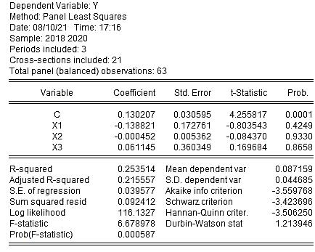

Lampiran 5 : Hasil Uji Common Effect Model
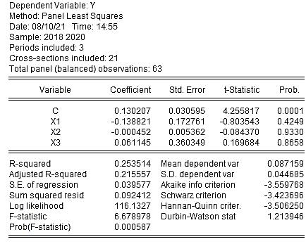

Lampiran 6 : Hasil Uji Fixed Effect Model
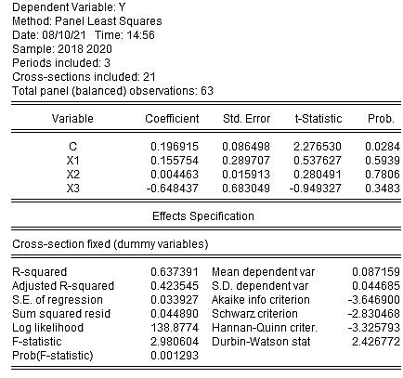

Lampiran 7 : Hasil Uji Random Effect Model
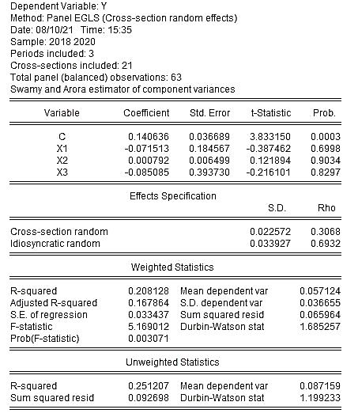
Lampiran 8 : Hasil Uji Chow
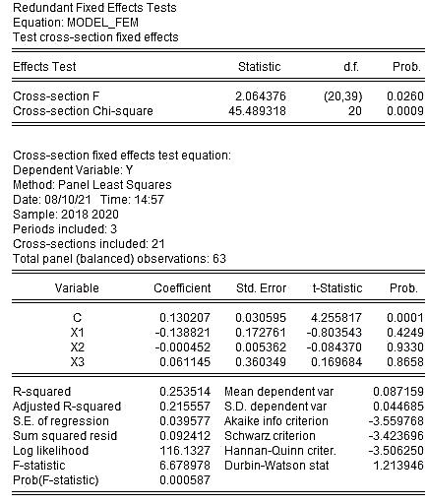

Lampiran 9 : Hasil Uji Hausman
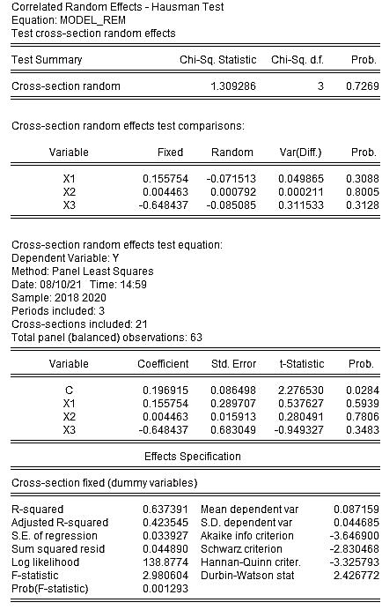
Lampiran 10 : Hasil Uji Langrange Multiplier
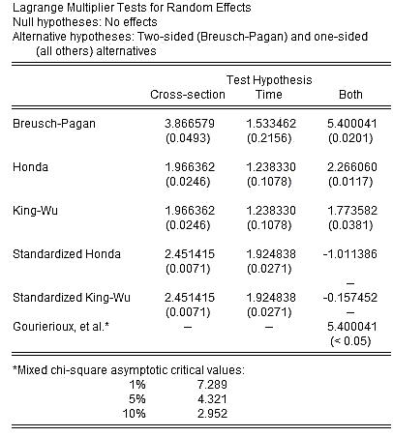

Lampiran 11 : Hasil Uji Normalitas

Lampiran 12 : Hasil Uji Multikolinearitas

 | X1 | X2 | X3
X1 | 1.000000 | -0.077490 | 0.883529
X2 | -0.077490 | 1.000000 | -0.023118
X3 | 0.883529 | -0.023118 | 1.000000

Lampiran 13 : Hasil Uji Heteroskedastisitas

Lampiran 14 : Hasil Uji Autokorelasi

Lampiran 15 : Hasil Uji t

Lampiran 16 : Hasil Uji F

Lampiran 17 : Nilai Koefisien Determinasi (R²)

