IMPROVING STUDENTS’ SPEAKING SKILL BY USING RECITATION METHOD IN IDIOMATIC EXPRESSION AT VIII GRADE OF SMP SWASTA PEMBANGUN MEDAN 2017-2018

SKRIPSI

BY :

HERLINA SARI DONGORAN
NPM : 141244105

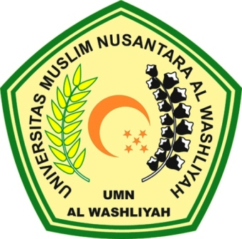

FAKULTAS KEGURUAN DAN ILMU PENDIDIKAN
UNIVERSITAS MUSLIM NUSANTARA AL WASHLIYAH
MEDAN
2018

